Figure S1 RNA-seq data of ZmLAZ1-3 in different tissue.
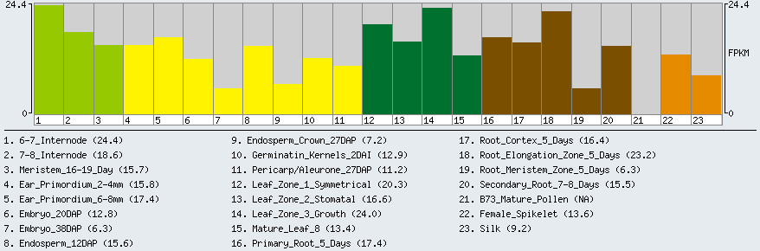
Figure S2 Promoter sequence and cis-affect elements of gene ZmLAZ1-3
