Supplementary Material
Combined application of arbuscular mycorrhizal fungi and selenium fertilizer increased wheat biomass under cadmium stress and shapes rhizosphere soil microbial communities
Haiyang Liu^{a,b 1}, Haoquan Wang^{a,b 1}, Zhaojun Nie^{a,b}, Zhikang Tao^{a,b}, Hongyu Peng^{a,b}, Huazhong Shi^{c}, Peng Zhao^{a,b}, Hongen Liu^{a,b,}*
ªCollege of Resources and Environment, Henan Agricultural University, Zhengzhou 450046, China
^{b}Key Laboratory of Soil Pollution Control and Remediation in Henan Province, Zhengzhou 450046, China
^{c}Department of Chemistry and Biochemistry, Texas Tech University, Lubbock, TX 79409, USA
¹Authors with equal contribution.
*Corresponding author
The file includes:
Supplementary Table S1
Supplementary Figure S1 to S4

Table S1. The pH values in rhizosphere and bulk soils after wheat planting.
Treatment | pH in  rhizosphere soil | pH in  bulk soil
CK | 8.63±0.11d | 8.67±0.02b
Se | 8.65±0.02cd | 8.66±0.06b
Fm | 8.74±0.03bc | 8.71±0.01ab
Ri | 8.76±0.03ab | 8.72±0.04ab
Se + Fm | 8.82±0.06ab | 8.75±0.01a
Se + Ri | 8.84±0.08a | 8.73±0.09ab

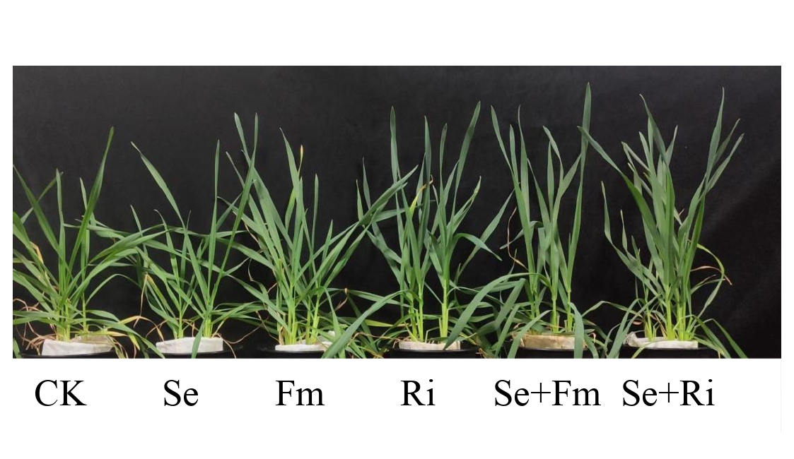
Fig. S1. The growth of wheat under different treatments after planting for 70 days.

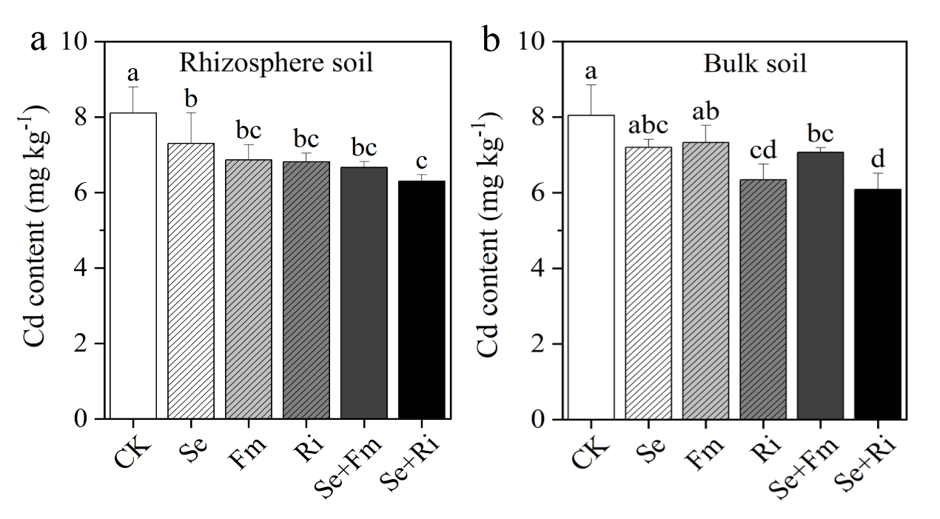
Fig. S2. Effects of different treatments on Cd concentrations in rhizosphere soil (a) and bulk soil (b) of wheat.

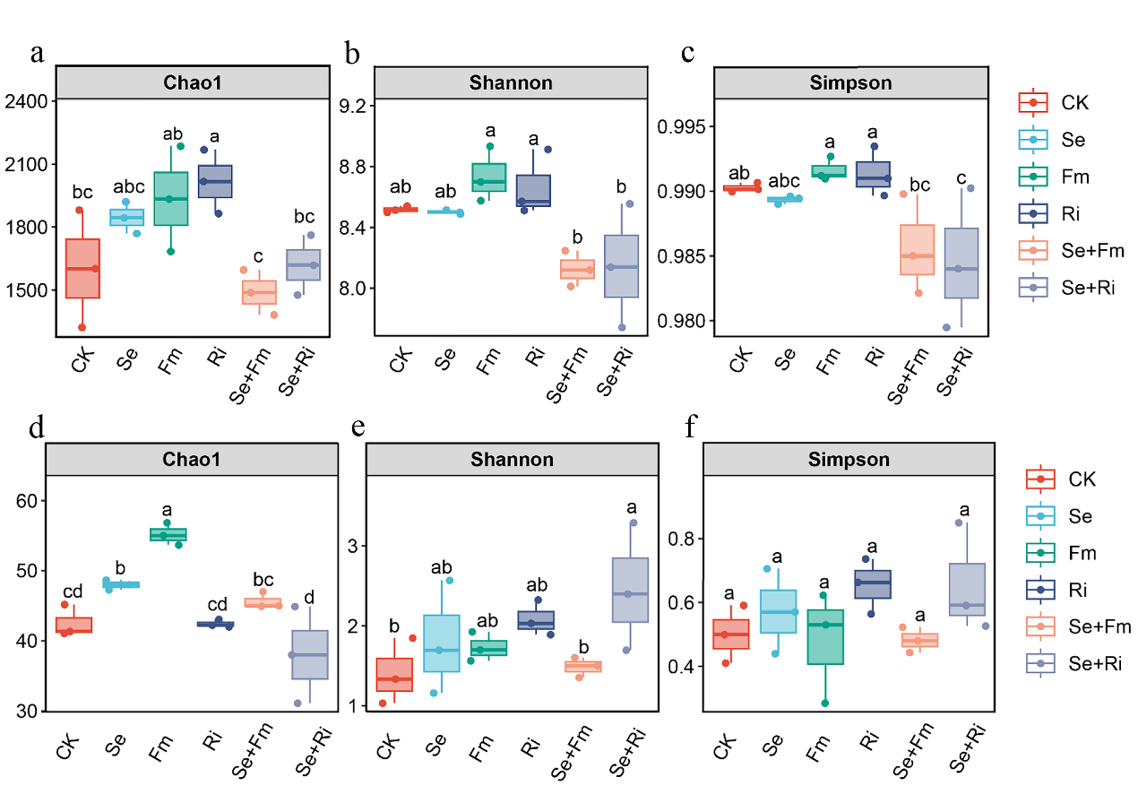
Fig. S3. Alpha diversity measurements of Chao 1 ( a and d ), Shannon index ( b and e ) and Simpson index ( c and f ) of bacteria ( a, b and c ) and fungi ( d, e and f ) under different treatments. Based on analysis of variance, different letters mean significant difference (P < 0.05).

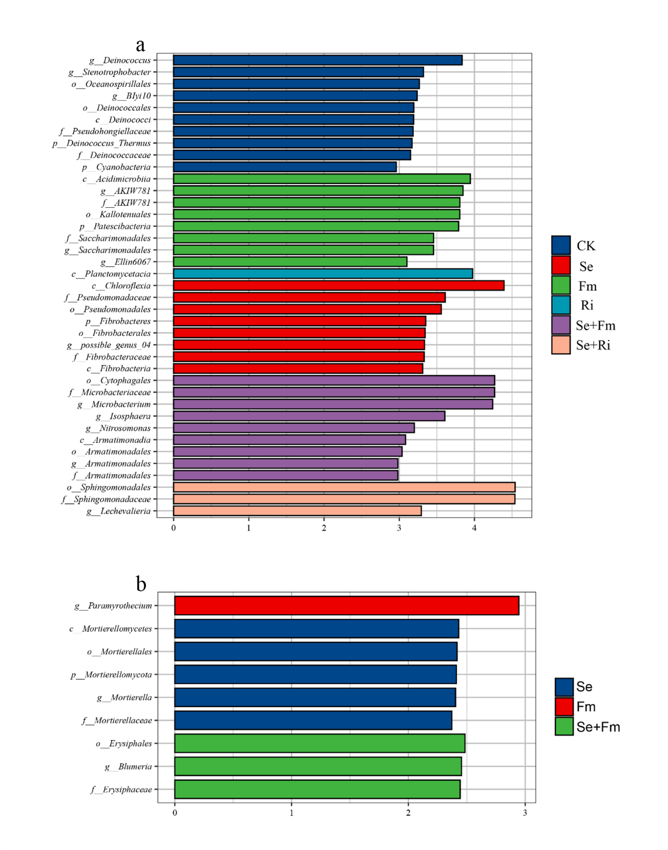Fig. S4. Key phylotypes of bacterial (a) and fungal (b) communities responding to different treatments using LEfSe. The histogram shows the LDA scores computed for features (on the ASV level) with differential abundance under the Six treatments. Only taxa meeting a linear discriminant analysis with significance threshold of 2.0 for microbial communities are shown.

