Chen et al

Supplementary Tables and Figures
Supplementary Table 1. Event selection process of 20 events from T1 to T3 generations for single locus, transgene homozygous events with increased WDS tolerance.
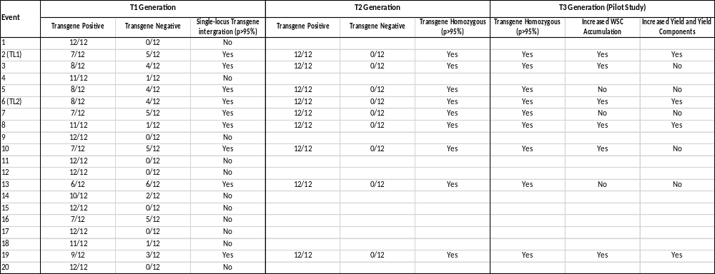
Supplementary Table 2. Quadruple potential waveform used in HPAEC-PAD analysis for carbohydrate.
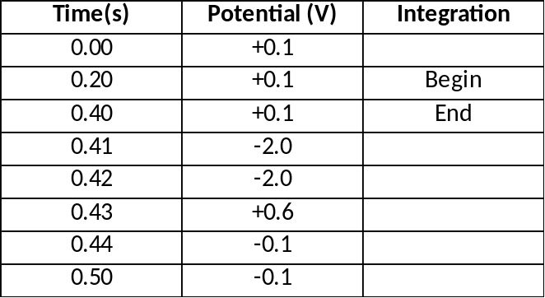

Supplementary Table 3. Gradient elution programme used for the quantification of glucose, fructose, sucrose, and raffinose.
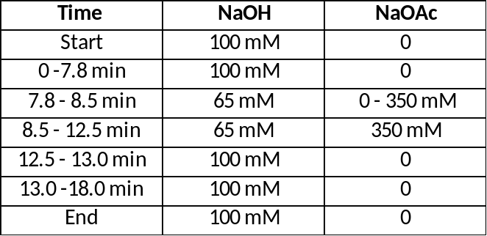

Supplementary Table 4. ANOVA tables for grain WSC components

Variate: Sucrose

Source of variation d.f. s.s. m.s. v.r. F pr.
Line 3 0.080313 0.026771 6.12 0.006
Trt 1 0.000924 0.000924 0.21 0.652
Line.Trt 3 0.013809 0.004603 1.05 0.396
Residual 16 0.069935 0.004371
Total 23 0.164981

Variate: Fructan

Source of variation d.f. s.s. m.s. v.r. F pr.
Line 3 0.45613 0.15204 7.07 0.003
Trt 1 0.41539 0.41539 19.32 <.001
Line.Trt 3 0.09277 0.03092 1.44 0.269
Residual 16 0.34401 0.02150
Total 23 1.30831

Variate: Total_WSC

Source of variation d.f. s.s. m.s. v.r. F pr.
Line 3 0.32155 0.10718 4.10 0.025
Trt 1 0.45550 0.45550 17.42 <.001
Line.Trt 3 0.13414 0.04471 1.71 0.205
Residual 16 0.41835 0.02615
Total 23 1.32954

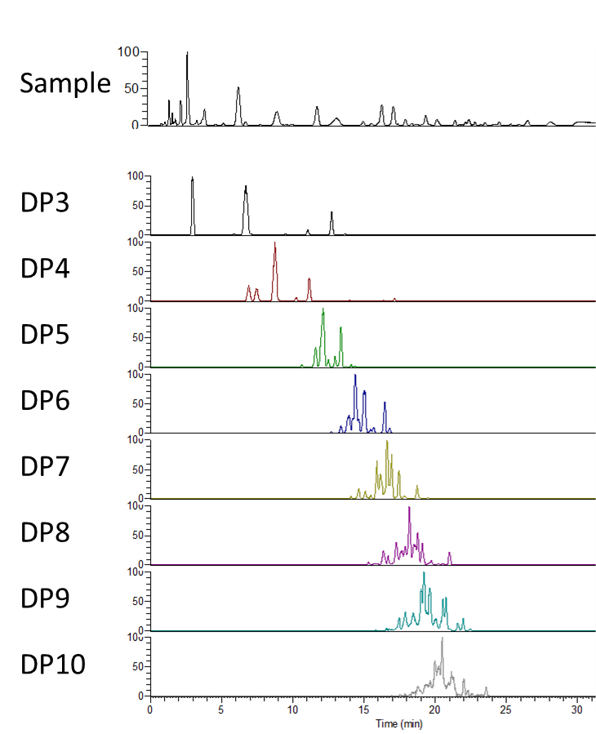
Supplementary Figure 1. Extracted Ion Chromatography (EIC) of fructan polymers from DP3 to DP10 in wheat leaf samples.

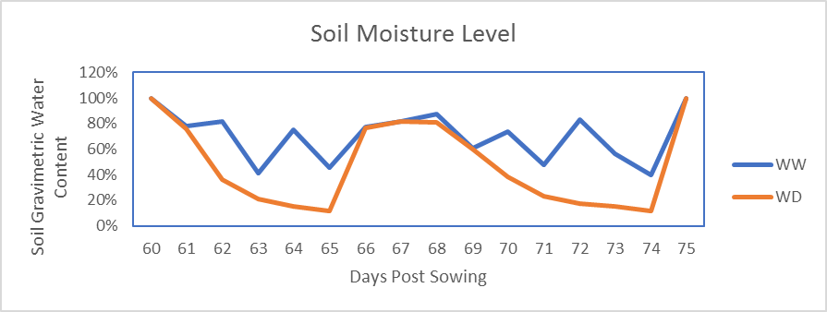
Supplementary Figure 2. Soil Moisture level of WW and WDS treated plants from 60 to 75 days post sowing.

