Comparative transcriptomic profiling of the two-stage response of rice to Xanthomonas oryzae pv. oryzicola interaction with two different pathogenic strains
Yunya Bi, Yue Yu, Shuaige Mao, Tao Wu, Tao Wang, Ying Zhou, Kabin Xie, Hua Zhang, Li Liu, Zhaohui Chu
*Correspondence: Zhaohui Chu (ORCID: 0000-0001-8320-7872) zchu77@whu.edu.cn; Li Liu liuli2020@hubu.edu.cn
†These authors contributed equally to this work.

Figure S1: GO analysis of the common DEGs at 12 hours post inoculation with HGA4 and RS105. Biological process analysis of the common DEGs for upregulated genes (A) and downregulated genes (B).

Figure S2: Histogram of the ratio of common DEGs at 3 dpi with HGA4 and RS105. Histogram of the ratio of up-regulated common DEGs (A) to down-regulated common DEGs (B) at 3 dpi with HGA4 and RS105.

Figure S3: Expression levels determined by qRT‒PCR. qRT-PCR was used to verify the expression of DEGs at 3 dpi with HGA4 and RS105. Unpaired t test, *P≤0.05, ** P ≤ 0.01, *** P≤ 0.001, **** P≤ 0.0001.

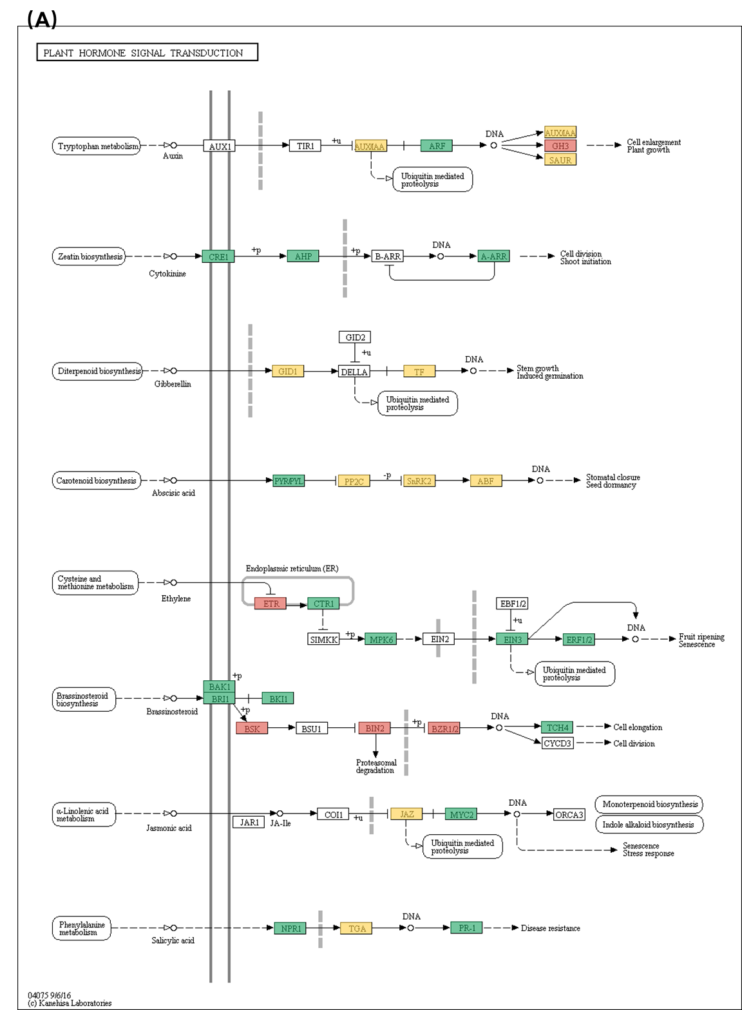

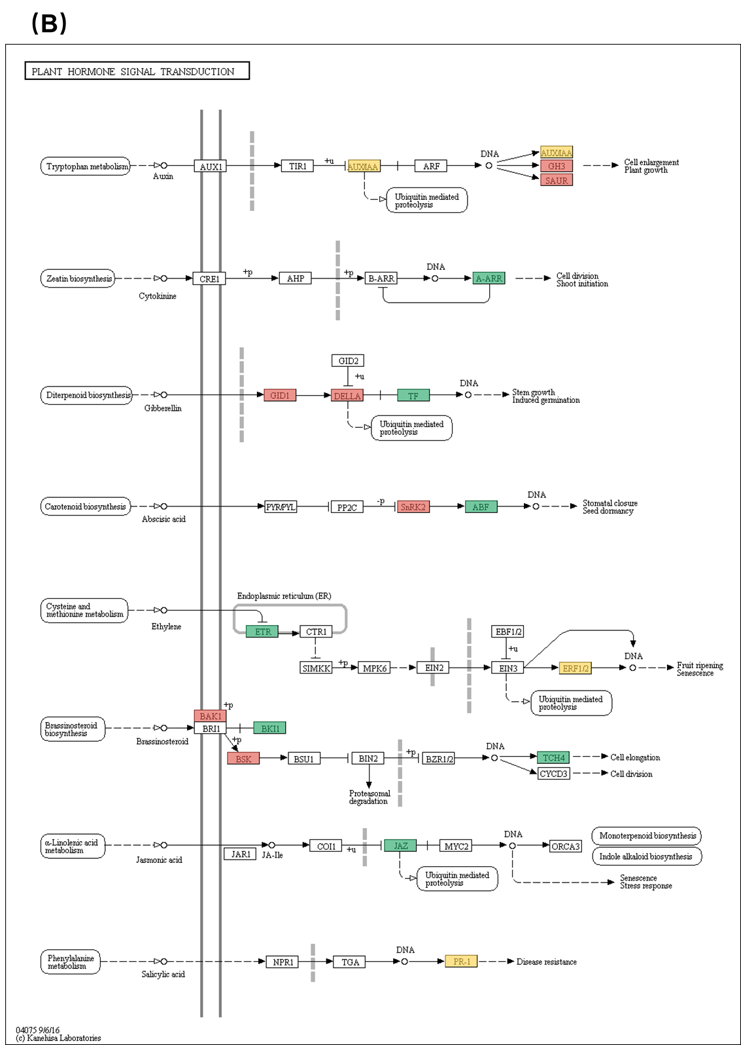

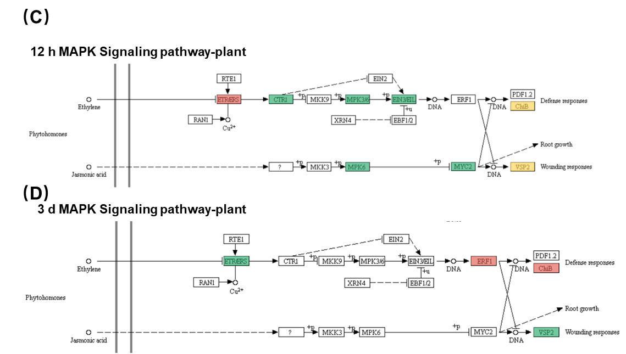
Figure S4: Important KEGG pathways related to plant disease resistance mechanism. The plant hormone signal transduction of 12 hpi (A) and 3 dpi (B) and the MAPK signaling pathway-plant of 12 hpi (C) and 3 dpi (D). Red: up-regulated; Green: down-regulated; Yellow: both up-regulated and down-regulated.

