Table S1 The primer sequences used for real-time qPCR
Gene Name | Forward（5’-3’） | Reverse（5’-3’）
PbActin  PbSNAT  PbCOMT  PbCOMT1  PbOPCL1  PbLOX  PbMFP2  PbC4H  PbCHS  PbPGT1 | ACAGTGTCTGGATTGGAGGGTC  GCTGCTGTGGATGGAGTACA  TTGGTATGCTCCCATCTGCAT  TGGTGCTGGTTTTAGTGGCA  GATTCGCTGGAGGAGAGTCG  AACGCACTTGCACGACAAAG  CCCAAGAAAAGTTTGAGAAGACGA  CCTTCTGGGTCTCTTCGTCG  GAGGAAGTTCGCAAGGCTCA  AGTTTCAAAGACCTCCGCGA | CATTTGGAGAACTCAGAAGCACT  ACCACGTCCCATATGATCGC  TGGGGGAAAATCCAGGTACG  TTTGAAAGCACTCTTGTCTACTTGT  CCGTCTTATTCGCCGCTAGT  ATGCTGCAGAGCTTACCTCC  AACCTTCTCAATAACGGCCTCT  GACCTGGAGCCAGTTTCCAA  CGGGGTATGTAGCTTGGTCC GTCCGAATAAGCAGGGTCGT

Figure.S1
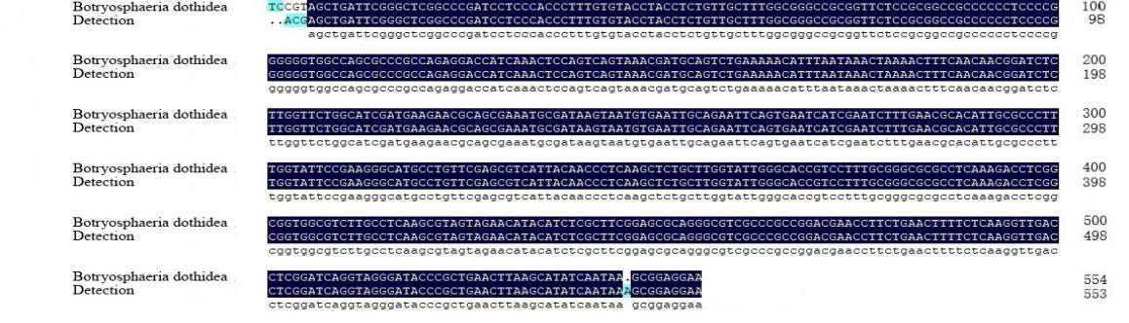
Figure.S1 The Strains used for ITS sequence alignment

Figure.S2

Figure.S2 PCA score chart of mass spectrometry data between each group of samples and quality control samples (A) in metabolomics, PC1 control chart of overall samples (C), and correlation chart between samples (B) . Correlation map between samples in transcriptomics (D).

