Table S1. Primers used in this article
Primer name | Primer sequence（5’ to 3’）
Bgactin-F | TAGACCCTCCTATCCAAACA
Bgactin-R | TTTTCCAGCCTTCACTTATC
BgAP1-F | AGCAGCAACTTAACAATG
BgAP1-R | TCAATCTTCTCCTTATCCTT
BgAPRR5-F | TGCTGCTCAACTTCGTAA
BgAPRR5-R | TATTGTGCTTCCGCTTCA
BgCMB1-F | GAATATCTGAAGTTGAAGG
BgCMB1-R | TGTGTTGTGTCTTAATTG
BgDEFA-F | ACTAATAGACAGGTGACT
BgDEFA-R | CAACATCCATCATCTTCT
BgEIL1-F | CTCATTGTCCTCATAATCA
BgEIL1-R | TCCATCTGTAAGTTGTTG
BgFULL-F | GAGAATAAGATAAGTCGTCAAGT
BgFULL-R | TCGCACAGAACAGAGATT
BgNFYA3-F | ATCATCCAGTCAATCAAC
BgNFYA3-R | CATTCTTAGCACAACTCA
BgSPL16-F | CATAAGGTCTGTGAGGTT
BgSPL16-R | ATCATCTTCTTCAATAATAAATCC
BgPORA-F | CTCACAATGCAGGAGTTC
BgPORA-R | CTCTGAACAAGCCAGTAG
BgALDO2-F | TCCATTGTTGTAGAAGTA
BgALDO2-R | TATCTGCCTGTATAACTC
BgALDO3-F | CCAGGCTCCAGAATATAC
BgALDO3-R | AGTAATGATGCGAATGTTG
BgSPL8-F | AACAACAGCAACAACAAG
BgSPL8-R | GGTGACTTAGGAGGAATATC

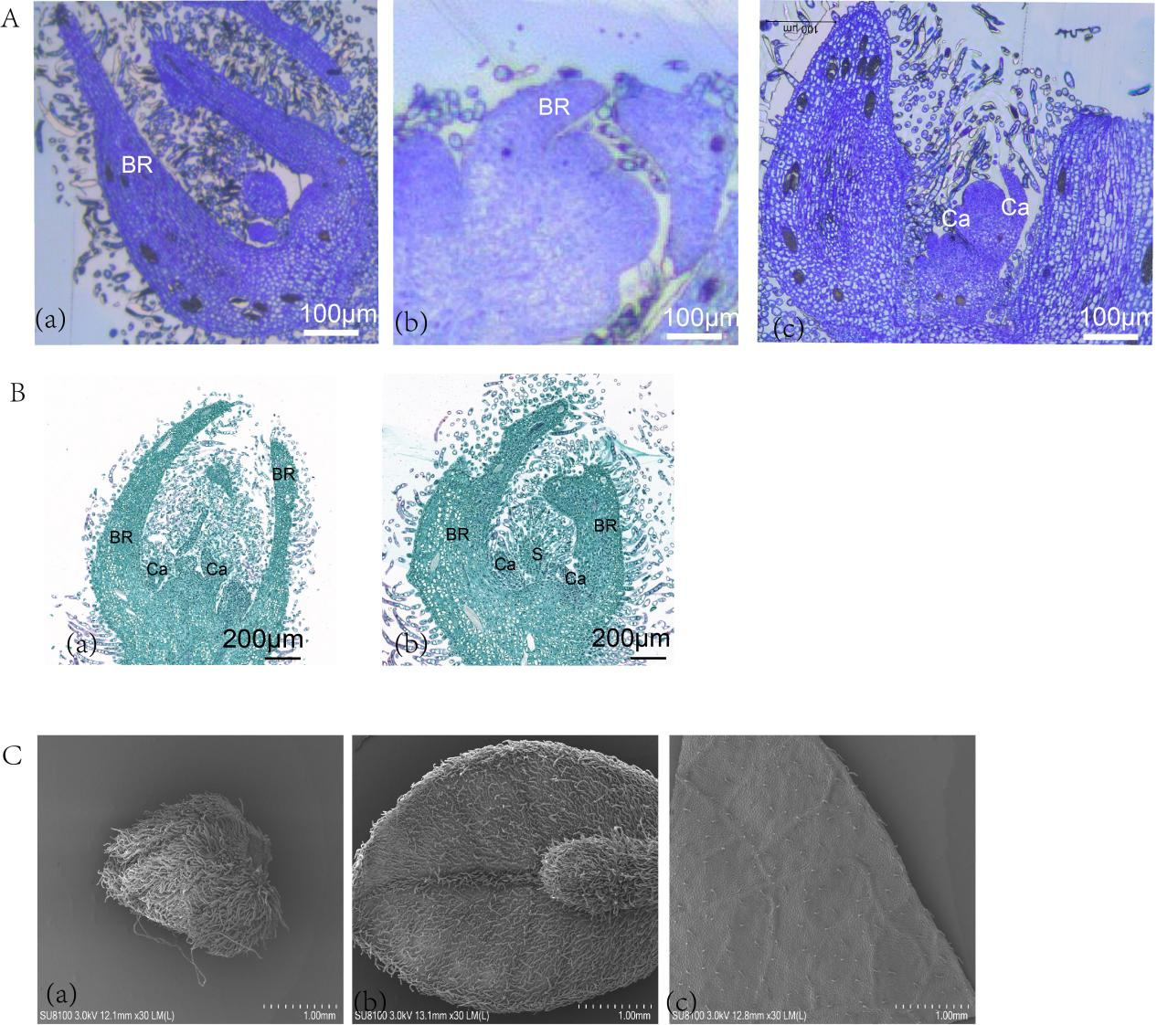
Fig.S1 A Resin section for B. glabra bud development process (a) undifferentiated period (b) floret primordial differentiation period .(c) whorls around the primordial perianth, Fig. B Paraffin sections of leaf buds and flower buds .(a) paraffin section at LB period. (b) paraffin section at FB period. Fig. C is an electron microscope scan of the development of B. glabra bracts at (a) B.glabra bracts at the BR1 period. (b) B.glabra bracts at the BR3 period. (c) B .glabra bract BR5 period.
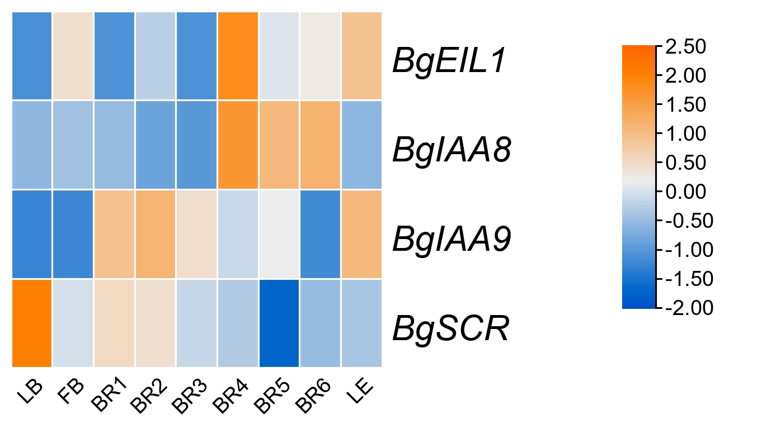
Fig.S2 Differential Gene Heat Map

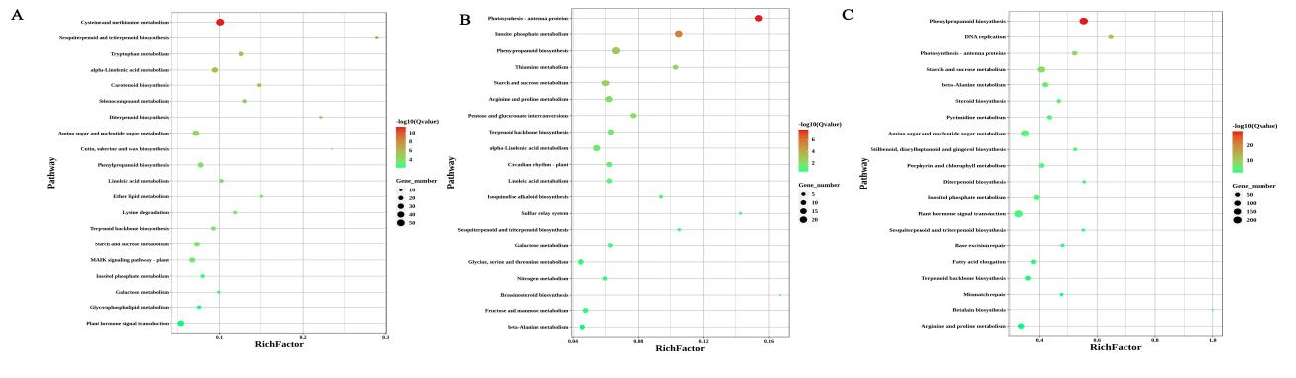
Fig.S3Significantly enriched KEGG metabolic pathways at developmental stages are represented by bubble plots.A Fig. FB-VS-BR1 period,B Fig. BR2-VS-BR3 period,C Fig. BR1-VS-BR5

Fig.S4 Differential protein network interaction map
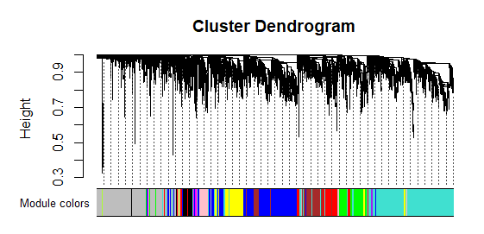
Fig.S5 Gene module partition map
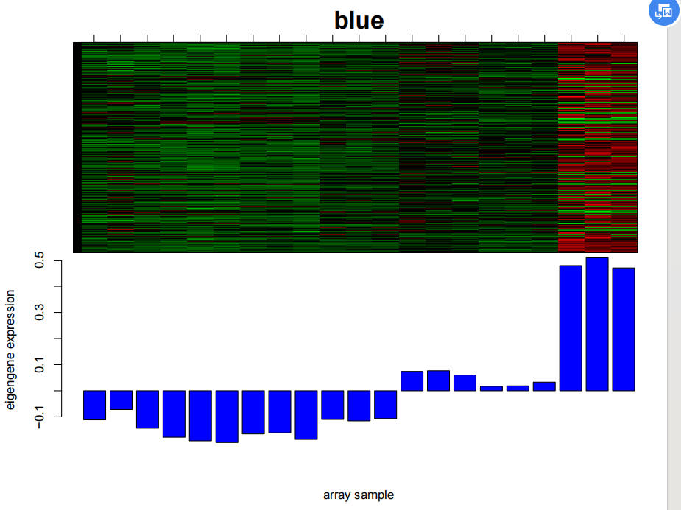
Fig.S6 Heatmap of gene expression pattern and bar plot of eigengen expression of genes in blue
module
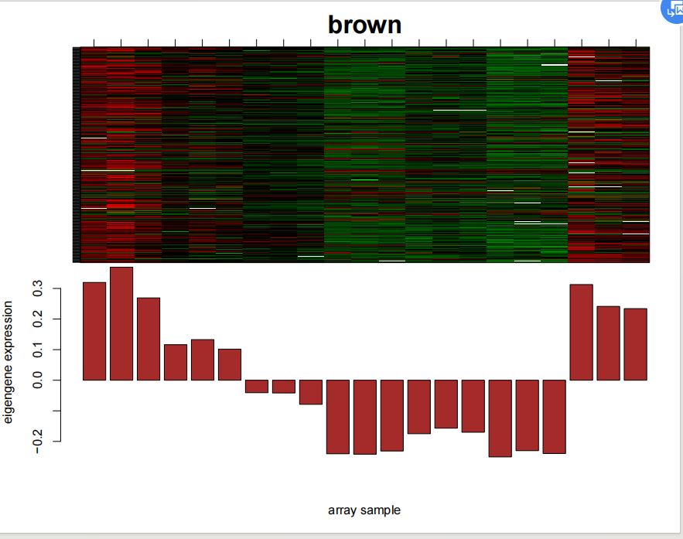
Fig.S7 Heatmap of gene expression pattern and bar plot of eigengen expression of genes in brown
Module
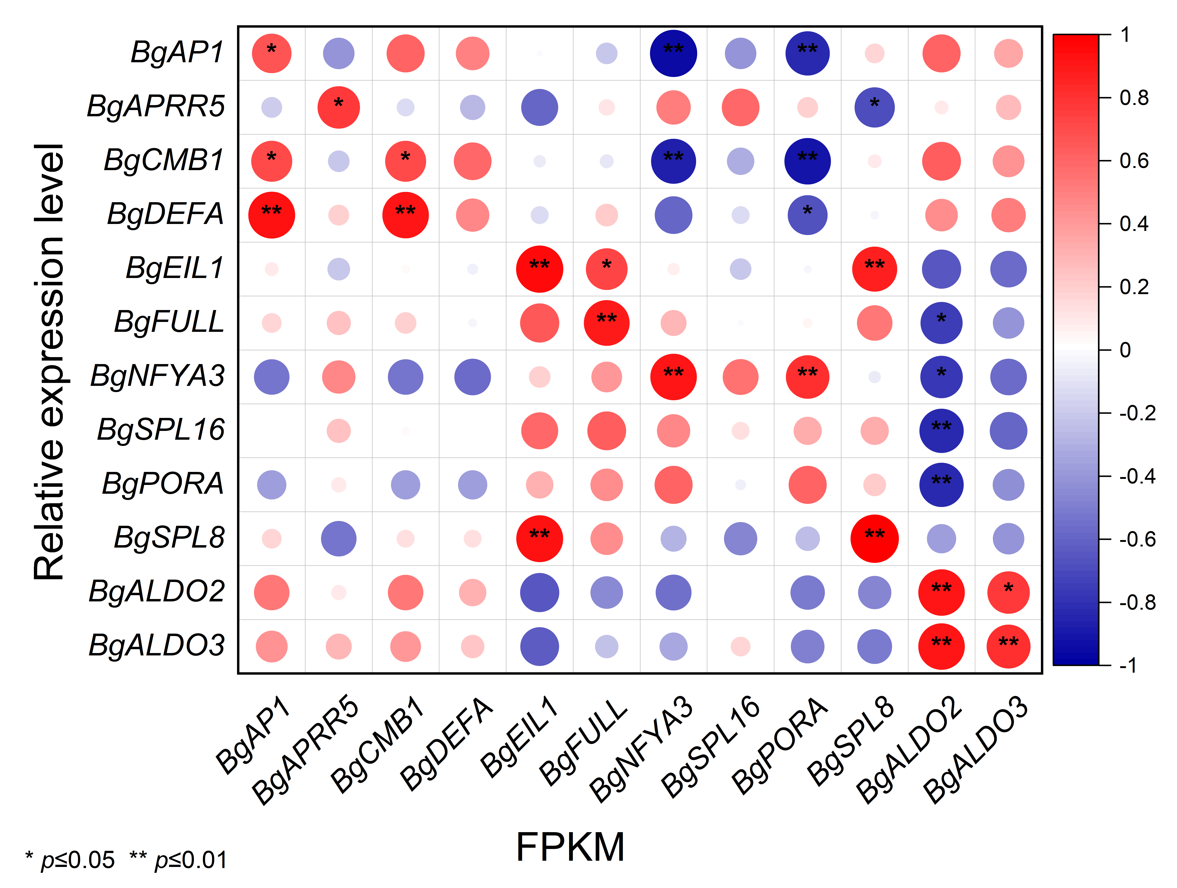
Fig.S8 Correlation analysis of gene FPKM values with RT-qPCR

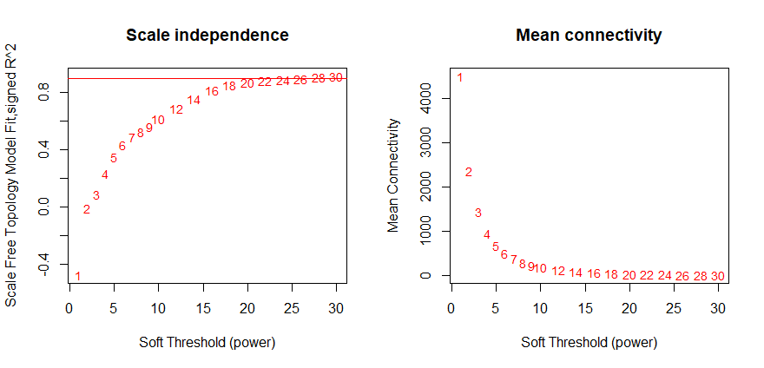
Fig.S9 Gene scale independence and average connectivity of different powers under the
assumption of scaleless networks

