Supplementary Material

Supplementary Table
Table S1 Zone of inhibition (mm) of select bacterial isolates against 4 different fungal pathogens of apple
Strain | Fusarium oxysporum | Botryosphaeria  ribis | Rhizoctonia  solani | Physalospora piricola
J-19 | 9.54±0.16 | 10.62±0.74 | 14.28±0.54 | 18.09±1.28
J-310 | 7.08±1.15 | 12.46±0.02 | 11.08±0.32 | 17.28±1.96
J-73 | 6.52±0.16 | 11.15±0.69 | 8.12±0.58 | 13.76±2.36
J-24 | 9.54±1.94 | 8.33±0.12 | 9.01±2.37 | 6.07±0.03
J-27 | 11.22±1.96 | 6.58±0.44 | 14.23±0.99 | 7.40±1.94
J-28 | 10.57±0.03 | 11.95±2.65 | 11.29±0.43 | 14.94±1.415
J-40 | 7.24±1.28 | 8.01±2.23 | 10.87±0.97 | 10.00±2.40
J-41 | 10.81±0.57 | 10.60±1.10 | 13.08±0.22 | 17.15±2.17
The zone of inhibition (ZOI) was precisely measured from the center of the bacterial colony to the leading edge of the fungal growth inhibition, showcasing the antibacterial activity of the strains.

Table S2 Antagonistic results among the 8 antagonistic strains
Strains | J-19 | J-24 | J-24 | J-28 | J-40 | J-41 | J-73 | J-310
J-19 | - | - | - | - | - | - | - | -
J-24 | - | - | - | - | - | - | - | -
J-24 | - | - | - | - | - | - | - | -
J-28 | - | - | - | - | - | - | - | -
J-40 | - | - | - | - | - | - | - | -
J-41 | - | - | - | - | - | - | - | -
J-73 | - | - | - | - | - | - | - | -
J-310 | - | - | - | - | - | - | - | -
"-" indicates no antagonism to each other.

Table S3 Topology parameters of co-occurring networks with different treatments
Treatment | Positive connection | Negative connection | Node | Edge | Average degree | Average weighted degree | Graph density | Modularity | Average clustering coefficient
S | 61% | 39% | 573 | 10790 | 36.221 | 3.592 | 0.066 | 6.899 | 0.502
P | 52% | 47% | 572 | 10088 | 34.967 | 1.479 | 0.061 | 8.537 | 0.461
M | 58% | 42% | 573 | 10615 | 37.051 | 1.208 | 0.065 | 11.916 | 0.459
A | 63% | 36% | 577 | 10970 | 38.024 | 4.997 | 0.066 | 4.899 | 0.511

Supplementary Figure

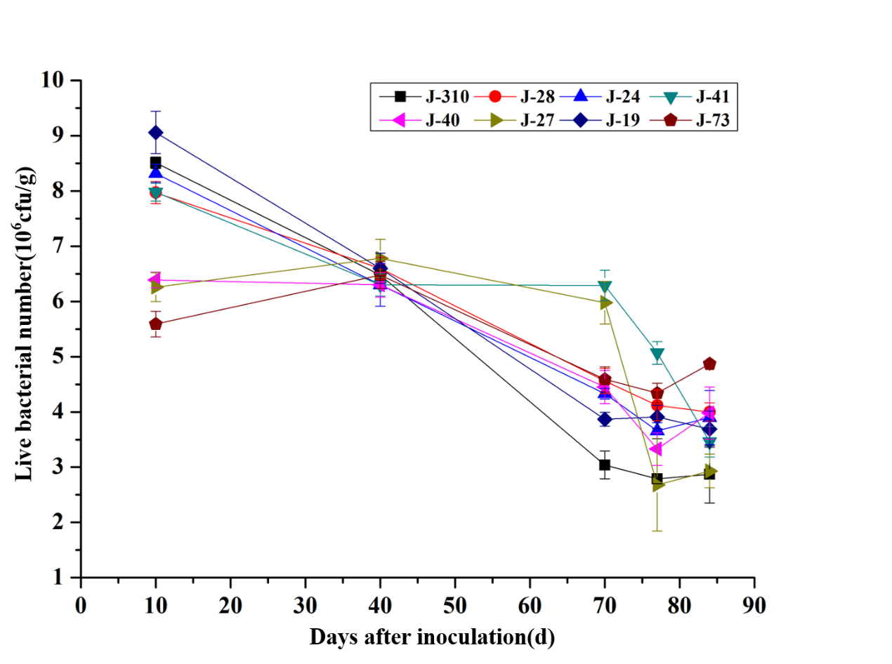
Figure S1 Growth and decline trend of marked bacteria in the rhizosphere soil

