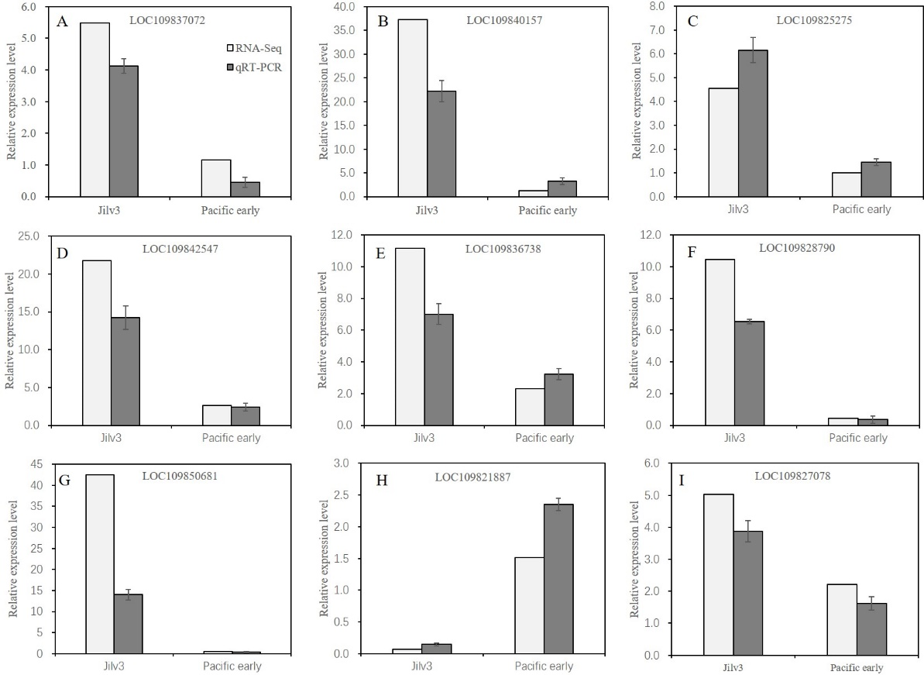

Fig. S1. RT-qPCR validation of 9 DEGs. The relative expression level of each gene was expressed as the fold change relative to the control (normal watering). (A). flavonoid 3-monooxygenase. (B) Sucrose synthase. (C) pyruvate kinase. (D) UDP-glucosyl transferase. (E) hexokinase. (F) peroxidase. (G) flavonol synthase. (H) caffeic acid 3-O-methyltransferase. (I) citrate synthase.

