Supplementary file 1 Comparison of gDNA and cDNA editing sites in the organelle genome PCGs of C. stoloniferus based on Sanger sequencing. The black arrow represents gene RNA editing sites

atpB
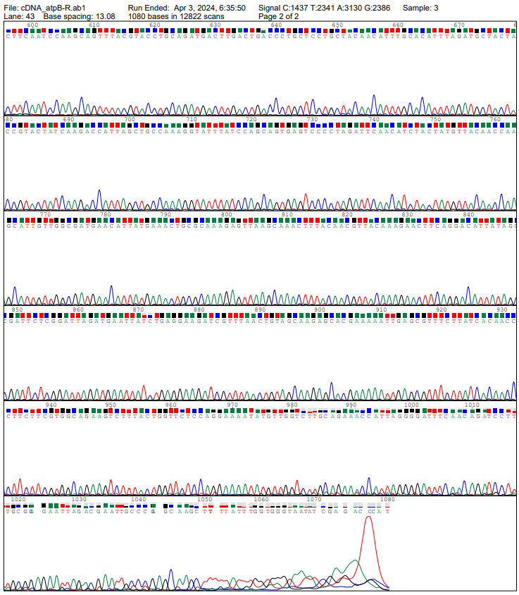
atpB-1458

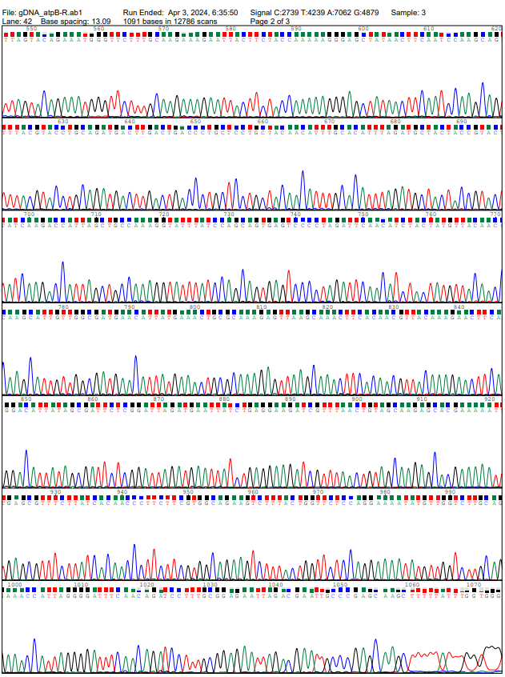
atpB-1458

matR
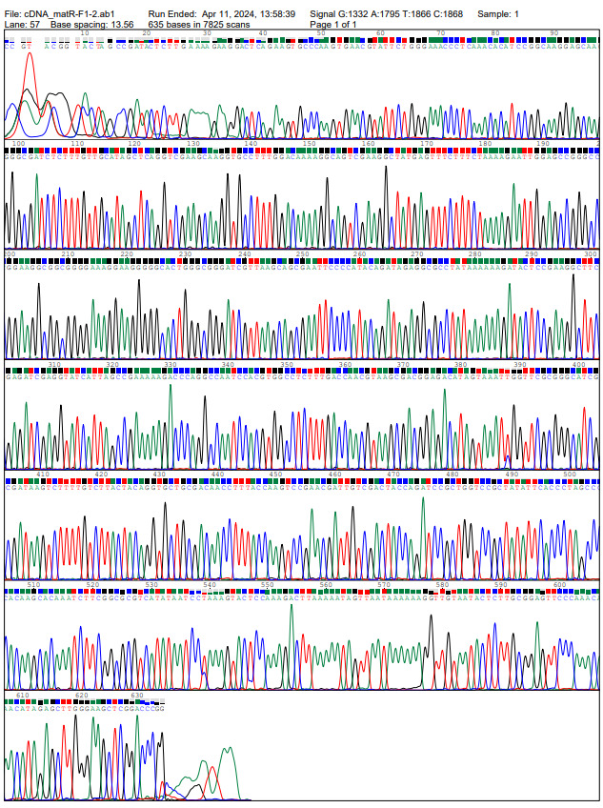
matR-1894
matR-1886
matR-1735

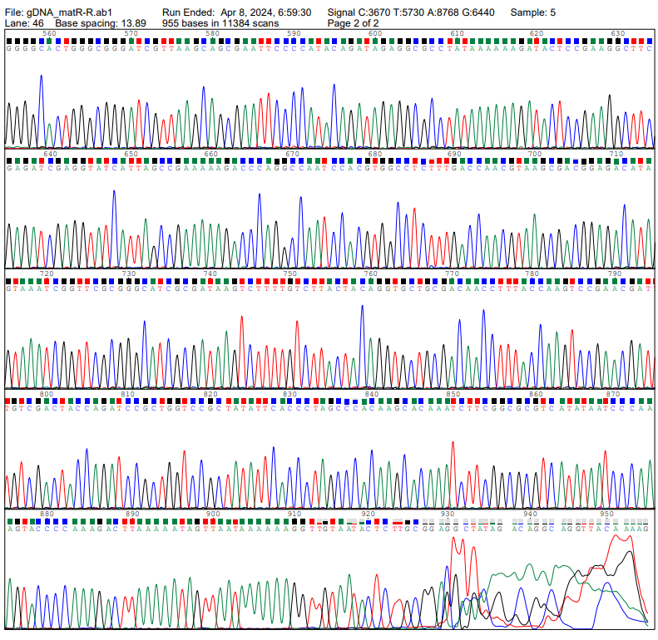
matR-1894
matR-1886
matR-1735

mttB
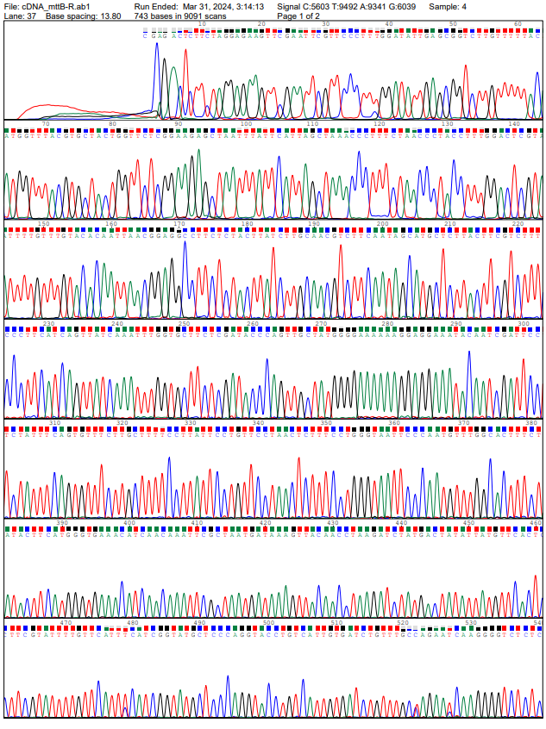
mttB-541
-1735
mttB-495
-1735
mttB-52
-1735

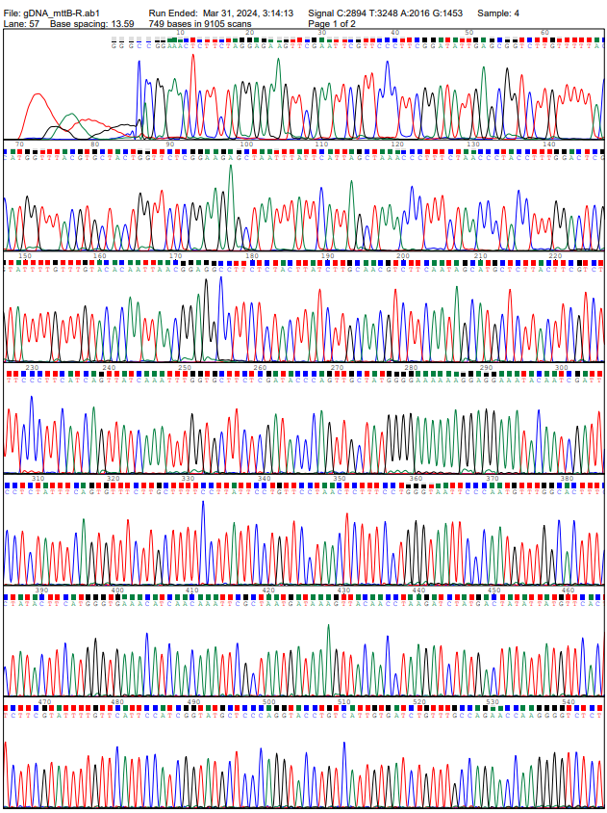
mttB-541
-1735
mttB-495
-1735
mttB-52
-1735

nad7
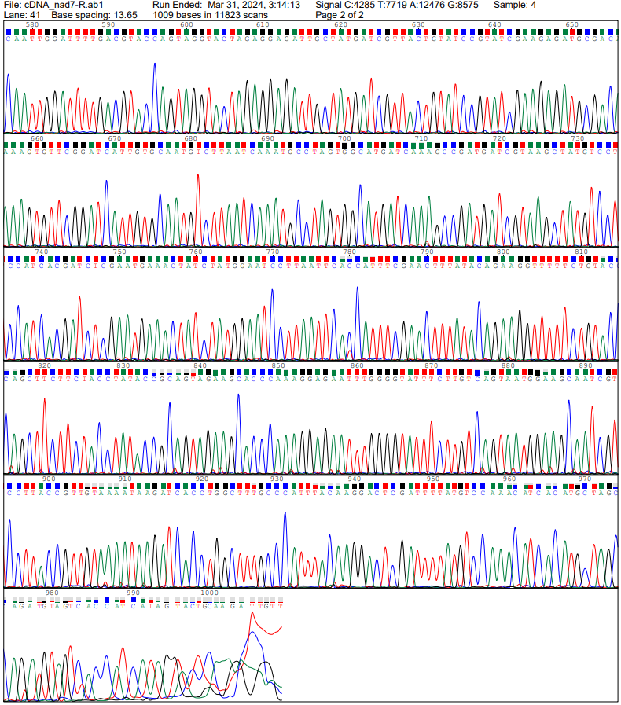
nad7-1103
-1735

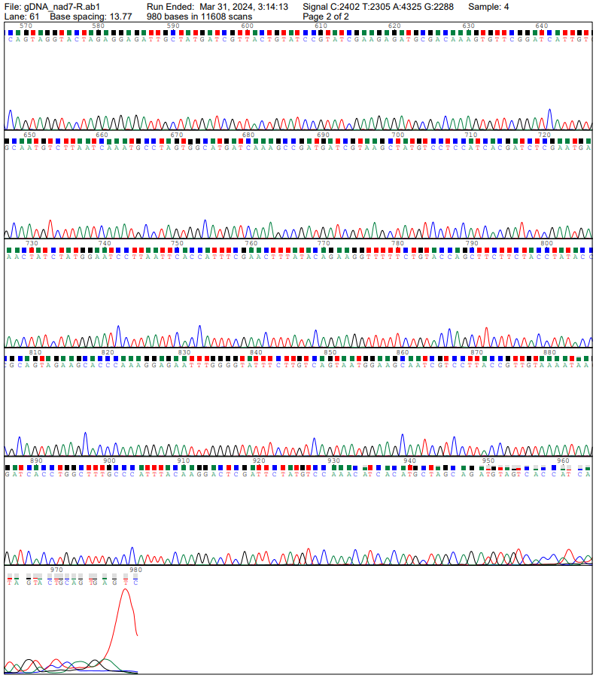
nad7-1103
-1735

rpl16
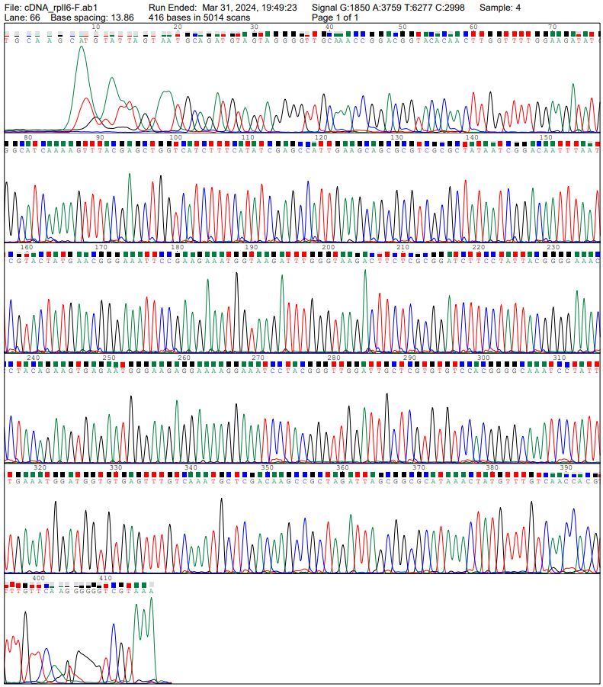
rpl16-1043
-1735
rpl16-4073
-1735

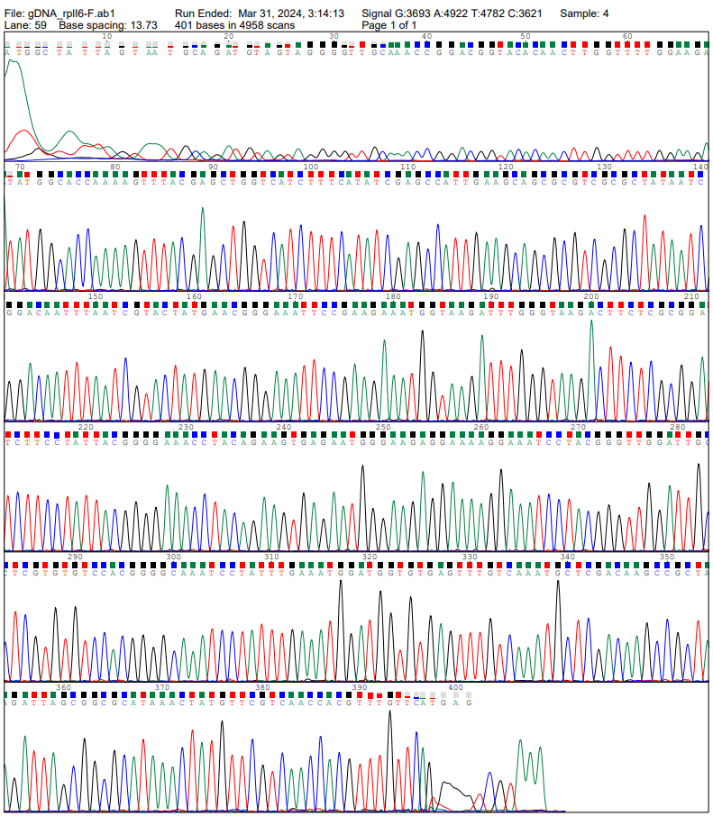
rpl16-4073
-1735
rpl16-1043
-1735

rps19
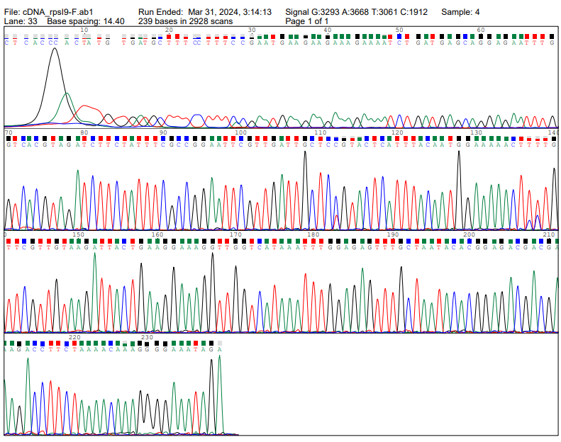
rps19-1603
-1735
rps19-1613
-1735
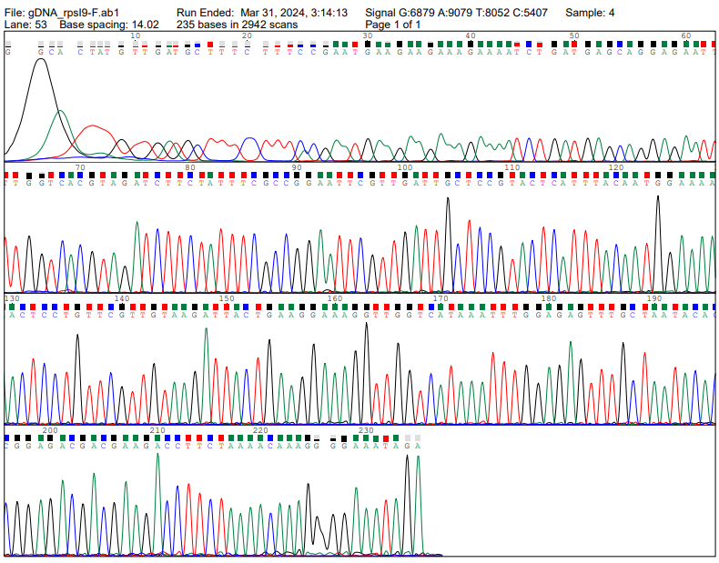
rps19-1603
-1735
rps19-1613
-1735

