We have exhibited the original gel figure of Actin. As reference gene, Atactin can be expressed in WT and two overexpressed lines.
The semi-quantitative PCR result of Atactin
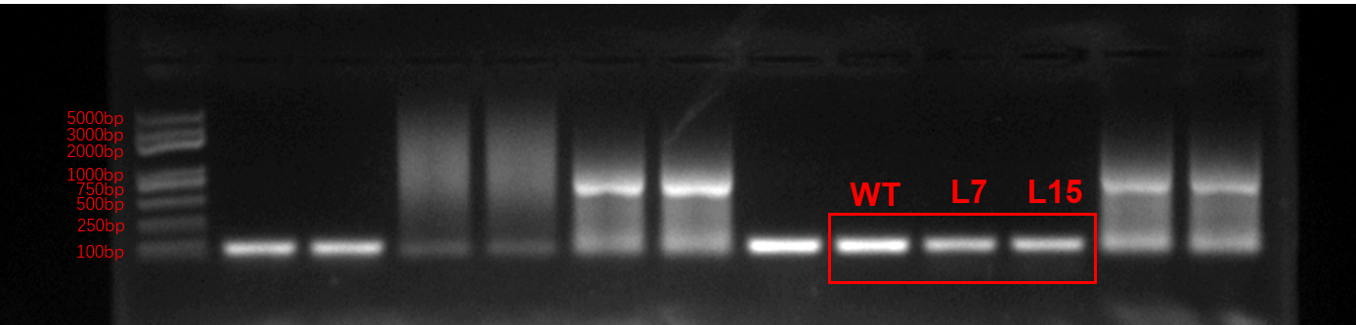
q-Atactin-F: AGAAACCCTCGTAGATTGGCAC
q-Atactin-R: ACTCTCCCGCTATGTATGTCGC
Reference：Diao Y, Zhan J, Zhao Y, et al. GhTIE1 regulates branching through modulating the
transcriptional activity of TCPs in cotton and Arabidopsis[J]. Frontiers in Plant Science, 2019,
10: 1348.

We have replaced the original gel figure of TaSPL6B with high-contrast and the latest results are
presented. TaSPL6B was highly expressed in two overexpressed lines.
The semi-quantitative PCR result of TaSPL6B
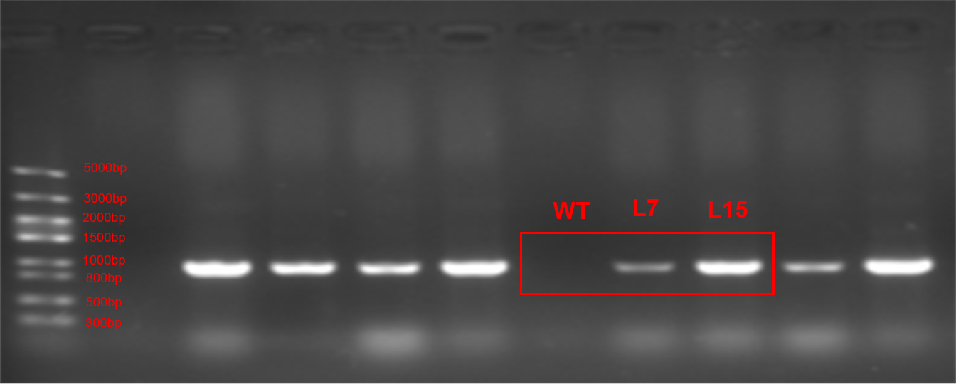
TaSPL6B-F：GGTGTGCTGTGACCAAAATGCTG
TaSPL6B-R：AACTTCAGGGTCAGCTTGC

