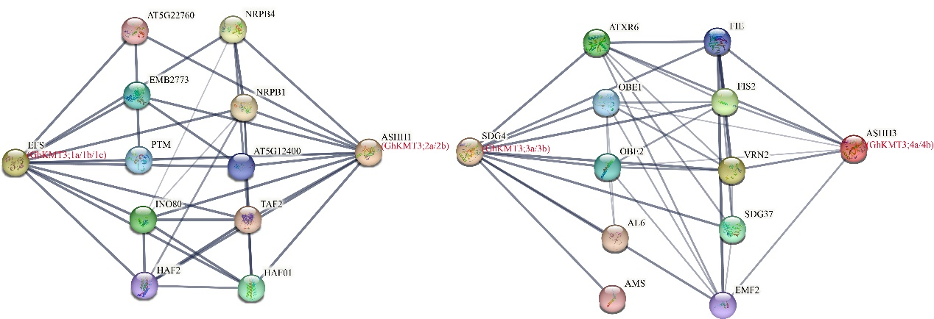
Supplementary Fig. S1 Interaction network of SDG proteins. Interaction network of SDG protein families in Arabidopsis. The red letters represent the SDG protein signaling pathways.
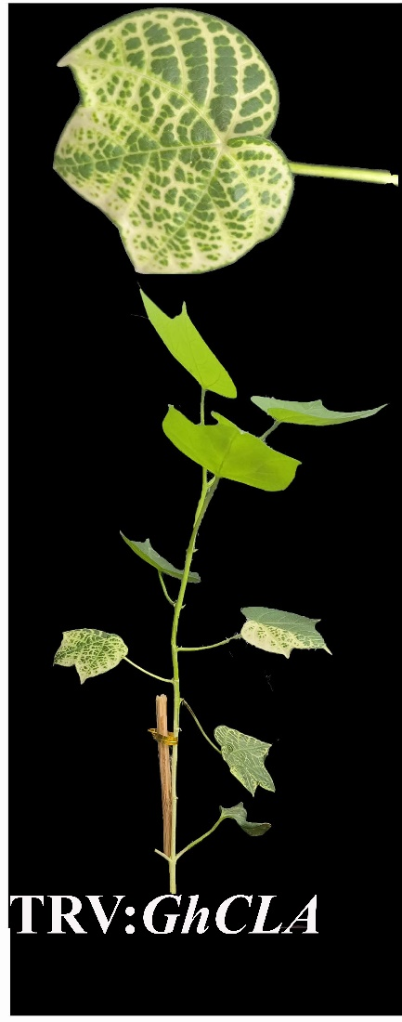
Supplementary Fig. S2 Positive plants were infiltrated with Agrobacterium carrying TRV: GhCLA.

