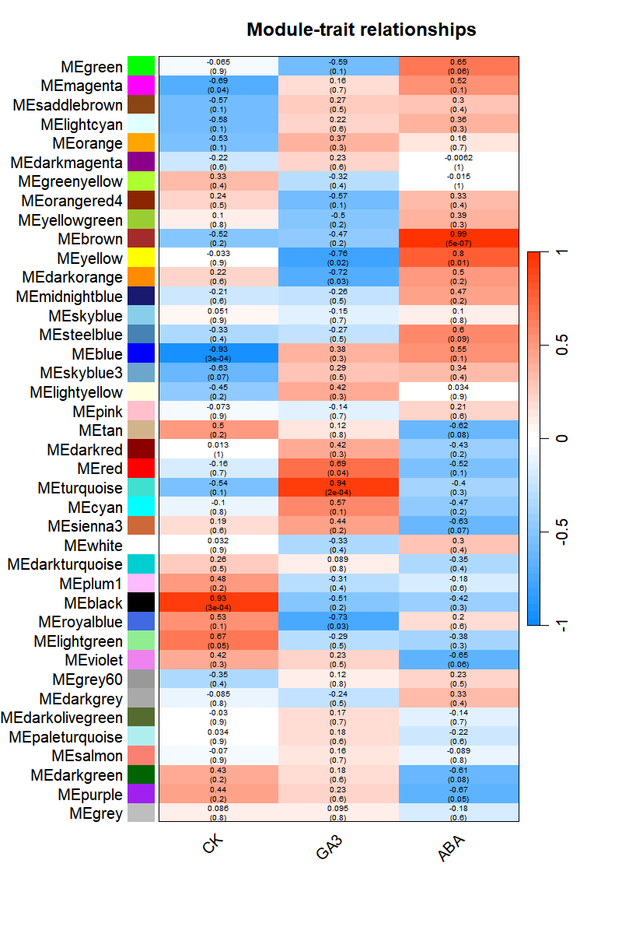
Fig. S5 The correlation heat map between the modules and the traits in WGCNA. The red represents the positive correlation, and the blue represents negative correlation.

