Figure legend for supplementary materials
Figure S1 Differentially expressed genes (DEGs) volcano maps of T30_vs_CK, T35_vs_CK, and T40_vs_CK comparing groups, respectively. Each point that arises in the differential expression volcano maps denotes a gene. The x-axis indicates the logarithm for the fold change of the discrepancy expression of a gene in two samples. Y-axis indicates the negative logarithm of significantly statistical level value for differentially expressed genes. The green dots indicate down-regulated discrepantly expressed genes, and the red dots up-regulated discrepantly expressed genes, the black dots no differentially expressed genes
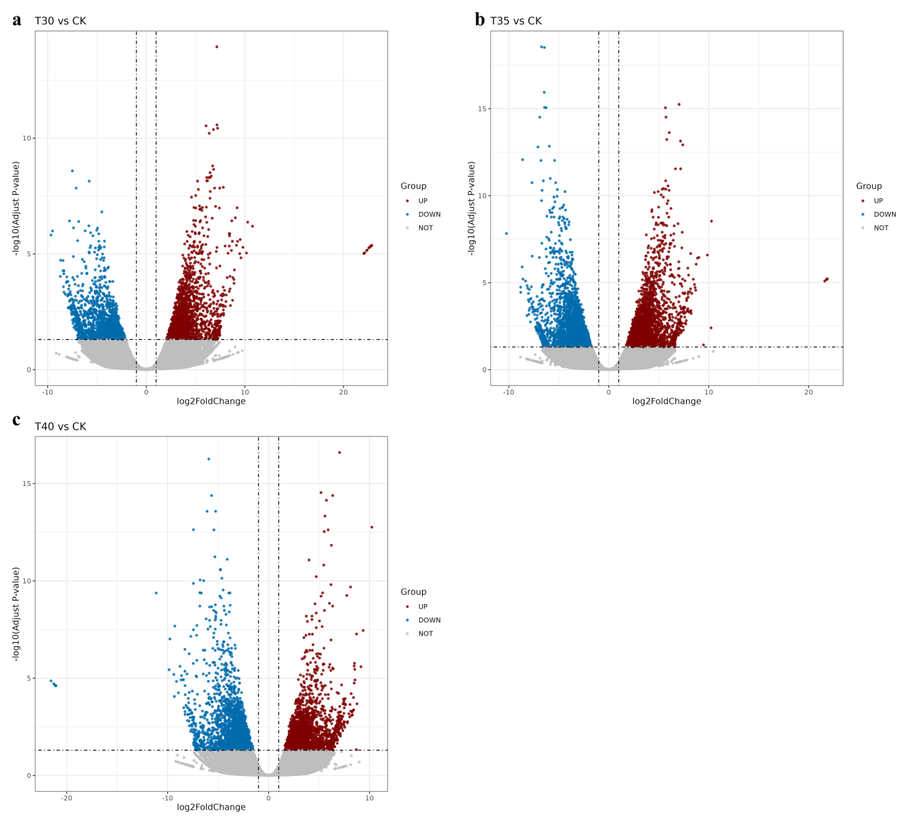

Figure S2 Volcano plots of significantly changed metabolites of positive ion mode in CK_vs_T30 (a), CK_vs_T35(b), and CK_vs_T40 (c) compare groups, and of negative ion mode in CK_vs_T30 (d), CK_vs_T35 (e), and CK_vs_T40 (f) compare groups, respectively. Red pixel dots denote significantly changed (upregulated or downregulated) metabolites, and black pixel dots denote insignificantly changed metabolites. The x-axis indicates the log₂ (fold-change, FC) of each metabolite. The y-axis represents -log₁₀ (p-value) relative to the corresponding control (CK).
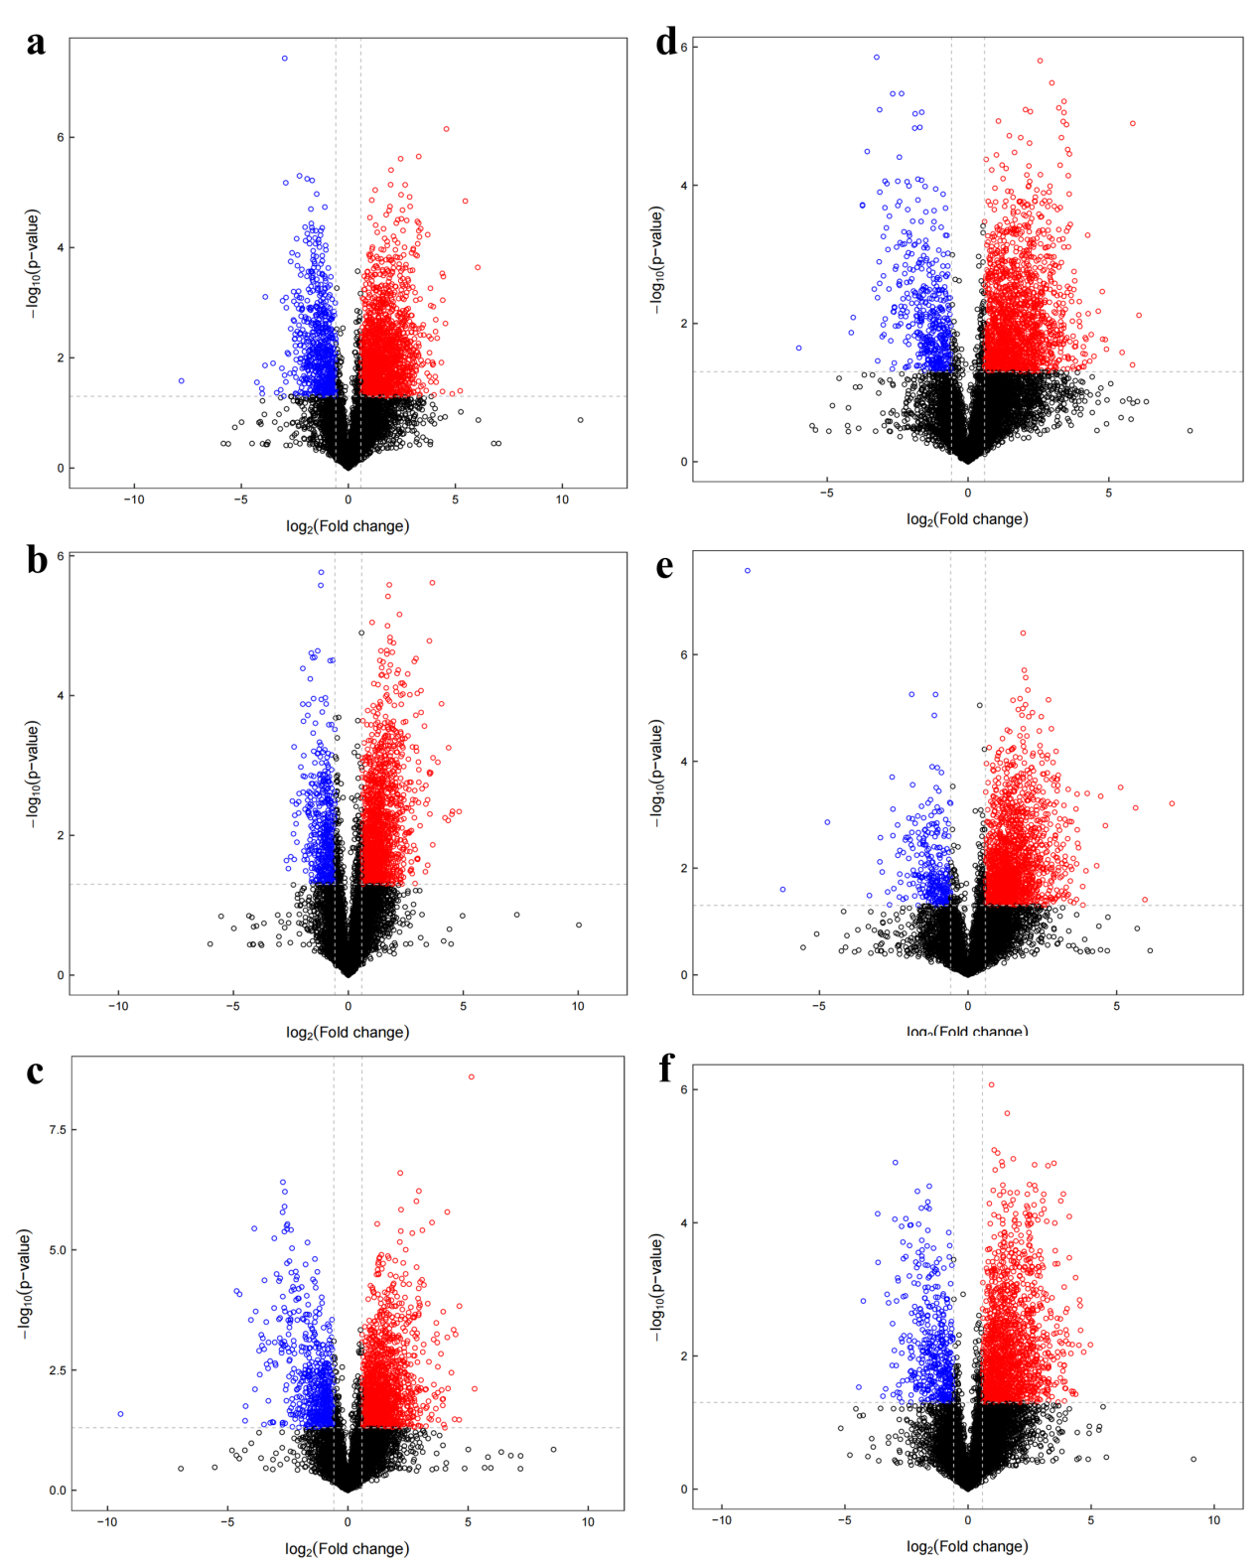

Table legend
Table S1. Summary of sequencing data quality
Sample | Raw reads | Clean reads | Error (%) | Q20(%) | Q30(%) | GC (%)
CK1 | 45013854 | 44677628 | 0.04 | 97.88 | 94.27 | 44.16
CK2 | 47375690 | 47112542 | 0.04 | 98.11 | 94.78 | 43.36
CK3 | 51949840 | 51593288 | 0.04 | 97.95 | 94.43 | 43.29
T30-1 | 92038004 | 91562804 | 0.04 | 98.54 | 95.93 | 46.24
T30-2 | 52212992 | 51946032 | 0.04 | 98.9 | 96.86 | 47.83
T30-3 | 85556062 | 85038274 | 0.04 | 98.37 | 95.49 | 46.73
T35-1 | 51337548 | 51028132 | 0.04 | 98.78 | 96.56 | 46.79
T35-2 | 60883348 | 60512282 | 0.04 | 98.18 | 94.98 | 44.05
T35-3 | 42864196 | 42637952 | 0.04 | 98.46 | 95.74 | 44.96
T40-1 | 66668714 | 66220592 | 0.04 | 97.86 | 94.14 | 43.87
T40-2 | 68934594 | 68501758 | 0.04 | 97.82 | 94.01 | 43.51
T40-3 | 64372214 | 63915926 | 0.04 | 97.85 | 94.1 | 43.72
average value | 60767254.67 | 60395600.83 | 0.04 | 98.23 | 95.11 | 44.88

Table S2. Summary of TFs under T30 stress
TFs famly | Gene numeber | Up regulated | Down  regulated | Gene id
zf-Dof | 18 | 3 | 15 | MS.gene76604; MS.gene47272; MS.gene021729; MS.gene070638; MS.gene79570; MS.gene066185; MS.gene031048; MS.gene045643; MS.gene62383; MS.gene76611; MS.gene55252; MS.gene045747; MS.gene032933; MS.gene045642; MS.gene032932; MS.gene55614; MS.gene55256; MS.gene78149
AP2 | 17 | 13 | 4 | MS.gene99339; MS.gene30851; MS.gene30845; MS.gene049593; MS.gene49042; MS.gene79328; MS.gene053409; MS.gene21367; MS.gene34125; MS.gene69041; MS.gene030784; MS.gene53892; MS.gene005871; MS.gene79326; MS.gene21592; MS.gene79327; MS.gene01048.
HSF_DNA-bind | 7 |  | 7 | MS.gene018149; MS.gene90989; MS.gene98248; MS.gene37417; MS.gene32806; MS.gene020288; MS.gene000756
WRKY | 6 | 4 | 2 | MS.gene009733; MS.gene005502; MS.gene20870; MS.gene060237; MS.gene013439; MS.gene057556
CSD | 6 | 6 |  | MS.gene003524; MS.gene44240; MS.gene52075; MS.gene017631; MS.gene057705; MS.gene012116
Homeobox | 5 | 2 | 3 | MS.gene054468; MS.gene044186; MS.gene25816; MS.gene36874; MS.gene019491
NAM | 4 | 2 | 2 | MS.gene57383; MS.gene008093; MS.gene059867; MS.gene40935
Tub | 4 | 4 |  | MS.gene60683; MS.gene060202; MS.gene20689; MS.gene63734
B3 | 3 | 3 |  | MS.gene065717; MS.gene34125; MS.gene005871
Zim | 2 | 2 |  | MS.gene54190; MS.gene026548
zf-BED | 2 | 1 | 1 | MS.gene59905; MS.gene92235
EIN3 | 2 | 2 |  | MS.gene70573; MS.gene25897
HTH_3 | 2 |  | 2 | MS.gene042957; MS.gene51432
zf-A20 | 2 | 2 |  | MS.gene050335; MS.gene22669
SBP | 2 | 2 |  | MS.gene93246; MS.gene071487
bZIP | 1 |  | 1 | MS.gene28809
CBFB_NFYA | 1 | 1 |  | MS.gene22534
zf-GRF | 1 |  | 1 | MS.gene44247
TCP | 1 |  | 1 | MS.gene37539
Total | 86 | 47 | 39

Table S3. Summary of TFs under T35 stress
TFs famly | Gene numeber | Up regulated | Down  regulated | Gene id
AP2 | 52 | 47 | 5 | MS.gene022547; MS.gene64497; MS.gene025278; MS.gene64499; MS.gene055836; MS.gene71873; MS.gene86613; MS.gene30851; MS.gene30845; MS.gene047826; MS.gene64500; MS.gene062865; MS.gene049593; MS.gene053499; MS.gene30844; MS.gene79307; MS.gene49042; MS.gene22325; MS.gene006620; MS.gene057432; MS.gene39643; MS.gene79328; MS.gene025283; MS.gene053409; MS.gene043401; MS.gene26633; MS.gene49255; MS.gene39646; MS.gene61292; MS.gene025280; MS.gene047825; MS.gene58366; MS.gene26632; MS.gene34125; MS.gene057427; MS.gene053501; MS.gene94206; MS.gene005871; MS.gene43298; MS.gene91822; MS.gene045576; MS.gene79326; MS.gene79327; MS.gene053503; MS.gene86607; MS.gene009654; MS.gene30848; MS.gene39645; MS.gene059766; MS.gene015522; MS.gene043632; MS.gene035911
zf-Dof | 21 | 3 | 18 | MS.gene032934; MS.gene76604; MS.gene47272; MS.gene021729; MS.gene070638; MS.gene044479; MS.gene79570; MS.gene55253; MS.gene031498; MS.gene031048; MS.gene045643; MS.gene62383; MS.gene76611; MS.gene55252; MS.gene045747; MS.gene83869; MS.gene032933; MS.gene045642; MS.gene032932; MS.gene55256; MS.gene78149
HSF_DNA-bind | 7 | 2 | 5 | MS.gene018149; MS.gene90989; MS.gene84114; MS.gene98248; MS.gene012268; MS.gene000756; MS.gene065968
WRKY | 7 | 5 | 2 | MS.gene009733; MS.gene060237; MS.gene41592; MS.gene33668; MS.gene99721; MS.gene50585; MS.gene008580
Homeobox | 6 | 2 | 4 | MS.gene60168; MS.gene054468; MS.gene044186; MS.gene25816; MS.gene36874; MS.gene019491
NAM | 5 | 3 | 2 | MS.gene013318; MS.gene065170; MS.gene28393; MS.gene059867; MS.gene000333
GATA | 4 | 1 | 3 | MS.gene57630; MS.gene34045; MS.gene063129; MS.gene94982
CSD | 4 | 4 |  | MS.gene003524; MS.gene44240; MS.gene52075; MS.gene012116
Tub | 4 | 3 | 1 | MS.gene26978; MS.gene060202; MS.gene012024; MS.gene63734
HLH | 4 | 3 | 1 | MS.gene65988; MS.gene028814; MS.gene008990; MS.gene048435
bZIP | 2 |  | 2 | MS.gene28809; MS.gene063143
SRF-TF | 3 | 1 | 2 | MS.gene90211; MS.gene38449; MS.gene068033
SBP | 3 | 2 | 1 | MS.gene026366; MS.gene61571; MS.gene050360
zf-LSD1 | 3 | 3 |  | MS.gene050269; MS.gene26022; MS.gene043744
zf-A20 | 3 | 3 |  | MS.gene050335; MS.gene22669; MS.gene22666
zf-BED | 3 | 2 | 1 | MS.gene98498; MS.gene81118; MS.gene02677
Zim | 2 | 2 | 0 | MS.gene54190; MS.gene037141
TCP | 2 | 1 | 1 | MS.gene072060; MS.gene36024
B3 | 2 | 2 |  | MS.gene34125; MS.gene005871
HTH_3 | 1 |  | 1 | MS.gene042957
zf-TAZ | 1 |  | 1 | MS.gene041062
EIN3 | 1 | 1 |  | MS.gene25897
SGT1 | 1 | 1 |  | MS.gene027792
zf-NF-X1 | 1 | 1 |  | MS.gene93979
Total | 142 | 92 | 50

Table S4. Summary of TFs under T40 stress
TFs famly | TFs  numeber | Up regulated | Down  regulated | Gene id
AP2 | 61 | 46 | 15 | MS.gene022547; MS.gene64497; MS.gene025278; MS.gene64499; MS.gene055836; MS.gene99339; MS.gene71873; MS.gene30851; MS.gene30845; MS.gene053908; MS.gene05128; MS.gene047826; MS.gene049593; MS.gene21646; MS.gene055338; MS.gene72344; MS.gene28098; MS.gene30844; MS.gene49042; MS.gene22325; MS.gene51085; MS.gene006620; MS.gene057432; MS.gene024665; MS.gene79328; MS.gene025283; MS.gene037133; MS.gene053409; MS.gene043401; MS.gene47337; MS.gene26633; MS.gene072747; MS.gene49255; MS.gene22326; MS.gene025280; MS.gene047825; MS.gene58366; MS.gene022500; MS.gene031689; MS.gene26632; MS.gene037131; MS.gene057427; MS.gene053501; MS.gene41388; MS.gene85966; MS.gene53892; MS.gene94206; MS.gene034921; MS.gene59647; MS.gene30842; MS.gene037134; MS.gene045576; MS.gene025893; MS.gene96392; MS.gene59520; MS.gene042671; MS.gene060687; MS.gene002528; MS.gene059766; MS.gene49040; MS.gene043632;
zf-Dof | 19 | 2 | 17 | MS.gene032934; MS.gene76604; MS.gene47272; MS.gene021729; MS.gene79570; MS.gene55253; MS.gene031048; MS.gene045643; MS.gene62383; MS.gene39419; MS.gene76611; MS.gene55252; MS.gene045747; MS.gene83869; MS.gene032933; MS.gene045642; MS.gene032932; MS.gene55614; MS.gene063518
Zim | 9 |  | 9 | MS.gene54192; MS.gene54190; MS.gene21514; MS.gene015369; MS.gene09703; MS.gene015368; MS.gene21515; MS.gene21516; MS.gene062084
Homeobox | 8 | 1 | 7 | MS.gene062541; MS.gene054468; MS.gene066293; MS.gene06857; MS.gene63172; MS.gene044186; MS.gene70737; MS.gene25816
zf-BED | 5 | 3 | 2 | MS.gene59905; MS.gene39434; MS.gene98498; MS.gene81118; MS.gene08893
GATA | 4 | 1 | 3 | MS.gene68780; MS.gene34045; MS.gene051874; MS.gene49445
B3 | 4 |  | 4 | MS.gene053908; MS.gene59647; MS.gene042671; MS.gene043723
NAM | 3 | 2 | 1 | MS.gene065170; MS.gene059867; MS.gene000333
HSF_DNA-bind | 3 |  | 3 | MS.gene84114; MS.gene98248; MS.gene000756
WRKY | 3 | 2 | 1 | MS.gene39903; MS.gene07321; MS.gene036950
HLH | 3 | 2 | 1 | MS.gene82542; MS.gene050661; MS.gene067314
Tub | 2 | 2 |  | MS.gene03015; MS.gene20689
TCP | 1 |  | 1 | MS.gene072060
SRF-TF | 1 | 1 |  | MS.gene033820
SBP | 1 |  | 1 | MS.gene000259
EIN3 | 1 | 1 |  | MS.gene029971
SGT1 | 1 |  | 1 | MS.gene86583
zf-A20 | 1 | 1 |  | MS.gene04844
CSD | 1 | 1 |  | MS.gene017631
Total | 131 | 65 | 66

Table S5. Summary for metabolites
SuperClass | percent | Freq
Lipids and lipid-like molecules | 22.678 | 481
Organic acids and derivatives | 20.226 | 429
Organoheterocyclic compounds | 13.201 | 280
Benzenoids | 12.824 | 272
Undefined | 11.315 | 240
Phenylpropanoids and polyketides | 7.544 | 160
Organic oxygen compounds | 7.261 | 154
Organic nitrogen compounds | 1.839 | 39
Nucleosides, nucleotides, and analogues | 1.509 | 32
Alkaloids and derivatives | 0.707 | 15
Lignans, neolignans and related compounds | 0.471 | 10
Homogeneous non-metal compounds | 0.141 | 3
Organometallic compounds | 0.094 | 2
Organosulfur compounds | 0.094 | 2
Hydrocarbon derivatives | 0.047 | 1
Organophosphorus compounds | 0.047 | 1

Table S6. Different metabolites in T30_vs_CK compare group participated in KEGG pathways.
Map_Name(11) | Test | p.value | richFactor
ABC transporters（ko02010） | 12 | 0.00014903 | 0.087591241
Citrate cycle (TCA cycle)（ko00020） | 4 | 0.001346639 | 0.2
Plant hormone signal transduction（ko04075） | 3 | 0.002881358 | 0.25
Glyoxylate and dicarboxylate metabolism（ko00630） | 5 | 0.019085761 | 0.080645161
cAMP signaling pathway（ko04024） | 3 | 0.023749908 | 0.12
Phenylpropanoid biosynthesis（ko00940） | 5 | 0.027306789 | 0.073529412
Alanine, aspartate and glutamate metabolism（ko00250） | 3 | 0.032040032 | 0.107142857
Glycine, serine and threonine metabolism（ko00260） | 4 | 0.035905465 | 0.08
Pantothenate and CoA biosynthesis（ko00770） | 3 | 0.038300384 | 0.1
beta-Alanine metabolism（ko00410） | 3 | 0.045136554 | 0.09375
Arginine and proline metabolism（ko00330） | 5 | 0.045431774 | 0.064102564

Table S7. Different metabolites in T35_vs_CKcompare group participated in KEGG pathways.
Map_Name(23) | test | p.value | richFactor
Plant hormone signal transduction（ko04075） | 3 | 0.002310858 | 0.25
Citrate cycle (TCA cycle)（ko00020） | 3 | 0.010455023 | 0.15
ABC transporters（ko02010） | 8 | 0.013977265 | 0.058394161
Glyoxylate and dicarboxylate metabolism（ko00630） | 4 | 0.05516615 | 0.064516129
Vitamin digestion and absorption（ko04977） | 3 | 0.061027837 | 0.076923077
Glycine, serine and threonine metabolism（ko00260） | 3 | 0.109292076 | 0.06
cAMP signaling pathway（ko04024） | 2 | 0.113583932 | 0.08
Glycerophospholipid metabolism（ko00564） | 3 | 0.119291876 | 0.057692308
Alanine, aspartate and glutamate metabolism（ko00250） | 2 | 0.136951834 | 0.071428571
beta-Alanine metabolism（ko00410） | 2 | 0.169531772 | 0.0625
Furfural degradation（ko00365） | 1 | 0.209526619 | 0.1
D-Arginine and D-ornithine metabolism（ko00472） | 1 | 0.227912842 | 0.090909091
Galactose metabolism（ko00052） | 2 | 0.2896315 | 0.043478261
Protein digestion and absorption（ko04974） | 2 | 0.298284044 | 0.042553191
Oxidative phosphorylation（ko00190） | 1 | 0.313666226 | 0.0625
Ascorbate and aldarate metabolism（ko00053） | 2 | 0.315537789 | 0.040816327
Pentose and glucuronate interconversions（ko00040） | 2 | 0.366629676 | 0.036363636
Valine, leucine and isoleucine biosynthesis（ko00290） | 1 | 0.418060114 | 0.043478261
Cysteine and methionine metabolism（ko00270） | 2 | 0.432324756 | 0.031746032
Carbohydrate digestion and absorption（ko04973） | 1 | 0.470467836 | 0.037037037
Phenylpropanoid biosynthesis（ko00940） | 2 | 0.471529571 | 0.029411765
Mineral absorption（ko04978） | 1 | 0.494886633 | 0.034482759
Carbon metabolism（ko01200） | 3 | 0.496751229 | 0.026315789
Table S8. Different metabolites in T40_vs_CK compare group participated in KEGG pathways.
Map_Name(16) | Test | p.value | richFactor
Alanine, aspartate and glutamate metabolism（ko00250） | 7 | 1.20596E-05 | 0.25
Protein digestion and absorption（ko04974） | 8 | 5.73158E-05 | 0.170212766
Mineral absorption（ko04978） | 6 | 0.000162994 | 0.206896552
ABC transporters（ko02010） | 13 | 0.0001798 | 0.094890511
Biosynthesis of amino acids（ko01230） | 12 | 0.000357881 | 0.09375
Aminoacyl-tRNA biosynthesis（ko00970） | 7 | 0.000750151 | 0.134615385
Pantothenate and CoA biosynthesis（ko00770） | 5 | 0.001648959 | 0.166666667
Glyoxylate and dicarboxylate metabolism（ko00630） | 7 | 0.002153576 | 0.112903226
Citrate cycle (TCA cycle)（ko00020） | 4 | 0.002445444 | 0.2
Glycine, serine and threonine metabolism（ko00260） | 6 | 0.003267374 | 0.12
Carbon metabolism（ko01200） | 9 | 0.006243681 | 0.078947368
Cysteine and methionine metabolism（ko00270） | 6 | 0.010203173 | 0.095238095
Galactose metabolism(ko00052) | 5 | 0.010857817 | 0.108695652
Glutathione metabolism(ko00480) | 4 | 0.024712254 | 0.105263158
Arginine biosynthesis(ko00220) | 3 | 0.028945497 | 0.130434783
Plant hormone signal transduction（ko04075） | 2 | 0.047007392 | 0.166666667

Table S9. Candidate gene primer design
Gene name | Primer | Sequence (5’-3’)
MS. gene08315 | Forward primer | CCTCGGCAACCGTTAGATTAT
MS. gene08315 | Reverse primer | GTGGTGGAGACACAAGAGAAA
MS. gene59331 | Forward primer | CTTCGTTCCCGAGTCCAATAC
MS. gene59331 | Reverse primer | CGGATGAATGGTAGGAGAAAGG
MS. gene89156 | Forward primer | GAGGAATTTCGGGCTCCTTTA
MS. gene89156 | Reverse primer | GCCTACGAATGCAACTGAGA
MS. gene54468 | Forward primer | GCATCAGGGTAAGCAGCAATA
MS. gene54468 | Reverse primer | GAACCACAAGTCACCAGGATAC
MS. gene73493 | Forward primer | TCAAAGGGCTGAAGAACCTTATC
MS. gene73493 | Reverse primer | CGGGTGAGTGTGGTTTCATT
MS. gene92218 | Forward primer | GCATCAGGGTAAGCAGCAATA
MS. gene92218 | Reverse primer | GAACCACAAGTCACCAGGATAC
MS. gene54467 | Forward primer | GGACAAAGGCATCAGGGTAA
MS. gene54467 | Reverse primer | ACGGACGTTACTGGACAATG
MS. gene80967 | Forward primer | GAACGTTGTCGTATCCGATGAT
MS. gene80967 | Reverse primer | GTGGAAGTTGCCTTTGTTTGG
MS. gene76907 | Forward primer | GCAACCCATCCCTTCCTTAT
MS. gene76907 | Reverse primer | TTTAGGTGTGGCCTCCTATTG
MsActin | Forward primer | ACTGGAATGGTGAAGGCTGG
MsActin | Reverse primer | TGACAATACCGTGCTCAATGG

