Table S1. Summary of the locations and climatic characteristics of the selected sampling sites
Sites |  | JA1 | JA2 | JA3 | CB1 | CB2 | CB3 | FS | YL1 | YL2 | SY
 | GPS coordinates
Longitude (° N) |  | 125.95 | 126.19 | 126.04 | 128.04 | 128.12 | 128.19 | 127.09 | 99.28 | 99.29 | 111.04
Latitude (° E) |  | 41.00 | 41.13 | 41.02 | 41.59 | 41.53 | 41.45 | 42.39 | 27.09 | 27.09 | 32.11
Latitude(m) |  | 182.00 | 182.00 | 217.00 | 1228.00 | 1086.00 | 1086.00 | 516.00 | 2856.00 | 2861.00 | 1323.00
 | Climatic characteristics
MAT (°C) |  | 6.71 | 7.63 | 7.15 | 0.73 | 1.60 | 2.05 | 4.07 | 5.82 | 2861.38 | 14.29
TS (°C) |  | 1265.43 | 1271.90 | 1263.06 | 1275.59 | 1284.56 | 1275.78 | 1357.06 | 517.11 | 7.25 | 852.70
MT (°C) |  | 27.20 | 28.60 | 27.70 | 22.40 | 23.20 | 23.50 | 26.30 | 15.80 | 518.72 | 30.10
MIT (°C) |  | -19.30 | -18.60 | -18.90 | -25.10 | -24.20 | -23.50 | -23.70 | -7.70 | 17.20 | -2.60
TR (°C) |  | 46.50 | 47.20 | 46.60 | 47.50 | 47.40 | 47.00 | 50.00 | 23.50 | -6.30 | 32.70
MAP (mm) |  | 950.00 | 926.00 | 939.00 | 764.00 | 720.00 | 716.00 | 765.00 | 829.00 | 2861.38 | 1011.00
PS (mm) |  | 101.45 | 100.74 | 101.86 | 95.66 | 94.66 | 92.08 | 97.83 | 61.55 | 7.25 | 65.78
Note: JA, Jian (Jilin); CB, Changbai (Jilin); FS, Fusong (Jilin); YL, Yvlong (Yunnan); SY, Shiyan (Hubei). MAT, Mean Annual Temperature; TS, Temperature Seasonality; MT, Maximum Temperature of Warmest Month; MIT, Minimum Temperature of Coldest Month; TR, Temperature Annual Range; MAP, Mean Annual Precipitation; PS, Precipitation Seasonality.

Table S2. Results of Shapiro-Wilk Normality Test and Levene's Test for Homogeneity of edaphic properties and Ginsenoside across the sampling groups
 | Shapiro-Wilk Test |  | Levene's Test
 | Statistic | p-value | Statistic | p-value
Re | 0.968 | 0.250 | 1.080 | 0.379
Rg1 | 0.988 | 0.918 | 0.599 | 0.666
Rf | 0.986 | 0.855 | 0.607 | 0.660
Rg2 | 0.972 | 0.348 | 0.864 | 0.494
Rh1 | 0.935 | 0.014 | 0.785 | 0.542
Rb1 | 0.968 | 0.251 | 0.557 | 0.695
Ro | 0.968 | 0.245 | 1.047 | 0.395
Rc | 0.972 | 0.343 | 0.412 | 0.799
Rb2 | 0.942 | 0.026 | 1.256 | 0.303
Rb3 | 0.964 | 0.170 | 0.629 | 0.645
Rd | 0.979 | 0.562 | 1.024 | 0.407
Rd2 | 0.675 | 0.000 | 4.767 | 0.003
TN | 0.886 | 0.000 | 10.304 | 0.000
AP | 0.973 | 0.369 | 2.612 | 0.050
AK | 0.982 | 0.715 | 3.725 | 0.011
Fe | 0.938 | 0.018 | 2.600 | 0.050
B | 0.923 | 0.005 | 1.571 | 0.201
SOM | 0.960 | 0.117 | 6.929 | 0.000
pH | 0.907 | 0.002 | 11.237 | 0.000
Note: pH, soil pH; SOM, soil organic matter; TN, total nitrogen; AP, available phosphorus; AK, available potassium; Fe, iron; and B, boron. The row Re to Rd2 are Ginsenoside. Bold values indicate P > 0.05 meet normal distribution or homogeneity of variance.

Table S3. The retention time and MRM Parameters for the UPLC-MS/MS method
Ginsenoside | t_{R}（min） | MRM Parameters
Ginsenoside | t_{R}（min） | Q1 MASS（Da） | Q3 MASS（Da） | DP（V） | CE（eV） | CXP（V）
Rb1 | 12.23 | 1107.6 | 621.6 | -277.31 | -71.05 | -29.02
 |  |  | 783.5 | -274.05 | -68.76 | -20.08
Rb2 | 13.83 | 1077.6 | 783.4 | -105.14 | -62.12 | -23.76
 |  |  | 945.5 | -201.98 | -67.02 | -16.07
Rb3 | 14.10 | 1077.6 | 621.5 | -283.52 | -72.52 | -21.00
 |  |  | 783.7 | -285.44 | -63.14 | -22.38
Rc | 13.03 | 1077.7 | 783.7 | -258.24 | -65.80 | -13.65
 |  |  | 945.3 | -243.02 | -60.88 | -28.20
Rd | 14.21 | 945.6 | 621.1 | -44.97 | -57.06 | -24.98
 |  |  | 783.6 | -213.99 | -51.86 | -22.96
Re | 5.50 | 945.6 | 475.6 | -285.13 | -63.32 | -17.76
 |  |  | 637.4 | -296.13 | -54.00 | -20.60
Rf | 9.80 | 799.6 | 475.4 | -245.90 | -52.34 | -14.11
 |  |  | 637.5 | -274.91 | -45.93 | -13.07
Rg1 | 9.79 | 845.6 | 637.3 | -154.97 | -43.04 | -19.02
 |  |  | 799.6 | -148.02 | -31.36 | -26.10
Rg2 | 11.51 | 829.7 | 783.5 | -226.80 | -24.21 | -22.92
 |  |  | 475.7 | -242.29 | -51.27 | -19.11
Ro | 12.76 | 955.6 | 569.6 | -187.28 | -75.25 | -19.90
 |  |  | 793.4 | -175.90 | -63.13 | -21.88
Rd2 | 14.73 | 915.7 | 191.0 | -252.91 | -48.71 | -15.11
 |  |  | 621.6 | -262.24 | -50.87 | -20.01
Rh1 | 12.57 | 683.5 | 161.0 | -159.12 | -37.16 | -19.22
 |  |  | 475.4 | -148.94 | -42.18 | -18.83
 |  |  | 637.5 | -165.98 | -26.05 | -20.92
Note: t_{R}, retention time; DP; Declustering potential; CE, Collision energy; CXP, Collision cell exit potential.

Table S4. The compound markers and calibration curves
Ginsenoside | Calibration curve | R² | Linear range（μg/mL）
Rg1 | Y=156662x+2000000 | 0.9987 | 16.92~253.75
Rb1 | Y=18057x+2000000 | 0.9961 | 80.00~400.00
Rb2 | Y=17568x+1000000 | 0.9945 | 26.80~402.00
Rb3 | Y=42306x+83877 | 0.9988 | 2.71~40.60
Rg2 | Y=566706x+3178377.5 | 0.9979 | 4.95~49.50
Rf | Y=251944x+4000000 | 0.9985 | 16.83~126.25
Ro | Y=130751x+3000000 | 0.9931 | 3.49~348.25
Rc | Y=56342x+584360 | 0.9951 | 8.08~101.00
Rd | Y=65778x+628293 | 0.9962 | 2.53~168.33
Re | Y=25792x+5000000 | 0.9965 | 79.60~398.00
Rd2 | Y=27923x-1873.5 | 0.9999 | 0.18~700.00
Rh1 | Y=66139x+4455.4 | 0.9995 | 0.10~50.50

Table S5. The eigenvalues, cumulative contribution rates and load matrix of principal components analysis (PCA) for the 8 investigated compounds in P. ginseng
Principal components | PC1 | PC2 | PC3 | PC4 | PC5 | PC6 | PC7 | PC8
Eigenvalue | 4.884 | 1.154 | 0.828 | 0.732 | 0.286 | 0.187 | 0.092 | 0.019
Contributionrates (%) | 63.530 | 19.400 | 8.470 | 3.160 | 2.910 | 1.590 | 0.760 | 0.180
Cumulative contribution rates (%) | 63.530 | 82.930 | 91.400 | 94.560 | 97.470 | 99.060 | 99.820 | 100.000
Ginsenoside Re | -0.143 | -0.127 | -0.333 | -0.281 | 0.134 | -0.815 | -0.297 | -0.061
Ginsenoside Rb1 | -0.364 | -0.162 | 0.323 | -0.421 | 0.677 | 0.273 | -0.149 | -0.070
Ginsenoside Ro | -0.071 | 0.017 | 0.140 | -0.653 | -0.403 | -0.055 | 0.526 | -0.327
Ginsenoside Rc | -0.277 | -0.141 | -0.188 | 0.479 | 0.282 | -0.093 | 0.454 | -0.587
Ginsenoside Rb2 | -0.541 | -0.301 | 0.336 | 0.200 | -0.513 | 0.014 | -0.408 | -0.181
Ginsenoside Rb3 | -0.415 | -0.167 | 0.115 | 0.110 | 0.016 | -0.212 | 0.483 | 0.704
Ginsenoside Rd | -0.359 | -0.072 | -0.776 | -0.183 | -0.136 | 0.445 | -0.059 | 0.104
Ginsenoside Rd2 | -0.414 | 0.902 | 0.050 | 0.044 | 0.012 | -0.078 | -0.059 | -0.029

Table S6. Clustering configurations with the largest differences between Gap Values and Standard Errors
Number of Clusters | Gap Standard Error | Standard Error | ratio
2 | 0.21823 | 0.02030 | 10.75
3 | 0.35047 | 0.02394 | 14.64
4 | 0.41322 | 0.03984 | 10.37
5 | 0.48917 | 0.04179 | 11.71
6 | 0.56108 | 0.04330 | 12.96
Note: The ratio value represents the proportion of the Gap to its Standard Error

Table S7. Spearman correlations between the ginsenosides content, soil properties and climate factors determined using (partial) Mantel tests
Correlation between ginsenosides content (Euclidean) and: | r | P
Soil properties | 0.179 | 0.023
Climate factors | 0.175 | 0.010
Controlling for:
Climate factors | 0.140 | 0.073
Soil properties | 0.135 | 0.042
Note: Soil properties and climate factors are the soil chemical properties and climate characteristics heterogeneity matrices calculated with Euclidean. Bold values indicate P < 0.05. P-values are one-tailed tests based on 999 permutations

Table S8. Spearman correlations between the ginsenosides content (Euclidean), and soil properties and climate factors determined using Mantel tests.
Variable | r | P-value | Variable | r | P-value
TN | 0.145149 | 0.091 | longitude | 0.189614 | 0.005
AP | 0.193481 | 0.022 | latitude | 0.178370 | 0.008
AK | 0.146630 | 0.091 | altitude | 0.162480 | 0.017
Fe | 0.227449 | 0.005 | MAT | 0.146201 | 0.067
B | 0.159215 | 0.061 | TS | 0.185741 | 0.004
SOM | 0.073876 | 0.427 | MT | 0.154606 | 0.036
pH | 0.188137 | 0.023 | MIT | 0.117104 | 0.077
 |  |  | TR | 0.173585 | 0.011
 |  |  | MAP | 0.131090 | 0.023
 |  |  | PS | 0.142829 | 0.018
Note: pH, soil pH; SOM, soil organic matter; TN, total nitrogen; AP, available phosphorus; AK, available potassium; Fe, iron; and B, boron; MAT, Mean Annual Temperature; TS, Temperature Seasonality; MT, Maximum Temperature of Warmest Month; MIT, Minimum Temperature of Coldest Month; TR, Temperature Annual Range; MAP, Mean Annual Precipitation; PS, Precipitation Seasonality. Bold values indicate P < 0.05. P-values are one-tailed tests based on 999 permutations.

Table S9. The variation in ginsenosides content explained by the significantly correlated soil properties and climate factors in the multiple regression models (using the first axis of the principal coordinates analysis [PCA1] based on Euclidean distances)
Variables | Partial R²(%)
AP | 13.90
Fe
pH
longitude
latitude
altitude
TS | 10.71
MT
TR
MAP
PS
Total model | (R²=48.43%, P=0.010)
Note: AP, available phosphorus; Fe, iron; and B, boron; TS, Temperature Seasonality; MT, Maximum Temperature of Warmest Month; TR, Temperature Annual Range; MAP, Mean Annual Precipitation; PS, Precipitation Seasonality.NA: not statistically significant (P > 0.05).
Table S10. The regressive equation between environmental factors and ginsenosides.
Compounds | Regression | R | R Square | F | P
Re | Y=1.247longitude**+1.190 | 0.393 | 0.154 | 7.849 | 0.008
Rh1 | Y=-1.948pH*+2.800 | 0.330 | 0.109 | 5.248 | 0.027
Rg2 | Y=0.471AP***-0.153TN*+2.179 | 0.514 | 0.264 | 7.530 | 0.002
Rb2 | Y=2.990TS***-3.451PS**+1.114 | 0.640 | 0.409 | 14.541 | 0.001
Rd | Y=0.758TS***-1.631pH*+1.984 | 0.608 | 0.370 | 12.338 | 0.001
Rb3 | Y=0.551AP***+0856MT**+0.459 | 0.609 | 0.371 | 12.361 | 0.001
Ro | Y=0.770TR***+0.151altitude**+1.996 | 0.569 | 0.324 | 10.056 | 0.001
Rc | Y=0.277AP*+0613MT*+1.863 | 0.482 | 0.232 | 6.347 | 0.004
Rb1 | Y=2.241TS***+0.815altitude***-0.488Fe*-4.485 | 0.592 | 0.351 | 7.388 | 0.001
Rd2 | Y=0.450B-1.131AK**+0.992AP*+1.668 | 0.654 | 0.427 | 10.188 | 0.001
Note: * indicates significance at P = 0.05; ** indicates significance at P = 0.01; *** indicates significance at P = 0.001; pH, soil pH; TN, total nitrogen; AP, available phosphorus; AK, available potassium; Fe, iron; and B, boron; TS, Temperature Seasonality; MT, Maximum Temperature of Warmest Month; TR, Temperature Annual Range; PS, Precipitation Seasonality.
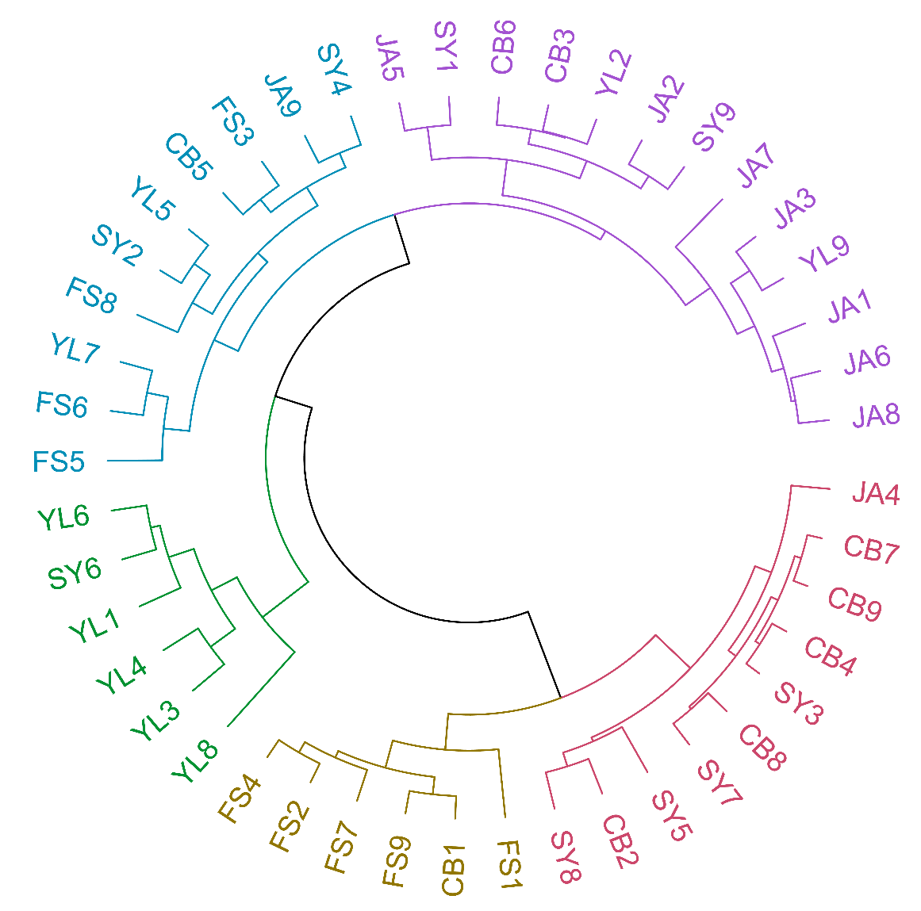
Fig S1. Dendrograms resulting from hierarchical cluster analysis of P. ginseng from different locations (k=5).

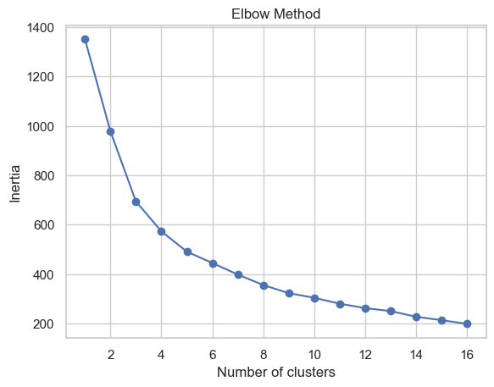
Fig S2. Elbow Method for Determining Optimal Cluster Number in HCA. The graph displays the number of clusters on the horizontal axis and inertia on the vertical axis. Inertia represents the total within-cluster sum of square, which measures the compactness of the clusters. The 'elbow' point in the graph, where the rate of decrease sharply changes, indicates the optimal number of clusters for HCA. This point is where adding another cluster doesn't give much better modeling of the data.
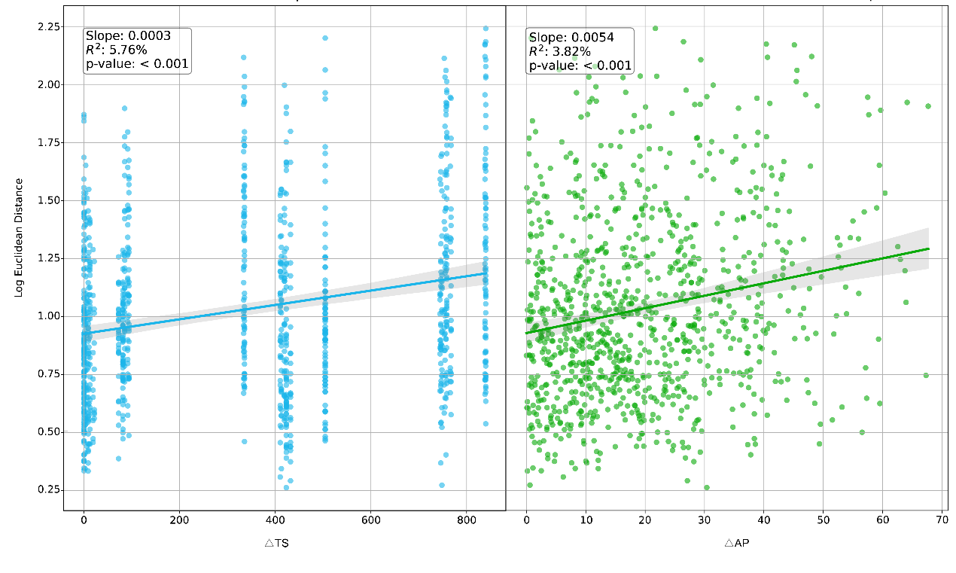
Fig S3. Observations focus on the relationship between AP (Annual Precipitation) and TS (Temperature Seasonality) with the Euclidean distance of ginsenoside content in ginseng. The rate of ginsenoside content change (slopes) across variations in AP and TS, and the fitting quality (R²) and significance (P-values) of the linear fitting model are documented.

Methods
(partial) Mantel tests
In the (partial) Mantel tests, we used the climatic factor distance matrix and the soil physicochemical properties distance matrix as control matrices. The specific steps are as follows:
- Calculate the Euclidean distance matrices for climatic factors and soil physicochemical properties, as well as for ginsenoside content. Assume we have three samples, each with two variables. The data are as follows:
Sample | Index 1 | Index 2
Sample 1 | 1 | 2
Sample 2 | 2 | 3
Sample 3 | 3 | 4
Then we can calculate the Euclidean distance matrices using the following formula:
$$d_{ij}=\sqrt{\sum_{k=1}^{m}{{\left(x_{ik}-x_{jk}\right)}^{2}}}$$
Obtain the Euclidean distance results between each pair of samples:
 | Sample1 | Sample2 | Sample3
Sample1 | 0 | √2 | √8
Sample2 | √2 | 0 | √2
Sample3 | √8 | √2 | 0
Using this method, we obtained the Euclidean distance matrices for climatic factors, soil physicochemical properties, and ginsenoside content.
- Conduct the (partial) Mantel test. Assess the independent correlation between soil physicochemical properties and ginsenoside content by controlling for the climatic factor distance matrix. Similarly, assess the independent correlation between climatic factors and ginsenoside content by controlling for the soil physicochemical properties distance matrix. The formula for calculating the partial Mantel test correlation coefficient, when evaluating the correlation between D_{X} and D_{Y} while controlling for the effect of the third distance matrix D_{Z}, is as follows:
$$r_{XY|Z=\frac{r_{XY}-r_{XZ}r_{YZ}}{\sqrt{\left(1-r_{XZ}^{2}\right)\left(1-r_{YZ}^{2}\right)}}}$$
Using this formula, we can calculate the correlation between other factors and ginsenoside content by controlling for climatic factors or soil physicochemical properties.

Path analysis
Path analysis is a multivariate statistical technique used to study the direct and indirect relationships between multiple variables. It extends regression analysis by using path diagrams to illustrate the causal relationships among variables. Its foundation is the Structural Equation Model (SEM), represented by a set of linear equations describing the relationships between variables. We used path analysis to evaluate the direct and indirect effects of environmental factors on secondary metabolites.
First, we constructed a path model based on literature and theory [7], hypothesizing that environmental factors indirectly affect secondary metabolites through certain mediator variables. Then, the data were log-transformed to eliminate the effects of different dimensions. Finally, we performed path analysis using AMOS software, assessing the model's fit with fit indices, including Chi-square test, Comparative Fit Index (CFI), Tucker-Lewis Index (TLI), and Root Mean Square Error of Approximation (RMSEA). For example, in the path analysis of ginsenoside Rd2, we used the following model (FigS4):
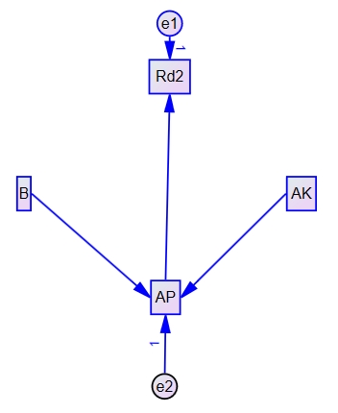
Fig S4. Path analysis model of Rd2.
Based on this model, we calculated the indirect and direct effects and filled them into the corresponding positions in the table. Then, we replaced the variable at the position of AP with B and AK, respectively, and filled the resulting data into the table. This completed the path analysis for Rd2.

