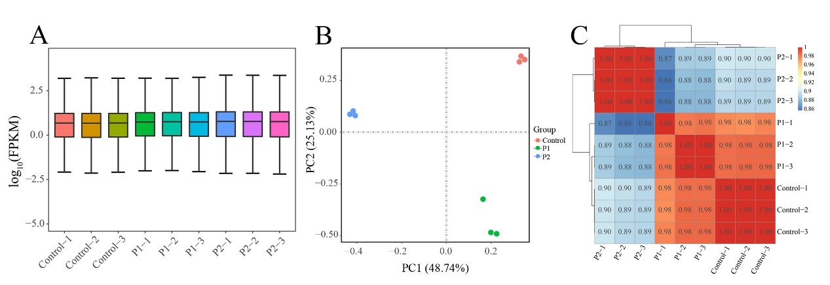
Additional File 2 Transcriptome profile of A. officinalis under salt stress. (A) Overall distribution of gene expression. (B) Principal Component Analysis (PCA) of the expressed genes. (C) Pearson Correlation Coefficient (PCC) between control, P1, and P2.

