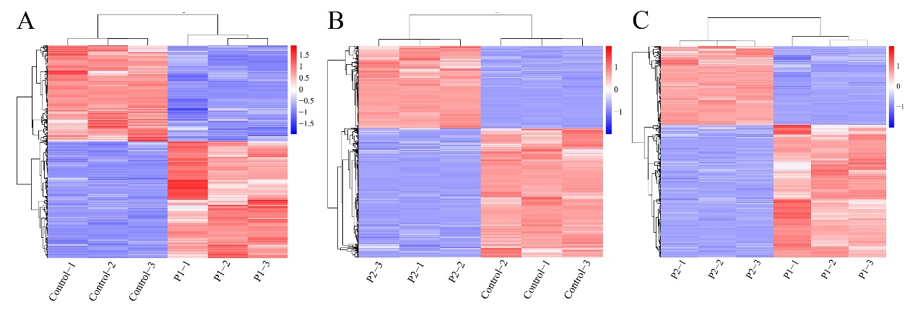
Additional File 3 Heatmap of DEGs identified under salt stress.

