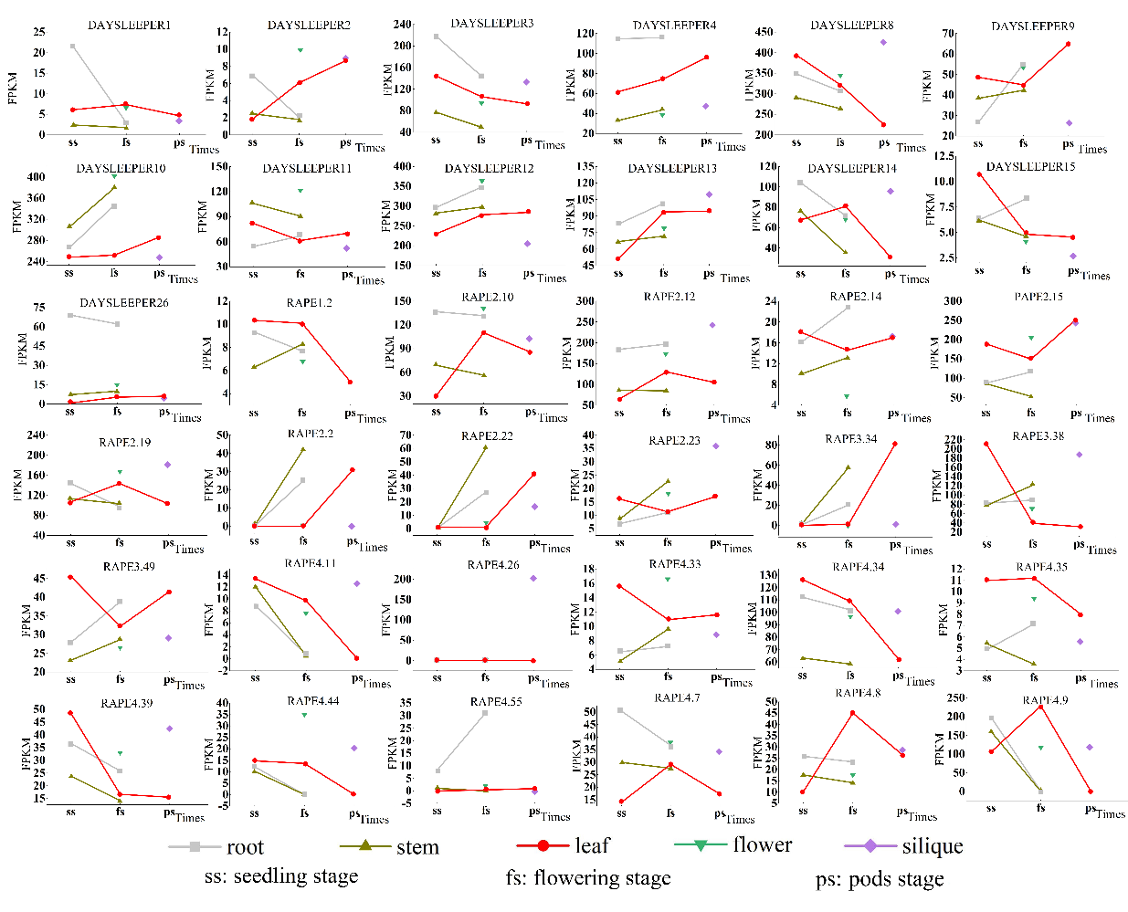
Figure S1 The changing trend of FPKM (fragments per kilobase of exon model per million reads mapped) of selected genes.

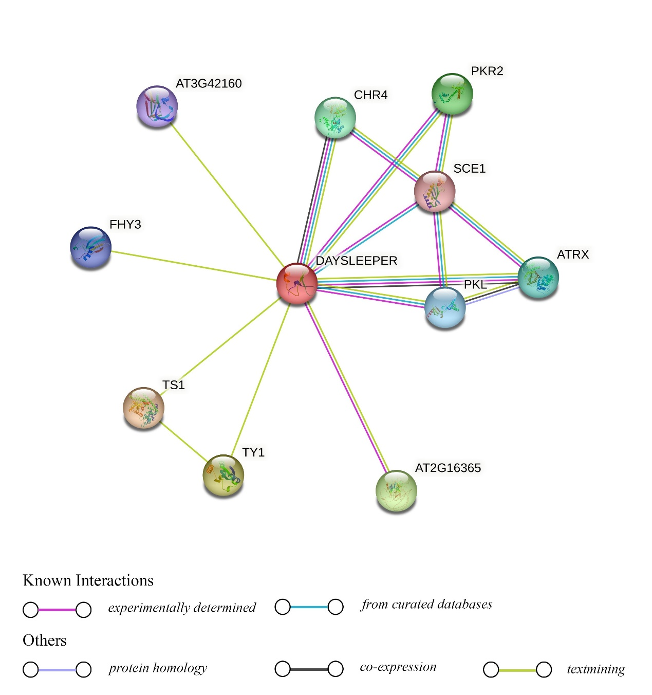
Figure S2 Protein-protein interaction networks of AtDAYSLEEPER. Different color threads represent different kinds of interactions and the circles represent different proteins.
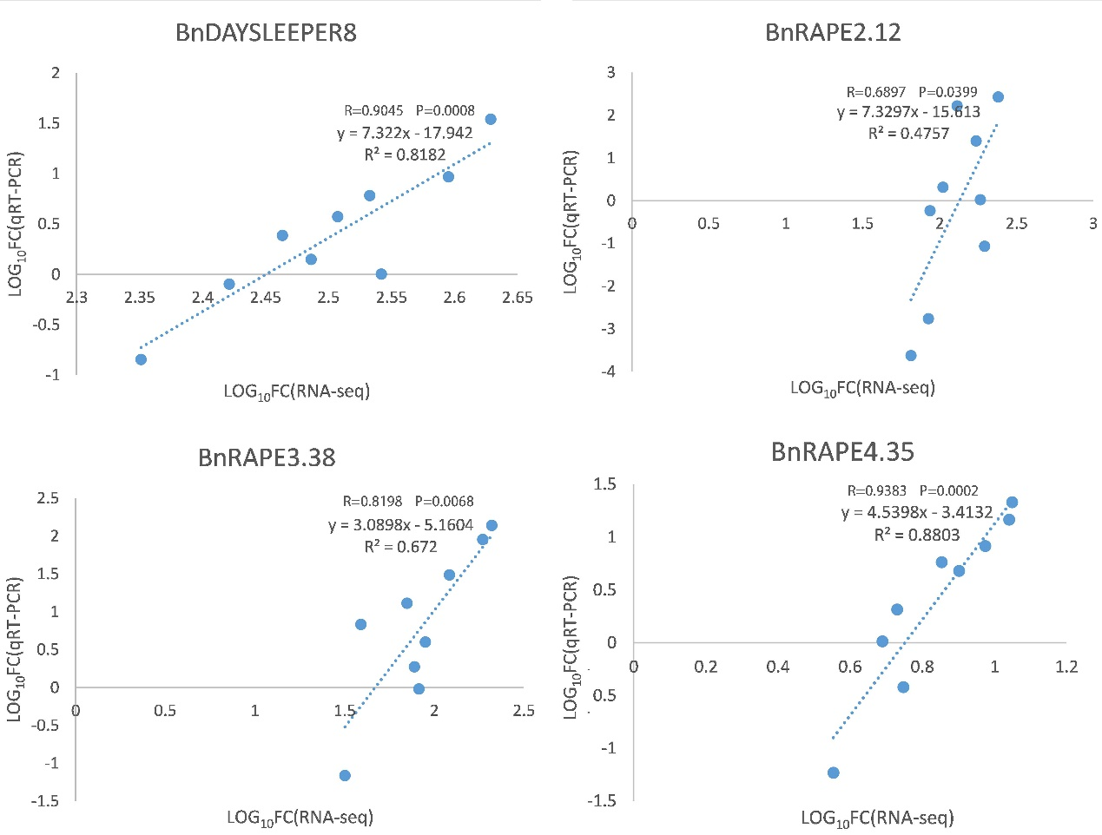
Figure S3 Correlation analysis of FoldChange values based on RNA-seq and qRT-PCR data. The RNA-seq FoldChange refers to the FPKM values.

