Supplementary information

Inoculation with arbuscular mycorrhizal fungi improves plant biomass and nitrogen and phosphorus nutrients: A meta-analysis

Yingjie Wu¹, Chongjuan Chen²*, Guoan Wang³
¹ Taiyuan Ecological Environmental Monitoring and Scientific Research Center, Taiyuan, 030002, China
² School of Earth System Science, Tianjin University, Tianjin, 300072, China
³ Beijing Key Laboratory of Farmland Soil Pollution Prevention and Remediation, Department of Environmental Sciences and Engineering, College of Resources and Environmental Sciences, China Agricultural University, Beijing, 100193, China.

*Corresponding author; Email: chencj@tju.edu.cn
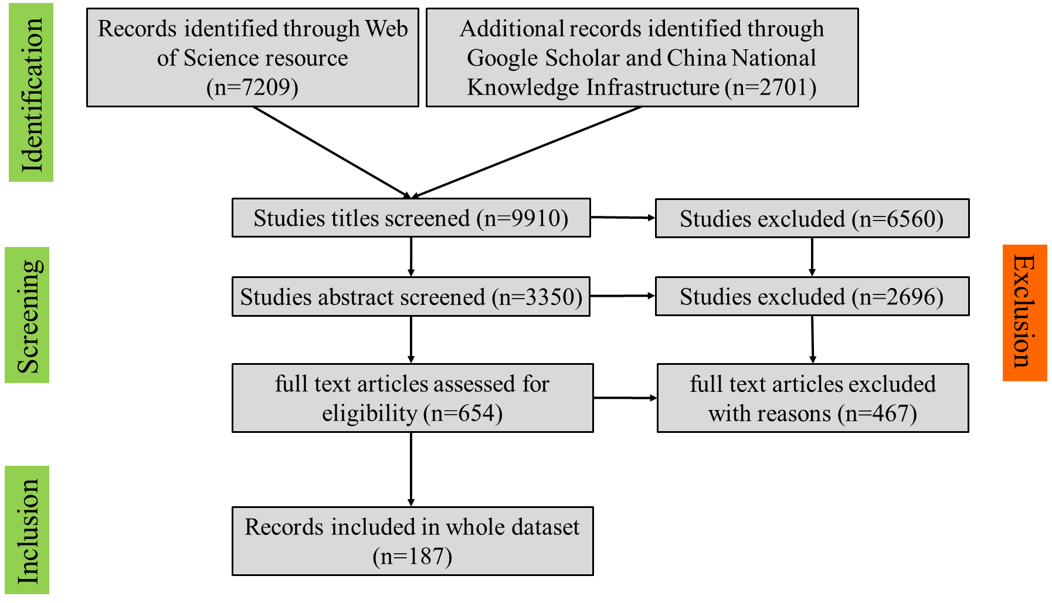
Fig. S1 PRISMA (Preferred Reporting Items for Systematic Reviews and Meta-Analyses) diagram showing the process used for study selection for the meta-analysis.

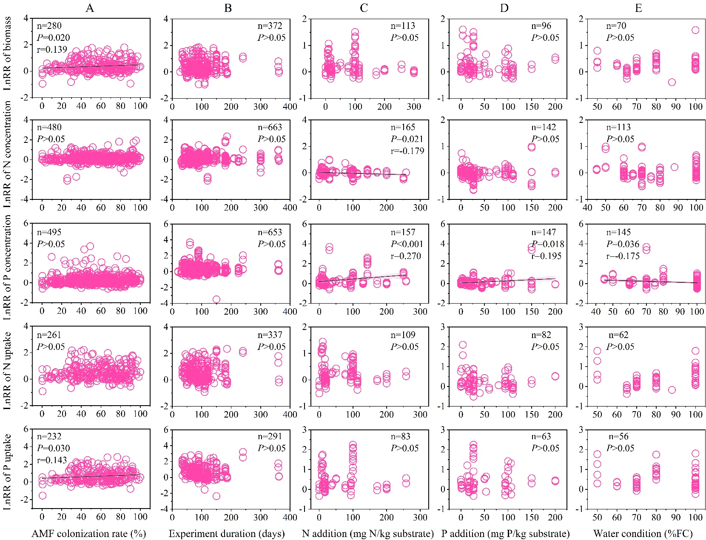
Fig. S2 Relationships between the response ratios (lnRR) of biomass, N concentration, P concentration, N uptake, and P uptake of plant aboveground with (A) AMF colonization rate, (B) experiment duration, (C) N addition, (D)P addition, and (E) water condition. Dark lines represent the regression results as P < 0.05, and pink shaded areas represent the 95% CIs. The n indicates the sample size and r values are the corresponding correlation coefficients.
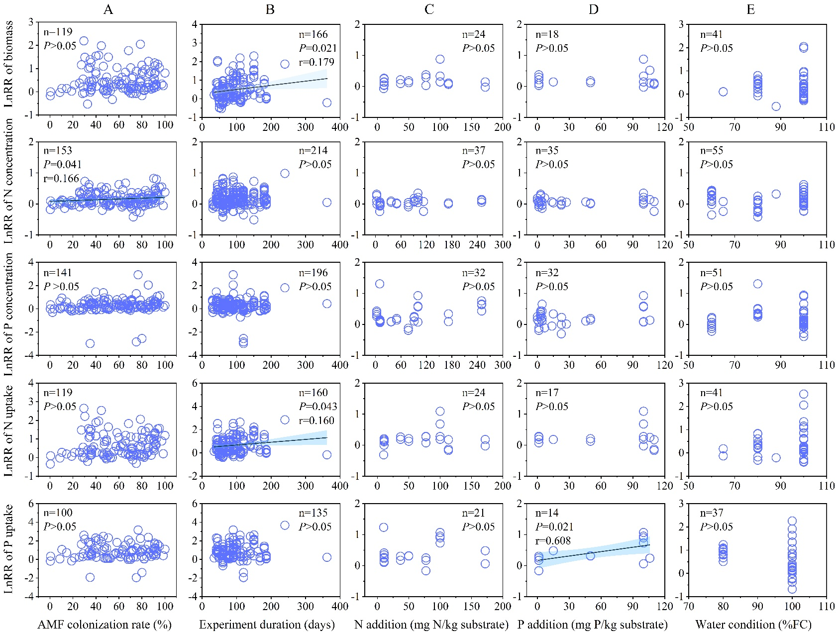
Fig. S3 Relationships between the response ratios (lnRR) of biomass, N concentration, P concentration, N uptake, and P uptake of plant belowground with (A) AMF colonization rate, (B) experimental duration, (C) N addition, (D)P addition, and (E) water condition. Dark lines represent the regression results as P < 0.05, and blue shaded areas represent the 95% CIs. The n indicates the sample size and r values are the corresponding correlation coefficients.

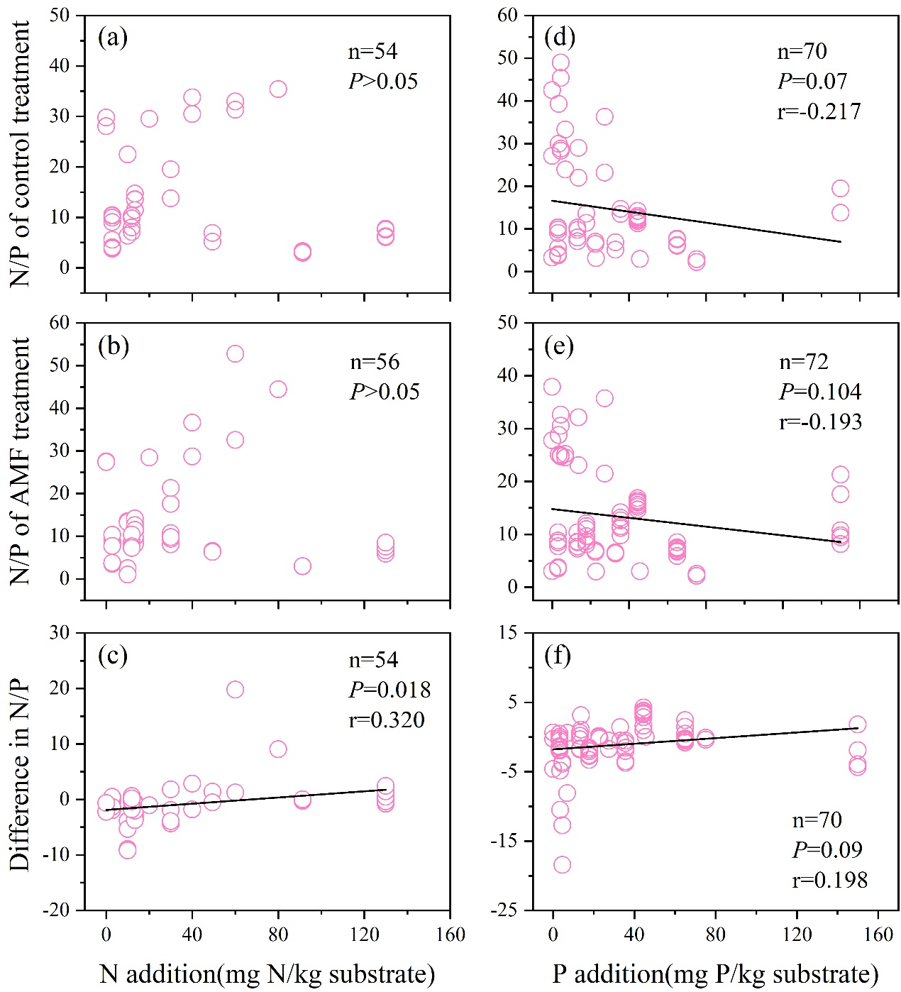
Fig. S4 Variations in N/P values of plant aboveground in control treatment and AMF treatment and variations in N/P differences (N/P value of AMF treatment minus those of control treatment) with N addition (a-c) and P addition (d-f). The n indicates the sample size and r values are the corresponding correlation coefficients.
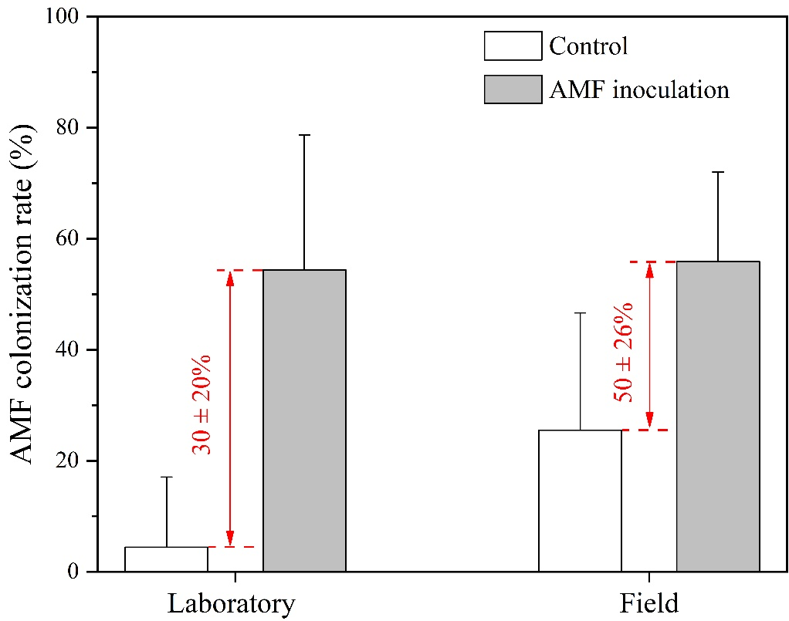
Fig. S5 Differences in AMF colonization rate of control and AMF inoculation treatments in laboratory- and field-based experiments. The red values represent the difference values between control and AMF inoculation treatments.

