Supplementary Figures
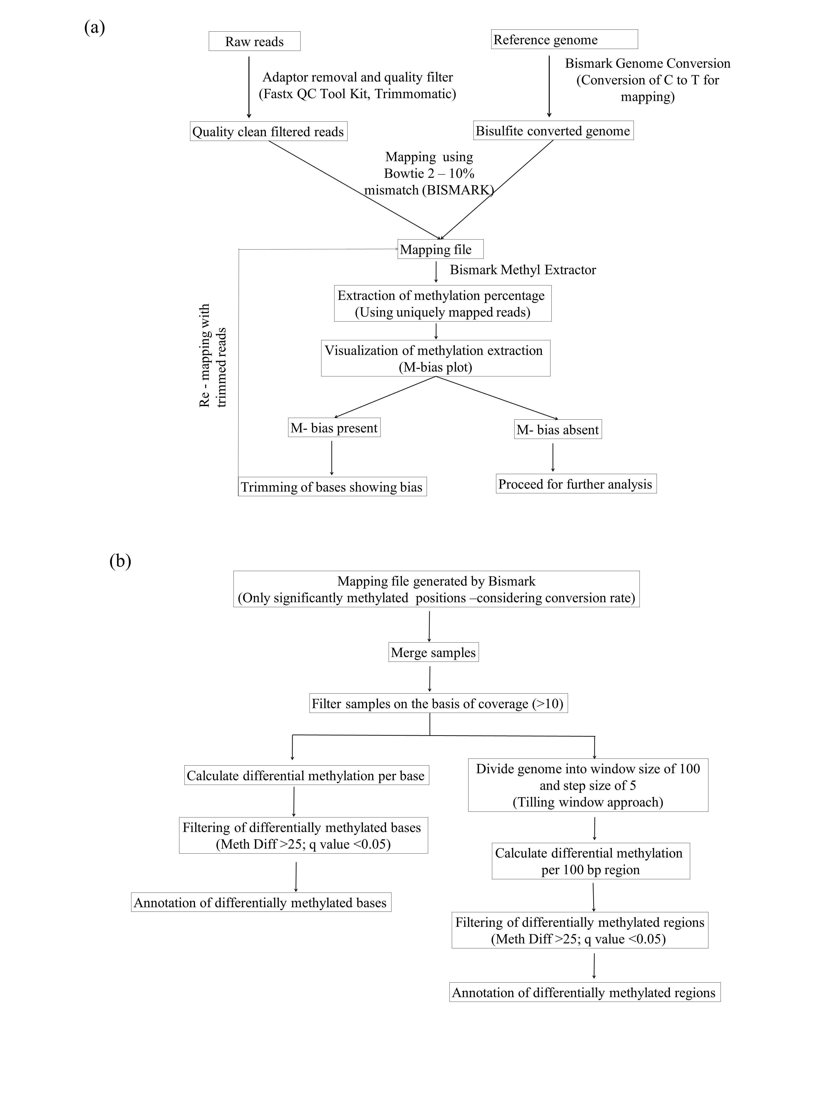
Supplementary Figure S1. (a) Flow chart showing method followed for processing of bisulfite converted sequenced reads and (b) identification of differentially methylated positions (DMPs) and differentially methylated regions (DMRs).
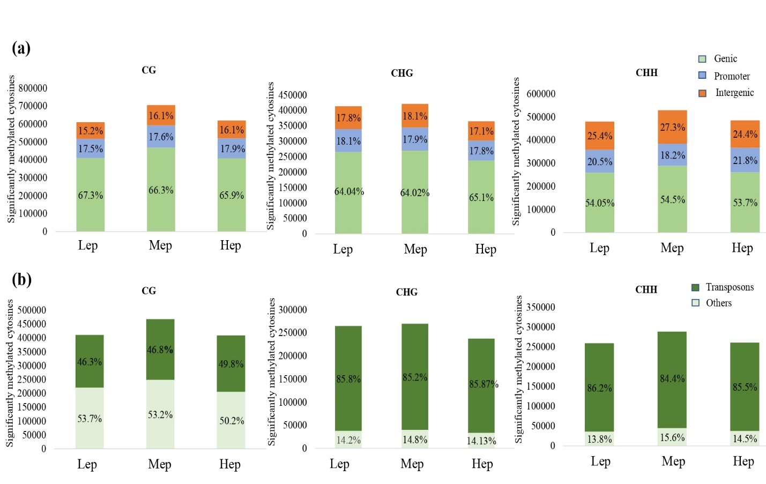

Supplementary Figure S2. (a) Global distribution of mC patterns in CG-, CHG- and CHH- sequence contexts vis-a-vis-genomic features contexts of genic, promoter and intergenic in the three populations form the native field condition, (b) Distribution pattern of genic mCs in protein coding and transposable element region.

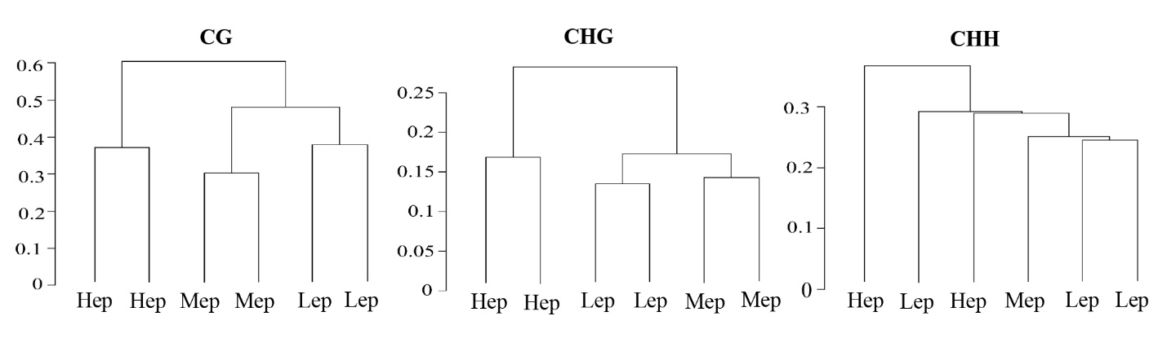
Supplementary Figure S3. Dendrograms showing correlation based clustering based on common mCs of the three populations under native field condition. Hep, Mep and Lep clustered separately on CG and CHG context while showing mixed clustering on CHH context.

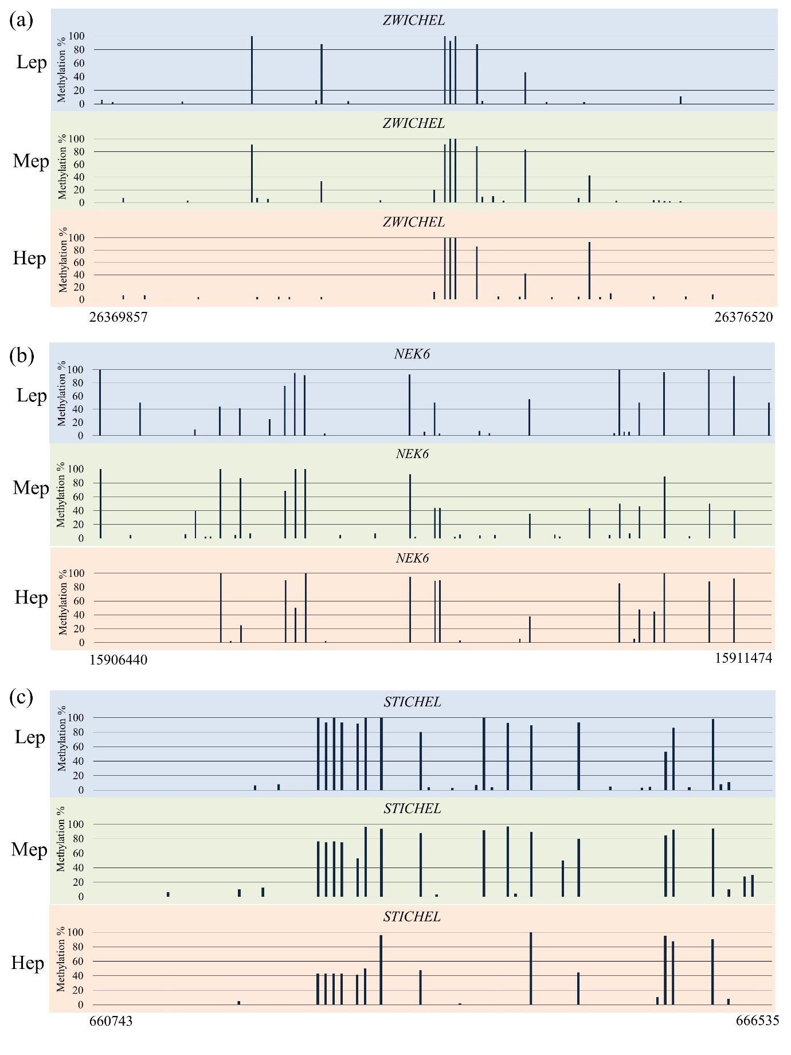
Supplementary Figure S4. Methylation status of trichome development related genes in Lep, Mep and Hep and trichome density under native field condition.
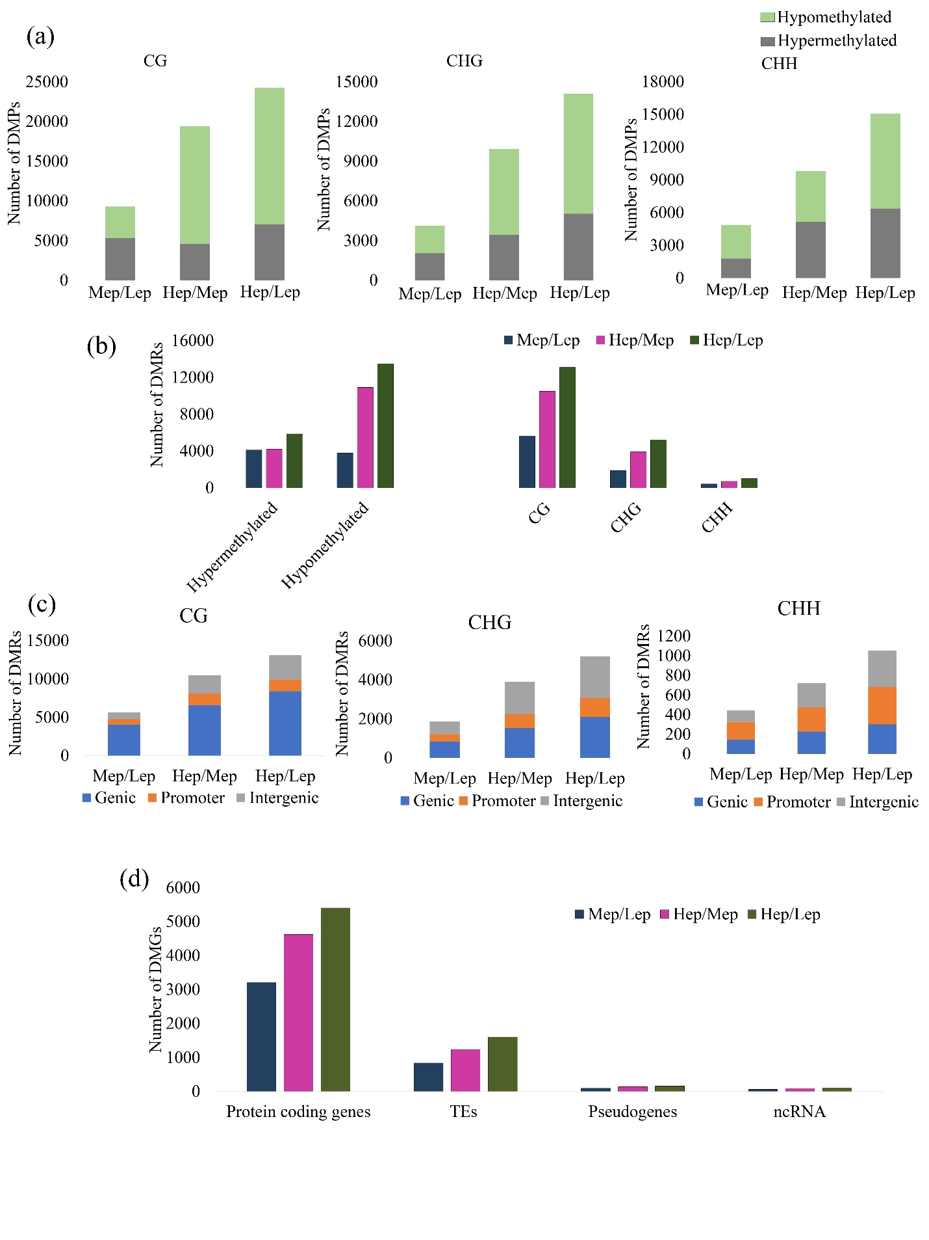
Supplementary Figure S5. (a) Bar chart showing number of differentially methylated positions (DMPs) (hyper- and hypomethylated), (b) differentially methylated regions (DMRs) (hyper- and hypomethylated), (c) whole genome distribution of DMRs, and (d) number of differentially methylated genes at different genomic contexts (protein coding genes, TEs, pseudogenes and non-coding RNA).
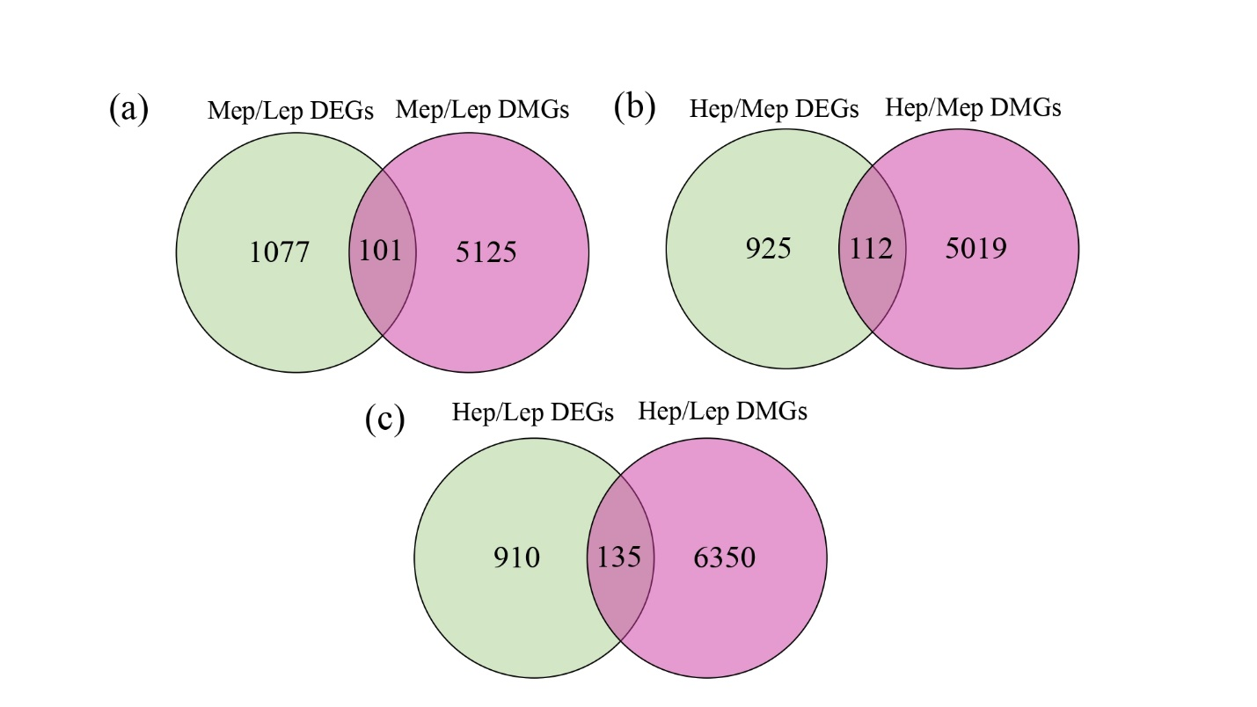

Supplementary Figure S6. Venn diagram showing common differentially methylated and differentially expressed genes between the populations under native field condition.
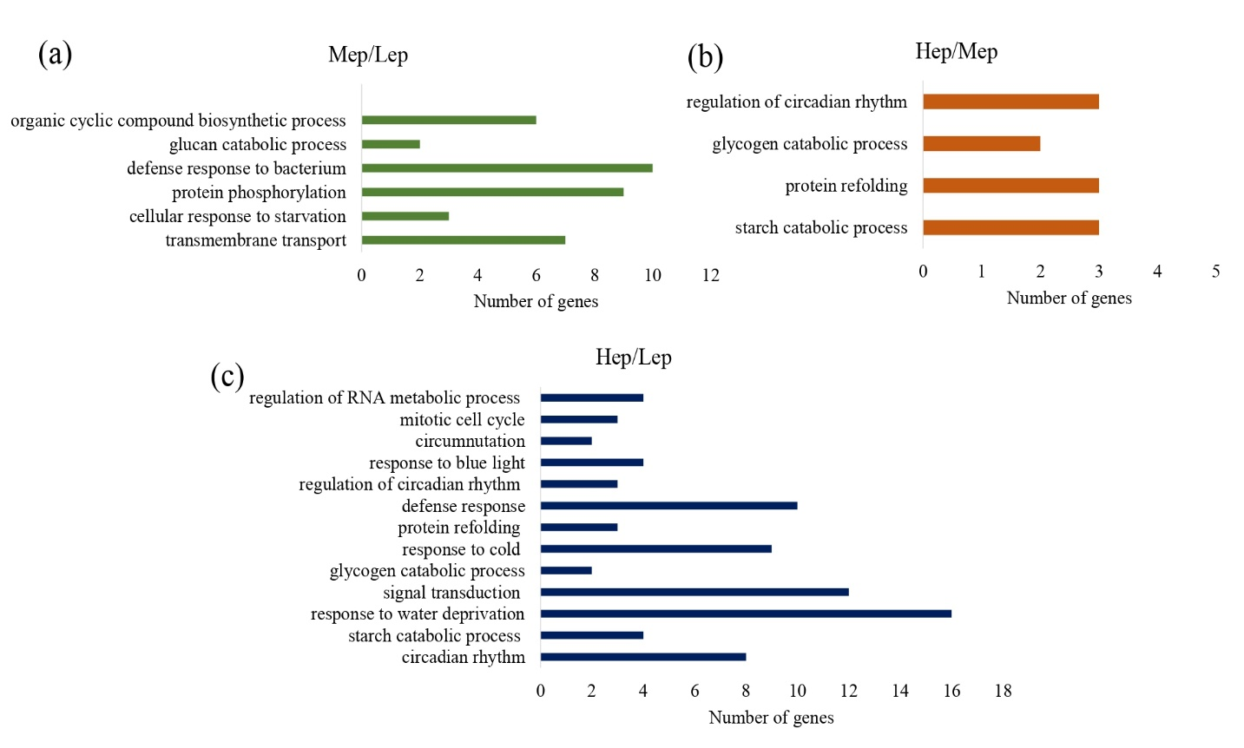
Supplementary Figure S7. Bar diagram shows the gene ontology enrichment term of commonly differentially methylated as well as differentially expressed genes between the populations ((a) Mep/Lep, (b) Hep/Mep, and (c) Hep/Lep) under native field condition.
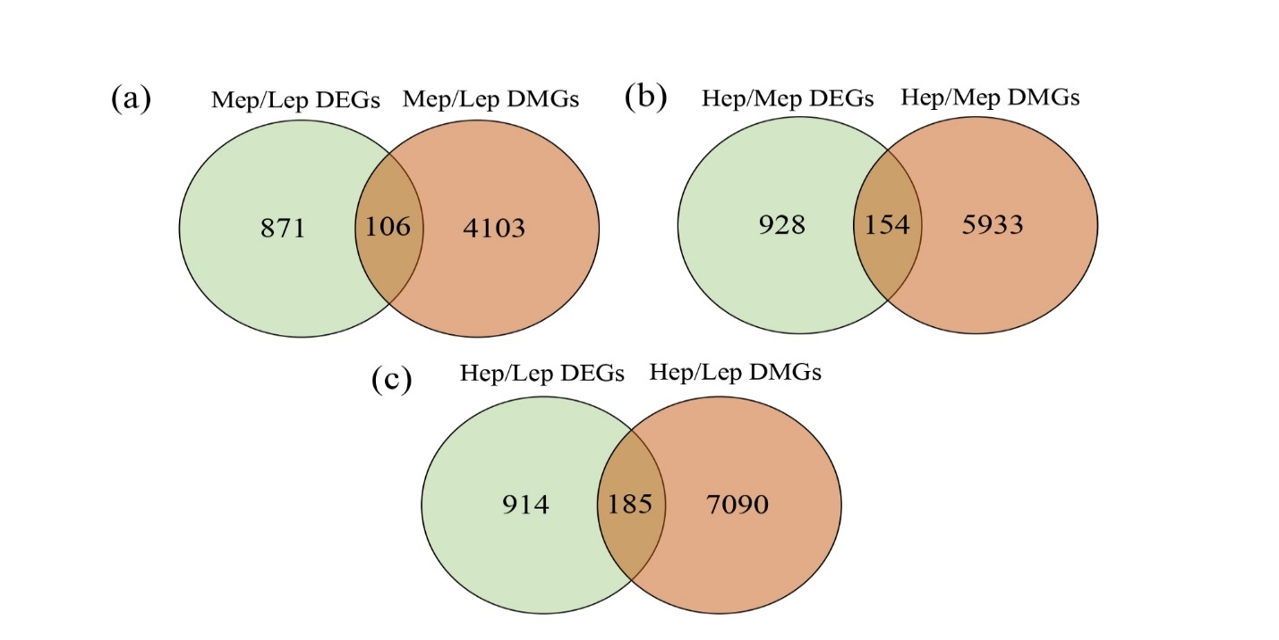

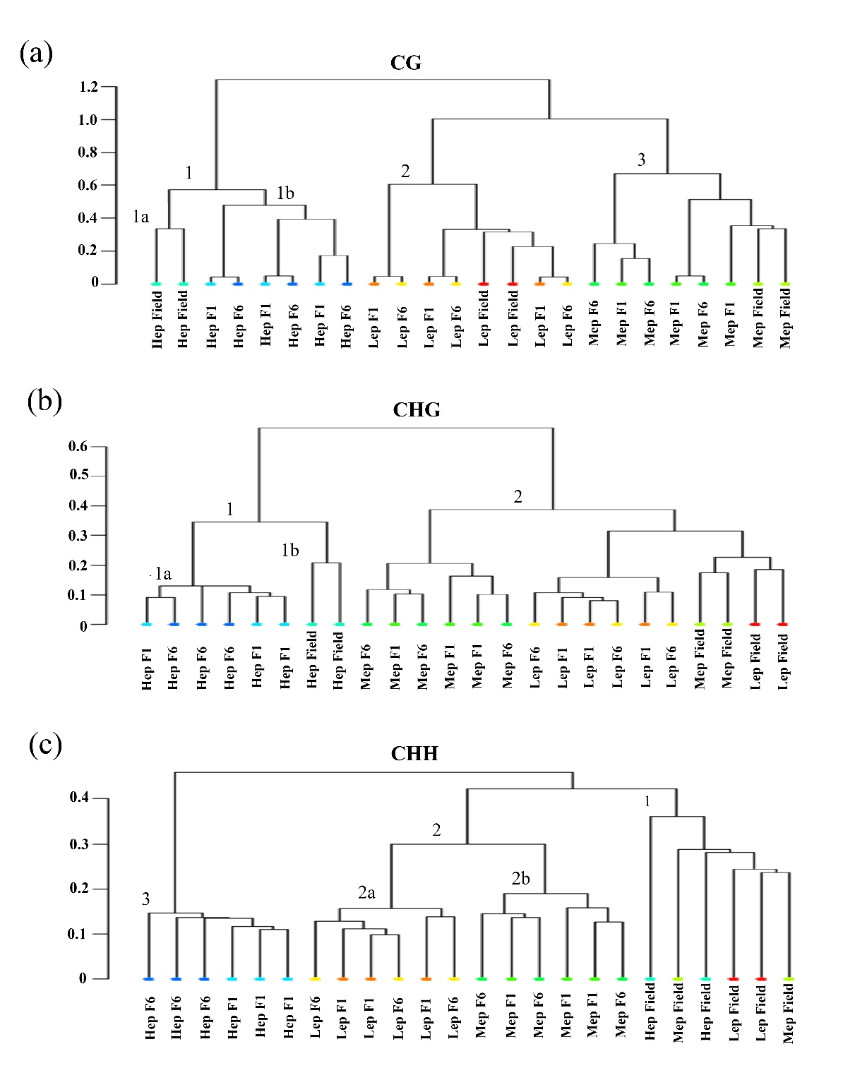
Supplementary Figure S8. Venn diagram showing common differentially methylated and differentially expressed genes between the populations grown under common controlled condition (F1 generation).

Supplementary Figure S9. Correlation based clustering of the accessions of the three populations on the basis of methylation status of common cytosine positions among field, F1 and F6 samples
Supplementary Figure S10. Methylation status of differentially methylated genes BIM3 (a), SUV2 (b), and NEK6 (c). The region represents 100bp differentially methylated region between the Hep and the Lep under controlled grown plants.
Supplementary Tables
Supplementary Table S1. Details of the sample collection sites: The geographical co-ordinates (degree°-min'-sec''), altitude (Meters Above Mean Sea Level) and growing season of the populations.
Supplementary Table S2. Climatic variables of the three sample collection sites in west Himalayan region
Supplementary Table S3. Summary statistics of bisulfite sequencing of DNA methylation data.
Supplementary Table S4. Number of methylated cytosine associated with the significantly variable traits under native field conditions as identified by the epi-genome-wide association analysis.
Supplementary Table S5. Primer used in this study for the validation of DNA methylation regulated gene expression.
Supplementary Table S6. Whole genome cytosine methylation statistics for three populations (average of two individuals per population ± standard deviation (SD)) under native field condition.
Supplementary Table S7. Gene ontology term enrichment of biological process of DMG under native field condition.
Supplementary Table S8. Differentially expressed genes involved in DNA methylation and demethylation between three population under common glasshouse condition.

Supplementary Table S9. Gene ontology term enrichment of biological process of DMGs of CHH context between Hep and Lep under controlled growth condition.
Supplementary Table S10. Differentially methylated genes between Hep and Lep CHH context of genic region and promoter region.
Supplementary Table S11. Common DMGs and DEGs and their methylation and expression status between the populations under native field condition.
Supplementary Table S12. Gene ontology term enrichment of biological process of differentially methylated as well as differentially expressed genes between the populations under native field condition.
Supplementary Table S13. Gene ontology term enrichment of biological process of differentially methylated as well as differentially expressed genes between the populations under controlled growth condition in f1 generation.
Supplementary Table S14. Common DMG and DEGs their methylation and expression between Field vs F1 condition.
Supplementary Table S15. Gene ontology term enrichment of biological procress of differentially methylated as well as differentially expressed genes between field and F1 condition of the three populations.
Supplementary Table S16. Gene ontology term enrichment of biological process of differentially methylated genes between F1 and F6 condition of the three populations.

