Fig. S1 Total ions current and multi-substance extraction ion current spectrum of qualitative and quantitative metabolites. A: MRM metabolite detection multimodal graph (multi-substance extraction ion current spectrum, XIC). B: QC sample mass spectrometry detection TIC overlap image. (a): negative ion mode, (b): positive ion mode. The different colored peaks indicate the detected metabolites.
Fig.S2 Cluster analysis of flavonoid metabolites in two spine grape callus cultures (ALA25 and CK)

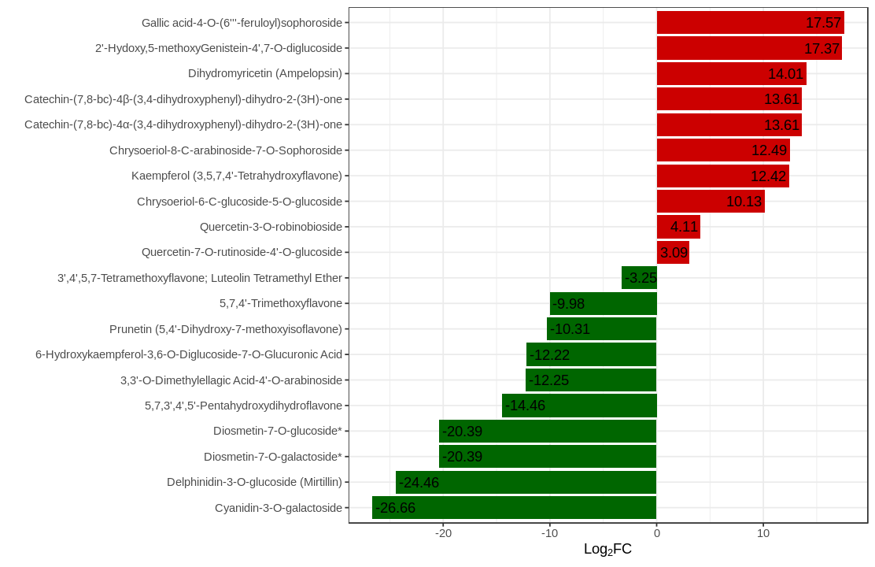
Fig. S3 The bar chart of the difference in the content of the top 10 up- and down-regulated flavonoid metabolites (CK vs ALA25). The x-coordinate is log₂FC of differential metabolites, and the y-coordinate is differential metabolites. Red represents up-regulated differential metabolites and green represents down-regulated differential metabolites.

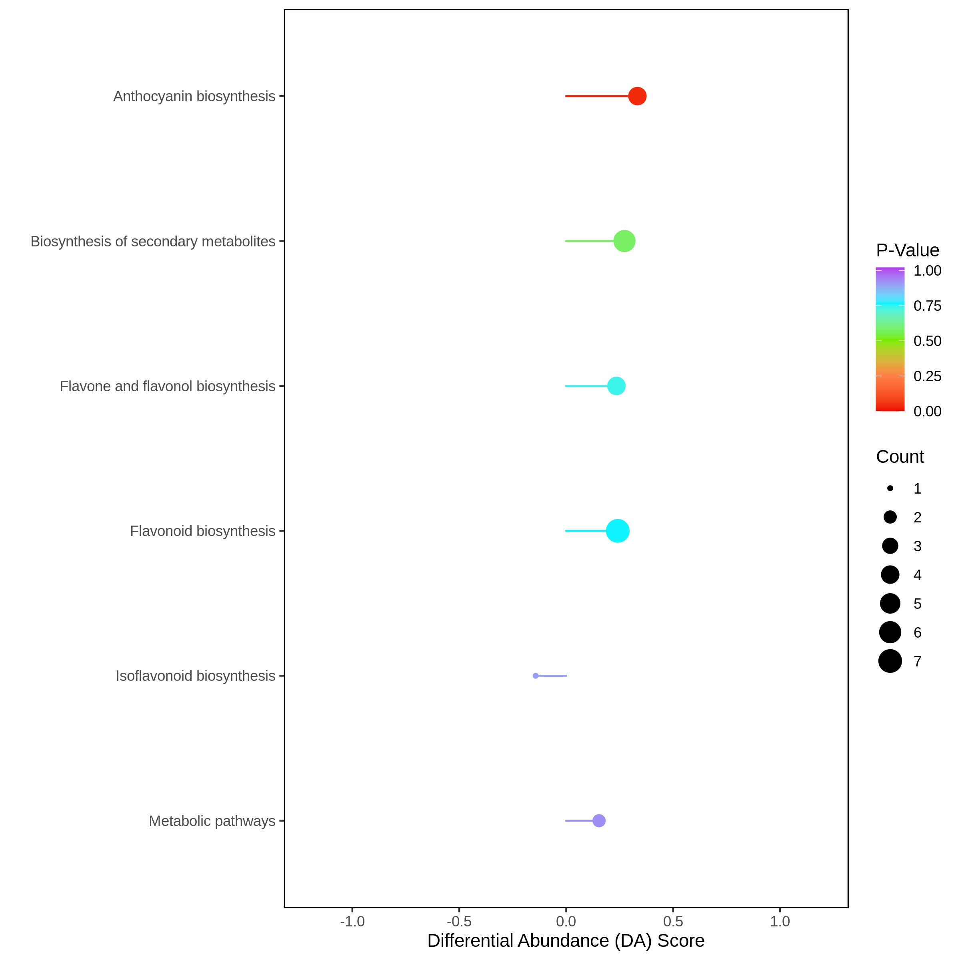
Fig. S4 The chart of differential abundance (DA) score (CK vs ALA25). The ordinate denotes the name of the differential pathway, while the abscissa represents the DA Score. The colors of line segments and dots reflect the magnitude of p-value, with red indicating smaller values and purple indicating larger ones. The colors of line segments and dots correspond to the magnitude of p-values. The closer the line segment is to red, the smaller the p-value; conversely, the closer it is to purple, the larger the p-value.

Fig. S5 qRT-PCR analysis of key genes involved in the anthocyanin biosynthesis pathway. Different lower-case letters above the bar chart indicate significant differences in relative expression of gene in different culture stages by Duncan's new multiple range test (p < 0.05).

