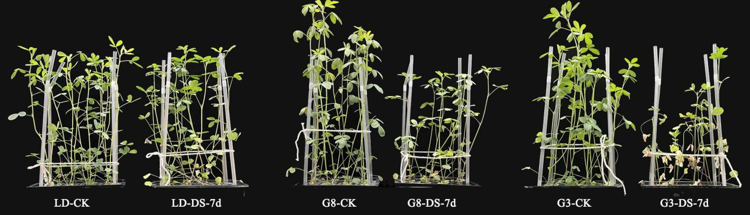
Fig. S1 Morphological changes of alfalfa after 7 days of drought stress.

