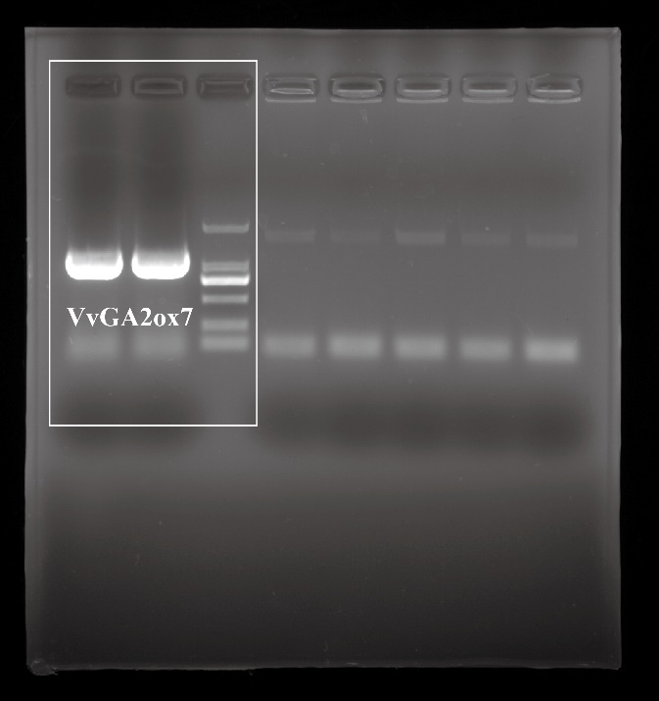
Fig. S1B The original images of the electrophoresis of PCR products for cloning of VvGA2ox7.

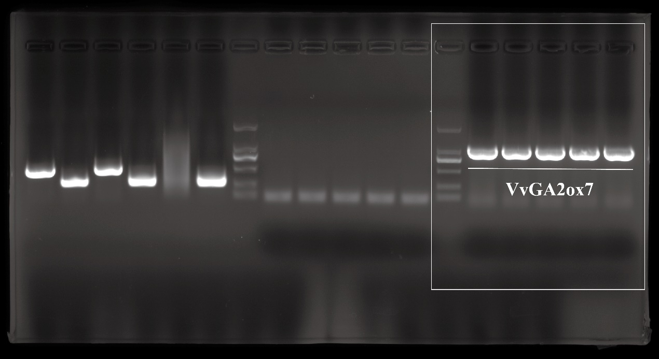
Fig. S1C The original images of the PCR gel electrophoresis analysis of the target gene linked to Escherichia coli.

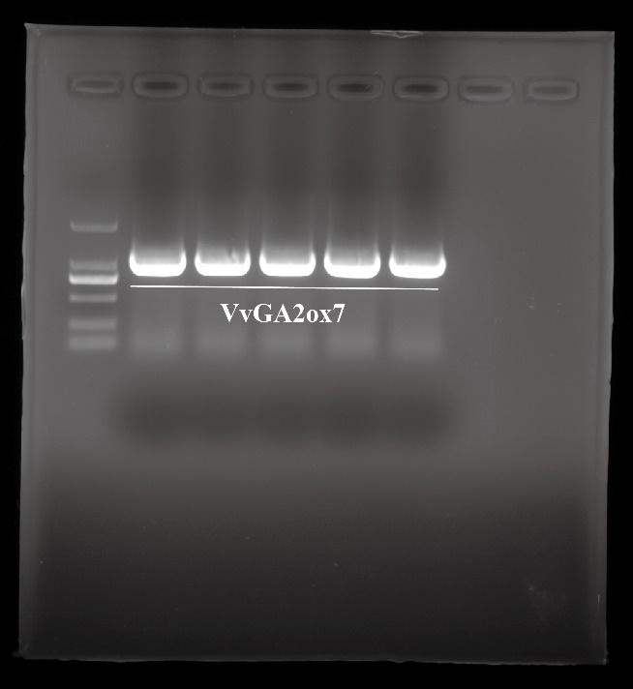
Fig. S1D The original images of the PCR gel electrophoresis analysis of target gene-GV3101 colony PCR detection.

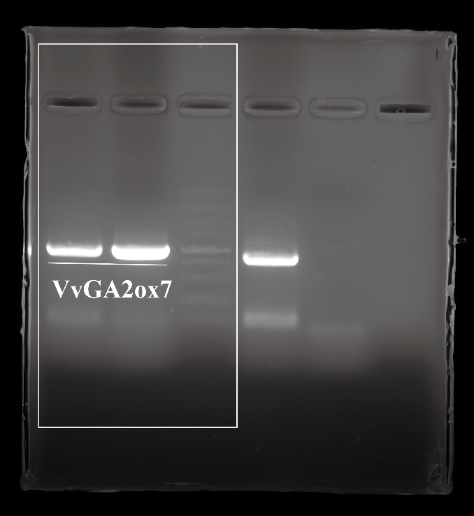
Fig. S2A The original images of the amplification electropherogram of the VvGA2ox7 gene.

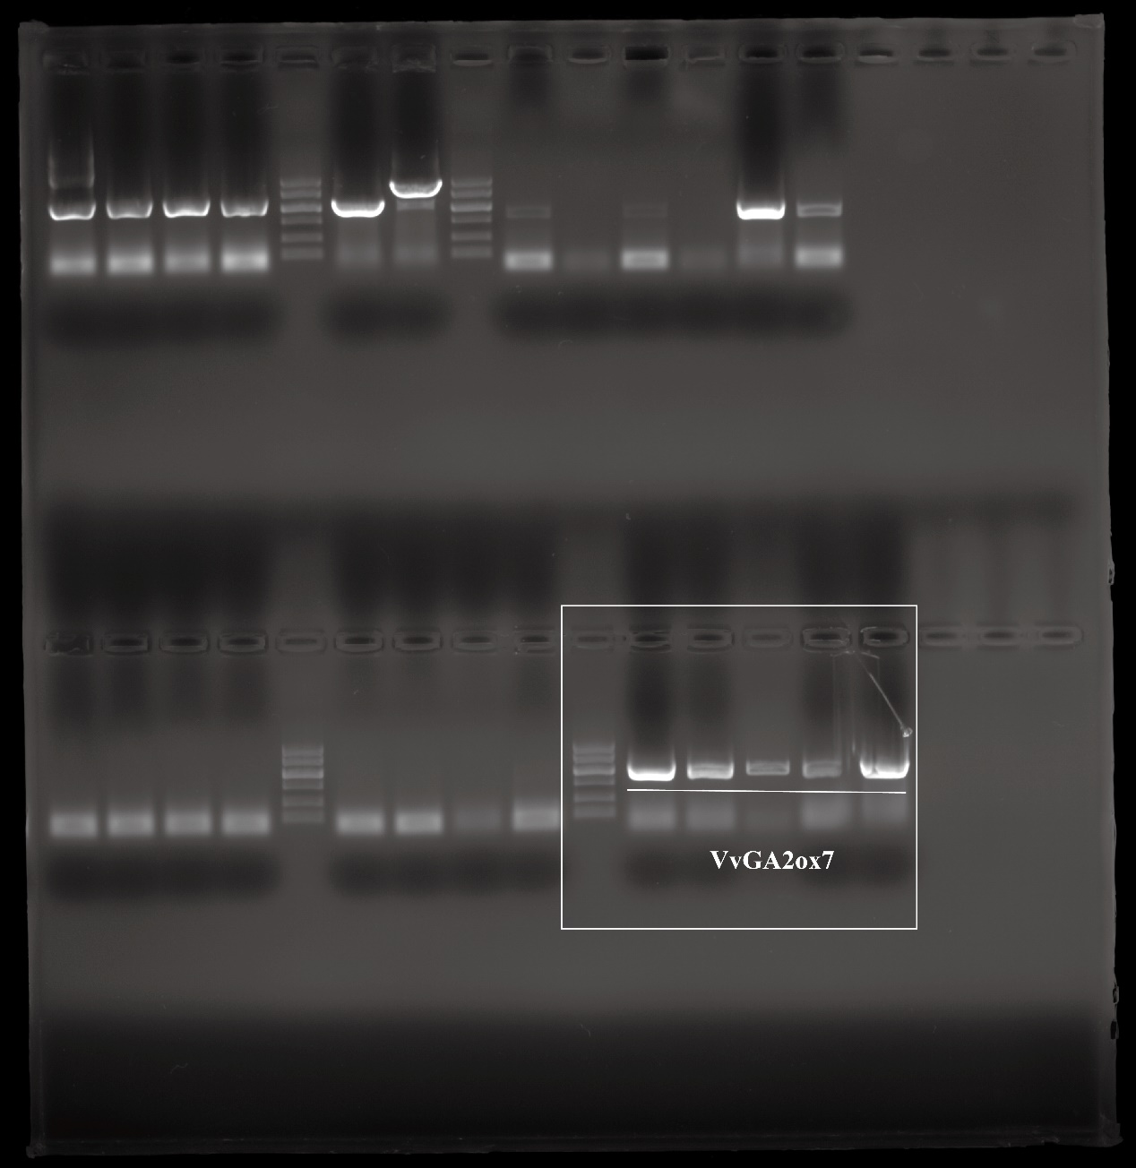
Fig. S2B The original images of the electrophoretogram of VvGA2ox7 E. coli.

Fig. S2E The original images of the PCR strip charts for AD library vector coliforms.

Fig. S2E The original images of the PCR strip charts for AD library vector coliforms.

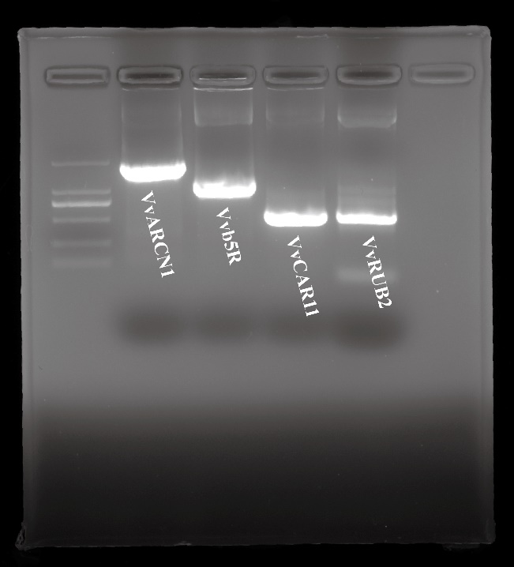
Fig. S2F The original images of the amplification electropherograms of VvARCN1, Vvb5R, VvCAR11, and VvRUB2 proteins.

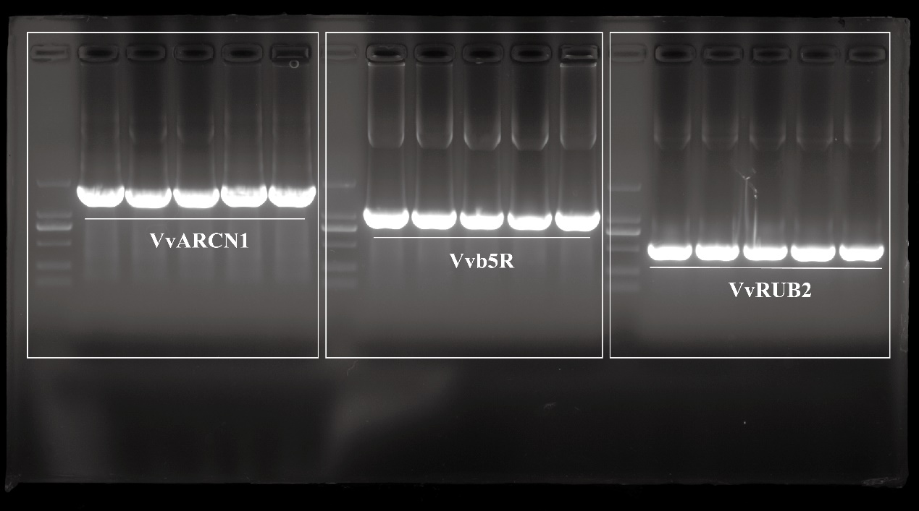
Fig. S2G The original images of the electropherograms of VvARCN1, Vvb5R, and VvRUB2 E. coli.

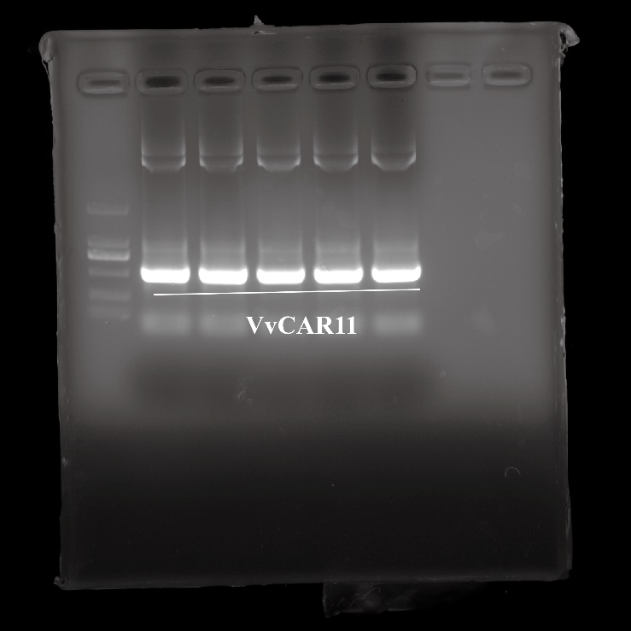
Fig. S2G The original images of the electropherograms of VvCAR11 E. coli.
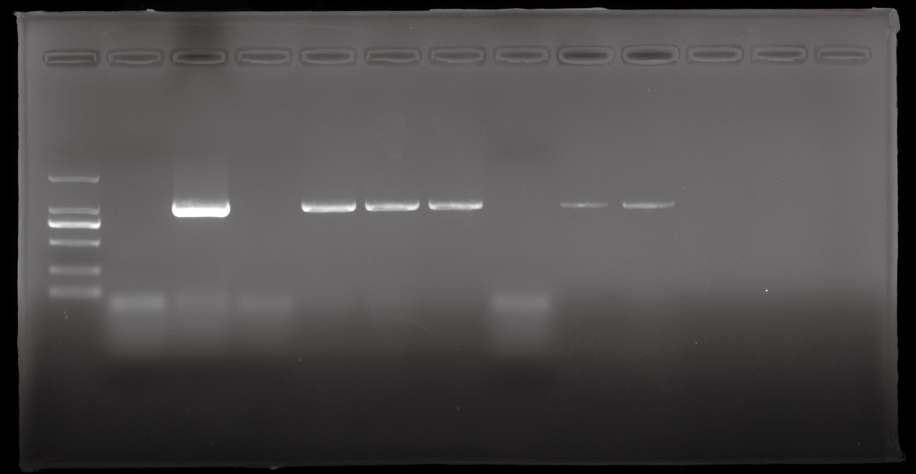
Fig. S3E The original images of the identification results of homozygous Arabidopsis.

