Supplementary Information

Title
The role of gibberellin synthase gene VvGA2ox7 acts as a positive regulator to salt stress in transgenic Arabidopsis thaliana

This file includes:
Figs S1 to S3
Tables S1 to S3

Fig. S1 The construction of VvGA2ox7 overexpression vector.
(A) The construction of an overexpression vector map of VvGA2ox7. (B) Electrophoresis of PCR products for cloning of VvGA2ox7. M is Marker 2000. (C) PCR gel electrophoresis analysis of target gene linked to Escherichia coli. (D) PCR gel electrophoresis analysis of target gene-GV3101 colony PCR detection.

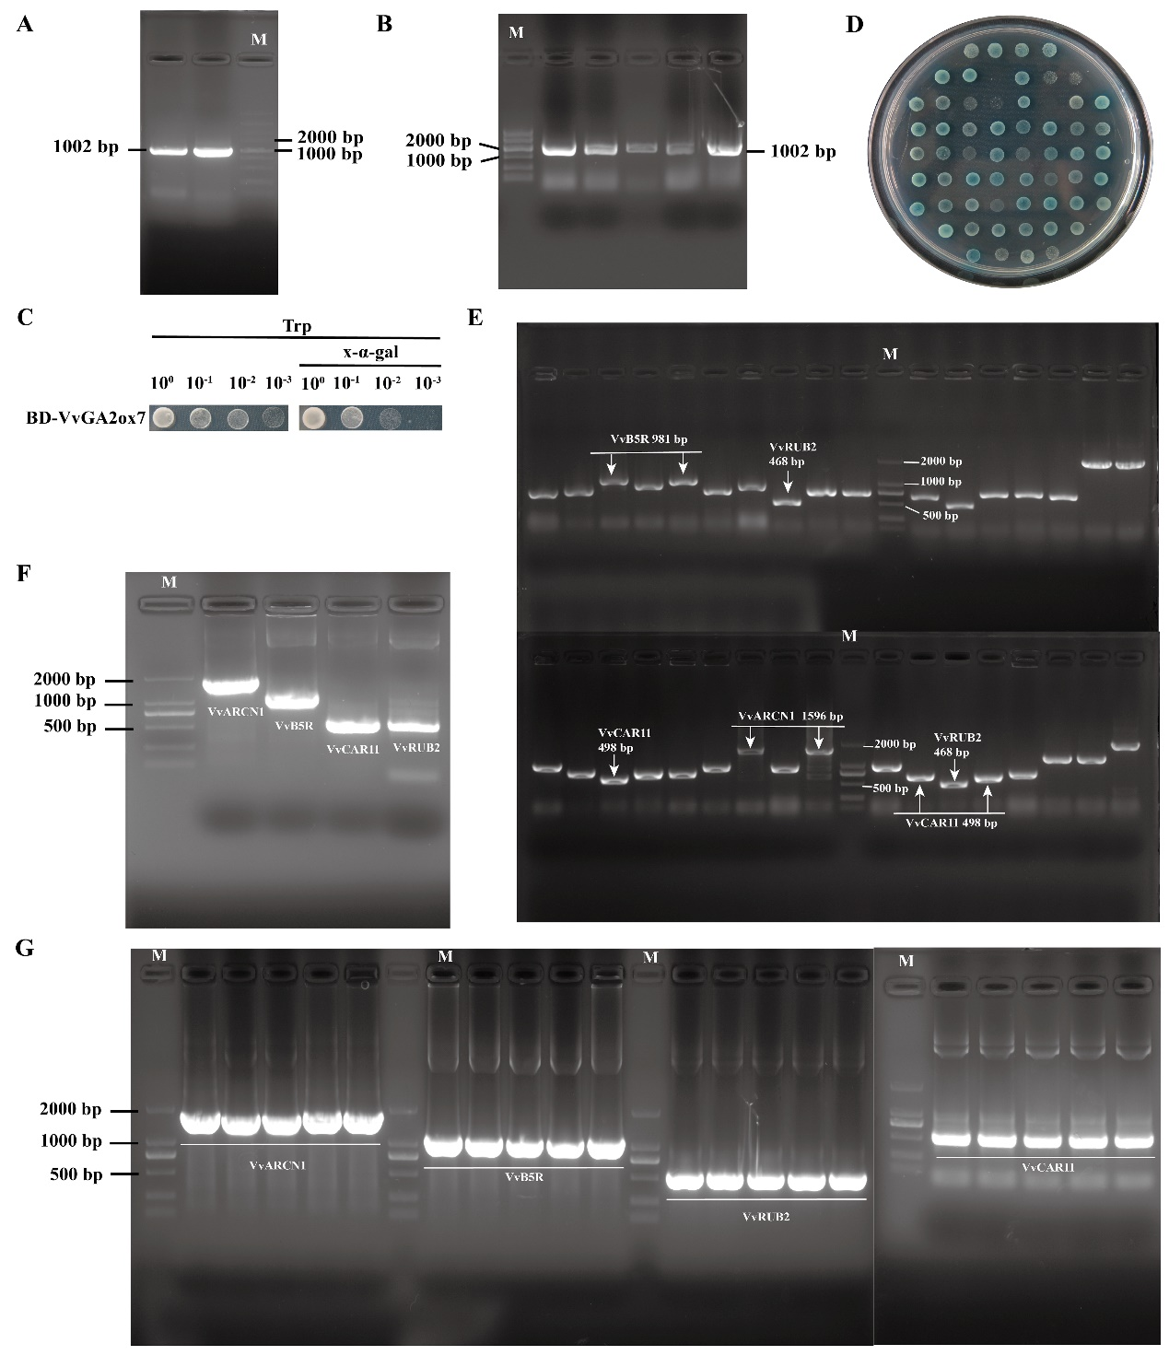
Fig. S2 VvGA2ox7 protein yeast two-hybrid.
(A) Amplification electropherogram of the VvGA2ox7 gene. M is Marker 2000. (B) Electrophoretogram of VvGA2ox7 E. coli. (C) The self-activation and toxicity test of VvGA2ox7 protein. (D) Mating-method two-hybrid library screening. (E) PCR strip charts for AD library vector coliforms. (F) Amplification electropherograms of VvARCN1, Vvb5R, VvCAR11, and VvRUB2 proteins. (G) Electropherograms of VvARCN1, Vvb5R, VvRUB2, and VvCAR11 E. coli.

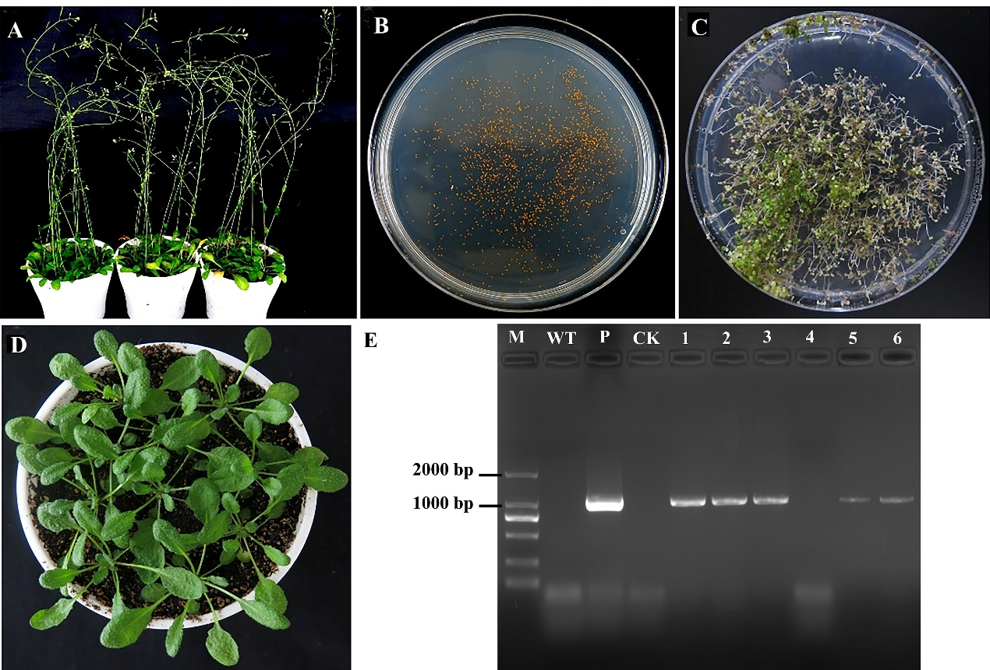
Fig. S3 The process of obtaining transgenic lines of Arabidopsis.
(A) The flaccid infected Agrobacterium with the target gene GA2ox7. (B) T0 generation seeds are planted on a selection medium containing Kana. (C) T1 generation Arabidopsis. (D) T2 generation homozygous transgenic Arabidopsis plants were screened. (E) The identification results of homozygous Arabidopsis. The M stands for Maker 2000, WT for wild-type Arabidopsis, P for Agrobacterium broth containing the target gene, CK for the control group, and 1-6 for homozygous transgenic Arabidopsis strains.

Table S1 Primers for cloning and qRT-PCR.
Gene | Sequences of oligonucleotides forward (F) and reverse (R)
VvGA2ox7-pMD18-T | F | 5'-ATGGTTGTGTTATCGCAGAATGG-3'
VvGA2ox7-pMD18-T | R | 5'-TCATGGCTGCTCTTTTTTCTCAAAGAG-3'
pBI221-GA2ox7-EGFP | F | 5'-AACACGGGGGACTCTAGAATGGTTGTGTTATCGCAGAAT-3'
pBI221-GA2ox7-EGFP | R | 5’-AAGCTTGTCGACGGAGCTTGGCTGCTCTTTTTCTCAAAG-3'
pCAM-GA2ox7-FLAG | F | 5'-GGAGAGGACACGCTCGAGATGGTTGTGTTATCGCAGAAT-3'
pCAM-GA2ox7-FLAG | R | 5'-ATCCTTGTAGTCGAATTCTGGCTGCTCTTTTTCTCAAAG-3'
VvGA2ox7 | F  R | 5'-TTATCGCAGAATGGTCGTCAGCAG-3'  5'-CCATGTGAGCCTTGGCGTGAG-3'
AtLEA | F | 5'-GATTGACCCGGCTGAGCTACGA-3'
AtLEA | R | 5'-AGATGGGATTCACCACAAAAG-3'
AtP5CS1 | F | 5'-GGGACAAGTTGTGGATGGAGAC-3'
AtP5CS1 | R | 5'-TGGTACAAACCTCAAGGAACAC-3'
AtAVP1 | F | 5'-TCTTTGGTGCCTTTGTGAGC-3'
AtAVP1 | R | 5'-GTCTGGTTTTGCGGTTCCTT-3'
AtCBF1 | F | 5'-GAATCCCGGAGTCAACATGC-3'
AtCBF1 | R | 5'-ACAAAGTCGGCATCCCAAAC-3'
AtFLC | F | 5'-ATCGATTCCGTTCTCGATGT-3'
AtFLC | R | 5'-ATCCAGTTCCTCCTCCCAAC-3'
AtFT | F | 5'-GGAACAACCTTTGGCAATGAGAT-3'
AtFT | R | 5'-CTGCCAAGCTGTCGAAACAA-3'
AtActin | F | 5'-CTAGAGACAGCCAAGAGCAGTTC-3'
AtActin | R | 5'-GTTTCATGGATTCCAGGAGCTTC-3'
BD-VvGA2ox7 | F | 5'-aggccgaattcccggggatccttATGGTTGTGTTATCGCAGAATGG-3'
BD-VvGA2ox7 | R | 5'-ccgctgcaggtcgacggatccTCATGGCTGCTCTTTTTTCTCA-3'
AD-VvARCN1 | F | 5'-gtgggcatcgatacgggatccttATGGTTGTTCTTGCAGCTTCTATTG-3'
AD-VvARCN1 | R | 5'-cagctcgagctcgatggatccTTACACCACTTGATAGTTCTCCGTG-3'
AD-Vvb5R | F | 5'-gtgggcatcgatacgggatccttATGGCGCTCTTCTTCAAGAGAC-3'
AD-Vvb5R | R | 5'-cagctcgagctcgatggatccTCAAAATTTGTAAACCATGTCTTCCG-3'
AD-VvCAR11 | F | 5'-gtgggcatcgatacgggatccttATGGGGGAGCCAGTGGGC-3'
AD-VvCAR11 | R | 5'-cagctcgagctcgatggatccTCAAGGAGCAGCAGGAGGATC-3'
AD-VvRUB2 | F | 5'-gtgggcatcgatacgggatccttATGCAGATCTTCGTGAAAACCC-3'
AD-VvRUB2 | R | 5'-cagctcgagctcgatggatccTCAGGCGCTGCCTCCACC-3'

Table S2 cis-acting regulatory elements in the promoter of VvGA2ox7.
Site name | Sequence | Function of site | Location
3-AF1 binding site | TAAGAGAGGAA | light responsive element | -680
ABRE | ACGTG | cis-acting element involved in the abscisic acid responsiveness | -559
ARE | AAACCA | cis-acting regulatory element essential for the anaerobic induction | +1186
G-box | TACGTG | cis-acting regulatory element involved in light responsiveness | -559
GT1-motif | GGTTAA  GGTTAA | light responsive element  light responsive element | -532  +1304
GTGGC-motif | GATTCTGTGGC | part of a light-responsive element | -957
HD-Zip 1 | CAAT(A/T)ATTG | element involved in differentiation of the palisade mesophyll cells | +748
LTR | CCGAAA | cis-acting element involved in low-temperature responsiveness | +879
O2-site | GATGACATGG | cis-acting regulatory element involved in zein metabolism regulation | +795
P-box | CCTTTTG | gibberellin-responsive element | -1609
TATC-box | TATCCCA | cis-acting element involved in gibberellin-responsiveness | +651
TC-rich repeats | GTTTTCTTAC | cis-acting element involved in defense and stress responsiveness | -1291
TCCC-motif | TCTCCCT | part of a light-responsive element | +1951
WUN-motif | AAATTTCTT  AAATTTCTT | wound-responsive element  wound-responsive element | -299  -995

Table S3 Screed proteins of VvGA2ox7.

Screed proteins | Locus | CDS length | Predicted
VvARCN1 | XM_019223808.1 | 1596 | Vitis vinifera coatomer subunit delta-like, transcript variant X2, mRNA
Vvb5R | XM_002285037.4 | 981 | Vitis vinifera NADH-cytochrome b5 reductase-like protein
VvCAR11 | XM_010648859.2 | 498 | Vitis vinifera protein C2-domain ABA-related 1, transcript variant X2, mRNA
VvRUB2 | XM_002265828.4 | 468 | Vitis vinifera ubiquitin-NEDD8-like protein RUB, mRNA

