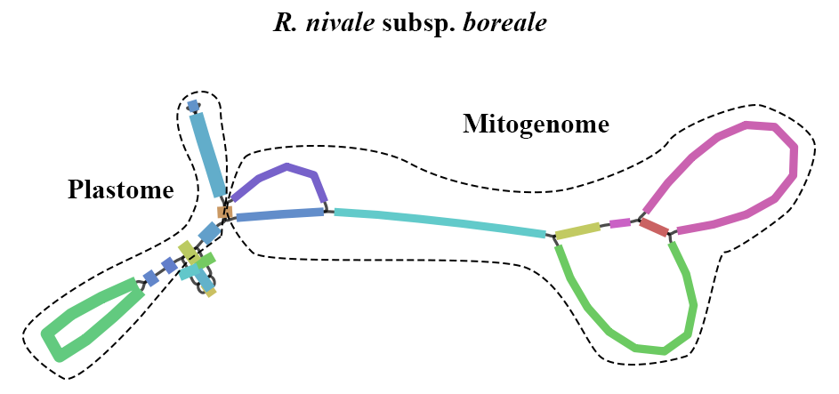
Fig S1. The organelle genome assemblies of R. nivale subsp. boreale using PMAT.

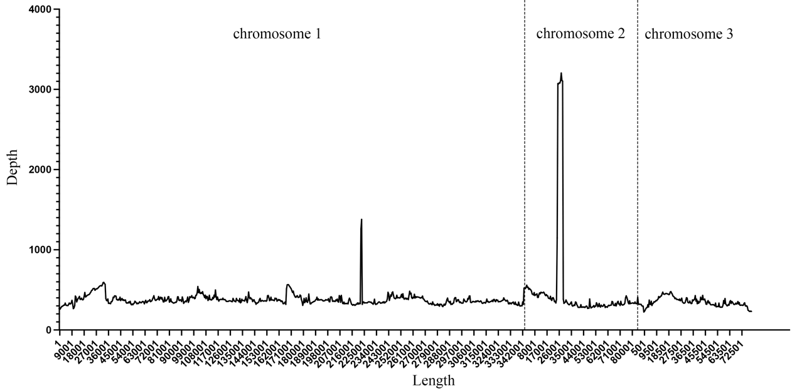
Fig S2. Depth and coverage of R. nivale subsp. boreale mitogenome.

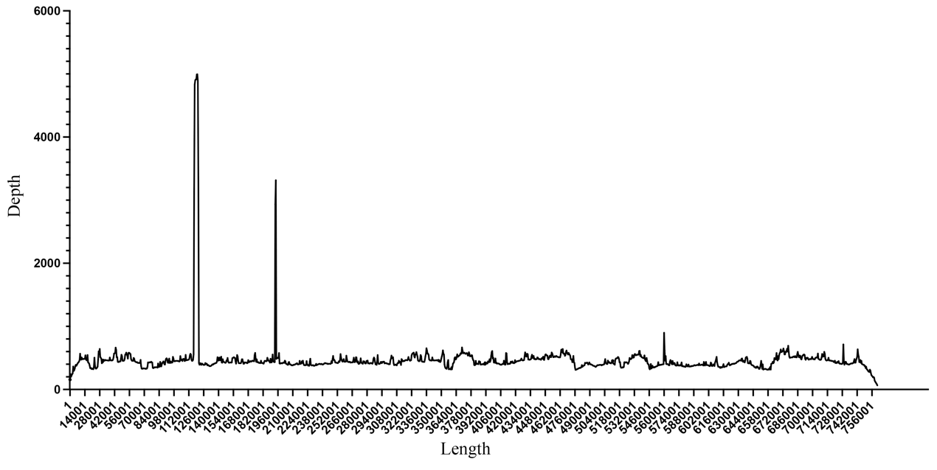
Fig S3. Depth and coverage of R. vialii mitogenome.

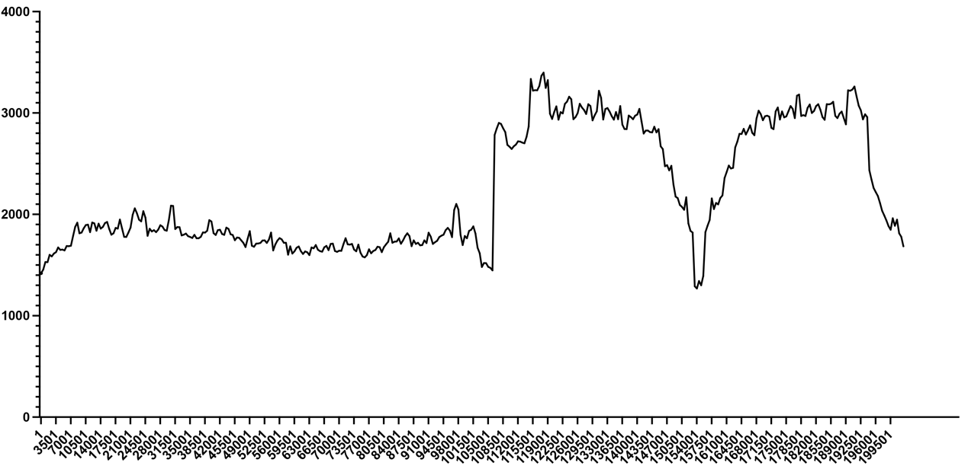
Fig S4. Depth and coverage of R. nivale subsp. boreale plastome.

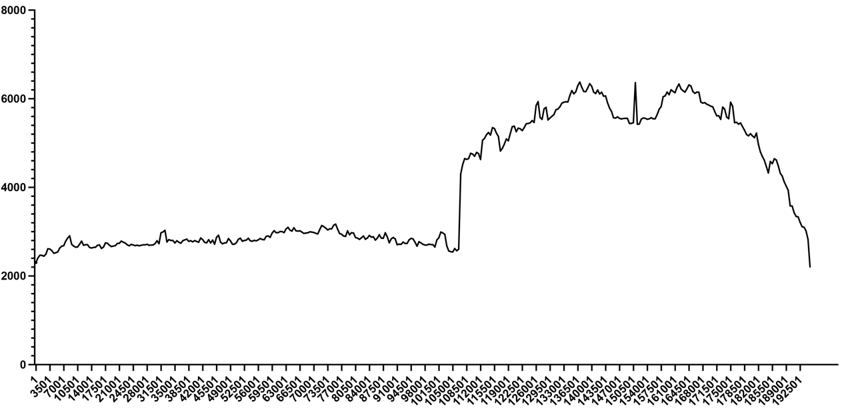
Fig S5. Depth and coverage of R. vialii plastome.

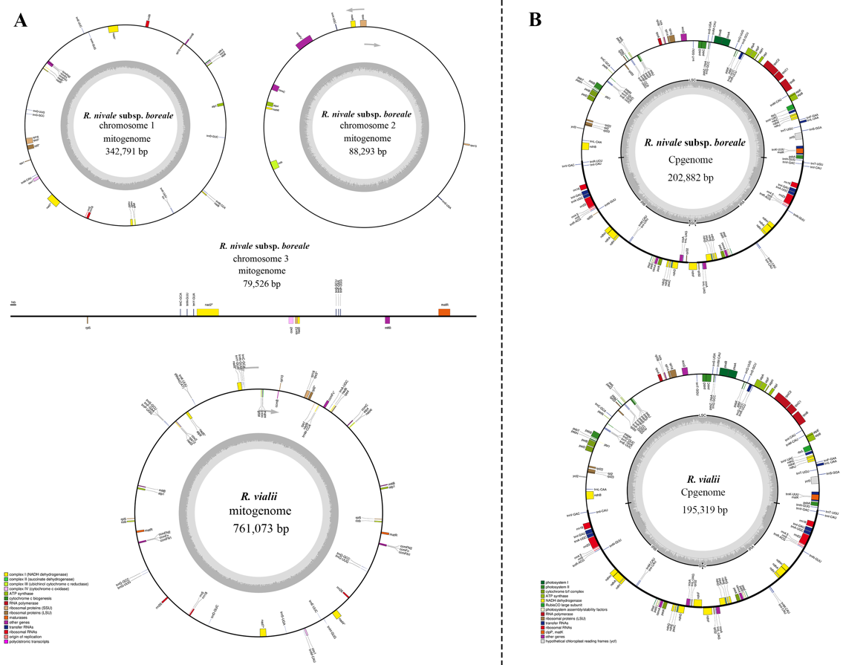
Fig S6. Maps of the R. nivale subsp. boreale and R. vialii organelle genomes. A. The mitogenome of two Rhododendron species; B. The plastome of two Rhododendron species. On the inside and outside of the map, genes are transcribed in clockwise and counterclockwise directions, respectively. The gray circular areas indicate the GC content.

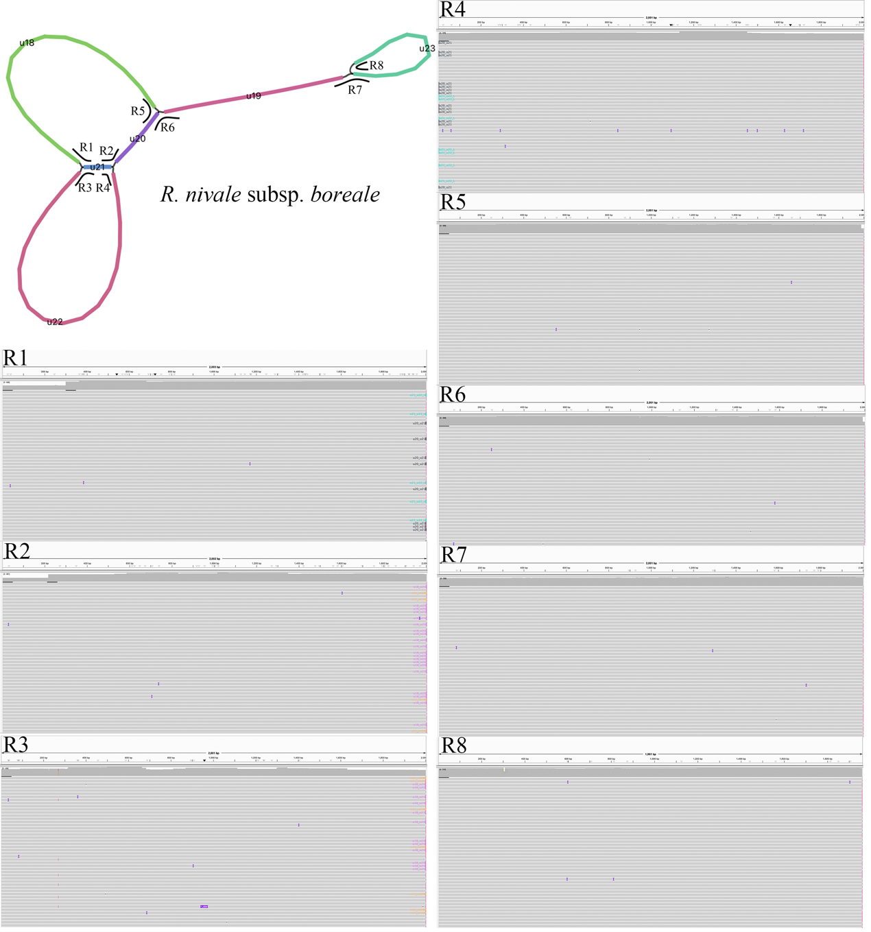
Fig S7. The mapping completeness of eight paths in the mitogenome of R. nivale subsp. boreale. R1-R8 indicate different connection patterns of the paths.

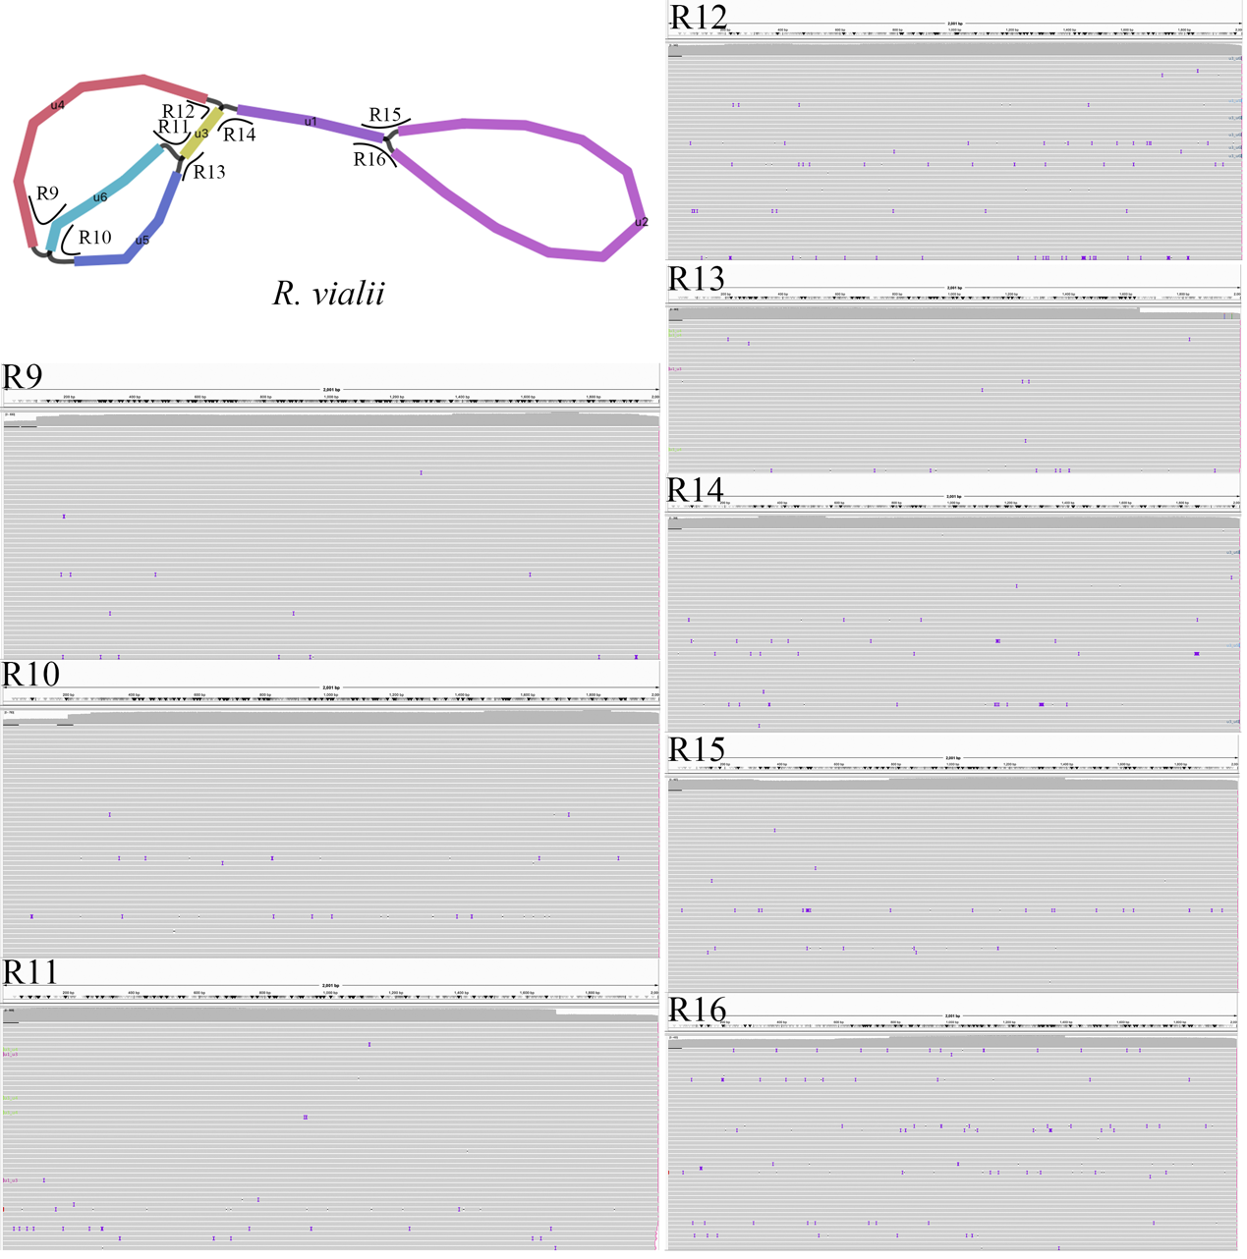
Fig S8. The mapping completeness of eight paths in the mitogenome of R. vialii. R9-R16 indicate different connection patterns of the paths.

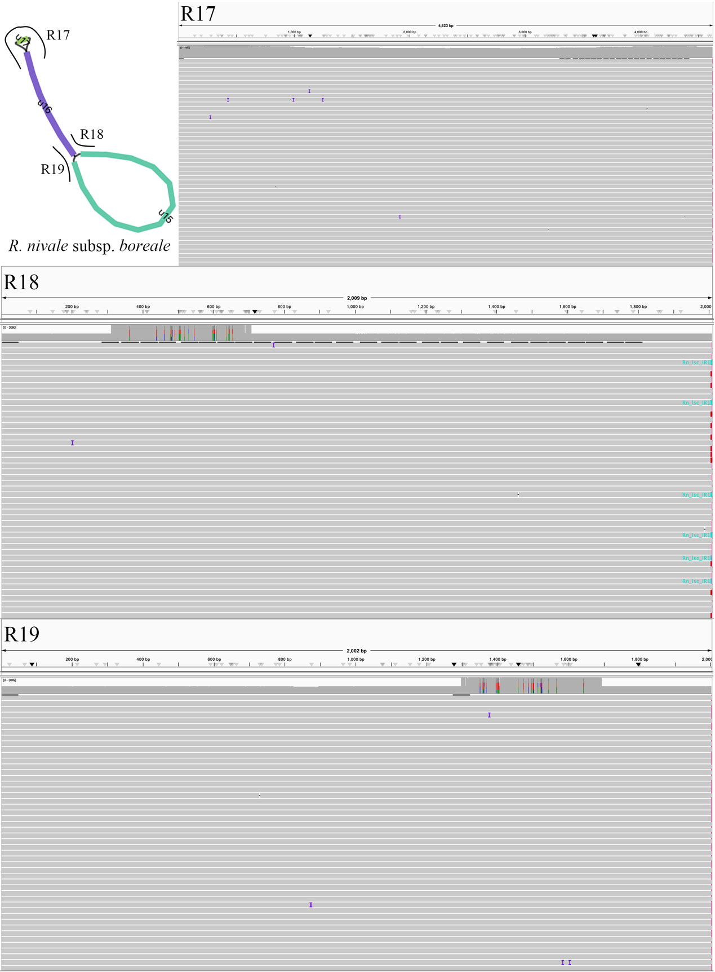
Fig S9. The mapping completeness of three paths in the plastome of R. nivale subsp. boreale. R17-R19 indicate different connection patterns of the paths.

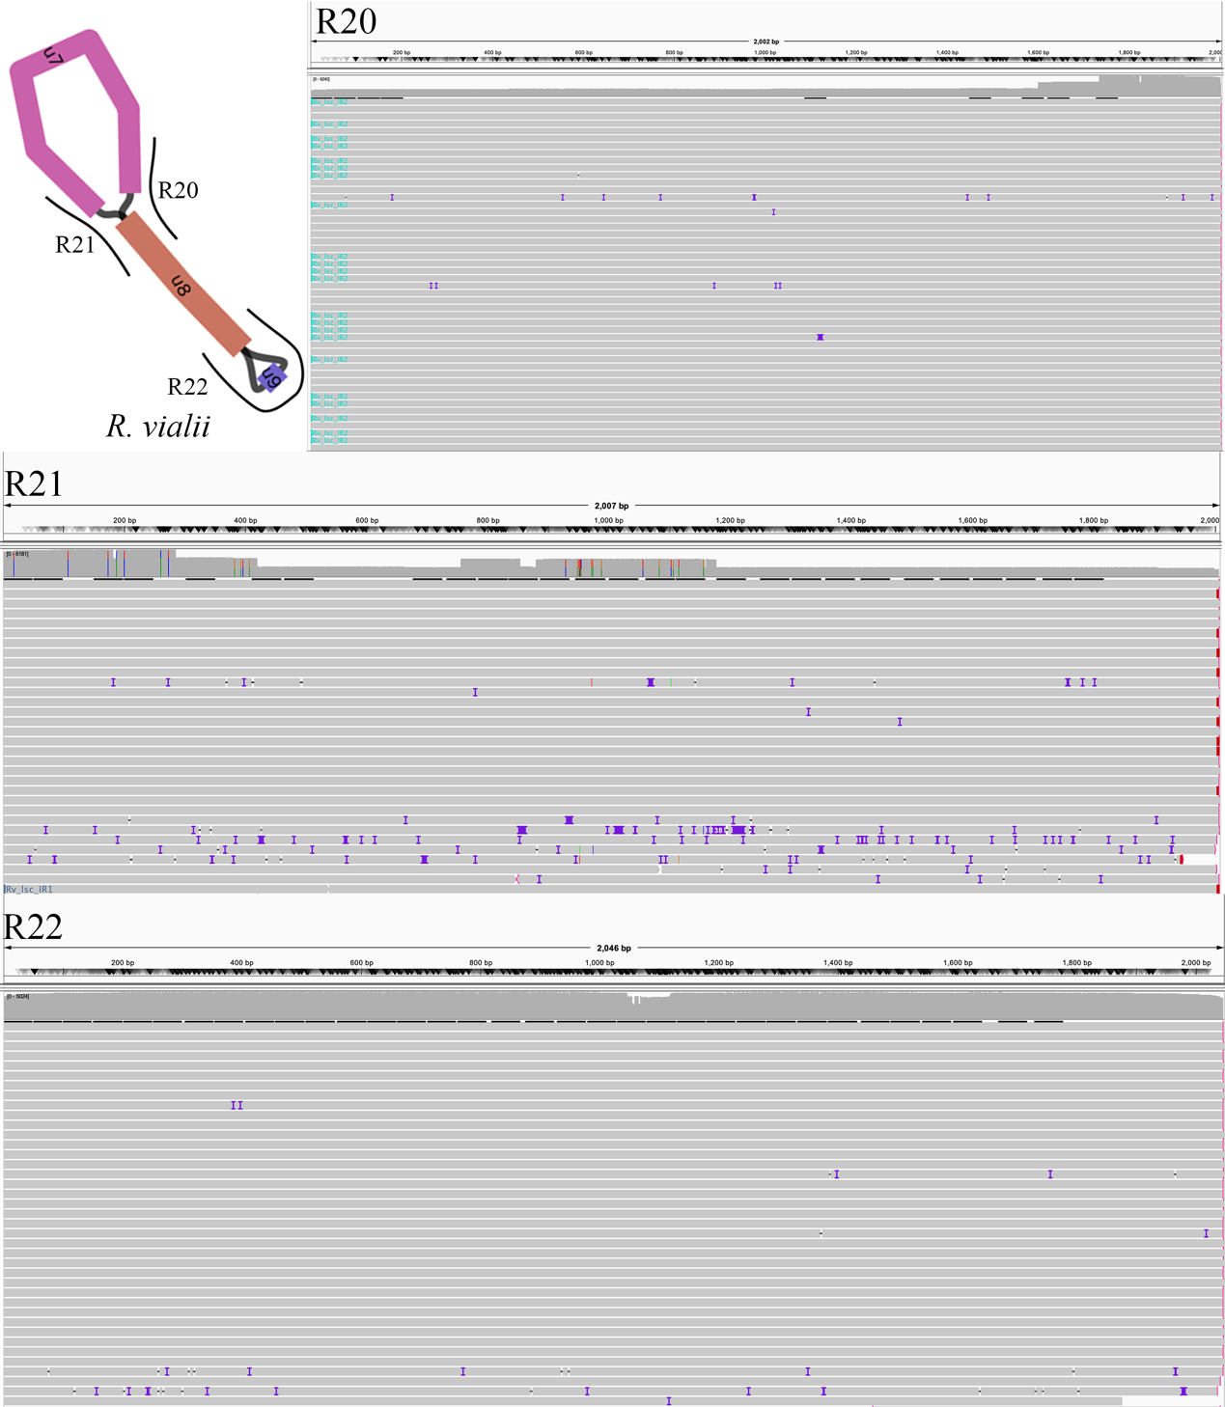
Fig S10. The mapping completeness of three paths in the plastome of R. vialii. R20-R22 indicate different connection patterns of the paths.

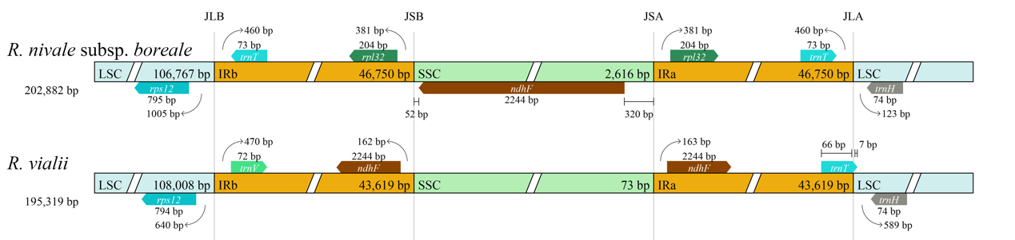
Fig S11. Comparison of the borders of LSC, SSC, and IR regions in R. nivale subsp. boreale and R. vialii. Genes or gene segments are highlighted in colored boxes on both sides of the junctions. The numbers above or below the gene features represent the distances between the gene ends and the junction sites, with arrows indicating the location of the distance.

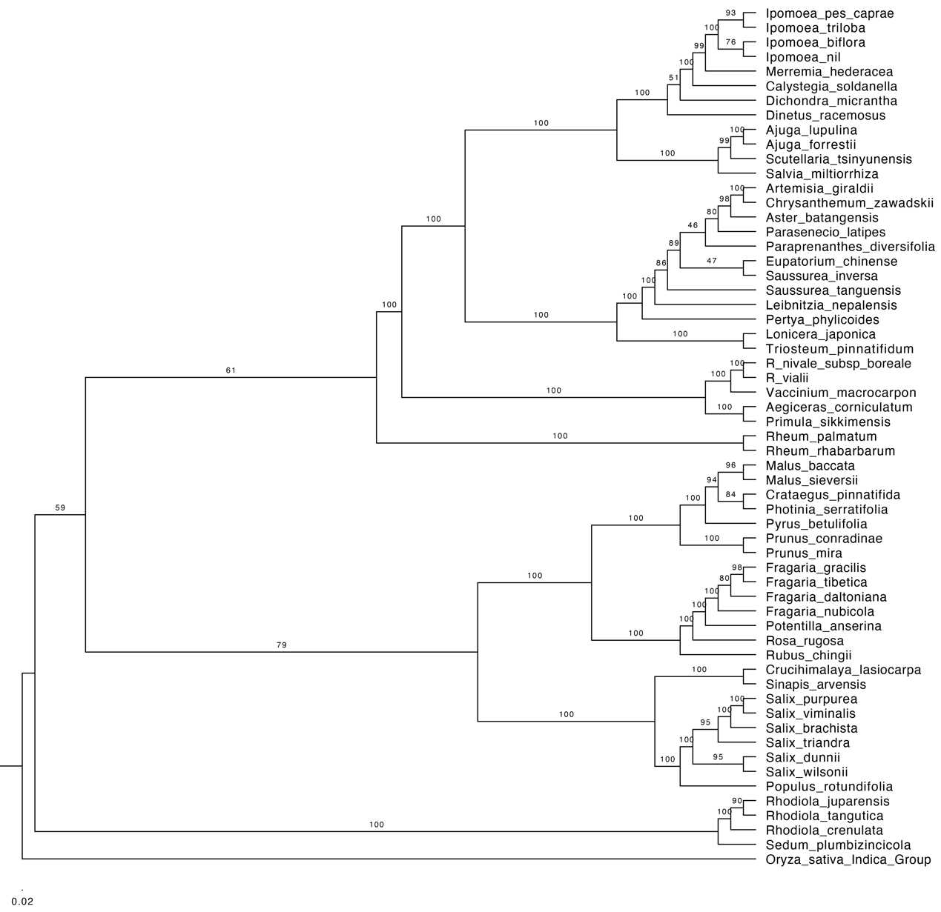
Fig S12. The Maximum Likelihood (ML) tree is based on a concatenation-based analysis of 32 mitogenome genes. The numbers on the branches represent bootstrap support values.

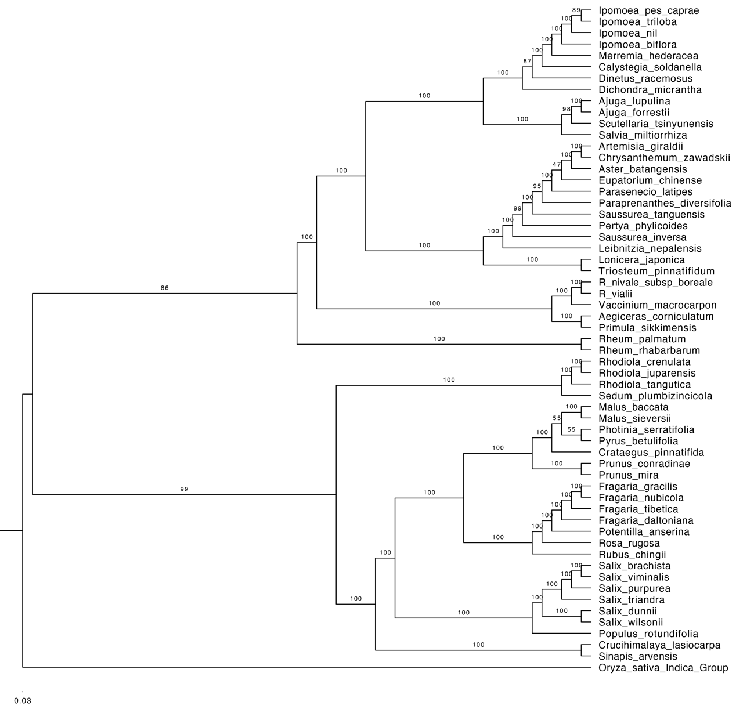
Fig S13. The Maximum Likelihood (ML) tree is based on a concatenation-based analysis of 78 plastome genes. The numbers on the branches represent bootstrap support values.

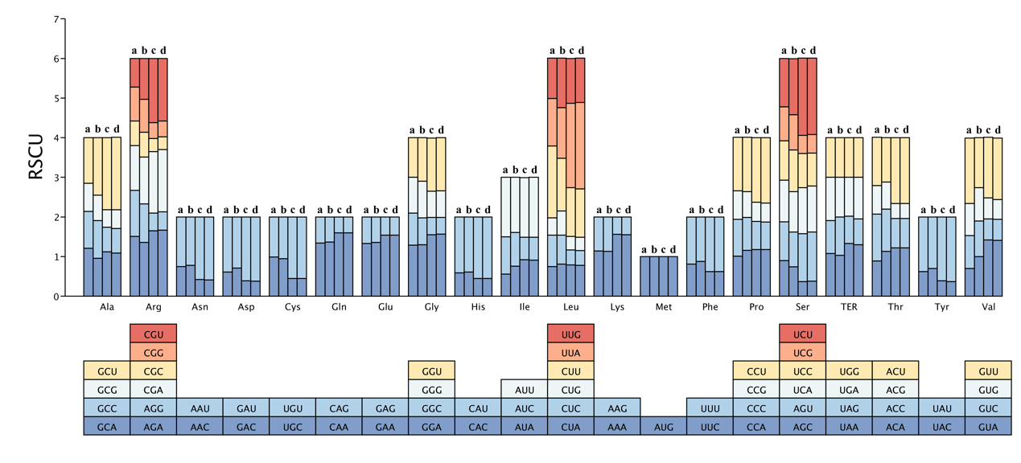
Fig S14. The relative synonymous codon usage (RSCU) preference distribution maps for the mitogenomes and plastomes of R. nivale subsp. boreale and R. vialii. (a) represents the mitogenome of R. nivale subsp. boreale; (b) represents the mitogenome of mitogenome of R. vialii; (c) represents the plastome of R. nivale subsp. boreale; (d) represents the plastome of R. vialii.

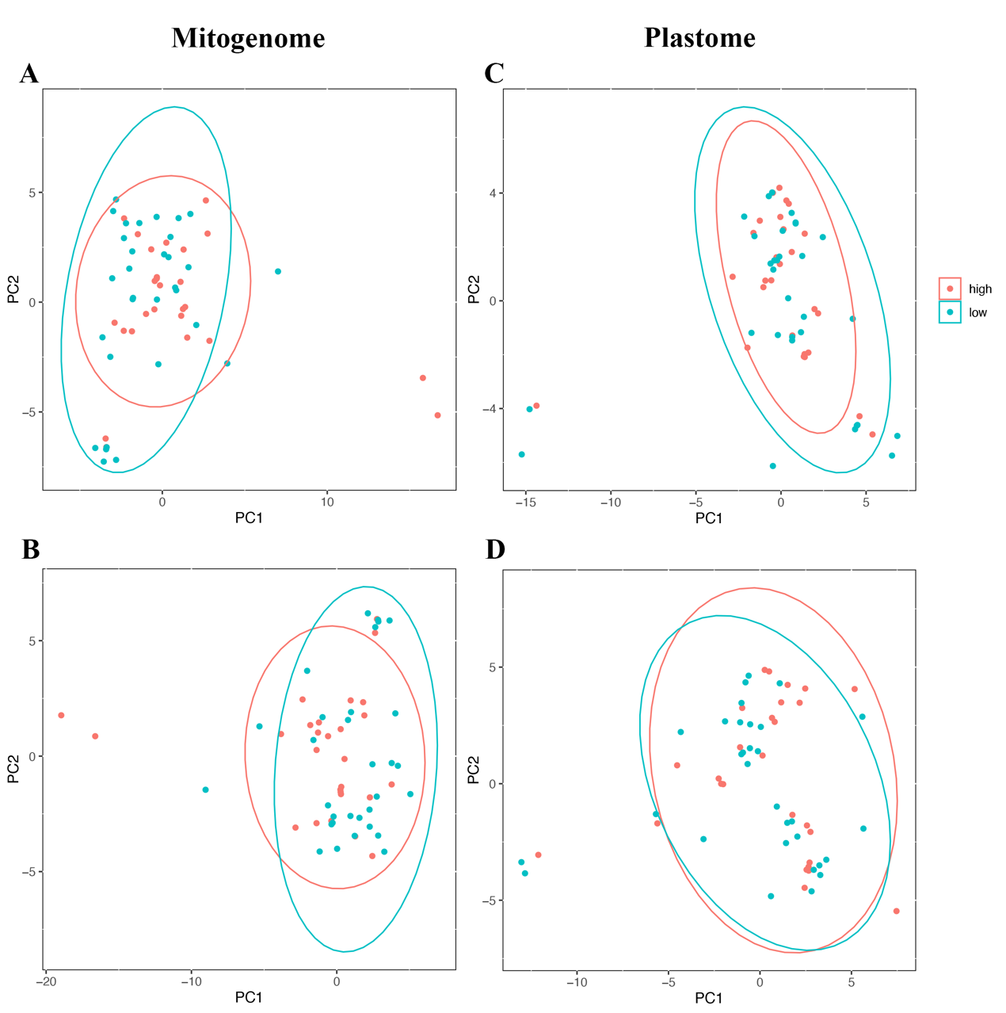
Fig S15. The PCA plots of codon usage frequencies are grouped by altitude. A. The PCA plot based on absolute codon usage frequencies (absCUFs) of mitogenomes. B. The PCA plot based on synonymous codon usage frequencies (synCUFs) of mitogenomes. C. The PCA plot based on absolute codon usage frequencies (absCUFs) of plastomes. D. The PCA plot based on synonymous codon usage frequencies (synCUFs) of plastomes. The red dots represent high-altitude species, and the blue dots represent low-altitude species.

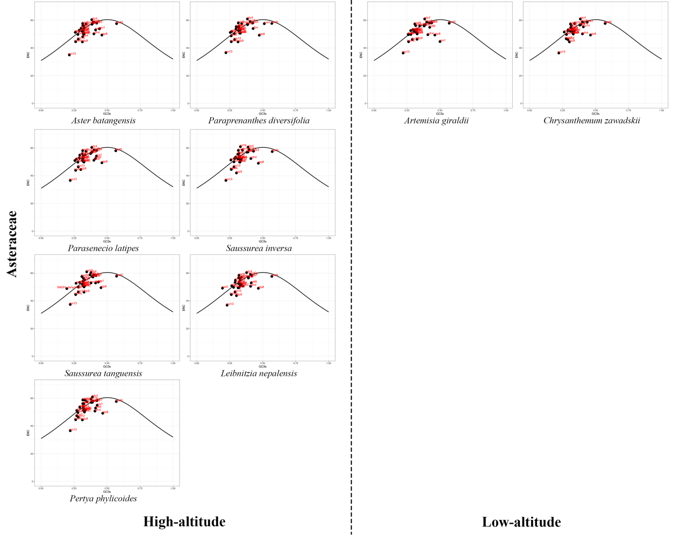
Fig S16. The ENc-plots of Asteraceae species mitogenomes in this study sample. The solid line represents the expected trendline of gene positions given codon usage solely driven by GC3s composition. The black dots represent the protein-coding genes, and the red labels represent the gene names.

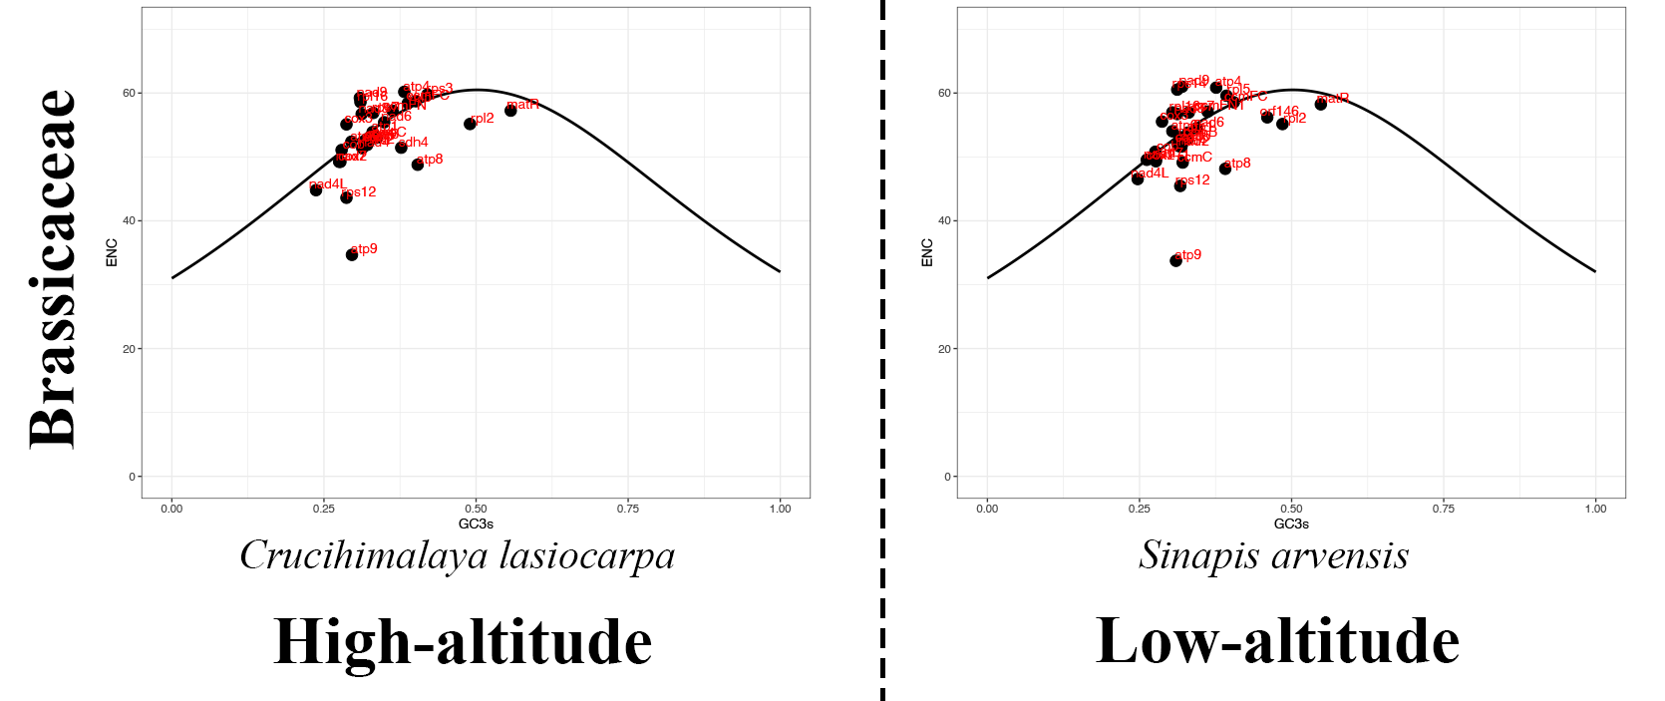
Fig S17. The ENc-plots of Brassicaceae species mitogenomes in this study sample. The solid line represents the expected trendline of gene positions given codon usage solely driven by GC3s composition. The black dots represent the protein-coding genes, and the red labels represent the gene names.

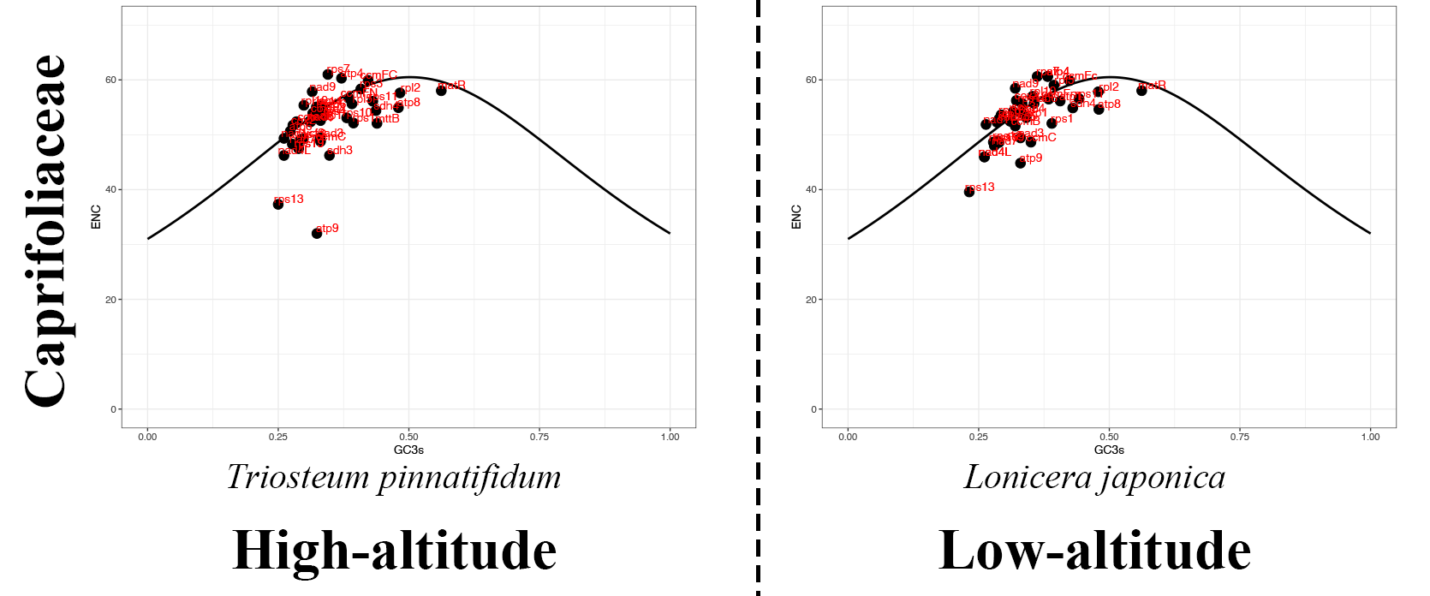
Fig S18. The ENc-plots of Caprifolaceae species mitogenomes in this study sample. The solid line represents the expected trendline of gene positions given codon usage solely driven by GC3s composition. The black dots represent the protein-coding genes, and the red labels represent the gene names.

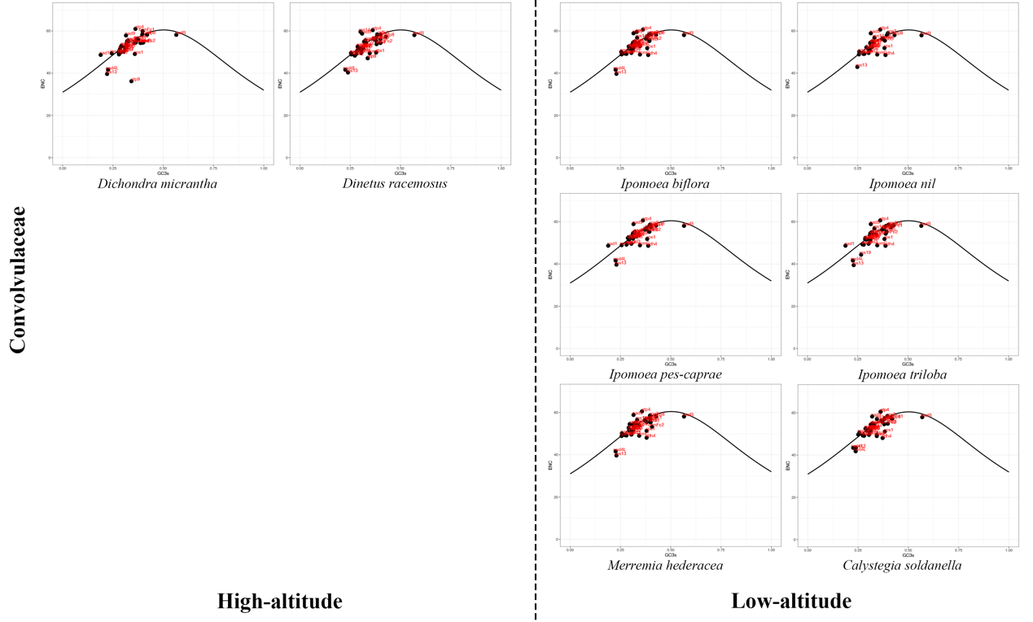
Fig S19. The ENc-plots of Convolvulaceae species mitogenomes in this study sample. The solid line represents the expected trendline of gene positions given codon usage solely driven by GC3s composition. The black dots represent the protein-coding genes, and the red labels represent the gene names.

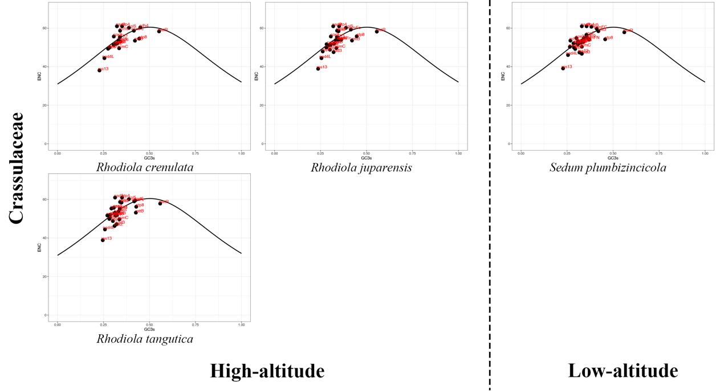
Fig S20. The ENc-plots of Crassulaceae species mitogenomes in this study sample. The solid line represents the expected trendline of gene positions given codon usage solely driven by GC3s composition. The black dots represent the protein-coding genes, and the red labels represent the gene names.

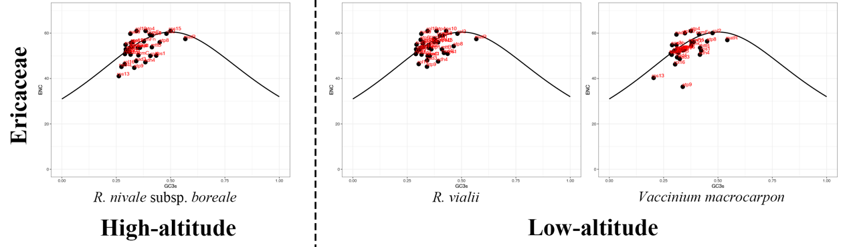
Fig S21. The ENc-plots of Eriaceae species mitogenomes in this study sample. The solid line represents the expected trendline of gene positions given codon usage solely driven by GC3s composition. The black dots represent the protein-coding genes, and the red labels represent the gene names.

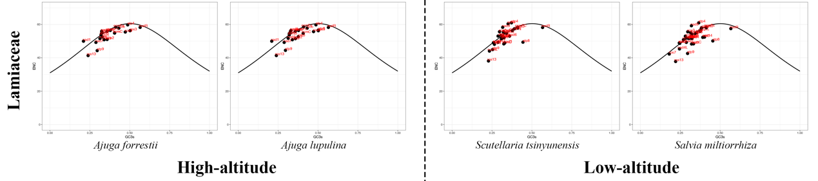
Fig S22. The ENc-plots of Lamiaceae species mitogenomes in this study sample. The solid line represents the expected trendline of gene positions given codon usage solely driven by GC3s composition. The black dots represent the protein-coding genes, and the red labels represent the gene names.

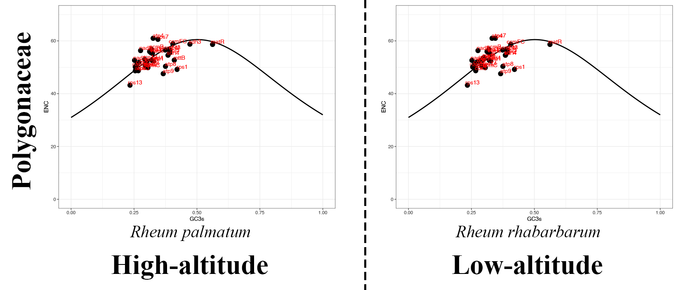
Fig S23. The ENc-plots of Polygonaceae species mitogenomes in this study sample. The solid line represents the expected trendline of gene positions given codon usage solely driven by GC3s composition. The black dots represent the protein-coding genes, and the red labels represent the gene names.

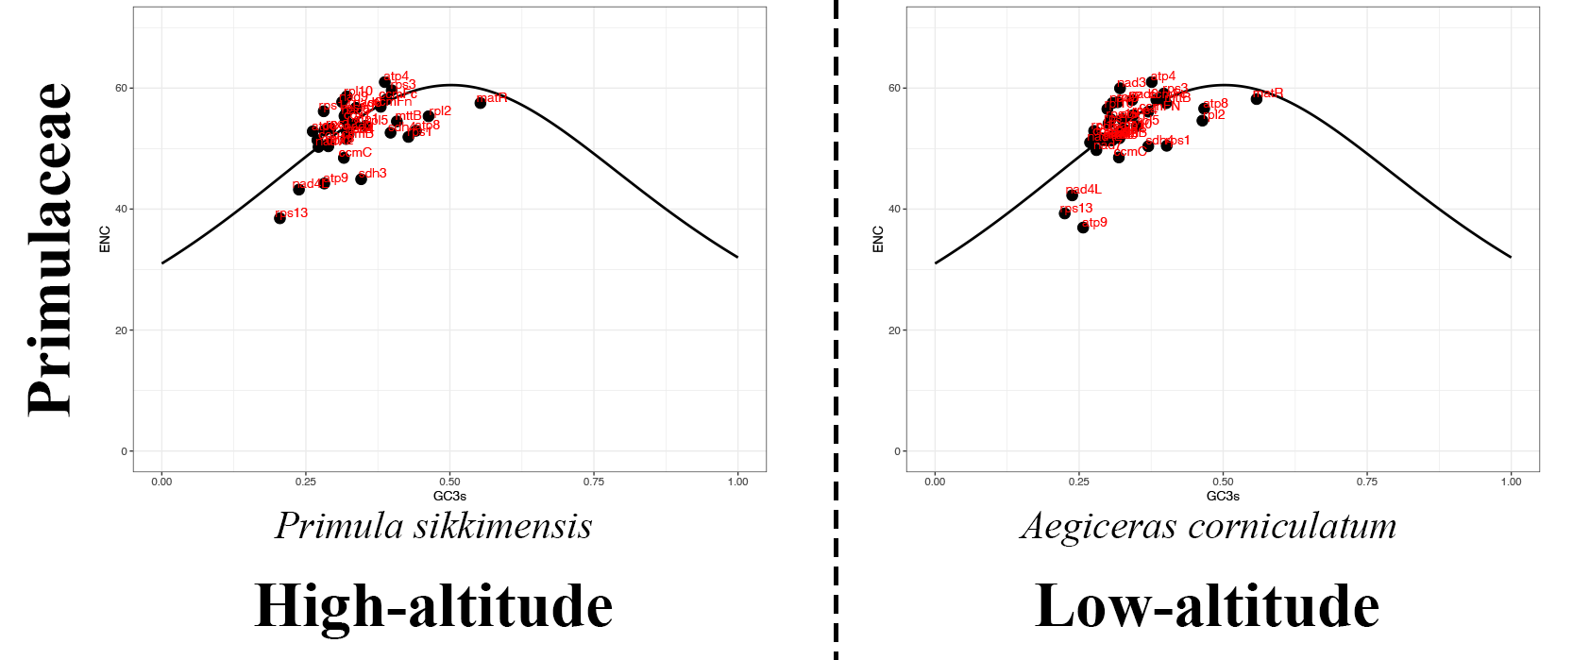
Fig S24. The ENc-plots of Primulaceae species mitogenomes in this study sample. The solid line represents the expected trendline of gene positions given codon usage solely driven by GC3s composition. The black dots represent the protein-coding genes, and the red labels represent the gene names.

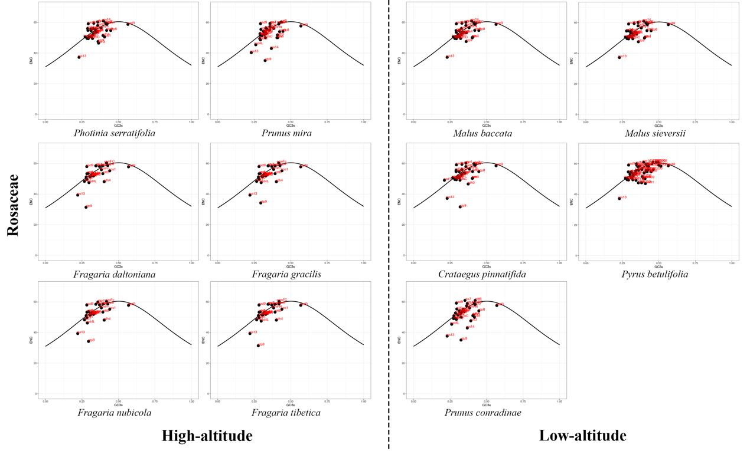
Fig S25. The ENc-plots of Rosaceae species mitogenomes in this study sample. The solid line represents the expected trendline of gene positions given codon usage solely driven by GC3s composition. The black dots represent the protein-coding genes, and the red labels represent the gene names.

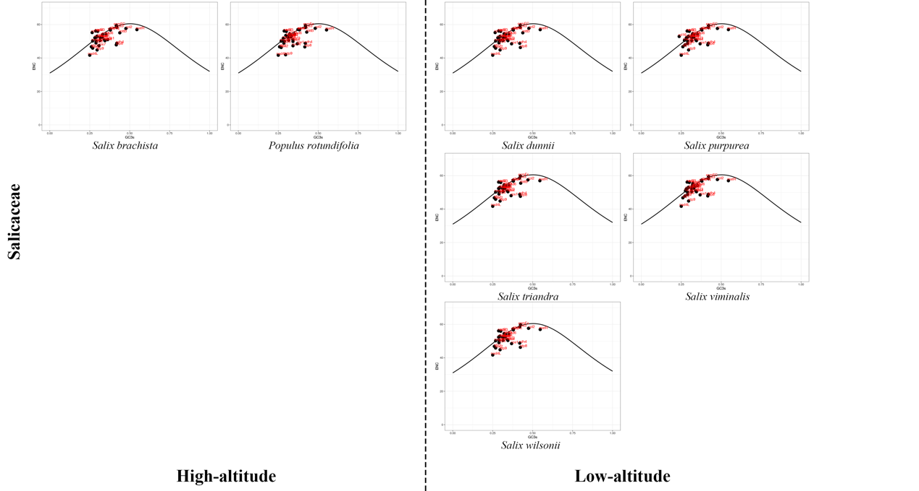
Fig S26. The ENc-plots of Saliaceae species mitogenomes in this study sample. The solid line represents the expected trendline of gene positions given codon usage solely driven by GC3s composition. The black dots represent the protein-coding genes, and the red labels represent the gene names.

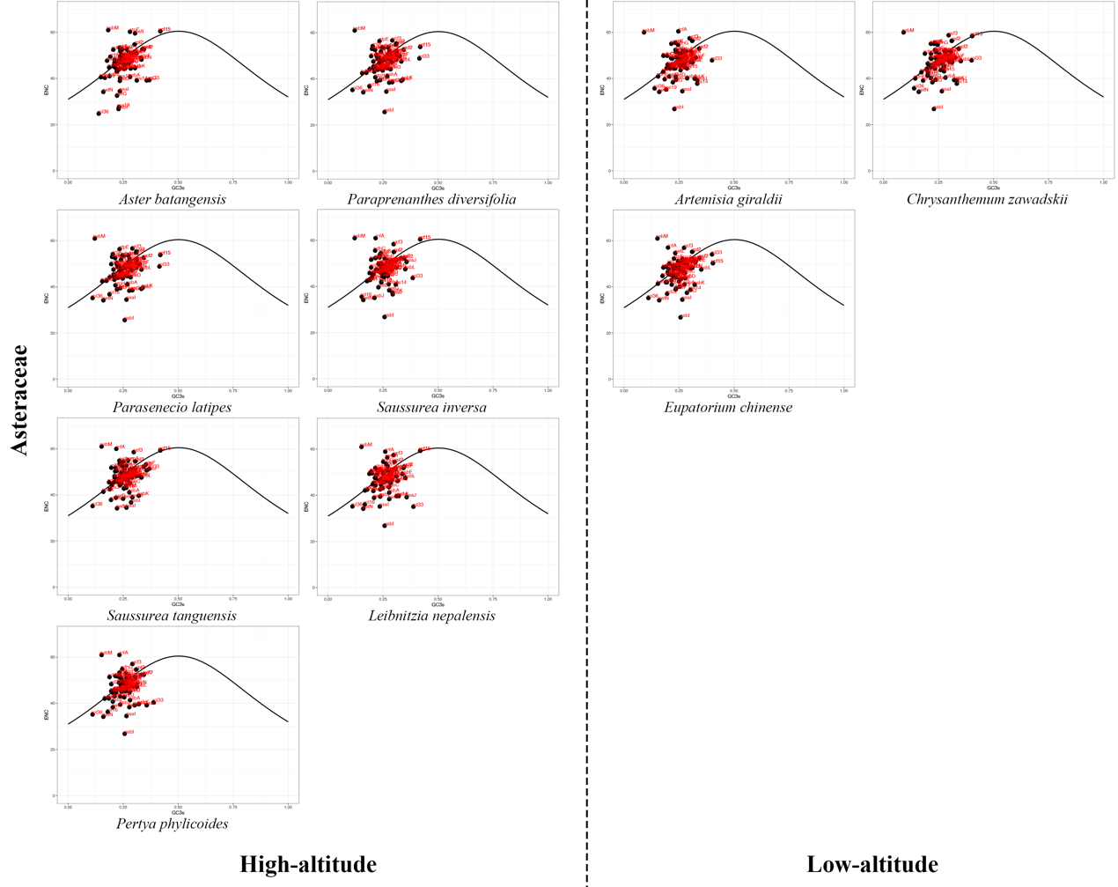
Fig S27. The ENc-plots of Asteraceae species plastomes in this study sample. The solid line represents the expected trendline of gene positions given codon usage solely driven by GC3s composition. The black dots represent the protein-coding genes, and the red labels represent the gene names.

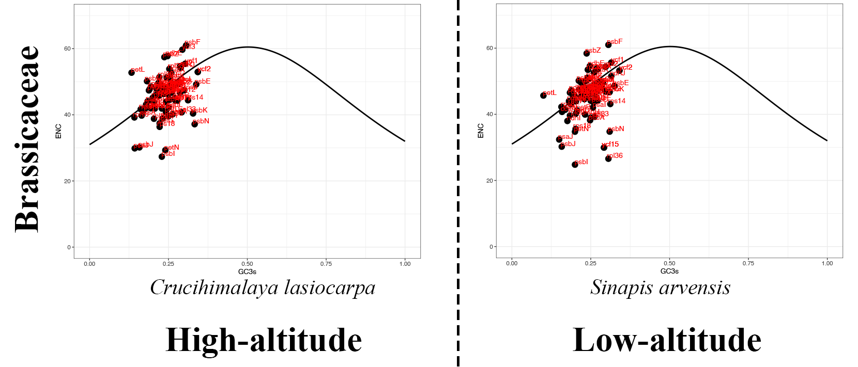
Fig S28. The ENc-plots of Brassicaceae species plastomes in this study sample. The solid line represents the expected trendline of gene positions given codon usage solely driven by GC3s composition. The black dots represent the protein-coding genes, and the red labels represent the gene names.

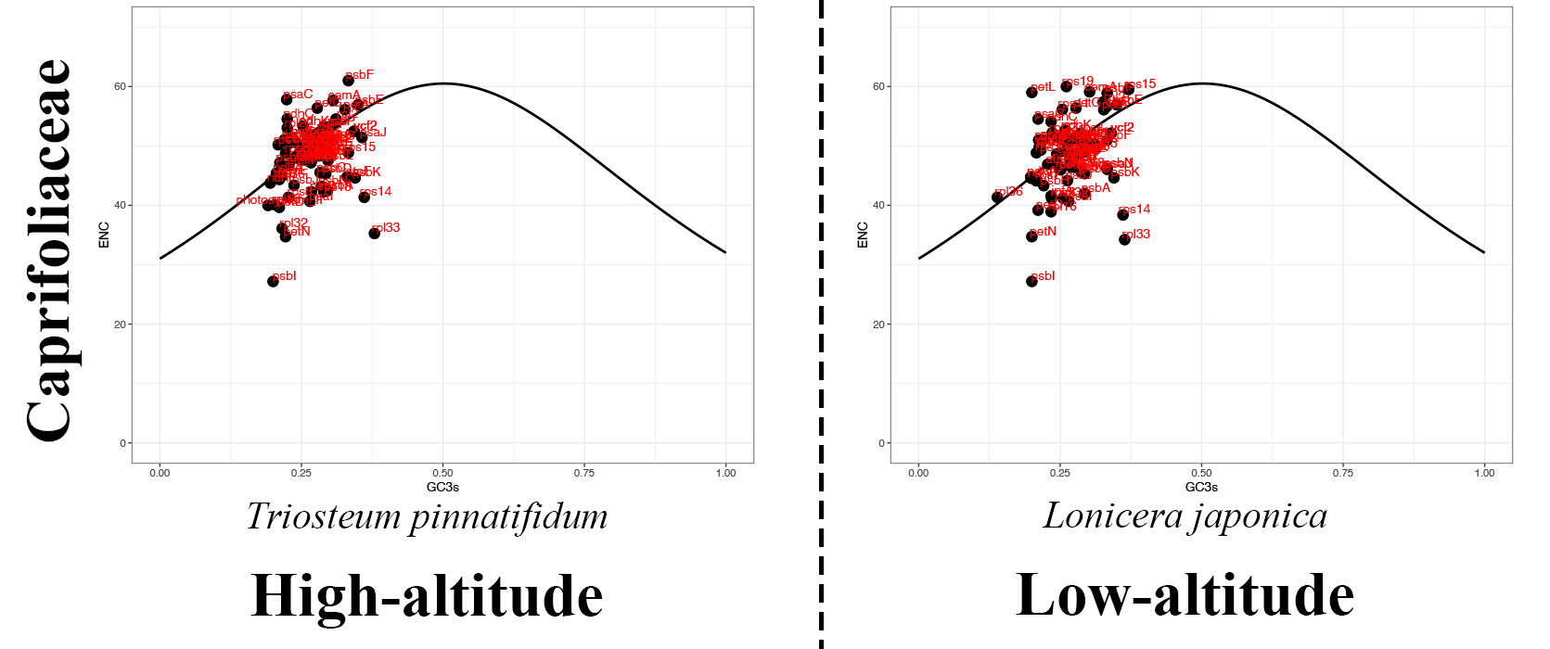
Fig S29. The ENc-plots of Caprifolaceae species plastomes in this study sample. The solid line represents the expected trendline of gene positions given codon usage solely driven by GC3s composition. The black dots represent the protein-coding genes, and the red labels represent the gene names.

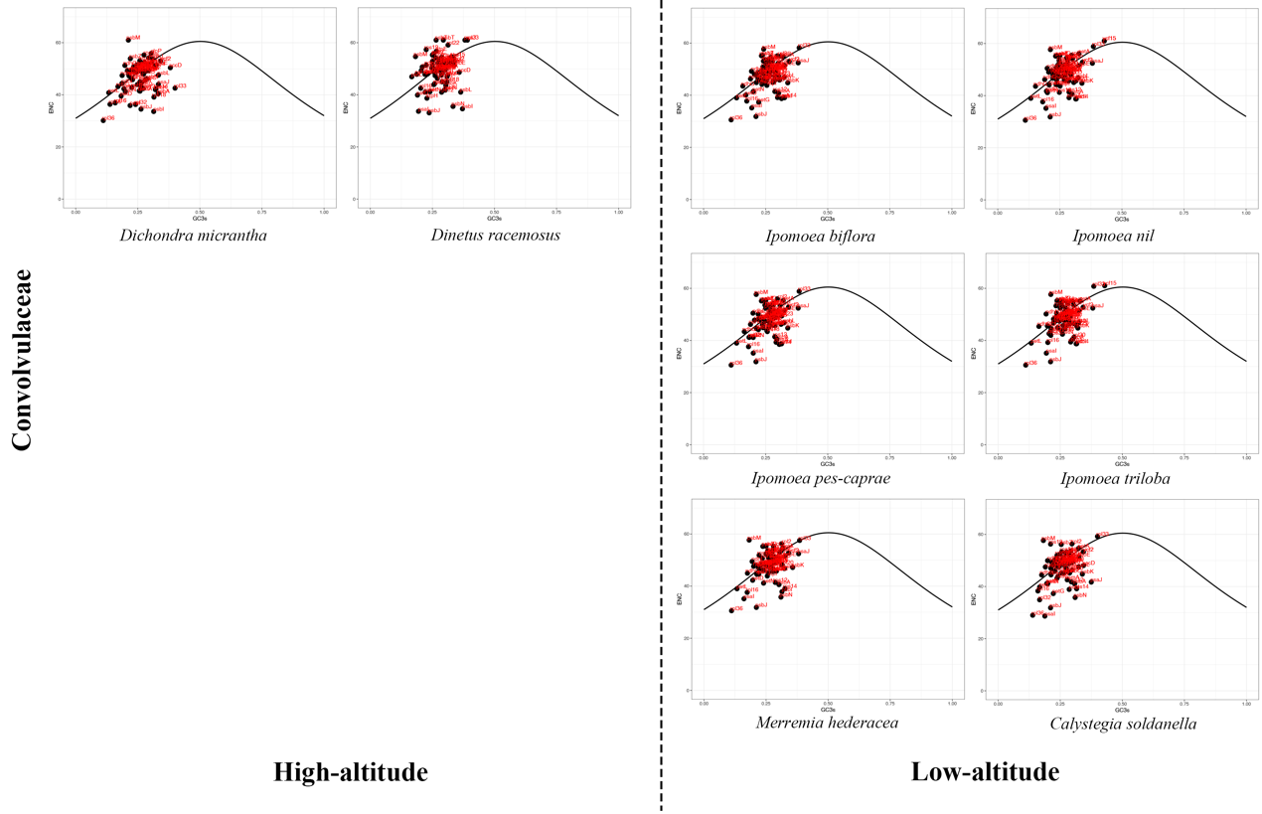
Fig S30. The ENc-plots of Convolvulaceae species plastomes in this study sample. The solid line represents the expected trendline of gene positions given codon usage solely driven by GC3s composition. The black dots represent the protein-coding genes, and the red labels represent the gene names.

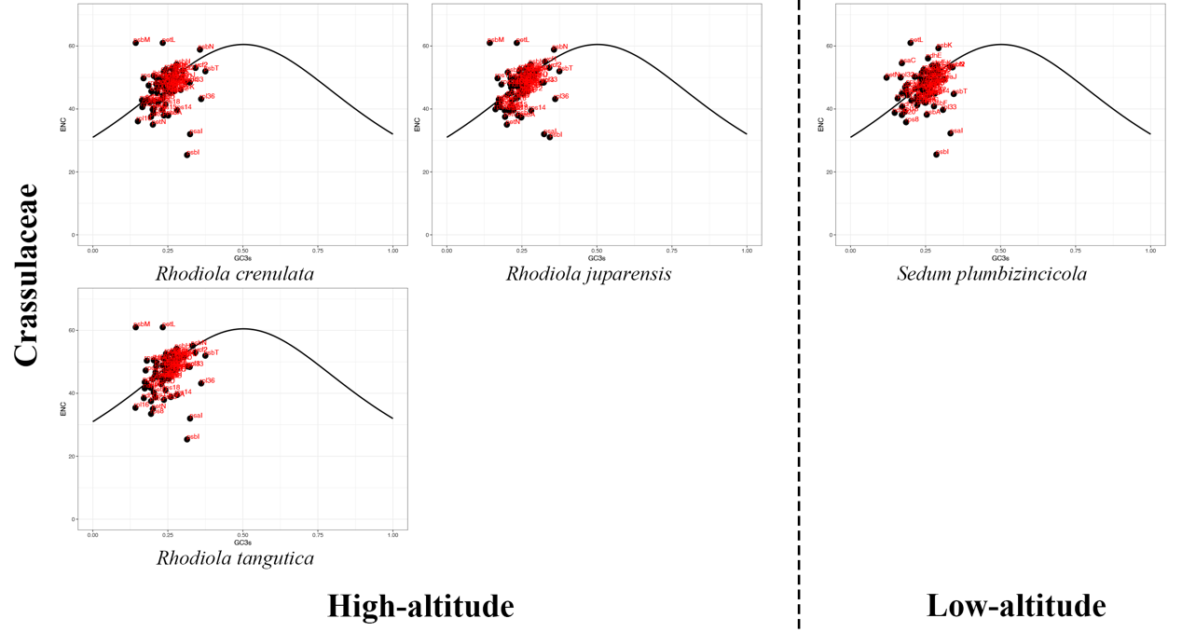
Fig S31. The ENc-plots of Crassulaceae species plastomes in this study sample. The solid line represents the expected trendline of gene positions given codon usage solely driven by GC3s composition. The black dots represent the protein-coding genes, and the red labels represent the gene names.

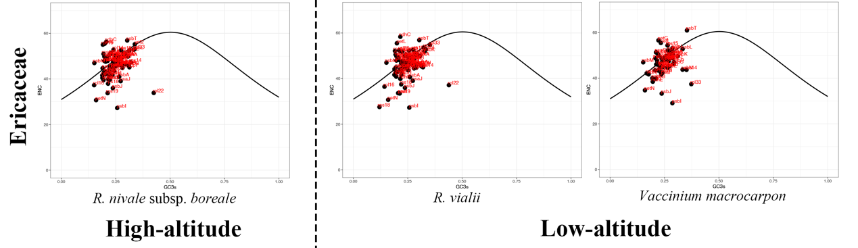
Fig S32. The ENc-plots of Eriaceae species plastomes in this study sample. The solid line represents the expected trendline of gene positions given codon usage solely driven by GC3s composition. The black dots represent the protein-coding genes, and the red labels represent the gene names.

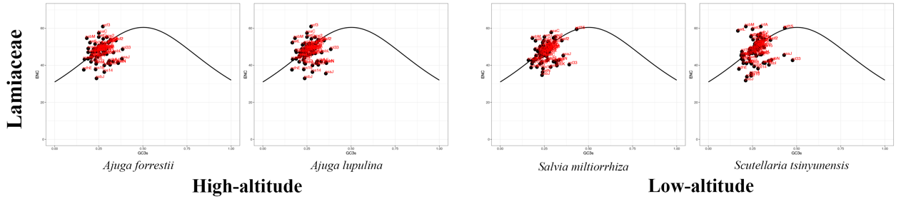
Fig S33. The ENc-plots of Lamiaceae species plastomes in this study sample. The solid line represents the expected trendline of gene positions given codon usage solely driven by GC3s composition. The black dots represent the protein-coding genes, and the red labels represent the gene names.

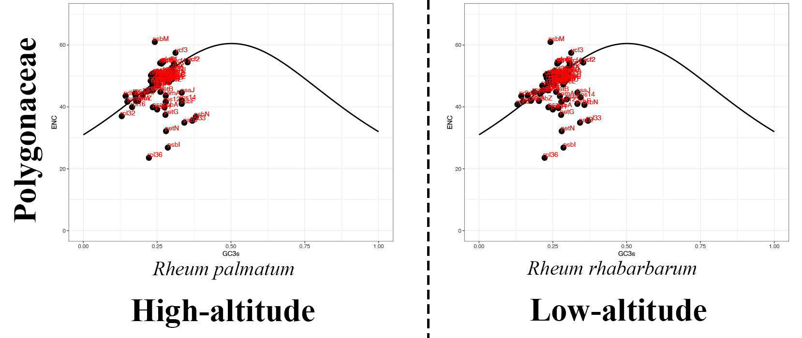
Fig S34. The ENc-plots of Polygonaceae species plastomes in this study sample. The solid line represents the expected trendline of gene positions given codon usage solely driven by GC3s composition. The black dots represent the protein-coding genes, and the red labels represent the gene names.

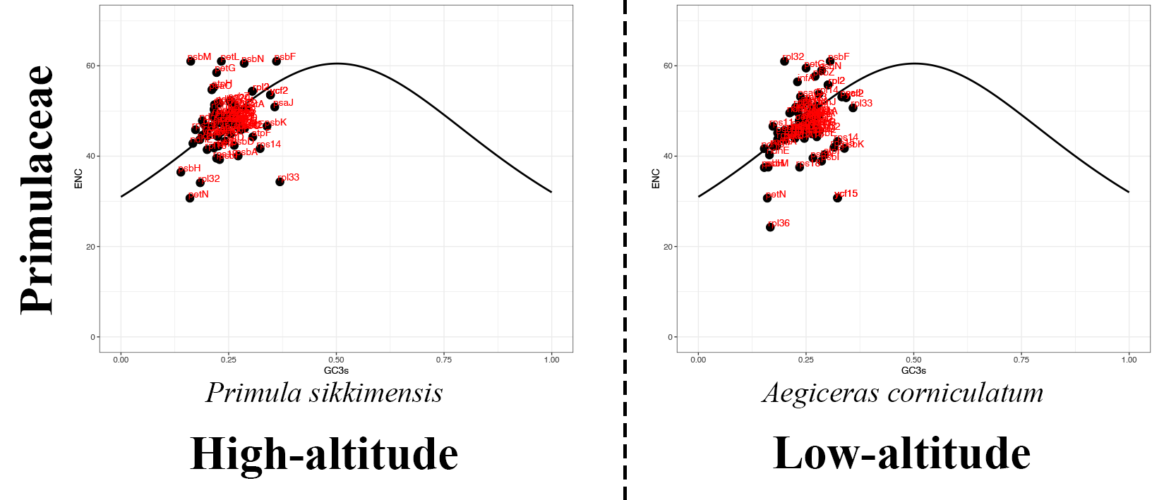
Fig S35. The ENc-plots of Primulaceae species plastomes in this study sample. The solid line represents the expected trendline of gene positions given codon usage solely driven by GC3s composition. The black dots represent the protein-coding genes, and the red labels represent the gene names.

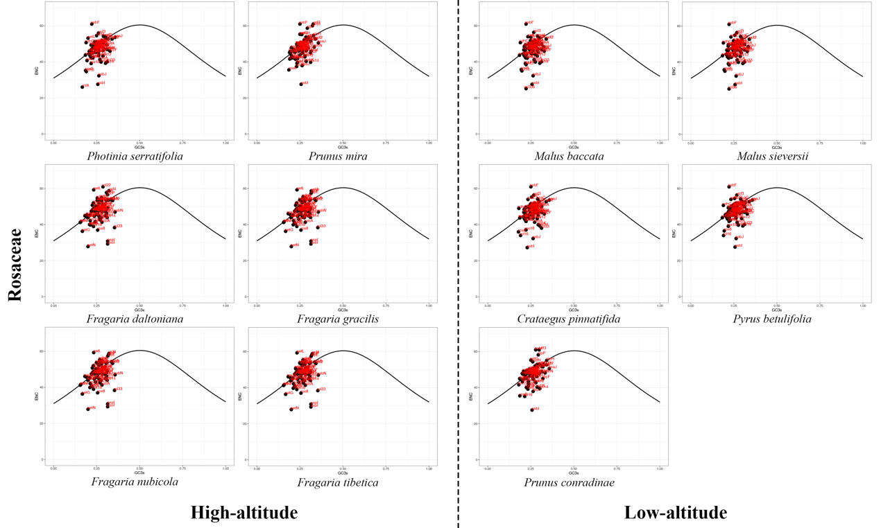
Fig S36. The ENc-plots of Rosaceae species plastomes in this study sample. The solid line represents the expected trendline of gene positions given codon usage solely driven by GC3s composition. The black dots represent the protein-coding genes, and the red labels represent the gene names.

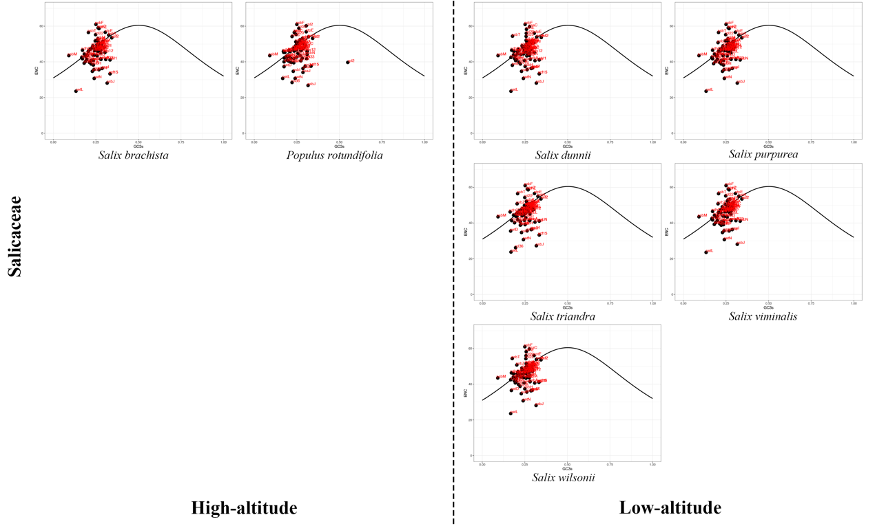
Fig S37. The ENc-plots of Saliaceae species plastomes in this study sample. The solid line represents the expected trendline of gene positions given codon usage solely driven by GC3s composition. The black dots represent the protein-coding genes, and the red labels represent the gene names.

