Supplementary Figures 1–5
Supplementary Figures 1
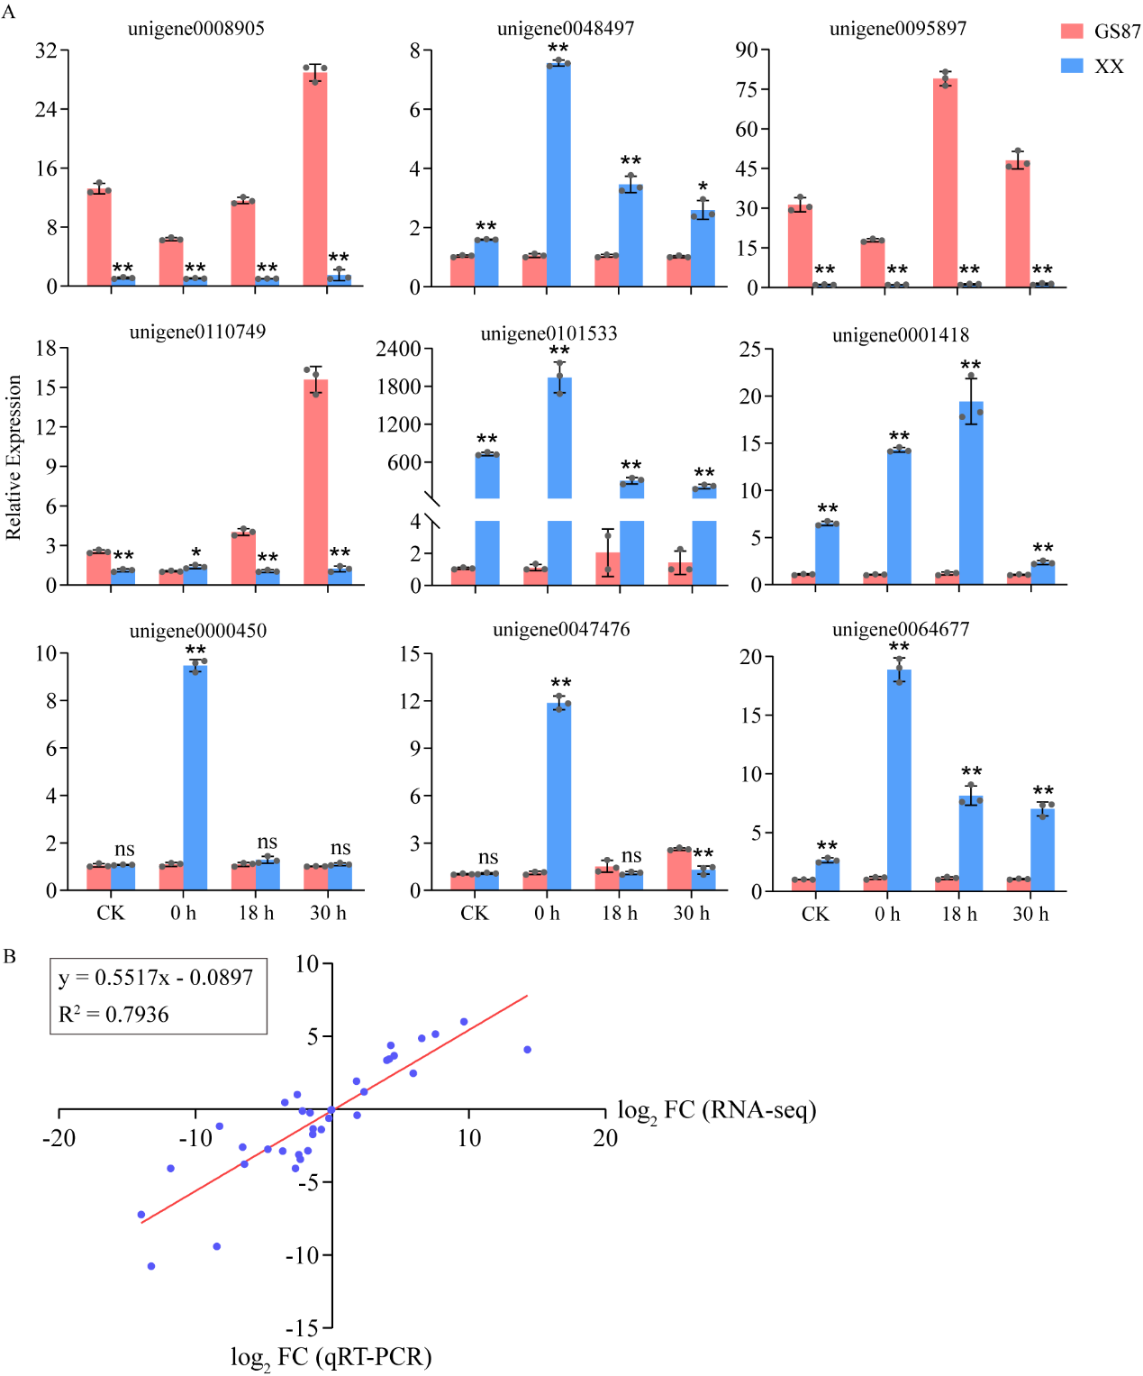
Fig. S1. Validation of RNA-seq data using RT-qPCR. (A) The relative expressions of nine unigenes in the GS87 and XX samples at CK, 0, 18, and 30 hpi. R genes, unigene0095897, unigene0110749, unigene0101533, and unigene0001418; Pathogenesis-related (PR) genes, unigene0064677 and unigene0000450; WRKY genes, unigene0008905 and unigene0048497, Phenylalanine ammonia-lyase-like (PAL) gene, unigene0047476. The β-actin gene of sweetpotato served as the internal control gene. Data is the mean ± SD (n = 3). **P < 0.01; 0.01 < *P < 0.05; ns: statistically nonsignificant. (B) The linear regression model described the linear relationship between results of RNA-seq and RT-qPCR, with log₂FC determined in RNA-seq and by RT-qPCR in x- and y- axes respectively.

Supplementary Figures 2:
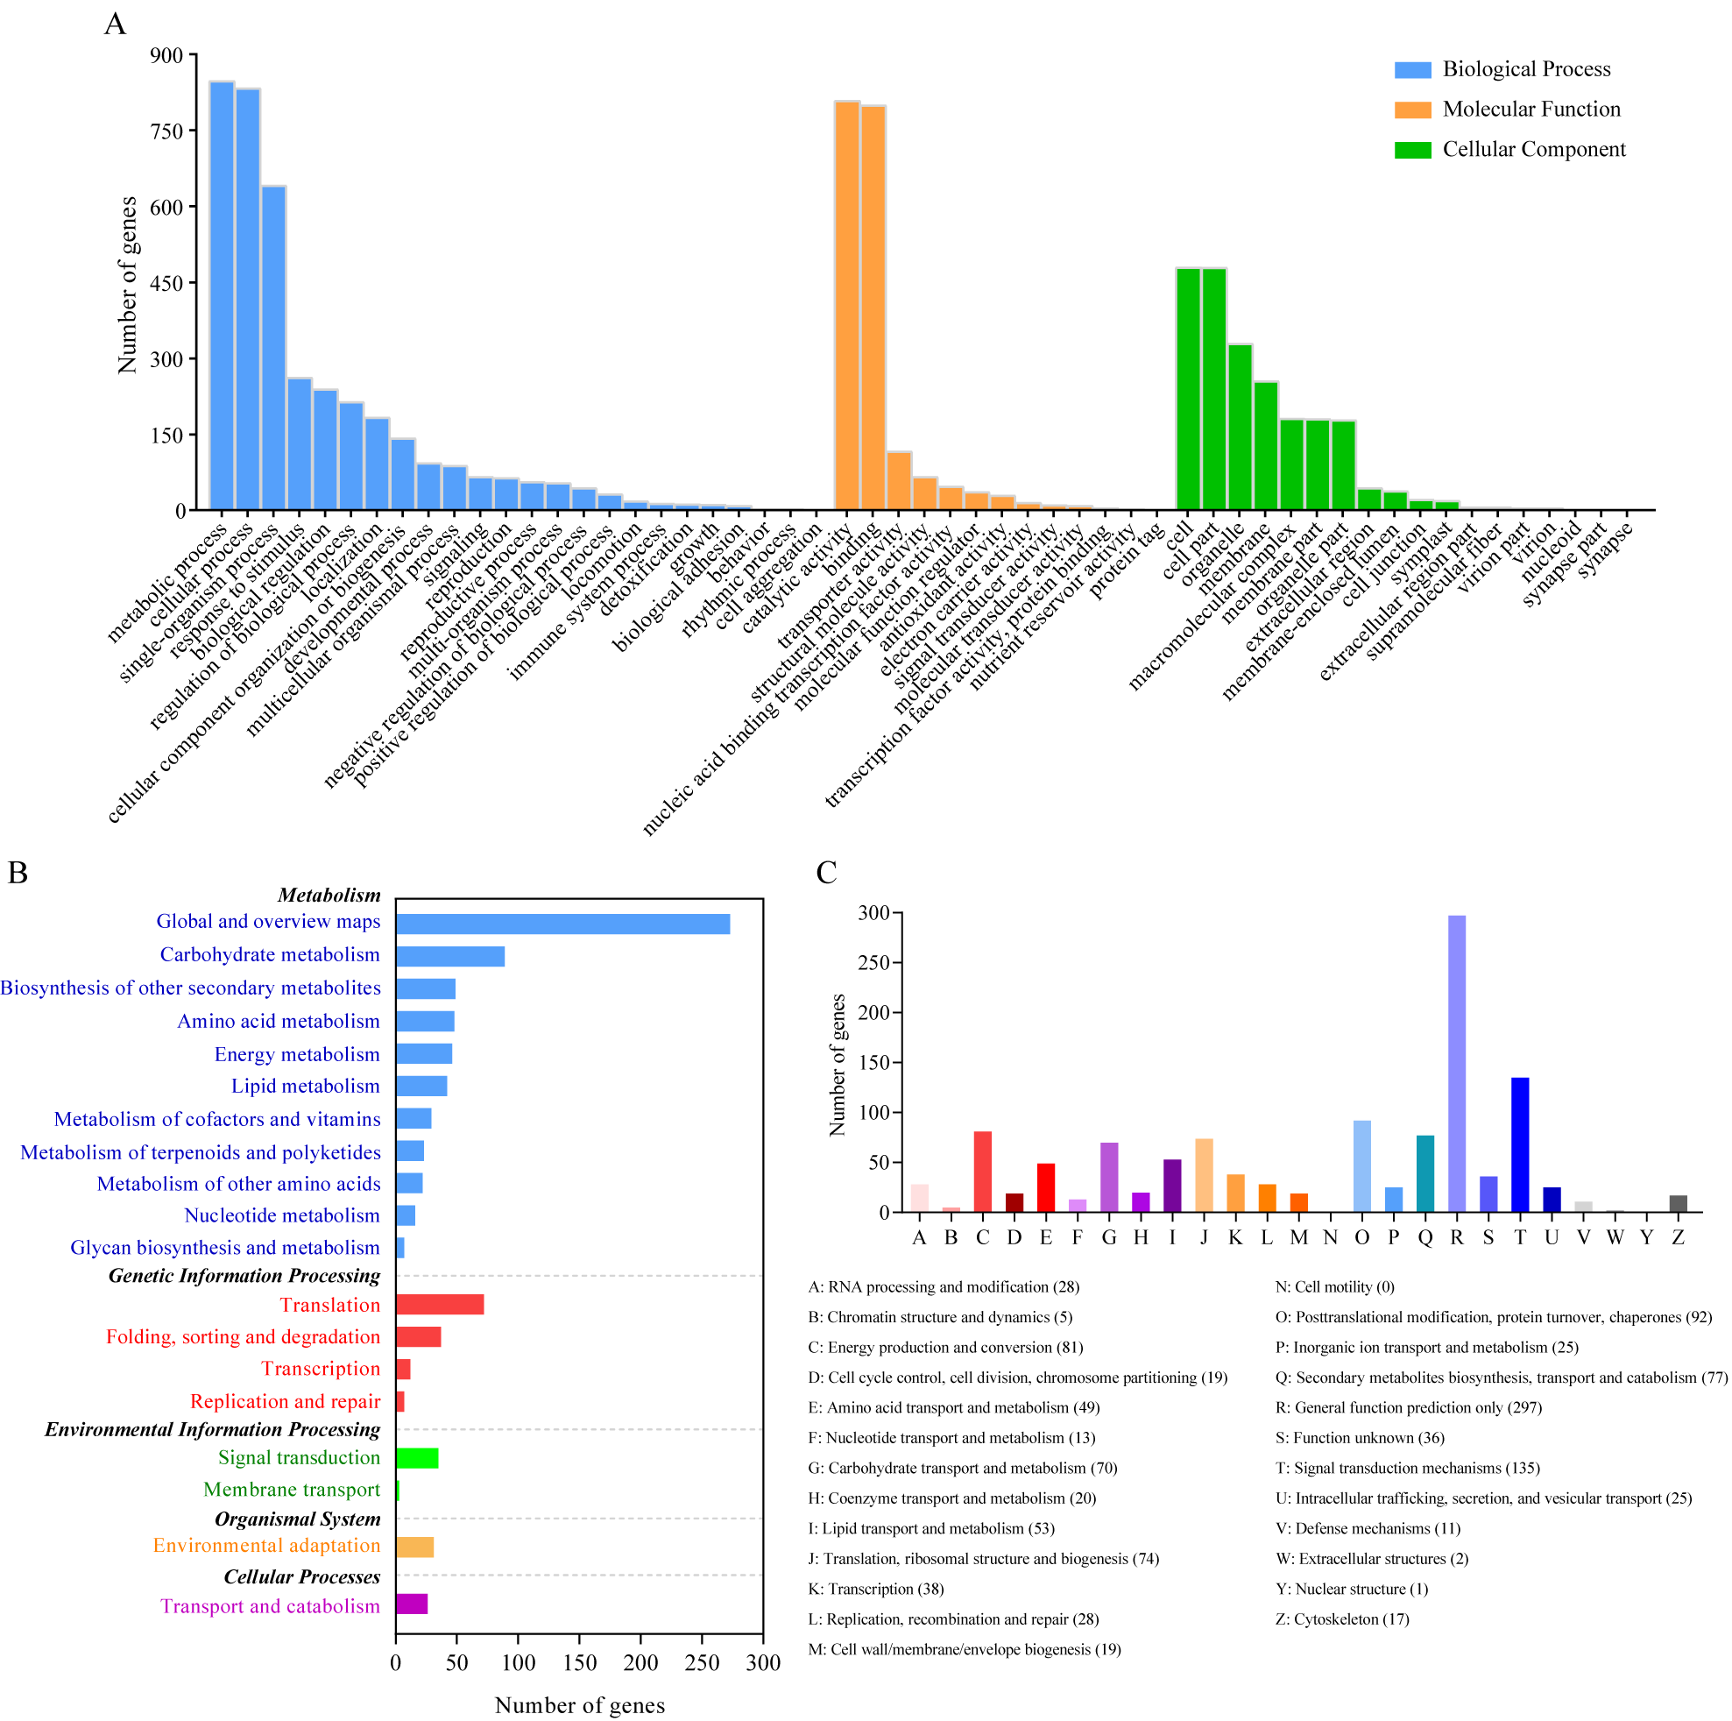
Fig. S2. Functional annotation of the 2294 DEGs shared between GS87 and XX at 0, 18, and 30 hpi. a A total of 1,990 DEGs endowed with 55 GO terms (level 2). b A total of 451 DEGs enriched in 19 KEGG pathways. c A total of 1,015 DEGs classified into 25 KOG classes.
Supplementary Figures 3:
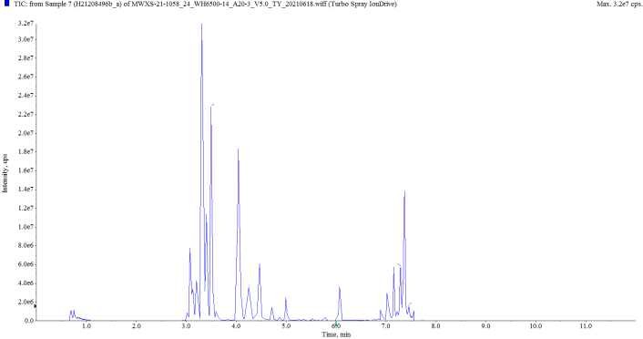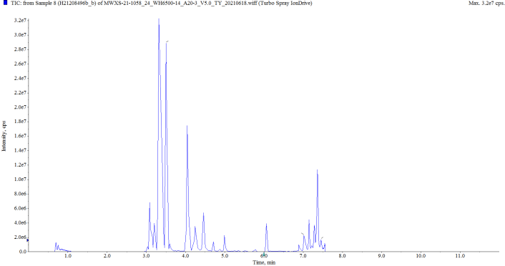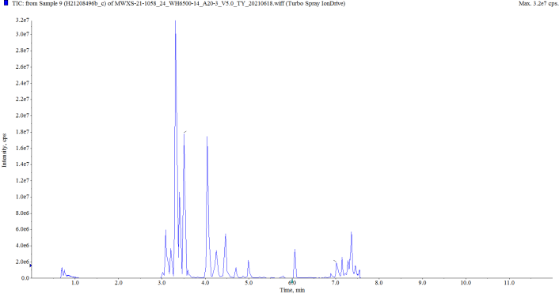
CK-GS87-1
CK-GS87-3
CK-GS87-2
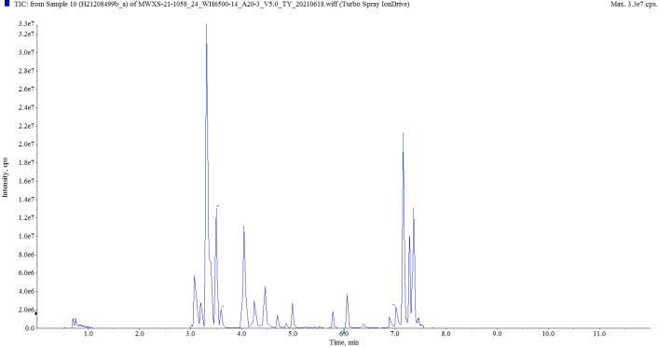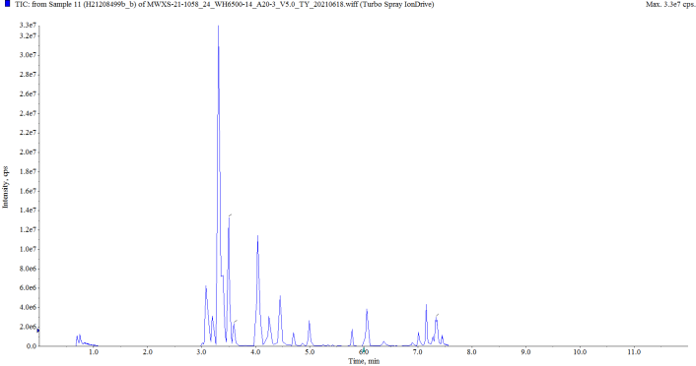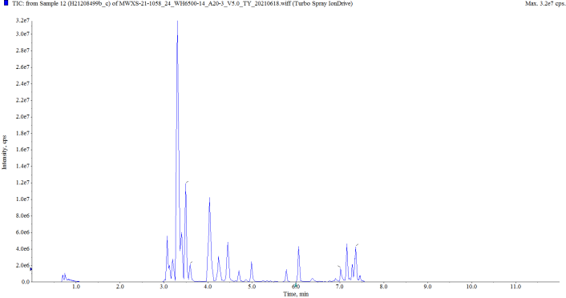
T0-GS87-1
T0-GS87-2
T0-GS87-3
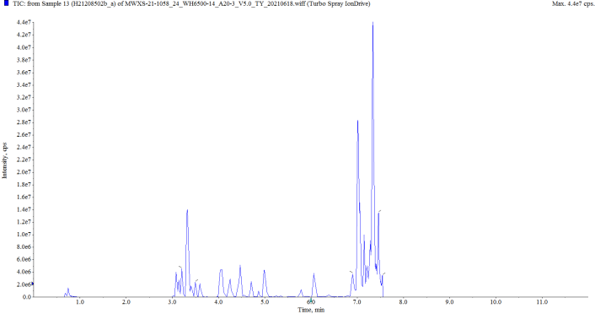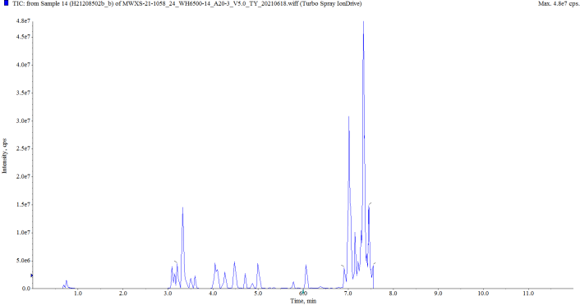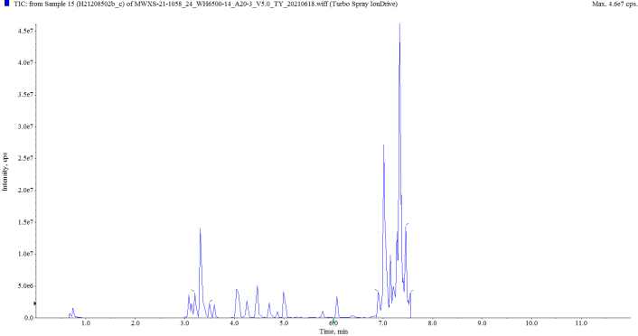
T18-GS87-1
T18-GS87-2
T18-GS87-3
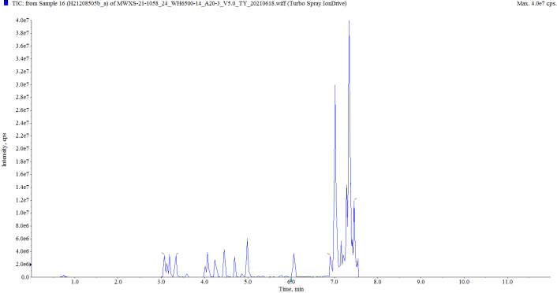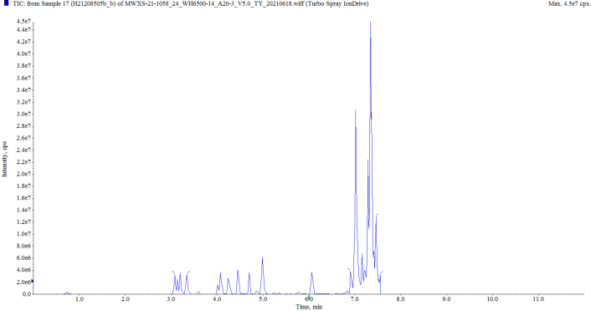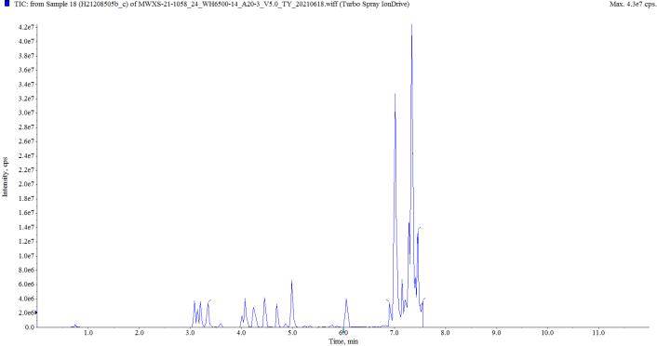
T30-GS87-1
T30-GS87-2
T30-GS87-3
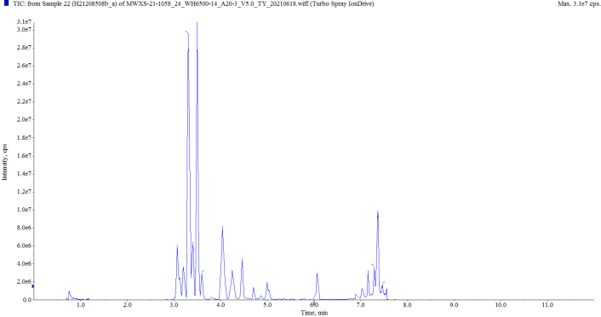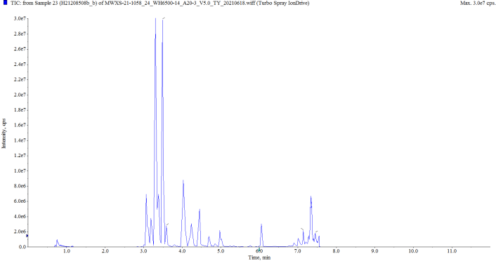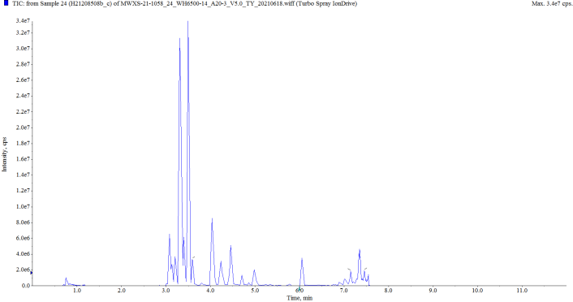
CK-XX-1
CK-XX-2
CK-XX-3
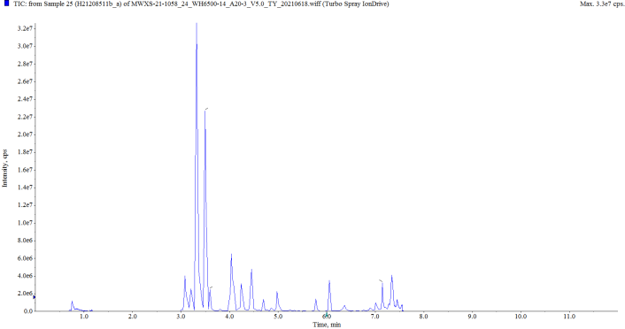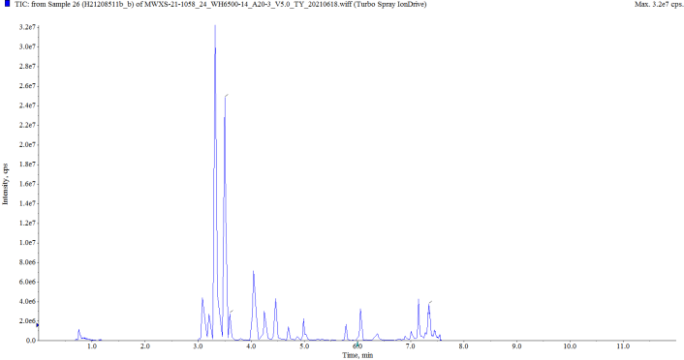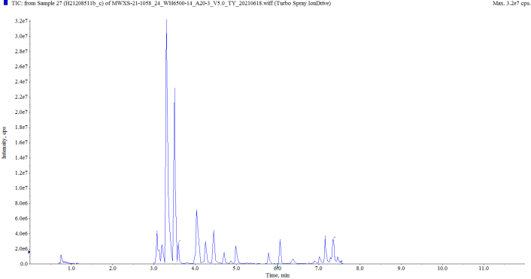
T0-XX-1
T0-XX-2
T0-XX-3
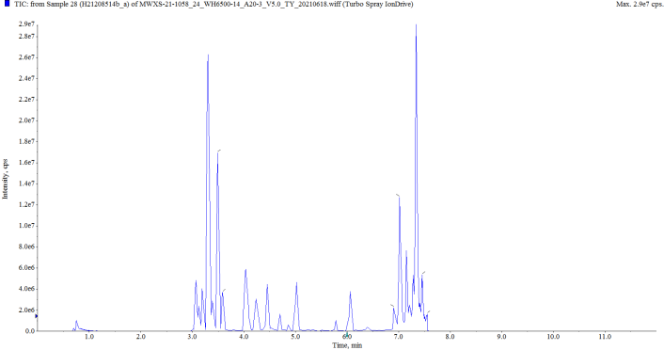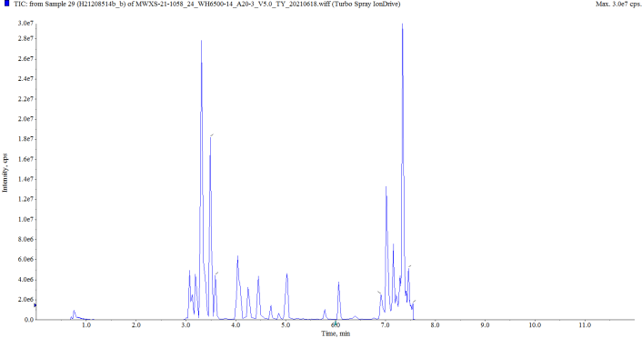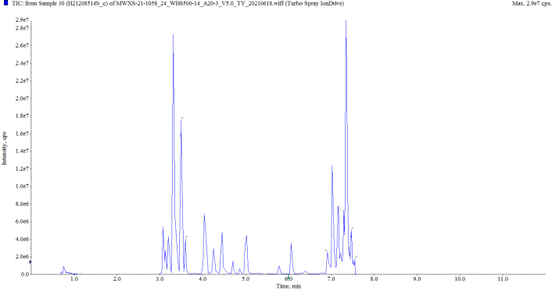
T18-XX-1
T18-XX-2
T18-XX-3
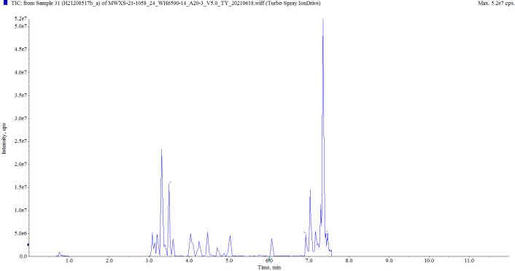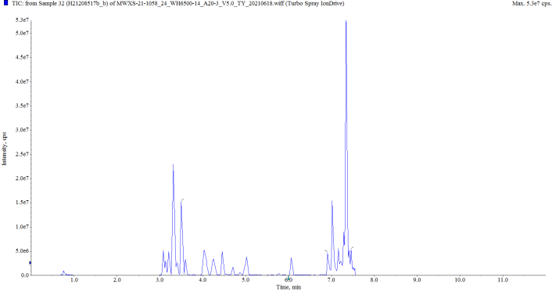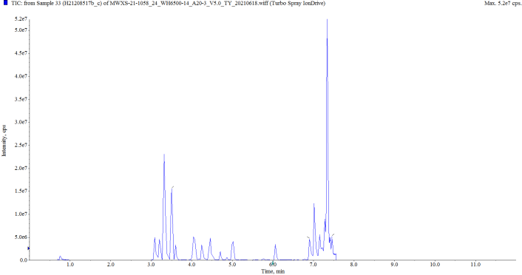
T30-XX-1
T30-XX-2
T30-XX-3
Fig. S3. The total ion chromatograms (TICs) of each replicates of GS87 and XX..

Supplementary Figures 4:

Compound name: OPDA

Regression Equation: y = 1.92969 x + 0.10557 (r = 0.99368) (weighting: 1 / x^2)
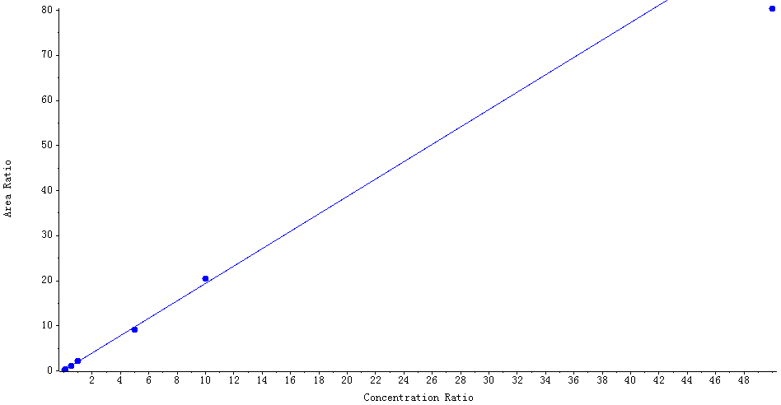

Peak Review
Blank
OPDA AREA:N/A S/N:N/A
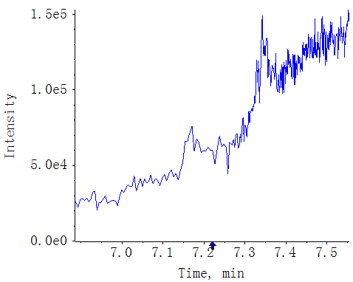
MWMS_20210617_1
OPDA AREA:3.85e6 S/N:232.5
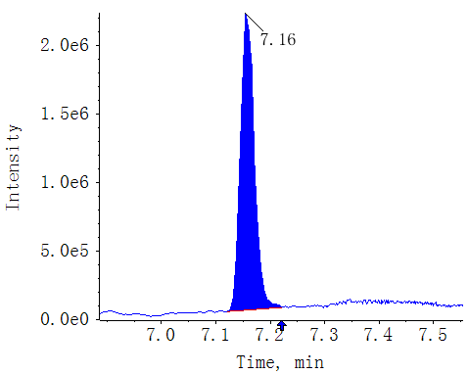
CK-GS87-1
OPDA AREA:6.93e6 S/N:23.6
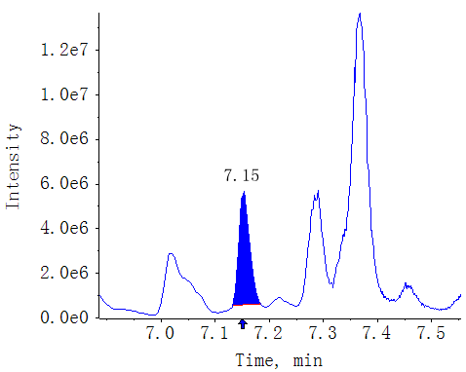
CK-GS87-2
OPDA AREA:5.70e6 S/N:26.4
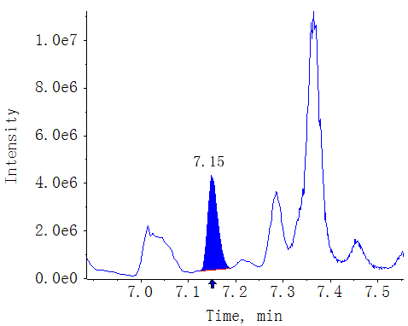
CK-GS87-3
OPDA AREA:4.03e6 S/N:22.9
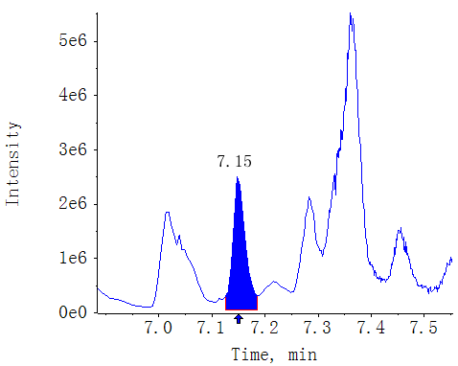
T0-GS87-1
OPDA AREA:7.05e6 S/N:46.3
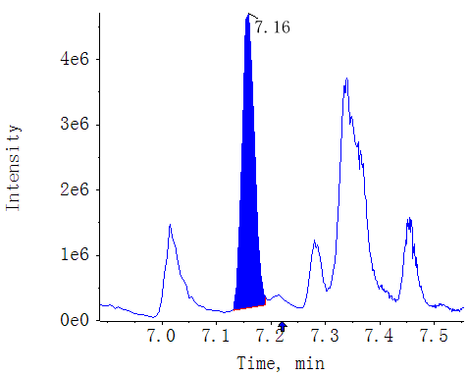
T0-GS87-2
OPDA AREA:6.44e6 S/N:54.1
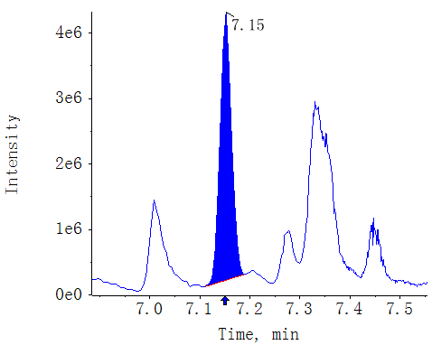
T0-GS87-3
OPDA AREA:7.32e6 S/N:47.5
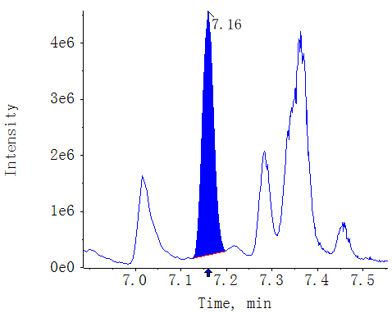
T18-GS87-1
OPDA AREA:1.05e7 S/N:10.2
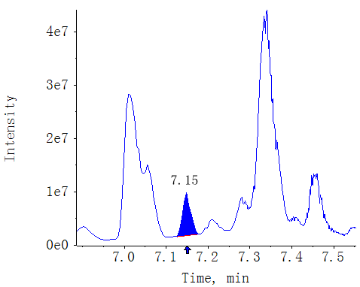
T18-GS87-2
OPDA AREA:1.20e7 S/N:9.5
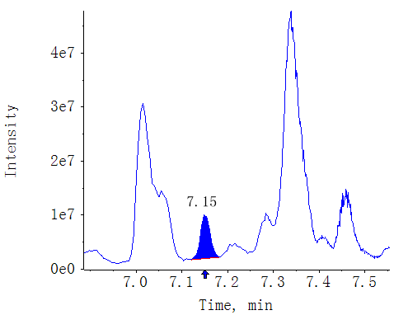
T18-GS87-3
OPDA AREA:1.08e7 S/N:9.4
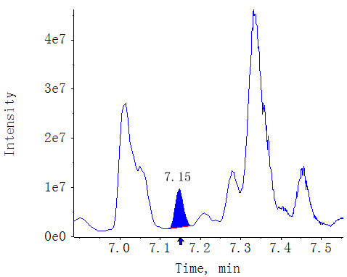
T30-GS87-1
OPDA AREA:5.37e6 S/N:5.1
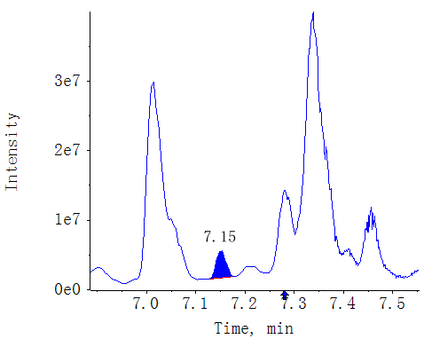
T30-GS87-2
OPDA AREA:6.83e6 S/N:5.2
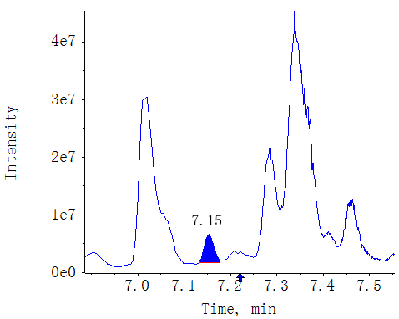
T30-GS87-3
OPDA AREA:6.55e6 S/N:6.1
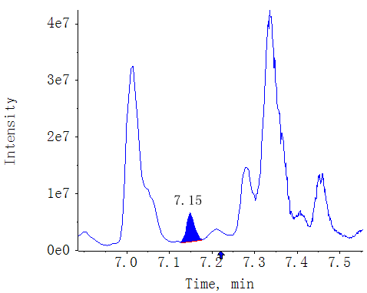
CK-XX-1
OPDA AREA:3.55e6 S/N:19.1
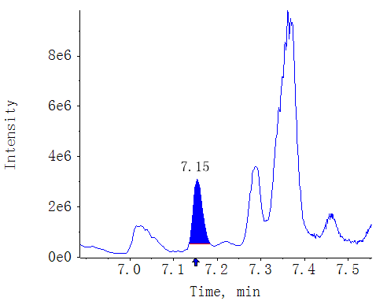
CK-XX-2
OPDA AREA:2.79e6 S/N:18.0
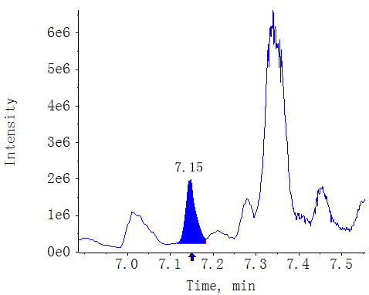
CK-XX-3
OPDA AREA:2.41e6 S/N:19.4
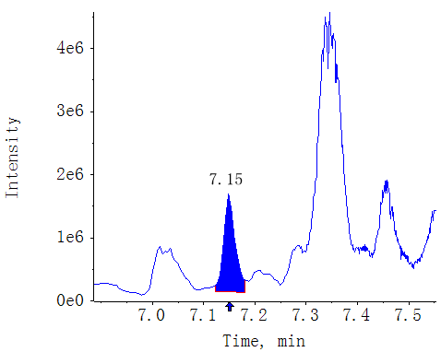
T0-XX-1
OPDA AREA:4.43e6 S/N:35.1
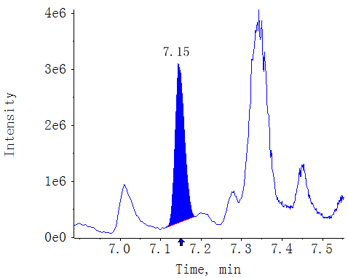
T0-XX-2
OPDA AREA:6.06e6 S/N:45.7
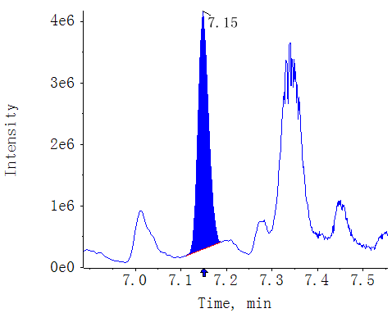
T0-XX-3
OPDA AREA:5.51e6 S/N:42.3
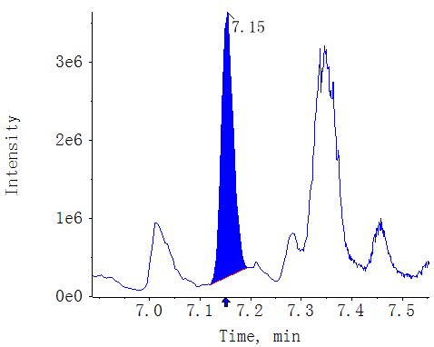
T18-XX-1
OPDA AREA:8.99e6 S/N:16.6
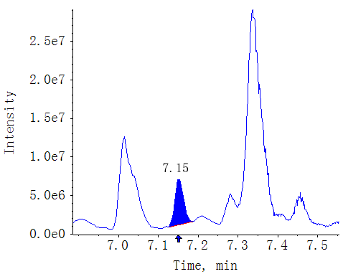
T18-XX-2
OPDA AREA:9.37e6 S/N:18.0
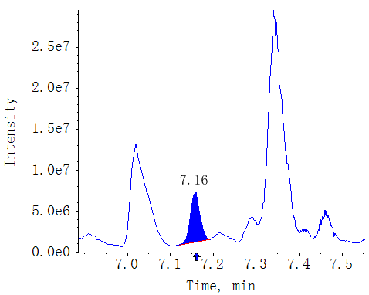
T18-XX-3
OPDA AREA:9.86e6 S/N:16.3
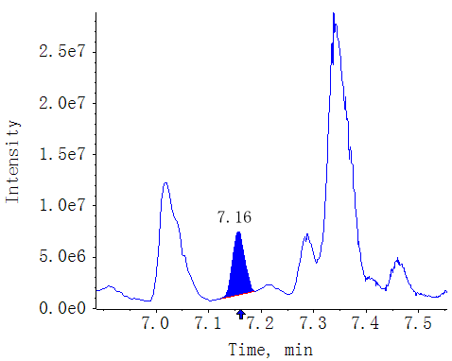
T30-XX-1
OPDA AREA:5.40e6 S/N:8.0
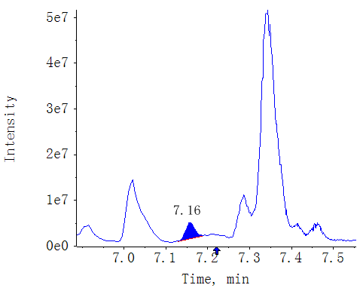
T30-XX-2
OPDA AREA:5.39e6 S/N:8.6
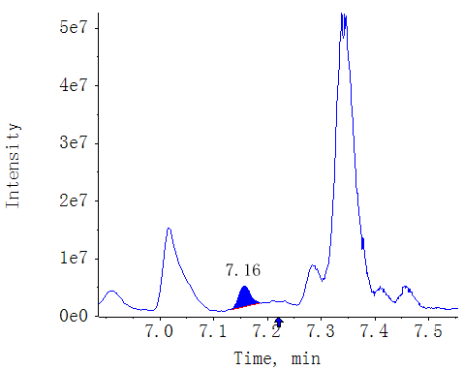
T30-XX-3
OPDA AREA:5.14e6 S/N:10.3
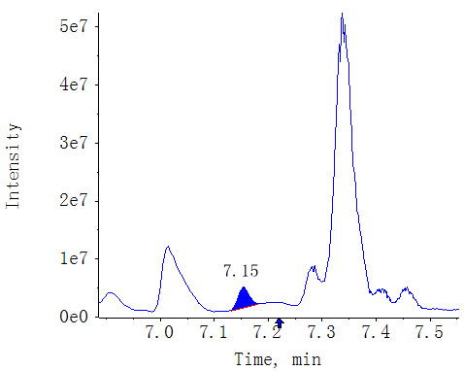

Compound name: JA

Regression Equation: y = 0.09536 x + 0.00268 (r = 0.99928) (weighting: 1 / x)
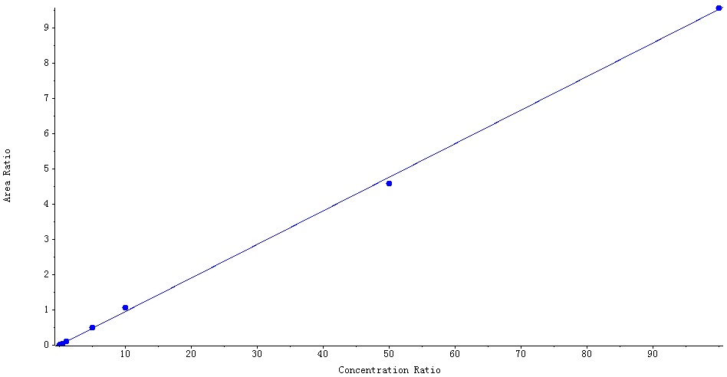

Peak Review
Blank
JA AREA:N/A S/N:N/A
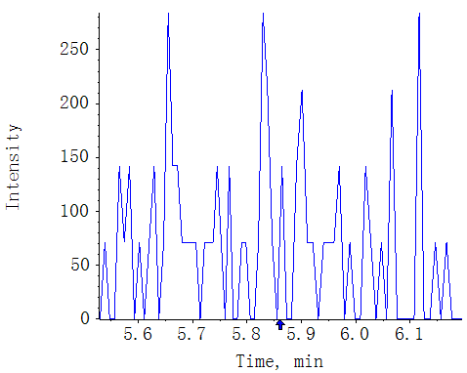
MWMS_20210617_1
JA AREA:1.84e5 S/N:324.6
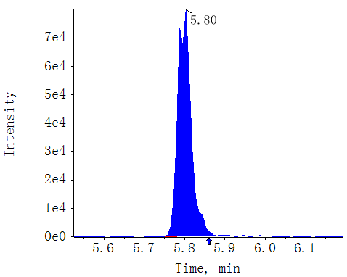
CK-GS87-1
JA AREA:3.41e5 S/N:350.4
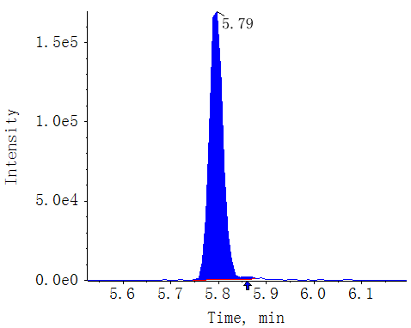
CK-GS87-2
JA AREA:2.89e5 S/N:304.6
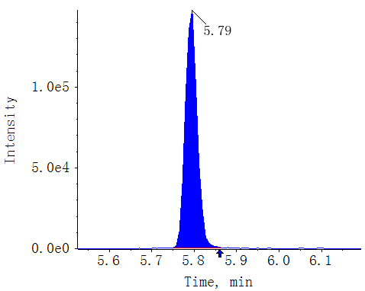
CK-GS87-3
JA AREA:2.62e5 S/N:286.7
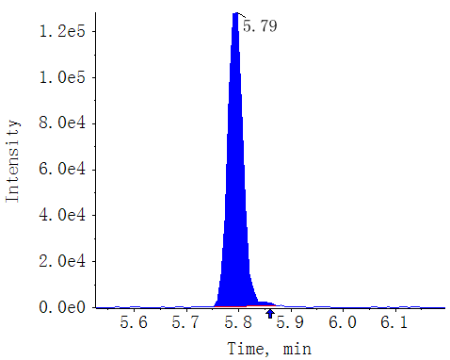
T0-GS87-1
JA AREA:3.09e6 S/N:515.3
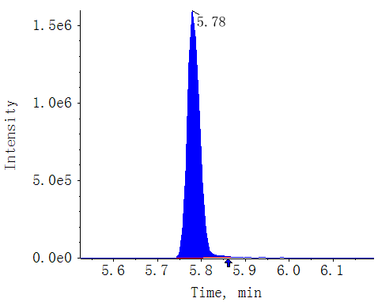
T0-GS87-2
JA AREA:3.02e6 S/N:495.2
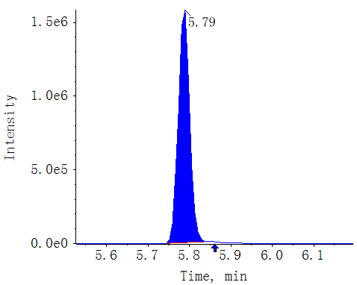
T0-GS87-3
JA AREA:2.62e6 S/N:558.2
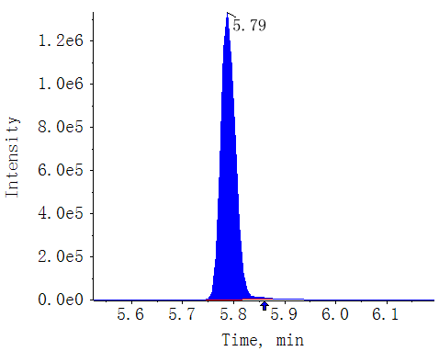
T18-GS87-1
JA AREA:1.85e6 S/N:446.4
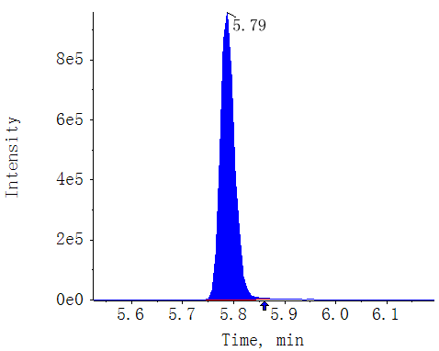
T18-GS87-2
JA AREA:1.94e6 S/N:477.5
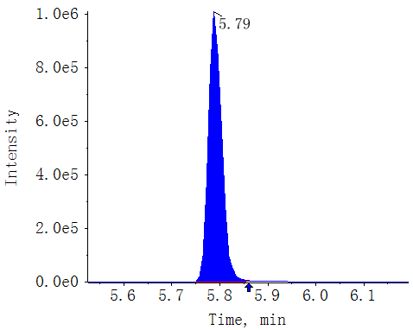
T18-GS87-3
JA AREA:1.72e6 S/N:355.1
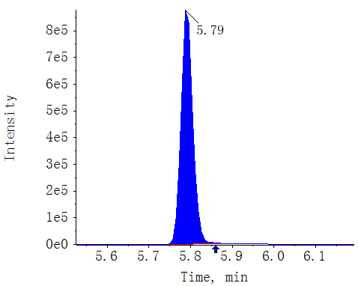
T30-GS87-1
JA AREA:2.57e5 S/N:280.3
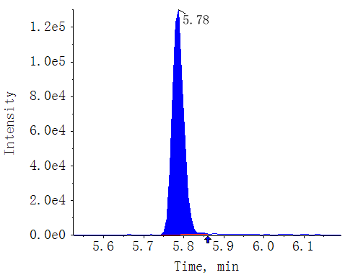
T30-GS87-2
JA AREA:2.60e5 S/N:289.2
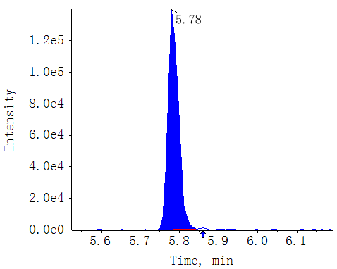
T30-GS87-3
JA AREA:2.67e5 S/N:408.3
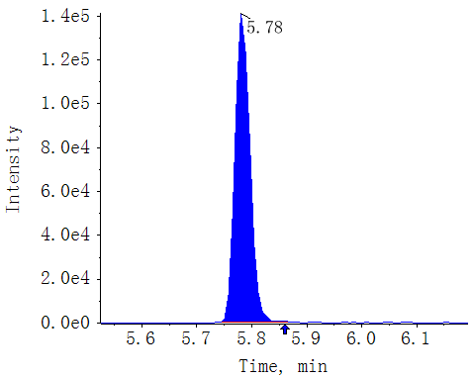
CK-XX-1
JA AREA:1.29e5 S/N:251.7
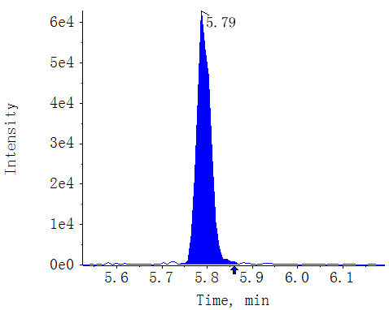
CK-XX-2
JA AREA:1.12e5 S/N:171.1
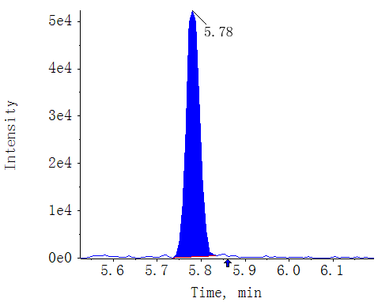
CK-XX-3
JA AREA:1.09e5 S/N:183.0
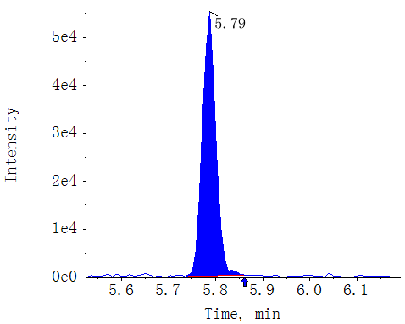
T0-XX-1
JA AREA:2.50e6 S/N:511.1
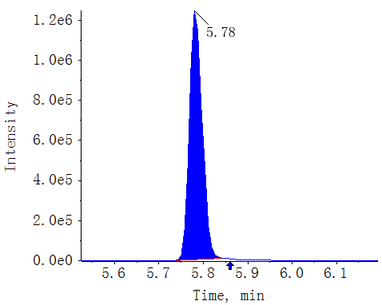
T0-XX-2
JA AREA:3.04e6 S/N:472.3
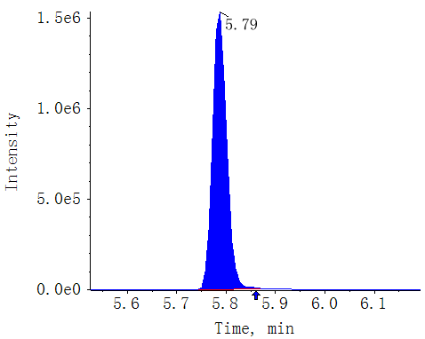
T0-XX-3
JA AREA:2.79e6 S/N:450.1
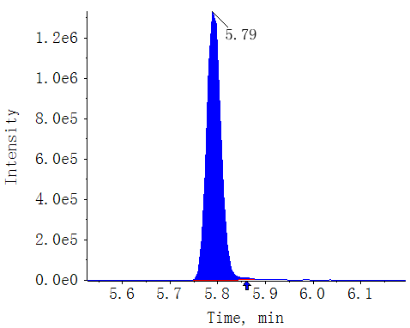
T18-XX-1
JA AREA:1.58e6 S/N:494.0
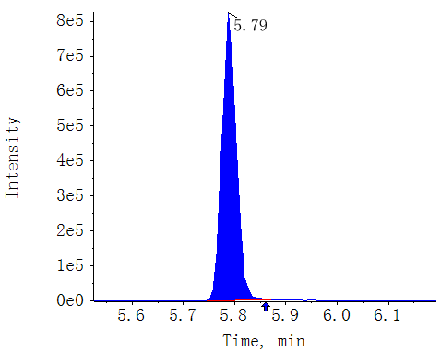
T18-XX-2
JA AREA:1.59e6 S/N:408.3
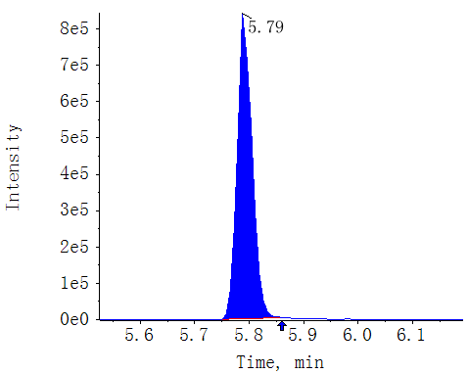
T18-XX-3
JA AREA:1.61e6 S/N:459.9
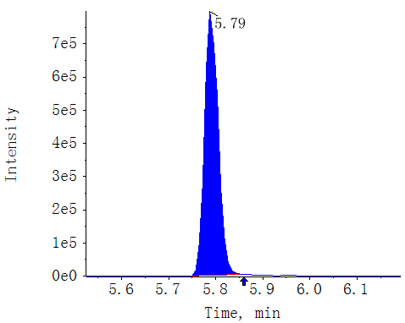
T30-XX-1
JA AREA:3.62e5 S/N:277.9
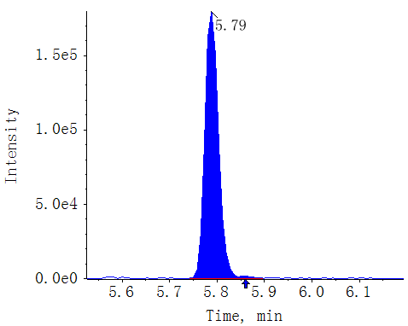
T30-XX-2
JA AREA:3.37e5 S/N:259.0
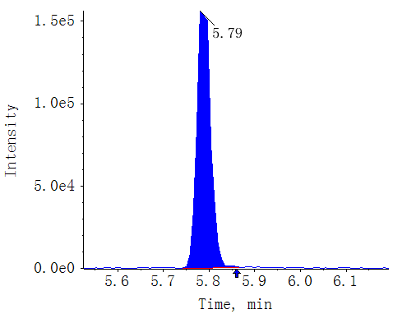
T30-XX-3
JA AREA:3.29e5 S/N:311.6
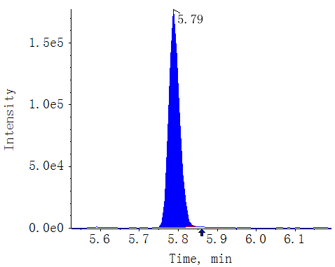

Compound name: MeJA

Regression Equation: y = 0.38383 x + 0.00299 (r = 0.99874) (weighting: 1 / x)
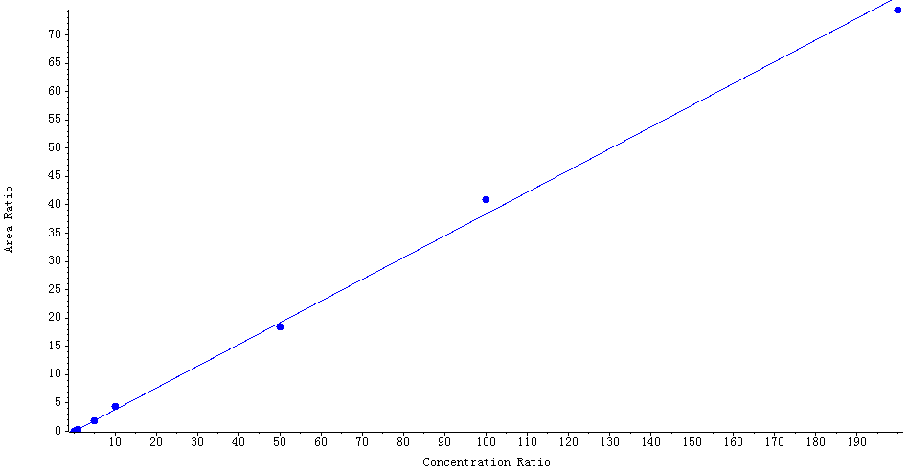

Peak Review
Blank
MeJA AREA:N/A S/N:N/A
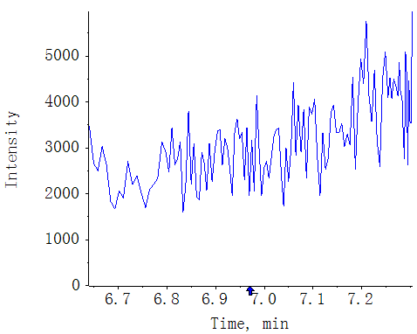
MWMS_20210617_1
MeJA AREA:6.68e5 S/N:319.5
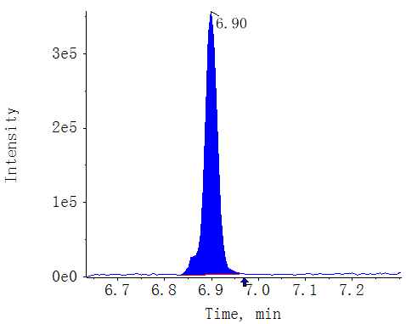
CK-GS87-1
MeJA AREA:N/A S/N:N/A
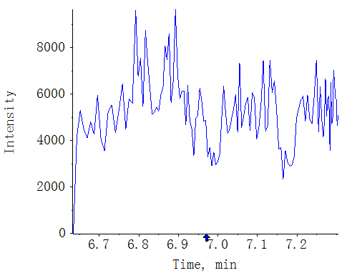
CK-GS87-2
MeJA AREA:N/A S/N:N/A
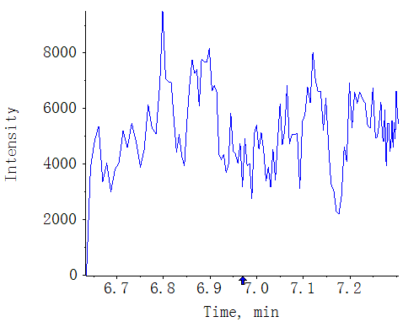
CK-GS87-3
MeJA AREA:N/A S/N:N/A
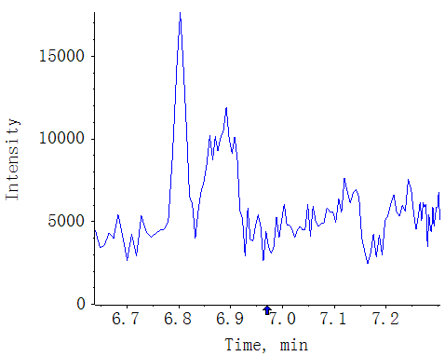
T0-GS87-1
MeJA AREA:3.37e4 S/N:19.6
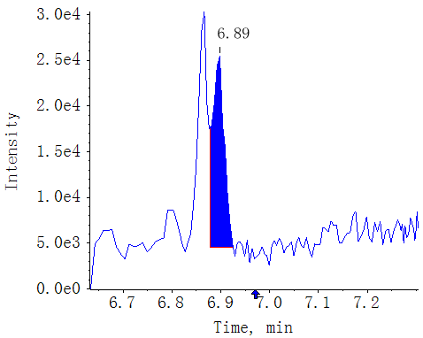
T0-GS87-2
MeJA AREA:3.12e4 S/N:20.9
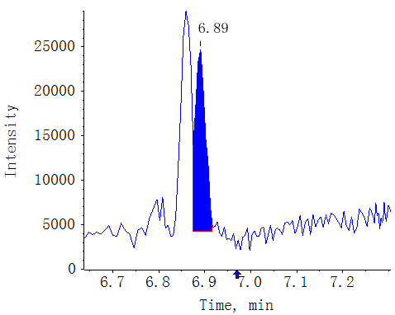
T0-GS87-3
MeJA AREA:2.97e4 S/N:19.7
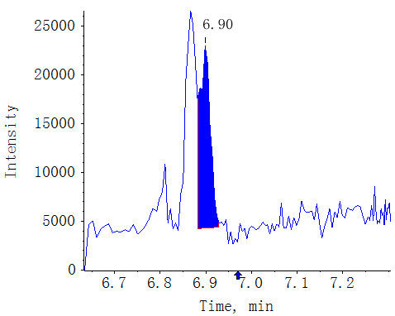
T18-GS87-1
MeJA AREA:5.31e4 S/N:21.5
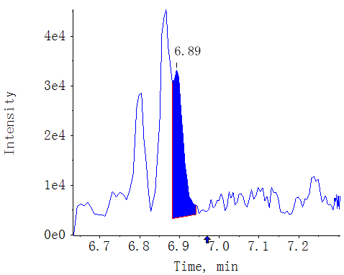
T18-GS87-2
MeJA AREA:4.56e4 S/N:20.8
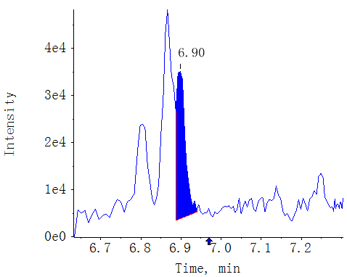
T18-GS87-3
MeJA AREA:4.79e4 S/N:15.5
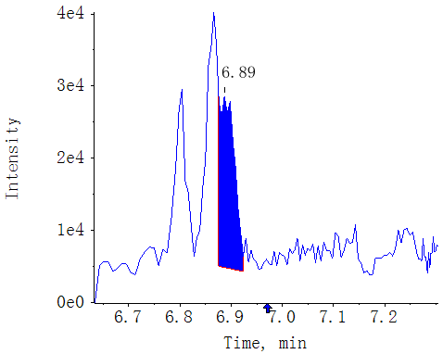
T30-GS87-1
MeJA AREA:2.57e4 S/N:10.3
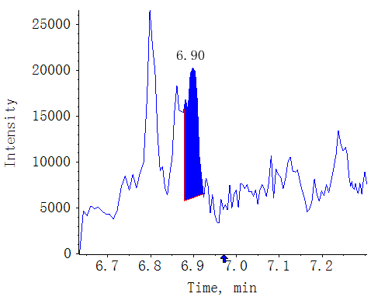
T30-GS87-2
MeJA AREA:2.53e4 S/N:9.2
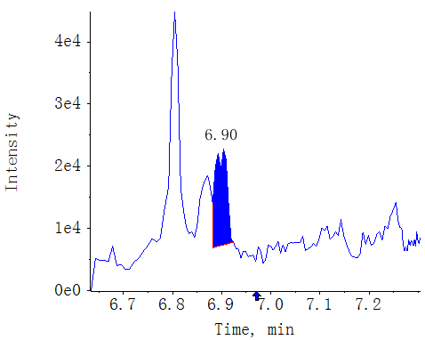
T30-GS87-3
MeJA AREA:2.62e4 S/N:11.0
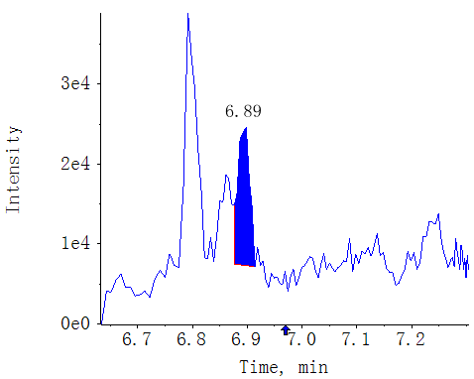
CK-XX-1
MeJA AREA:N/A S/N:N/A
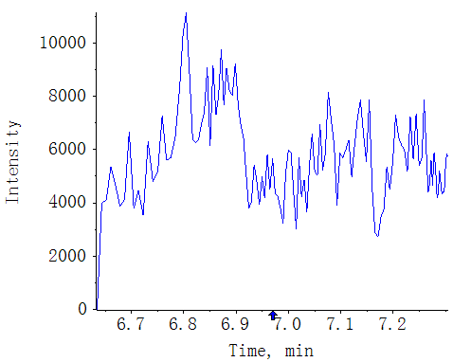
CK-XX-2
MeJA AREA:N/A S/N:N/A
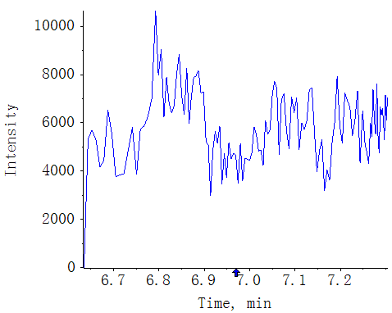
CK-XX-3
MeJA AREA:N/A S/N:N/A
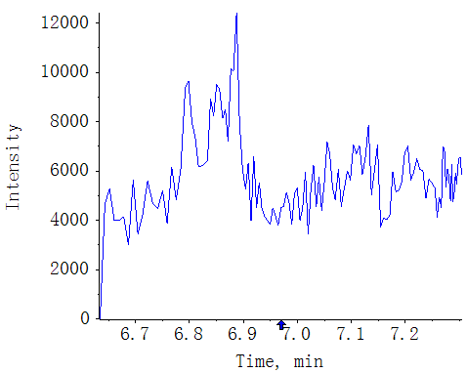
T0-XX-1
MeJA AREA:4.56e4 S/N:31.9
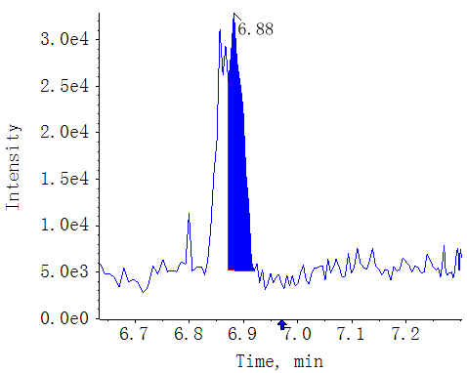
T0-XX-2
MeJA AREA:5.81e4 S/N:31.9
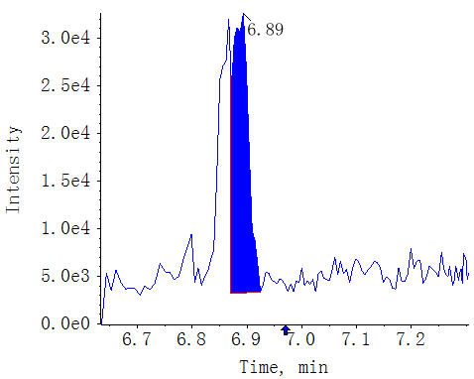
T0-XX-3
MeJA AREA:4.49e4 S/N:32.8
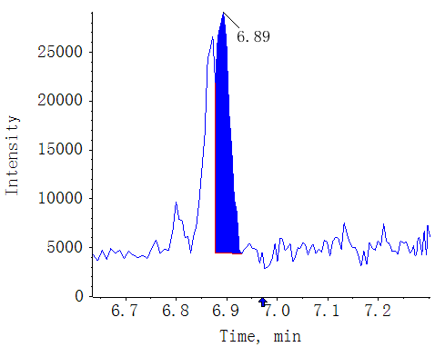
T18-XX-1
MeJA AREA:3.03e4 S/N:19.0
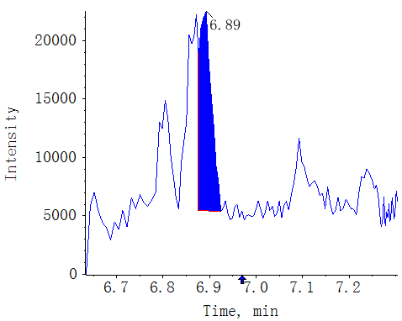
T18-XX-2
MeJA AREA:2.61e4 S/N:16.8
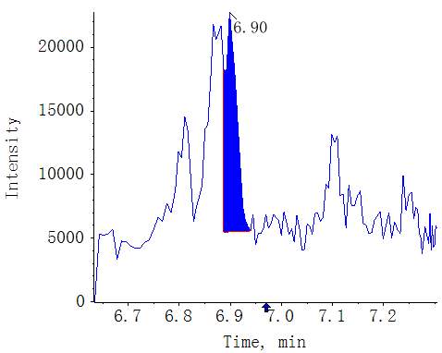
T18-XX-3
MeJA AREA:2.49e4 S/N:12.1
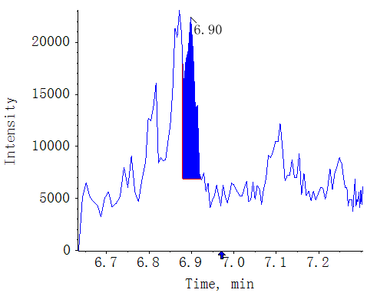
T30-XX-1
MeJA AREA:1.94e4 S/N:11.7
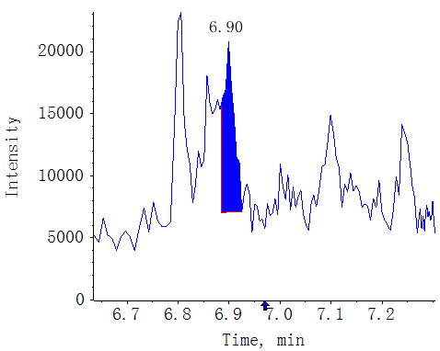
T30-XX-2
MeJA AREA:2.13e4 S/N:8.9
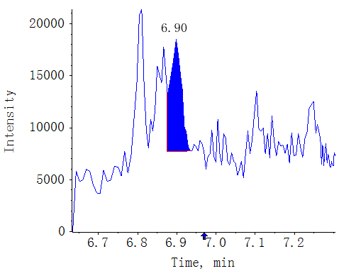
T30-XX-3
MeJA AREA:1.33e4 S/N:7.3
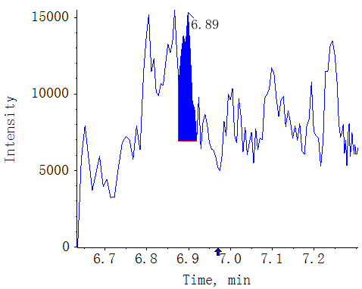

Compound name: JA-ILE

Regression Equation: y = 0.27030 x + 0.00863 (r = 0.99832) (weighting: 1 / x)
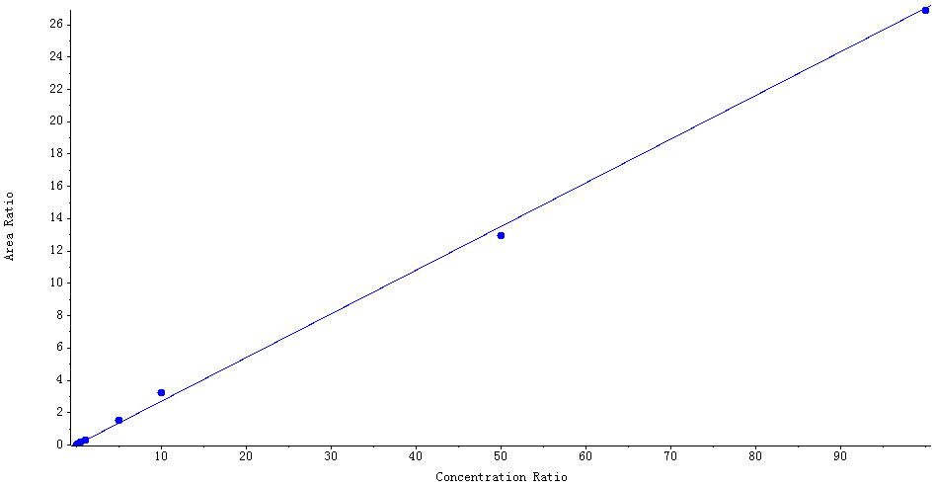

Peak Review
Blank
JA-ILE AREA:N/A S/N:N/A
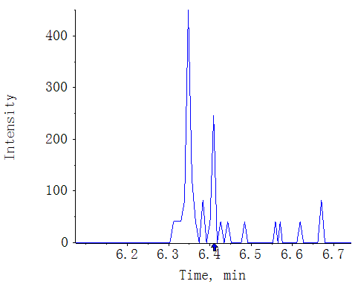
MWMS_20210617_1
JA-ILE AREA:4.61e5 S/N:443.4
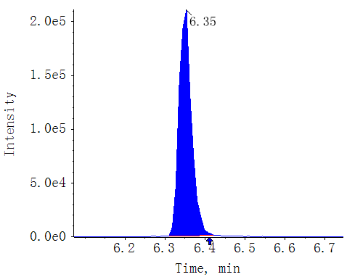
CK-GS87-1
JA-ILE AREA:7.52e4 S/N:350.7
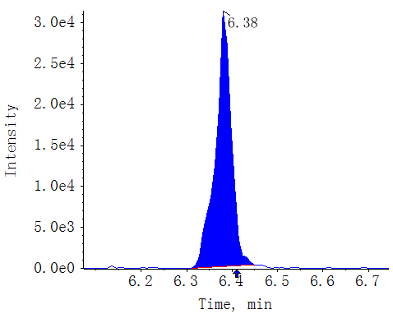
CK-GS87-2
JA-ILE AREA:7.36e4 S/N:216.1
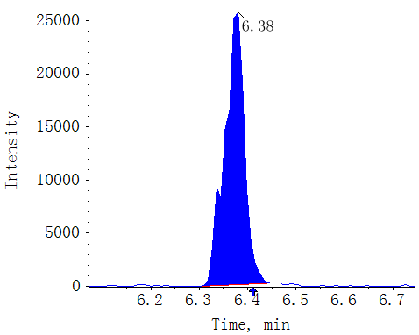
CK-GS87-3
JA-ILE AREA:6.54e4 S/N:180.7
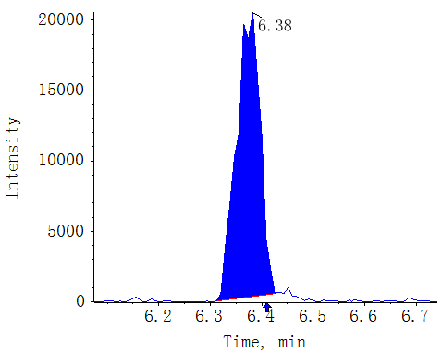
T0-GS87-1
JA-ILE AREA:1.27e6 S/N:444.8
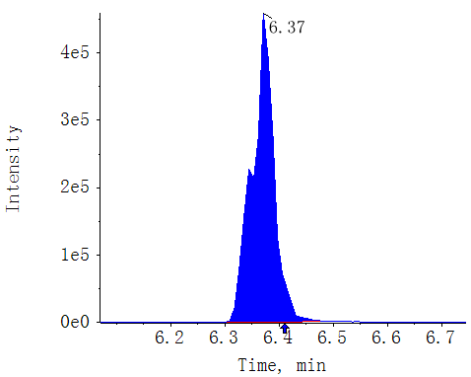
T0-GS87-2
JA-ILE AREA:1.29e6 S/N:477.0
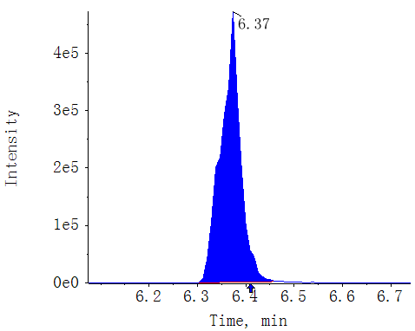
T0-GS87-3
JA-ILE AREA:1.13e6 S/N:483.0
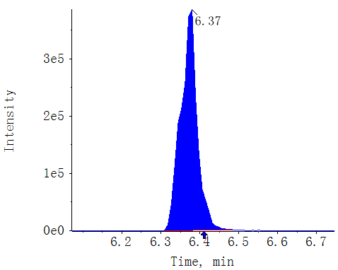
T18-GS87-1
JA-ILE AREA:5.48e5 S/N:457.3
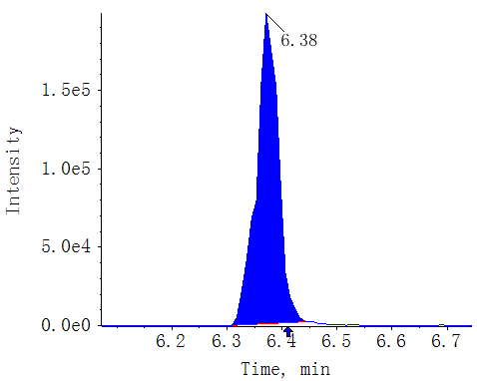
T18-GS87-2
JA-ILE AREA:6.29e5 S/N:415.7
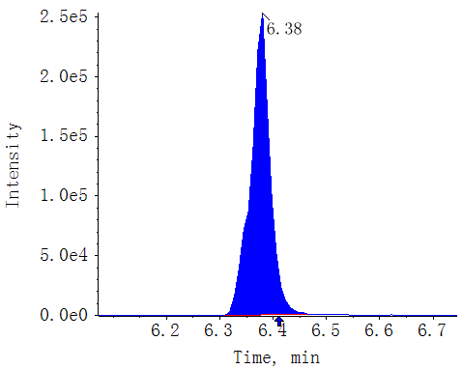
T18-GS87-3
JA-ILE AREA:5.51e5 S/N:525.5
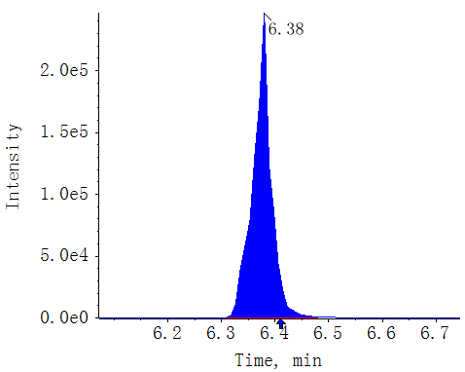
T30-GS87-1
JA-ILE AREA:4.72e4 S/N:248.4
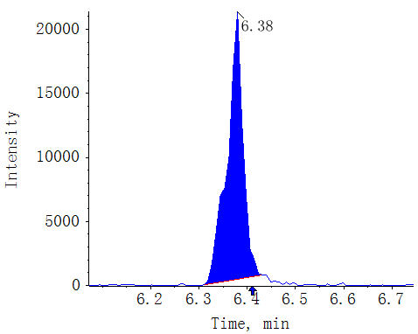
T30-GS87-2
JA-ILE AREA:5.26e4 S/N:251.9
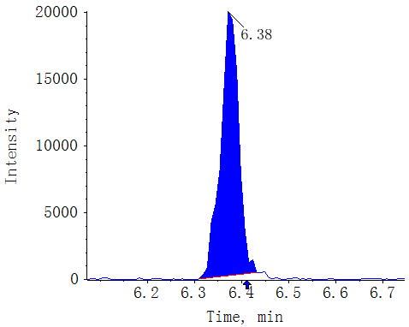
T30-GS87-3
JA-ILE AREA:5.22e4 S/N:211.5
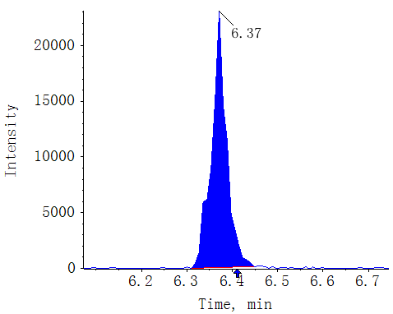
CK-XX-1
JA-ILE AREA:6.27e4 S/N:167.3
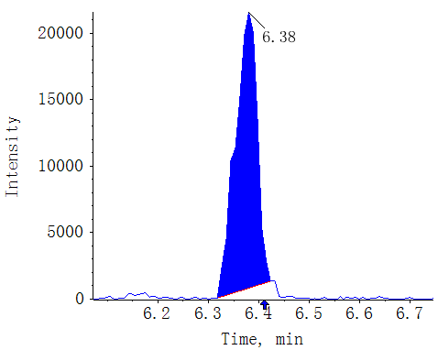
CK-XX-2
JA-ILE AREA:5.78e4 S/N:173.2
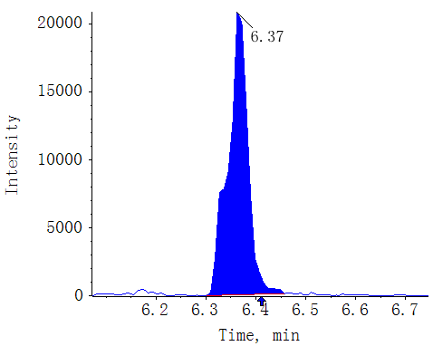
CK-XX-3
JA-ILE AREA:6.43e4 S/N:163.1
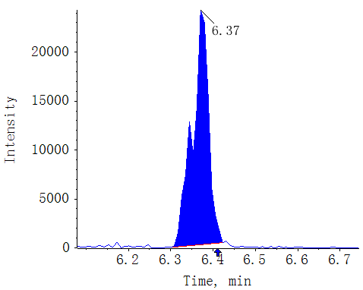
T0-XX-1
JA-ILE AREA:2.02e6 S/N:458.3
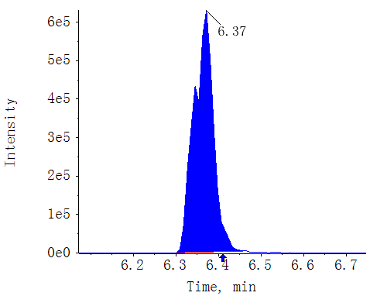
T0-XX-2
JA-ILE AREA:2.17e6 S/N:375.8
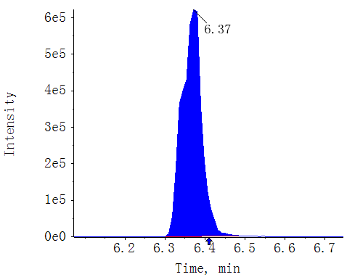
T0-XX-3
JA-ILE AREA:1.99e6 S/N:407.3
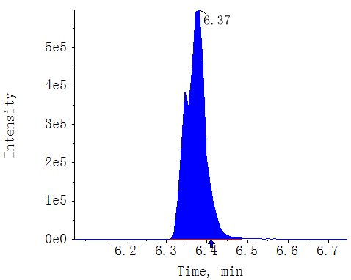
T18-XX-1
JA-ILE AREA:4.75e5 S/N:371.8
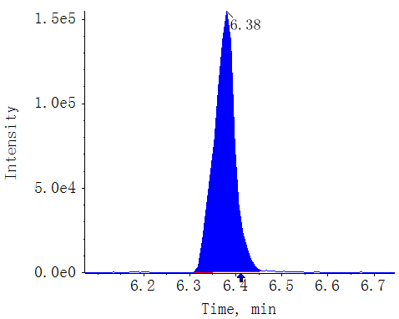
T18-XX-2
JA-ILE AREA:4.96e5 S/N:324.8
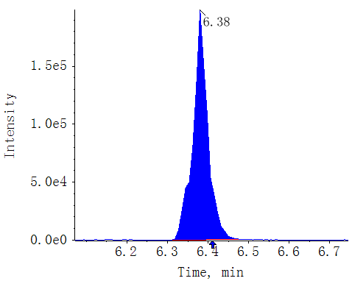
T18-XX-3
JA-ILE AREA:5.00e5 S/N:393.6
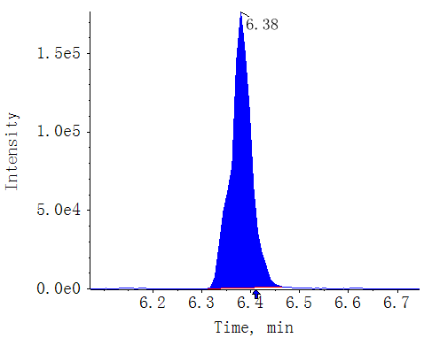
T30-XX-1
JA-ILE AREA:1.54e5 S/N:237.2
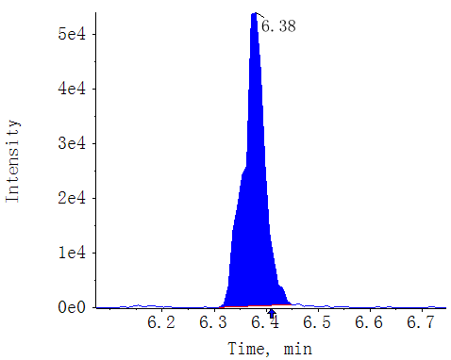
T30-XX-2
JA-ILE AREA:1.51e5 S/N:315.8
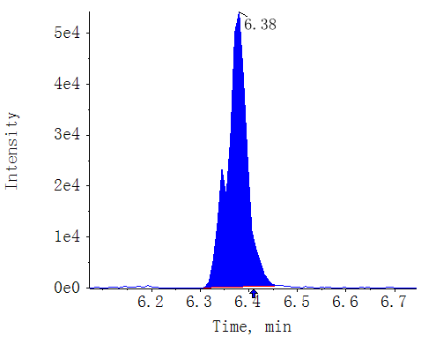
T30-XX-3
JA-ILE AREA:1.47e5 S/N:244.6
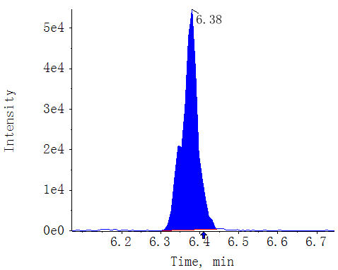

Compound name: JA-Phe

Regression Equation: y = 1.12613 x + 0.00365 (r = 0.99601) (weighting: 1 / x^2)
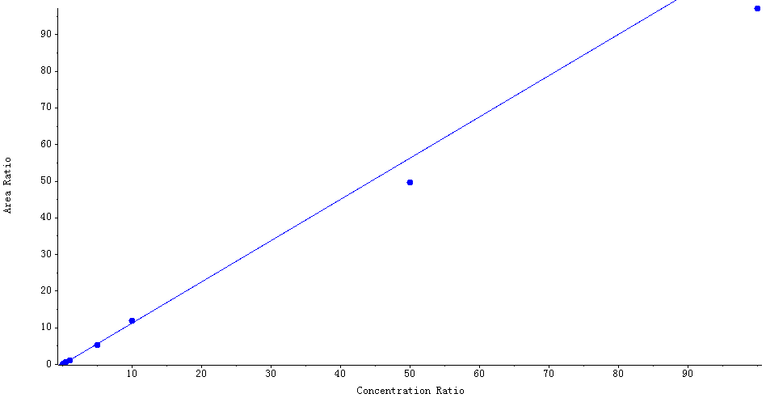

Peak Review
Blank
JA-Phe AREA:N/A S/N:N/A
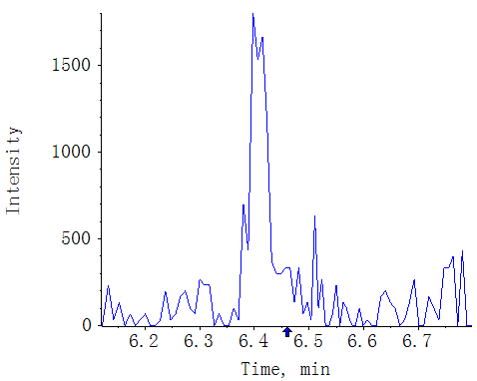
MWMS_20210617_1
JA-Phe AREA:2.60e6 S/N:485.4
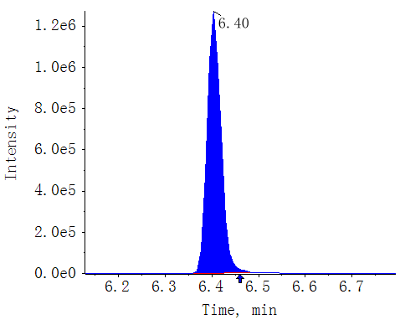
CK-GS87-1
JA-Phe AREA:N/A S/N:N/A
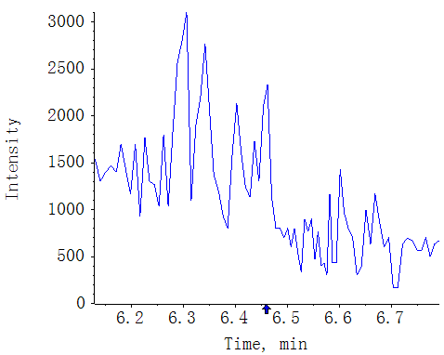
CK-GS87-2
JA-Phe AREA:N/A S/N:N/A
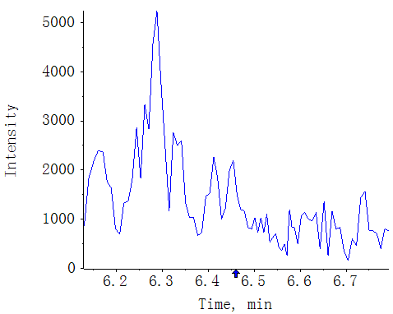
CK-GS87-3
JA-Phe AREA:N/A S/N:N/A
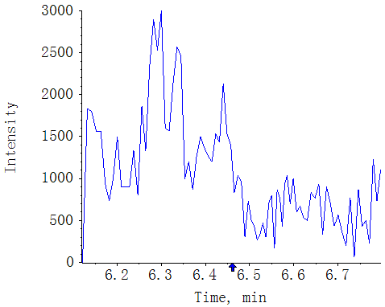
T0-GS87-1
JA-Phe AREA:2.49e4 S/N:26.6
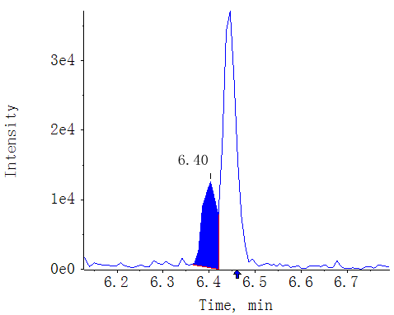
T0-GS87-2
JA-Phe AREA:2.35e4 S/N:27.1
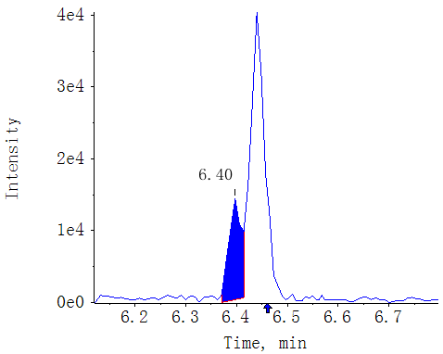
T0-GS87-3
JA-Phe AREA:2.09e4 S/N:24.8
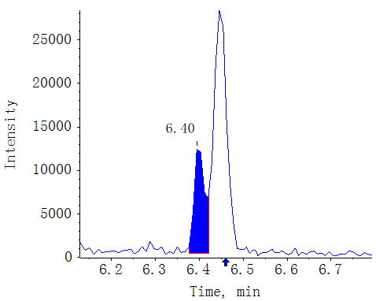
T18-GS87-1
JA-Phe AREA:1.05e4 S/N:11.8
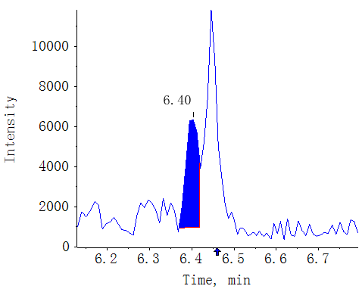
T18-GS87-2
JA-Phe AREA:8.57e3 S/N:8.3
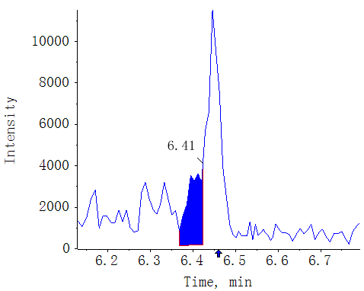
T18-GS87-3
JA-Phe AREA:6.74e3 S/N:7.4
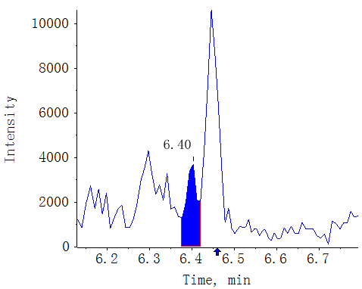
T30-GS87-1
JA-Phe AREA:N/A S/N:N/A
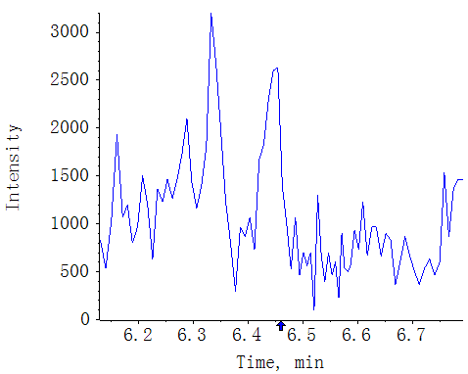
T30-GS87-2
JA-Phe AREA:N/A S/N:N/A
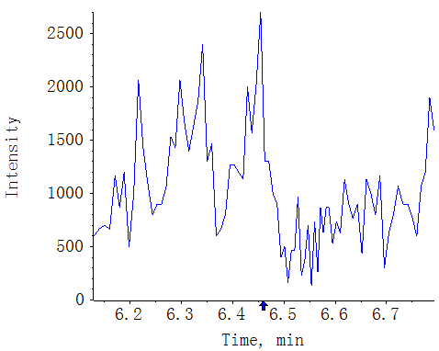
T30-GS87-3
JA-Phe AREA:N/A S/N:N/A
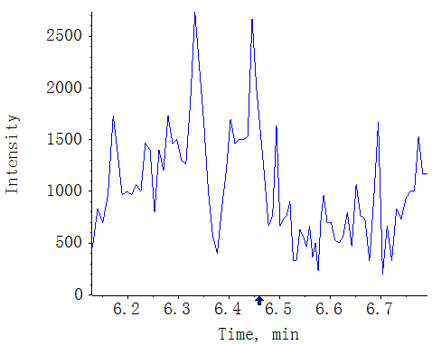
CK-XX-1
JA-Phe AREA:N/A S/N:N/A
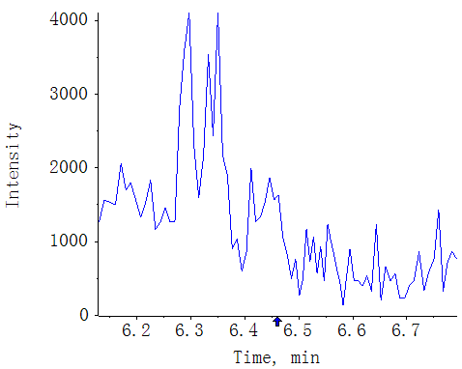
CK-XX-2
JA-Phe AREA:N/A S/N:N/A
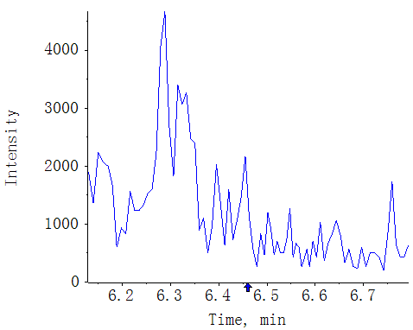
CK-XX-3
JA-Phe AREA:N/A S/N:N/A
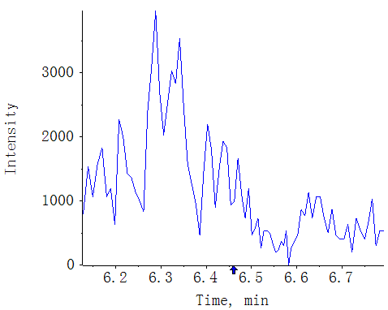
T0-XX-1
JA-Phe AREA:3.11e4 S/N:18.9
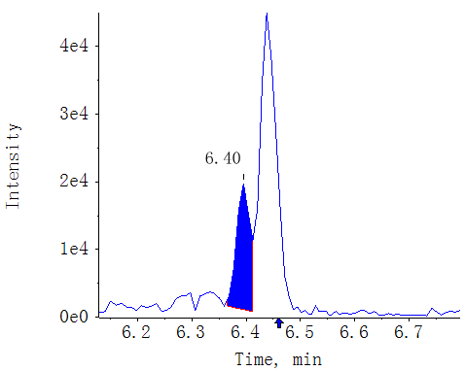
T0-XX-2
JA-Phe AREA:3.91e4 S/N:16.2
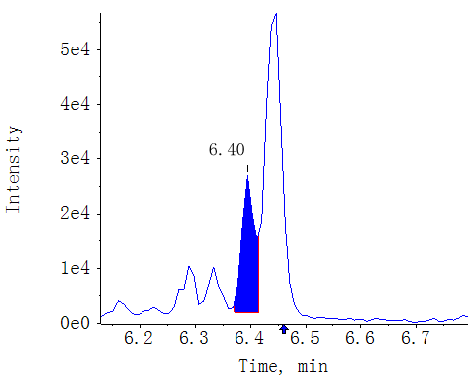
T0-XX-3
JA-Phe AREA:3.56e4 S/N:20.0
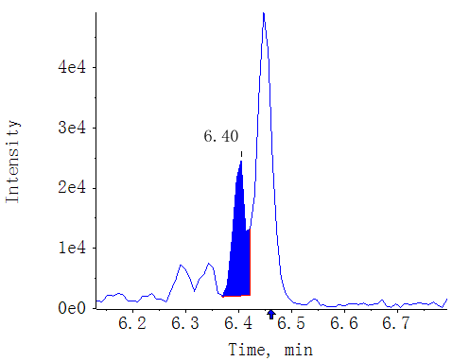
T18-XX-1
JA-Phe AREA:7.25e3 S/N:5.7
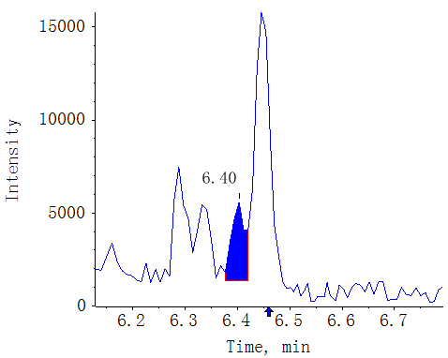
T18-XX-2
JA-Phe AREA:9.23e3 S/N:5.1
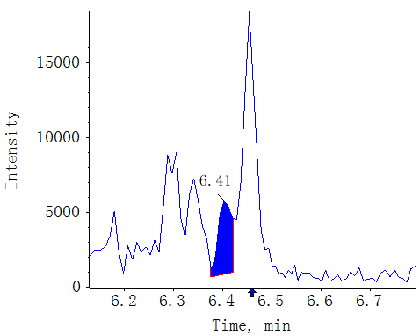
T18-XX-3
JA-Phe AREA:8.55e3 S/N:4.5
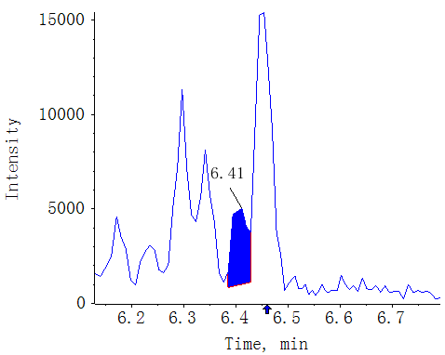
T30-XX-1
JA-Phe AREA:N/A S/N:N/A
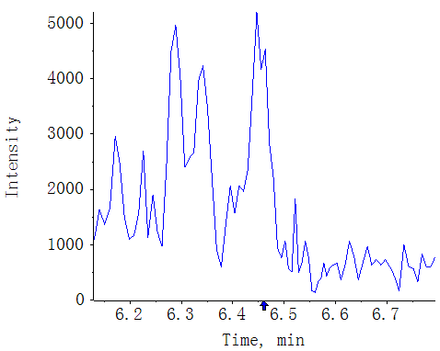
T30-XX-2
JA-Phe AREA:N/A S/N:N/A
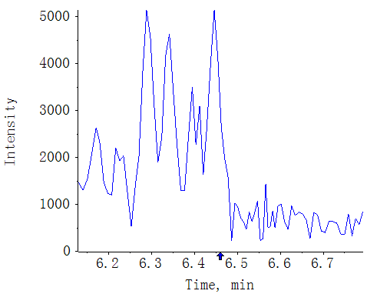
T30-XX-3
JA-Phe AREA:N/A S/N:N/A
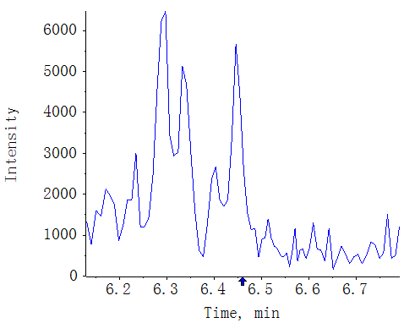

Compound name: JA-Val

Regression Equation: y = 0.54886 x + 0.00449 (r = 0.99549) (weighting: 1 / x^2)
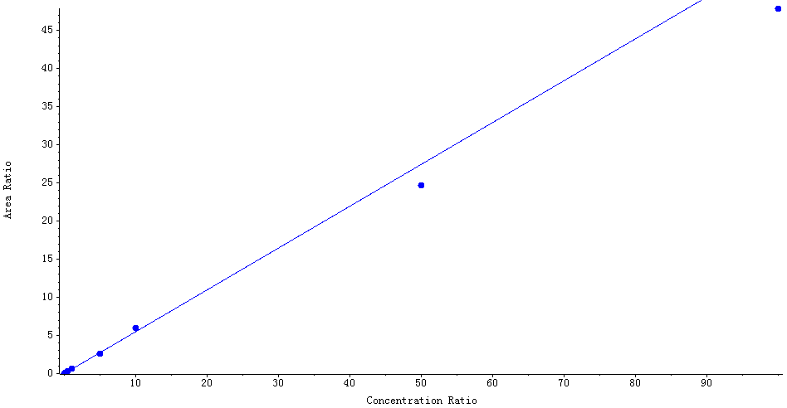

Peak Review
Blank
JA-Val AREA:N/A S/N:N/A
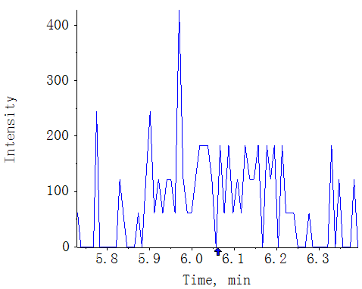
MWMS_20210617_1
JA-Val AREA:8.34e5 S/N:481.9
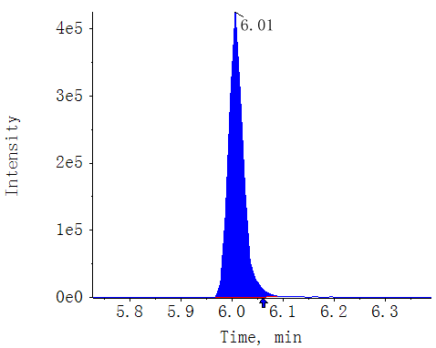
CK-GS87-1
JA-Val AREA:6.45e3 S/N:40.7
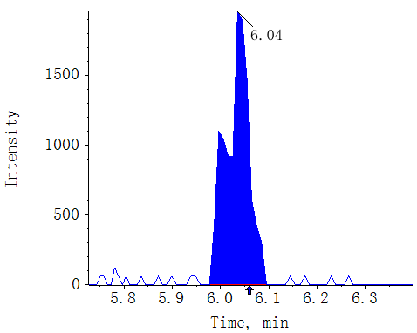
CK-GS87-2
JA-Val AREA:5.68e3 S/N:39.6
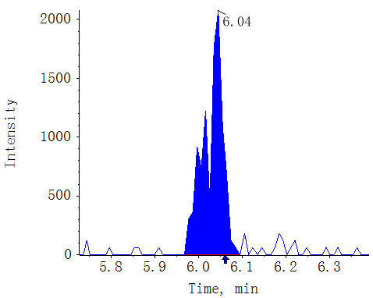
CK-GS87-3
JA-Val AREA:5.11e3 S/N:35.1
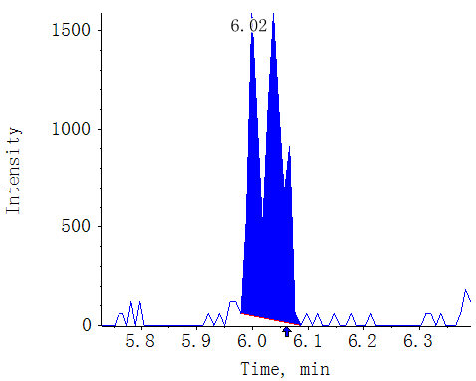
T0-GS87-1
JA-Val AREA:6.86e4 S/N:165.0
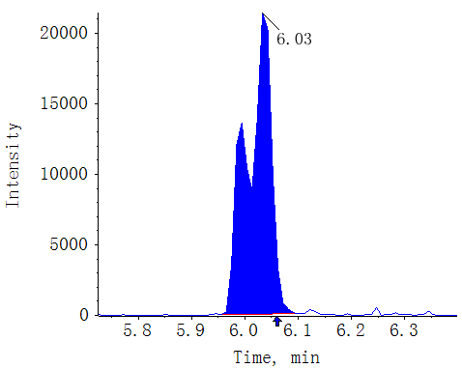
T0-GS87-2
JA-Val AREA:6.94e4 S/N:322.2
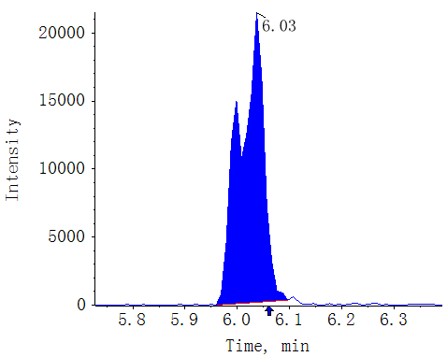
T0-GS87-3
JA-Val AREA:6.01e4 S/N:197.4
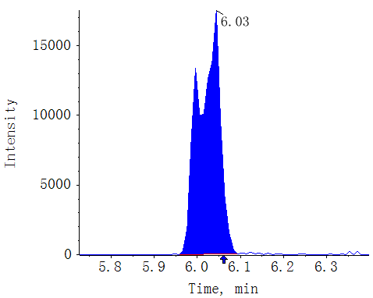
T18-GS87-1
JA-Val AREA:4.27e4 S/N:122.0
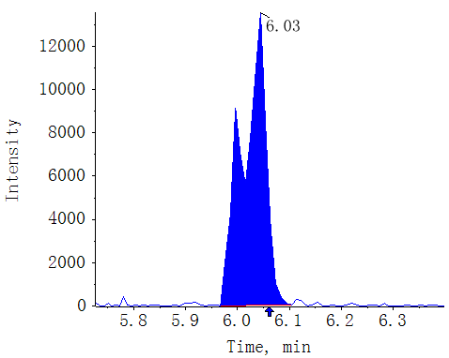
T18-GS87-2
JA-Val AREA:3.97e4 S/N:102.2
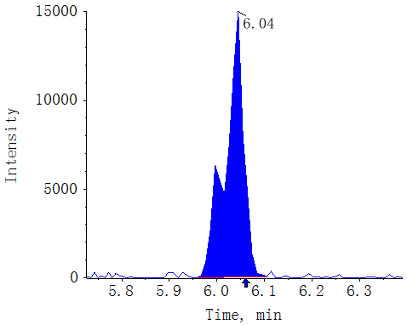
T18-GS87-3
JA-Val AREA:3.97e4 S/N:121.9
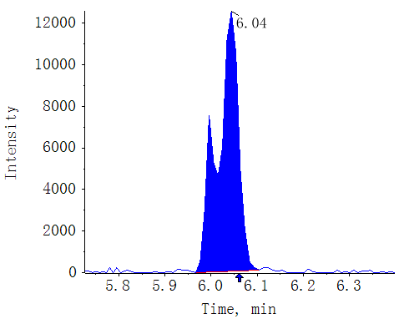
T30-GS87-1
JA-Val AREA:3.76e3 S/N:33.1
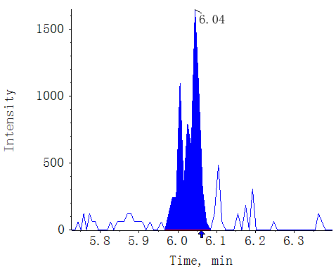
T30-GS87-2
JA-Val AREA:4.04e3 S/N:27.6
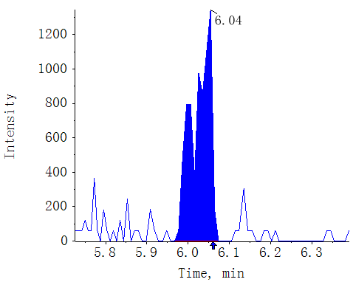
T30-GS87-3
JA-Val AREA:3.47e3 S/N:27.1
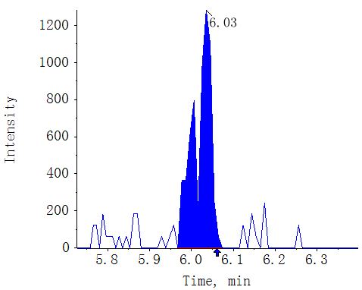
CK-XX-1
JA-Val AREA:5.34e3 S/N:44.1
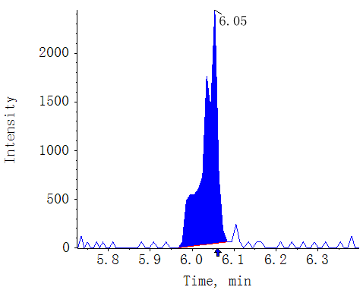
CK-XX-2
JA-Val AREA:5.28e3 S/N:37.6
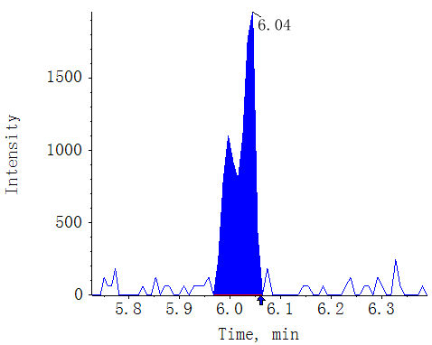
CK-XX-3
JA-Val AREA:4.35e3 S/N:26.1
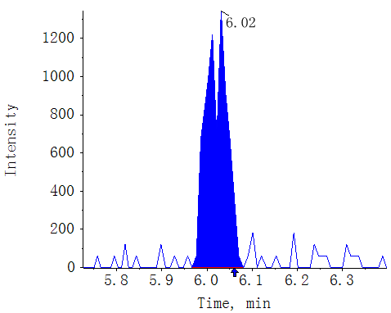
T0-XX-1
JA-Val AREA:1.34e5 S/N:300.5
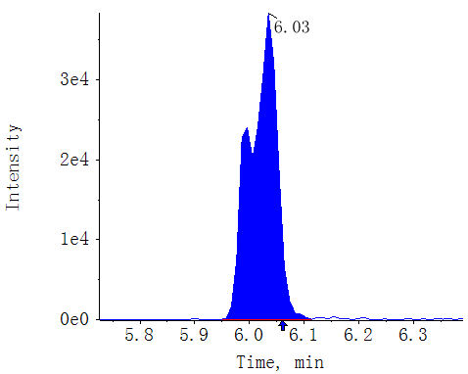
T0-XX-2
JA-Val AREA:1.44e5 S/N:203.6
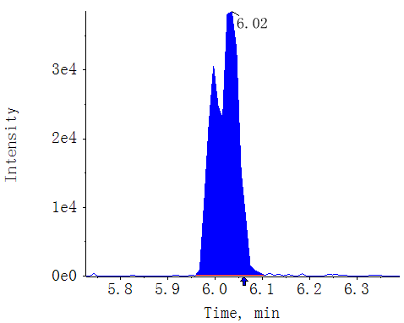
T0-XX-3
JA-Val AREA:1.38e5 S/N:208.5
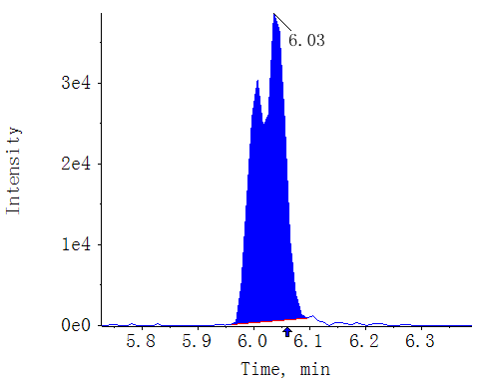
T18-XX-1
JA-Val AREA:6.54e4 S/N:141.0
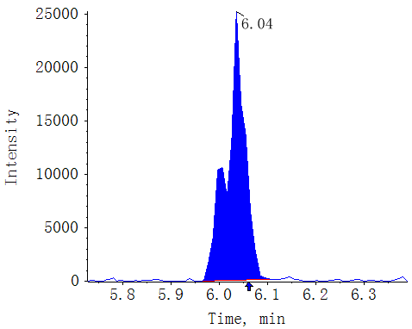
T18-XX-2
JA-Val AREA:7.04e4 S/N:187.4
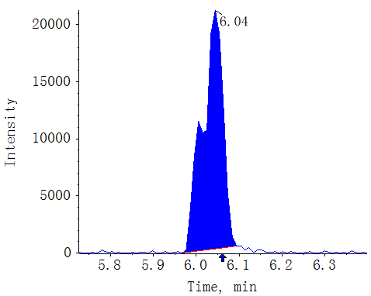
T18-XX-3
JA-Val AREA:6.88e4 S/N:214.6
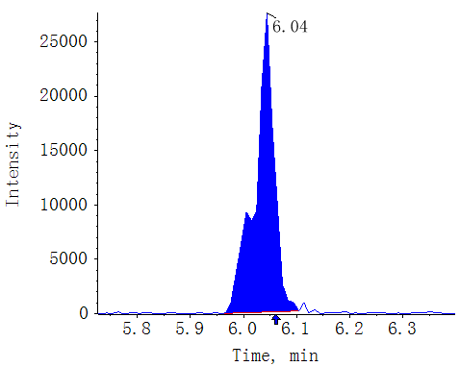
T30-XX-1
JA-Val AREA:2.02e4 S/N:72.8
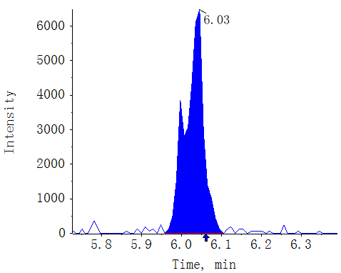
T30-XX-2
JA-Val AREA:1.65e4 S/N:62.4
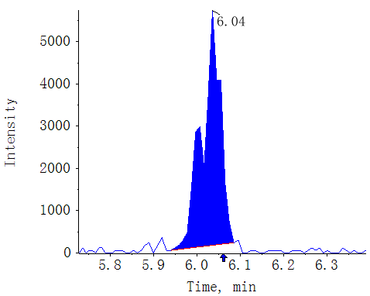
T30-XX-3
JA-Val AREA:1.55e4 S/N:63.3
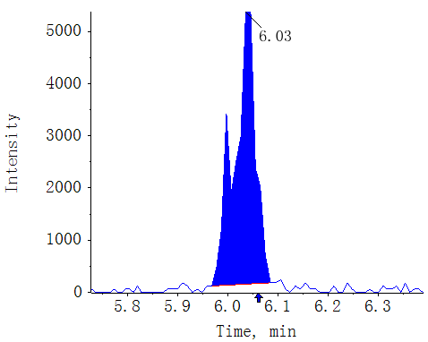

Compound name: SAG

Regression Equation: y = 0.04531 x + 0.00109 (r = 0.99612) (weighting: 1 / x^2)
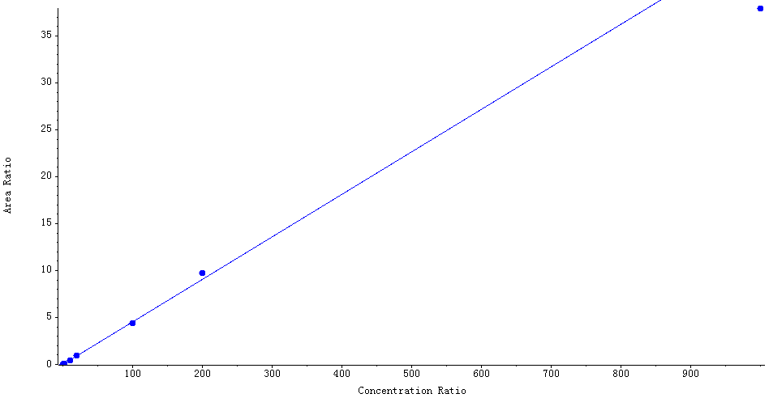

Peak Review
Blank
SAG AREA:N/A S/N:N/A
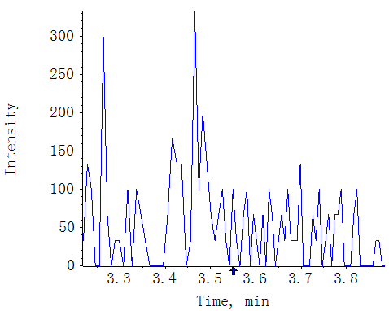
MWMS_20210617_1
SAG AREA:4.39e6 S/N:601.7
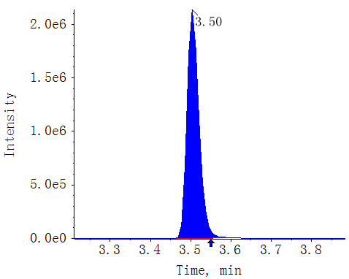
CK-GS87-1
SAG AREA:4.82e7 S/N:731.9
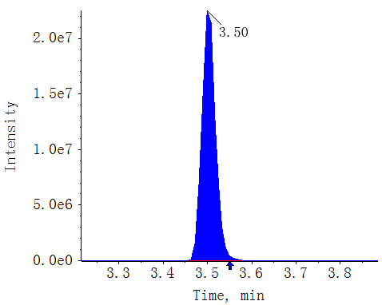
CK-GS87-2
SAG AREA:6.22e7 S/N:653.2
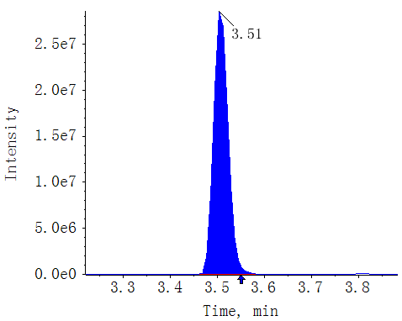
CK-GS87-3
SAG AREA:3.91e7 S/N:562.8
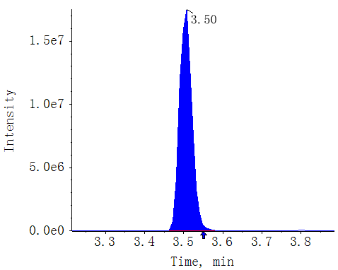
T0-GS87-1
SAG AREA:2.80e7 S/N:884.3
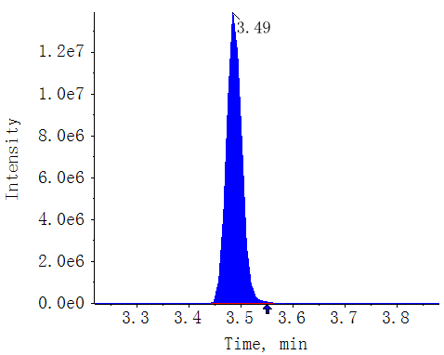
T0-GS87-2
SAG AREA:2.86e7 S/N:524.4
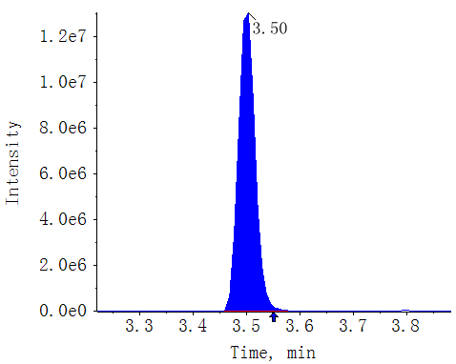
T0-GS87-3
SAG AREA:2.43e7 S/N:512.2
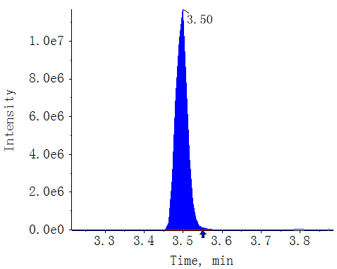
T18-GS87-1
SAG AREA:4.82e6 S/N:684.3
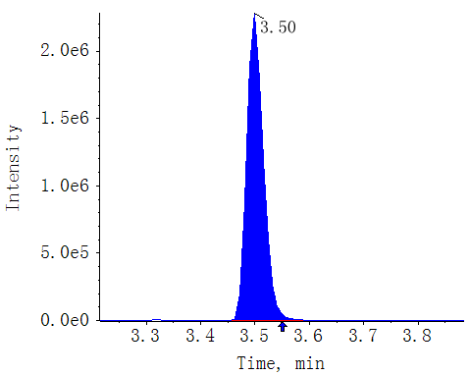
T18-GS87-2
SAG AREA:4.19e6 S/N:478.8
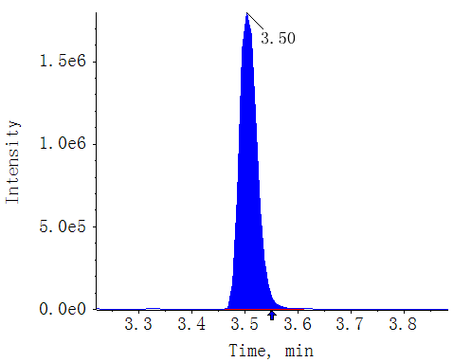
T18-GS87-3
SAG AREA:4.75e6 S/N:571.7
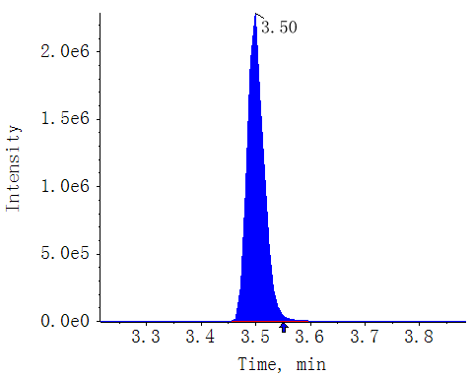
T30-GS87-1
SAG AREA:1.05e5 S/N:173.5
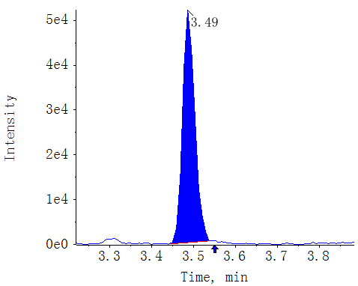
T30-GS87-2
SAG AREA:5.55e4 S/N:127.2
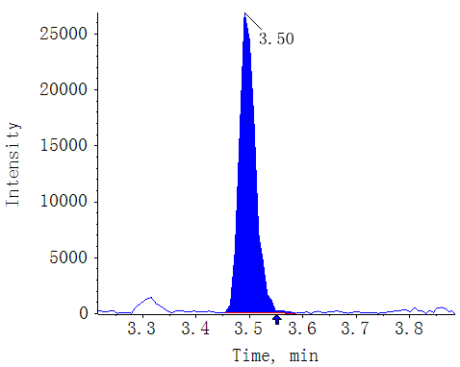
T30-GS87-3
SAG AREA:7.42e4 S/N:134.6
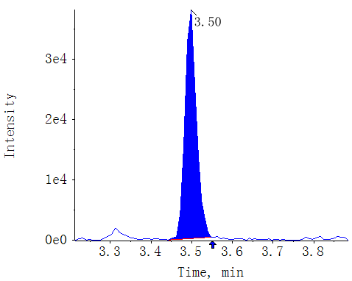
CK-XX-1
SAG AREA:7.15e7 S/N:467.0
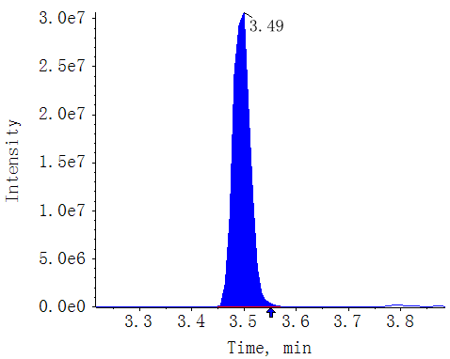
CK-XX-2
SAG AREA:6.96e7 S/N:517.1
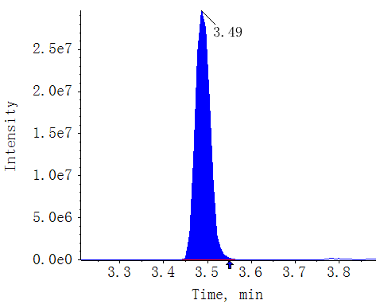
CK-XX-3
SAG AREA:7.13e7 S/N:499.2
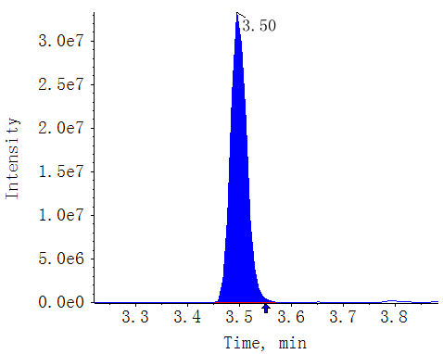
T0-XX-1
SAG AREA:4.77e7 S/N:529.3
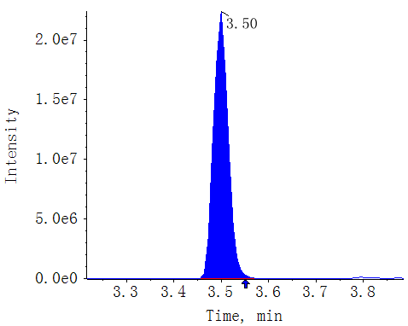
T0-XX-2
SAG AREA:5.13e7 S/N:666.8
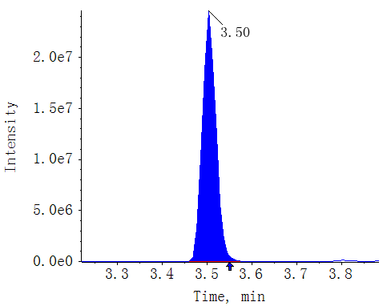
T0-XX-3
SAG AREA:5.11e7 S/N:597.7
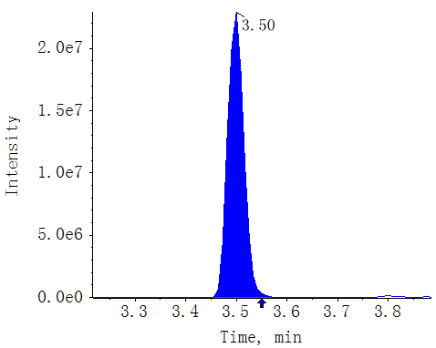
T18-XX-1
SAG AREA:3.80e7 S/N:584.1
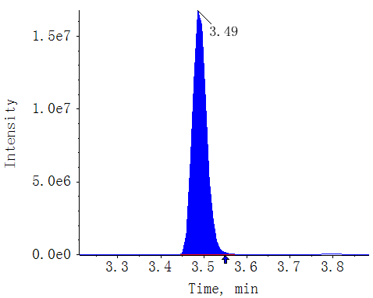
T18-XX-2
SAG AREA:4.17e7 S/N:483.4
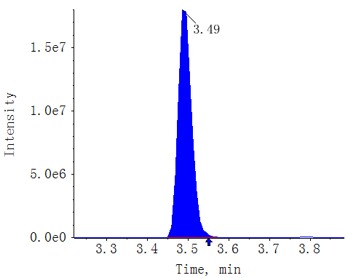
T18-XX-3
SAG AREA:4.07e7 S/N:524.7
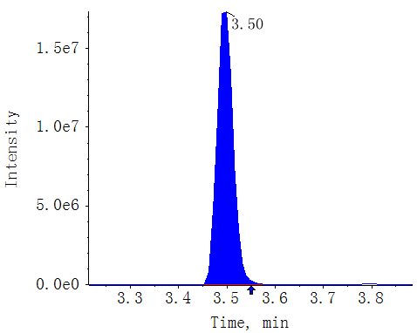
T30-XX-1
SAG AREA:3.46e7 S/N:784.7
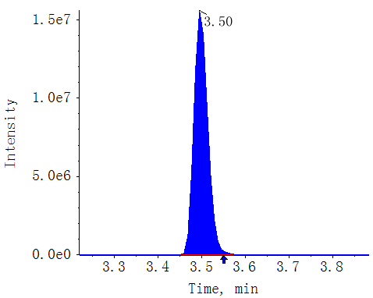
T30-XX-2
SAG AREA:3.39e7 S/N:589.4
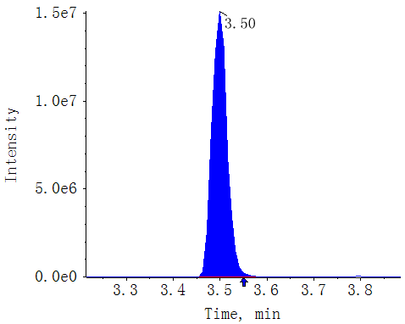
T30-XX-3
SAG AREA:3.30e7 S/N:613.4
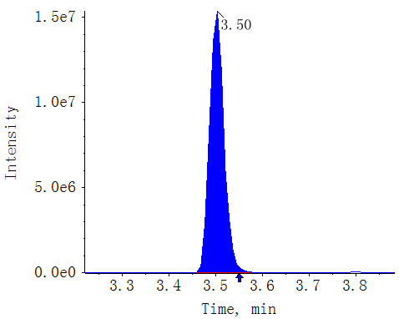

Compound name: SA

Regression Equation: y = 0.11344 x + 0.05839 (r = 0.99787) (weighting: 1 / x)
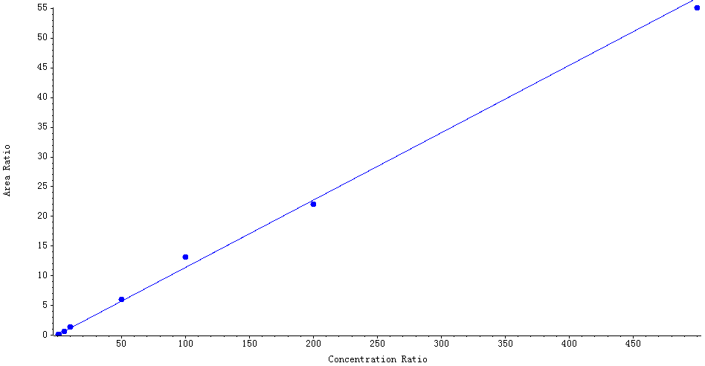

Peak Review
Blank
SA AREA:N/A S/N:N/A
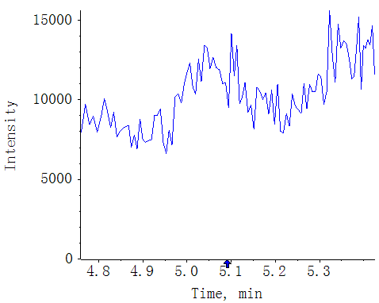
MWMS_20210617_1
SA AREA:9.11e5 S/N:175.7
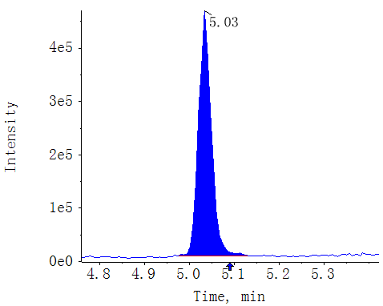
CK-GS87-1
SA AREA:7.12e5 S/N:72.4
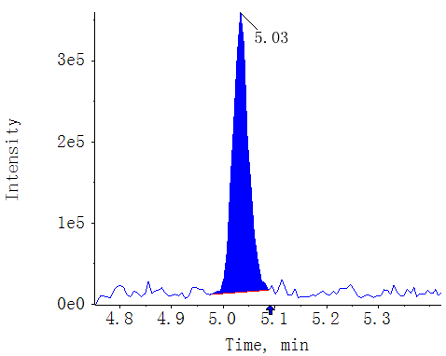
CK-GS87-2
SA AREA:7.78e5 S/N:84.2
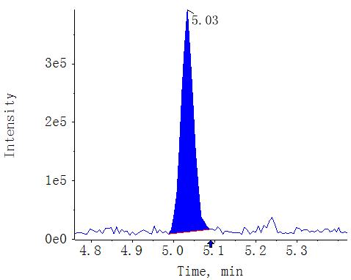
CK-GS87-3
SA AREA:6.73e5 S/N:80.2
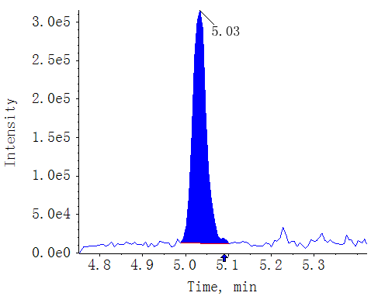
T0-GS87-1
SA AREA:4.49e5 S/N:76.8
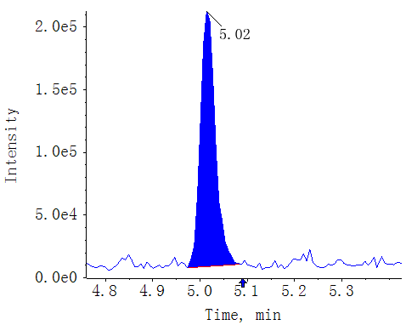
T0-GS87-2
SA AREA:4.42e5 S/N:68.0
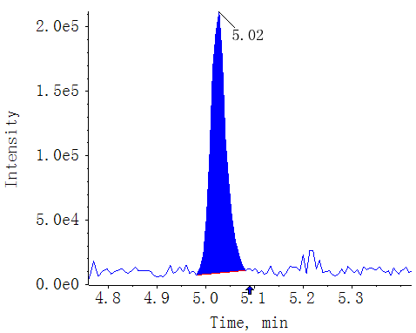
T0-GS87-3
SA AREA:4.58e5 S/N:64.0
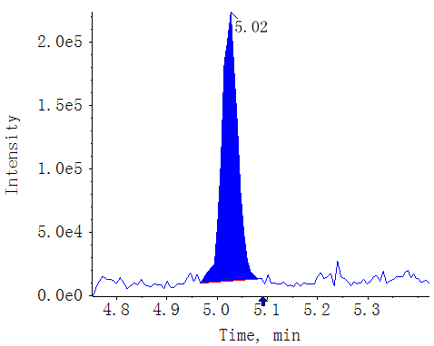
T18-GS87-1
SA AREA:4.19e6 S/N:331.6
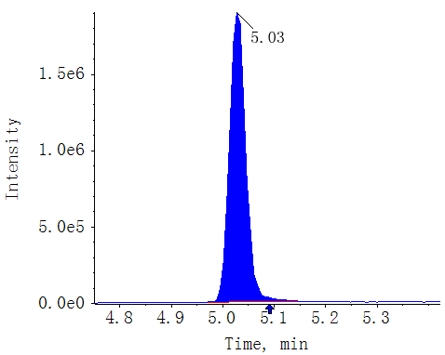
T18-GS87-2
SA AREA:4.63e6 S/N:428.8
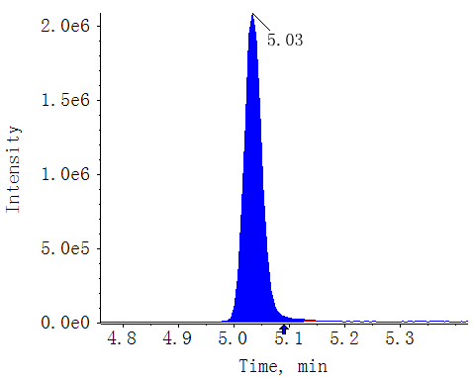
T18-GS87-3
SA AREA:4.30e6 S/N:421.7
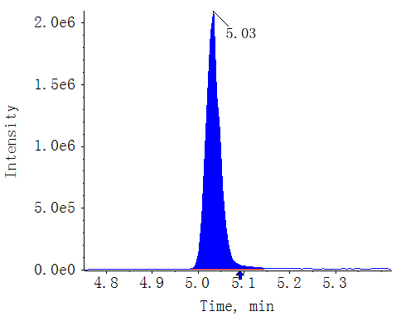
T30-GS87-1
SA AREA:2.06e6 S/N:228.5
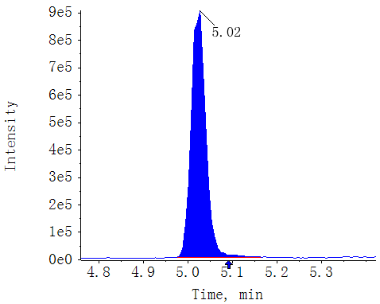
T30-GS87-2
SA AREA:2.51e6 S/N:347.0
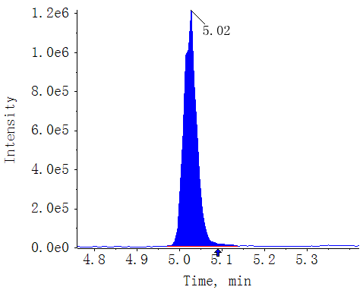
T30-GS87-3
SA AREA:2.38e6 S/N:381.1
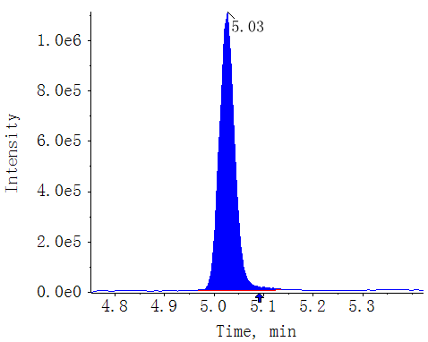
CK-XX-1
SA AREA:2.26e6 S/N:120.0
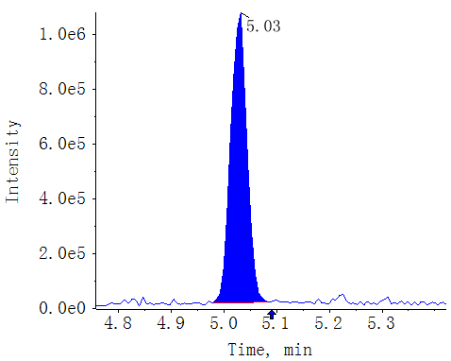
CK-XX-2
SA AREA:2.07e6 S/N:138.6
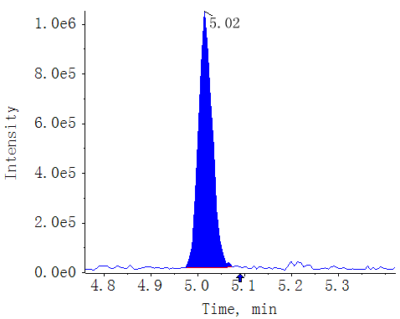
CK-XX-3
SA AREA:1.96e6 S/N:130.2
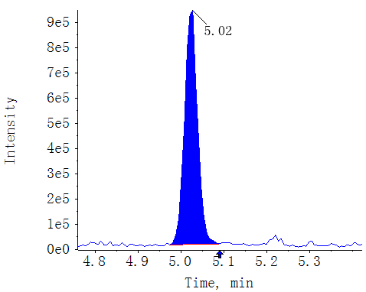
T0-XX-1
SA AREA:1.03e6 S/N:84.1
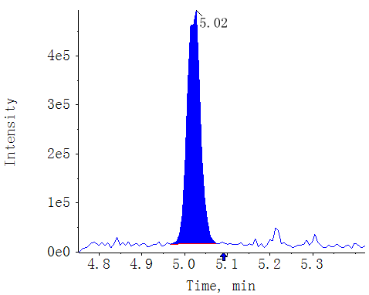
T0-XX-2
SA AREA:1.10e6 S/N:91.9
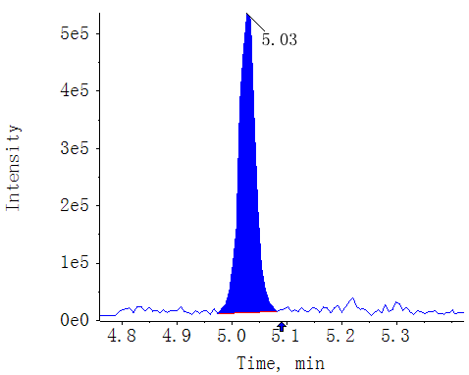
T0-XX-3
SA AREA:1.19e6 S/N:103.1
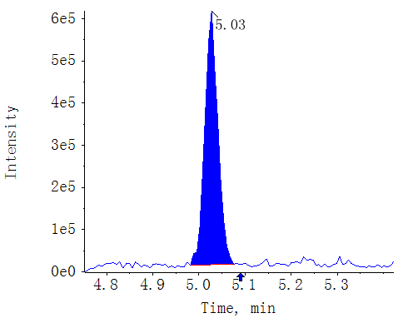
T18-XX-1
SA AREA:9.80e6 S/N:374.9
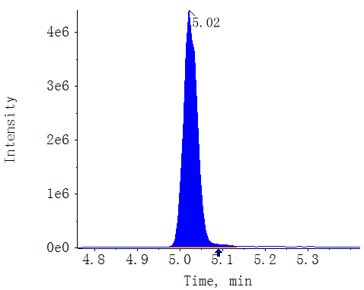
T18-XX-2
SA AREA:1.02e7 S/N:359.9
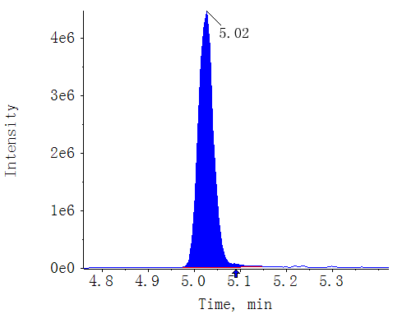
T18-XX-3
SA AREA:9.29e6 S/N:348.8
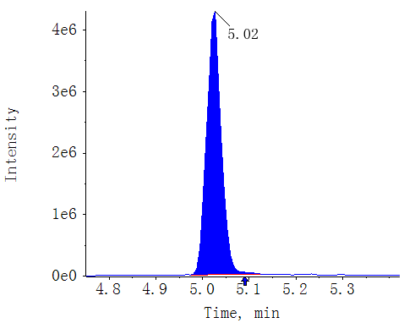
T30-XX-1
SA AREA:9.22e6 S/N:424.0
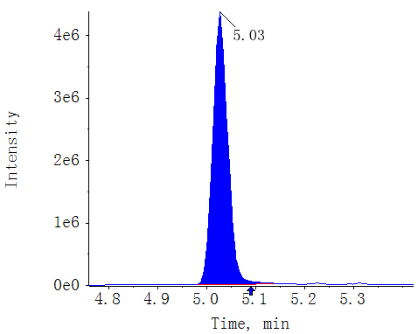
T30-XX-2
SA AREA:8.21e6 S/N:369.5
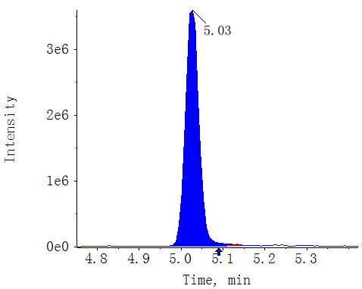
T30-XX-3
SA AREA:8.36e6 S/N:328.4
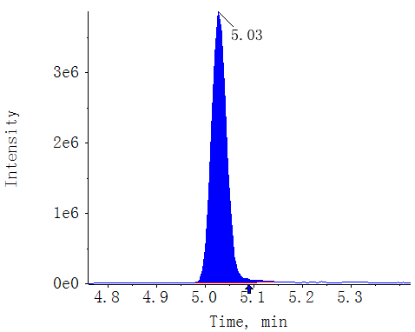
Fig. S4. The regression equation and extracted ion chromatograms (EICs) of JAs and SAs detected in each replicates of GS87 and XX.
Supplementary Figure 5:
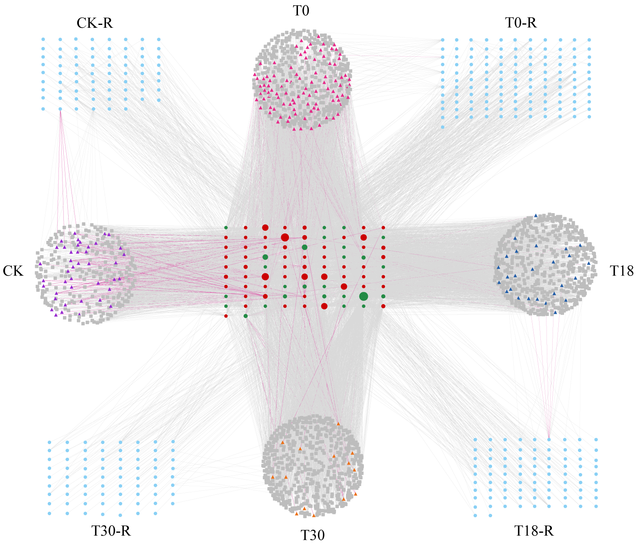
Fig. S5. Protein-Protein interaction (PPI) network lined by 2,338 proteins collected from four comparisons. Red dots: R proteins shared at four treatments. Green dots: R proteins shared at 0, 18, and 30 hpi. Light blue dots: R proteins unique at each treatment. Triangles: TFs. Squares: proteins of other types. Pink lines highlighted the interactions of R and WRKY proteins, and the grey lines highlighted the other type of interactions.

