Additional file 5 Predictions using independent model from external data.
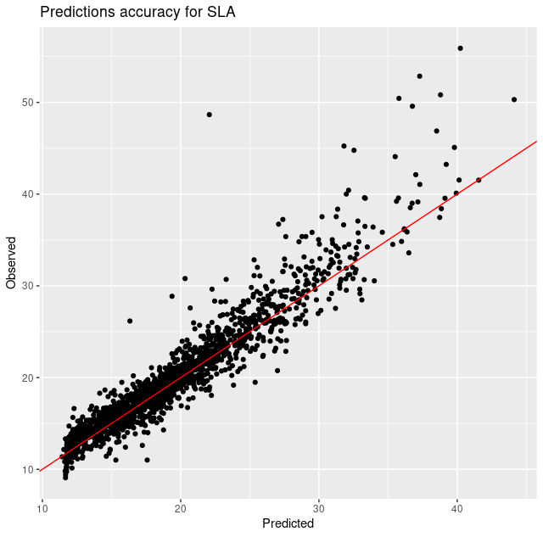
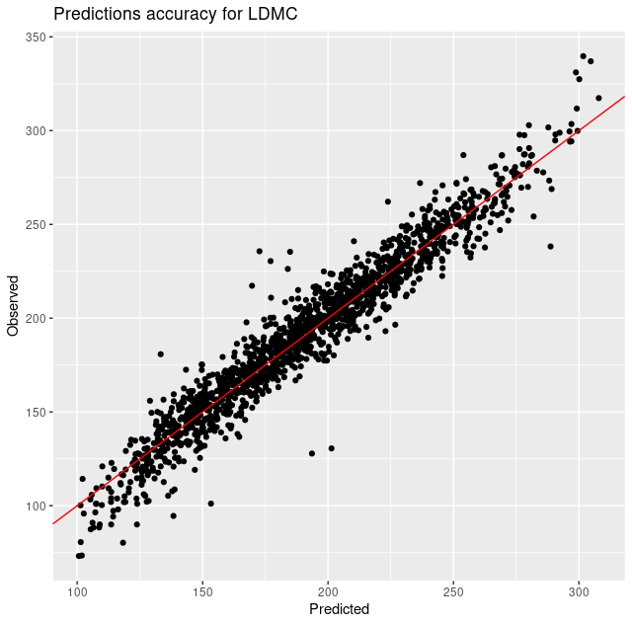

An external dataset of 1567 unique spectra associated with trait values has been used to build independent models through the “Predict traits with you own model” option of NIRSpredict. Then, those models have been used to make predictions. The comparison between predicted and observed values is represented here for SLA (A) and LDMC (B) showing a high accuracy (mean accuracy of respectively 93.6% and 95.6% for these two traits).

