Appendices of manuscript “Jingkun Zhang, Wanying Yu, Yuan Wang, Zhenying Huang, Yuejun He, Guofang Liu. Effects of climate, soil and leaf traits on nutrient resorption efficiency and proficiency of different plant functional types across arid and semiarid regions of northwest China. BMC Plant Biology.”

Table caption
Table S1 The plant species information and affiliated genus and family.
Table S2 The relationships between climate PC1 and MAT or MAP, between soil PC1 and soil N, P, N:P, sand content, pH, and between trait PC1 and leaf N, P, specific leaf area (SLA) and leaf dry matter content (LDMC).
Table S3 The results of random effects in linear mixed-effects models assessing fixed terms including climate, soil, and leaf traits and random terms including plant species and site on leaf nutrient resorption for each PFT.
Table S4 The standardized direct, indirect and total effects of predictors on leaf nutrient resorption (NRE and PRE) and senesced leaf N and P concentrations. Soil, climate and trait denotes the first axis of principal component analyses on soil properties, climate variables, and leaf traits, respectively.

Figure legends
Fig. S1 The sample sites collected in the study are shown on a map of China.
Fig. S2 Relationships between leaf N and P resorption efficiency and senesced leaf N and P and climate variables. The solid line denote a significant relationship at p < 0.05. The dashed line denotes a marginally significant relationship at 0.05 < p < 0.1. The red, green, and blue colors represent non-legume herbs, non-legume shrubs, and legumes, respectively.
Fig. S3 Biplot of principal component analysis representing a drought gradient.
Fig. S4 Relationships between leaf N resorption efficiency and senesced leaf N and soil variables. The solid line denote a significant relationship at p < 0.05. The dashed line denotes a marginally significant relationship at 0.05 < p < 0.1. The red, green, and blue colors represent non-legume herbs, non-legume shrubs, and legumes, respectively.
Fig. S5 Relationships between leaf P resorption efficiency and senesced leaf P and soil variables. The solid line denote a significant relationship at p < 0.05. The dashed line denotes a marginally significant relationship at 0.05 < p < 0.1. The red, green, and blue colors represent non-legume herbs, non-legume shrubs, and legumes, respectively.
Fig. S6 Biplot of principal component analysis representing a soil fertility gradient.
Fig. S7 Relationships between leaf N resorption efficiency and senesced leaf N and specific leaf area (SLA), and leaf dry matter content (LDMC). The solid line denote a significant relationship at p < 0.05. The dashed line denotes a marginally significant relationship at 0.05 < p < 0.1. The red, green, and blue colors represent non-legume herbs, non-legume shrubs, and legumes, respectively.
Fig. S8 Relationships between leaf N and P resorption efficiency (NRE and PRE) and senesced leaf N and P concentrations and green leaf N and P concentrations for each PFTs. The solid line denotes a significant relationship at p < 0.05. The red, green, and blue colors represent non-legume herbs, non-legume shrubs, and legumes, respectively.
Fig. S9 Biplot of principal component analysis representing leaf economics spectrum.

Table S1
PFT | Species | Genus | Family
Non-legume herbs | Stipa grandis | Stipa | Gramineae
 | Leymus chinensis | Leymus | Gramineae
 | Achnatherum splendens | Achnatherum | Gramineae
 | Leymus secalinus | Leymus | Gramineae
 | Pennisetum flaccidum | Pennisetum | Gramineae
 | Echinops gmelinii | Echinops | Compositae
 | Psammochloa villosa | Psammochloa | Gramineae
 | Agropyron cristatum | Agropyron | Gramineae
 | Stipa krylovii | Stipa | Gramineae
 | Calamagrostis pseudophragmites | Calamagrostis | Gramineae
 | Agriophyllum squarrosum | Agriophyllum | Chenopodiaceae
 | Stipa mongolorum | Stipa | Gramineae
 | Agropyron mongolicum | Agropyron | Gramineae
 | Cynanchum hancockianum | Cynanchum | Asclepiadaceae
 | Peganum nigellastrum | peganum | Zygophyllaceae
 | Carex duriuscula | Carex | Cyperaceae
 | Jurinea mongolica | Jurinea | Compositae
 | Zygophyllum xanthoxylon | Sarcozygium | Zygophyllaceae
 | Allium alabasicum | Allium | Liliaceae
 | Lagochilus ilicifolius | Lagochilus | Labiatae
 | Cleistogenes squarrosa | Cleistogenes | Gramineae
 | Setaria viridis | Setaria | Gramineae
 | Phragmites australis | Phragmites | Gramineae
 | Iris lactea | Iris | Iridaceae
 | Stellera chamaejasme | Stellera | Thymelaeaceae
 | Aeluropus pungens | Aeluropus | Gramineae
 | Stipa capillata | Stipa | Gramineae
 | Tragus mongolorum | Tragus | Gramineae
 | Allium mongolicum | Allium | Liliaceae
 | Enneapogon borealis | Enneapogon | Gramineae
 | Iridaceae | Iris | Iridaceae
 | Stipa breviflora | Stipa | Gramineae
 | Cleistogenes songorica | Cleistogenes | Gramineae
 | Eragrostis pilosa | Eragrostis | Gramineae
 | Salsola collina | Salsola | Chenopodiaceae
Non-legume shrubs | Artemisia ordosica | Artemisia | Compositae
 | Artemisia sphaerocephala | Artemisia | Compositae
 | Artemisia xerophytica | Artemisia | Compositae
 | Caryopteris mongholica | Caryopteris | Verbenaceae
 | Ceratoides latens | Ceratoides | Chenopodiaceae
 | Salsola arbuscula | Salsola | Chenopodiaceae
 | Nitraria roborowskii | Nitraria | Zygophyllaceae
 | Reaumuria songarica | Reaumuria | Tamaricaceae
 | Atraphaxis bracteata | Atraphaxis | Polygonaceae
 | Ephedra sinica | Ephedra | Ephedraceae
 | Kalidium gracile | Kalidium | Chenopodiaceae
 | Salix psammophila | Salix | Salicaceae
 | Convolvulus tragacanthoides | Convolvulus | Convolvulaceae
Legumes | Caragana korshinskii | Caragana | Leguminosae
 | Thermopsis lanceolata | Thermopsis | Leguminosae
 | Oxytropis aciphylla | Oxytropis | Leguminosae
 | Lespedeza davurica | Lespedeza | Leguminosae
 | Ammopiptanthus mongolicus | Ammopiptanthus | Leguminosae
 | Sophora alopecuroides | Sophora | Leguminosae
 | Hedysarum fruticosum | Hedysarum | Leguminosae
 | Vicia sepium | Vicia | Leguminosae
 | Glycyrrhiza uralensis | Glycyrrhiza | Leguminosae
 | Hedysarum scoparium | Hedysarum | Leguminosae
 | Caragana stenophylla | Caragana | Leguminosae

Table S2
 | Climate PC1 |  |  | Trait PC1 |  |  | Soil PC1
 |  | r | p |  | r | p |  | r | p
Total
 | MAT | 0.65 | <0.001 | Green leaf N | -0.72 | <0.001 | Soil N | 0.84 | <0.001
 | MAP | -0.70 | <0.001 | Green leaf P | -0.76 | <0.001 | Soil P | 0.70 | <0.001
 |  |  |  | SLA | -0.63 | <0.001 | Soil N/P | 0.68 | <0.001
 |  |  |  | LDMC | 0.65 | <0.001 | Soil sand | -0.76 | <0.001
 |  |  |  |  |  |  | pH | -0.39 | <0.001
Non-legumes herbs
 | MAT | 0.85 | <0.001 | Green leaf N | -0.74 | <0.001 | Soil N | 0.96 | <0.001
 | MAP | -0.84 | <0.001 | Green leaf P | -0.77 | <0.001 | Soil P | 0.81 | <0.001
 |  |  |  | SLA | -0.69 | <0.001 | Soil N/P | 0.73 | <0.001
 |  |  |  | LDMC | 0.69 | <0.001 | Soil sand | -0.86 | <0.001
 |  |  |  |  |  |  | pH | -0.26 | 0.02
Non-legumes shrubs
 | MAT | 0.84 | <0.001 | Green leaf N | -0.81 | <0.001 | Soil N | 0.96 | <0.001
 | MAP | -0.88 | <0.001 | Green leaf P | -0.81 | <0.001 | Soil P | 0.73 | <0.001
 |  |  |  | SLA | -0.36 | 0.02 | Soil N/P | 0.81 | <0.001
 |  |  |  | LDMC | 0.47 | 0.002 | Soil sand | -0.81 | <0.001
 |  |  |  |  |  |  | pH | -0.53 | <0.001
Legumes
 | MAT | 0.82 | <0.001 | Green leaf N | -0.69 | <0.001 | Soil N | 0.96 | <0.001
 | MAP | -0.84 | <0.001 | Green leaf P | -0.88 | <0.001 | Soil P | 0.86 | <0.001
 |  |  |  | SLA | -0.69 | <0.001 | Soil N/P | 0.78 | <0.001
 |  |  |  | LDMC | 0.57 | <0.001 | Soil sand | -0.87 | <0.001
 |  |  |  |  |  |  | pH | -0.28 | 0.093

Table S3
 | NRE |  | PRE |  | Senesced leaf N |  | Senesced leaf P
 | Site | Species | Site | Species | Site | Species | Site | Species
 | p | p | p | p | p | p | P | p
Non-legume herbs | 0.122 | 0.002 | 0.028 | 0.002 | 0.002 | <0.001 | 0.016 | <0.001
Non-legume shrubs | 1 | 0.009 | 1 | 1 | 1 | 0.057 | 1 | 0.336
Legumes | 0.003 | 0.613 | 0.1208 | 1 | 1 | 0.003 | 0.294 | 0.467

Table S4
 |  |  | Predictors
 | Response variable | Effects | Climate PC1 | Soil PC1 | Trait PC1
Non-legume herbs
 | NRE | Total | -0.1772
 |  | Direct | -0.1772
 |  | Indirect
 | PRE | Total | -0.1084
 |  | Direct | -0.1084
 |  | Indirect
 | Senesced leaf N | Total | 0.343 | -0.0779 | -0.312
 |  | Direct | 0.2689 |  | -0.312
 |  | Indirect | 0.0741 | -0.0779
 | Senesced leaf P | Total | 0.1366 | -0.1436 | -0.5751
 |  | Direct |  |  | -0.5751
 |  | Indirect | 0.1397 | -0.1466
Non-legume shrubs
 | NRE | Total |  | -0.269
 |  | Direct |  | -0.269
 |  | Indirect
 | PRE | Total
 |  | Direct
 |  | Indirect
 | Senesced leaf N | Total |  | 0.3542 | -0.3129
 |  | Direct |  | 0.3542 | -0.3129
 |  | Indirect
 | Senesced leaf P | Total |  |  | -0.5228
 |  | Direct |  |  | -0.5228
 |  | Indirect
Legumes
 | NRE | Total | 0.2934 |  | -0.3092
 |  | Direct | 0.2934 |  | -0.3092
 |  | Indirect
 | PRE | Total |  | 0.2956 | -0.1801
 |  | Direct |  | 0.2956 | -0.1801
 |  | Indirect
 | Senesced leaf N | Total |  |  | -0.4256
 |  | Direct |  |  | -0.4256
 |  | Indirect
 | Senesced leaf P | Total | -0.3362 |  | -0.5702
 |  | Direct | -0.3362 |  | -0.5702
 |  | Indirect

Fig. S1
Fig. S2
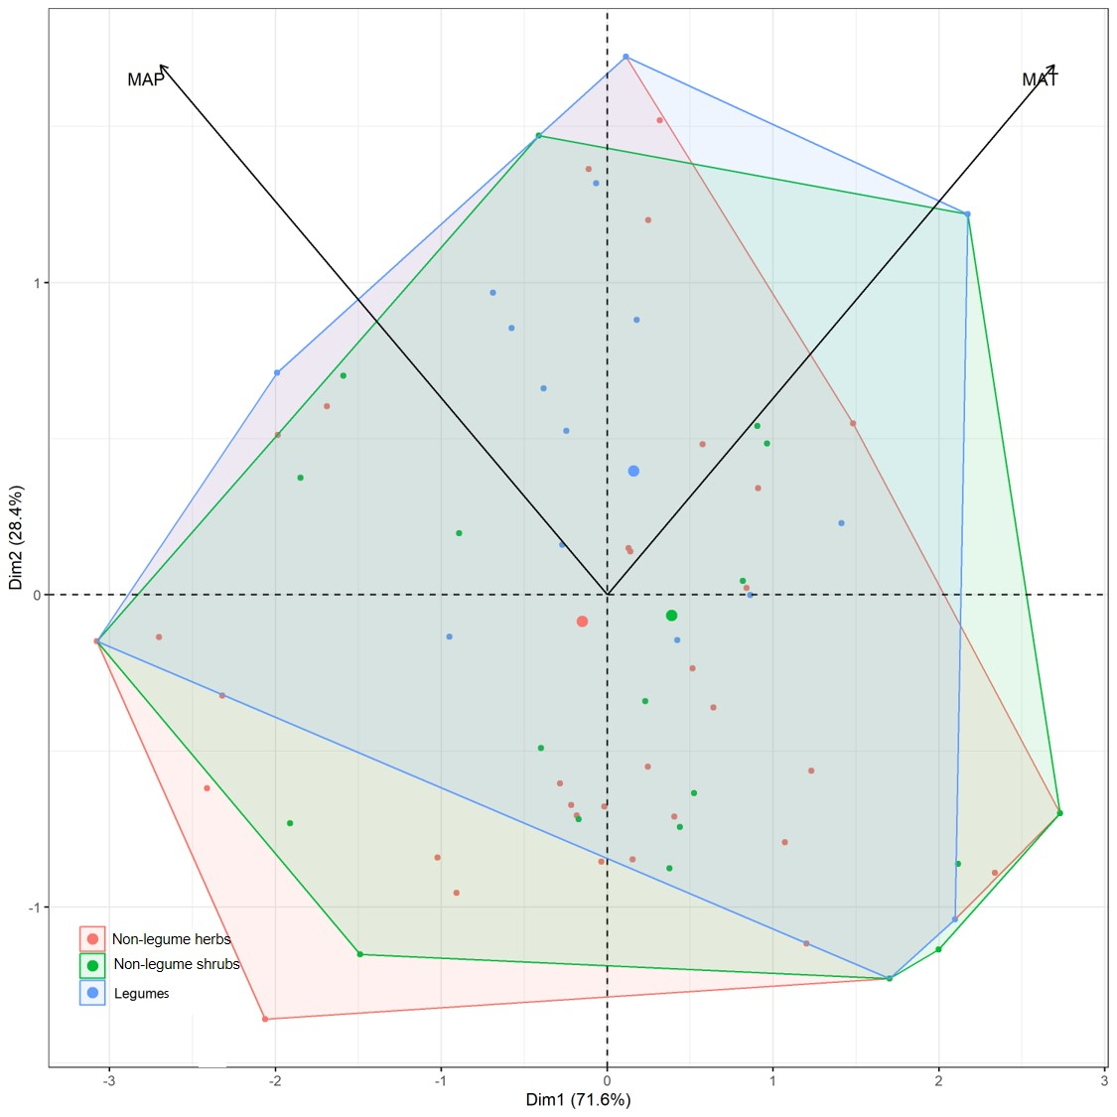

Fig. S3

Fig. S4
Fig. S5
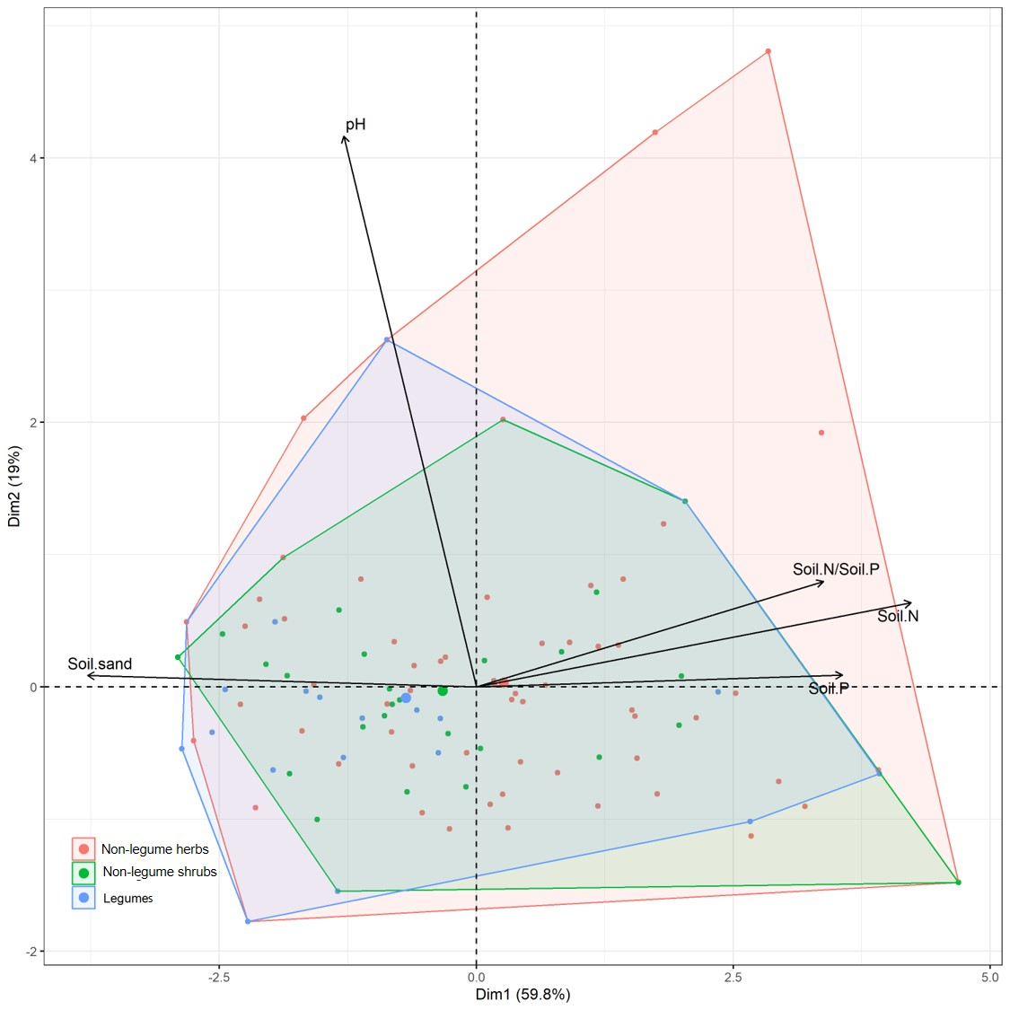Fig. S6

Fig.S7
Fig. S8
Fig. S9

