Supplementary Material
Exploration of key genes and pathways in response to submergence stress in red clover (Trifolium pratense L.) by WGCNA
Panpan Shang¹, Lei Bi¹, Wenwen Li¹, Xiaoli Zhou¹, Yanlong Feng¹, Jiahai Wu^{2 *}, Bing Zeng^{1 *}
* Correspondence: Bing Zeng:zbin78@163.com ；Jiahai Wu: 1848266168@qq.com

Supplementary Figures and Tables

Supplementary Figures
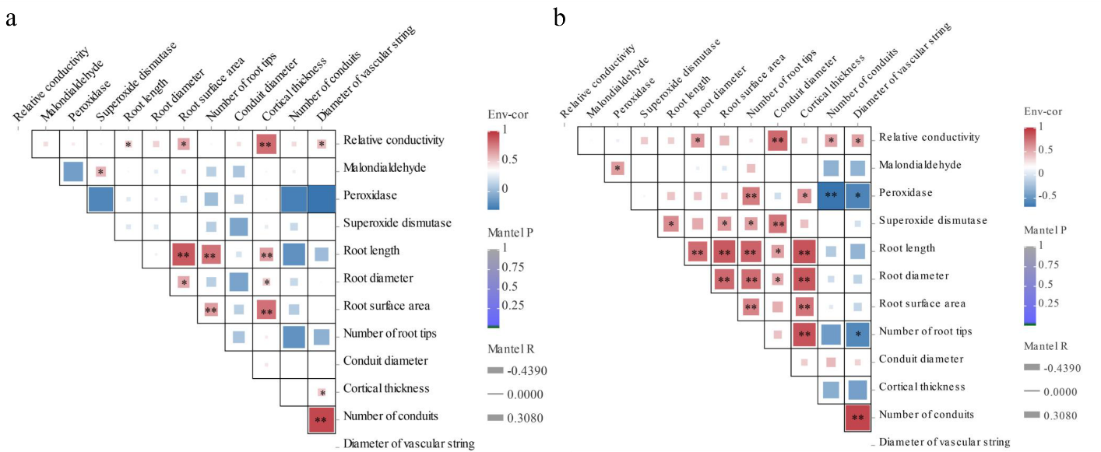
Fig. S1 Correlation analysis plot for each physiological trait of HL(a) and ZY(b). * Indicates significant differences between traits(P＜0.01). ** denotes highly significant differences between traits (P＜0.01).
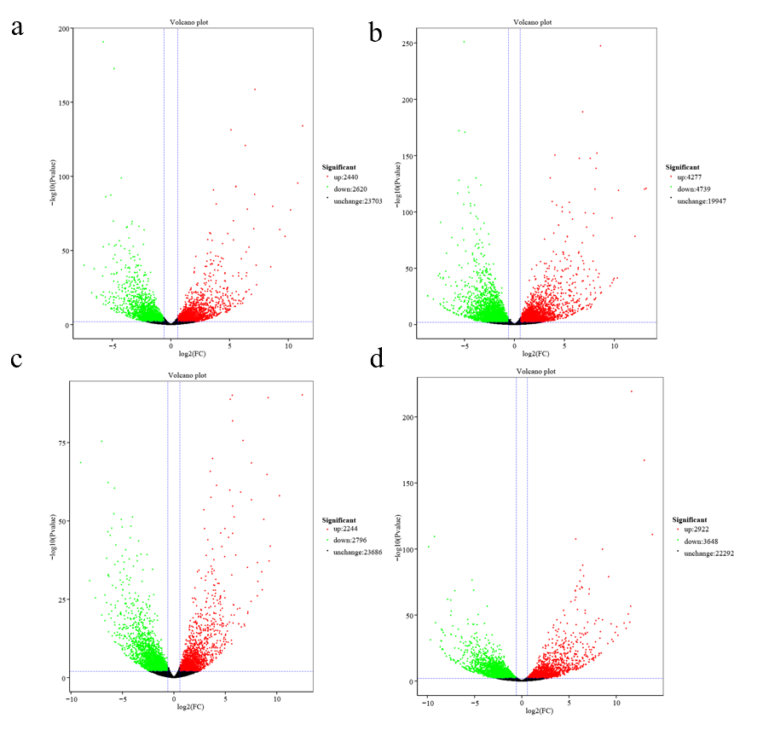
Fig. S2 Volcano plot of differentially expressed genes in each treatment group under submergence stress. (a) H8h vs 0h (b) H24h vs 0h (c) Z8h vs 0h (d) Z24h vs 0h
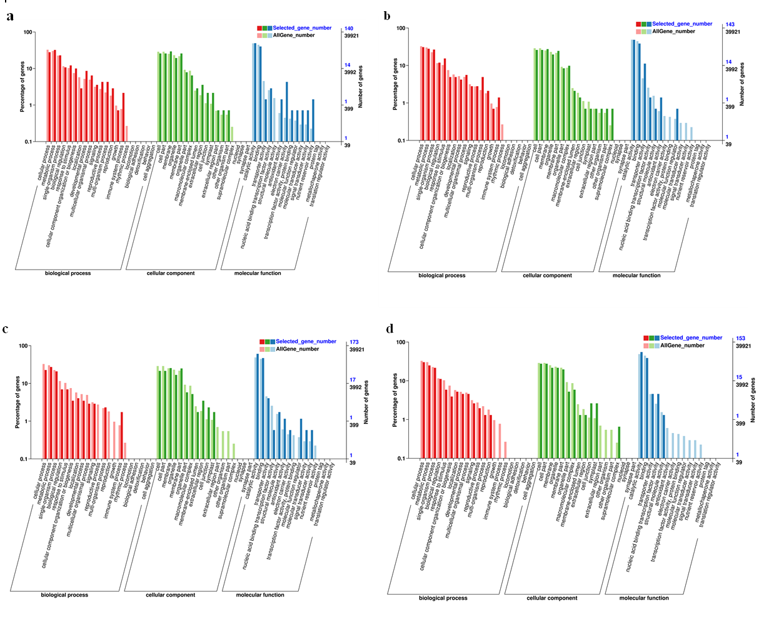
Fig. S3 Histogram of GO enrichment analysis under (a)cyan, (b)purple, (c) lightcyan and (d) ivory module.

Supplementary Tables
Table S1 Primers of differentially expressed genes.
Primer | Forward primers （5′-3′） | Reverse primers （5′-3′）
gene623 | GGGCAGAGTCCGTGGTATGATAATC | AAAGATCGCTGGGTTGCTCGTG
gene26262  gene11075 | CAACAACAAACACCACCACCAACG  TCTCTACGGTATGATCAACGATGCA | TTGAGTTACGACGGAGCAACACTG  CCCCCATGGTCTTCTCCTAACA
gene44440 | CACCACAACCACAATCACAACCATC | GCTCCGCTACAACGTGCTAGTG
gene21760 | CCCCAACTTGAGTCAGAAGCATC | TCCCTTTGATGTGCTGCACC
gene21720 | CGGATGAGTTAGGCGGATGGTTG | CGACATCTCCTCTTCTCCCAACATC
gene21305 | TCATCCCCTAAGAGGCCATACAGAG | CTGCTTCAGCGGTATCAAATGTTCC
gene3571 | TGACTTGCTCAACAATCCAGACCTC | GGCATGATGGCTTCGGTGACTG
GAPDH | TCTGACCGTTAGACTTGAGAAGG | CTTGAGCTTACCCTCAGACTCCT
Table S2 PCR reaction system.
Reagent | Dosage
TB Green Premix Ex Taq || (Tli RNaseH Plus) (2×) | 5μl
PCR Forward Primer(10μM) | 0.4μl
PCR Reverse Primer(10μM) | 0.4μl
ROX Reference Dye or Dye || (50×) *3 | 0.2μl
RT reaction solution (cDNA solution) | 1μl
Sterilized water | 3μl
Total | 10μl
Table S3 Basic statistics for quality control of sequencing reads and comparison with reference genomes.
Sample | Clean reads | Clean bases | GC Content | %≥Q30 | Mapped Reads
H0-1 | 21,397,140 | 6,395,717,310 | 41.76% | 93.95% | 35,486,057 (82.92%)
H0-2 | 21,857,534 | 6,532,928,926 | 41.69% | 94.09% | 36,362,495 (83.18%)
H0-3 | 19,569,973 | 5,851,935,352 | 41.57% | 93.94% | 32,347,565 (82.65%)
H8-1 | 23,040,082 | 6,890,947,266 | 42.35% | 94.36% | 37,362,124 (81.08%)
H8-2 | 19,333,333 | 5,775,427,470 | 43.44% | 94.31% | 30,216,711 (78.15%)
H8-3 | 26,332,328 | 7,873,279,856 | 41.72% | 94.44% | 43,972,928 (83.50%)
H24-1 | 18,119,992 | 5,414,773,508 | 42.65% | 94.65% | 28,099,032 (77.54%)
H24-2 | 39,179,129 | 11,705,420,840 | 42.69% | 94.27% | 63,574,337 (81.13%)
H24-3 | 20,547,211 | 6,143,134,312 | 41.70% | 94.30% | 34,030,303 (82.81%)
Z0-1 | 19,739,765 | 5,901,745,678 | 41.30% | 93.85% | 32,355,468 (81.96%)
Z0-2 | 20,924,073 | 6,252,526,708 | 41.84% | 94.12% | 34,717,635 (82.96%)
Z0-3 | 39,937,781 | 11,945,491,318 | 41.30% | 93.58% | 65,651,854 (82.19%)
Z8-1 | 19,142,434 | 5,714,479,222 | 42.77% | 94.23% | 31,441,007 (82.12%)
Z8-2 | 21,178,185 | 6,328,569,660 | 41.91% | 94.85% | 35,345,386 (83.45%)
Z8-3 | 24,685,296 | 7,386,127,964 | 41.85% | 93.91% | 41,213,200 (83.48%)
Z24-1 | 21,494,586 | 6,432,791,842 | 41.48% | 93.69% | 35,368,192 (82.27%)
Z24-2 | 19,631,502 | 5,866,200,904 | 42.23% | 94.64% | 32,247,472 (82.13%)
Z24-3 | 20,457,700 | 6,116,392,246 | 41.67% | 94.51% | 33,651,861 (82.25%)
Table S4 Statistics of differentially expressed genes in different differential groups.
Module | Gene numbers | Module | Gene numbers
grey 60 | 4206 | cyan | 211
darkturquoise | 1636 | darkgreen | 94
darkmagenta | 408 | darkolivegreen | 55
ivory | 249 | lightcyan | 258
lightgreen | 145 | purple | 215
royalblue | 98 | skyblue3 | 43
yellowgreen | 122
Table S5 Metabolic pathway statistics for P < 0.05 in the target module.
Module | Metabolic pathway | P value | Rich factor | Gene numbers
cyan | Flavonoid biosynthesis | 0.002018215 | 5.602079912 | 5
 | Glyoxylate and dicarboxylate metabolism | 0.004346541 | 4.684925236 | 5
 | Carbon metabolism | 0.005736005 | 2.722610837 | 9
 | Fatty acid elongation | 0.006432055 | 7.940948276 | 3
purple | Homologous recombination | 2.73E-05 | 5.6925533 | 9
 | Alanine, aspartate and glutamate metabolism | 0.0003635 | 8.19382672 | 5
lightcyan  ivory | Phenylpropanoid biosynthesis  Nucleotide excision repair  Glycosphingolipid biosynthesis - ganglio series  Other glycan degradation  Sphingolipid metabolism  Glycosaminoglycan degradation  Fatty acid degradation  Fatty acid biosynthesis  Starch and sucrose metabolism  Fatty acid metabolism  Glycosphingolipid biosynthesis - globo and isoglobo series  Sesquiterpenoid and triterpenoid biosynthesis  Carotenoid biosynthesis | 0.00101532  0.00123048  1.52E-05  5.24E-05  6.49E-05  6.66E-05  8.31E-05  0.001009637  0.003382064  0.005091482  0.009390712  0.005868148  0.009875234 | 3.50513699  5.0306285  11.30707856  7.251518219  5.904807692  8.712011349  6.739182692  6.560897436  2.466044976  4.518985479  13.62647929  8.207454707  6.78980344 | 9  6  6  7  8  6  7  5  12  5  2  3  3

