Supplementary material
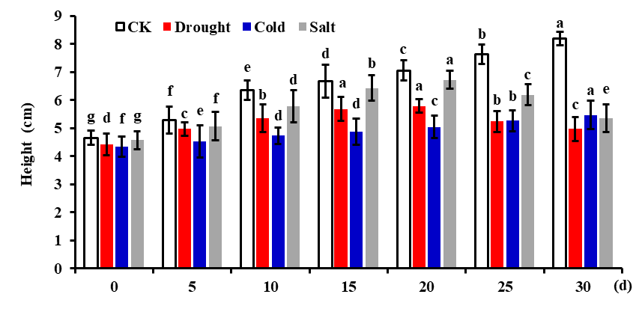
Figure S1. The height of L. gmelinii seedlings under different stress treatments and normal conditions.
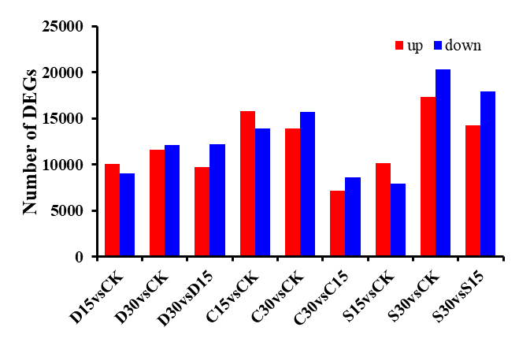
Figure S2. Statistics on the number of DEGs in L. gmelinii seedlings under different stress treatments
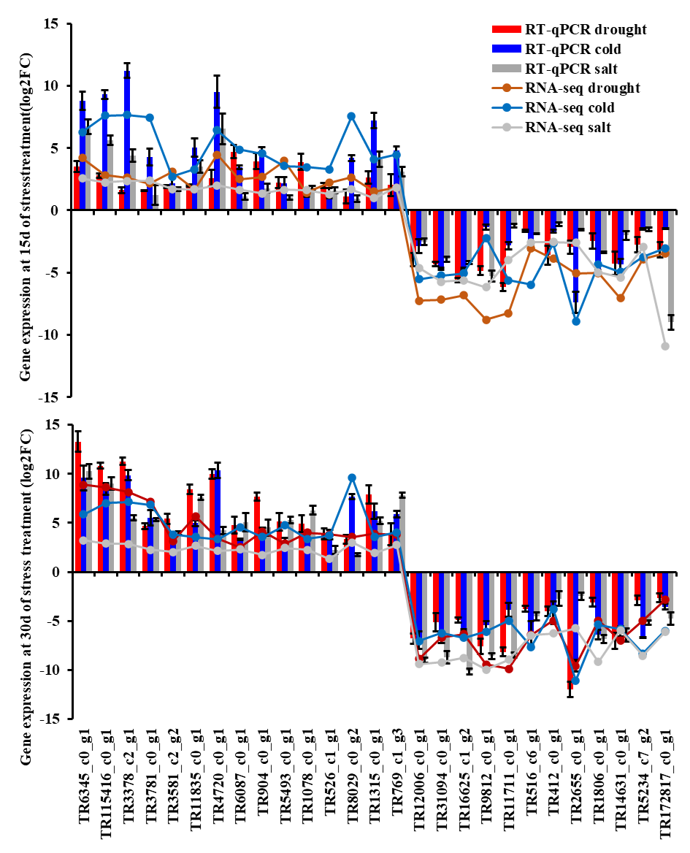
Figure S3. RT-qPCR verifies the expression patterns of 27 DEGs in L. gmelinii seedlings under different stress treatments

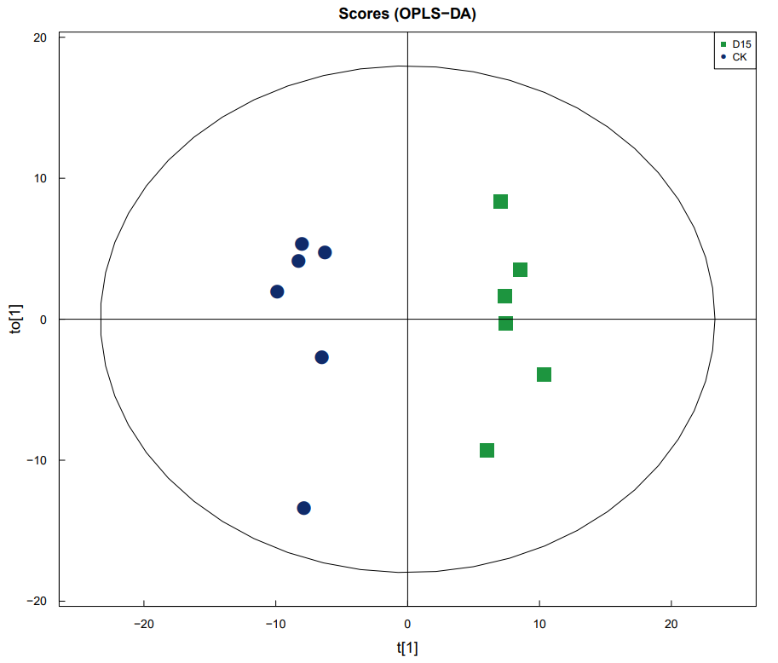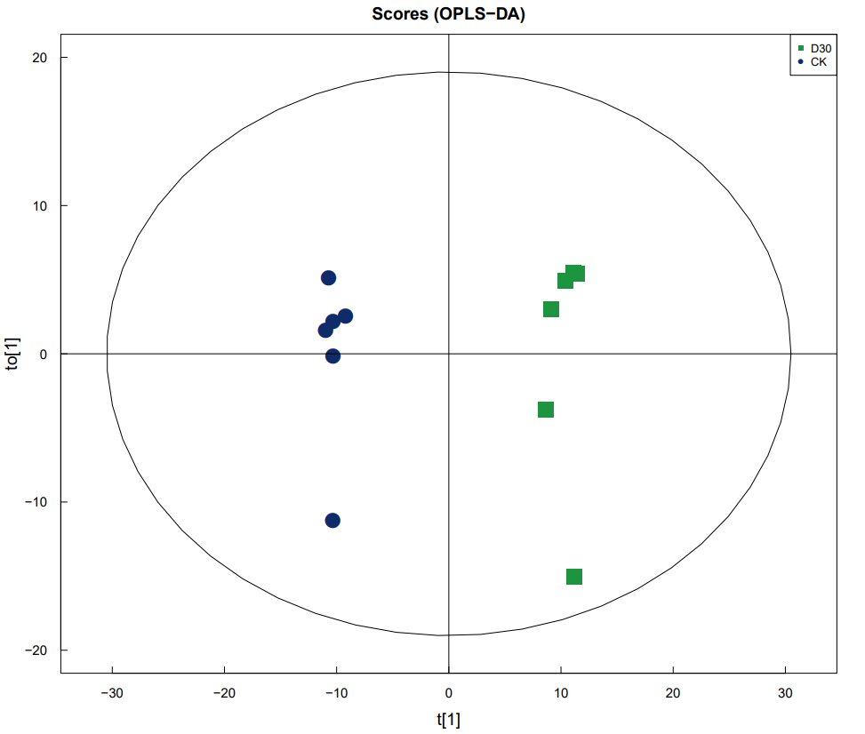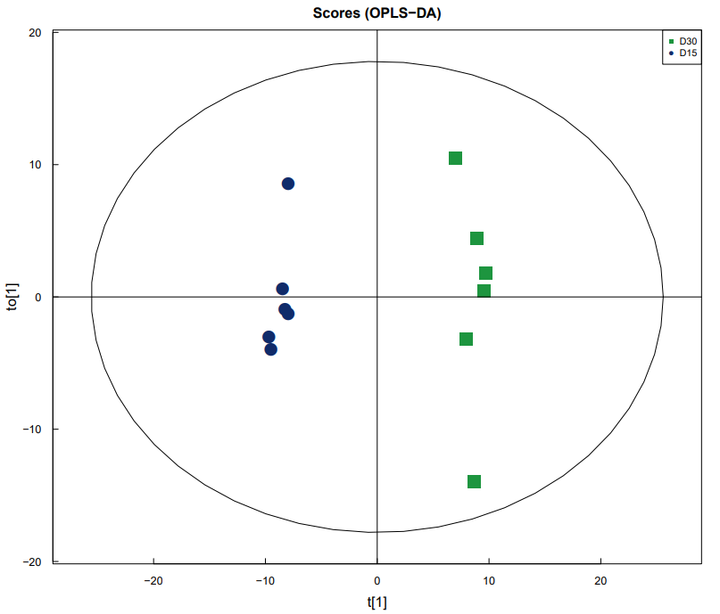
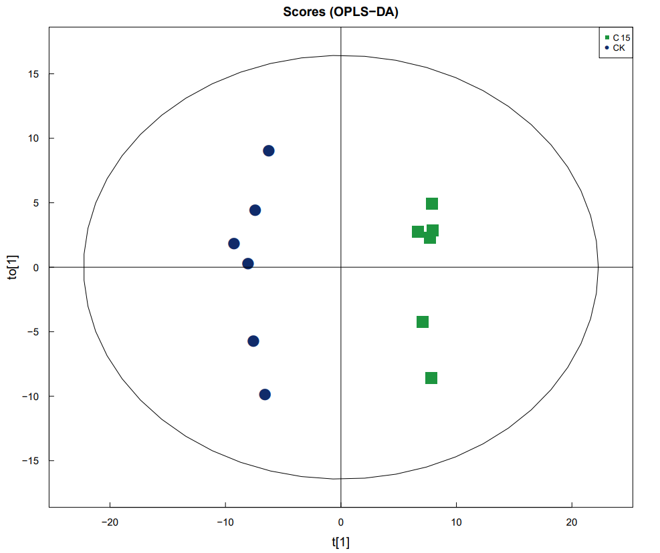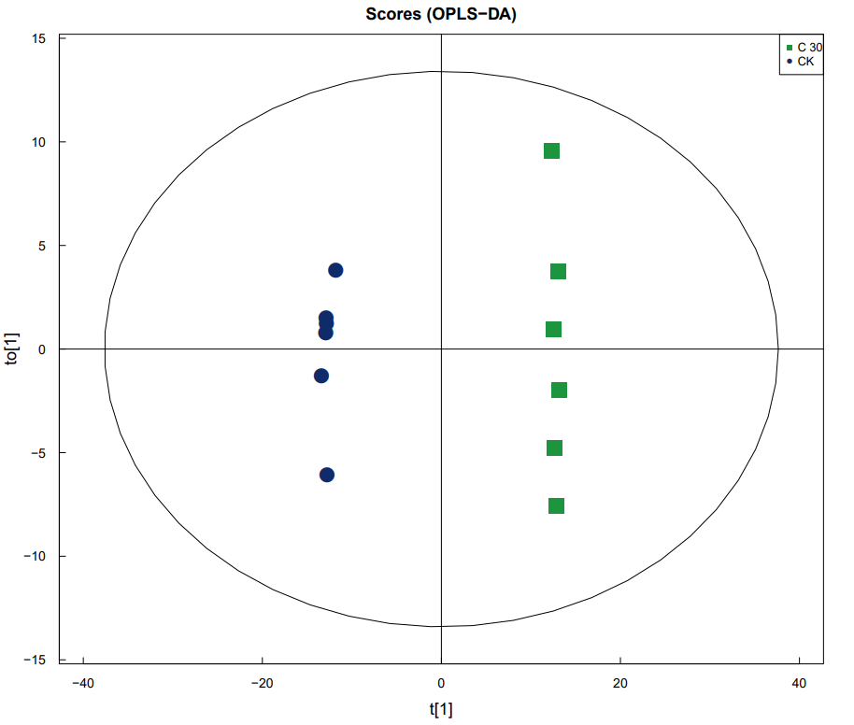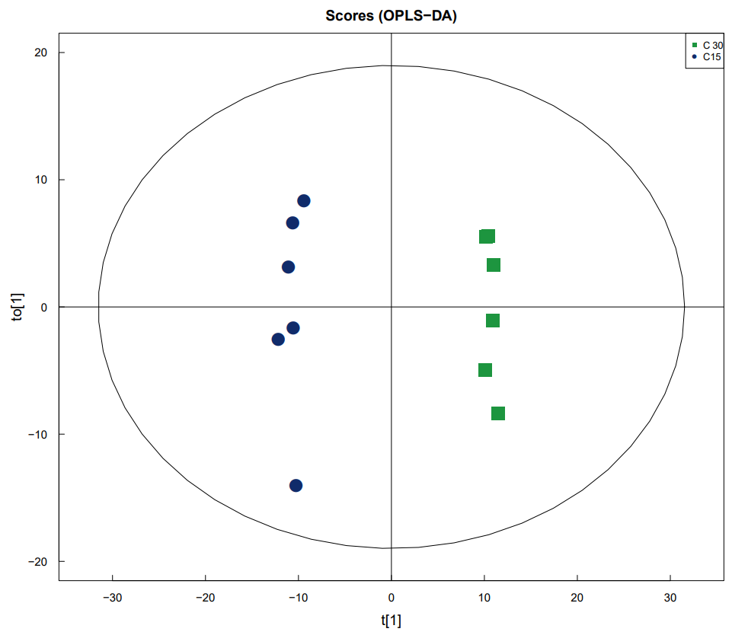
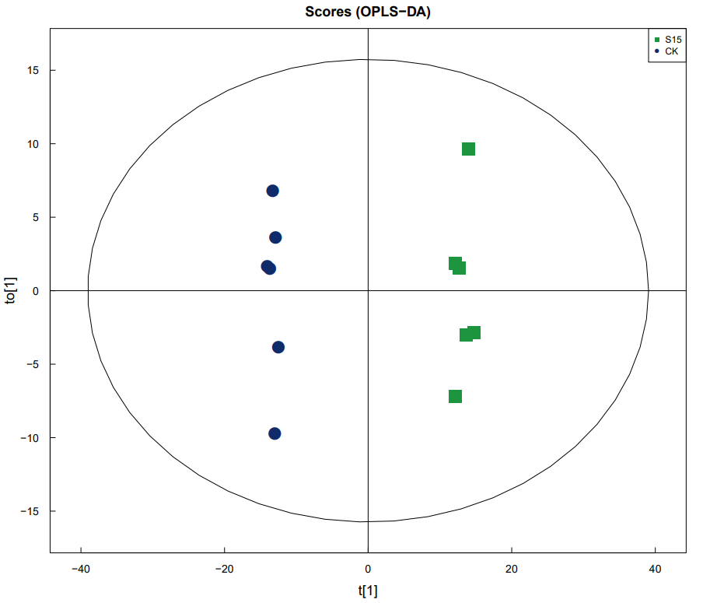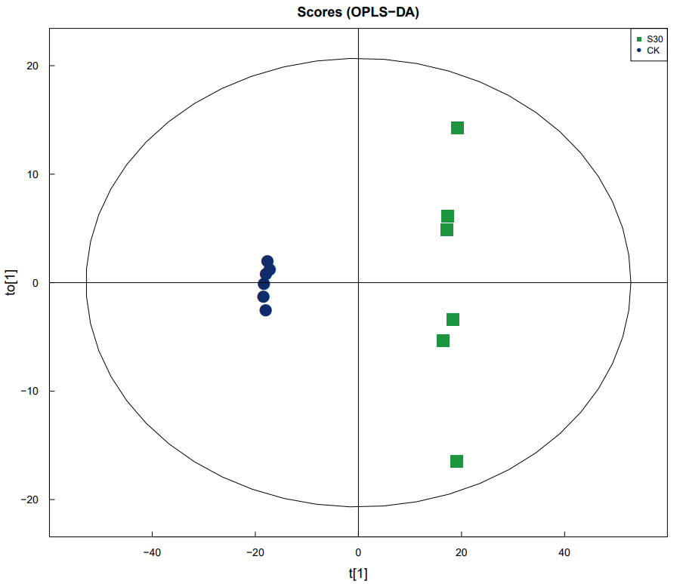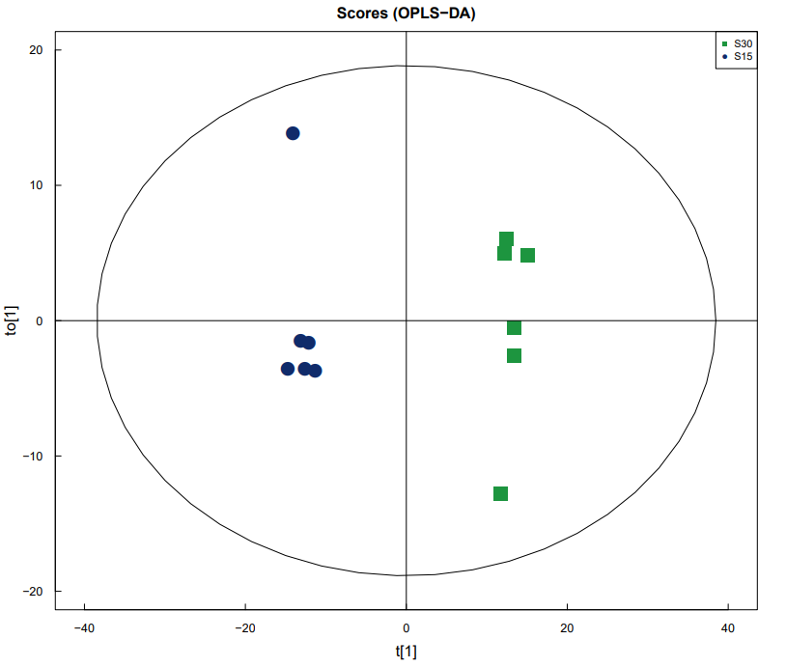
Figure S4 OPLS-DA score map of the metabolites of L. gmelinii seedling samples under 3 stress treatments

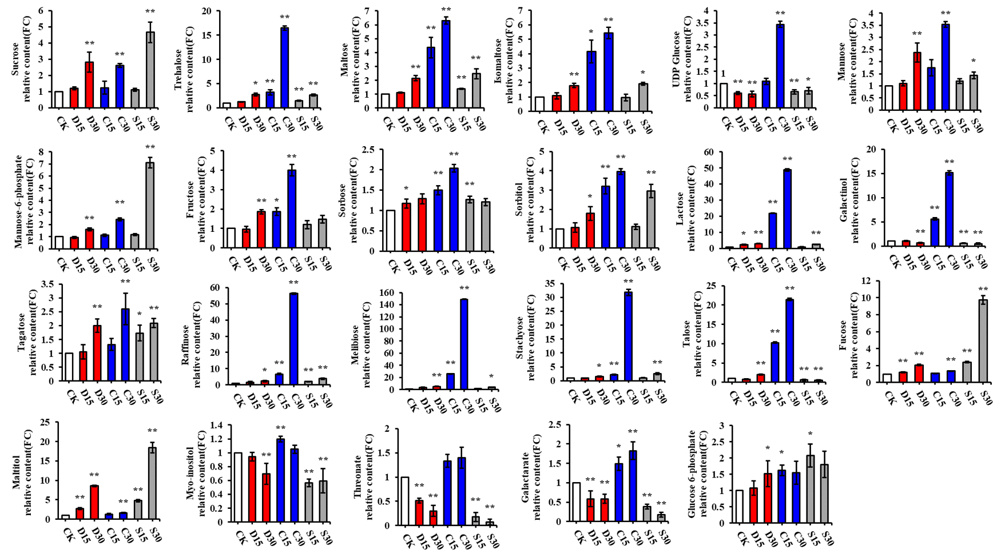 Figure S5. Variation patterns of main carbohydrates in L. gmelinii seedlings under different stress treatments. * representing P<0.05 and * * representing P<0.01
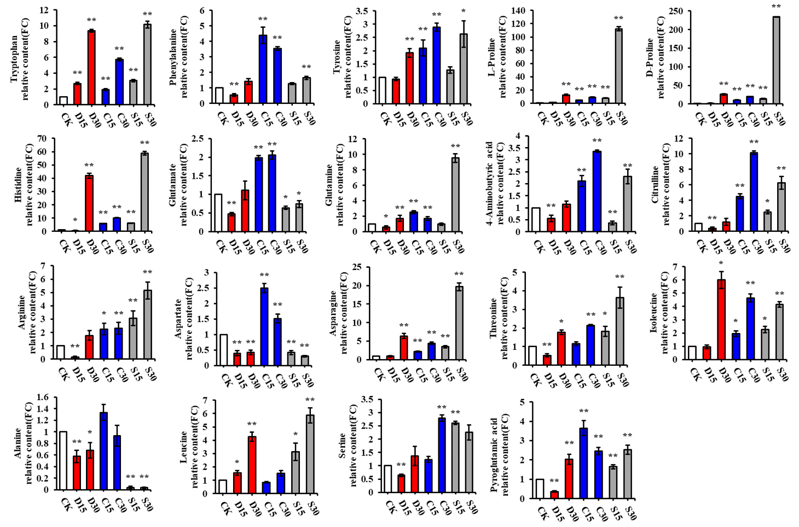
Figure S6. Variation patterns of main amino acids in L. gmelinii seedlings under different stress treatments. * representing P<0.05 and * * representing P<0.01

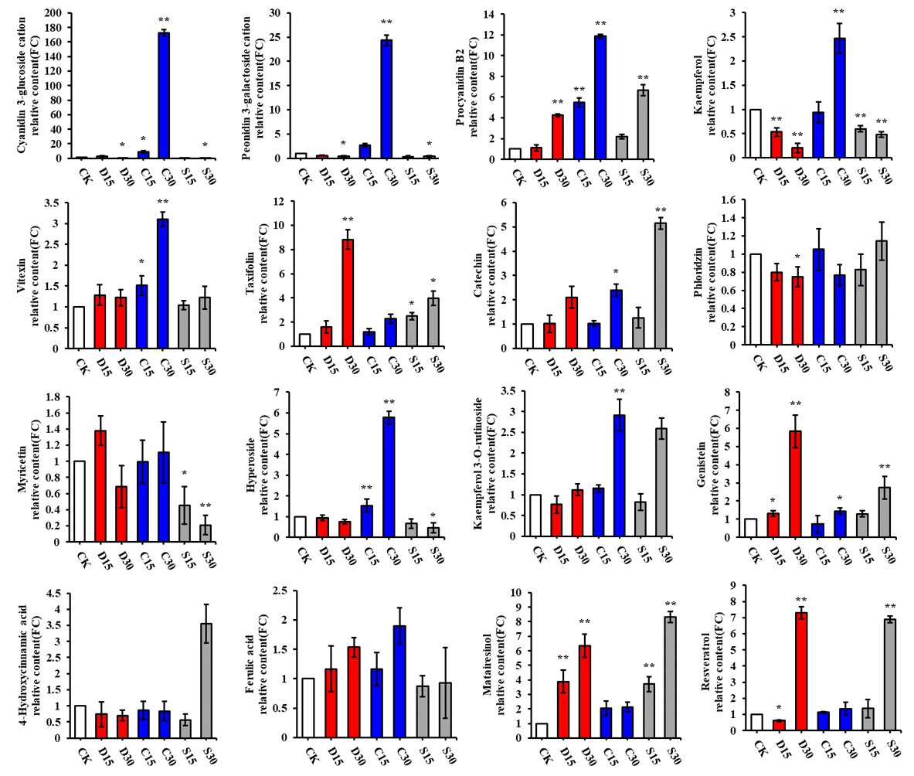
Figure S7. Change patterns of DAMs in secondary metabolism in L. gmelinii seedlings under different stress treatments. * representing P<0.05 and * * representing P<0.01.

Table S1 The sequence of primers used in the second part
Name | Sequence(5’-3’) | Function
Tubulin-S | AGCGACAAATGAGGGAGTGC | Reference gene
Tubulin-A | TACCGGCACCTGTCTCACTG | Reference gene
Q-DREB1A-S | CCTTGACCTTGTGGAGATGAAC | Abiotic stress marker genes
Q-DREB1A-A | ATGGAGGAGCTACCAACAGACC | Abiotic stress marker genes
Q-P5CS-S | TTCTGAAGACTGGTGACCTTGACA | Abiotic stress marker genes
Q-P5CS-A | CCAACCTCAGCACCAAGACCA | Abiotic stress marker genes
Q-SOS1-S | TTTGACAGCACGGGAAGAAGGA | Abiotic stress marker genes
Q-SOS1-A | TCTAGCAACTCTATGGGCACGA | Abiotic stress marker genes
TR6345_c0_g1-S | TCGCCCCAAATAACGCCTTC | NAC domain-containing protein
TR6345_c0_g1-A | GGGCTGCAAATCAGGACCAA | NAC domain-containing protein
TR115416_c0_g1-S | AGCACCAGAGCATCAGGACC | Dehydrin 9 protein
TR115416_c0_g1-A | CCGGAGGAGTTGGATAATAAGA | Dehydrin 9 protein
TR3378_c2_g1-S | TTCCATCGACTGCCCTCTTTAT | Dehydrin
TR3378_c2_g1-A | TCCTGATGCTCTGGTGCTTGTT | Dehydrin
TR3781_c0_g1-S | CAGAAACCCAAACCCAGCACA | Low temprature induced-like protein
TR3781_c0_g1-A | ACTGACGGTCGGTCGCAACTC | Low temprature induced-like protein
TR3581_c2_g2-S | CCCAGAAATCCAAGAAACGAA | Protein phosphatase 2C
TR3581_c2_g2-A | TAATGCAAATGTAAGGCTCCC | Protein phosphatase 2C
TR11835_c0_g1-S | AGGAGCCGTGAAGACGAATG | 4-hydroxyphenylpyruvat dioxygenase
TR11835_c0_g1-A | TGCGACCAATACCAACAAGC | 4-hydroxyphenylpyruvat dioxygenase
TR4720_c0_g1-S | CCCAGGAGGCACCGAGATA | glucose-6-phosphate/phosphate translocator
TR4720_c0_g1-A | CAGAGGGAGCGCAGCAGAT | glucose-6-phosphate/phosphate translocator
TR6087_c0_g1-S | CCCAGTCTCGGTAACTTCCTC | AMP-binding enzyme
TR6087_c0_g1-A | GATAATGTTCCTTGCGGTGAT | AMP-binding enzyme
TR904_c0_g1-S | AGGGTAAAGCAAGGCAGGTT | BEL1-like homeodomain protein
TR904_c0_g1-A | TGGACAATGGACAAGGCAAA | BEL1-like homeodomain protein
TR5493_c0_g1-S | CTGCGGTTGGAACTCTACAC | UDP-glycosyltransferase
TR5493_c0_g1-A | CCTTACCCTCATCCCACTCT | UDP-glycosyltransferase
TR1078_c0_g1-S | AGCATTGTCACCTGGTTACTG | Glutathione peroxidase-like protein
TR1078_c0_g1-A | CCTCGTGCCTTACACTTTCTT | Glutathione peroxidase-like protein
TR526_c1_g1-S | TGTTGTCTCGCAACTCGTTT | transporter
TR526_c1_g1-A | AATCCTCCATCCATTCTTCC | transporter
TR8029_c0_g2-S | ATGGTGGAAGAGGTGGTGAC | ABA/WDS induced protein
TR8029_c0_g2-A | GGACTGGACGTGTTAATTTGT | ABA/WDS induced protein
TR1315_c0_g1-S | AGCTTCCAGAACTTGTCCCTA | NAC domain-containing protein
TR1315_c0_g1-A | CTTGAATCGGTGAGCAGAATA | NAC domain-containing protein
TR769_c1_g3-S | TGCCATCATTGCGATTCTTGT | mannitol dehydrogenase
TR769_c1_g3-A | CCGAGGCTCTTTCCAGGTTCT | mannitol dehydrogenase
TR12006_c0_g1-S | AATGGACGATAAATGGTGGA | Tetraspanin family
TR12006_c0_g1-A | CAGCAGAACGGATTGTGAAA | Tetraspanin family
TR31094_c0_g1-S | CAGGGTCAACTGTCGTAGGGT | Peroxidase
TR31094_c0_g1-A | AGGAGCGGCAAGAATACTGAA | Peroxidase
TR16625_c1_g2-S | TCCATTTCCGTTCTGGTTGT | Peroxidase
TR16625_c1_g2-A | GCAGCTCGTGACTCTGTGGT | Peroxidase
TR9812_c0_g1-S | TTTTCAGTTTCTCCTCCACC | hypothetical protein
TR9812_c0_g1-A | CTCTTTCATGCAGCCTCTGT | hypothetical protein
TR11711_c0_g1-S | GCAGACCAACATTTACGCTCAT | Glycosyl hydrolases family
TR11711_c0_g1-A | GCCTGCCTGTTCAGATACGG | Glycosyl hydrolases family
TR516_c6_g1-S | TATTGTCTCATGCTCGCTGTG | GDSL esterase/lipase
TR516_c6_g1-A | GCTGTATCTGCTTGTGGGTTT | GDSL esterase/lipase
TR412_c0_g1-S | AGACCATCACCAACTGCTCCAA | Fatty acid hydroxylase superfamily
TR412_c0_g1-A | ACAAATCCACCCTTTCTCAACC | Fatty acid hydroxylase superfamily
TR2655_c0_g1-S | CGAACTCCTCCTTTCCTCACG | Expansin
TR2655_c0_g1-A | CGACATGGCTCAACCTGCTTA | Expansin
TR1806_c0_g1-S | AGGTCAGACAAATGCCTCGTA | Cytochrome P450
TR1806_c0_g1-A | AGGAAGGAATTGGCTATGGAA | Cytochrome P450
TR14631_c0_g1-S | ATCAGGCTTAACTGTCTTCGC | Chlorophyllase enzyme
TR14631_c0_g1-A | TATCCCGTCGTAATGTTCCT | Chlorophyllase enzyme
TR5234_c7_g2-S | GCATCTGCTATGGACCTGACC | Chlorophyll a-b binding protein
TR5234_c7_g2-A | CCAACATGGACCATCTGGAGT | Chlorophyll a-b binding protein
TR172817_c0_g1-S | AGCCTGTAGGATTAGGTGCCG | Chlorophyll a-b bindingprotein
TR172817_c0_g1-A | GGAGCTGAAGGTGGAGGAGAT | Chlorophyll a-b bindingprotein

Table S2. Quality of the sequencing results of the seedling samples of L. gmelinii under different treatments
Sample | Raw reads | Clean reads | Clean bases | Q20(%) | Q30(%) | GC(%)
CK-1 | 149874926 | 148427330 | 19.47G | 97.74 | 93.4 | 45.28
CK-2 | 140106588 | 138731142 | 18.28G | 97.6 | 93.09 | 45.28
CK-3 | 133768166 | 132534210 | 17.49G | 97.73 | 93.35 | 45.25
D15-1 | 133464640 | 131748620 | 17.37G | 97.92 | 93.76 | 44.68
D15-2 | 144401708 | 142199322 | 18.87G | 97.67 | 93.25 | 44.75
D15-3 | 138999448 | 136893966 | 18.1G | 97.89 | 93.72 | 44.67
D30-1 | 136787122 | 135544152 | 17.99G | 97.59 | 93.06 | 44.45
D30-2 | 125201146 | 123894618 | 16.48G | 97.62 | 93.08 | 44.47
D30-3 | 124623912 | 123246218 | 16.39G | 97.67 | 93.23 | 44.46
C15-1 | 131335854 | 129540396 | 17.06G | 97.84 | 93.58 | 44.72
C15-2 | 146939146 | 144736874 | 19.1G | 97.57 | 93.03 | 44.67
C15-3 | 135247090 | 133225404 | 17.71G | 97.82 | 93.55 | 44.64
C30-1 | 157866968 | 156444266 | 20.67G | 97.57 | 93.03 | 44.56
C30-2 | 125260500 | 124052526 | 16.45G | 97.61 | 93.06 | 44.52
C30-3 | 120030864 | 118794210 | 15.76G | 97.65 | 93.2 | 44.54
S15-1 | 142685844 | 141237680 | 18.68G | 97.65 | 93.18 | 44.56
S15-2 | 136286666 | 134795104 | 17.81G | 97.68 | 93.25 | 44.55
S15-3 | 131928770 | 130672792 | 17.3G | 97.91 | 93.75 | 44.54
S30-1 | 139452758 | 138190662 | 18.32G | 97.74 | 93.39 | 45.29
S30-2 | 145774946 | 144397526 | 19.2G | 97.56 | 92.99 | 45.32
S30-3 | 149735004 | 148430214 | 19.8G | 97.7 | 93.29 | 45.28
Table S3. Unigenes annotation of the seedling samples of L. gmelinii under different treatments
Type | Number of Unigenes | Percentage (%)
Annotated in NR | 113619 | 19.98
Annotated in SwissProt | 43333 | 7.62
Annotated in PFAM | 36892 | 6.49
Annotated in GO | 13431 | 2.36
Annotated in KO | 8606 | 1.51
Annotated in all Databases | 1185 | 0.21
Annotated in at least one Database | 118901 | 20.91
Total Unigenes | 568660 | 100

