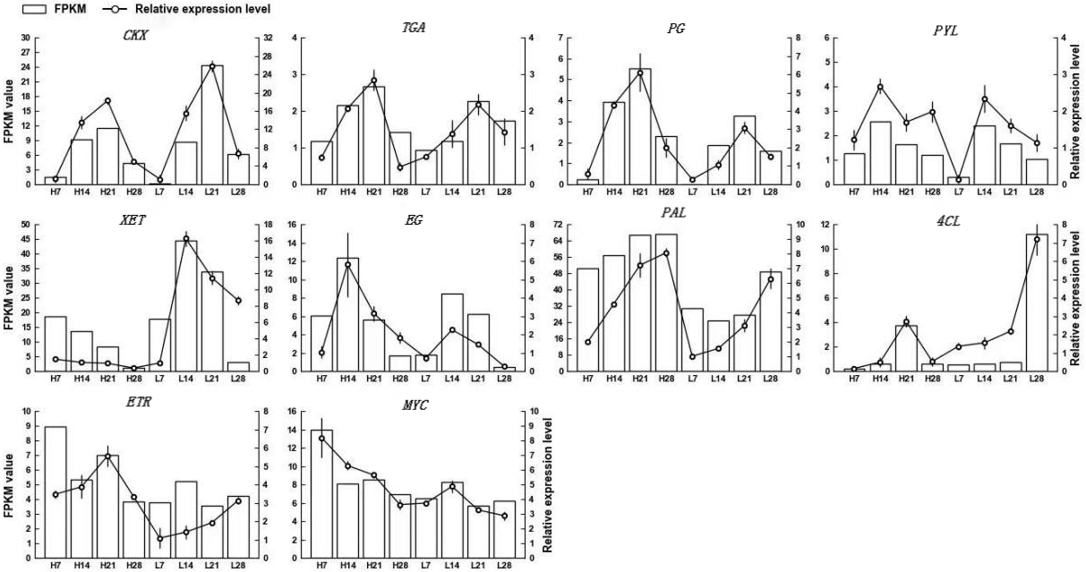

Fig S5. Expression of SS unigenes in Psathrostachys juncea quantified by RNA-Seq and qRT-PCR analysis. White bars represent changes in transcript abundance based on FPKM values from transcriptome sequencing (left y-axis). Lines indicate relative expression levels measured by qRT-PCR (right y-axis). Error bars represent the mean ± standard deviation.

