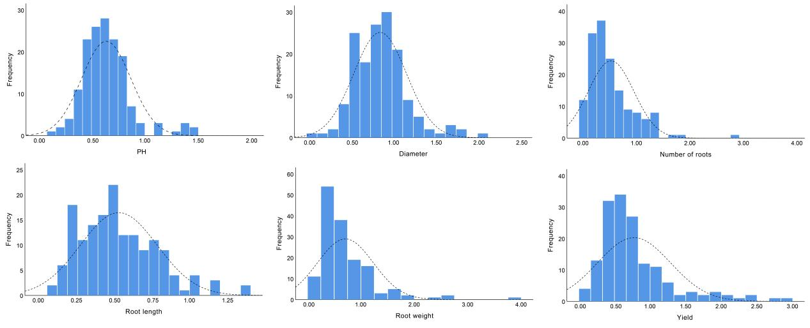
Fig. S1 Frequency distribution of phenotypic traits in alfalfa.

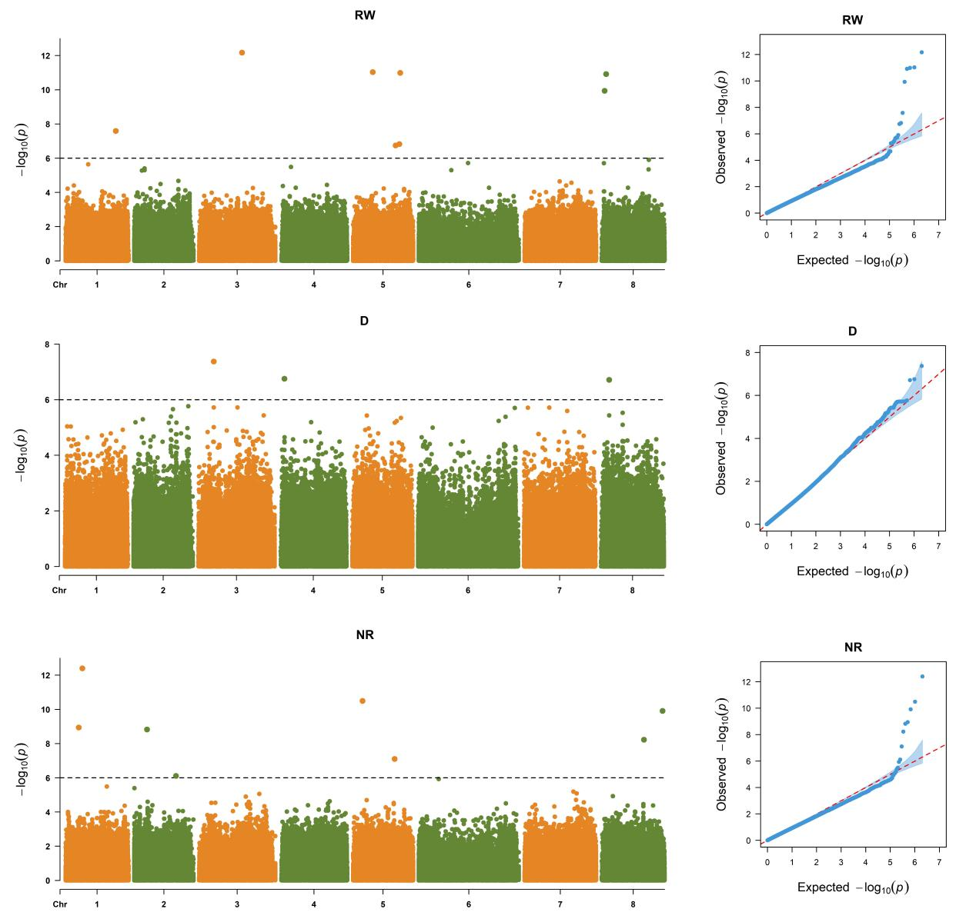
Fig. S2 Manhattan plots and QQ plots for relative root weight (RW), relative diameter (D), and relative number of roots (NR) in alfalfa.
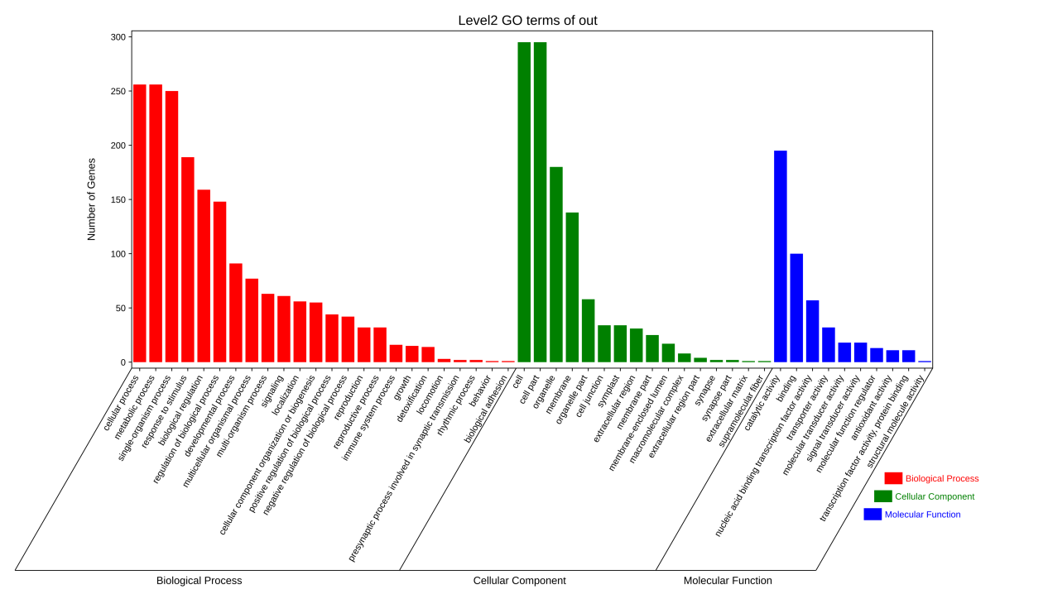
Fig. S3 GO analysis of differentially expressed genes in response to alfalfa root rot stress.

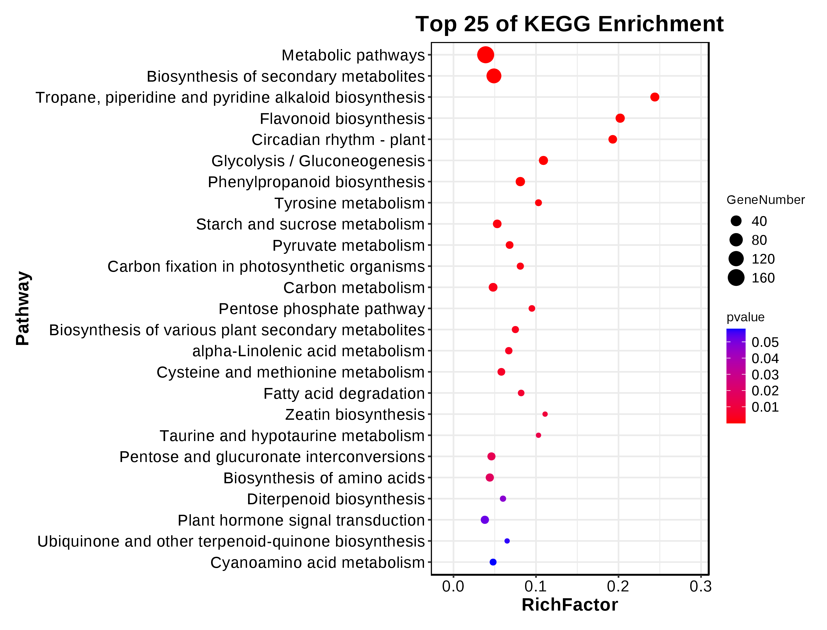
Fig. S4 KEGG analysis of differentially expressed genes in response to alfalfa root rot stress.

