Supplementary Figures

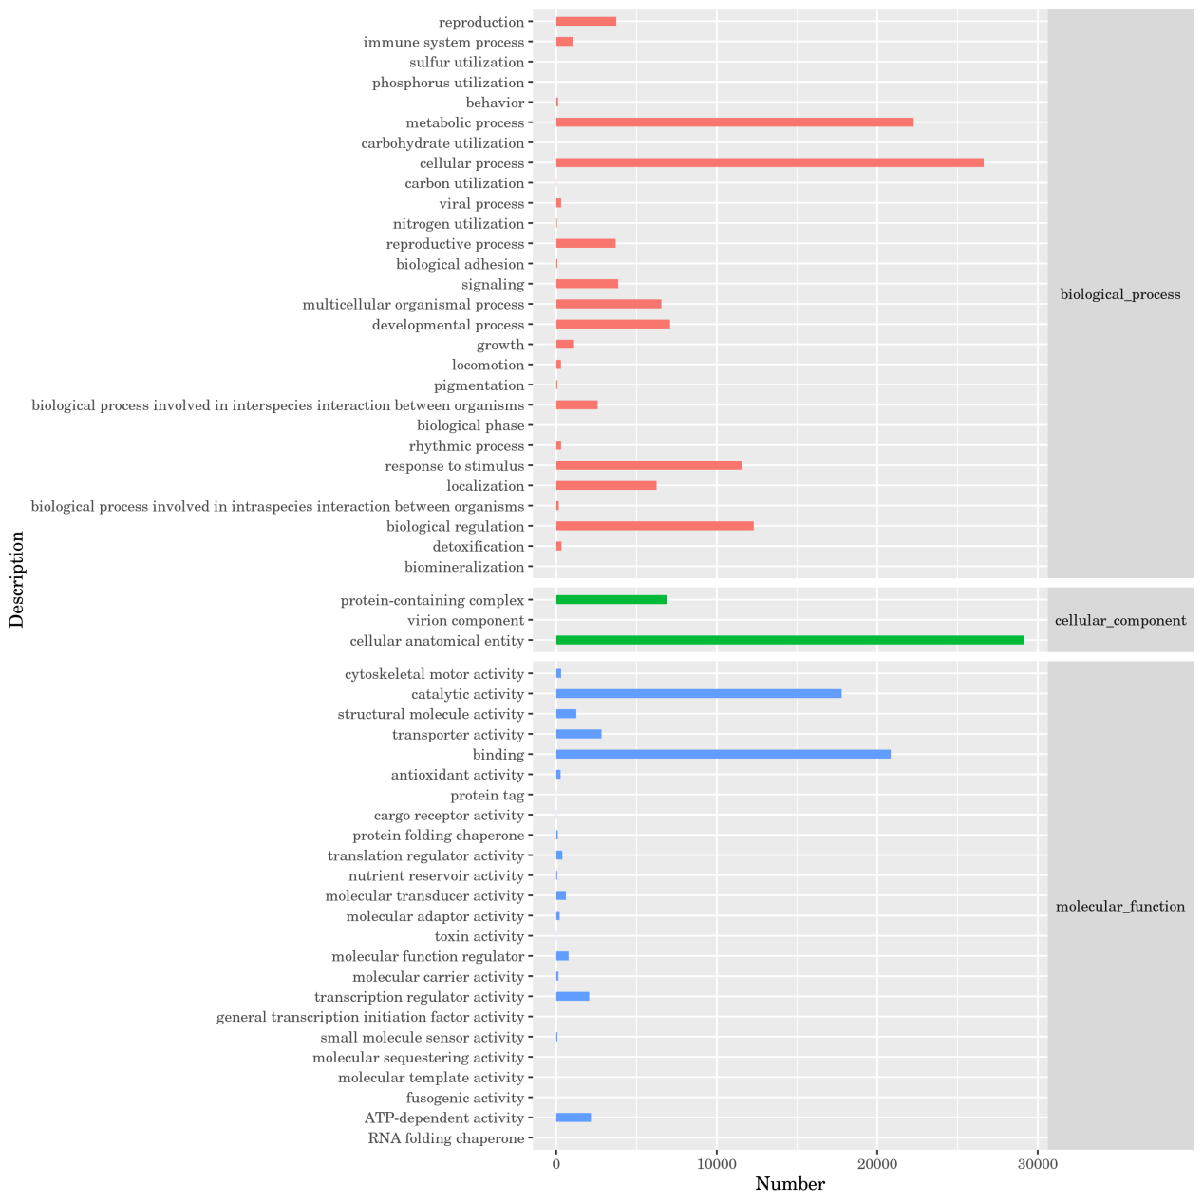
Fig. S1 The GO enrichment analysis of DEGs in P. japonicus seeds.

Fig. S2. The KEGG enrichment analysis of DEGs in P. japonicus seeds.

