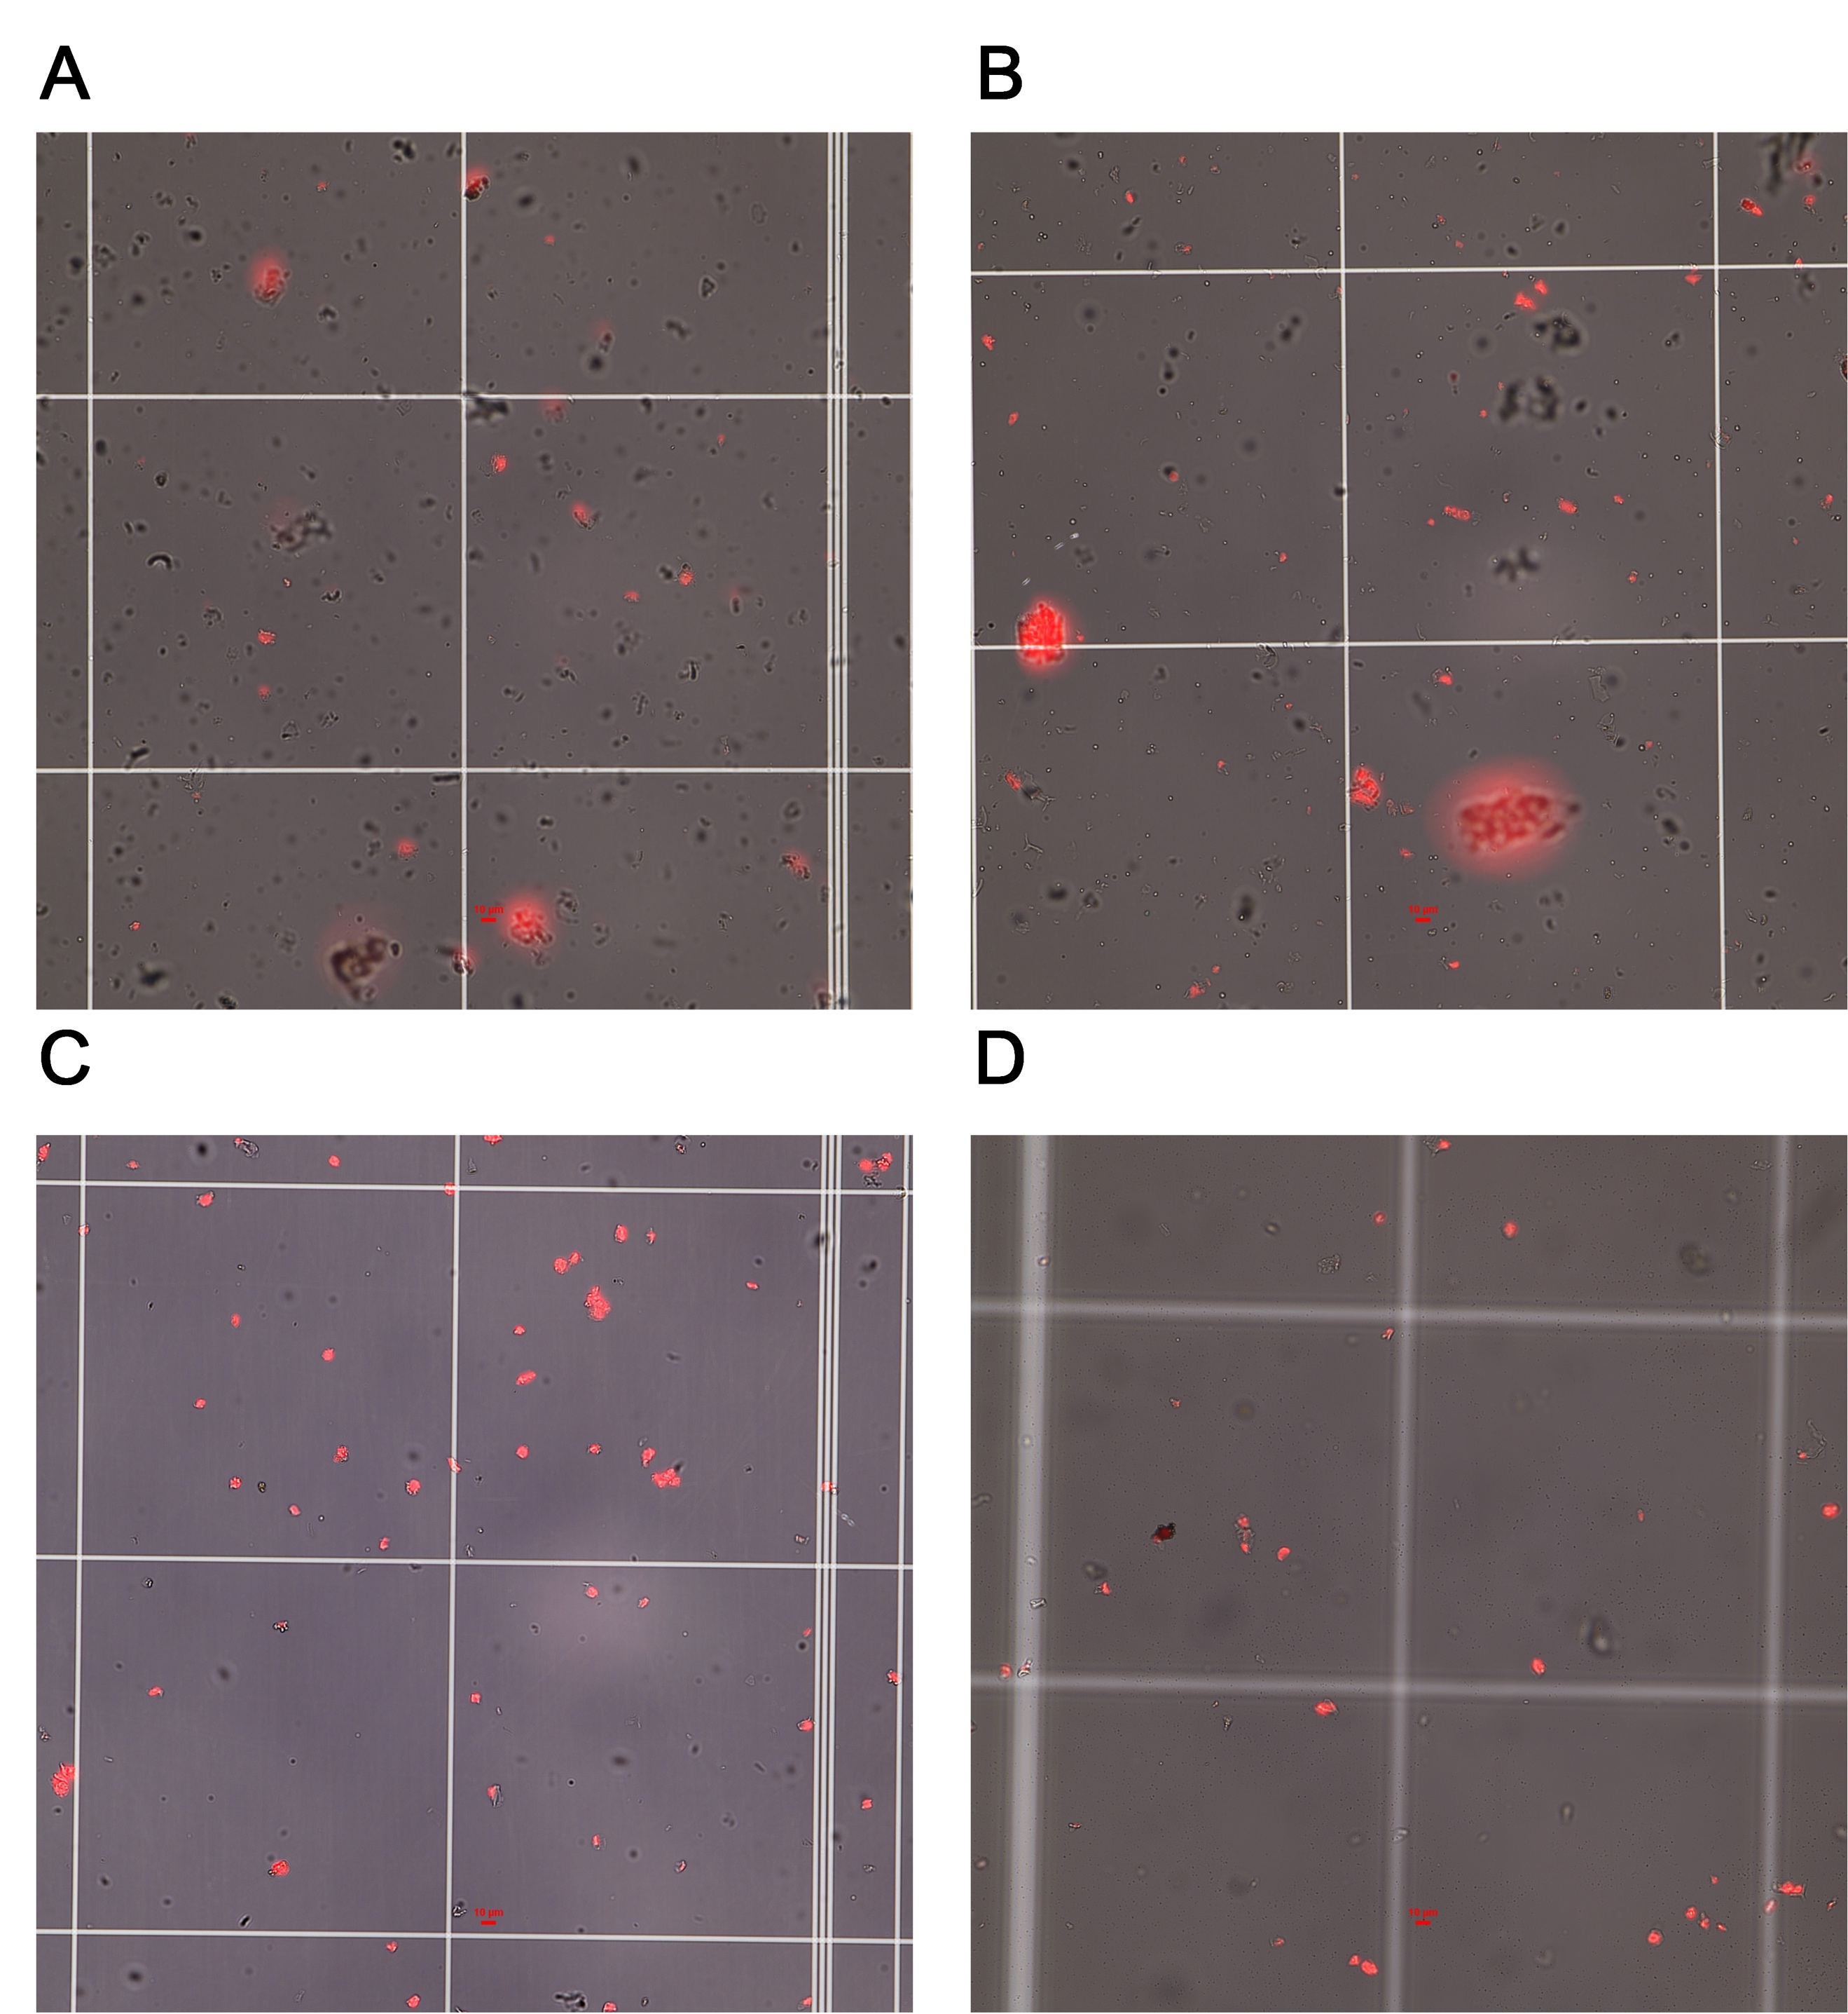
Figure S1: The single-nucleus suspensions separated under different temperature treatments. (A) Nuclear suspension without flow cytometry sorting at low (permissive) temperature (LT). (B) Nuclear suspension without flow cytometry sorting at high (restrictive) temperature (HT). (C) Nuclear suspension sorted by flow cytometry at low (permissive) temperature (LT). (D) Nuclear suspension sorted by flow cytometry at high (restrictive) temperature (HT).

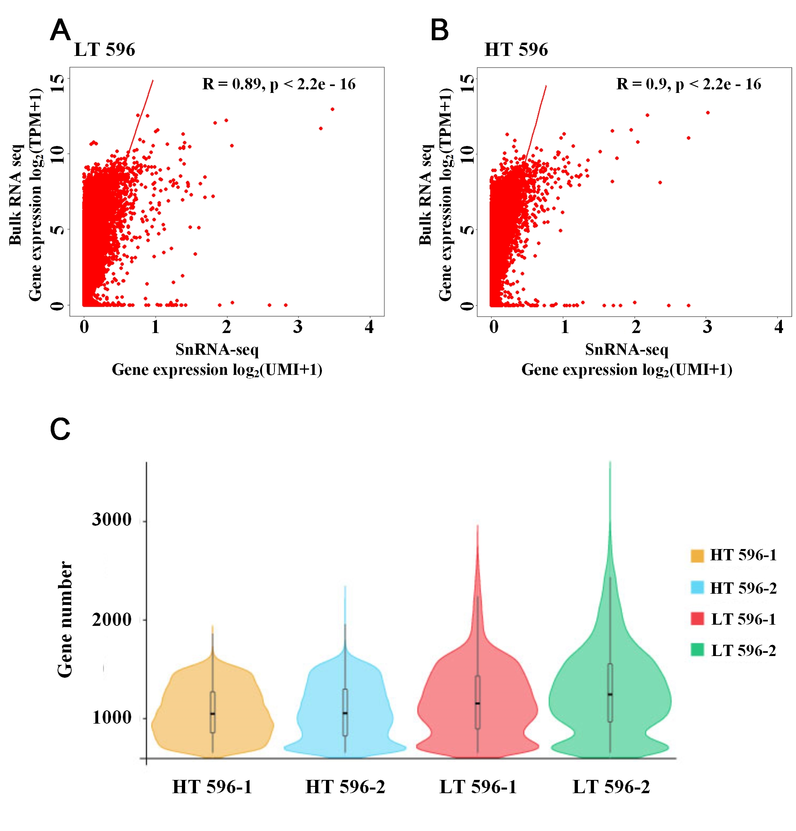
Figure S2: Estimation of the data quality. (A) Low (permissive) temperature (LT) treatment scatter plots showing the correlations between combined SnRNA seq and Bulk RNA seq. (B) High (restrictive) temperature (HT) treatment scatter plots showing the correlations between combined SnRNA seq and Bulk RNA seq. (C) The basic comparison of single nuclei sequencing in different treatment. HT means the data generated from high (restrictive) temperature (HT) treatment single cell RNA sequencing. LT means the data generated from low (permissive) temperature treatment single nuclei RNA. HT: high (restrictive) temperature, LT: low (permissive) temperature.

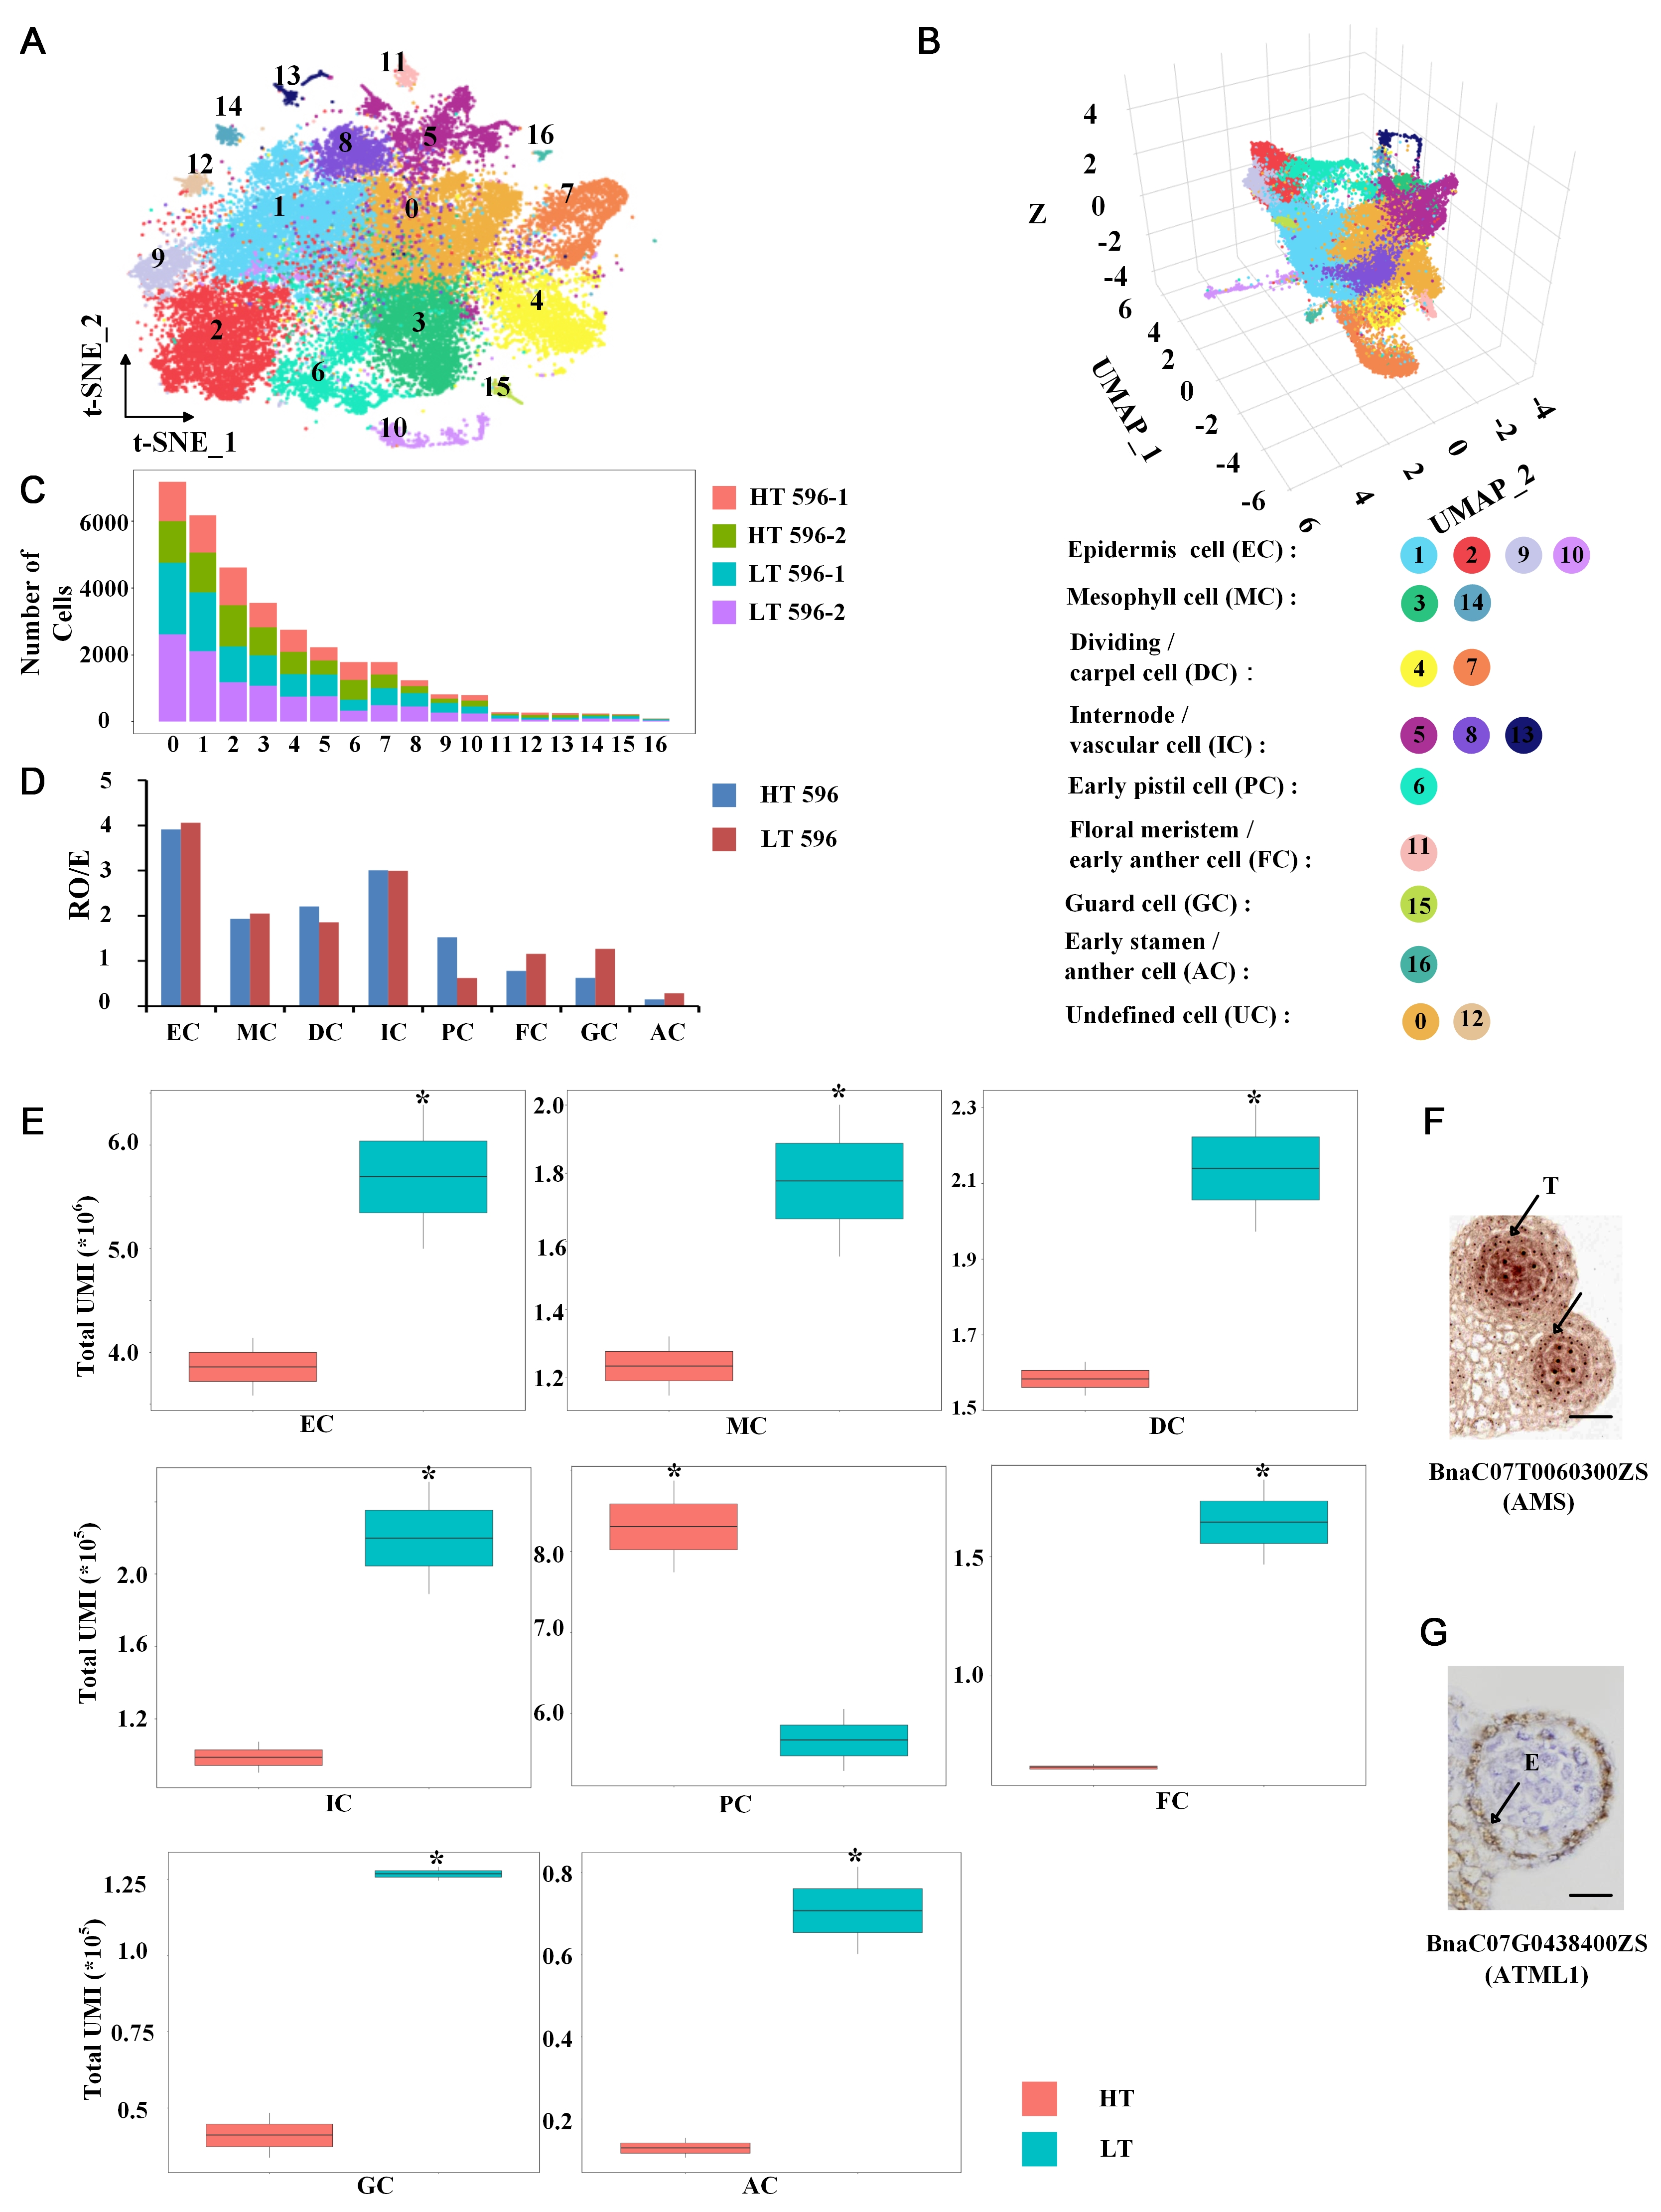
Figure S3: Cell dimensionality reduction clustering results. (A) t-SNE visualization of 17 cell clusters annotated for early frower buds under low (permissive) and high (restrictive) temperature treatment conditions. Each dot represents a single cell. (B) Three-dimensional UMAP scatterplot for cell clusters. (C) Sample distribution under 17 cell cluster. (D) Preference of each cell type under HT. (E) Comparison of total UMI numbers under HT and LT treatment in different cell type. EC: epidermis cell; MC: mesophyll cell; DC: dividing/carpel cell; IC: internode cell/vascular cell; PC: early pistil cell; FC: floral meristem/early anther cell; GC: guard cell; AC: early stamen/anther cell. (F) and (G) RNA in situ hybridization assays to confirm the expression pattern of marker genes in anther of early flower buds. (F) The marker genes of early stamen/anther (tapetum) cell. (G) The marker genes of epidermis cell. Bar: 50 μm. HT: high (restrictive) temperature, LT: low (permissive) temperature. T: tapetum cell, E: eprdermis cell.
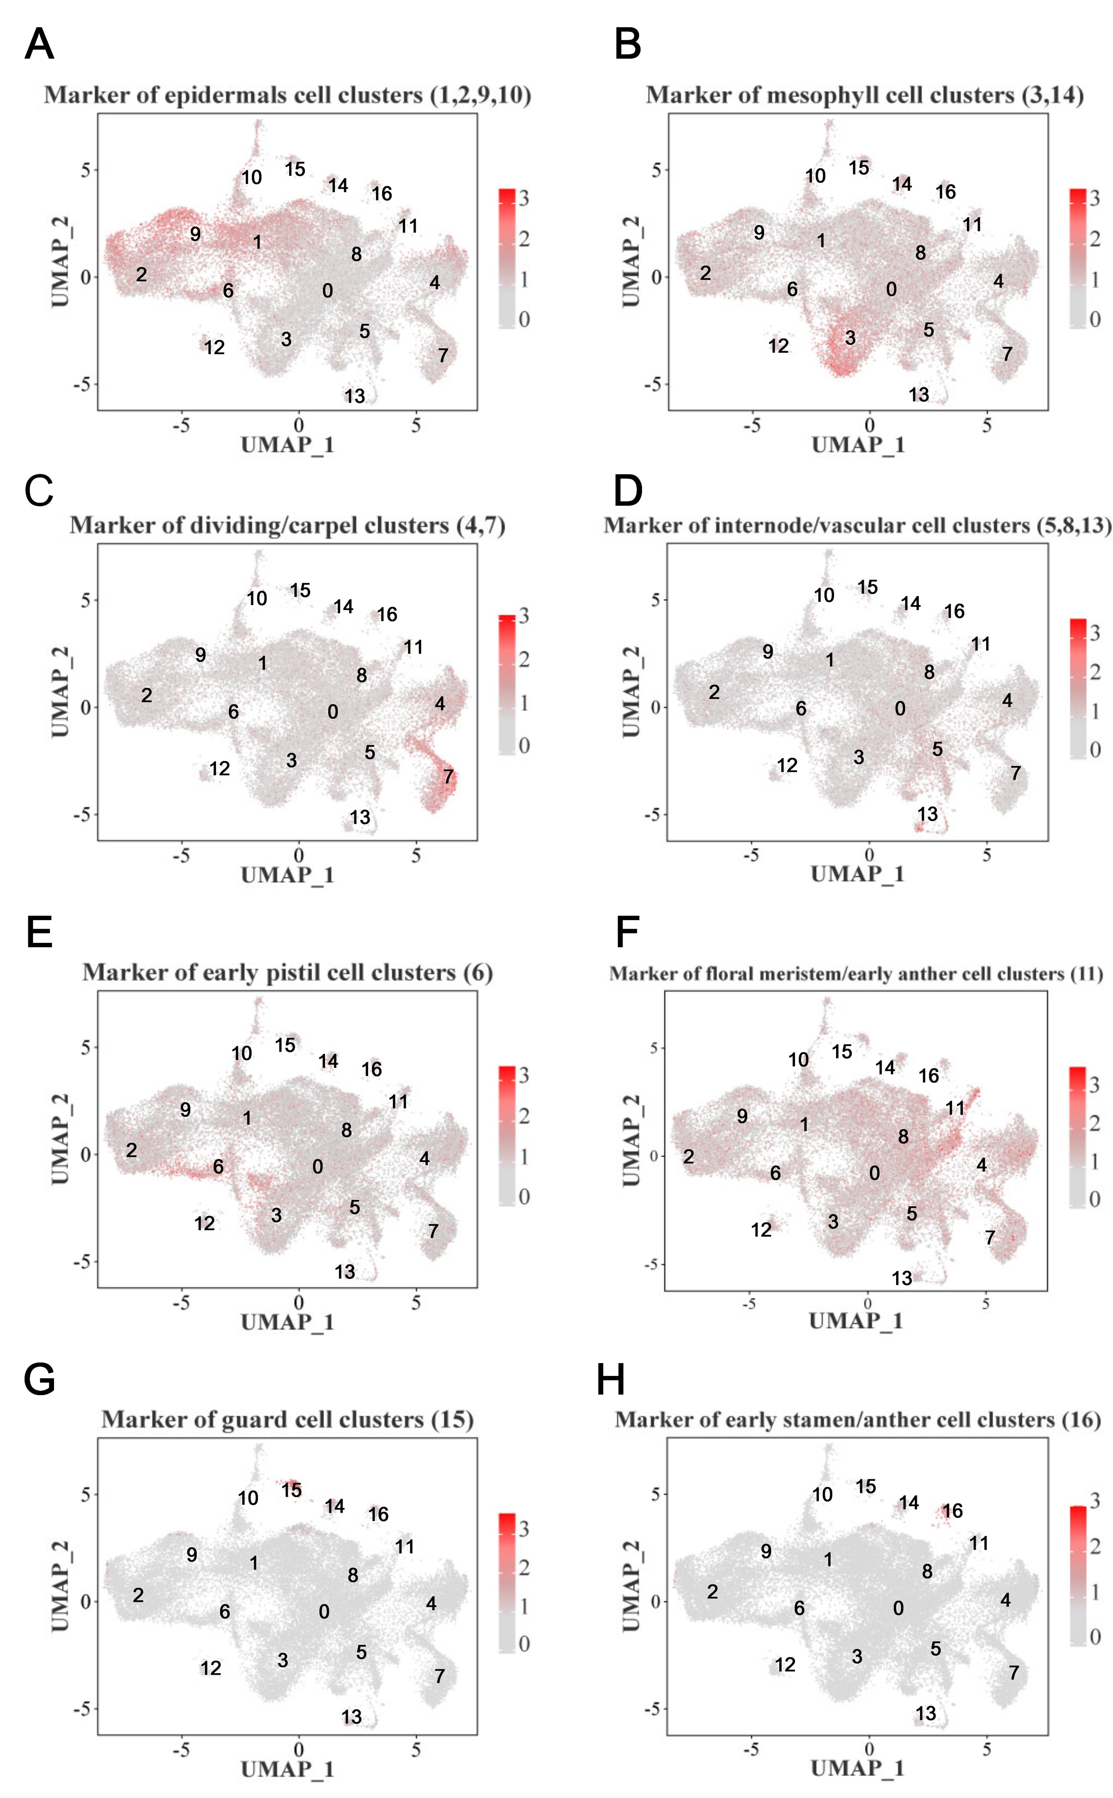
Figure S4: Marker genes for different cell types. (A) to (H) UMAP plot showing the cell distribution of samples and the expression distribution of selected marker genes.
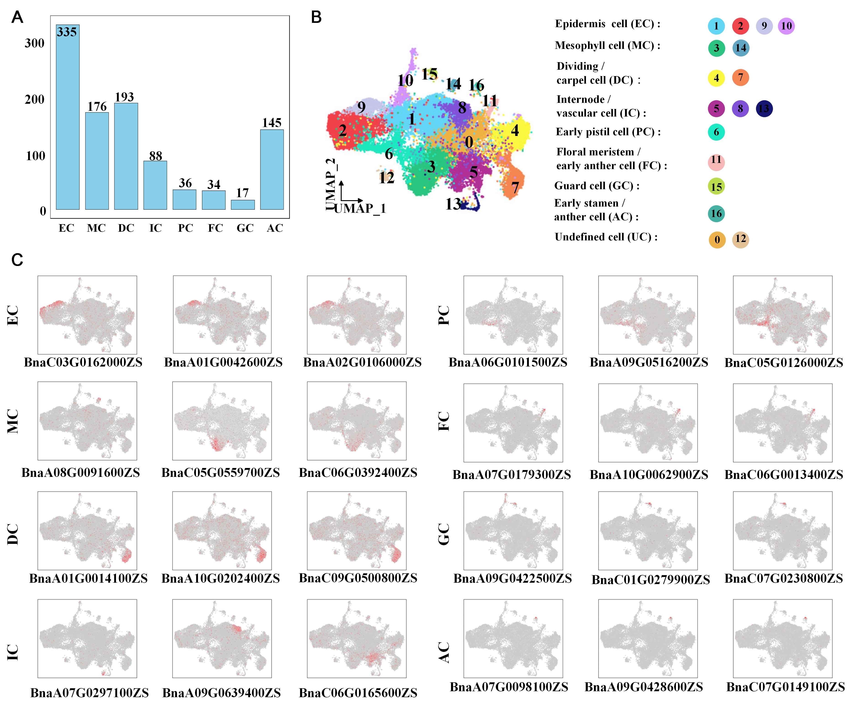
Figure S5: Identification of novel cell‑type marker genes. (A) Statistical analysis of the novel cell-type marker genes number in each cell type. (B) UMAP visualization of 17 cell clusters in B.napus early flower buds under low (permissive) and high (restrictive) temperature treatment conditions. Each dot represents a single cell. The color indicates the corresponding cell cluster. (C) UMAP plots show the top three marker genes with the highest expression in each cell type. EC: epidermis cell; MC: mesophyll cell; DC: dividing/carpel cell; IC: internode cell/vascular cell; PC: early pistil cell; FC: floral meristem/early anther cell; GC: guard cell; AC: early stamen/anther cell.

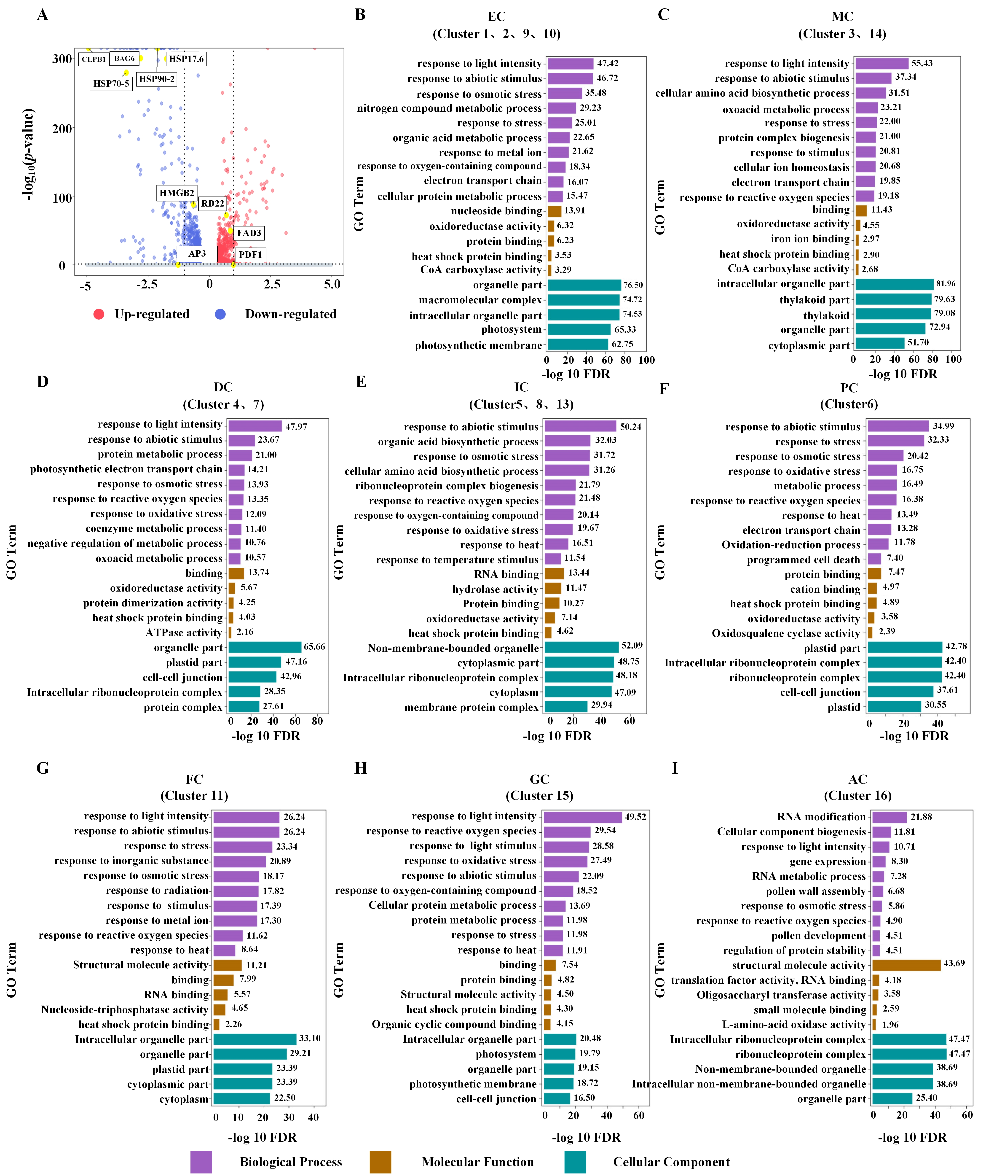
Figure S6: Differential expression genes (DEGs) in different cell types after undergoing high (restrictive) temperature treatment. (A) Volcano diagram of differentially expressed genes, The red dots represent up-regulated genes, and the blue dots represent down-regulated genes. (B) to (I) The top 20 Enrichment of Gene Ontology functions of differentially expressed genes (DEGs) in 17 cell clusters. EC: epidermis cell; MC: mesophyll cell; DC: dividing/carpel tissue cell; IC: internode/vascular tissue cell; PC: early pistil cell; FC: floral meristem/early anther tissue cell; GC: guard cell; AC: early stamen/anther tissue cell.

Figure S7: KEGG functional enrichment analysis of differentially expressed genes (DEGs) under different cell types. (A) to (H) EC: epidermis cell; MC: mesophyll cell; DC: dividing/carpel tissue cell; IC: internode/vascular tissue cell; PC: early pistil cell; FC: floral meristem/early anther tissue cell; GC: guard cell; AC: early stamen/anther tissue cell.

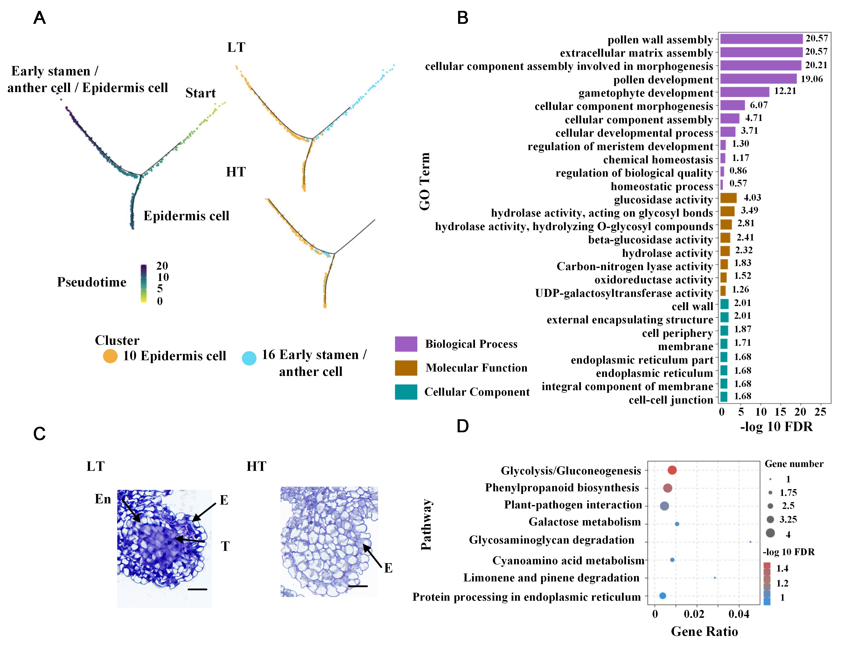
Figure S8: The differentiation fate of different cells under varied temperature treatments.. (A) The differentiation and developmental trajectories of epidermal cells (cluster 10) and early stamen/anther tissue cells (cluster 16) under HT treatment. (B) GO functional enrichment analysis of unique branches in the developmental trajectory of epidermal cells (cluster 10) and early stamen/anther tissue cells (cluster 16) under LT treatment conditions. (C) Microscopic observation results of semi thin sections of anther in early flower buds under LT and HT treatment. (D) KEGG functional enrichment analysis of unique branches in the developmental trajectory of epidermal cells (cluster 10) and early stamen/anther tissue cells (cluster 16) under LT treatment conditions. HT: high (restrictive) temperature; LT: low (permissive) temperature. E: epidermis; En: endothecium; T: tapetum; MMC: microspore mother cell. Bar: 100 μm

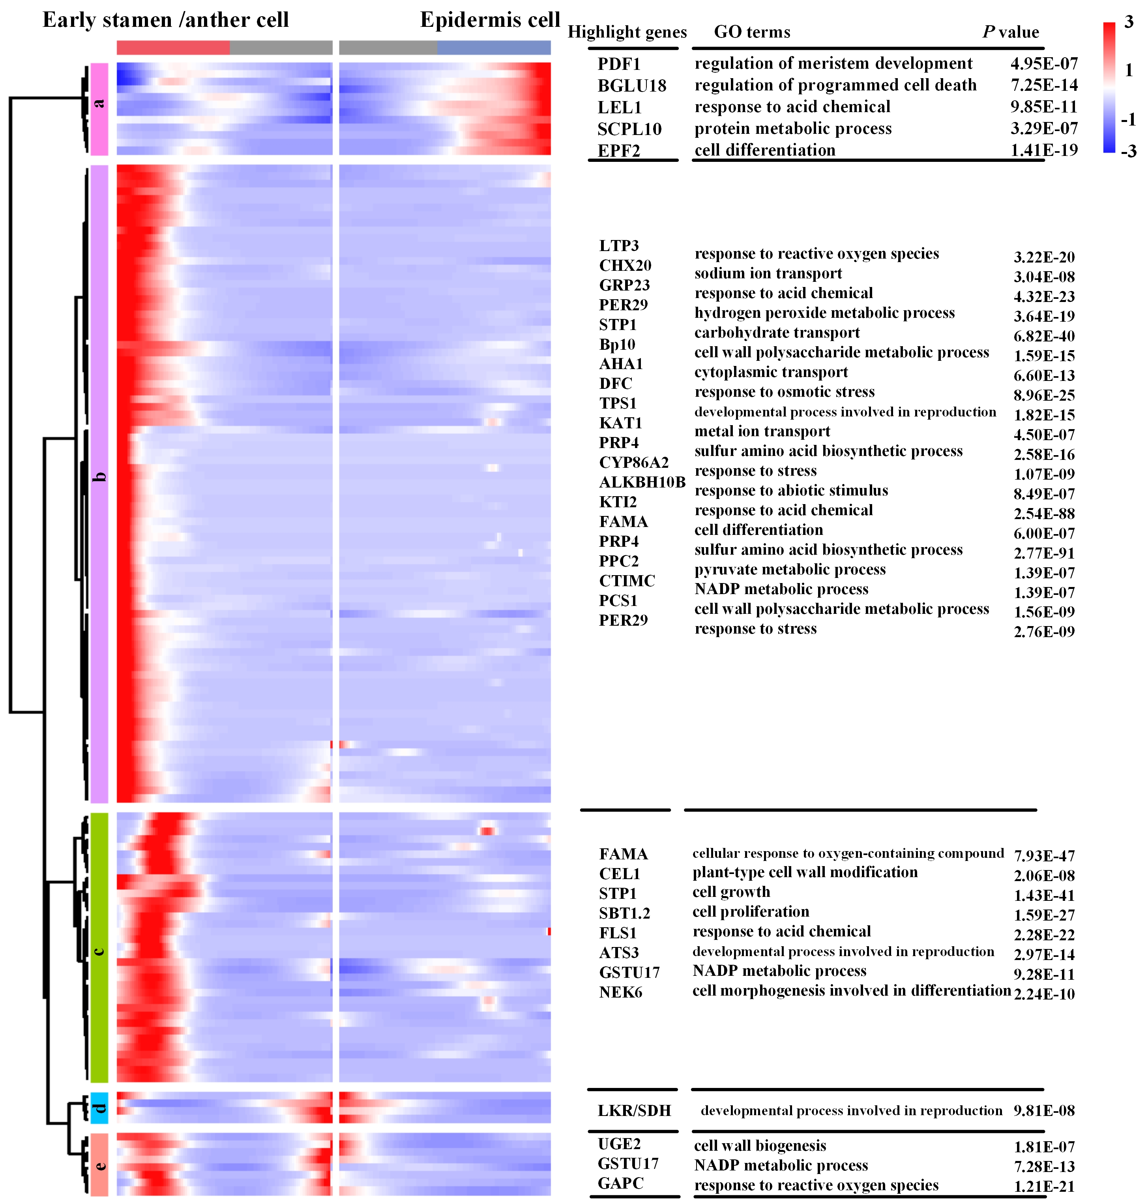
Figure S9: Branch heatmaps showing the expression of regulatory genes over the pseudo-time differentiation trajectories for early stamen/anther tissue cells (cluster16) and epidermis cells (cluster10.)

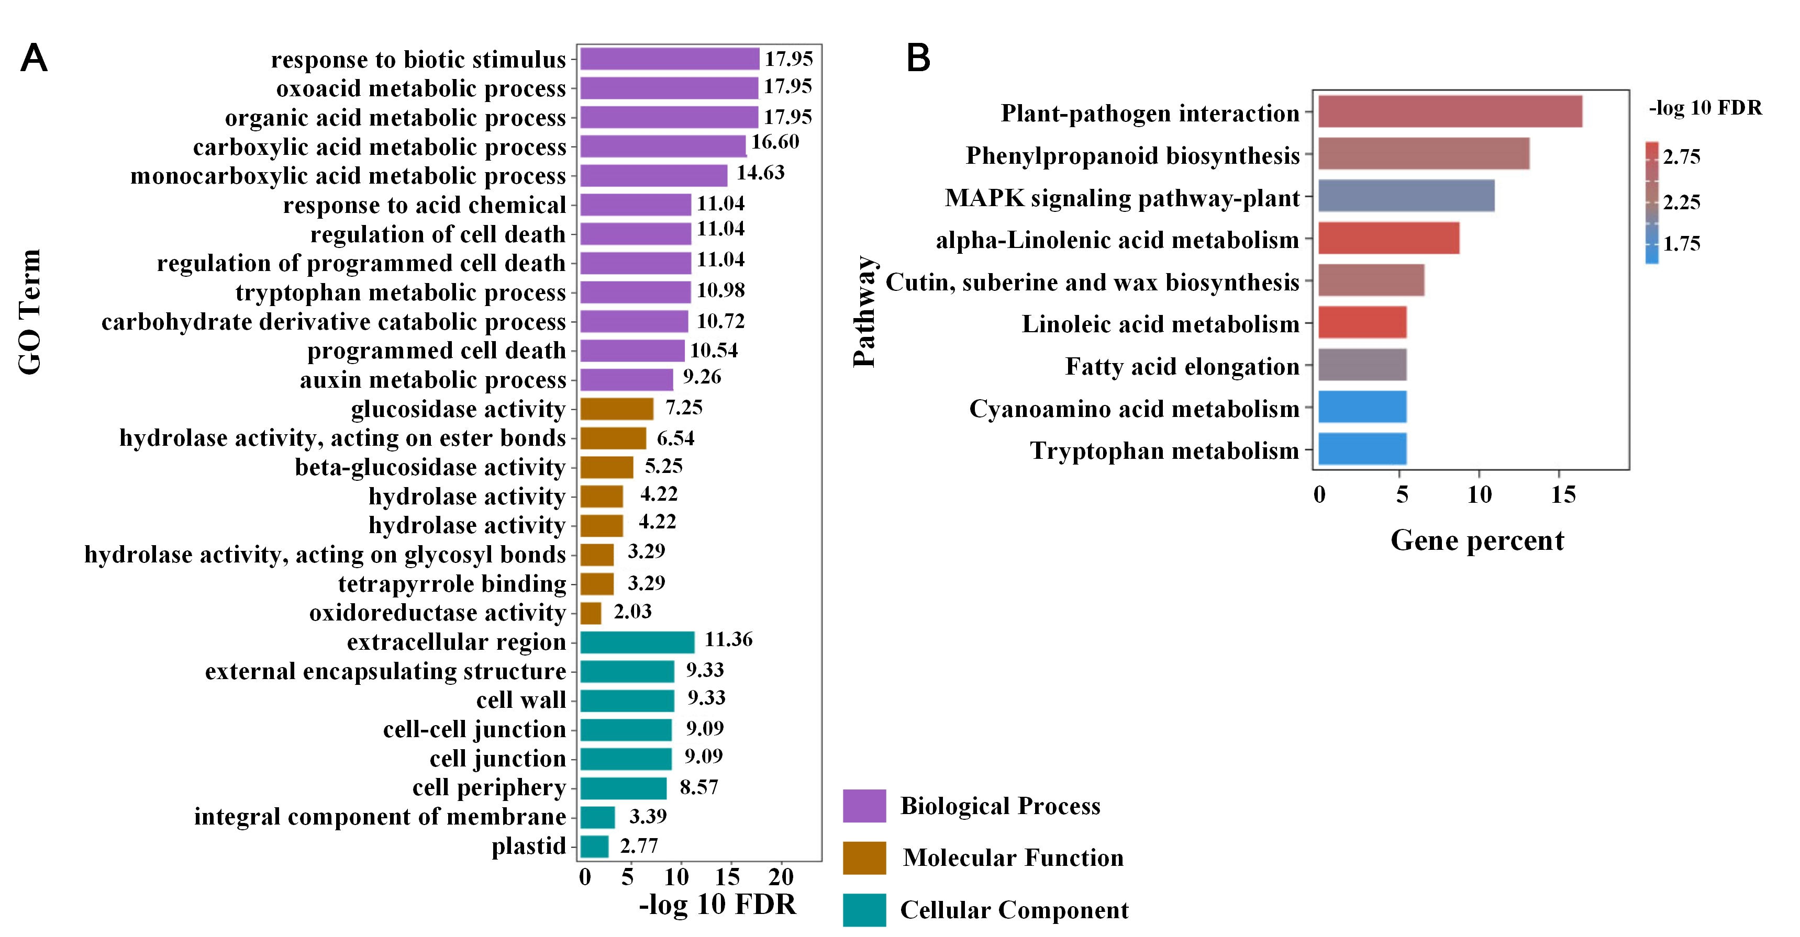
Figure S10: Functional enrichment analysis of genes in the disappearing early stamen/anther tissue cells under high (restrictive) temperature treatment. (A) The top Enrichment of Gene Ontology functions of genes in the disappearing early stamen/anther tissue cells under high (restrictive) temperature treatment in cluster 16. (B) The top Enrichment of KEGG functional enrichment analysis of genes in the disappearing early stamen/anther tissue cells under high (restrictive) temperature treatment in cluster 16.

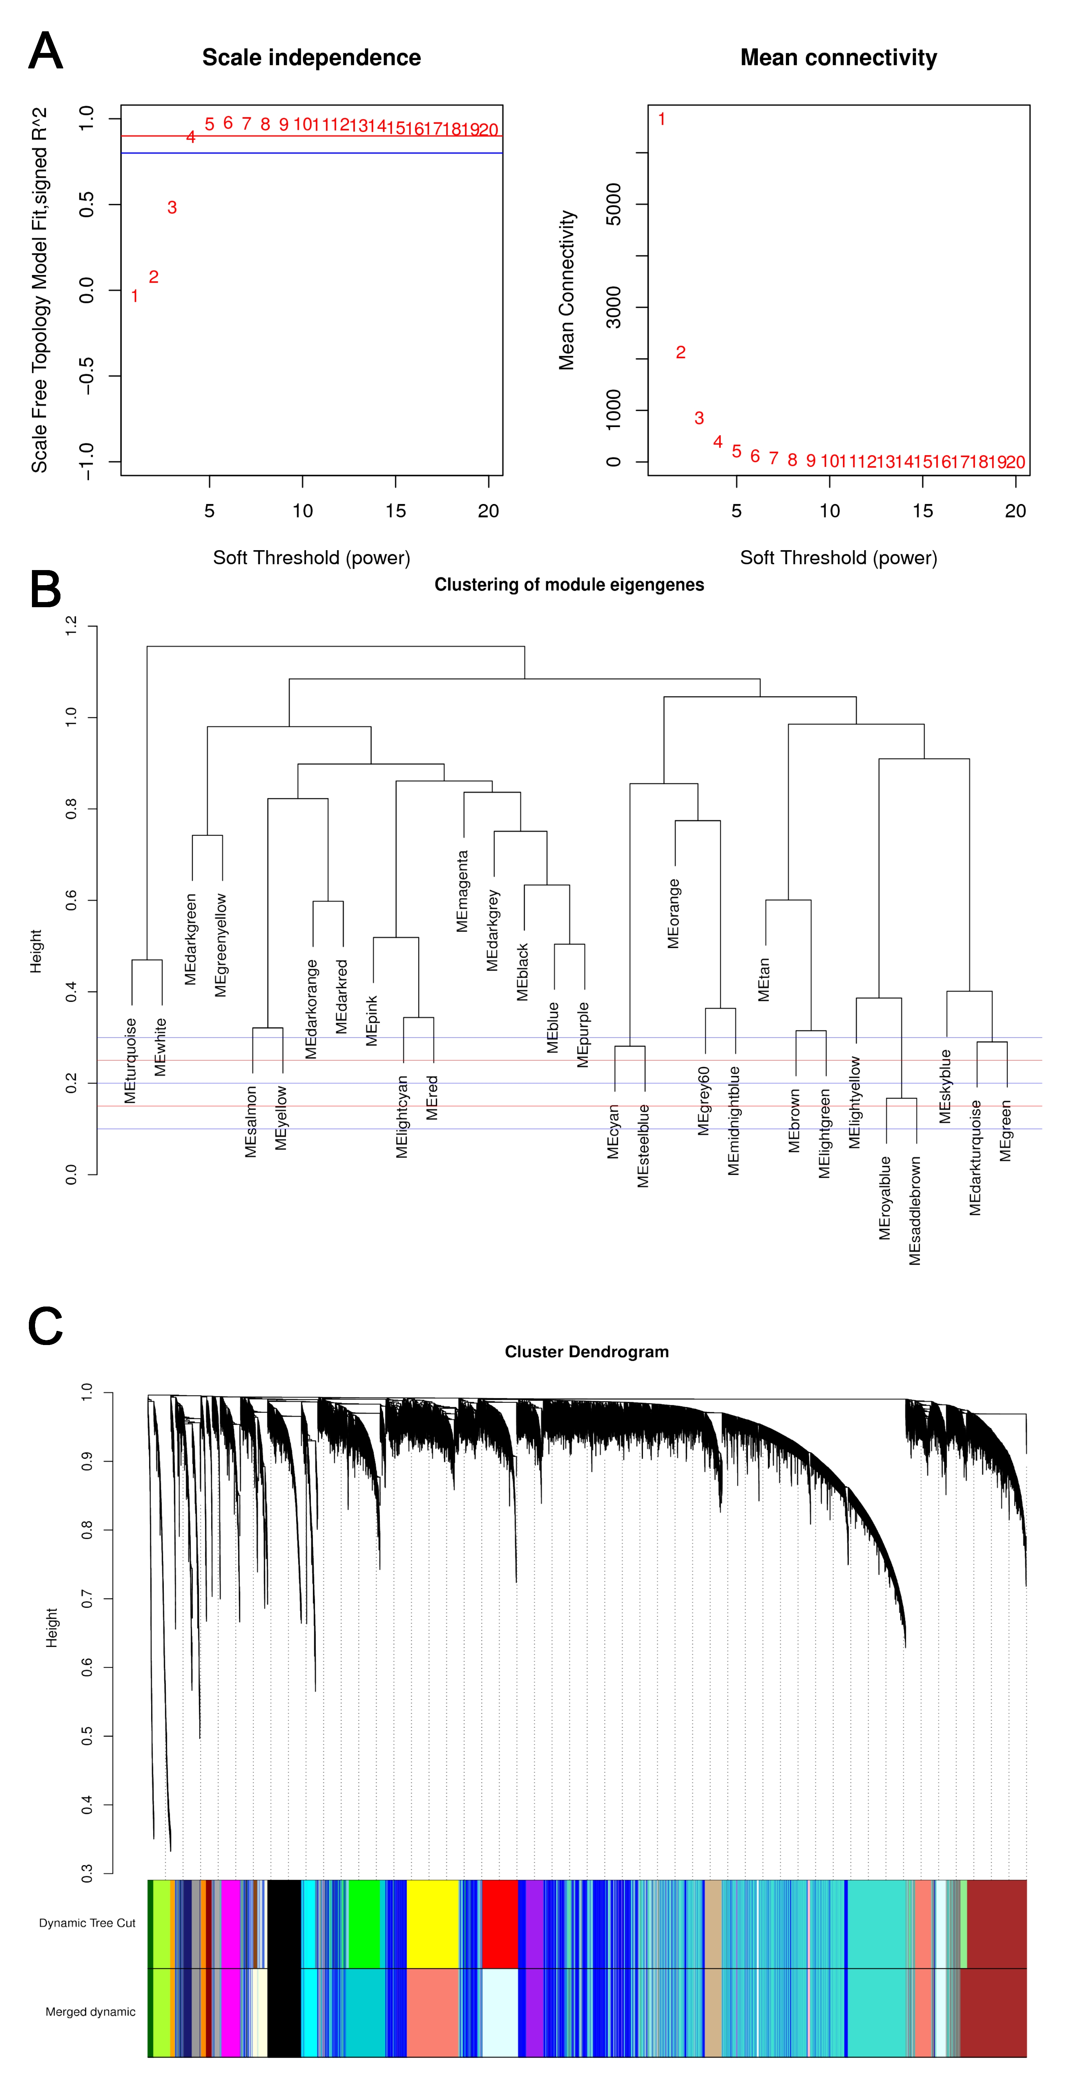
Figure S11: Soft threshold (power) scatter plots and hierarchical cluster tree showing co expression modules identified by WGCNA. (A) The result of soft thresholding. (B) Cluster results of each module eigengenes. (C) Samples of low (permissive) temperature treatment and high (restrictive) temperature treatment were calculated by WGCNA algorithm. Each leaf in the tree is one gene. The major tree branches constitute several gene modules labeled by different colors.

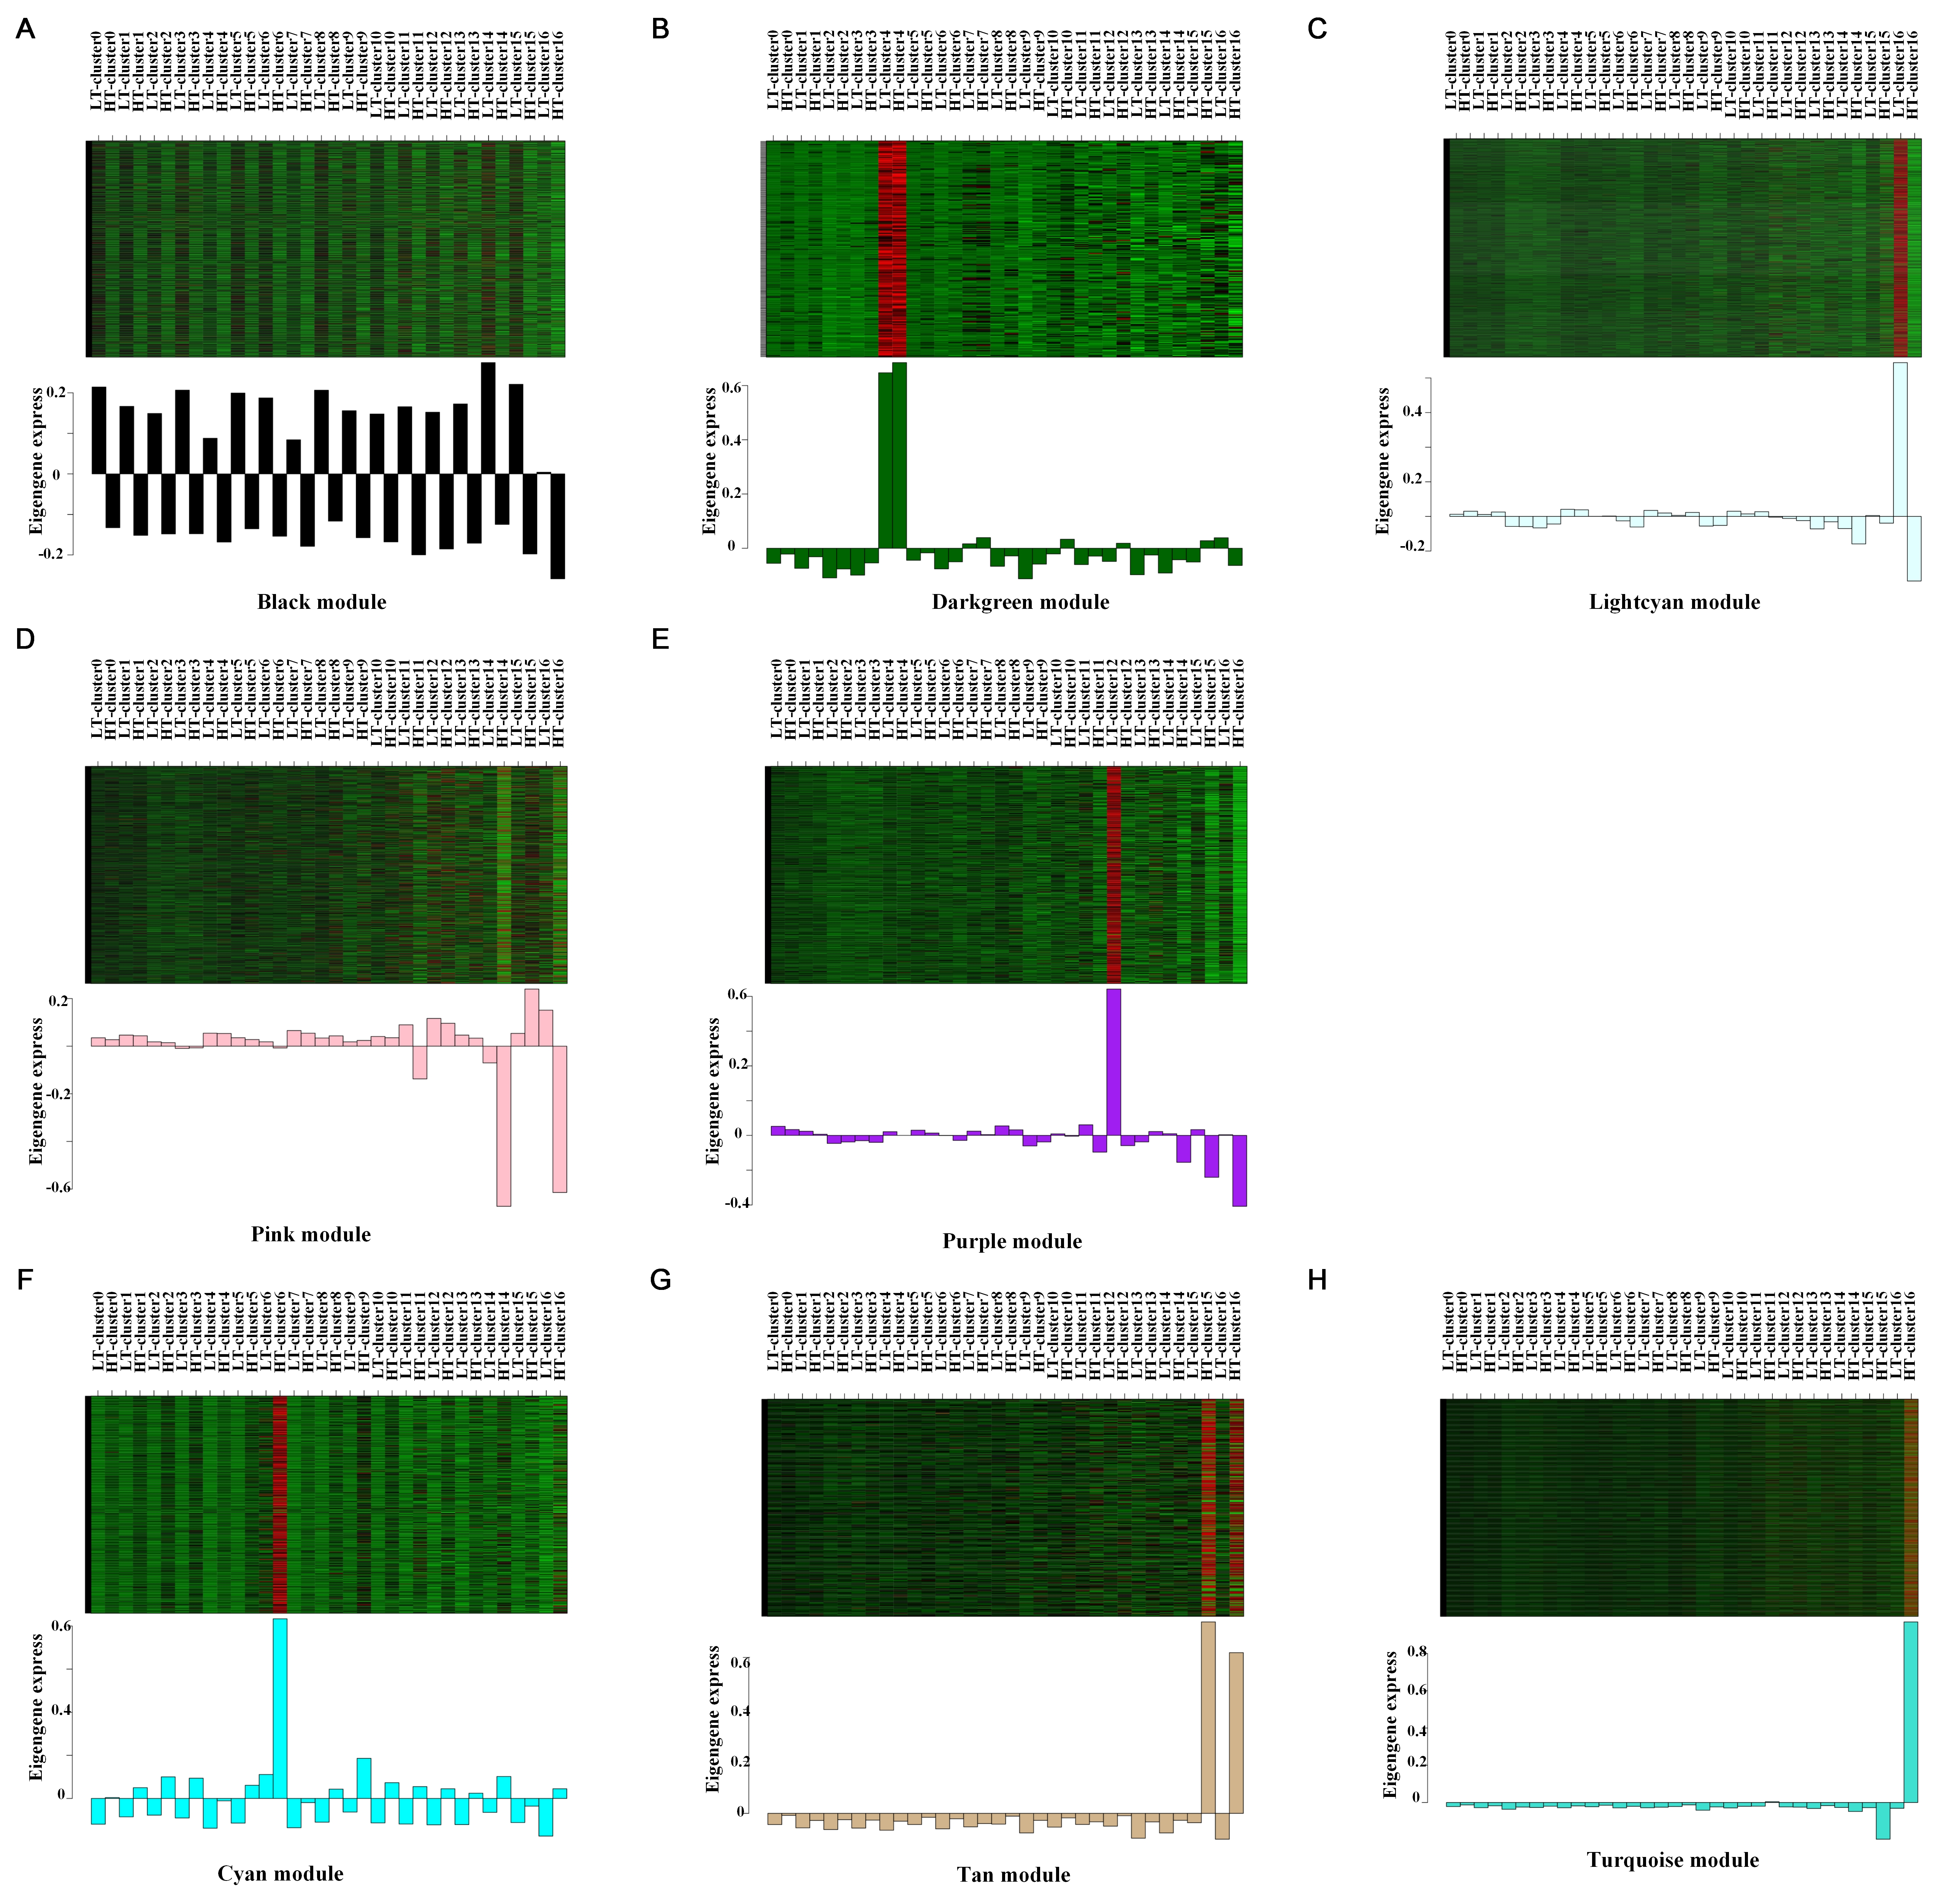
Figure S12: Expression patterns of genes under different modules. (A) Expression patterns of genes under black modules. (B) Expression patterns of genes under darkgreen modules. (C) Expression patterns of genes under lightcyan modules. (D) Expression patterns of genes under pink modules. (E) Expression patterns of genes under purple modules. (F) Expression patterns of genes under cyan modules. (G) Expression patterns of genes under tan modules. (H) Expression patterns of genes under turquoise modules.

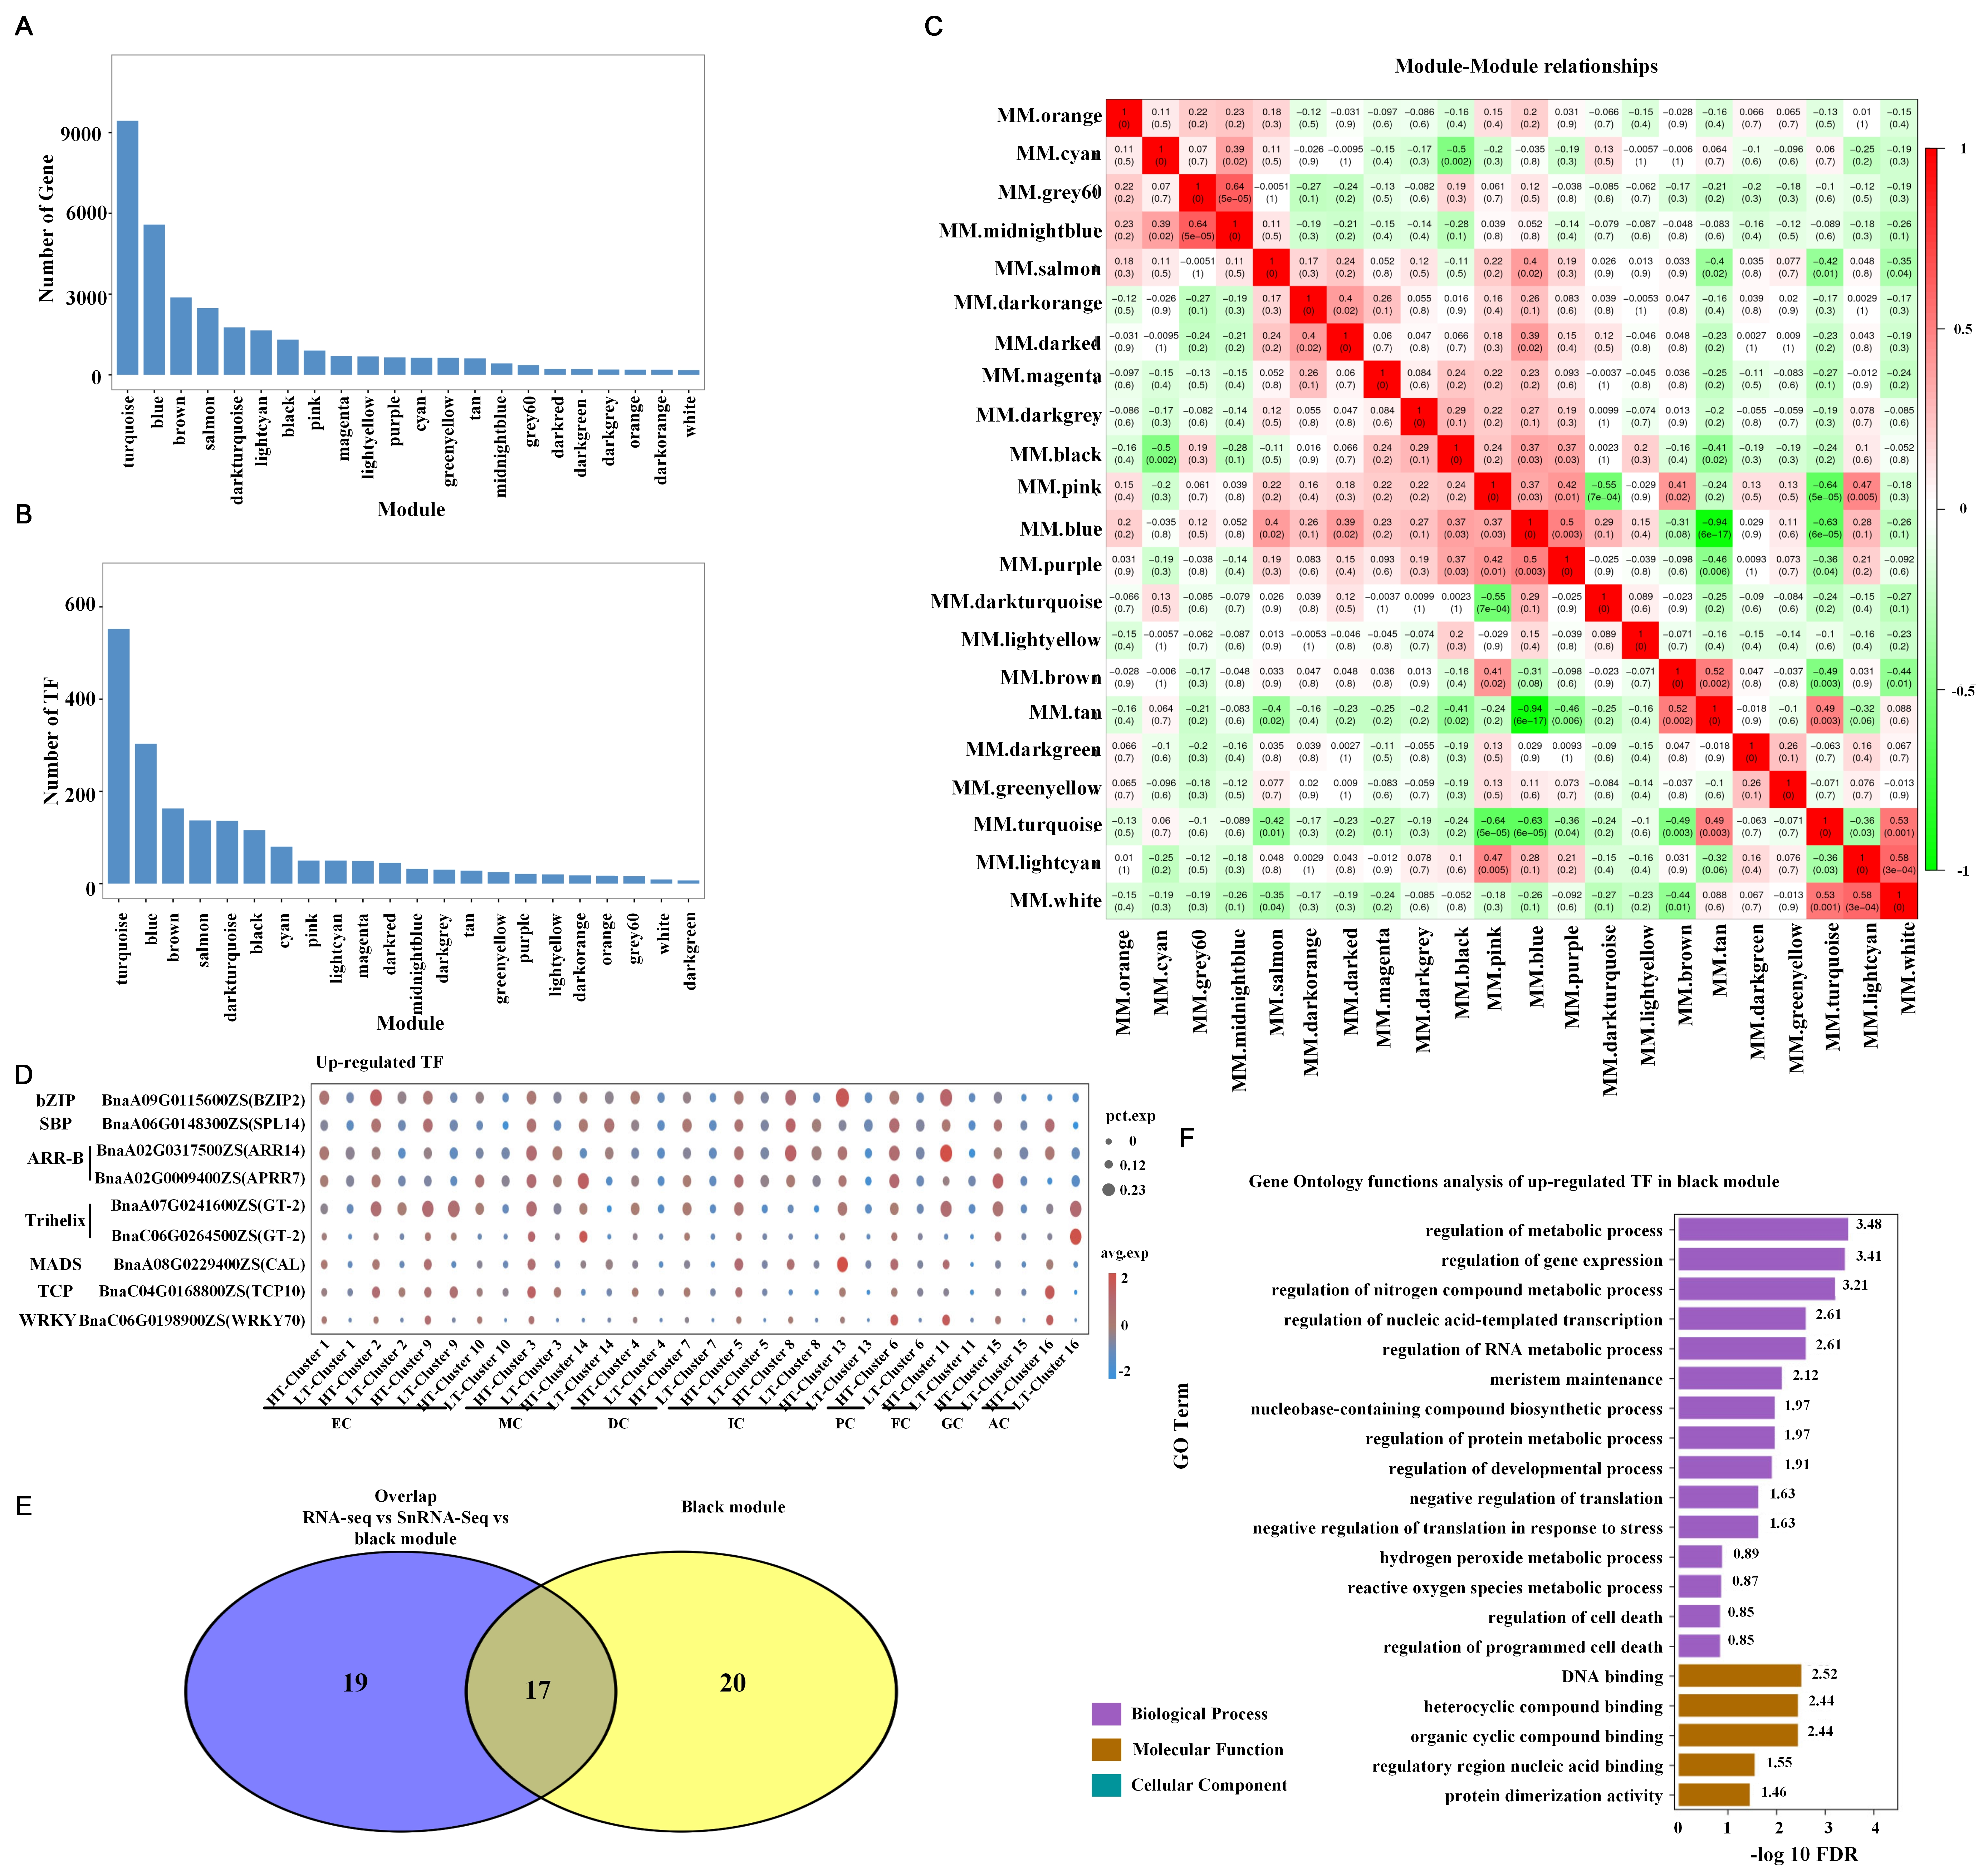
Figure S13: Identification of modules by weighted co-expression network (WGCNA). (A) The gene number in each module. (B) The TFs number in each module. (C) Heatmap of correlations between each module. (D) Up-regulated TFs expression in the black module. (E) venny shows genes in RNAseq, SnRNA-seq, black module and with weight greater than 0.3 of black module. (F) Gene ontology functional enrichment analysis of up-regulated TFs in the black module.

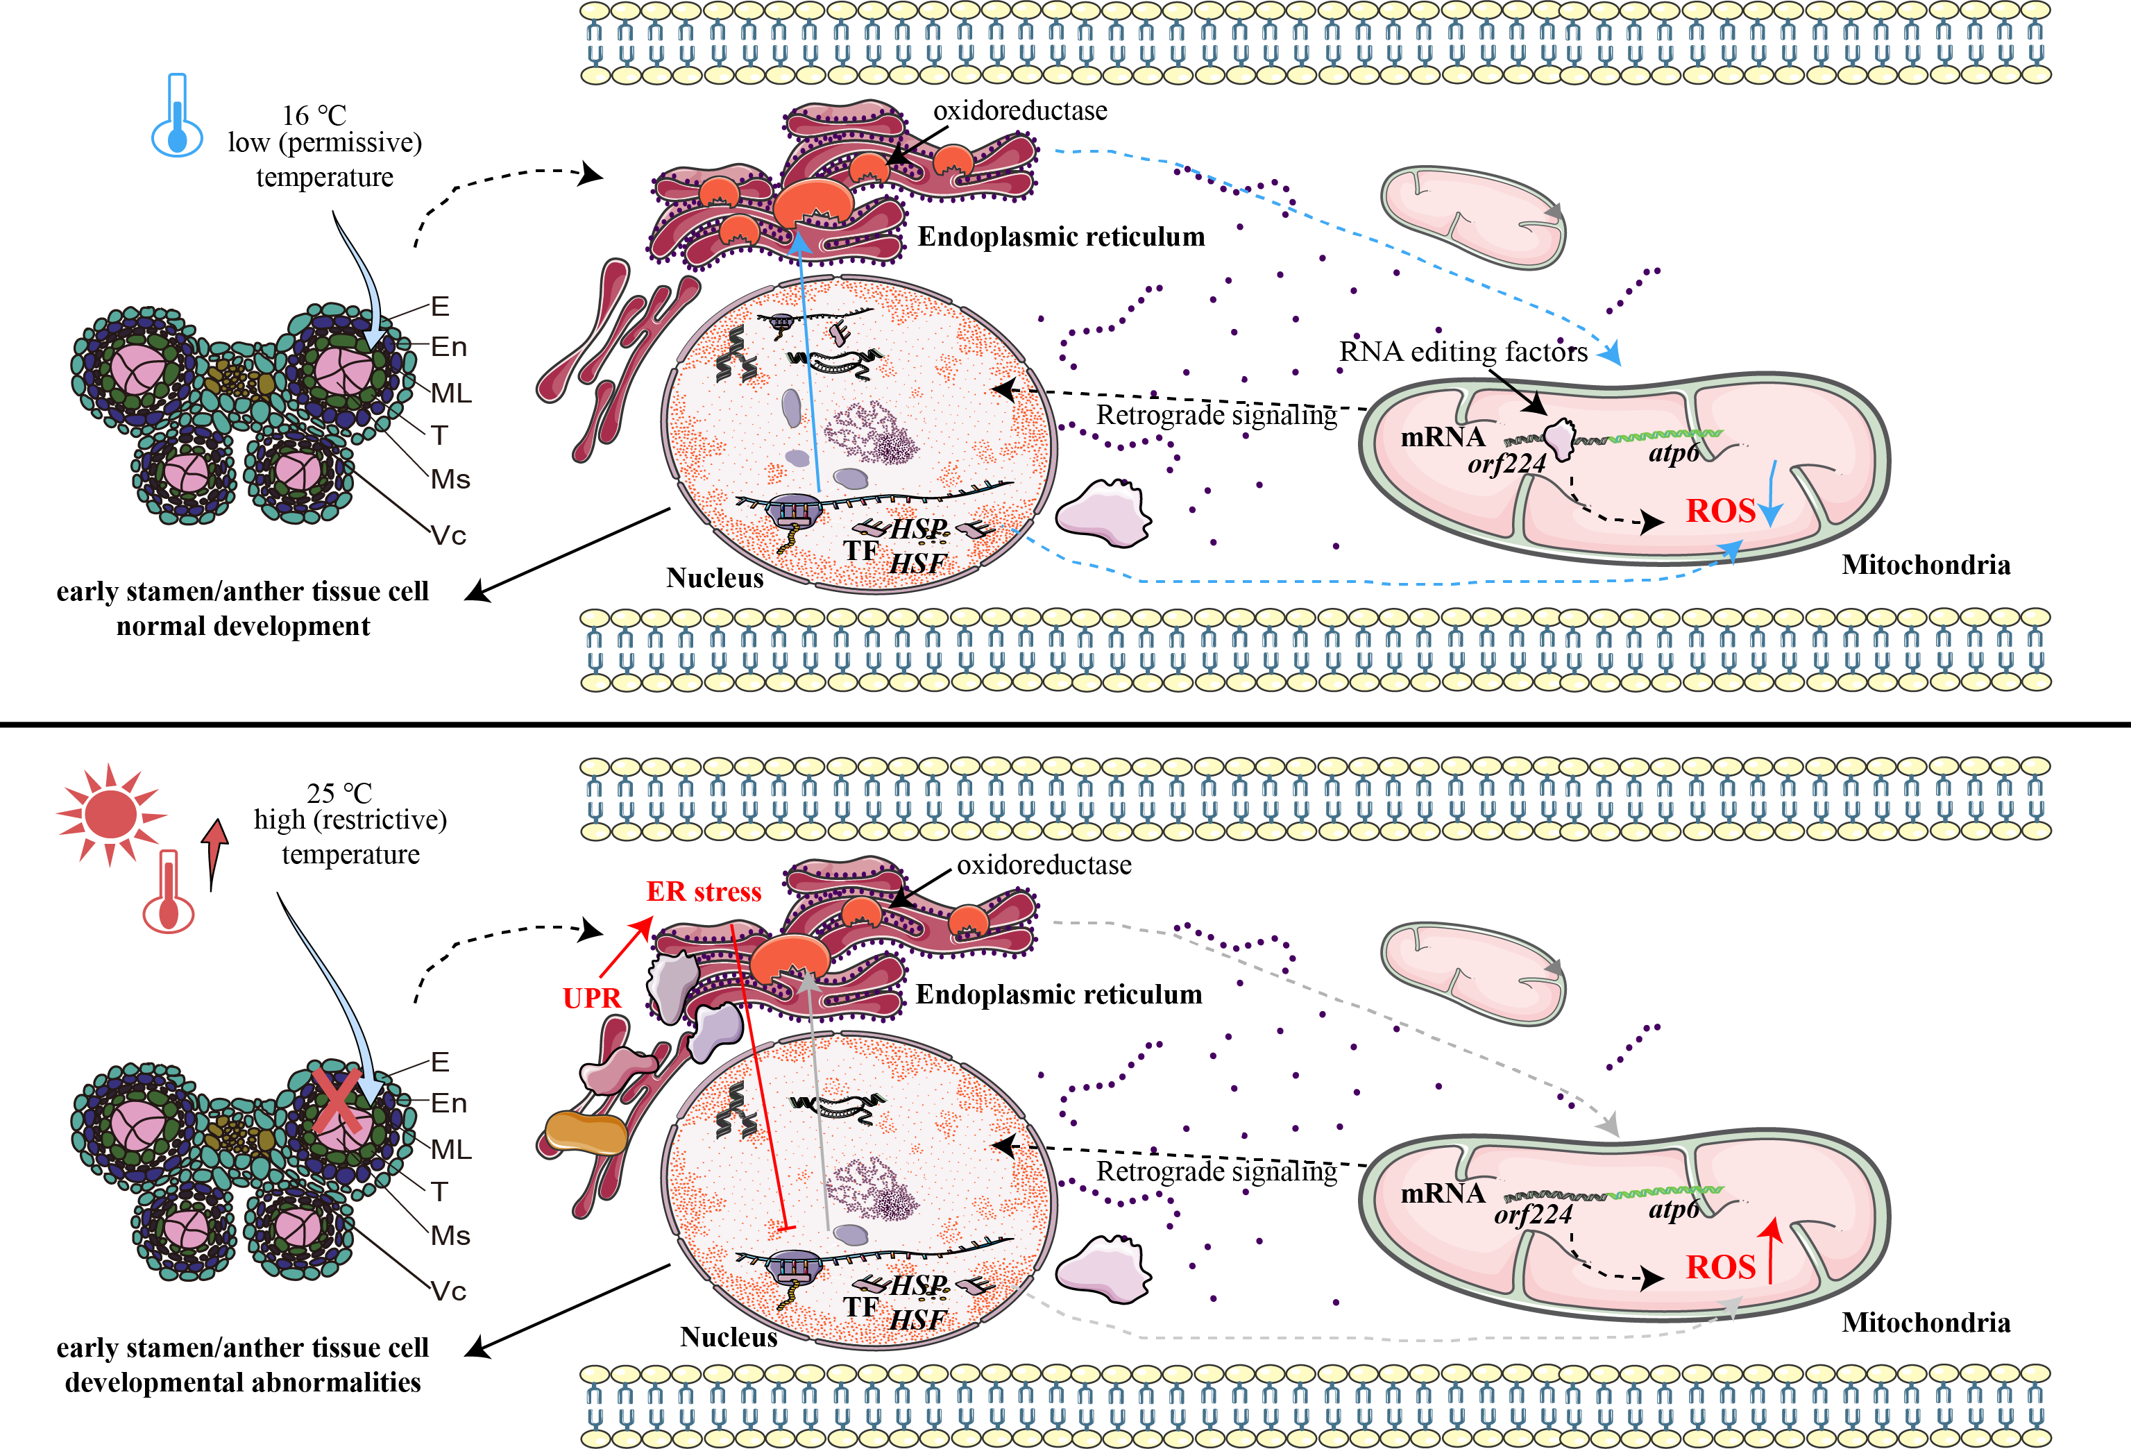
Figure S14: The putative fertility transition model in the low (permissive) and high (restrictive) temperature treatment. E: epidermis; En: endothecium; ML: middle layer; T: tapetum; Ms: microspore; Vc: vascular region; ER: Endoplasmic reticulum; UPR: Unfolded protein response.
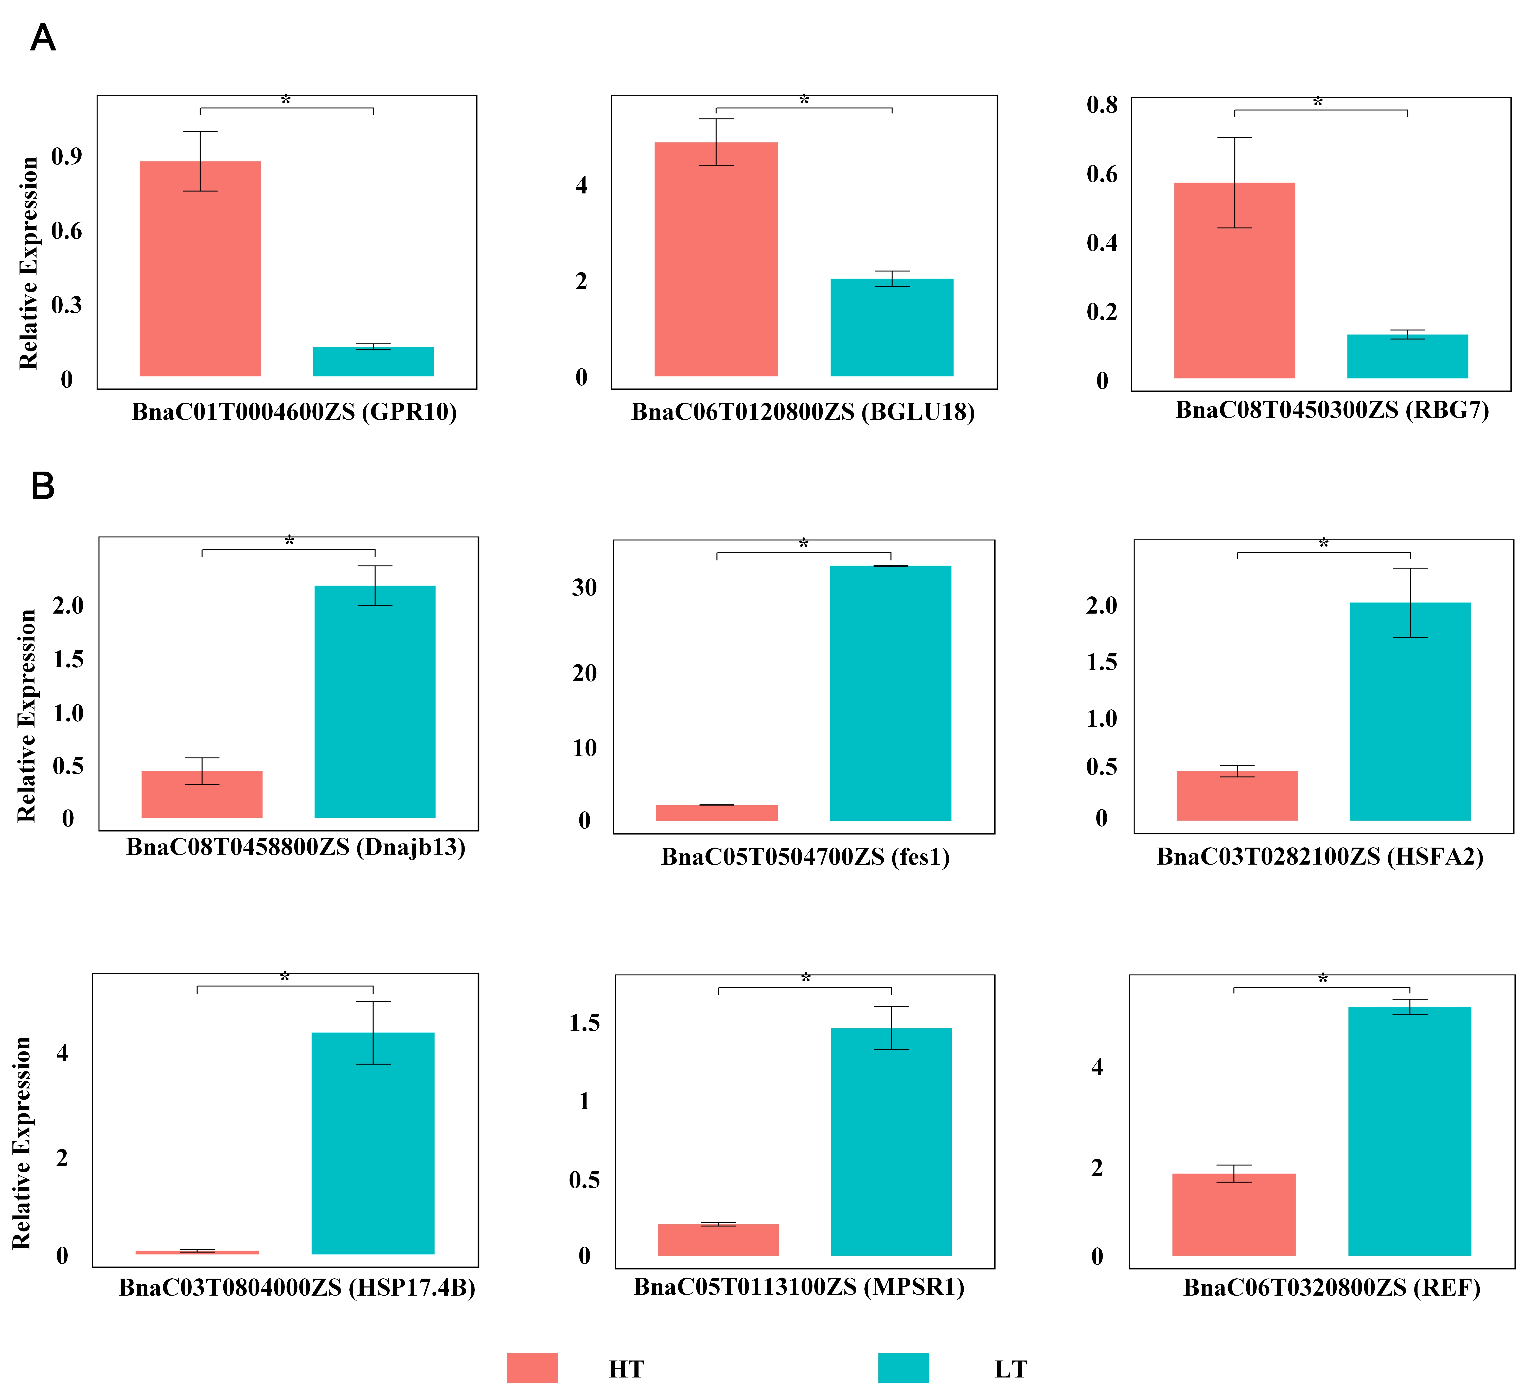
Figure S15: Results of RT-qPCR. A: up-regulated genes after HT treatment, B: down-regulated genes after HT treatment.

