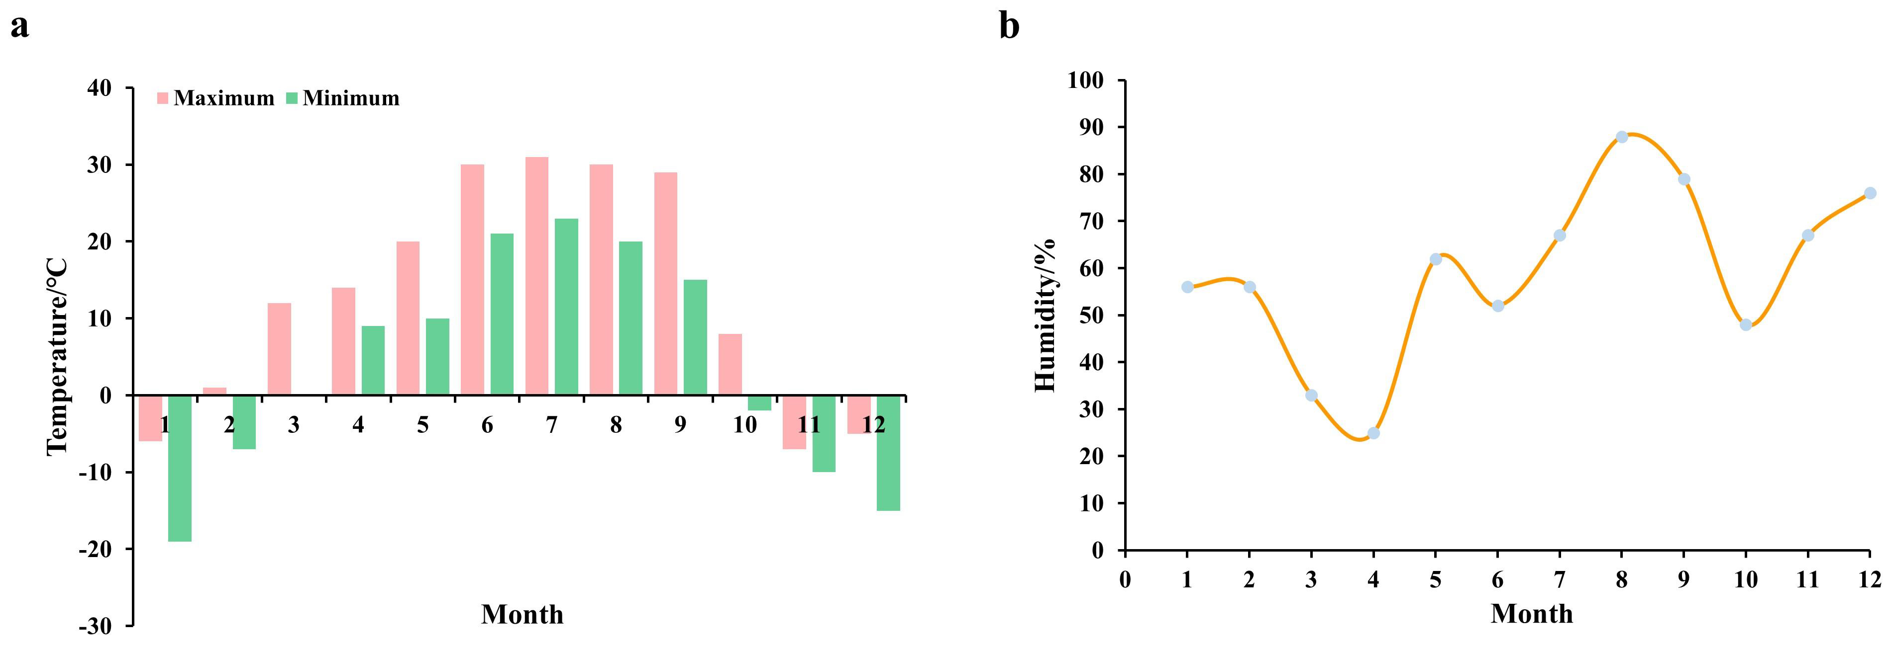
Figure S1. Temperature and humidity on the day of sample collection.

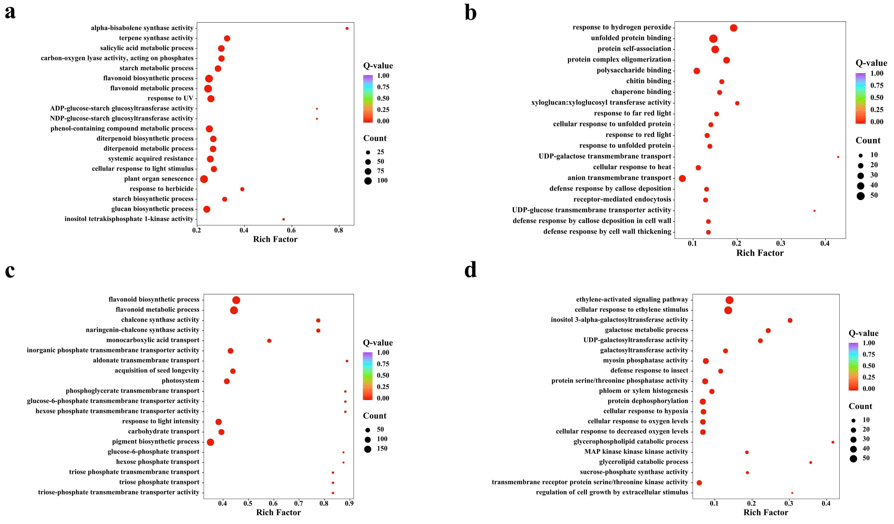
Figure S2. GO enrichment analysis of DEGs for the S2 vs. S3, S3 vs. S4, S4 vs. S5, and S1 vs. S6.

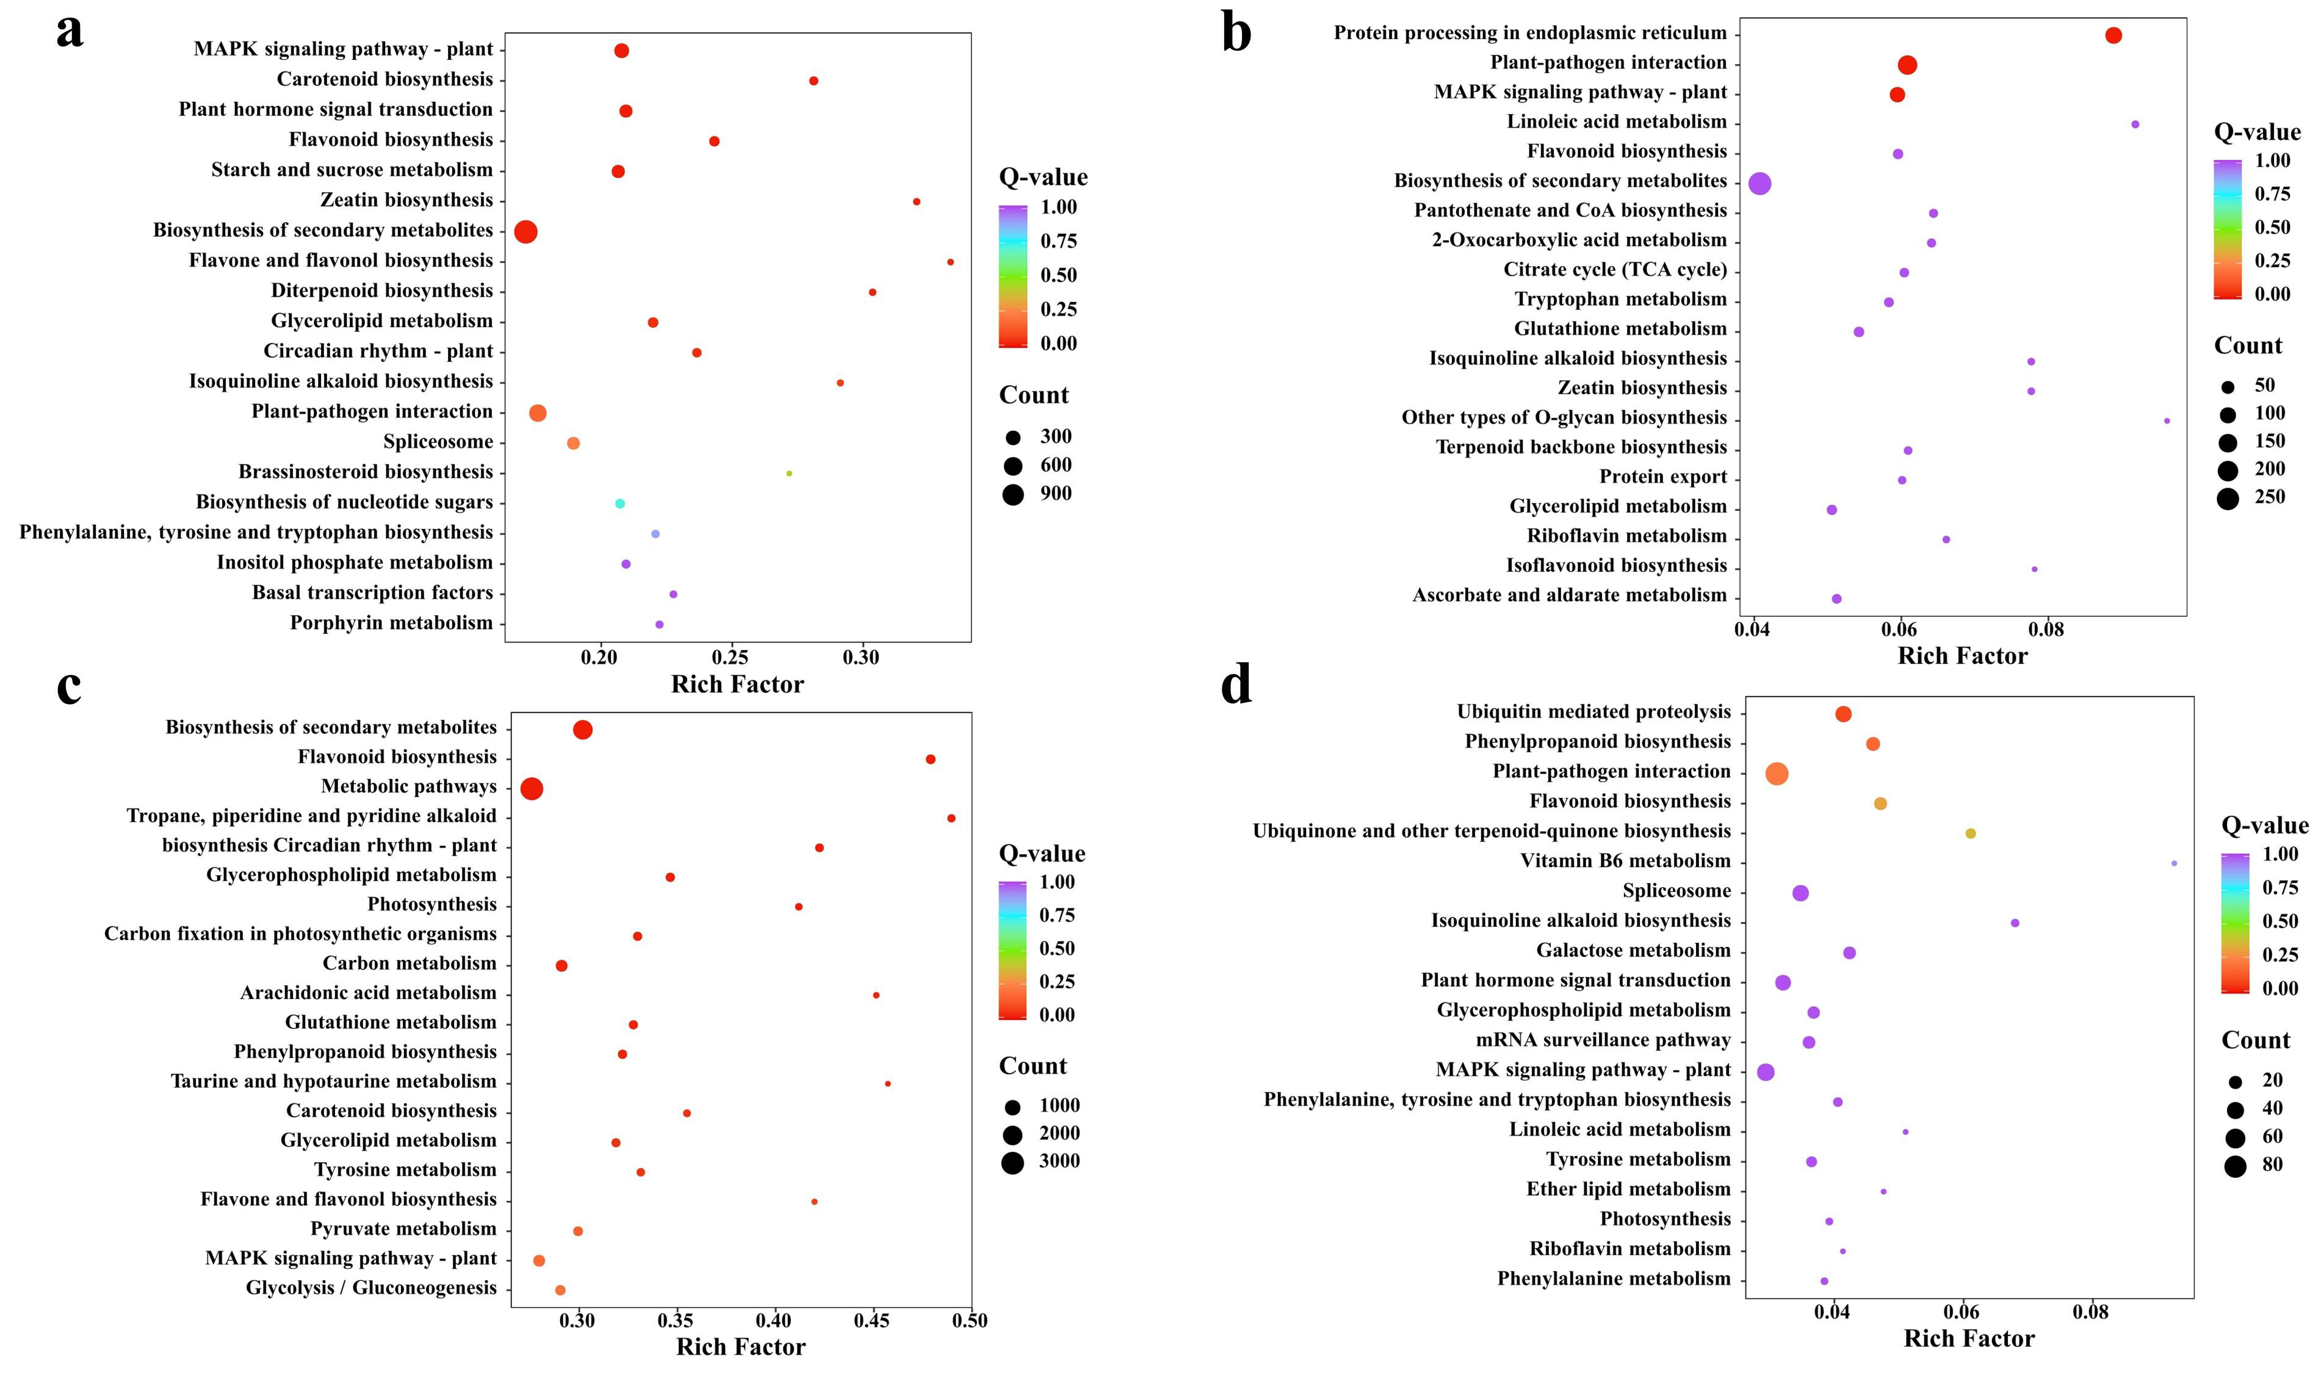
Figure S3. KEGG enrichment analysis of DEGs for the S2 vs. S3, S3 vs. S4, S4 vs. S5, and S1 vs. S6.

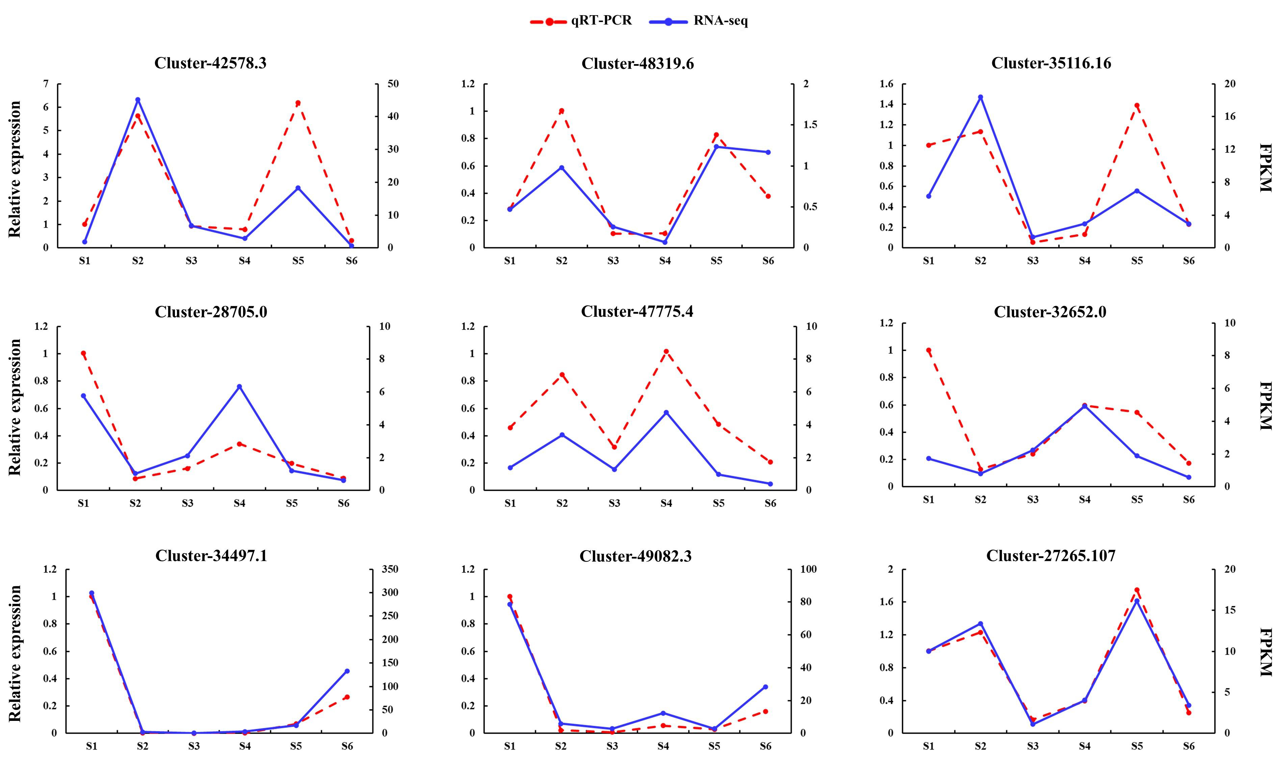
Figure S4. Expression analysis of DEGs by qRT-PCR.

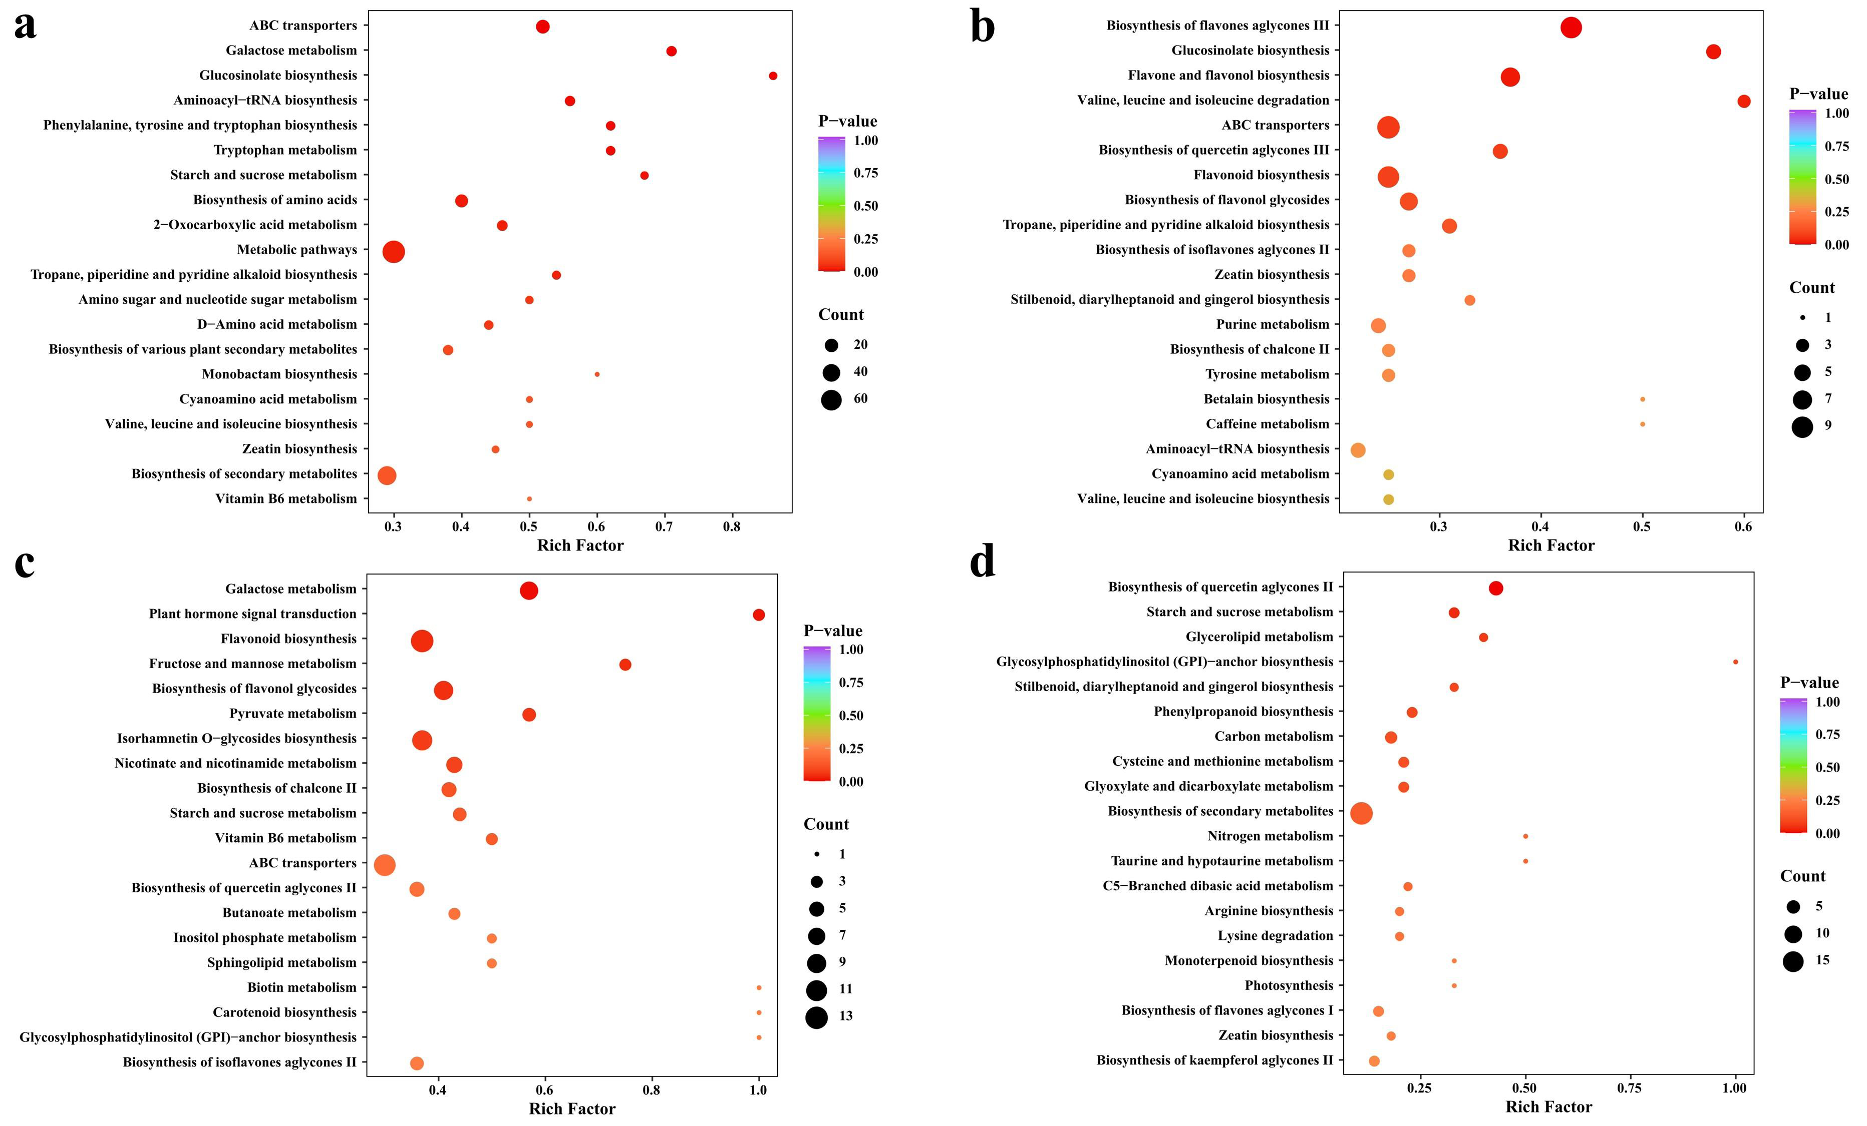
Figure S5. KEGG enrichment analysis of DEMs for the S2 vs. S3, S3 vs. S4, S4 vs. S5, and S1 vs. S6.

