Tab. S1 List of primers
Sequence ID | Unigene ID | Primer ID | Primer Sequence  (5’-3’) | Primer Tm | Primer GC | Product Size
CpANR | Unigene1936 | CpANR_1_F | GCAACCCAAACAGCCGTG | 59.973 | 61.111 | 126
CpANR | Unigene1936 | CpANR_1_R | TGCTGGGTCTCTGACGGT | 60.204 | 61.111 | 126
CpAP2 | Unigene22376 | CpAP2_3_F | AGGCCGGAAAAGAACCCG | 59.966 | 61.111 | 145
CpAP2 | Unigene22376 | CpAP2_3_R | CCATCCCGACGGCGTTAA | 59.815 | 61.111 | 145
CpCCR | Unigene18015 | CpCCR_5_F | AGCTGTGGCATGCACTGT | 59.885 | 55.556 | 150
CpCCR | Unigene18015 | CpCCR_5_R | CCGCCGCTCCTTTCAGAT | 59.812 | 61.111 | 150
CpCYP73A | Unigene2501 | CpCYP73A_5_F | AGGAGACATTGCGCCTCC | 59.413 | 61.111 | 142
CpCYP73A | Unigene2501 | CpCYP73A_5_R | TTCTGGGGGTTGTTGGCG | 60.203 | 61.111 | 142
CpDFR | Unigene5720 | CpDFR_2_F | TGTGGTCACTGGAGCTGC | 59.573 | 61.111 | 87
CpDFR | Unigene5720 | CpDFR_2_R | CTAACGGTGGCCCTGACG | 60.126 | 66.667 | 87
CpEIF1 | Unigene22702 | CpEIF1_2_F | TACCGTCGTCCAGGACCC | 60.362 | 66.667 | 94
CpEIF1 | Unigene22702 | CpEIF1_2_R | AACGCCAGCCTGAACGAG | 60.358 | 61.111 | 94
CpERF1 | Unigene26160 | CpERF1_3_F | ATAGCGCTGAGGCTGCTG | 59.891 | 61.111 | 137
CpERF1 | Unigene26160 | CpERF1_3_R | GGAGCACCCATCATCGCA | 59.81 | 61.111 | 137
CpF3H | Unigene13283 | CpF3H_1_F | GGGAGAGGCTGTCCAGGA | 59.96 | 66.667 | 111
CpF3H | Unigene13283 | CpF3H_1_R | GCCACCTCTTTCCACCCC | 59.964 | 66.667 | 111
CpGLP1 | Unigene25930 | CpGLP1_2_F | GGGTTCGCTGTGACCACA | 59.89 | 61.111 | 119
CpGLP1 | Unigene25930 | CpGLP1_2_R | CGTGGGTGAGTGTGAGGG | 59.656 | 66.667 | 119
CpGLP2 | Unigene26377 | CpGLP2_1_R | GATGGGAGTGGGGAGGGT | 59.957 | 66.667 | 81
CpGLP2 | Unigene26377 | CpGLP2_2_F | TGCCGGGACTCAACACAC | 59.89 | 61.111 | 120
CpIDH1 | Unigene10014 | CpIDH1_3_F | TGCACACAGGGCCAAGTT | 59.722 | 55.556 | 147
CpIDH1 | Unigene10014 | CpIDH1_3_R | TGCTCTCGGGCGAGTTTG | 60.048 | 61.111 | 147
CpJAZ1 | Unigene9306 | CpJAZ1_4_F | TTCATGCCGTCCGTCACC | 60.048 | 61.111 | 144
CpJAZ1 | Unigene9306 | CpJAZ1_4_R | GTCGGCCGGGAAATCGTT | 60.435 | 61.111 | 144
CpLAR | Unigene7737 | CpLAR_3_F | CGTGGACCGAGCTGATCC | 59.895 | 66.667 | 134
CpLAR | Unigene7737 | CpLAR_3_R | GGTAAGGCCAGGCAGCAA | 59.964 | 61.111 | 134
CpPR1 | Unigene24071 | CpPR1_3_F | CCTCTTTTGGGGCTCCGG | 60.045 | 66.667 | 114
CpPR1 | Unigene24071 | CpPR1_3_R | CATTGTTTCCCGGCAGCG | 59.821 | 61.111 | 114
CpSAUR | Unigene27393 | CpSAUR_5_F | AGTCTGCGAGTGCTCTGC | 59.739 | 61.111 | 121
CpSAUR | Unigene27393 | CpSAUR_5_R | TTGTCCGGAGCAACCCAC | 59.888 | 61.111 | 121
CpTCH4 | Unigene3180 | CpTCH4_4_F | GCCCCTTTCTCTGCCTCC | 59.726 | 66.667 | 129
CpTCH4 | Unigene3180 | CpTCH4_4_R | GCTCGCCGAGTCCATCTC | 59.973 | 66.667 | 129

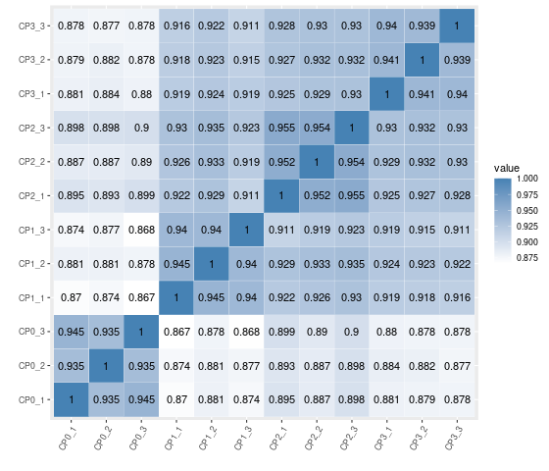
Fig. S1 The correlation of samples. In the figure, the darker the color, the better the correlation between the two samples.
Tab. S2 Statistics on function annotation results
Item | Count | Percentage
All | 75,027 | 100.00%
Annotation | 25,467 | 33.94%
Uniprot | 24,594 | 32.78%
Pfam | 19,705 | 26.26%
GO | 18,199 | 24.26%
KEGG | 10,249 | 13.66%
Pathway | 5,242 | 6.99%
KOG | 483 | 0.64%
Nr | 24,710 | 32.93%

Tab. S3 Number of differentially expressed transcripts
Comparison | DEGs | Up | Down
CP0 vs CP1 | 7,060 | 2,865 | 4,195
CP0 vs CP2 | 5,918 | 2,756 | 3,162
CP0 vs CP3 | 6,637 | 3,019 | 3,618

Tab. S4. GO enrichment analyses of DEGs
Group | ID | Description | GeneRatio | pvalue | Count
CP0  vs  CP1 | GO:0003700 | DNA-binding transcription factor activity | 177/4050 | 6.36E-20 | 177
CP0  vs  CP1 | GO:0005506 | iron ion binding | 111/4050 | 1.20E-12 | 111
CP0  vs  CP1 | GO:0004497 | monooxygenase activity | 86/4050 | 1.98E-12 | 86
CP0  vs  CP1 | GO:0009535 | chloroplast thylakoid membrane | 38/4050 | 9.59E-12 | 38
CP0  vs  CP1 | GO:0020037 | heme binding | 131/4050 | 3.15E-11 | 131
CP0  vs  CP1 | GO:0043565 | sequence-specific DNA binding | 74/4050 | 8.51E-11 | 74
CP0  vs  CP1 | GO:0015979 | photosynthesis | 35/4050 | 1.09E-10 | 35
CP0  vs  CP1 | GO:0016705 | oxidoreductase activity, acting on paired donors, with incorporation or reduction of molecular oxygen | 92/4050 | 1.72E-10 | 92
CP0  vs  CP1 | GO:0016747 | acyltransferase activity, transferring groups other than amino-acyl groups | 39/4050 | 1.02E-08 | 39
CP0  vs  CP1 | GO:0016491 | oxidoreductase activity | 105/4050 | 2.14E-07 | 105
CP0  vs  CP1 | GO:0009523 | photosystem II | 17/4050 | 1.30E-06 | 17
CP0  vs  CP1 | GO:0009522 | photosystem I | 15/4050 | 2.14E-06 | 15
CP0  vs  CP1 | GO:0009765 | photosynthesis, light harvesting | 13/4050 | 3.06E-06 | 13
CP0  vs  CP1 | GO:0004553 | hydrolase activity, hydrolyzing O-glycosyl compounds | 44/4050 | 5.00E-06 | 44
CP0  vs  CP1 | GO:0008171 | O-methyltransferase activity | 17/4050 | 6.37E-06 | 17
CP0  vs  CP1 | GO:0015995 | chlorophyll biosynthetic process | 11/4050 | 1.21E-05 | 11
CP0  vs  CP1 | GO:0016301 | kinase activity | 114/4050 | 1.50E-05 | 114
CP0  vs  CP1 | GO:0048046 | apoplast | 35/4050 | 2.05E-05 | 35
CP0  vs  CP1 | GO:0009654 | photosystem II oxygen evolving complex | 15/4050 | 2.58E-05 | 15
CP0  vs  CP1 | GO:0016168 | chlorophyll binding | 15/4050 | 2.58E-05 | 15
CP0  vs  CP1 | GO:0005576 | extracellular region | 55/4050 | 4.05E-05 | 55
CP0  vs  CP1 | GO:0009734 | auxin-activated signaling pathway | 34/4050 | 7.40E-05 | 34
CP0  vs  CP1 | GO:0022857 | transmembrane transporter activity | 71/4050 | 0.000105 | 71
CP0  vs  CP1 | GO:0018298 | protein-chromophore linkage | 20/4050 | 0.000106 | 20
CP0  vs  CP1 | GO:0015267 | channel activity | 14/4050 | 0.000140 | 14
CP0  vs  CP1 | GO:0005975 | carbohydrate metabolic process | 88/4050 | 0.000146 | 88
CP0  vs  CP1 | GO:0019898 | extrinsic component of membrane | 11/4050 | 0.000208 | 11
CP0  vs  CP1 | GO:0005509 | calcium ion binding | 83/4050 | 0.000245 | 83
CP0  vs  CP1 | GO:0016788 | hydrolase activity, acting on ester bonds | 25/4050 | 0.000314 | 25
CP0  vs  CP1 | GO:0016773 | phosphotransferase activity, alcohol group as acceptor | 11/4050 | 0.000428 | 11
CP0  vs  CP1 | GO:0005618 | cell wall | 35/4050 | 0.000433 | 35
CP0  vs  CP1 | GO:0016760 | cellulose synthase (UDP-forming) activity | 17/4050 | 0.000807 | 17
CP0  vs  CP1 | GO:0000155 | phosphorelay sensor kinase activity | 10/4050 | 0.001198 | 10
CP0  vs  CP1 | GO:0005992 | trehalose biosynthetic process | 10/4050 | 0.001198 | 10
CP0  vs  CP1 | GO:0015276 | ligand-gated ion channel activity | 23/4050 | 0.001605 | 23
CP0  vs  CP1 | GO:0016762 | xyloglucan:xyloglucosyl transferase activity | 13/4050 | 0.001722 | 13
CP0  vs  CP1 | GO:0004601 | peroxidase activity | 32/4050 | 0.001796 | 32
CP0  vs  CP1 | GO:0006979 | response to oxidative stress | 34/4050 | 0.001797 | 34
CP0  vs  CP1 | GO:0042910 | xenobiotic transmembrane transporter activity | 15/4050 | 0.002599 | 15
CP0  vs  CP1 | GO:0030244 | cellulose biosynthetic process | 17/4050 | 0.003324 | 17
CP0  vs  CP1 | GO:0005516 | calmodulin binding | 28/4050 | 0.003363 | 28
CP0  vs  CP1 | GO:0005507 | copper ion binding | 20/4050 | 0.003561 | 20
CP0  vs  CP1 | GO:0019252 | starch biosynthetic process | 14/4050 | 0.003854 | 14
CP0  vs  CP1 | GO:0042744 | hydrogen peroxide catabolic process | 28/4050 | 0.004152 | 28
CP0  vs  CP1 | GO:0006749 | glutathione metabolic process | 22/4050 | 0.004942 | 22
CP0  vs  CP1 | GO:0006869 | lipid transport | 15/4050 | 0.005170 | 15
CP0  vs  CP1 | GO:0000160 | phosphorelay signal transduction system | 14/4050 | 0.005468 | 14
CP0  vs  CP1 | GO:0008194 | UDP-glycosyltransferase activity | 51/4050 | 0.006873 | 51
CP0  vs  CP1 | GO:0015297 | antiporter activity | 15/4050 | 0.007067 | 15
CP0  vs  CP1 | GO:0016791 | phosphatase activity | 13/4050 | 0.008070 | 13
CP0  vs  CP1 | GO:0009058 | biosynthetic process | 26/4050 | 0.011277 | 26
CP0  vs  CP1 | GO:0004674 | protein serine/threonine kinase activity | 105/4050 | 0.011959 | 105
CP0  vs  CP1 | GO:0016740 | transferase activity | 64/4050 | 0.012717 | 64
CP0  vs  CP1 | GO:0042546 | cell wall biogenesis | 10/4050 | 0.013253 | 10
CP0  vs  CP1 | GO:0003824 | catalytic activity | 35/4050 | 0.014875 | 35
CP0  vs  CP1 | GO:0030145 | manganese ion binding | 13/4050 | 0.014978 | 13
CP0  vs  CP1 | GO:0006865 | amino acid transport | 14/4050 | 0.017936 | 14
CP0  vs  CP1 | GO:0004650 | polygalacturonase activity | 10/4050 | 0.018857 | 10
CP0  vs  CP1 | GO:0010411 | xyloglucan metabolic process | 10/4050 | 0.018857 | 10
CP0  vs  CP1 | GO:0009055 | electron transfer activity | 19/4050 | 0.020539 | 19
CP0  vs  CP1 | GO:0051537 | 2 iron, 2 sulfur cluster binding | 11/4050 | 0.023861 | 11
CP0  vs  CP1 | GO:0006629 | lipid metabolic process | 28/4050 | 0.024212 | 28
CP0  vs  CP1 | GO:0005886 | plasma membrane | 60/4050 | 0.027050 | 60
CP0  vs  CP1 | GO:0055085 | transmembrane transport | 30/4050 | 0.029651 | 30
CP0  vs  CP1 | GO:0005388 | P-type calcium transporter activity | 10/4050 | 0.034924 | 10
CP0  vs  CP1 | GO:0016829 | lyase activity | 10/4050 | 0.034924 | 10
CP0  vs  CP1 | GO:0004190 | aspartic-type endopeptidase activity | 19/4050 | 0.036068 | 19
CP0  vs  CP1 | GO:0045490 | pectin catabolic process | 14/4050 | 0.036545 | 14
CP0  vs  CP1 | GO:0030246 | carbohydrate binding | 71/4050 | 0.048766 | 71
CP0  vs  CP2 | GO:0009535 | chloroplast thylakoid membrane | 40/3423 | 5.96E-16 | 40
CP0  vs  CP2 | GO:0020037 | heme binding | 127/3423 | 2.99E-15 | 127
CP0  vs  CP2 | GO:0015979 | photosynthesis | 37/3423 | 1.15E-14 | 37
CP0  vs  CP2 | GO:0005506 | iron ion binding | 102/3423 | 9.51E-14 | 102
CP0  vs  CP2 | GO:0004497 | monooxygenase activity | 79/3423 | 3.82E-13 | 79
CP0  vs  CP2 | GO:0016705 | oxidoreductase activity, acting on paired donors, with incorporation or reduction of molecular oxygen | 84/3423 | 3.49E-11 | 84
CP0  vs  CP2 | GO:0016747 | acyltransferase activity, transferring groups other than amino-acyl groups | 39/3423 | 5.99E-11 | 39
CP0  vs  CP2 | GO:0003700 | DNA-binding transcription factor activity | 134/3423 | 9.94E-11 | 134
CP0  vs  CP2 | GO:0009523 | photosystem II | 19/3423 | 8.58E-10 | 19
CP0  vs  CP2 | GO:0016491 | oxidoreductase activity | 97/3423 | 9.96E-09 | 97
CP0  vs  CP2 | GO:0009522 | photosystem I | 16/3423 | 1.84E-08 | 16
CP0  vs  CP2 | GO:0009765 | photosynthesis, light harvesting | 14/3423 | 2.59E-08 | 14
CP0  vs  CP2 | GO:0005576 | extracellular region | 57/3423 | 2.77E-08 | 57
CP0  vs  CP2 | GO:0016168 | chlorophyll binding | 17/3423 | 3.97E-08 | 17
CP0  vs  CP2 | GO:0008171 | O-methyltransferase activity | 18/3423 | 6.79E-08 | 18
CP0  vs  CP2 | GO:0048046 | apoplast | 36/3423 | 1.06E-07 | 36
CP0  vs  CP2 | GO:0009654 | photosystem II oxygen evolving complex | 16/3423 | 3.73E-07 | 16
CP0  vs  CP2 | GO:0006979 | response to oxidative stress | 38/3423 | 1.26E-06 | 38
CP0  vs  CP2 | GO:0004601 | peroxidase activity | 35/3423 | 3.80E-06 | 35
CP0  vs  CP2 | GO:0019898 | extrinsic component of membrane | 12/3423 | 4.63E-06 | 12
CP0  vs  CP2 | GO:0018298 | protein-chromophore linkage | 20/3423 | 8.14E-06 | 20
CP0  vs  CP2 | GO:0043565 | sequence-specific DNA binding | 54/3423 | 1.32E-05 | 54
CP0  vs  CP2 | GO:0016788 | hydrolase activity, acting on ester bonds | 25/3423 | 1.76E-05 | 25
CP0  vs  CP2 | GO:0015995 | chlorophyll biosynthetic process | 10/3423 | 2.60E-05 | 10
CP0  vs  CP2 | GO:0042744 | hydrogen peroxide catabolic process | 30/3423 | 3.91E-05 | 30
CP0  vs  CP2 | GO:0015276 | ligand-gated ion channel activity | 24/3423 | 4.12E-05 | 24
CP0  vs  CP2 | GO:0004553 | hydrolase activity, hydrolyzing O-glycosyl compounds | 36/3423 | 0.000120 | 36
CP0  vs  CP2 | GO:0008194 | UDP-glycosyltransferase activity | 51/3423 | 0.000142 | 51
CP0  vs  CP2 | GO:0009734 | auxin-activated signaling pathway | 28/3423 | 0.000703 | 28
CP0  vs  CP2 | GO:0005975 | carbohydrate metabolic process | 72/3423 | 0.001868 | 72
CP0  vs  CP2 | GO:0003680 | minor groove of adenine-thymine-rich DNA binding | 11/3423 | 0.002265 | 11
CP0  vs  CP2 | GO:0009058 | biosynthetic process | 25/3423 | 0.002390 | 25
CP0  vs  CP2 | GO:0004857 | enzyme inhibitor activity | 14/3423 | 0.002906 | 14
CP0  vs  CP2 | GO:0005886 | plasma membrane | 57/3423 | 0.002958 | 57
CP0  vs  CP2 | GO:0005507 | copper ion binding | 18/3423 | 0.003139 | 18
CP0  vs  CP2 | GO:0006749 | glutathione metabolic process | 20/3423 | 0.003401 | 20
CP0  vs  CP2 | GO:0030145 | manganese ion binding | 13/3423 | 0.003464 | 13
CP0  vs  CP2 | GO:0016301 | kinase activity | 88/3423 | 0.003723 | 88
CP0  vs  CP2 | GO:0006865 | amino acid transport | 14/3423 | 0.003944 | 14
CP0  vs  CP2 | GO:0005618 | cell wall | 28/3423 | 0.004801 | 28
CP0  vs  CP2 | GO:0016762 | xyloglucan:xyloglucosyl transferase activity | 11/3423 | 0.004852 | 11
CP0  vs  CP2 | GO:0022857 | transmembrane transporter activity | 55/3423 | 0.006222 | 55
CP0  vs  CP2 | GO:0051537 | 2 iron, 2 sulfur cluster binding | 11/3423 | 0.006817 | 11
CP0  vs  CP2 | GO:0030599 | pectinesterase activity | 12/3423 | 0.007729 | 12
CP0  vs  CP2 | GO:0042545 | cell wall modification | 12/3423 | 0.007729 | 12
CP0  vs  CP2 | GO:0045330 | aspartyl esterase activity | 12/3423 | 0.007729 | 12
CP0  vs  CP2 | GO:0030247 | polysaccharide binding | 33/3423 | 0.008462 | 33
CP0  vs  CP2 | GO:0045490 | pectin catabolic process | 14/3423 | 0.008956 | 14
CP0  vs  CP2 | GO:0000981 | DNA-binding transcription factor activity, RNA polymerase II-specific | 14/3423 | 0.011442 | 14
CP0  vs  CP2 | GO:0003824 | catalytic activity | 31/3423 | 0.012123 | 31
CP0  vs  CP2 | GO:0042910 | xenobiotic transmembrane transporter activity | 12/3423 | 0.013456 | 12
CP0  vs  CP2 | GO:0004185 | serine-type carboxypeptidase activity | 15/3423 | 0.014611 | 15
CP0  vs  CP2 | GO:0016791 | phosphatase activity | 11/3423 | 0.016521 | 11
CP0  vs  CP2 | GO:0009055 | electron transfer activity | 17/3423 | 0.017596 | 17
CP0  vs  CP2 | GO:0006869 | lipid transport | 12/3423 | 0.021949 | 12
CP0  vs  CP2 | GO:0015297 | antiporter activity | 12/3423 | 0.027438 | 12
CP0  vs  CP2 | GO:0016760 | cellulose synthase (UDP-forming) activity | 12/3423 | 0.027438 | 12
CP0  vs  CP2 | GO:0016740 | transferase activity | 53/3423 | 0.034444 | 53
CP0  vs  CP2 | GO:0032259 | methylation | 51/3423 | 0.038505 | 51
CP0  vs  CP2 | GO:0051213 | dioxygenase activity | 14/3423 | 0.046346 | 14
CP0  vs  CP2 | GO:0008289 | lipid binding | 22/3423 | 0.047015 | 22
CP0  vs  CP3 | GO:0003700 | DNA-binding transcription factor activity | 167/3850 | 3.47E-18 | 167
CP0  vs  CP3 | GO:0020037 | heme binding | 141/3850 | 8.59E-17 | 141
CP0  vs  CP3 | GO:0004497 | monooxygenase activity | 87/3850 | 3.26E-14 | 87
CP0  vs  CP3 | GO:0005506 | iron ion binding | 111/3850 | 3.55E-14 | 111
CP0  vs  CP3 | GO:0016705 | oxidoreductase activity, acting on paired donors, with incorporation or reduction of molecular oxygen | 95/3850 | 4.61E-13 | 95
CP0  vs  CP3 | GO:0009535 | chloroplast thylakoid membrane | 38/3850 | 1.87E-12 | 38
CP0  vs  CP3 | GO:0015979 | photosynthesis | 35/3850 | 2.43E-11 | 35
CP0  vs  CP3 | GO:0016747 | acyltransferase activity, transferring groups other than amino-acyl groups | 39/3850 | 2.24E-09 | 39
CP0  vs  CP3 | GO:0005576 | extracellular region | 59/3850 | 2.87E-07 | 59
CP0  vs  CP3 | GO:0008171 | O-methyltransferase activity | 18/3850 | 4.43E-07 | 18
CP0  vs  CP3 | GO:0048046 | apoplast | 37/3850 | 6.73E-07 | 37
CP0  vs  CP3 | GO:0009522 | photosystem I | 15/3850 | 1.08E-06 | 15
CP0  vs  CP3 | GO:0006979 | response to oxidative stress | 41/3850 | 1.10E-06 | 41
CP0  vs  CP3 | GO:0009765 | photosynthesis, light harvesting | 13/3850 | 1.67E-06 | 13
CP0  vs  CP3 | GO:0009654 | photosystem II oxygen evolving complex | 16/3850 | 1.98E-06 | 16
CP0  vs  CP3 | GO:0015276 | ligand-gated ion channel activity | 28/3850 | 2.57E-06 | 28
CP0  vs  CP3 | GO:0004601 | peroxidase activity | 38/3850 | 2.65E-06 | 38
CP0  vs  CP3 | GO:0009607 | response to biotic stimulus | 15/3850 | 2.73E-06 | 15
CP0  vs  CP3 | GO:0043565 | sequence-specific DNA binding | 60/3850 | 4.81E-06 | 60
CP0  vs  CP3 | GO:0042910 | xenobiotic transmembrane transporter activity | 19/3850 | 5.36E-06 | 19
CP0  vs  CP3 | GO:0016491 | oxidoreductase activity | 96/3850 | 5.67E-06 | 96
CP0  vs  CP3 | GO:0015995 | chlorophyll biosynthetic process | 11/3850 | 7.18E-06 | 11
CP0  vs  CP3 | GO:0019898 | extrinsic component of membrane | 12/3850 | 1.67E-05 | 12
CP0  vs  CP3 | GO:0042744 | hydrogen peroxide catabolic process | 33/3850 | 1.98E-05 | 33
CP0  vs  CP3 | GO:0009523 | photosystem II | 15/3850 | 2.72E-05 | 15
CP0  vs  CP3 | GO:0015297 | antiporter activity | 19/3850 | 2.90E-05 | 19
CP0  vs  CP3 | GO:0008194 | UDP-glycosyltransferase activity | 57/3850 | 5.54E-05 | 57
CP0  vs  CP3 | GO:0005618 | cell wall | 36/3850 | 6.39E-05 | 36
CP0  vs  CP3 | GO:0003680 | minor groove of adenine-thymine-rich DNA binding | 14/3850 | 7.82E-05 | 14
CP0  vs  CP3 | GO:0022857 | transmembrane transporter activity | 68/3850 | 0.000127 | 68
CP0  vs  CP3 | GO:0004568 | chitinase activity | 10/3850 | 0.000184 | 10
CP0  vs  CP3 | GO:0006032 | chitin catabolic process | 10/3850 | 0.000184 | 10
CP0  vs  CP3 | GO:0016998 | cell wall macromolecule catabolic process | 10/3850 | 0.000184 | 10
CP0  vs  CP3 | GO:0016773 | phosphotransferase activity, alcohol group as acceptor | 11/3850 | 0.000267 | 11
CP0  vs  CP3 | GO:0030247 | polysaccharide binding | 41/3850 | 0.000357 | 41
CP0  vs  CP3 | GO:0005509 | calcium ion binding | 79/3850 | 0.000359 | 79
CP0  vs  CP3 | GO:0015267 | channel activity | 13/3850 | 0.000386 | 13
CP0  vs  CP3 | GO:0016168 | chlorophyll binding | 13/3850 | 0.000386 | 13
CP0  vs  CP3 | GO:0016788 | hydrolase activity, acting on ester bonds | 24/3850 | 0.000387 | 24
CP0  vs  CP3 | GO:0031969 | chloroplast membrane | 10/3850 | 0.000786 | 10
CP0  vs  CP3 | GO:0046274 | lignin catabolic process | 10/3850 | 0.000786 | 10
CP0  vs  CP3 | GO:0052716 | hydroquinone:oxygen oxidoreductase activity | 10/3850 | 0.000786 | 10
CP0  vs  CP3 | GO:0016301 | kinase activity | 101/3850 | 0.000848 | 101
CP0  vs  CP3 | GO:0030145 | manganese ion binding | 15/3850 | 0.001031 | 15
CP0  vs  CP3 | GO:0004553 | hydrolase activity, hydrolyzing O-glycosyl compounds | 36/3850 | 0.001245 | 36
CP0  vs  CP3 | GO:0005975 | carbohydrate metabolic process | 80/3850 | 0.001359 | 80
CP0  vs  CP3 | GO:0005516 | calmodulin binding | 28/3850 | 0.001536 | 28
CP0  vs  CP3 | GO:0018298 | protein-chromophore linkage | 17/3850 | 0.001878 | 17
CP0  vs  CP3 | GO:0004857 | enzyme inhibitor activity | 15/3850 | 0.003104 | 15
CP0  vs  CP3 | GO:0005886 | plasma membrane | 62/3850 | 0.004071 | 62
CP0  vs  CP3 | GO:0016760 | cellulose synthase (UDP-forming) activity | 15/3850 | 0.004295 | 15
CP0  vs  CP3 | GO:0000981 | DNA-binding transcription factor activity, RNA polymerase II-specific | 16/3850 | 0.005222 | 16
CP0  vs  CP3 | GO:0010333 | terpene synthase activity | 13/3850 | 0.007178 | 13
CP0  vs  CP3 | GO:0006865 | amino acid transport | 14/3850 | 0.011572 | 14
CP0  vs  CP3 | GO:0009055 | electron transfer activity | 19/3850 | 0.012177 | 19
CP0  vs  CP3 | GO:0030244 | cellulose biosynthetic process | 15/3850 | 0.013215 | 15
CP0  vs  CP3 | GO:0004650 | polygalacturonase activity | 10/3850 | 0.013274 | 10
CP0  vs  CP3 | GO:0046983 | protein dimerization activity | 78/3850 | 0.015474 | 78
CP0  vs  CP3 | GO:0019252 | starch biosynthetic process | 12/3850 | 0.019530 | 12
CP0  vs  CP3 | GO:0042626 | ATPase-coupled transmembrane transporter activity | 42/3850 | 0.020022 | 42
CP0  vs  CP3 | GO:0006869 | lipid transport | 13/3850 | 0.022138 | 13
CP0  vs  CP3 | GO:0005507 | copper ion binding | 17/3850 | 0.024298 | 17
CP0  vs  CP3 | GO:0004674 | protein serine/threonine kinase activity | 98/3850 | 0.024745 | 98
CP0  vs  CP3 | GO:0008289 | lipid binding | 25/3850 | 0.030010 | 25
CP0  vs  CP3 | GO:0006633 | fatty acid biosynthetic process | 18/3850 | 0.030654 | 18
CP0  vs  CP3 | GO:0009733 | response to auxin | 11/3850 | 0.037377 | 11
CP0  vs  CP3 | GO:0004185 | serine-type carboxypeptidase activity | 15/3850 | 0.039371 | 15
CP0  vs  CP3 | GO:0006629 | lipid metabolic process | 26/3850 | 0.039627 | 26
CP0  vs  CP3 | GO:0051537 | 2 iron, 2 sulfur cluster binding | 10/3850 | 0.043154 | 10

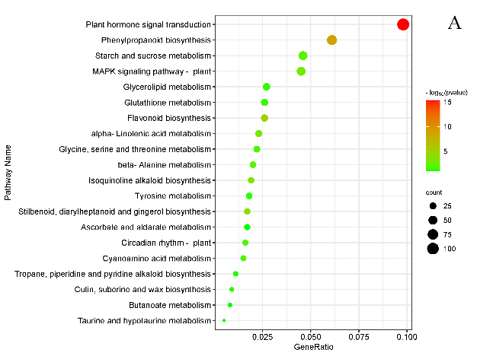 | 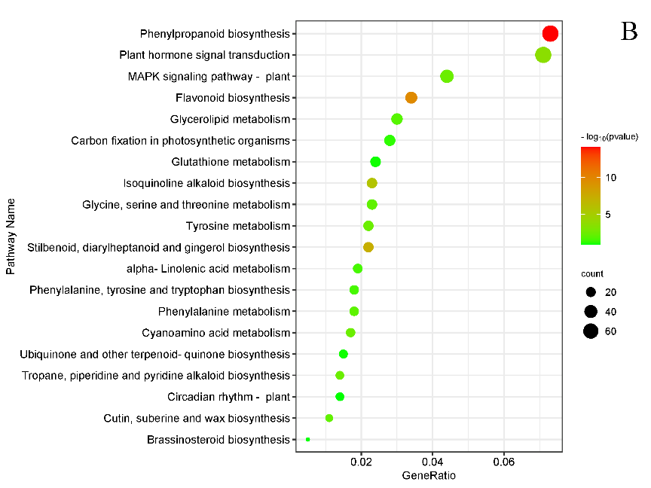
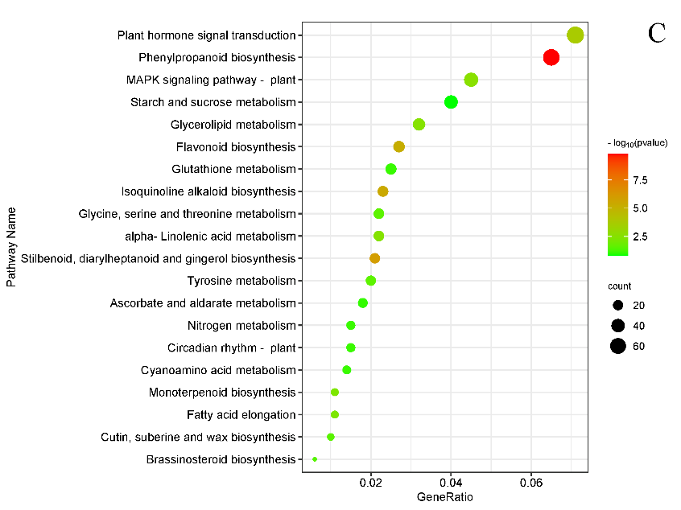
Fig. S2. Dotplot plot of DEGs utilizing KEGG enrichment analysis. (A) CP0 vs CP1. (B) CP0 vs CP2. (C) CP0 vs CP3. In the figure, the horizontal axis is GeneRatio (the proportion of differentially expressed genes in the KEGG to all differentially expressed genes), the vertical axis is KEGG Pathway, the color of the dot represents pvalues, and the size of the dot represents the number of DEGs.

Tab. S5. KEGG enrichment analyses of DEGs
Group | ID | Description | GeneRatio | pvalue | Count
CP0 vs CP1 | ko04075 | Plant hormone signal transduction | 107/1097 | 3.93E-18 | 107
CP0 vs CP1 | ko00940 | Phenylpropanoid biosynthesis | 67/1097 | 2.01E-11 | 67
CP0 vs CP1 | ko00195 | Photosynthesis | 35/1097 | 1.17E-10 | 35
CP0 vs CP1 | ko00941 | Flavonoid biosynthesis | 28/1097 | 4.45E-07 | 28
CP0 vs CP1 | ko00196 | Photosynthesis - antenna proteins | 13/1097 | 4.12E-06 | 13
CP0 vs CP1 | ko00945 | Stilbenoid, diarylheptanoid and gingerol biosynthesis | 19/1097 | 4.27E-06 | 19
CP0 vs CP1 | ko00860 | Porphyrin and chlorophyll metabolism | 21/1097 | 1.60E-05 | 21
CP0 vs CP1 | ko00950 | Isoquinoline alkaloid biosynthesis | 21/1097 | 1.60E-05 | 21
CP0 vs CP1 | ko00592 | alpha-Linolenic acid metabolism | 25/1097 | 5.23E-05 | 25
CP0 vs CP1 | ko04016 | MAPK signaling pathway - plant | 49/1097 | 8.20E-05 | 49
CP0 vs CP1 | ko00500 | Starch and sucrose metabolism | 50/1097 | 0.000759634 | 50
CP0 vs CP1 | ko00410 | beta-Alanine metabolism | 22/1097 | 0.000944602 | 22
CP0 vs CP1 | ko00460 | Cyanoamino acid metabolism | 17/1097 | 0.001610778 | 17
CP0 vs CP1 | ko04712 | Circadian rhythm - plant | 18/1097 | 0.001997328 | 18
CP0 vs CP1 | ko00260 | Glycine, serine and threonine metabolism | 24/1097 | 0.002101266 | 24
CP0 vs CP1 | ko00561 | Glycerolipid metabolism | 30/1097 | 0.005616242 | 30
CP0 vs CP1 | ko00480 | Glutathione metabolism | 28/1097 | 0.00627165 | 28
CP0 vs CP1 | ko00073 | Cutin, suberine and wax biosynthesis | 10/1097 | 0.008433319 | 10
CP0 vs CP1 | ko00350 | Tyrosine metabolism | 20/1097 | 0.009163608 | 20
CP0 vs CP1 | ko00960 | Tropane, piperidine and pyridine alkaloid biosynthesis | 12/1097 | 0.013377504 | 12
CP0 vs CP1 | ko00430 | Taurine and hypotaurine metabolism | 6/1097 | 0.014496427 | 6
CP0 vs CP1 | ko00650 | Butanoate metabolism | 9/1097 | 0.01904252 | 9
CP0 vs CP1 | ko00053 | Ascorbate and aldarate metabolism | 19/1097 | 0.019476956 | 19
CP0 vs CP1 | ko00910 | Nitrogen metabolism | 15/1097 | 0.029231267 | 15
CP0 vs CP2 | ko00940 | Phenylpropanoid biosynthesis | 72/980 | 7.05E-17 | 72
CP0 vs CP2 | ko00195 | Photosynthesis | 35/980 | 4.02E-12 | 35
CP0 vs CP2 | ko00941 | Flavonoid biosynthesis | 33/980 | 5.25E-12 | 33
CP0 vs CP2 | ko00945 | Stilbenoid, diarylheptanoid and gingerol biosynthesis | 22/980 | 1.82E-09 | 22
CP0 vs CP2 | ko00196 | Photosynthesis - antenna proteins | 14/980 | 8.48E-08 | 14
CP0 vs CP2 | ko00950 | Isoquinoline alkaloid biosynthesis | 23/980 | 9.03E-08 | 23
CP0 vs CP2 | ko00860 | Porphyrin and chlorophyll metabolism | 22/980 | 4.94E-07 | 22
CP0 vs CP2 | ko04075 | Plant hormone signal transduction | 70/980 | 1.70E-05 | 70
CP0 vs CP2 | ko00350 | Tyrosine metabolism | 22/980 | 0.000331057 | 22
CP0 vs CP2 | ko04016 | MAPK signaling pathway - plant | 43/980 | 0.000415919 | 43
CP0 vs CP2 | ko00460 | Cyanoamino acid metabolism | 17/980 | 0.000418147 | 17
CP0 vs CP2 | ko00960 | Tropane, piperidine and pyridine alkaloid biosynthesis | 14/980 | 0.000424543 | 14
CP0 vs CP2 | ko00073 | Cutin, suberine and wax biosynthesis | 11/980 | 0.000861576 | 11
CP0 vs CP2 | ko00260 | Glycine, serine and threonine metabolism | 23/980 | 0.001028366 | 23
CP0 vs CP2 | ko00360 | Phenylalanine metabolism | 18/980 | 0.001260765 | 18
CP0 vs CP2 | ko00561 | Glycerolipid metabolism | 29/980 | 0.002002122 | 29
CP0 vs CP2 | ko00906 | Carotenoid biosynthesis | 12/980 | 0.003834347 | 12
CP0 vs CP2 | ko00400 | Phenylalanine, tyrosine and tryptophan biosynthesis | 18/980 | 0.004610101 | 18
CP0 vs CP2 | ko00592 | alpha-Linolenic acid metabolism | 19/980 | 0.004700461 | 19
CP0 vs CP2 | ko00710 | Carbon fixation in photosynthetic organisms | 27/980 | 0.011213213 | 27
CP0 vs CP2 | ko00480 | Glutathione metabolism | 24/980 | 0.020000049 | 24
CP0 vs CP2 | ko00130 | Ubiquinone and other terpenoid-quinone biosynthesis | 15/980 | 0.020508839 | 15
CP0 vs CP2 | ko00905 | Brassinosteroid biosynthesis | 5/980 | 0.024805503 | 5
CP0 vs CP2 | ko04712 | Circadian rhythm - plant | 14/980 | 0.02540611 | 14
CP0 vs CP2 | ko00500 | Starch and sucrose metabolism | 39/980 | 0.031735573 | 39
CP0 vs CP2 | ko01200 | Carbon metabolism | 68/980 | 0.035529797 | 68
CP0 vs CP2 | ko00430 | Taurine and hypotaurine metabolism | 5/980 | 0.038614285 | 5
CP0 vs CP2 | ko00630 | Glyoxylate and dicarboxylate metabolism | 25/980 | 0.045758978 | 25
CP0 vs CP3 | ko00940 | Phenylpropanoid biosynthesis | 66/1010 | 1.26E-12 | 66
CP0 vs CP3 | ko00195 | Photosynthesis | 32/1010 | 1.86E-09 | 32
CP0 vs CP3 | ko00945 | Stilbenoid, diarylheptanoid and gingerol biosynthesis | 21/1010 | 2.63E-08 | 21
CP0 vs CP3 | ko00860 | Porphyrin and chlorophyll metabolism | 23/1010 | 1.62E-07 | 23
CP0 vs CP3 | ko00950 | Isoquinoline alkaloid biosynthesis | 23/1010 | 1.62E-07 | 23
CP0 vs CP3 | ko00941 | Flavonoid biosynthesis | 27/1010 | 3.23E-07 | 27
CP0 vs CP3 | ko00196 | Photosynthesis - antenna proteins | 13/1010 | 1.54E-06 | 13
CP0 vs CP3 | ko04075 | Plant hormone signal transduction | 72/1010 | 1.30E-05 | 72
CP0 vs CP3 | ko04016 | MAPK signaling pathway - plant | 45/1010 | 0.000198655 | 45
CP0 vs CP3 | ko00561 | Glycerolipid metabolism | 32/1010 | 0.000297867 | 32
CP0 vs CP3 | ko00906 | Carotenoid biosynthesis | 14/1010 | 0.000379185 | 14
CP0 vs CP3 | ko00592 | alpha-Linolenic acid metabolism | 22/1010 | 0.000384602 | 22
CP0 vs CP3 | ko00062 | Fatty acid elongation | 11/1010 | 0.000678345 | 11
CP0 vs CP3 | ko00902 | Monoterpenoid biosynthesis | 11/1010 | 0.000678345 | 11
CP0 vs CP3 | ko00350 | Tyrosine metabolism | 20/1010 | 0.003486651 | 20
CP0 vs CP3 | ko00260 | Glycine, serine and threonine metabolism | 22/1010 | 0.003730805 | 22
CP0 vs CP3 | ko00073 | Cutin, suberine and wax biosynthesis | 10/1010 | 0.00456207 | 10
CP0 vs CP3 | ko00905 | Brassinosteroid biosynthesis | 6/1010 | 0.005201115 | 6
CP0 vs CP3 | ko00460 | Cyanoamino acid metabolism | 14/1010 | 0.013852595 | 14
CP0 vs CP3 | ko00910 | Nitrogen metabolism | 15/1010 | 0.01430832 | 15
CP0 vs CP3 | ko04712 | Circadian rhythm - plant | 15/1010 | 0.01430832 | 15
CP0 vs CP3 | ko00480 | Glutathione metabolism | 25/1010 | 0.015265057 | 25
CP0 vs CP3 | ko00053 | Ascorbate and aldarate metabolism | 18/1010 | 0.017798154 | 18
CP0 vs CP3 | ko00500 | Starch and sucrose metabolism | 40/1010 | 0.031710197 | 40
CP0 vs CP3 | ko00750 | Vitamin B6 metabolism | 6/1010 | 0.036946245 | 6
CP0 vs CP3 | ko00052 | Galactose metabolism | 19/1010 | 0.039282244 | 19
CP0 vs CP3 | ko00564 | Glycerophospholipid metabolism | 26/1010 | 0.047435378 | 26
CP0 vs CP3 | ko00960 | Tropane, piperidine and pyridine alkaloid biosynthesis | 10/1010 | 0.048533421 | 10

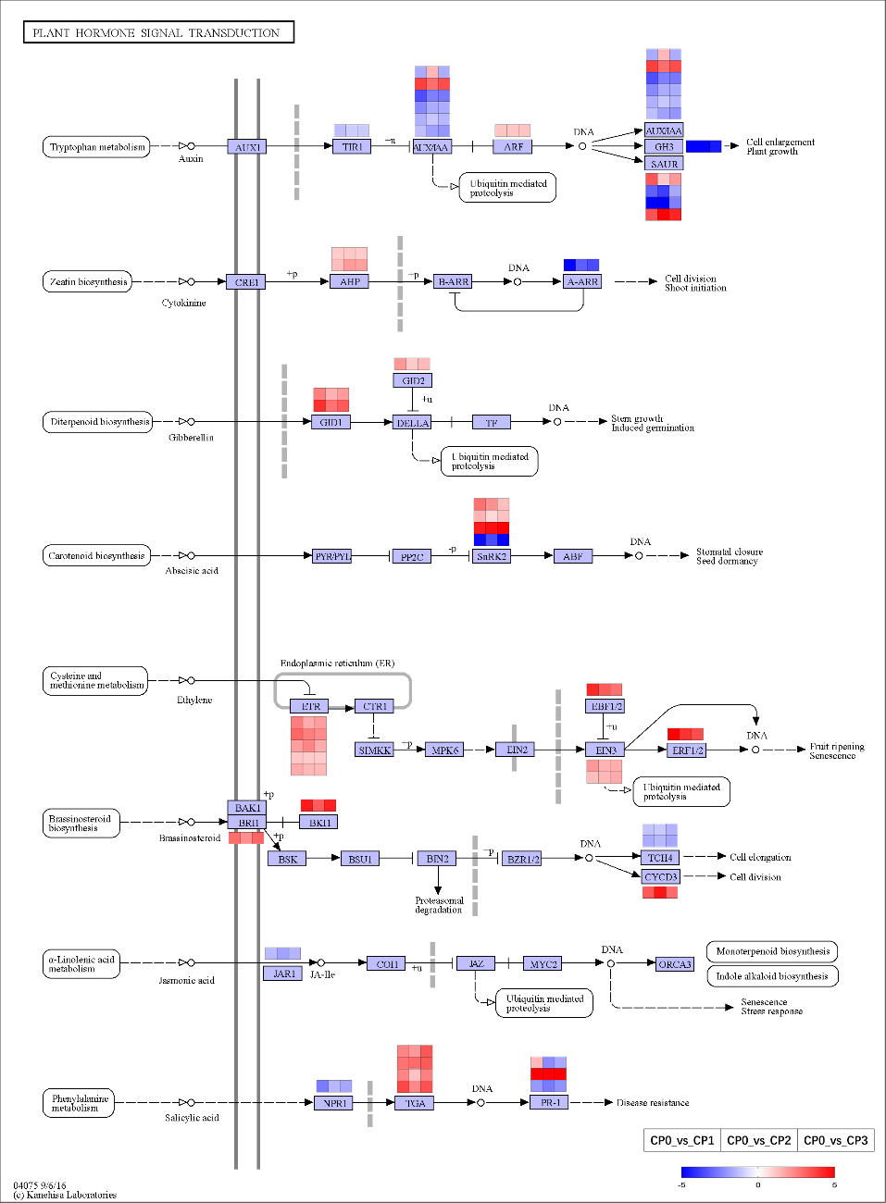
Fig. S3 The common DEGs involved in the plant hormone signal transduction pathway during AR formation. The change in transcriptional expression levels in the three comparison groups is illustrated with colored boxes. The boxes from the left to right indicate CP0 vs CP1, CP0 vs CP2, and CP0 vs CP3, respectively. Each row of boxes represents a DEG. The color code from blue to red represents the changes in transcriptional expression level between –5 and 5. The solid or dashed arrows indicate direct or indirect positive effects, and the T-type lines indicate inhibitory effects. This figure is redrawn based on the KEGG pathways.

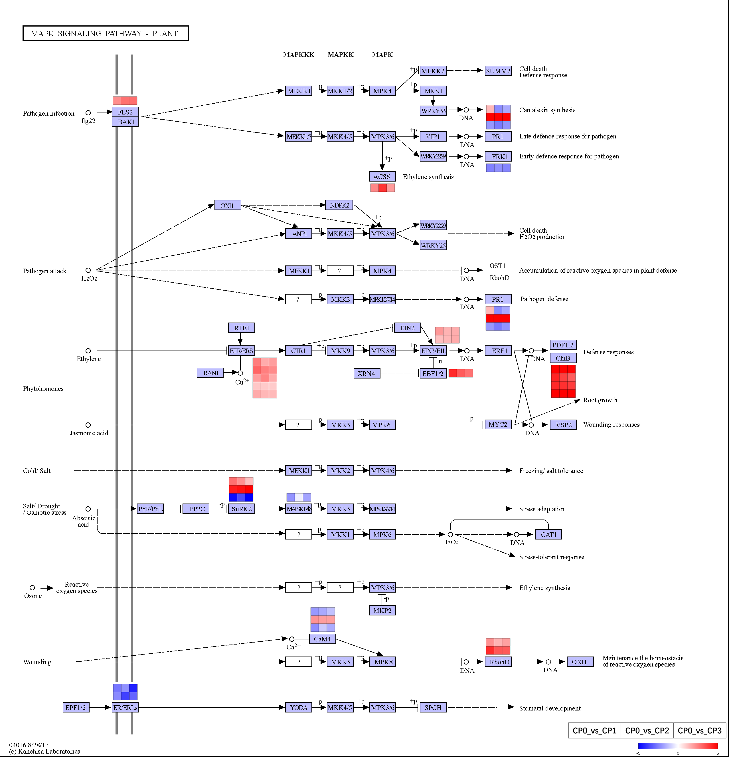
Fig. S4 The common DEGs involved in the MAPK signal pathway during AR formation. The change in transcriptional expression levels in the three comparison groups is illustrated with colored boxes. The boxes from the left to right indicate CP0 vs CP1, CP0 vs CP2, and CP0 vs CP3, respectively. Each row of boxes represents a DEG. The color code from blue to red represents the changes in transcriptional expression level between –5 and 5. The solid or dashed arrows indicate direct or indirect positive effects, and the T-type lines indicate inhibitory effects. This figure is redrawn based on the KEGG pathways.
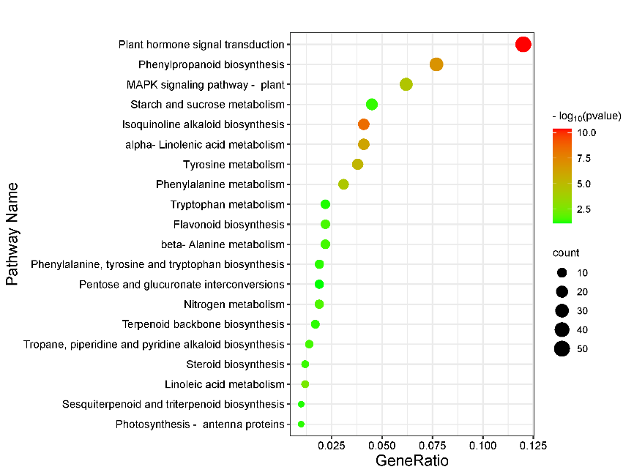
Fig. S5 Dotplot plot of DEGs utilizing KEGG enrichment analysis in CP1 vs CP2. In the figure, the horizontal axis is GeneRatio (the proportion of differentially expressed genes in the KEGG to all differentially expressed genes), the vertical axis is KEGG Pathway, the color of the dot represents pvalues, and the size of the dot represents the number of DEGs.

Tab. S6. KEGG enrichment analyses of DEGs in AR primordia induction stages (CP1 vs CP2).
ID | Description | GeneRatio | pvalue | Count
ko04075 | Plant hormone signal transduction | 50/418 | 4.12E-11 | 50
ko00950 | Isoquinoline alkaloid biosynthesis | 17/418 | 3.92E-09 | 17
ko00940 | Phenylpropanoid biosynthesis | 32/418 | 1.31E-07 | 32
ko00592 | alpha-Linolenic acid metabolism | 17/418 | 8.23E-07 | 17
ko00350 | Tyrosine metabolism | 16/418 | 5.48E-06 | 16
ko04016 | MAPK signaling pathway - plant | 26/418 | 3.72E-05 | 26
ko00360 | Phenylalanine metabolism | 13/418 | 4.98E-05 | 13
ko00591 | Linoleic acid metabolism | 5/418 | 0.003441 | 5
ko00910 | Nitrogen metabolism | 8/418 | 0.021153 | 8
ko00941 | Flavonoid biosynthesis | 9/418 | 0.025404 | 9
ko00410 | beta-Alanine metabolism | 9/418 | 0.028319 | 9
ko00960 | Tropane, piperidine and pyridine alkaloid biosynthesis | 6/418 | 0.028479 | 6
ko00100 | Steroid biosynthesis | 5/418 | 0.037745 | 5
ko00500 | Starch and sucrose metabolism | 19/418 | 0.042726 | 19
ko00196 | Photosynthesis - antenna proteins | 4/418 | 0.049783 | 4
ko00900 | Terpenoid backbone biosynthesis | 7/418 | 0.051434 | 7
ko00400 | Phenylalanine, tyrosine and tryptophan biosynthesis | 8/418 | 0.05167 | 8
ko00909 | Sesquiterpenoid and triterpenoid biosynthesis | 4/418 | 0.059235 | 4
ko00380 | Tryptophan metabolism | 9/418 | 0.060362 | 9
ko00040 | Pentose and glucuronate interconversions | 8/418 | 0.074163 | 8
ko00062 | Fatty acid elongation | 4/418 | 0.080764 | 4
ko00564 | Glycerophospholipid metabolism | 12/418 | 0.088105 | 12
ko00073 | Cutin, suberine and wax biosynthesis | 4/418 | 0.092789 | 4
ko00460 | Cyanoamino acid metabolism | 6/418 | 0.094784 | 6
ko00750 | Vitamin B6 metabolism | 3/418 | 0.094855 | 3
ko00860 | Porphyrin and chlorophyll metabolism | 6/418 | 0.103987 | 6
ko00561 | Glycerolipid metabolism | 11/418 | 0.113088 | 11
ko00330 | Arginine and proline metabolism | 8/418 | 0.117449 | 8
ko00250 | Alanine, aspartate and glutamate metabolism | 8/418 | 0.143249 | 8
ko00260 | Glycine, serine and threonine metabolism | 8/418 | 0.143249 | 8
ko00053 | Ascorbate and aldarate metabolism | 7/418 | 0.165622 | 7
ko00450 | Selenocompound metabolism | 3/418 | 0.168766 | 3
ko00905 | Brassinosteroid biosynthesis | 2/418 | 0.186825 | 2
ko00511 | Other glycan degradation | 3/418 | 0.189303 | 3
ko00430 | Taurine and hypotaurine metabolism | 2/418 | 0.216943 | 2
ko00908 | Zeatin biosynthesis | 4/418 | 0.231146 | 4
ko00903 | Limonene and pinene degradation | 2/418 | 0.247438 | 2
ko04626 | Plant-pathogen interaction | 40/418 | 0.251359 | 40
ko00945 | Stilbenoid, diarylheptanoid and gingerol biosynthesis | 4/418 | 0.266972 | 4
ko04712 | Circadian rhythm - plant | 5/418 | 0.271641 | 5
ko00590 | Arachidonic acid metabolism | 2/418 | 0.278059 | 2
ko00051 | Fructose and mannose metabolism | 6/418 | 0.329706 | 6
ko00920 | Sulfur metabolism | 3/418 | 0.343828 | 3
ko00531 | Glycosaminoglycan degradation | 2/418 | 0.368707 | 2
ko04141 | Protein processing in endoplasmic reticulum | 22/418 | 0.387889 | 22
ko00565 | Ether lipid metabolism | 3/418 | 0.410818 | 3
ko00270 | Cysteine and methionine metabolism | 10/418 | 0.413875 | 10
ko00052 | Galactose metabolism | 6/418 | 0.43212 | 6
ko00902 | Monoterpenoid biosynthesis | 2/418 | 0.508 | 2
ko00030 | Pentose phosphate pathway | 5/418 | 0.512358 | 5
ko00480 | Glutathione metabolism | 7/418 | 0.52259 | 7
ko00240 | Pyrimidine metabolism | 5/418 | 0.542708 | 5
ko04070 | Phosphatidylinositol signaling system | 6/418 | 0.545385 | 6
ko01230 | Biosynthesis of amino acids | 19/418 | 0.549674 | 19
ko00513 | Various types of N-glycan biosynthesis | 3/418 | 0.556347 | 3
ko00071 | Fatty acid degradation | 5/418 | 0.557548 | 5
ko00603 | Glycosphingolipid biosynthesis - globo and isoglobo series | 1/418 | 0.564709 | 1
ko00340 | Histidine metabolism | 2/418 | 0.581441 | 2
ko00904 | Diterpenoid biosynthesis | 2/418 | 0.581441 | 2
ko00790 | Folate biosynthesis | 2/418 | 0.604064 | 2
ko00520 | Amino sugar and nucleotide sugar metabolism | 10/418 | 0.615637 | 10
ko00280 | Valine, leucine and isoleucine degradation | 4/418 | 0.619947 | 4
ko00730 | Thiamine metabolism | 2/418 | 0.62575 | 2
ko00740 | Riboflavin metabolism | 1/418 | 0.63149 | 1
ko01240 | Biosynthesis of cofactors | 20/418 | 0.645165 | 20
ko03440 | Homologous recombination | 4/418 | 0.663574 | 4
ko00760 | Nicotinate and nicotinamide metabolism | 2/418 | 0.666339 | 2
ko00220 | Arginine biosynthesis | 3/418 | 0.6782 | 3
ko00195 | Photosynthesis | 4/418 | 0.703674 | 4
ko00770 | Pantothenate and CoA biosynthesis | 3/418 | 0.708096 | 3
ko00310 | Lysine degradation | 3/418 | 0.722227 | 3
ko00670 | One carbon pool by folate | 1/418 | 0.735941 | 1
ko00290 | Valine, leucine and isoleucine biosynthesis | 1/418 | 0.757062 | 1
ko00780 | Biotin metabolism | 1/418 | 0.776497 | 1
ko02010 | ABC transporters | 3/418 | 0.80659 | 3
ko00650 | Butanoate metabolism | 1/418 | 0.825978 | 1
ko00510 | N-Glycan biosynthesis | 2/418 | 0.868444 | 2
ko00710 | Carbon fixation in photosynthetic organisms | 5/418 | 0.88026 | 5
ko00130 | Ubiquinone and other terpenoid-quinone biosynthesis | 2/418 | 0.898948 | 2
ko00562 | Inositol phosphate metabolism | 3/418 | 0.906688 | 3
ko00906 | Carotenoid biosynthesis | 1/418 | 0.910778 | 1
ko00230 | Purine metabolism | 5/418 | 0.918756 | 5
ko01040 | Biosynthesis of unsaturated fatty acids | 1/418 | 0.930569 | 1
ko00600 | Sphingolipid metabolism | 1/418 | 0.936139 | 1
ko04130 | SNARE interactions in vesicular transport | 1/418 | 0.936139 | 1
ko00970 | Aminoacyl-tRNA biosynthesis | 2/418 | 0.937043 | 2
ko04145 | Phagosome | 4/418 | 0.946212 | 4
ko01212 | Fatty acid metabolism | 3/418 | 0.94878 | 3
ko04136 | Autophagy - other | 1/418 | 0.950315 | 1
ko03430 | Mismatch repair | 1/418 | 0.954304 | 1
ko00630 | Glyoxylate and dicarboxylate metabolism | 4/418 | 0.954571 | 4
ko04146 | Peroxisome | 4/418 | 0.954571 | 4
ko00061 | Fatty acid biosynthesis | 1/418 | 0.957974 | 1
ko03410 | Base excision repair | 1/418 | 0.96135 | 1
ko03020 | RNA polymerase | 1/418 | 0.969938 | 1
ko00190 | Oxidative phosphorylation | 5/418 | 0.978418 | 5
ko00010 | Glycolysis / Gluconeogenesis | 6/418 | 0.978842 | 6
ko01200 | Carbon metabolism | 15/418 | 0.983475 | 15
ko03030 | DNA replication | 1/418 | 0.989015 | 1
ko00620 | Pyruvate metabolism | 4/418 | 0.989753 | 4
ko03018 | RNA degradation | 4/418 | 0.990371 | 4
ko01210 | 2-Oxocarboxylic acid metabolism | 1/418 | 0.992151 | 1
ko03420 | Nucleotide excision repair | 1/418 | 0.992783 | 1
ko03015 | mRNA surveillance pathway | 4/418 | 0.995776 | 4
ko00020 | Citrate cycle (TCA cycle) | 1/418 | 0.997372 | 1
ko04144 | Endocytosis | 8/418 | 0.997638 | 8
ko03013 | RNA transport | 6/418 | 0.9997 | 6
ko04120 | Ubiquitin mediated proteolysis | 4/418 | 0.999712 | 4
ko03040 | Spliceosome | 5/418 | 0.999916 | 5

