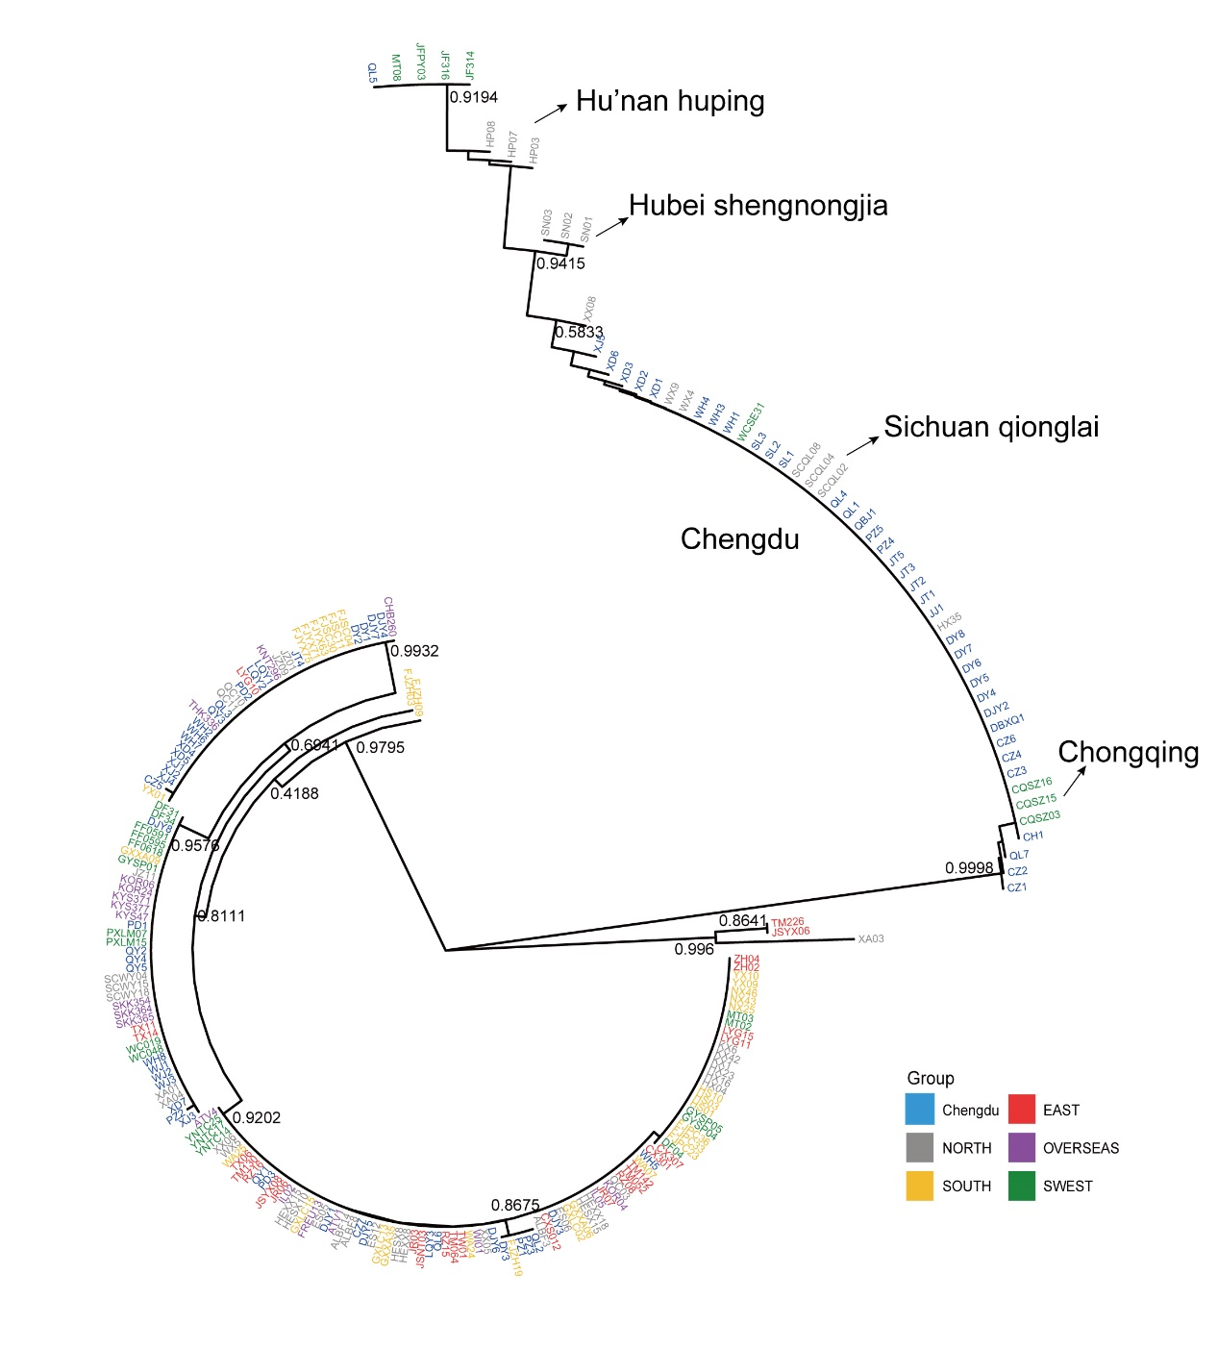
Supplementary Figure 1. Neighbor joining (NJ) tree constructed from 227 Ginkgo plastomes. Bootstrap support values are shown for major branches. Colors indicate geographic lineages.

