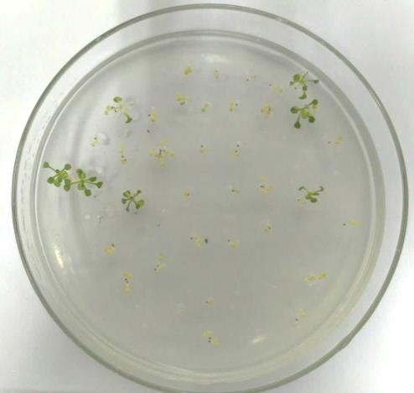 | 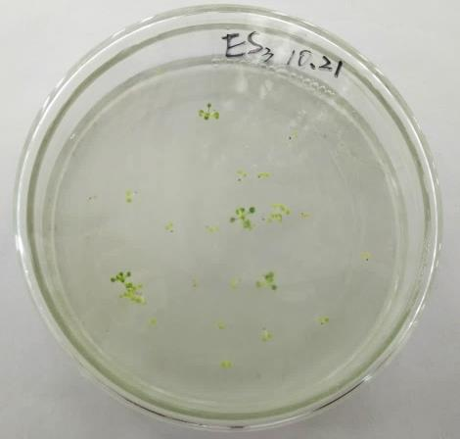
(a) | (b)
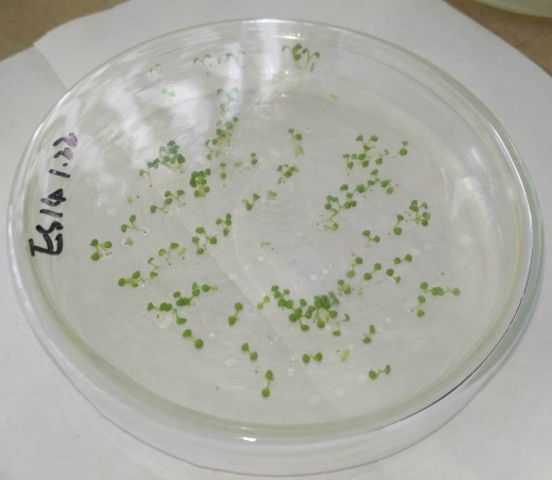 | 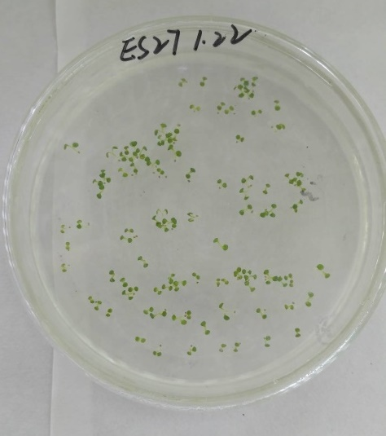
(c) | (d)
Fig.S1 Screening of transgenic A. thaliana kanamycin resistant plants. (a) and (b) are transgenic plants from different lines of T0 generation, respectively, while the plants in (c) and (d) are of different T1 generations. In the figure, green seedlings indicate positive plants, whereas yellowing seedlings indicate negative plants, such as those with yellow arrows.

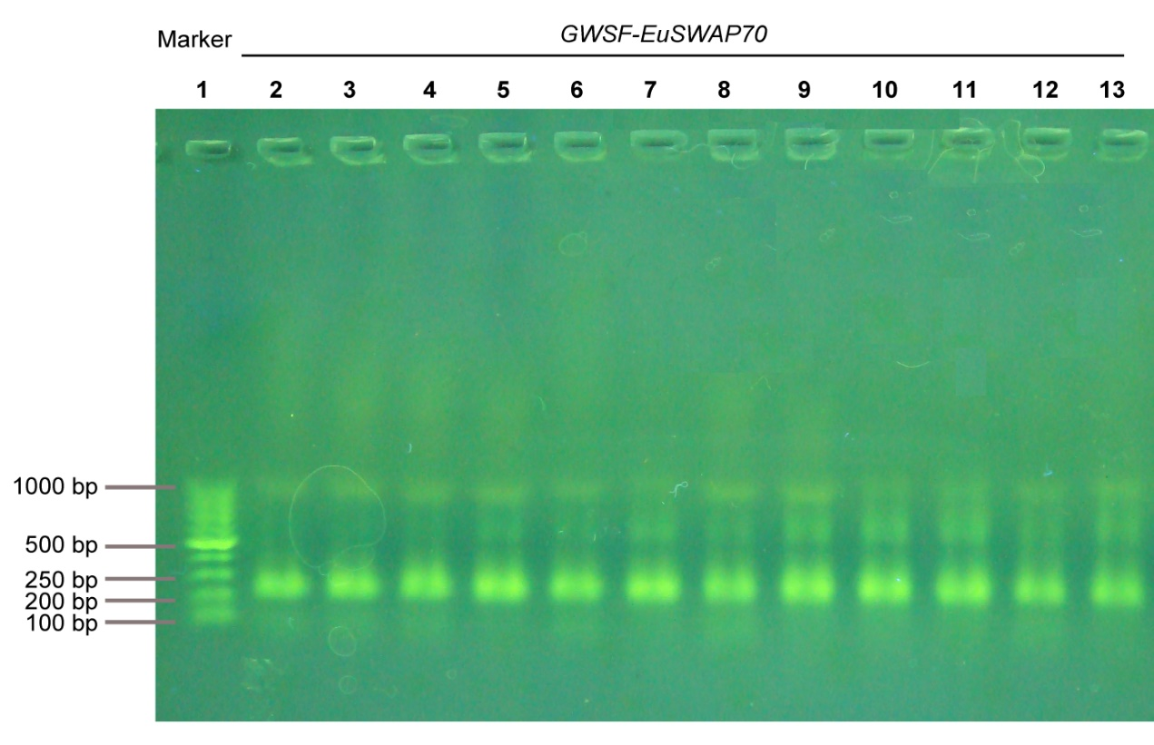Fig.S2 PCR detection of GWSF promoter in EuSWAP-GWSF transgenic Arabidopsis plants. In the figure, lane 1: DNA Marker (DL1000); lane 2-13: EuSWAP70 transgenic plants induced by a GWSF promoter. The main band of electrophoresis appears near the Marker 250 bp band, which is the amplified fragment of the GWSF promoter.

