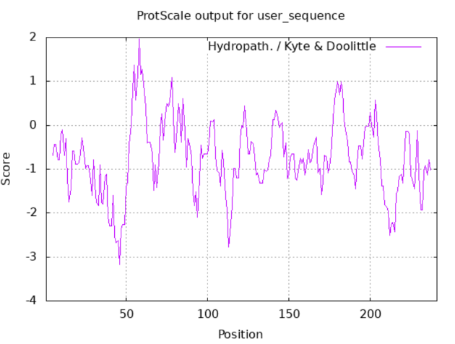
Fig1 A: The hydrophilicity of StbHLH47 protein

Fig1 B: The prediction of cis-acting elements of StbHLH47 promoter
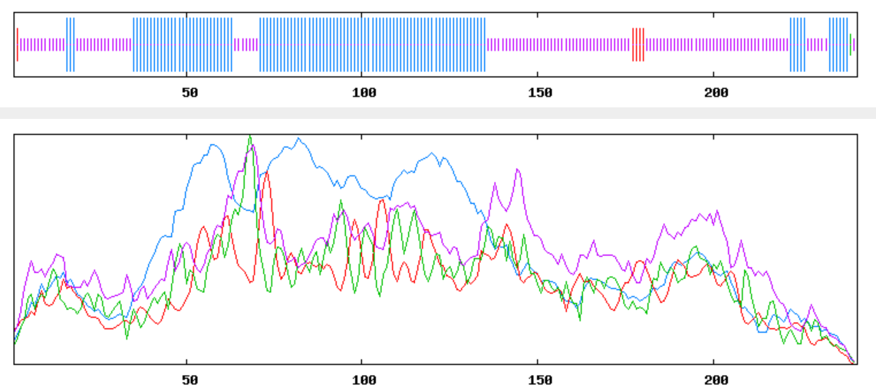
Fig1 C and D: The secondary(C) and tertiary(D) structure prediction of StbHLH47 protein

Fig2 A: The expression levels of StbHLH47 in response to drought treatment were examined across both drought-resistant and drought-sensitive varieties

Fig2 B: Expression of StbHLH47 in different tissues of potato
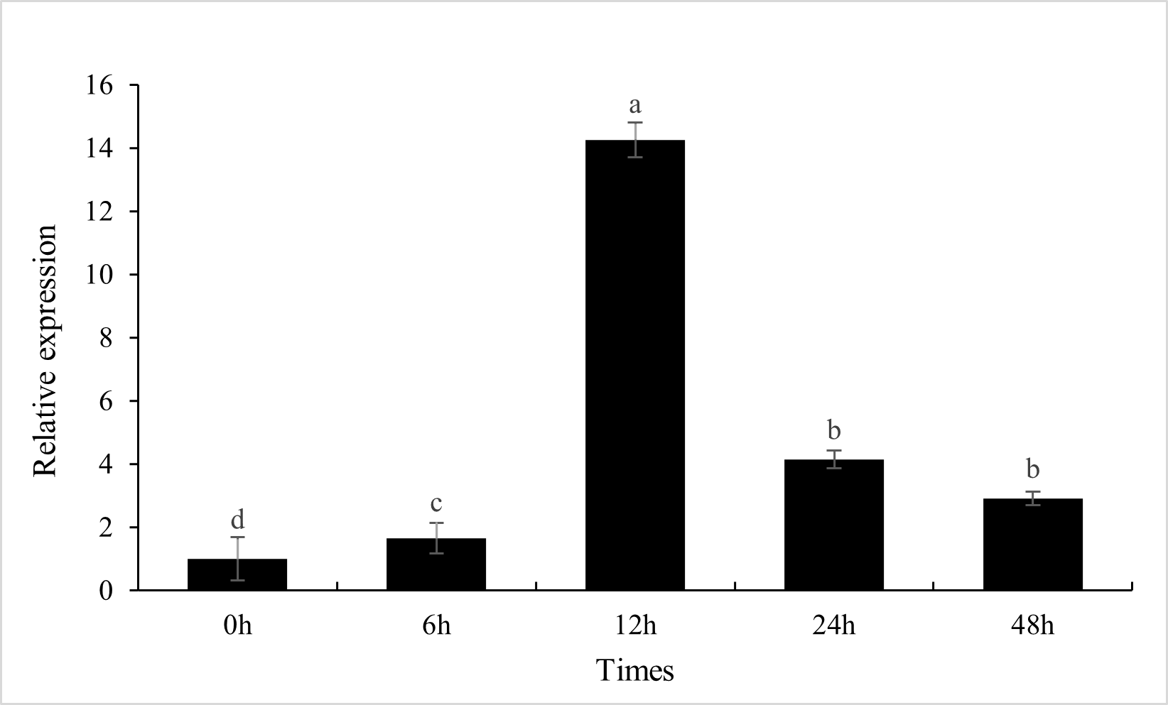
Fig2 B: Expression pattern of StbHLH47 gene in WT plants under 20% PEG6000 simulated osmotic stress for different time periods

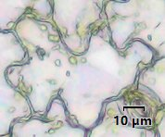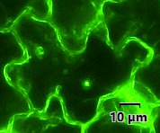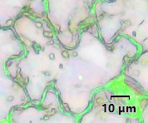
Fig3 Subcellular localization of StbHLH47 protein PBI121-GFP

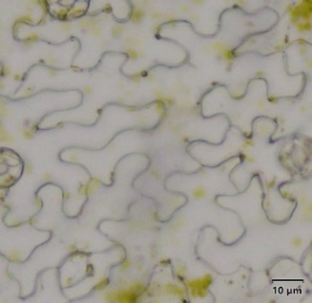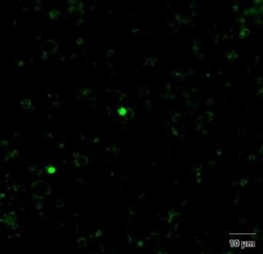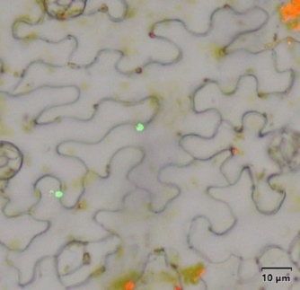
Fig3 Subcellular localization of StbHLH47 protein PBI121-StbHLH47-GFP

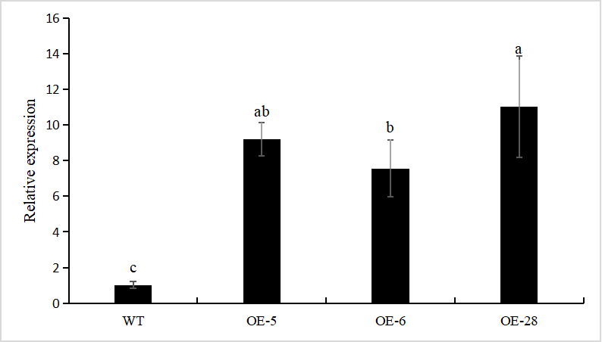
A
B
Fig4 Detection of positive transgenic plants
Note: A: From left to right 1-10 are water, maker D2000, OE1, OE2, OE3, OE4, OE5, OE6, OE28, WT. B: The gene expression of StbHLH47 in WT and obtained transgenic plants OE-5, OE-6 and OE28 was detected by RT-qPCR. Lower case letters were analyzed for difference significance at 0.05 level, P<0.05, the same below.

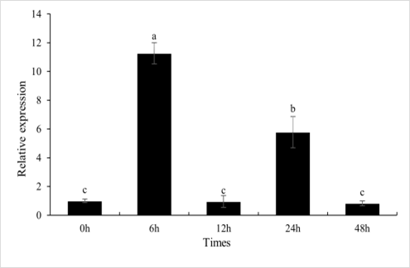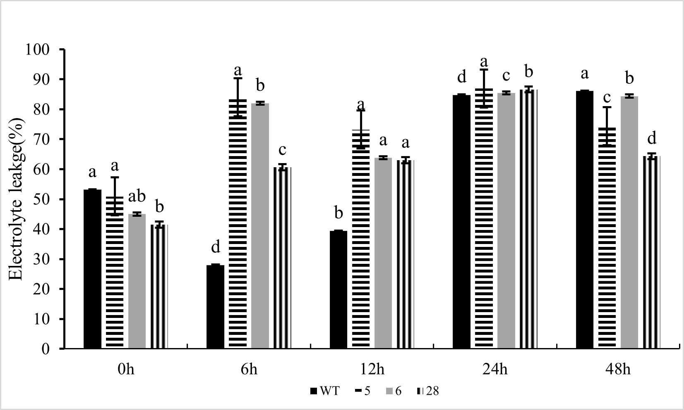
B
A
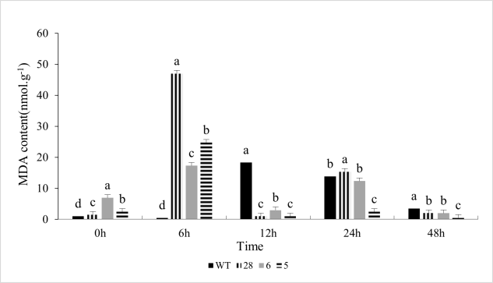
D
C
Fig5 The expression and physiological indexes of transgenic plants were measured under simulated drought stress of 20%PEG6000
Note: A:The RT-qPCR of OE-28 plants under 20%PEG6000 stress. B: Determination of Electrolyte leakge under simulated drought by 20% PEG6000. C: Determination of MDA content under simulated drought by 20% PEG6000. D: Determination of POD content under simulated drought by 20% PEG6000.

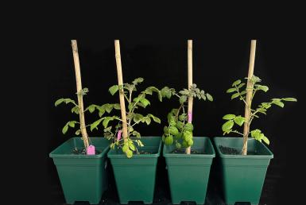  A | 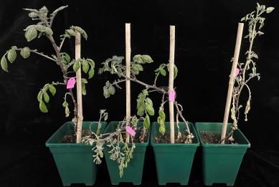  B | 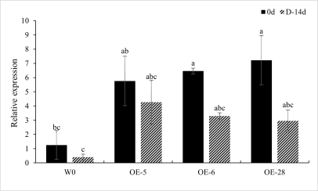  C
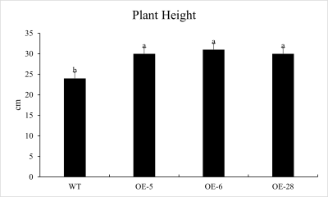  D | 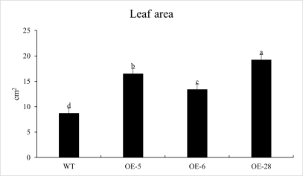  E | 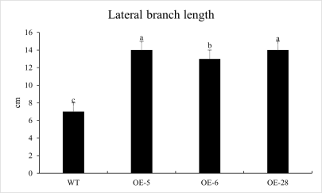  F
G | H | 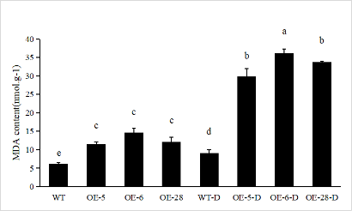  I
Fig6 StbHLH47 negatively regulates drought stress in potato
Note: A: Growth of WT and OE plants under normal conditions. B: after 14 d of water control. C: Relative expression of StbHLH47 gene in WT and OE-28 plants under potted drought conditions; D-F: Comparison of plant height, leaf area and lateral branch length of WT and OE-StbHLH47 plants under normal conditions; G-I: relative conductivity, chlorophyll content and MDA content of StbHLH47 gene in WT and OE-StbHLH47 plants under potted drought conditions.

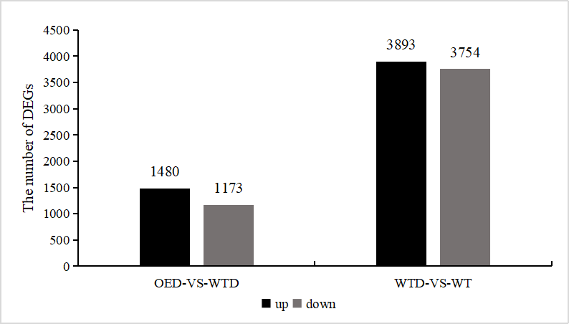

Fig7 A: Distribution of DEGs and statistics of the number of up and down regulated genes and StbHLH47 affects the expression of drought stress-responsive genes

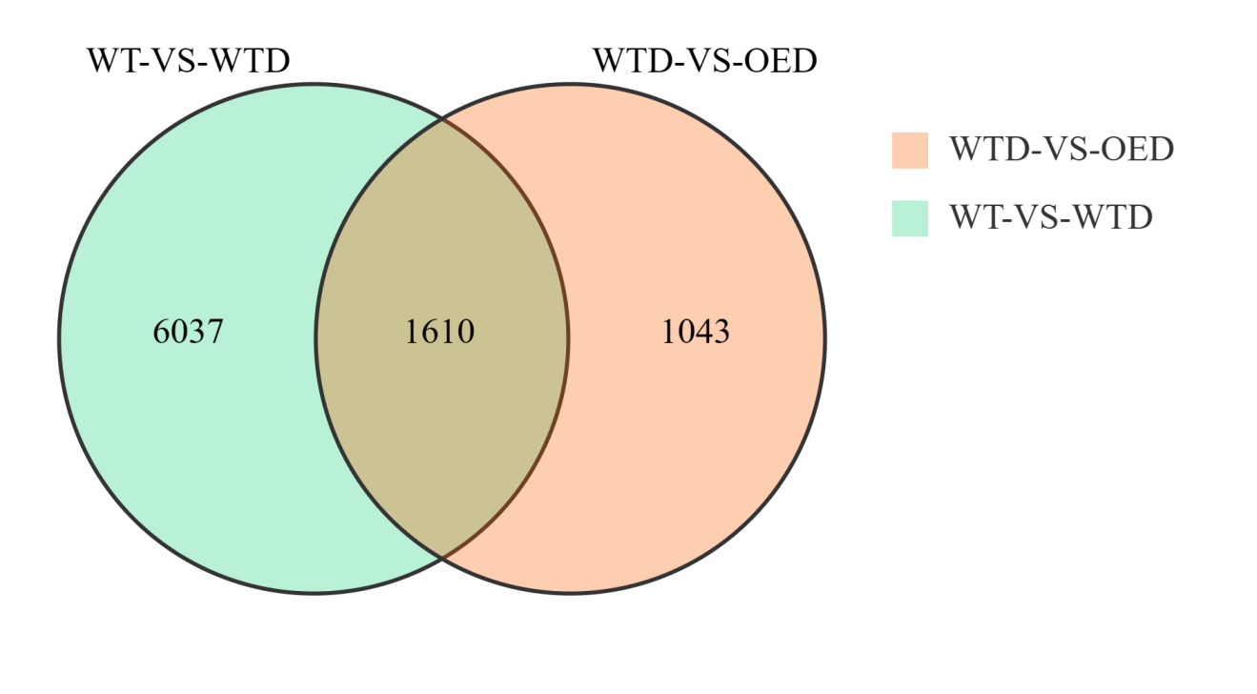
Fig7 B: Venn diagrams showing the genes regulated by StbHLH47 and 20% PEG6000 treatment based on the RNA-seq analysis. WT, normal; WTD-VS-OED, 20% PEG6000.

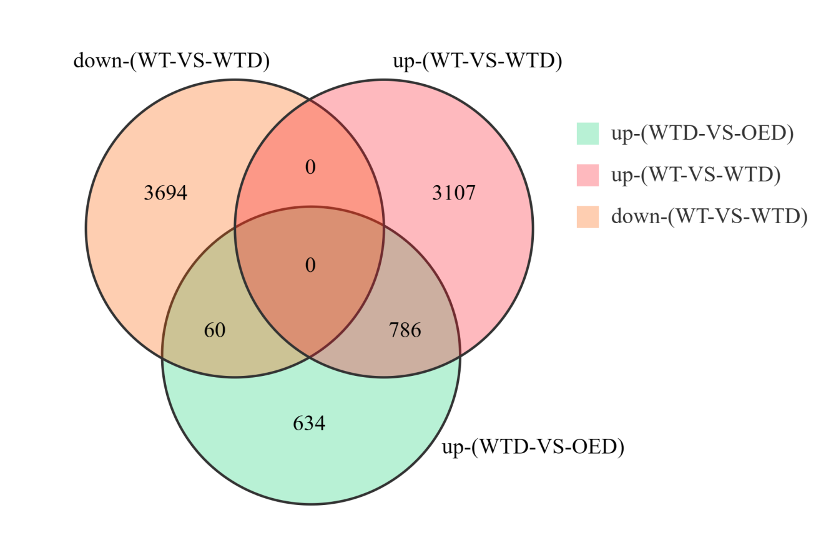

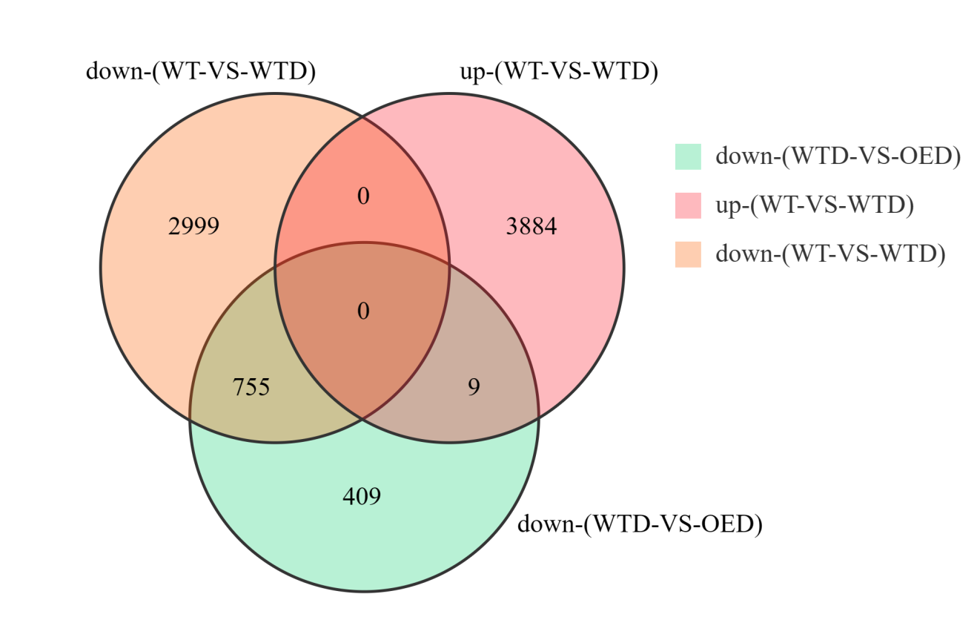
Fig7 C-D: Venn diagrams showing the overlap of StbHLH47-regualted and drought stress-responsive genes. WT, normal; WTD-VS-OED, 20% PEG6000.

Fig7 E: Heatmap showing the expression of 14 drought- and ABA-related DEGs in WT and OE plants. WT, normal; WTD-VS-OED, 20% PEG6000.

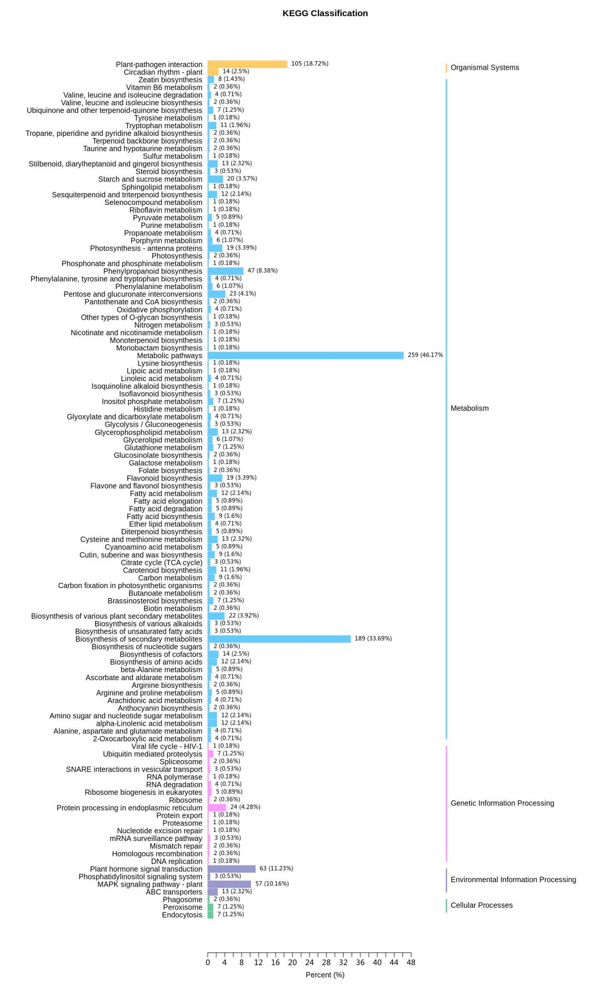
Fig8 A: Top50 KEGG enrichment analysis of DEGs

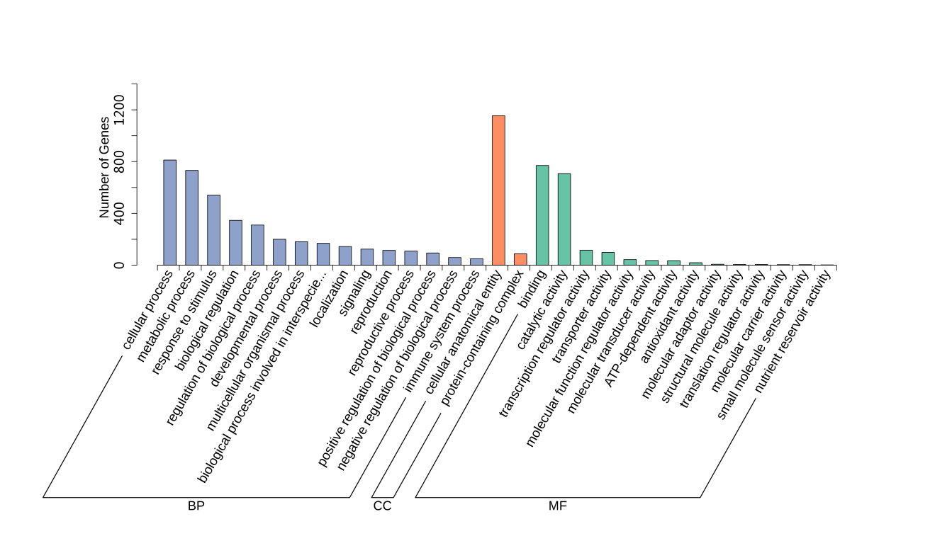
Fig8 B: GO enrichment analysis of DEGs

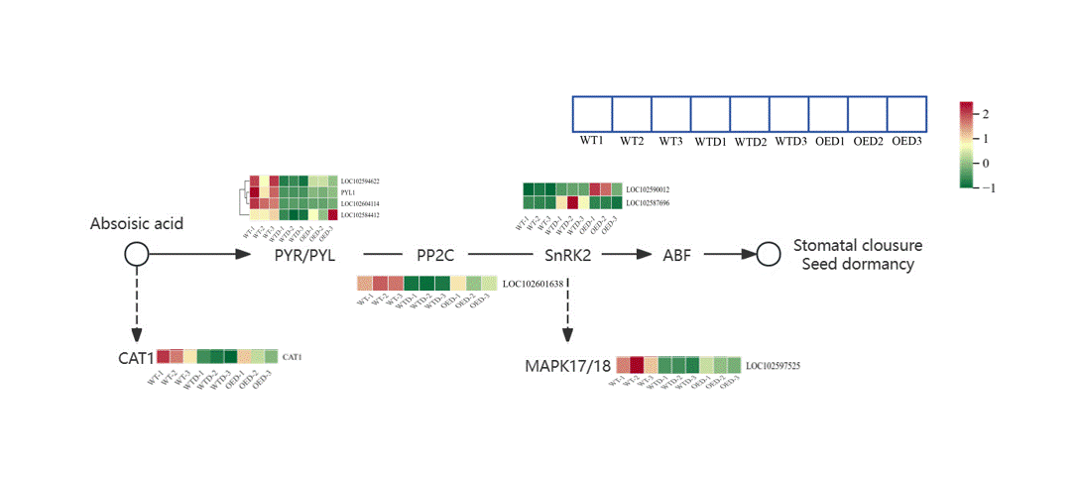
Fig8 C: The abscisic acid (ABA) signal transduction pathway in OE and WT plants
Note: The expression levels of each gene were normalized to a range of -1 to 2.

Fig9 The biosynthetic pathways of phenylpropane in two comparison groups, WT-VS-WTD and WTD-VS-OED
Note: The expression levels of each gene were normalized to a range of -1 to 2.

A | B | C
D | E | F
G | H | I
J | K | L
M | N | O
P | Q
Fig10 Expression analysis of annotated genes related to ABA regulation and two candidate pathways in potato

