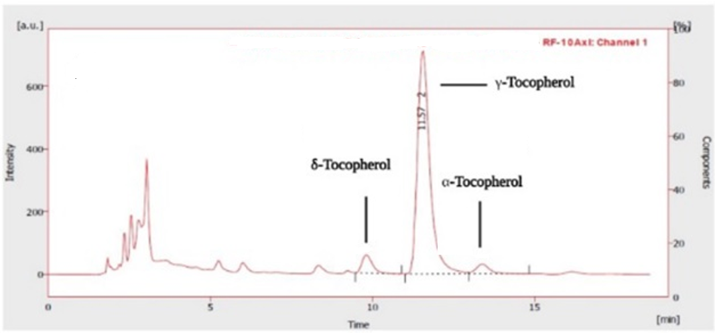
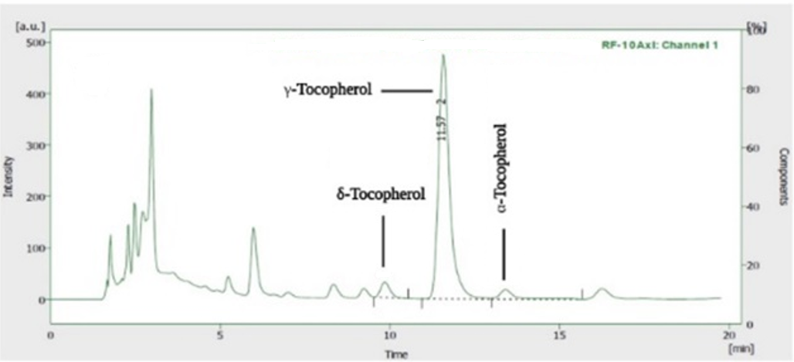
Figure 1. The HPLC chromatograms of standards for tocopherols

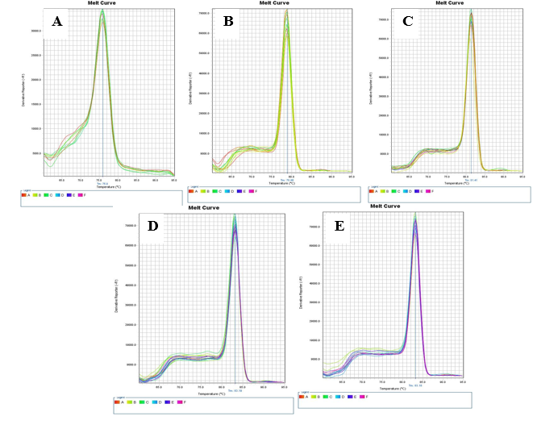
Figure2 . Melting curve of genes involved in the tocopherol biosynthesis pathway in the gene expression section, which indicates the specific and single-peak amplification of each gene. A) VTE1; B) VTE2; C) VTE3; D) PDS1; E) GAPDH

