Supplementary Figure 5
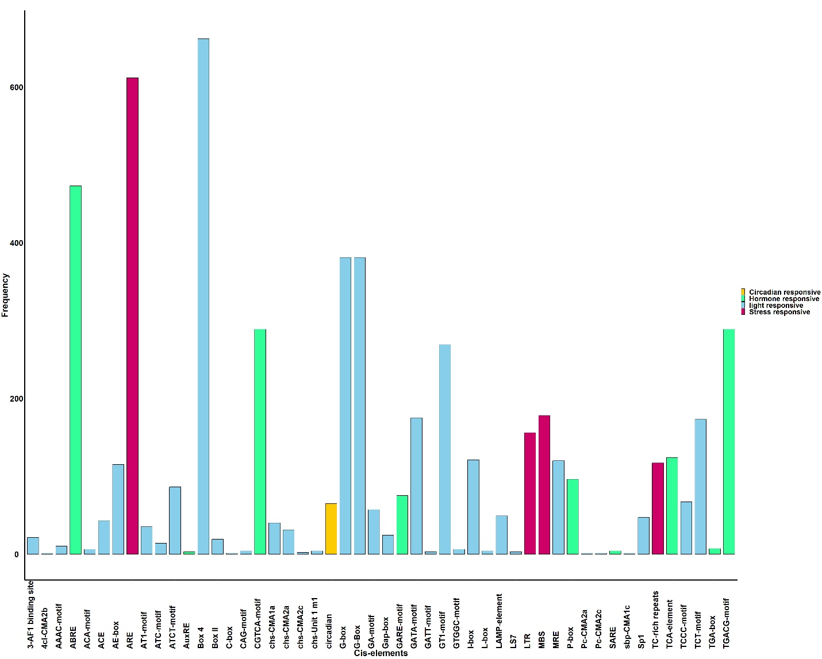
Supplementary Figure 5: Statistical analysis of cis-elements in the promoter of the ArUGTs.
The bar of each colour represents each type of cis-elements in the promoter region of all ArUGTs. In contrast, the Y axis represents the frequency of each type of cis-elements in the promoter region of all ArUGTs

