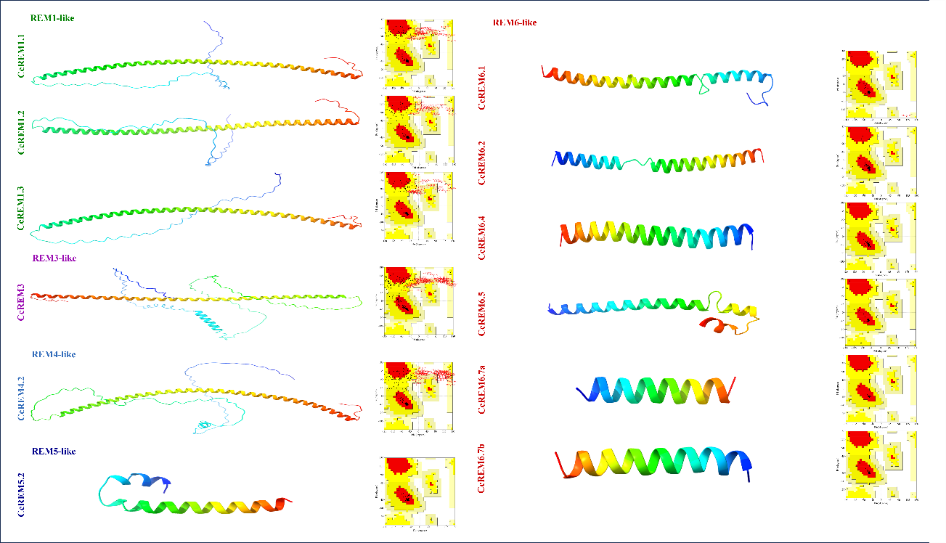

Supplementary Figure 1: 3D protein structure prediction and Ramachandran plot using AlphaFold2 and SAVES respectively. The structure images were edited using chimeraX software

