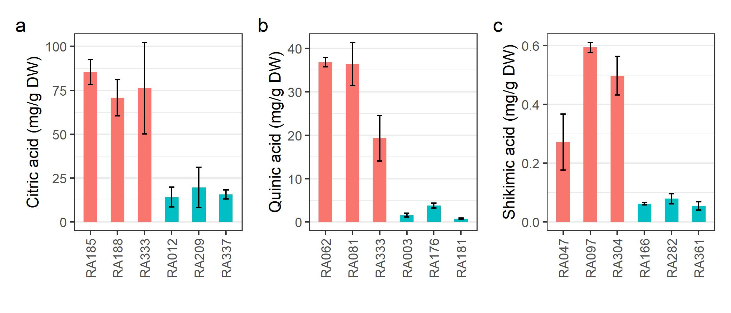
Supplementary Figure S1 Content of citric (a), quinic (b), and shikimic (c) acids of blueberry fruit from genotypes selected for RNA-seq analysis
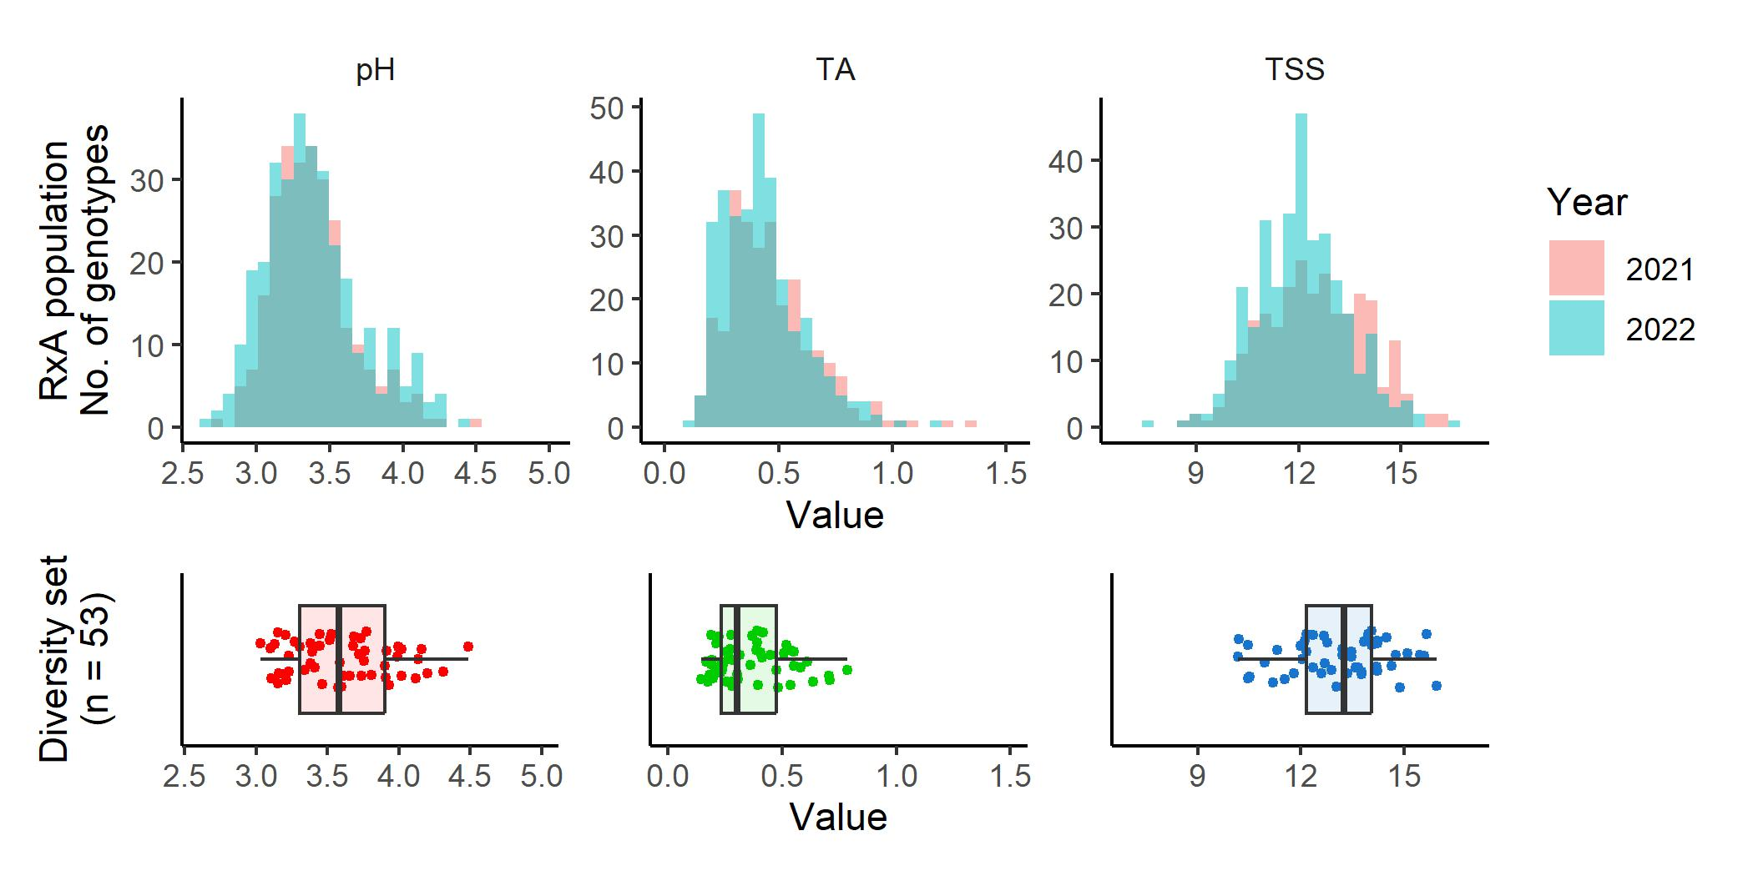
Supplementary Figure S2
Comparison of phenotypic variations of pH, titratable acidity (TA), and total soluble solids (TSS) between the ‘Reveille’ × ‘Arlen’ (R×A) biparental F₁ mapping population used in this study and a set of released cultivars consisting of 53 Northern and Southern highbush tetraploids (diversity set)

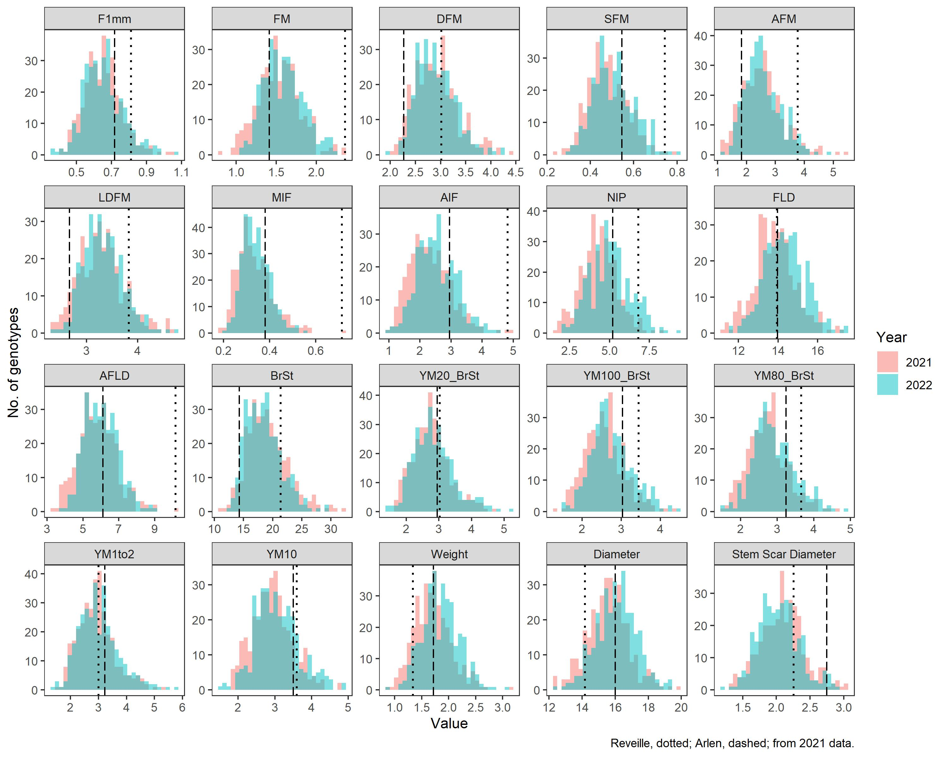
Supplementary Figure S3
Distribution of 2 mm flat probe penetration test texture parameters and appearance parameters (fruit weight (g), diameter (mm), and stem scar diameter (mm)) measured in a ‘Reveille’ × ‘Arlen’ F₁ population across two years (2021-2022). Dotted and dashed lines indicate the phenotype of the parents ‘Reveille’ and ‘Arlen’, respectively. AFLD, area force linear distance; AFM, area maximum force; AIF, area internal force; BrSt, burst strain; DFM, distance to maximum force; FLD, force linear distance; FM, maximum force; F1mm, force at 1 mm; LDFM, linear distance to maximum force; MIF, mean internal force; NIP, number of internal peaks; SFM, slope maximum force; YM1to2, Young’s modulus 1-2%; YM10, Young’s modulus 10%; YM100_BrSt, Young’s modulus 100% burst strain; YM20_BrSt, Young’s modulus 20% burst strain; YM80_BrSt, Young’s modulus 80% burst strain

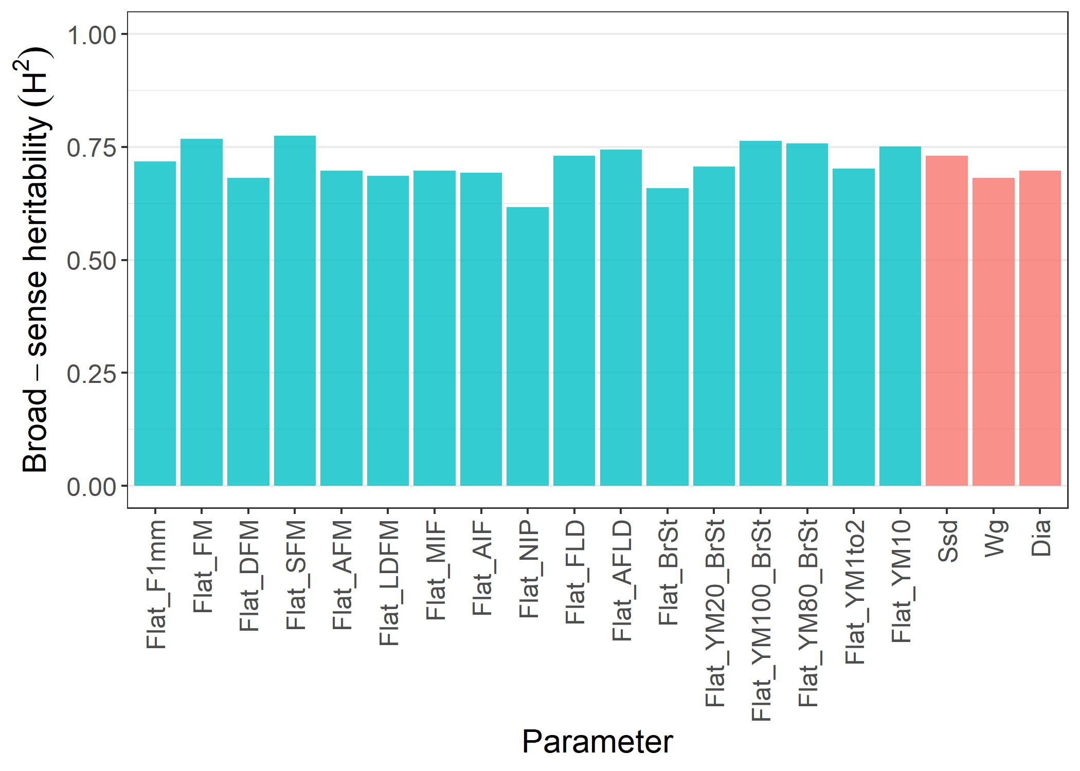
Supplementary Figure S4
Broad-sense heritability (H²) of 2 mm flat probe penetration test texture parameters and appearance parameters observed in a ‘Reveille’ × ‘Arlen’ F₁ population across two years (2021-2022). AFLD, area force linear distance; AFM, area maximum force; AIF, area internal force; BrSt, burst strain; DFM, distance to maximum force; Dia, fruit diameter; FLD, force linear distance; FM, maximum force; F1mm, force at 1 mm; LDFM, linear distance to maximum force; MIF, mean internal force; NIP, number of internal peaks; SFM, slope maximum force; Ssd, stem scar diameter; Wg, fruit weight; YM1to2, Young’s modulus 1-2%; YM10, Young’s modulus 10%; YM100_BrSt, Young’s modulus 100% burst strain; YM20_BrSt, Young’s modulus 20% burst strain; YM80_BrSt, Young’s modulus 80% burst strain

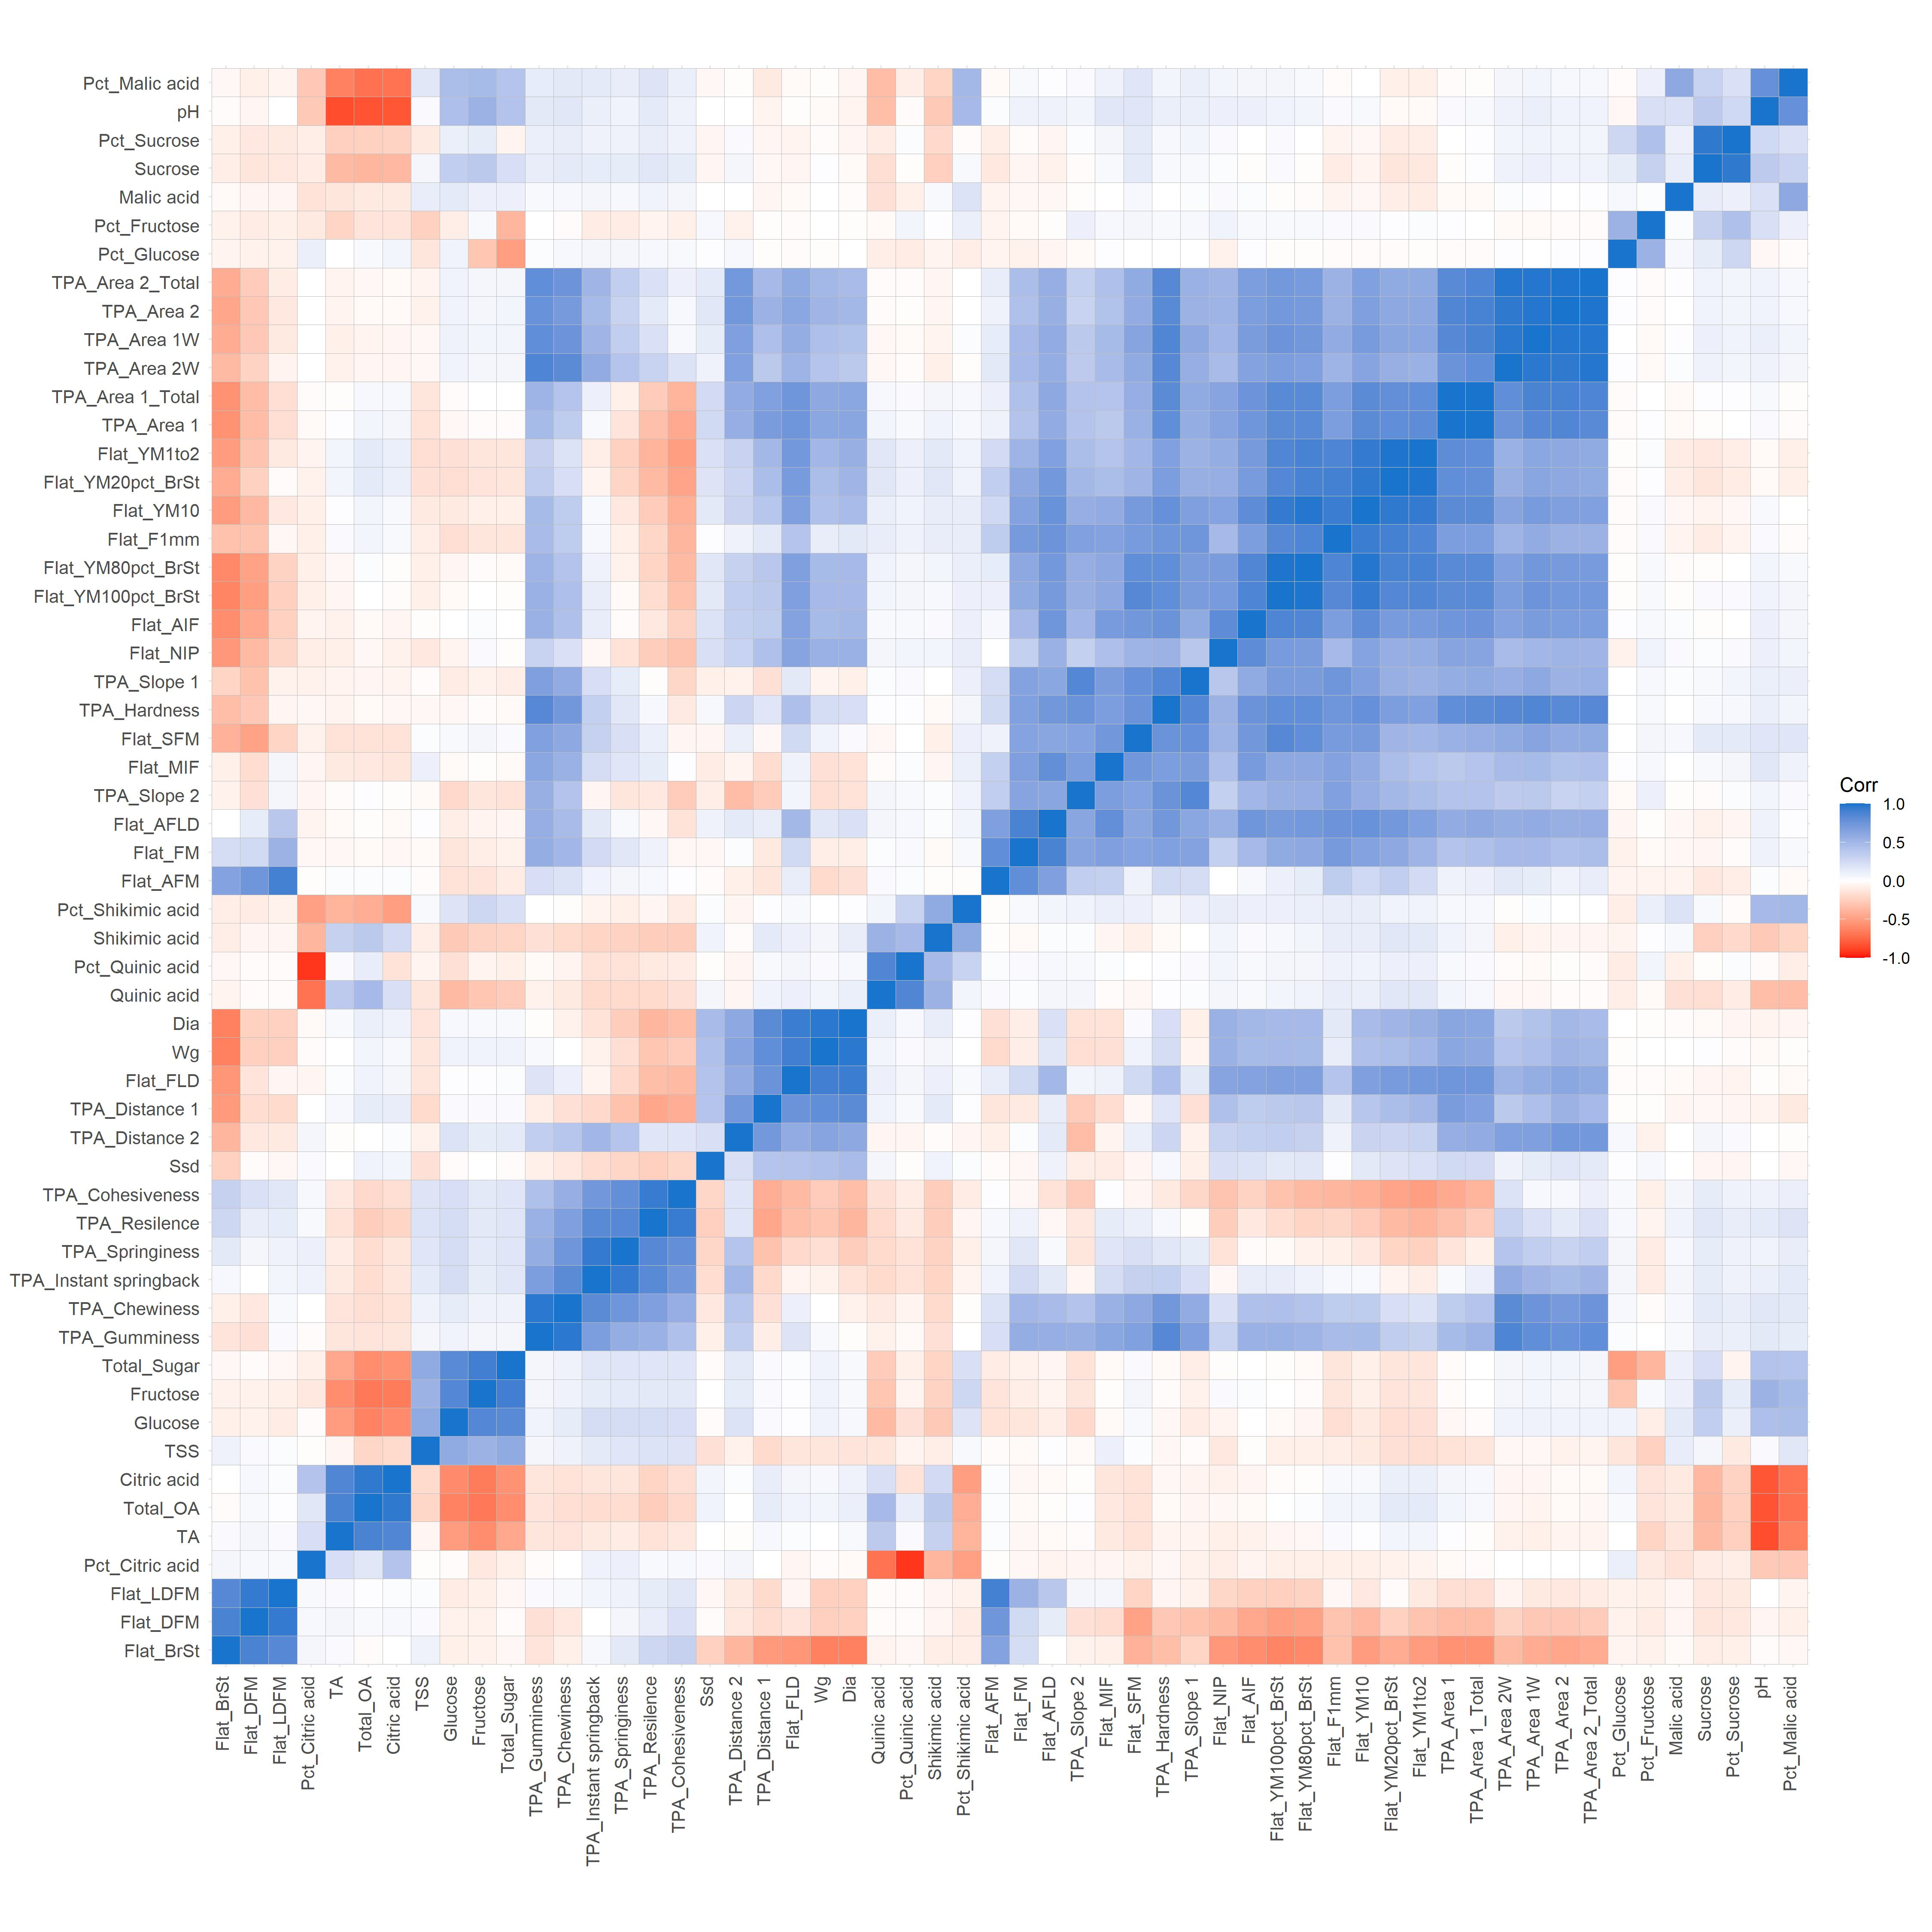
Supplementary Figure S5
Correlation analysis among chemical, textural, and appearance parameters evaluated in a ‘Reveille’ × ‘Arlen’ F₁ population. AFLD, area force linear distance; AFM, area maximum force; AIF, area internal force; BrSt, burst strain; DFM, distance to maximum force; Dia, fruit diameter; Flat, texture parameters measured using a 2 mm flat probe penetration method; FLD, force linear distance; FM, maximum force; F1mm, force at 1 mm; LDFM, linear distance to maximum force; MIF, mean internal force; NIP, number of internal peaks; OA, organic acid; Pct, percent concentration; SFM, slope maximum force; Ssd, stem scar diameter; TA, titratable acidity; TPA, texture parameters measured using a texture profile analysis method; TSS, total soluble solids; Wg, fruit weight; YM1to2, Young’s modulus 1-2%; YM10, Young’s modulus 10%; YM100_BrSt, Young’s modulus 100% burst strain; YM20_BrSt, Young’s modulus 20% burst strain; YM80_BrSt, Young’s modulus 80% burst strain
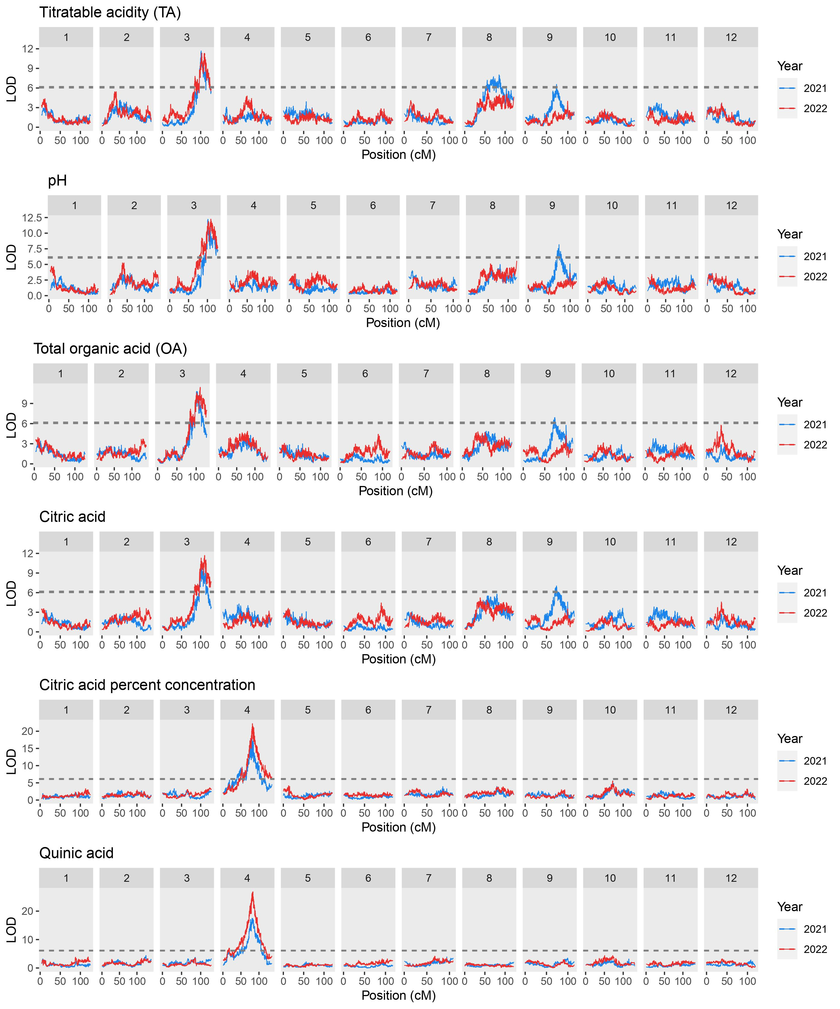
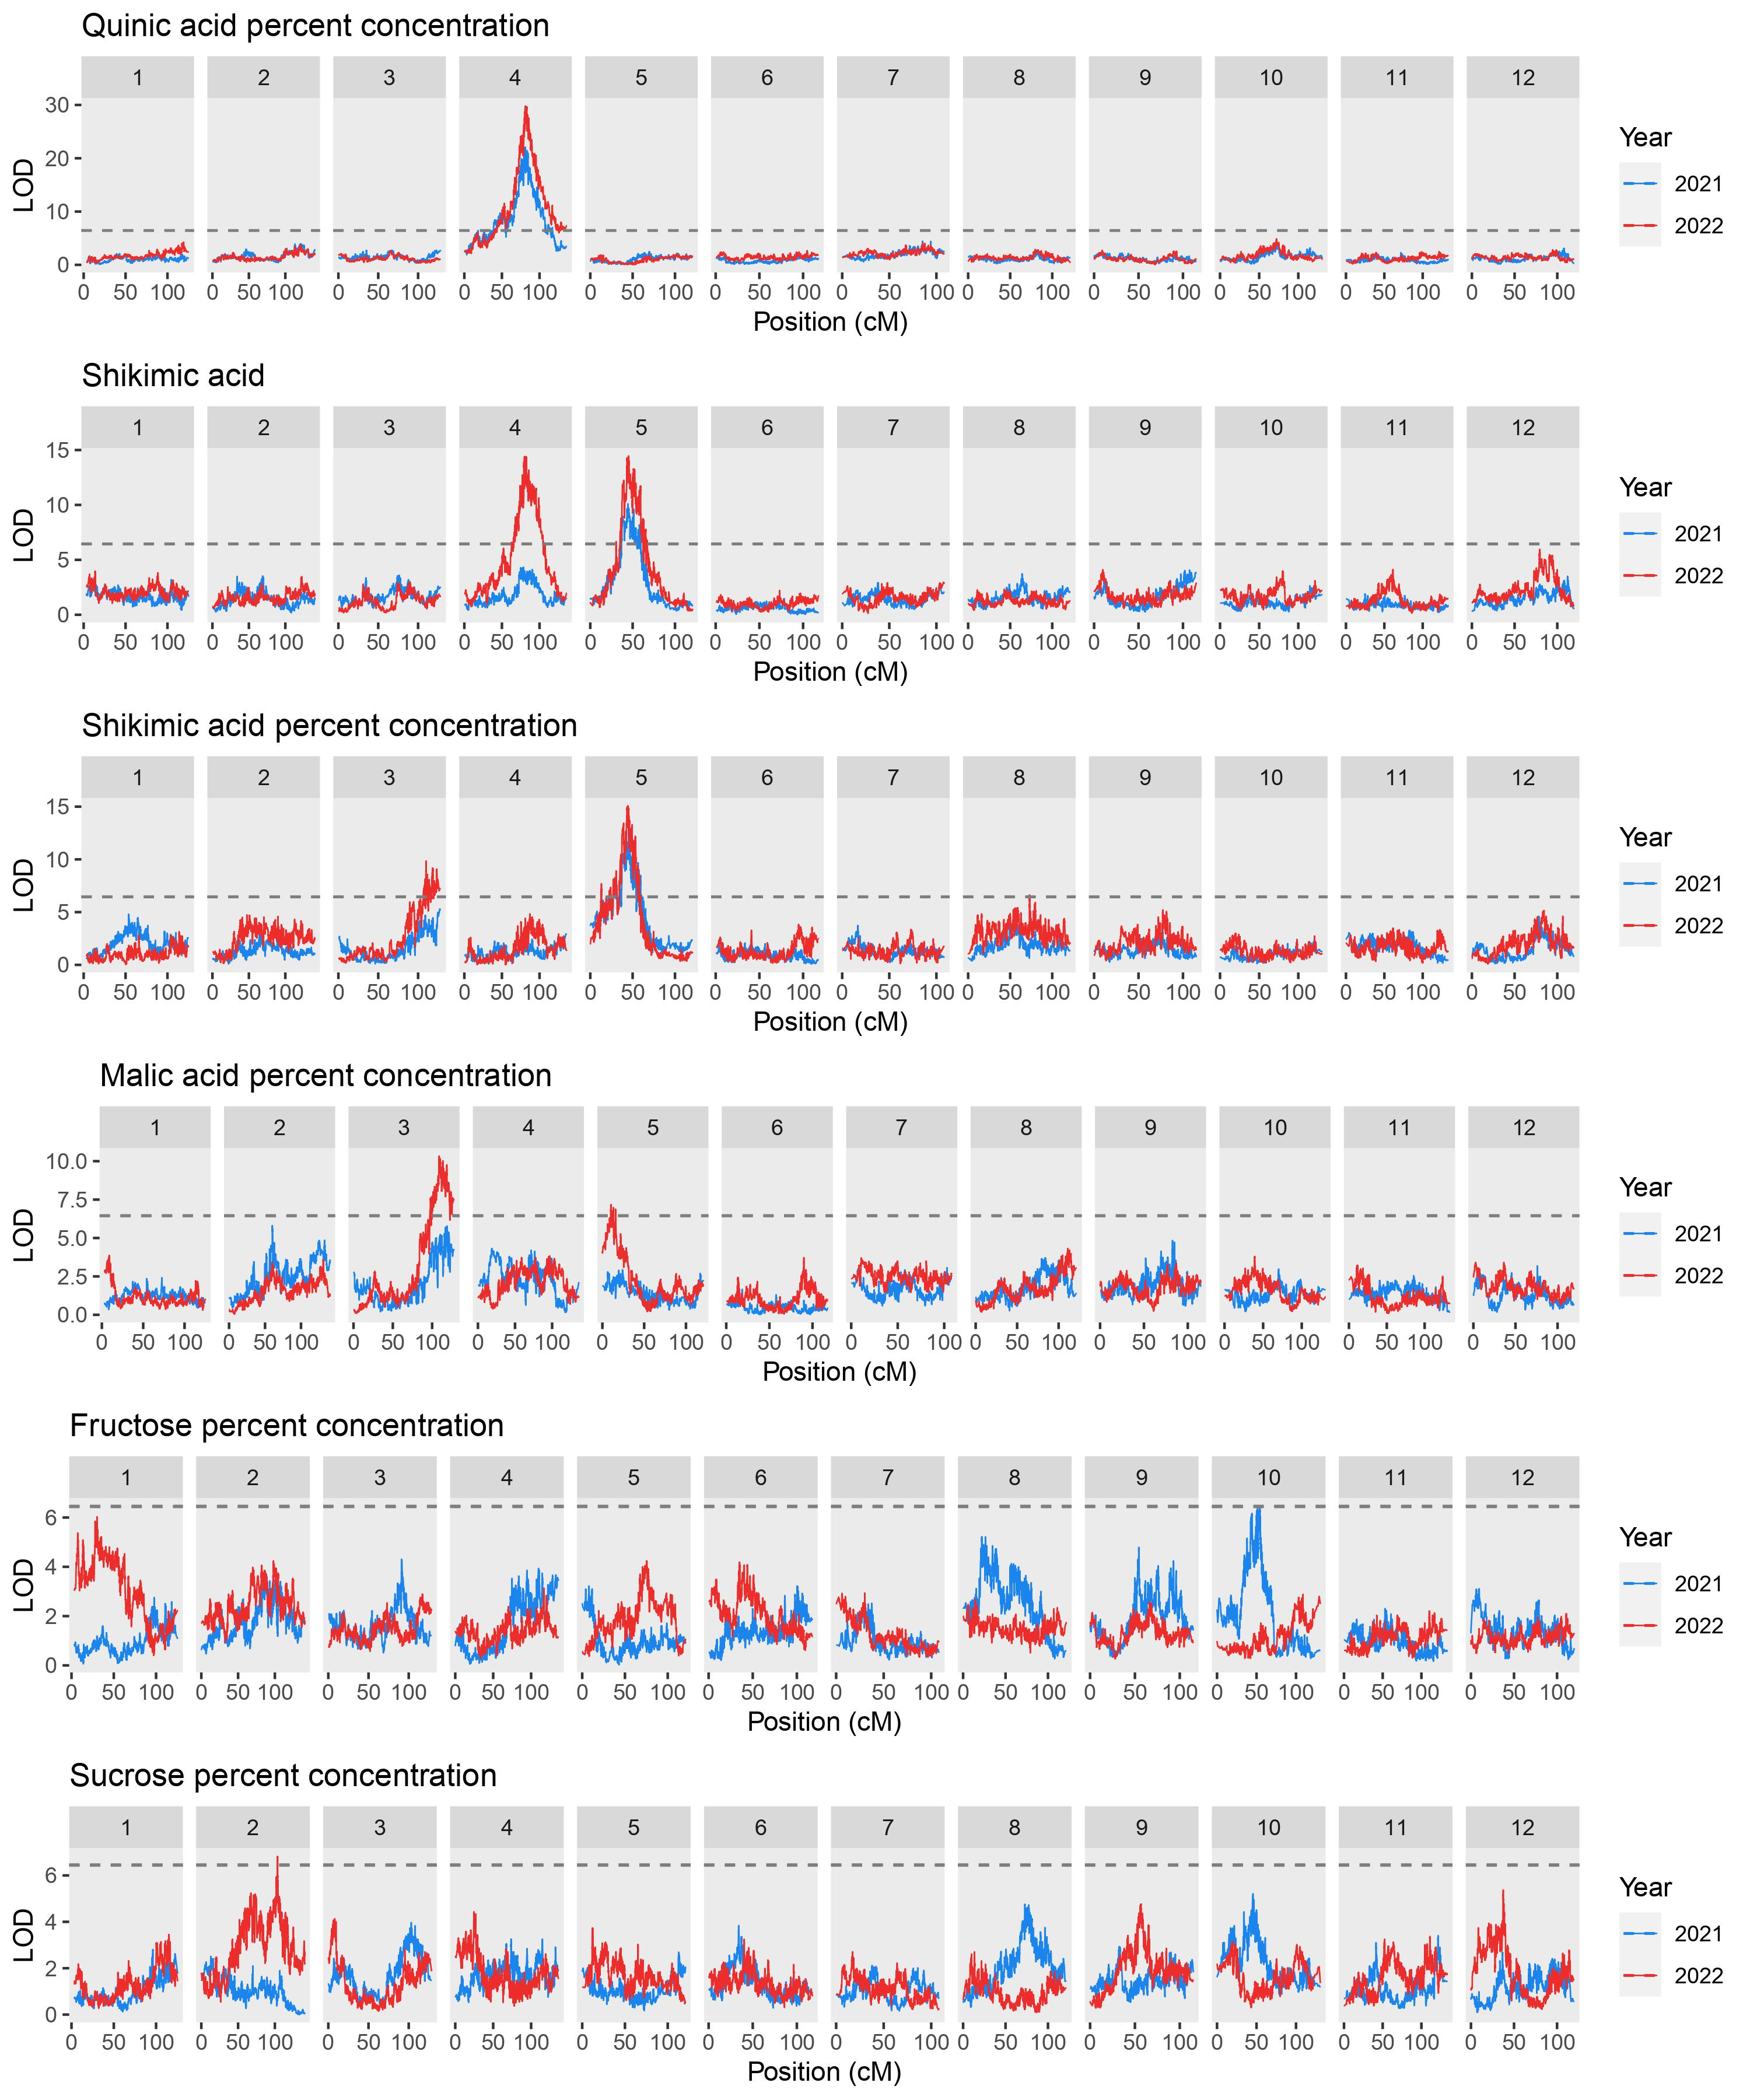
Supplementary Figure S6
Quantitative trait loci (QTLs) detected for chemistry parameters in ‘Reveille’ × ‘Arlen’ F₁ population across two years (2021-2022). Dashed lines indicate the LOD threshold (1,000 permutations, α = 0.05) for significant QTLs

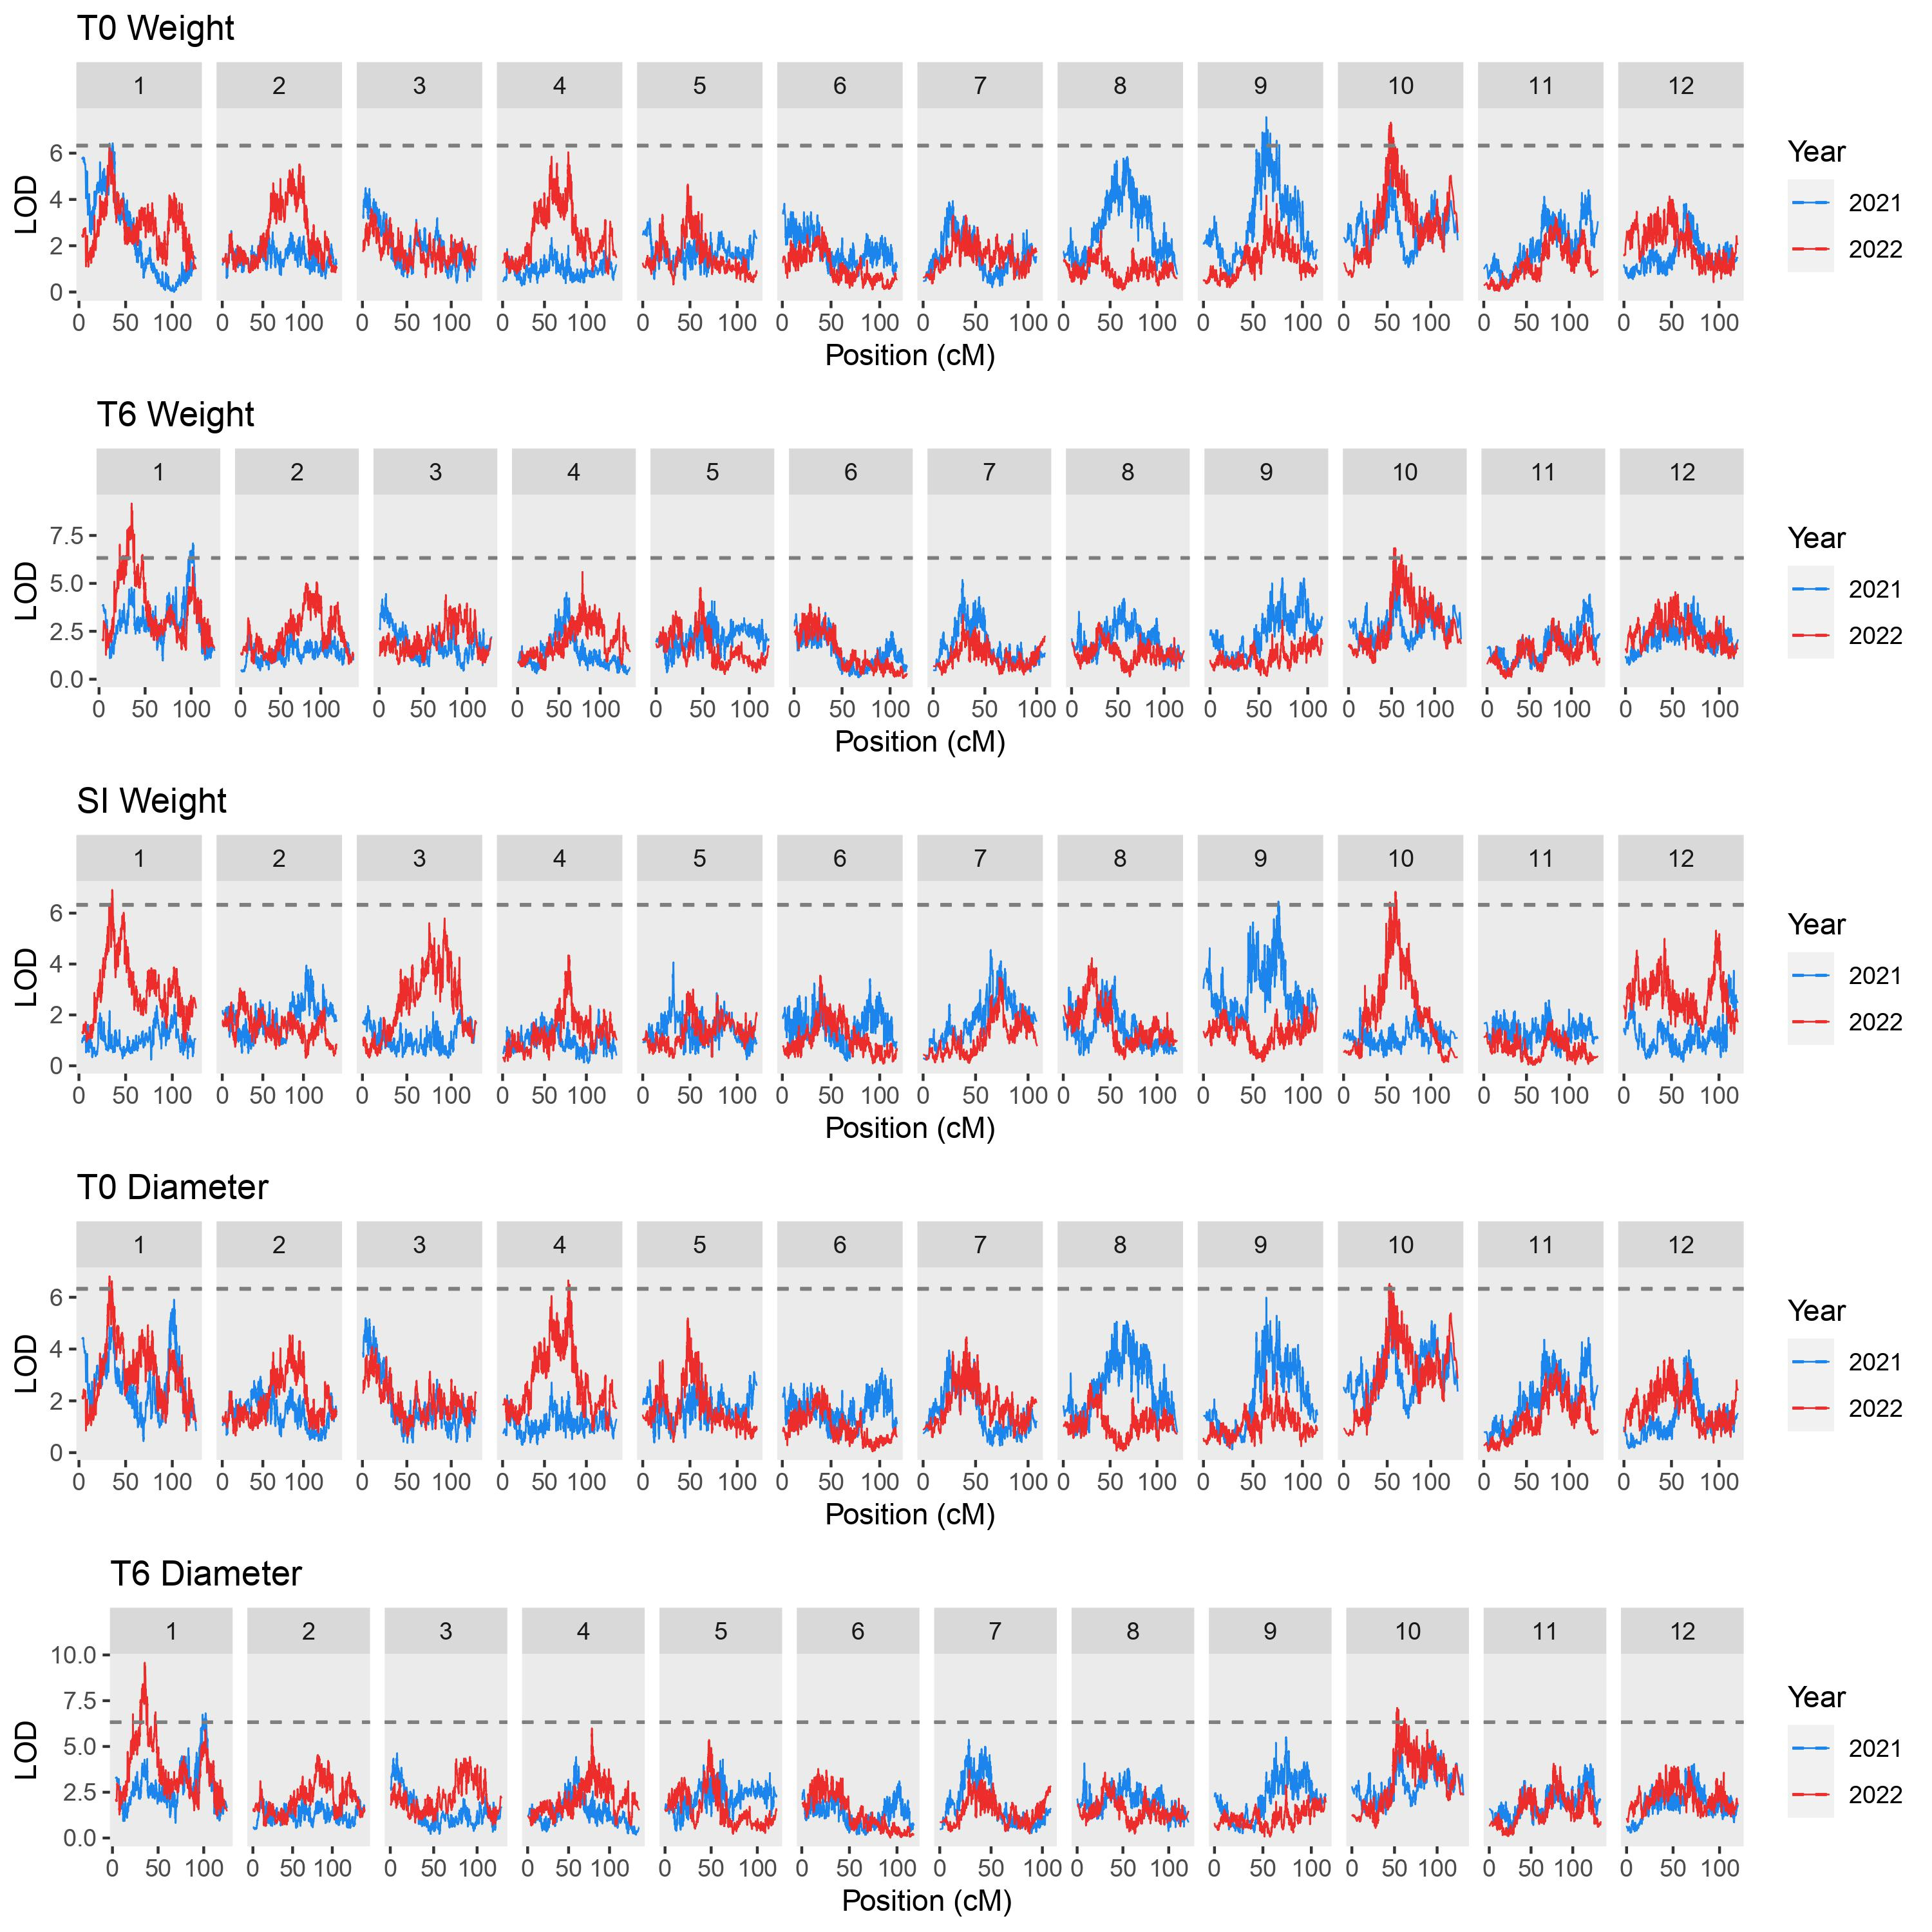
Supplementary Figure S7
Quantitative trait loci (QTLs) detected for appearance parameters in ‘Reveille’ × ‘Arlen’ F₁ population across two years (2021-2022). Dashed lines indicate the LOD threshold (1,000 permutations, α = 0.05) for significant QTLs

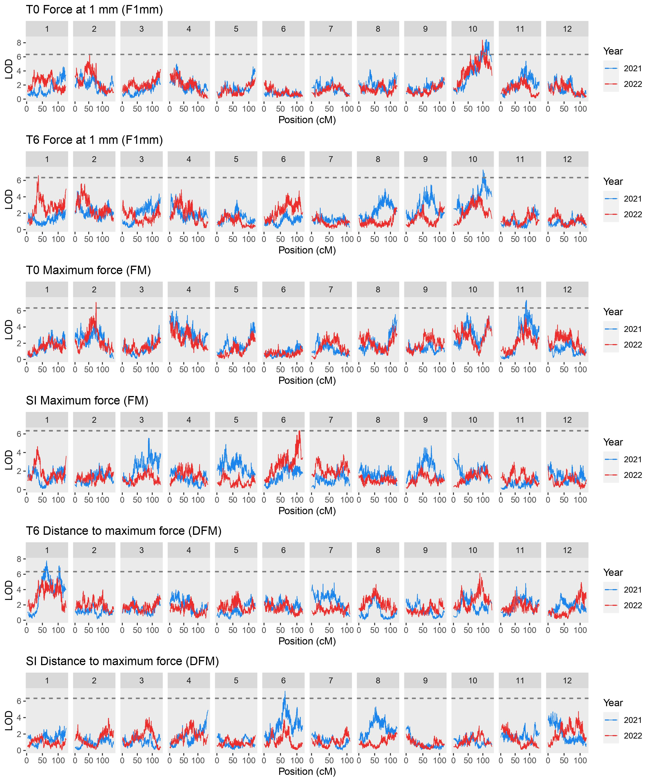
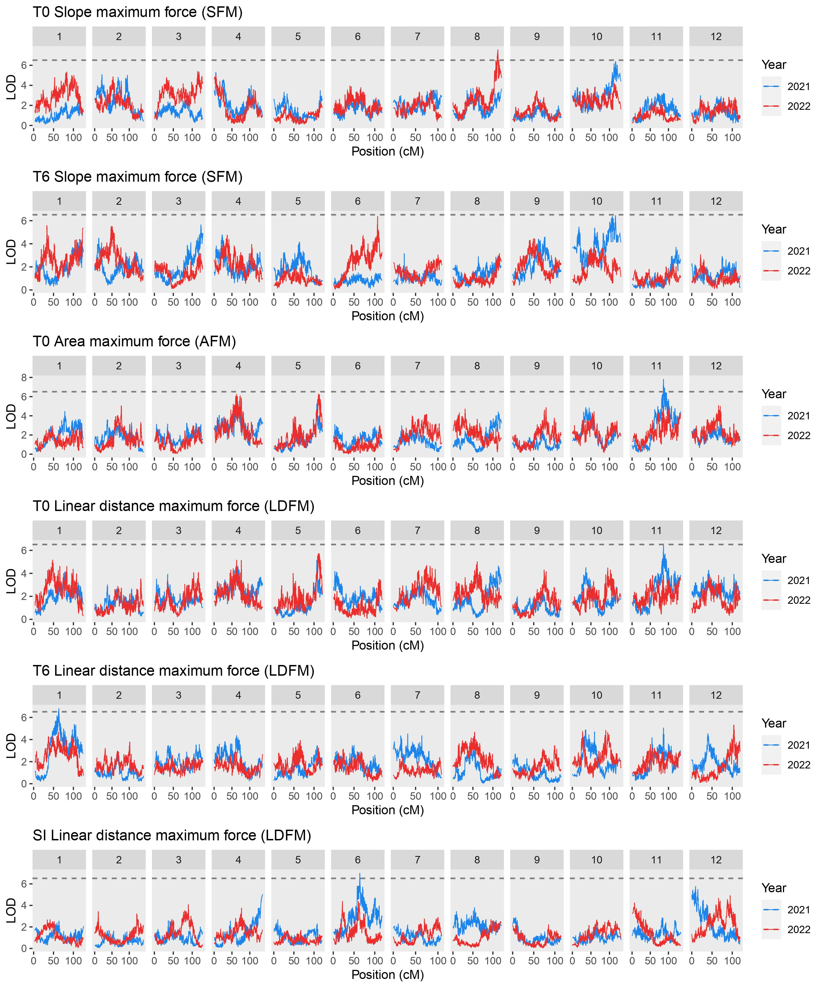
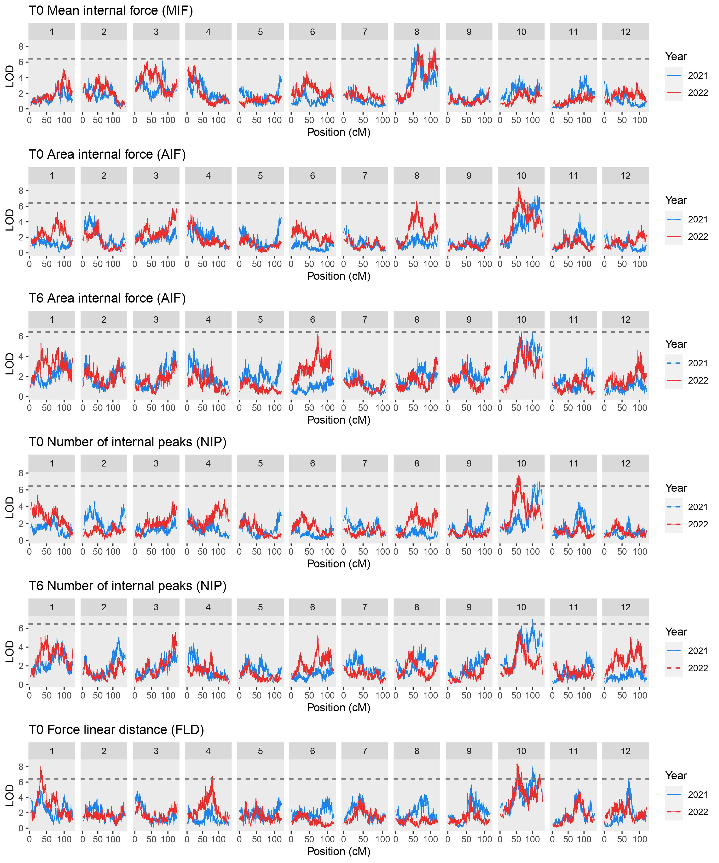
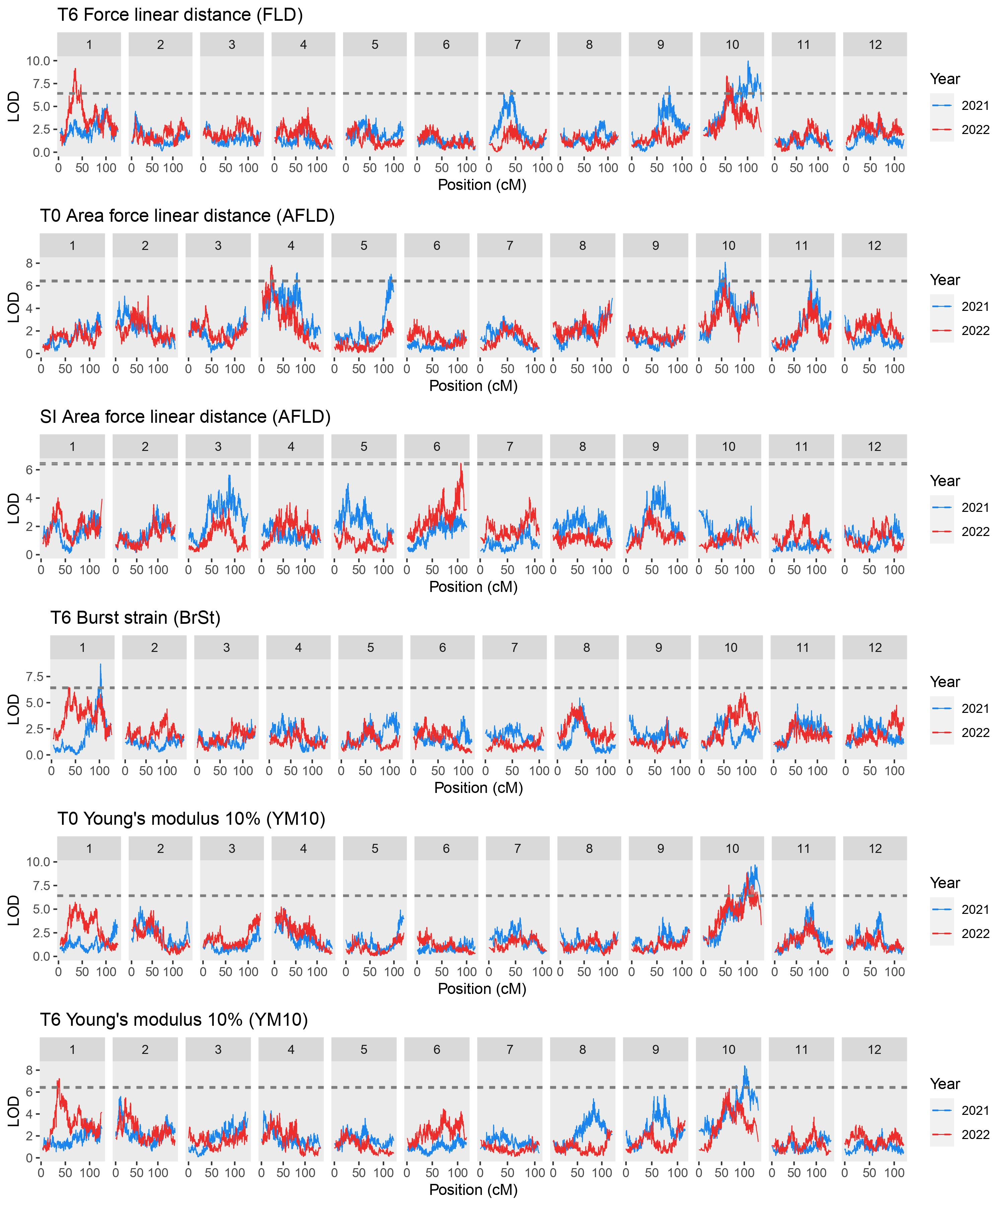
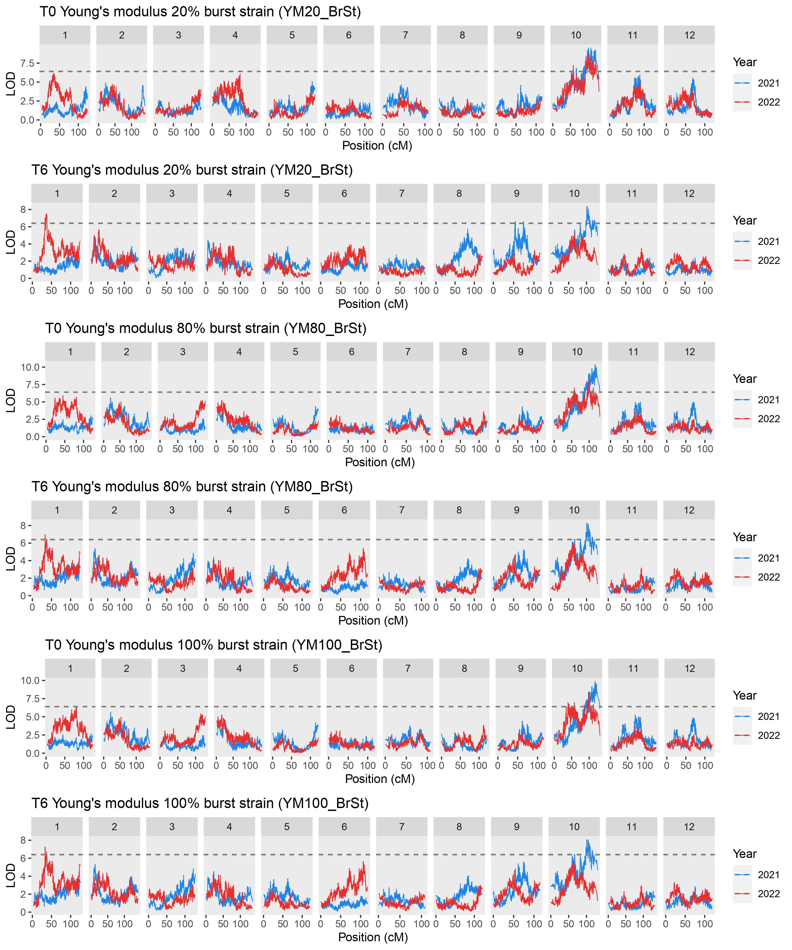
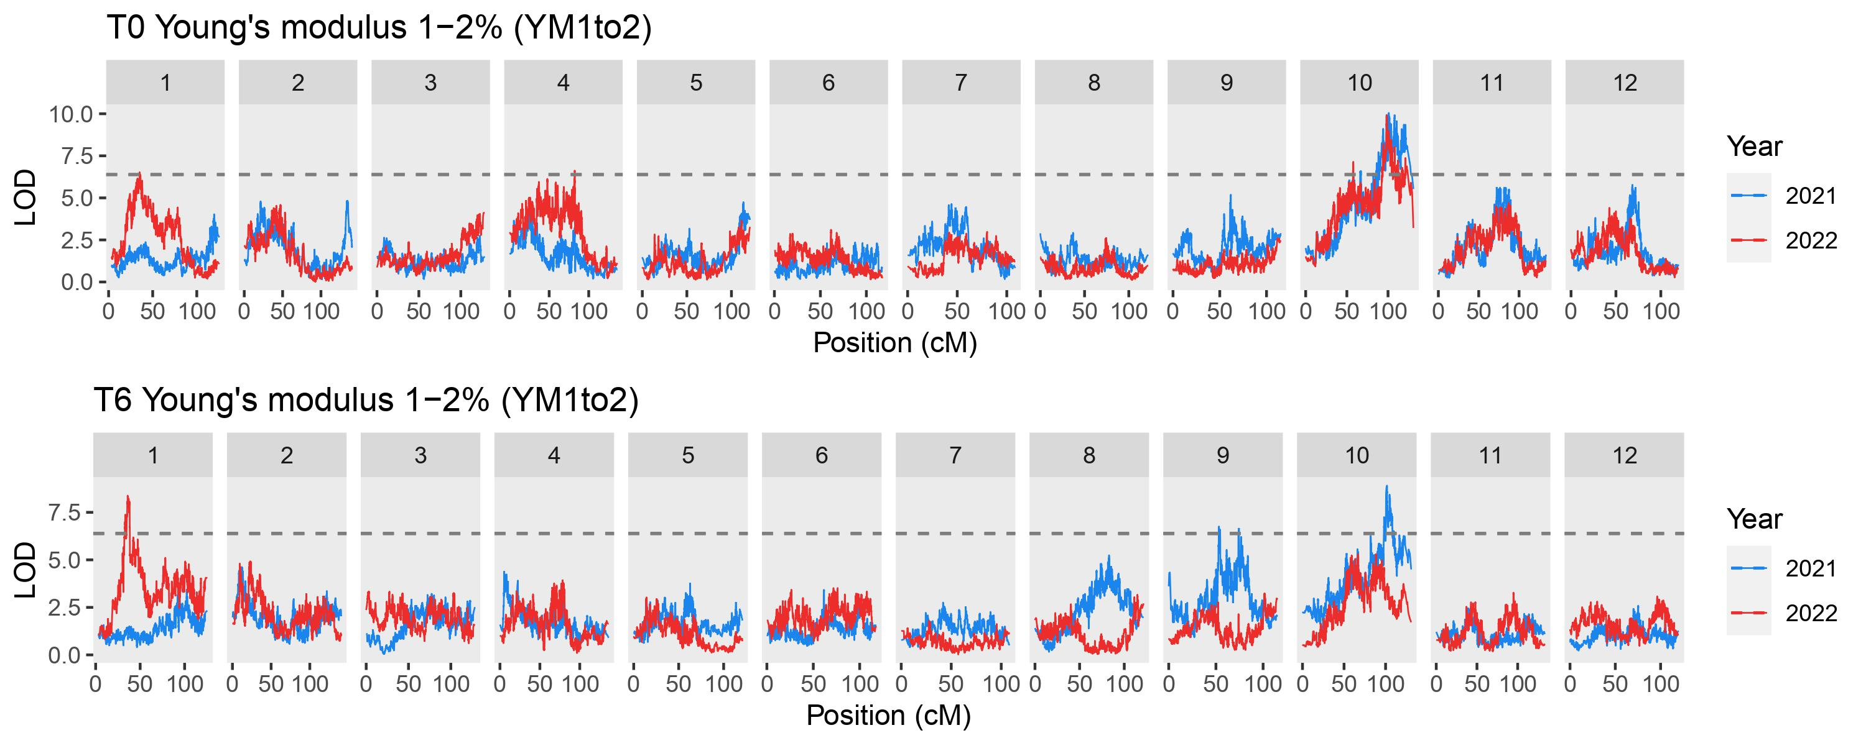Supplementary Figure S8
Quantitative trait loci (QTLs) detected for 2 mm flat probe texture parameters in ‘Reveille’ × ‘Arlen’ F₁ population across two years (2021-2022). Dashed lines indicate the LOD threshold (1,000 permutations, α = 0.05) for significant QTLs. SI, change during storage calculated as storage index (SI = log₂ (T₆ / T₀)); T0, 24 h after storage at 2 ºC, 80 % RH; T6, six weeks after storage at 2 ºC, 80 % RH

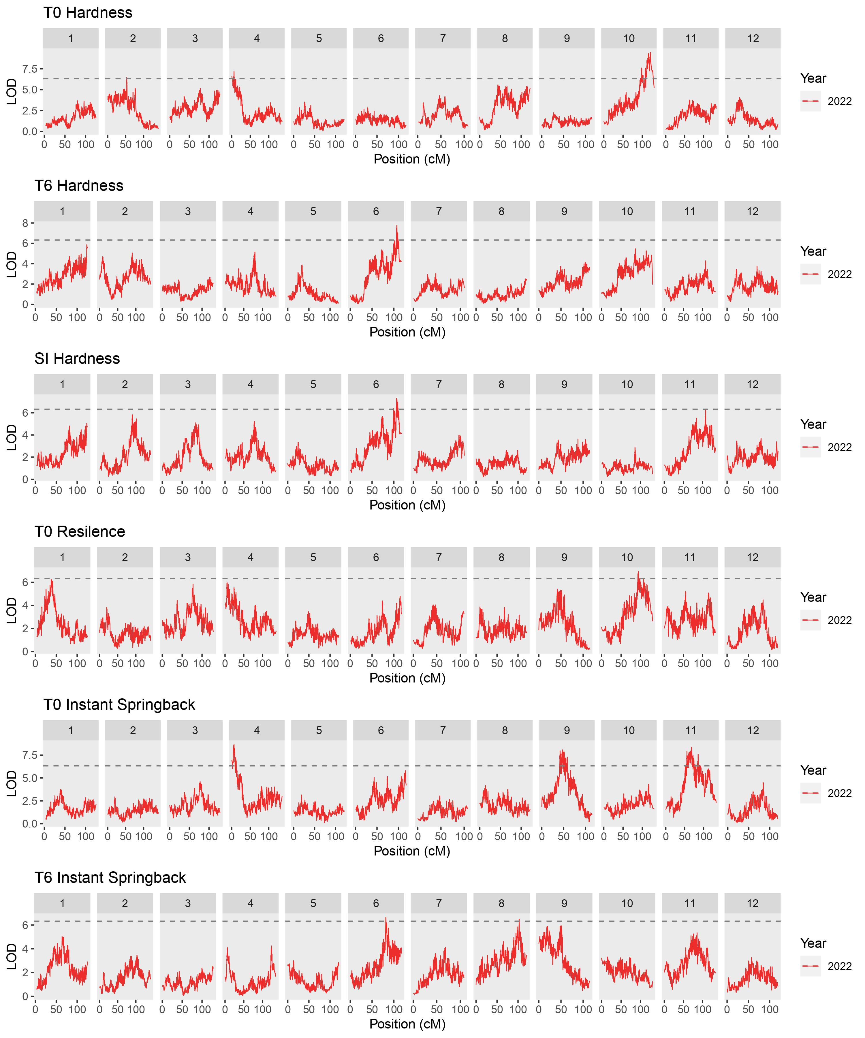
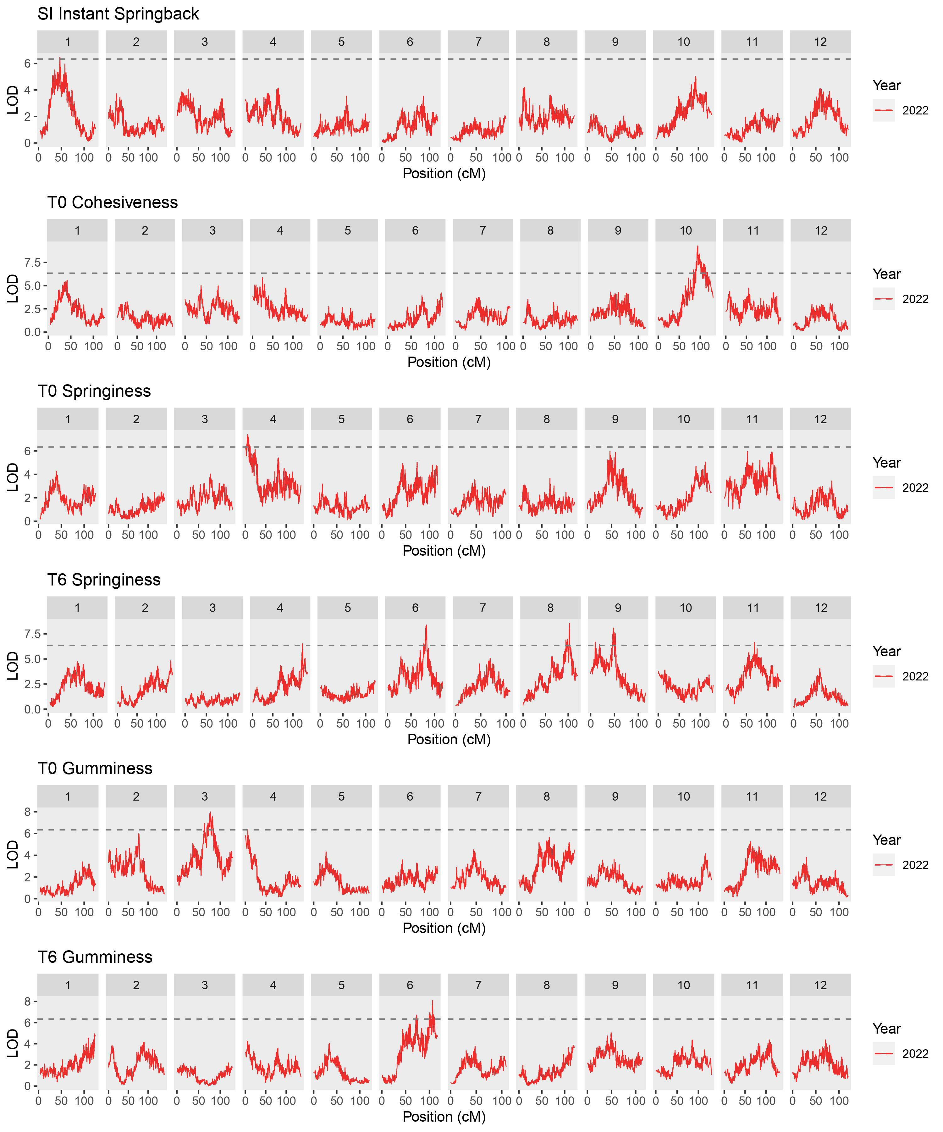
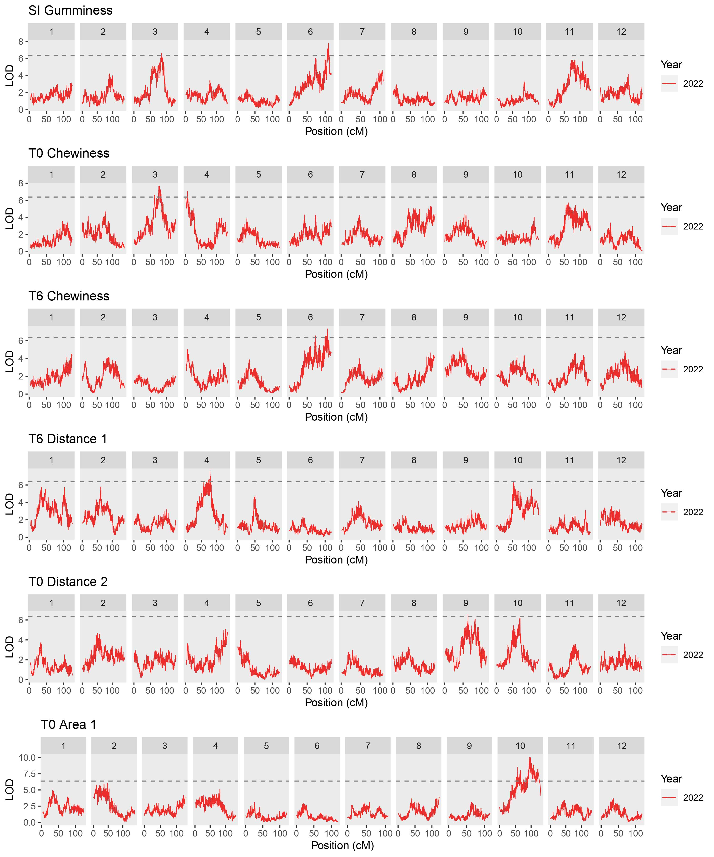
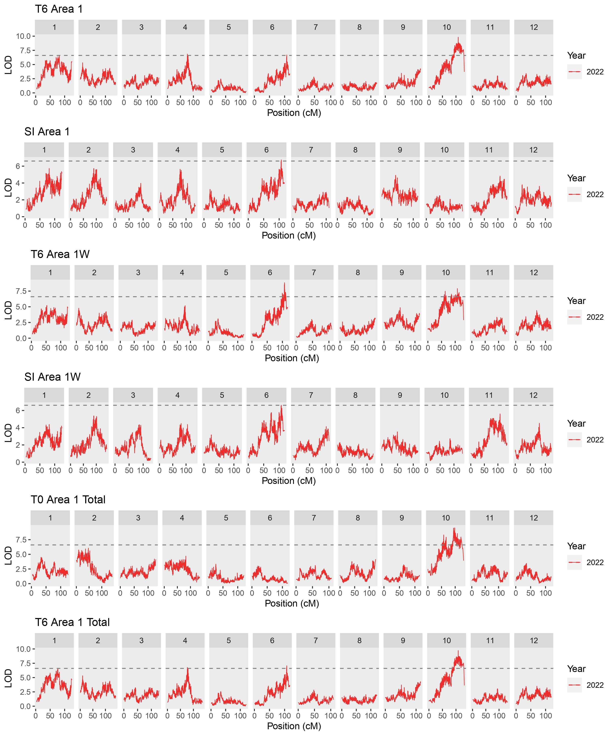
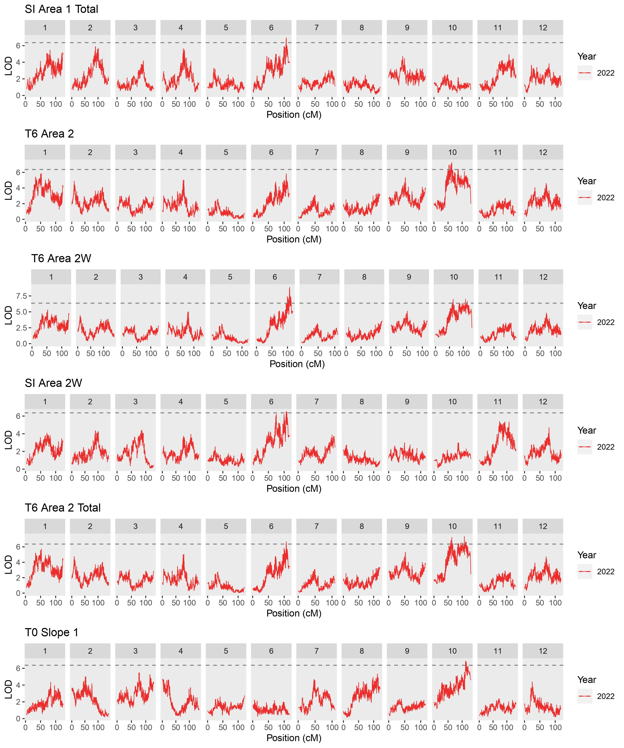
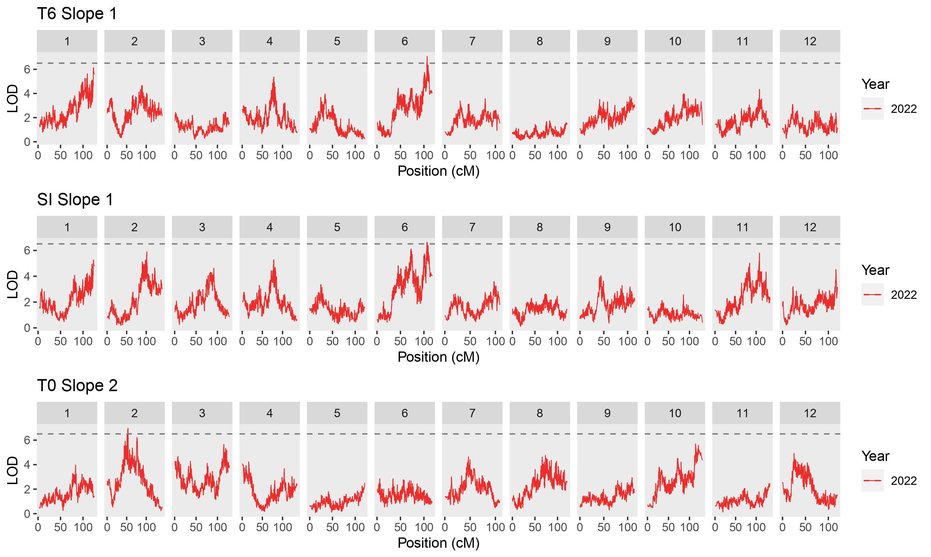
Supplementary Figure S9
Quantitative trait loci (QTLs) detected for texture profile analysis (TPA) parameters in ‘Reveille’ × ‘Arlen’ F₁ population in 2022. Dashed lines indicate the LOD threshold (1,000 permutations, α = 0.05) for significant QTLs. SI, change during storage calculated as storage index (SI = log₂ (T₆ / T₀)); T0, 24 h after storage at 2 ºC, 80 % RH; T6, six weeks after storage at 2 ºC, 80 % RH

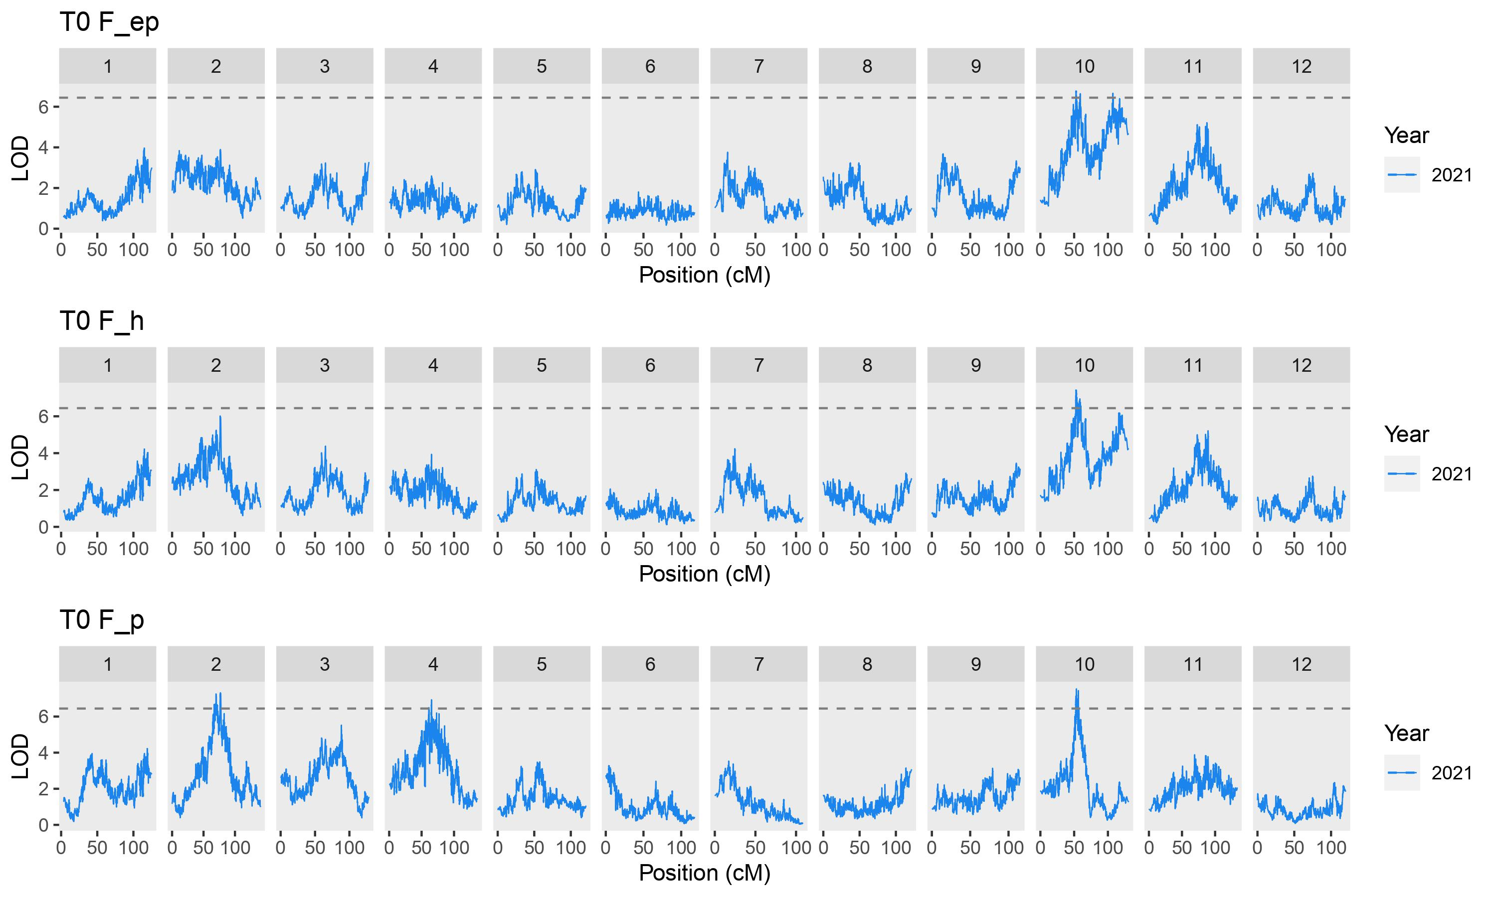
Supplementary Figure S10
Quantitative trait loci (QTLs) detected for needle probe parameters in ‘Reveille’ × ‘Arlen’ F₁ population in 2021. Dashed lines indicate the LOD threshold (1,000 permutations, α = 0.05) for significant QTLs. F_ep, force at epidermis level (between 2 and 3.7 µm); F_h, force at hypodermis level (0.240 mm); F_p, force at parenchyma level (0.341 mm); T0, 24 h after storage at 2 ºC, 80 % RH

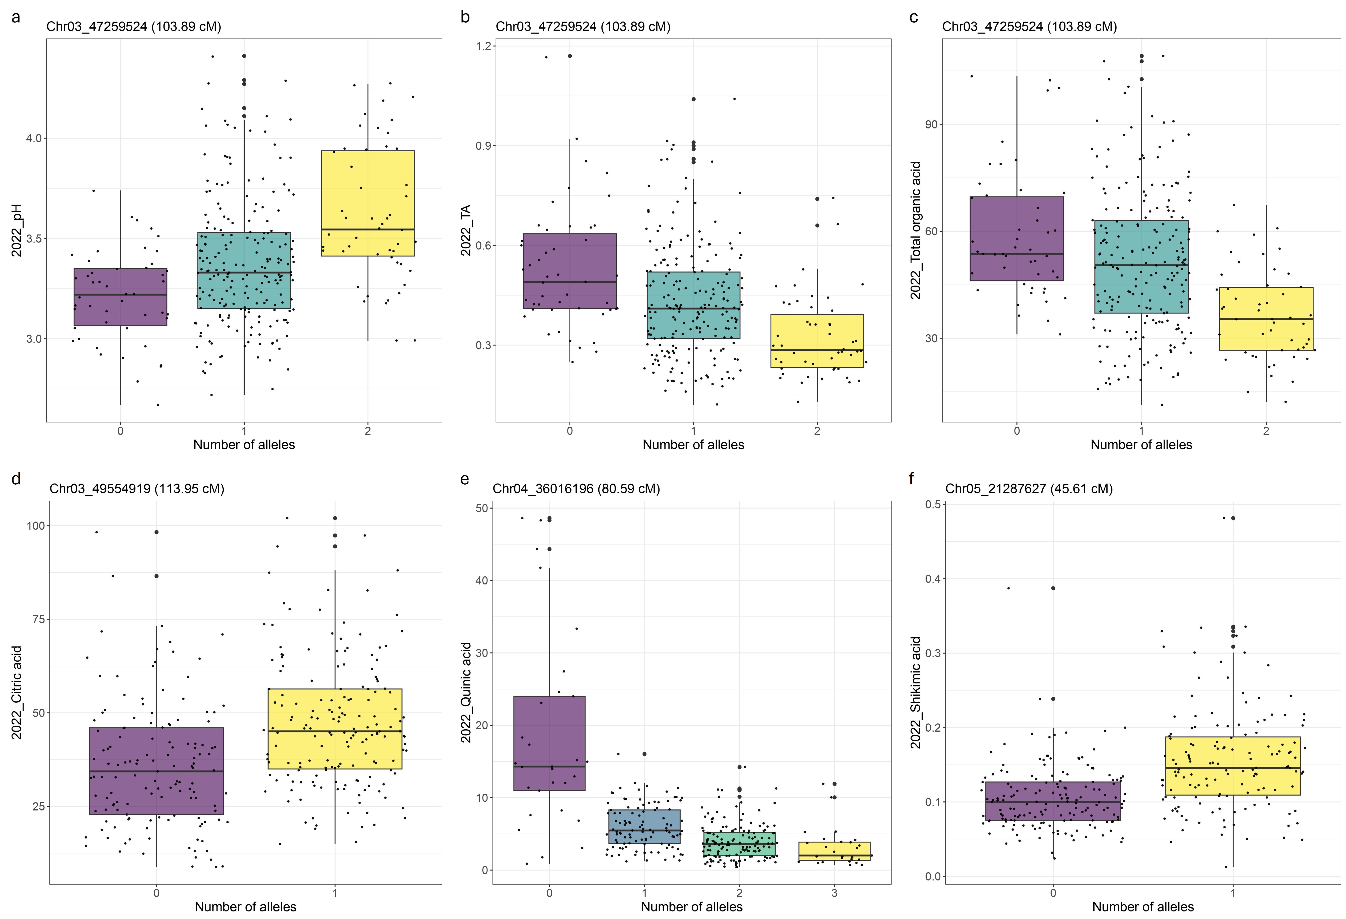
Supplementary Figure S11
Average allele dosage effect of SNP markers that had the highest LOD score for pH (a), titratable acidity (TA) (b), total organic acid content (c), citric acid content (d), quinic acid content (e), and shikimic acid content (f) in 2022

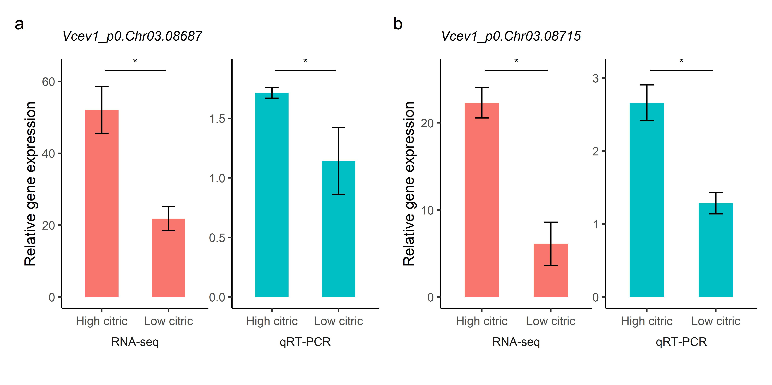
Supplementary Figure S12
Validation of RNA‑seq results using quantitative real‑time PCR (qRT-PCR). Asterisks indicate statistically significant differences between average expression levels of high and low citric acid genotypes (p < 0.05). Vertical bars indicate standard errors of the means. RNA-seq results are illustrated in transcripts per kilobase million (TPM) values

