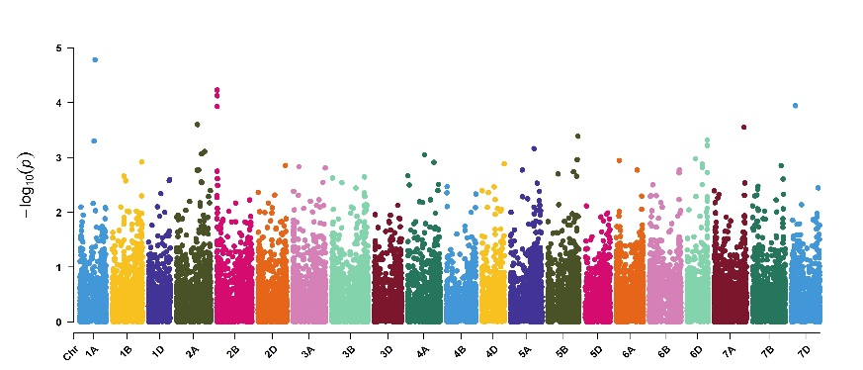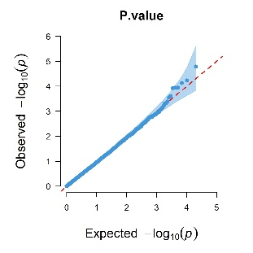
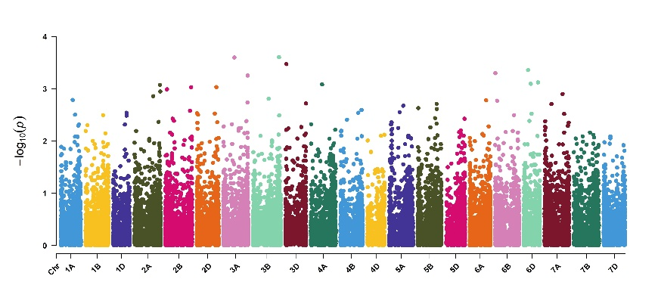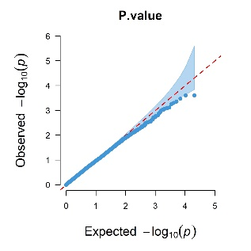
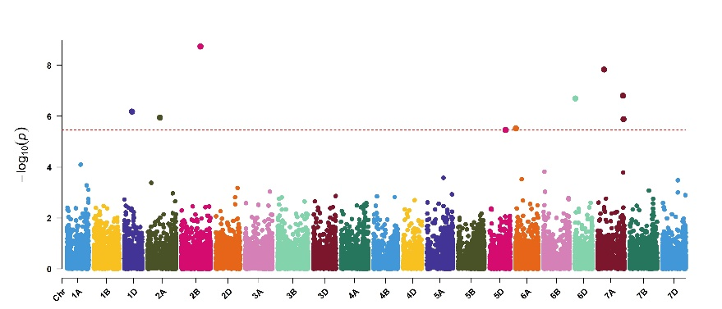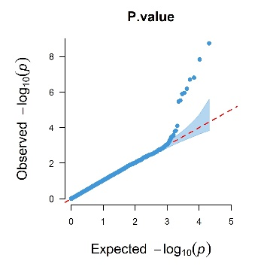

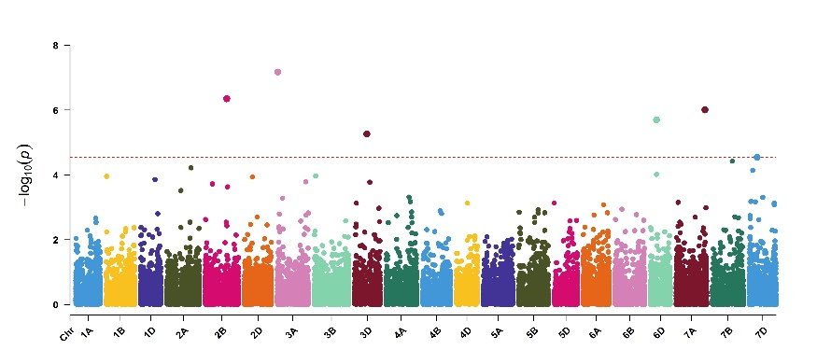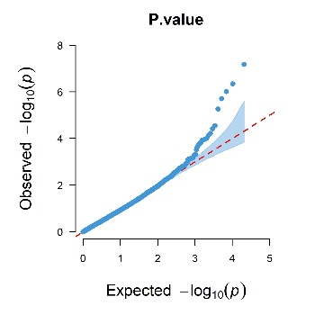

Figure S1a. Manhattan plot (left) and quantile-quantile plots (right) showing genome-wide SNP loci associated with fruiting efficiency (FE) ordered on C18, Q17, Q18, and Combined. The horizontal line in Manhattan plot represents the expected value with a uniform suggestive genome wide significance threshold [-FDR ≤ 0.10].
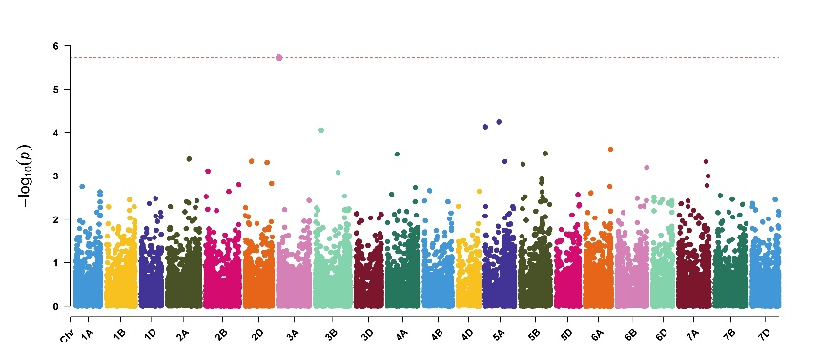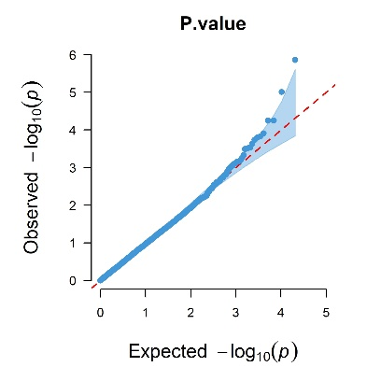
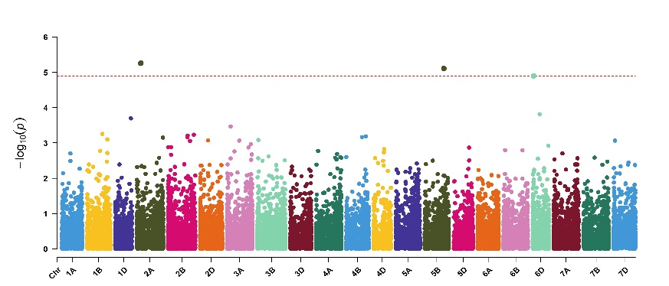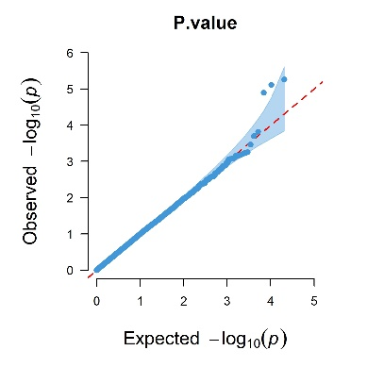
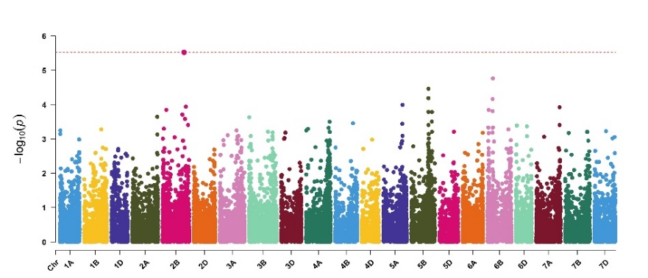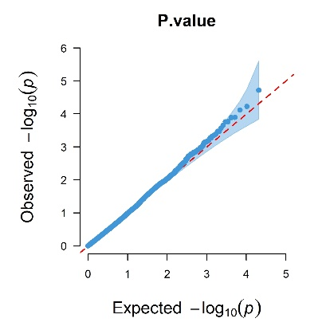
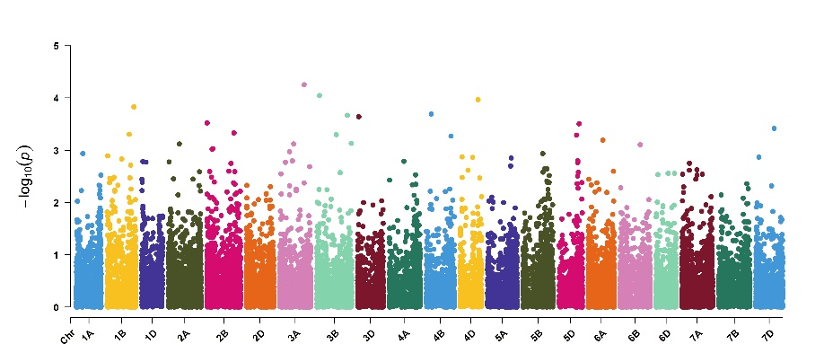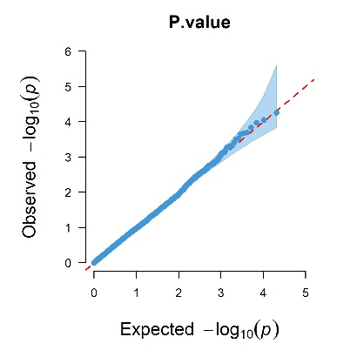
Figure S1b. Manhattan plot (left) and quantile-quantile plots (right) showing genome-wide SNP loci associated with Thousand Grain Weight (TGW) ordered on C18, Q17, Q18, and Combined. The horizontal line in Manhattan plot represents the expected value with a uniform suggestive genome wide significance threshold [-FDR ≤ 0.10].

