Table S1 Eigenvalues and explained variance for the factor analysis within each mega-environments (ME1, ME2, ME3, ME4, ME5, and ME6)
Model | Principal component | Eigenvalues | Variance (%) | Cumulative variance (%)
ME1 | PC1 | 1.76 | 35.20 | 35.20
ME1 | PC2 | 1.36 | 27.30 | 62.50
ME1 | PC3 | 0.78 | 15.60 | 78.1
ME1 | PC4 | 0.63 | 12.70 | 90.80
ME1 | PC5 | 0.46 | 9.24 | 100.0
ME2 | PC1 | 2.11 | 42.2 | 42.2
ME2 | PC2 | 1.13 | 22.7 | 64.8
ME2 | PC3 | 1.00 | 20.0 | 84.8
ME2 | PC4 | 0.65 | 12.9 | 97.8
ME2 | PC5 | 0.11 | 2.22 | 100.0
ME3 | PC1 | 1.87 | 37.4 | 37.4
ME3 | PC2 | 1.40 | 28.0 | 65.4
ME3 | PC3 | 0.85 | 17.00 | 82.4
ME3 | PC4 | 0.61 | 12.2 | 94.7
ME3 | PC5 | 0.27 | 5.32 | 100.0
ME4 | PC1 | 1.78 | 35.6 | 35.6
ME4 | PC2 | 1.14 | 22.7 | 58.3
ME4 | PC3 | 0.92 | 18.4 | 76.7
ME4 | PC4 | 0.80 | 16.0 | 92.6
ME4 | PC5 | 0.37 | 7.4 | 100.0
ME5 | PC1 | 1.80 | 35.9 | 35.9
ME5 | PC2 | 1.10 | 22.0 | 57.9
ME5 | PC3 | 1.01 | 20.3 | 78.2
ME5 | PC4 | 0.72 | 14.4 | 92.5
ME5 | PC5 | 0.37 | 7.5 | 100.0
ME6 | PC1 | 1.88 | 37.6 | 37.6
ME6 | PC2 | 1.60 | 32.0 | 69.6
ME6 | PC3 | 0.75 | 15.0 | 84.6
ME6 | PC4 | 0.49 | 9.82 | 94.4
ME6 | PC5 | 0.28 | 5.56 | 100.0
ME mega-environment, PC Principal component

Table S2 Selecion differentials for mean performance and stability of the evaluated traits in the six delineated mega-environments
ME | Traits | Factor | Mean performance |  |  | Stability
ME | Traits | Factor | Overhall | Selected | SD | Overhall | Selected | SD
ME1 | GY | FA1 | 9.80 | 10.50 | 0.71 | 54.2 | 74.0 | 19.7
ME1 | SF | FA1 | 1.27 | 0.41 | -0.86 | 32.2 | 46.6 | 14.4
ME1 | ESR | FA1 | 2.12 | 1.20 | -0.93 | 59.3 | 79.7 | 20.4
ME1 | SR | FA2 | 0.95 | 0.53 | -0.42 | 80.6 | 89.1 | 8.5
ME1 | LR | FA2 | 1.74 | 0.75 | -1.00 | 67.4 | 89.2 | 21.8
ME2 | GY | FA1 | 9.59 | 9.89 | 0.30 | 60.1 | 73.7 | 13.6
ME2 | LR | FA1 | 2.55 | 0.93 | -1.62 | 76.7 | 91.4 | 14.7
ME2 | ESR | FA1 | 3.30 | 1.81 | -1.50 | 61.0 | 81.5 | 20.6
ME2 | SR | FA2 | 2.06 | 0.81 | -1.25 | 74.8 | 93.1 | 18.3
ME2 | SF | FA2 | 2.60 | 1.06 | -1.54 | 77.5 | 89.9 | 12.4
ME3 | LR | FA1 | 5.11 | 2.98 | -2.13 | 69.2 | 80.3 | 11.1
ME3 | ESR | FA1 | 3.22 | 2.35 | -0.86 | 63.7 | 82.5 | 18.9
ME3 | GY | FA2 | 10.10 | 10.10 | -0.03 | 46.3 | 51.3 | 5.0
ME3 | SR | FA2 | 1.44 | 0.97 | -0.47 | 74.6 | 85.1 | 10.5
ME3 | SF | FA2 | 2.54 | 7.51 | 4.96 | 71.5 | 15.9 | -55.6
ME4 | GY | FA1 | 9.64 | 10.10 | 0.44 | 53.2 | 76.9 | 23.7
ME4 | SF | FA1 | 2.83 | 2.76 | -0.06 | 84.7 | 87.0 | 2.3
ME4 | SR | FA2 | 1.65 | 1.12 | -0.53 | 86.9 | 92.8 | 5.9
ME4 | LR | FA2 | 3.70 | 0.93 | -2.77 | 72.8 | 93.8 | 20.9
ME4 | ESR | FA2 | 3.95 | 2.59 | -1.37 | 68.6 | 82.7 | 14.1
ME5 | LR | FA1 | 3.06 | 0 | -3.06 | 71.0 | 97.1 | 26.1
ME5 | SR | FA2 | 1.92 | 0 | -1.92 | 85.3 | 94.4 | 9.05
ME5 | SF | FA2 | 3.92 | 0.29 | -3.63 | 74.7 | 92.2 | 17.5
ME5 | GY | FA3 | 9.64 | 9.88 | 0.24 | 59.5 | 72.4 | 13.0
ME5 | ESR | FA3 | 2.18 | 1.08 | -1.10 | 55.1 | 81.5 | 26.4
ME6 | SR | FA1 | 1.28 | 0.35 | -0.93 | 56.9 | 86.6 | 29.7
ME6 | LR | FA1 | 3.15 | 1.01 | -2.14 | 64.5 | 88.2 | 23.8
ME6 | ESR | FA1 | 2.62 | 1.45 | -1.17 | 59.5 | 79.3 | 19.8
ME6 | GY | FA2 | 9.97 | 10.50 | 0.50 | 61.5 | 79.1 | 17.7
ME6 | SF | FA2 | 1.48 | 0.57 | -0.91 | 72.8 | 92.8 | 20.0
GY Grain yield, SR Stalk rot, LR Lodging rate, SF Stalk folding rate, ESR Empty stalk rate, ME mega-environment

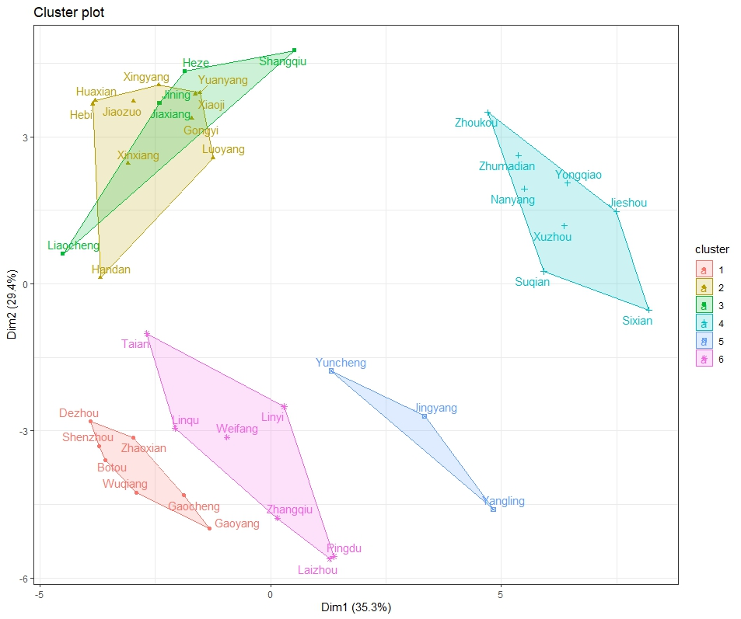
Fig. S1 Six mega-environments cluster plot based on 20 years of climate information and soil covariates

Fig. S2 The correlation heat map of study traits in 6 MEs

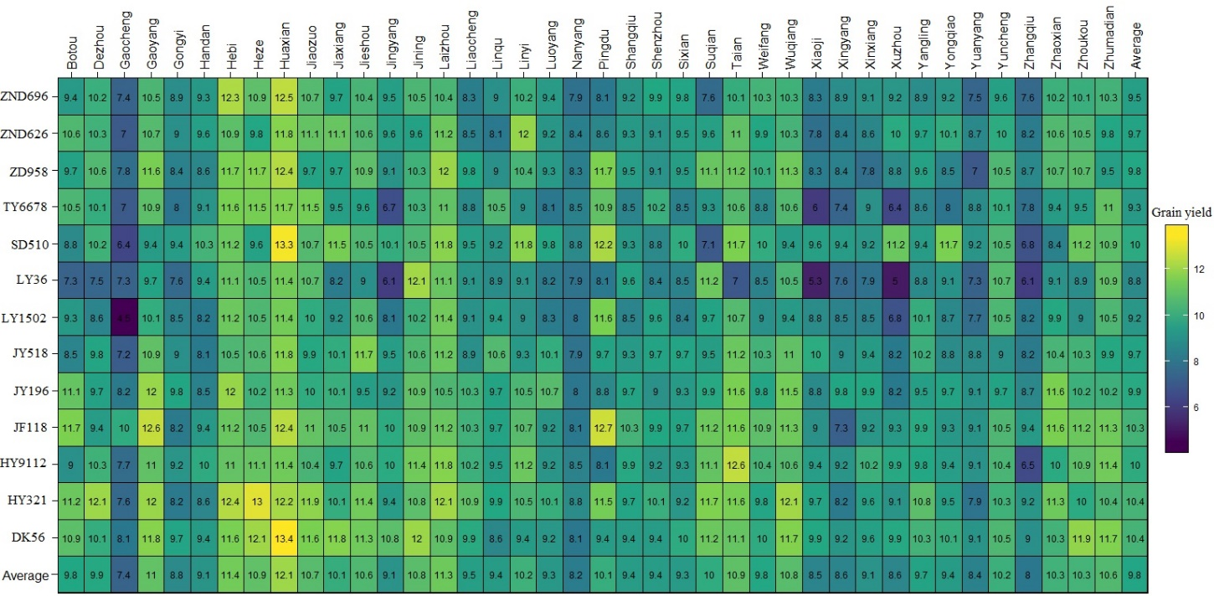
Fig. S3 Heatmap showing the average yield of the studied genotypes in each environment

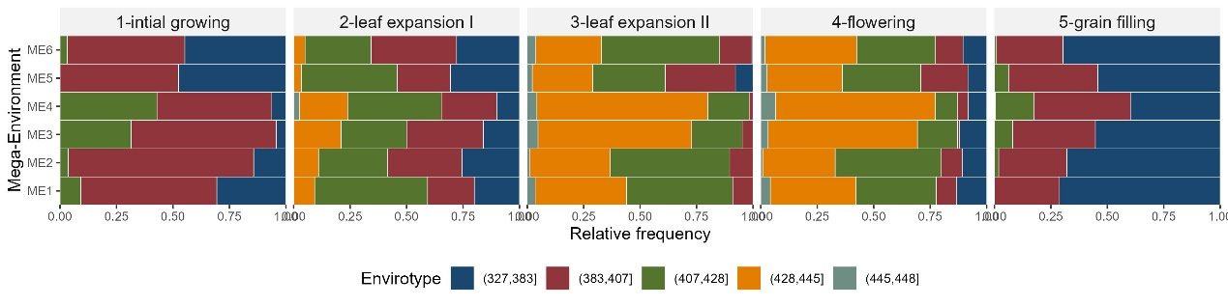
Fig. S4 Quantiles for the downward thermal infrared (longwave) radiative flux (ASKLW) observed in the delineated mega-environments

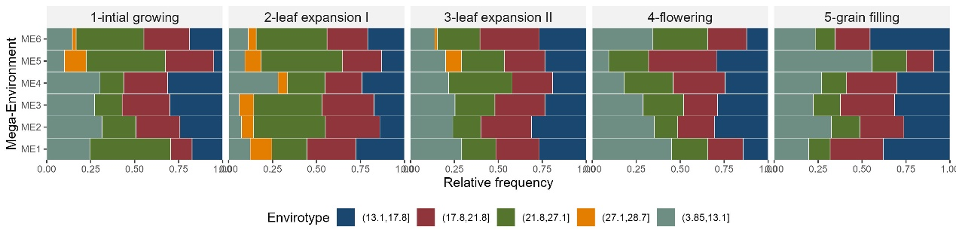
Fig. S5 Quantiles for the all sky insolation incident on a horizontal surface (ASKSW) observed in the delineated mega-environments

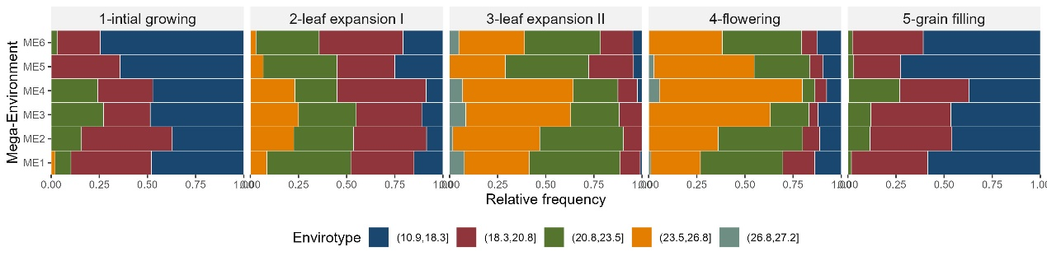
Fig. S6 Quantiles for the minimum temperature observed in the delineated mega-environments

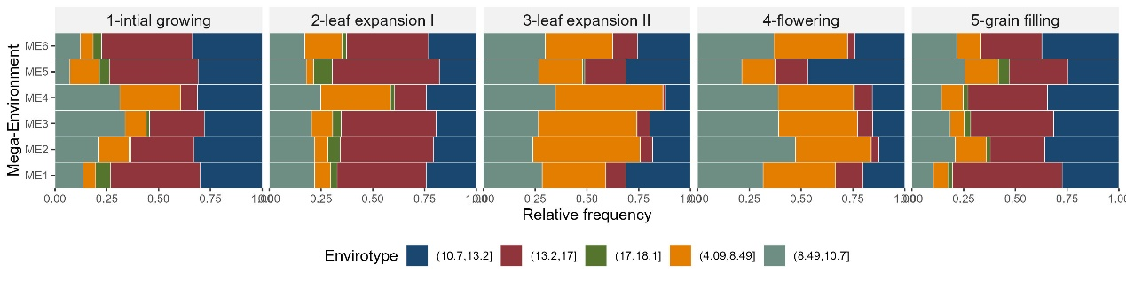
Fig. S7 Quantiles for the daily temperature range observed in the delineated mega-environments

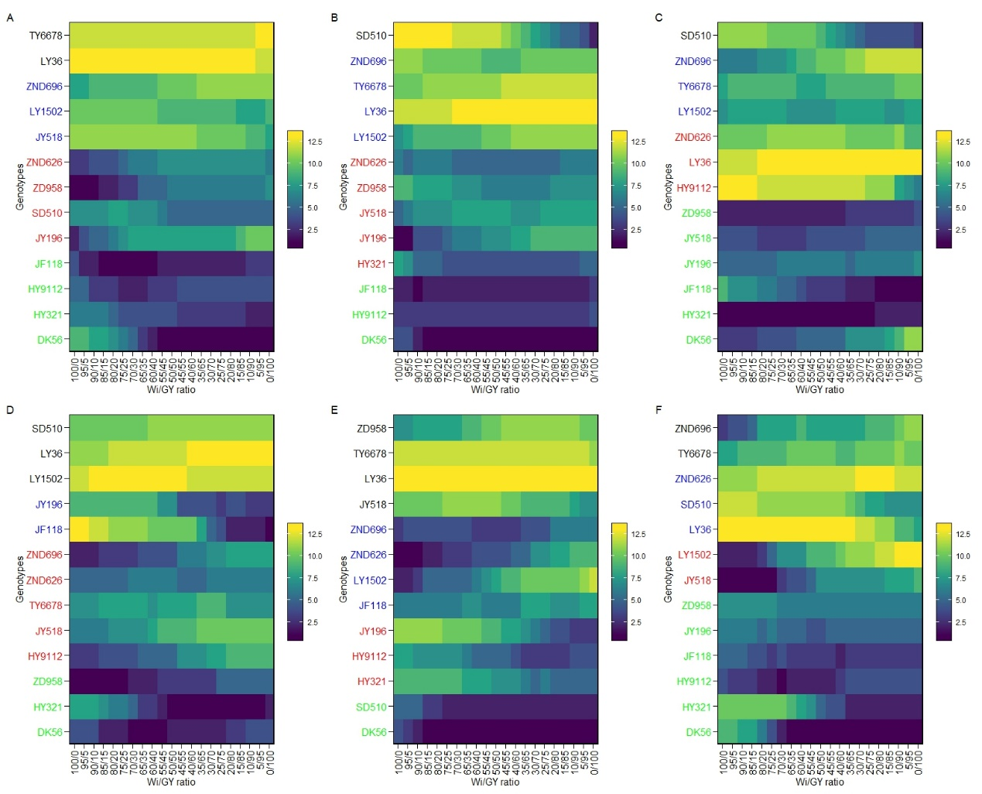
Fig. S8 Ranks of 13 maize hybrids considering different weights for stability computed as the Wricke’s ecovalence (Wi) and grain yield (GY) for ME1 (A), ME2 (B), ME3 (C), ME4 (D), ME5 (E), and ME6 (F)

