Correlation Between Aboveground Vegetation Composition and Soil Seed Bank of Raudhat Desert Habitat: A Case Study of Raudhat Alkhafs, Saudi Arabia

Asma A. Al-Huqail¹, Hanan F. Al-Harbi¹, Abdullah M. Alowaifeer², Mohamed A. El-Sheikh¹, Abdulaziz M. Assaeed³, Turki S. Alsaleem², Hazem S. Kassem¹, Omar M. Azab^{1,3}, Basharat A. Dar^{1,3}, Jahangir A. Malik^{1,3} and Ahmed M. Abd-ElGawad^{1,3,}*
¹ Chair of Climate Change, Environmental Development and Vegetation Cover, Department of Botany and Microbiology, College of Science, King Saud University, Riyadh, 11451, Saudi Arabia
² King Abdulaziz Royal Reserve Development Authority
³ Plant Production Department, College of Food & Agriculture Sciences, King Saud University, P.O. Box 2460 Riyadh 11451, Saudi Arabia

* Correspondence: aibrahim2@ksu.edu.sa; Tel.: (+966562680864)

Table S1 The coordinates of the studied sites and their represented quadrates.
Site Name | Site | Quadrat | N | E | Altitude
Alkhafs-S | 1 | 1 | 25.459030 | 46.449750 | 571
 |  | 2 | 25.458580 | 46.450410 | 570
 |  | 3 | 25.458620 | 46.450950 | 565
 | 2 | 1 | 25.473940 | 46.447370 | 567
 |  | 2 | 25.473100 | 46.448020 | 568
 |  | 3 | 25.473460 | 46.449310 | 568
 | 3 | 1 | 25.481470 | 46.451190 | 578
 |  | 2 | 25.481700 | 46.452200 | 573
 |  | 3 | 25.482600 | 46.452270 | 574
 | 4 | 1 | 25.486670 | 46.456010 | 573
 |  | 2 | 25.486090 | 46.455270 | 570
 |  | 3 | 25.485220 | 46.455510 | 572
 | 5 | 1 | 25.469190 | 46.459360 | 573
 |  | 2 | 25.470090 | 46.458550 | 574
 |  | 3 | 25.471440 | 46.458190 | 576
AlKhafs-N | 6 | 1 | 25.544040 | 46.411500 | 574
 |  | 2 | 25.545240 | 46.411600 | 578
 |  | 3 | 25.545370 | 46.412000 | 570
 | 7 | 1 | 25.548850 | 46.434560 | 576
 |  | 2 | 25.549330 | 46.423840 | 570
 |  | 3 | 25.548180 | 46.423640 | 572
 | 8 | 1 | 25.561250 | 46.425460 | 569
 |  | 2 | 25.560680 | 46.424900 | 568
 |  | 3 | 25.056115 | 46.424200 | 571
 | 9 | 1 | 25.535200 | 46.435180 | 564
 |  | 2 | 25.536090 | 46.435230 | 565
 |  | 3 | 25.535290 | 46.433820 | 569
 | 10 | 1 | 25.516790 | 46.446040 | 566
 |  | 2 | 25.517930 | 46.444240 | 566
 |  | 3 | 25.518960 | 46.443170 | 565

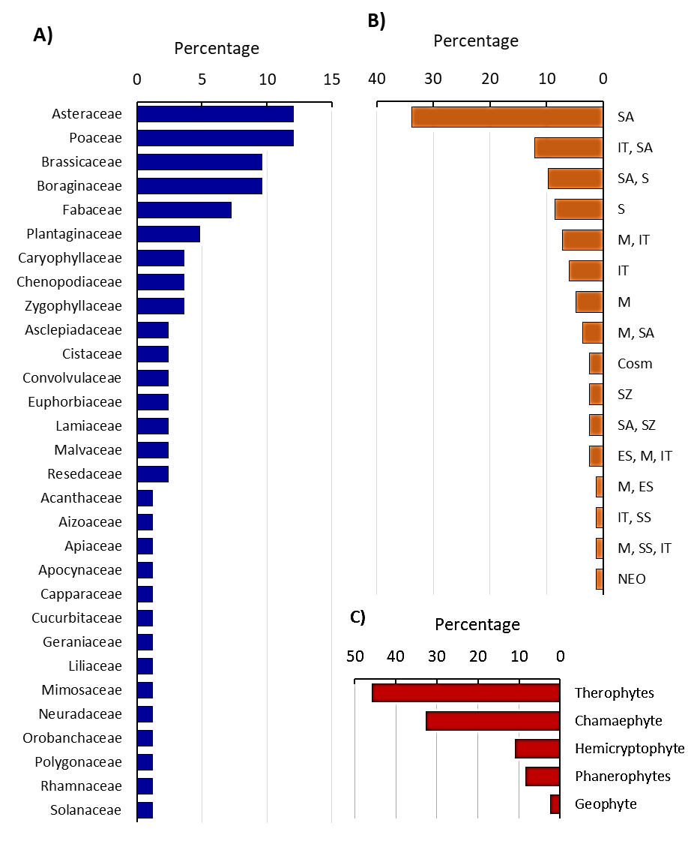
Fig. S1 Floristic composition of the studied sites within Raudhat Alkhafs, Saudi Arabia. a) represented families, b) chorotype spectra, and c) life forms.

