Table S1 Effect of different concentrations of CaCl₂ (10 and 15 mol/m³) on the protein profile of 21-day old salt-stressed Vicia Faba (L.) seedlings

Band number | M.wt  (kDa) | Samples |  |  |  |  |  | Band type
Band number | M.wt  (kDa) | 1 | 2 | 3 | 4 | 5 | 6 | Band type
01 | 147 | 0 | 0 | 0 | 0 | 1 | 0 | U
02 | 137 | 1 | 0 | 1 | 0 | 1 | 0 | P
03 | 124 | 0 | 1 | 0 | 0 | 0 | 1 | P
04 | 120 | 0 | 0 | 1 | 1 | 0 | 0 | P
05 | 114 | 1 | 0 | 0 | 0 | 0 | 1 | P
06 | 80 | 0 | 1 | 1 | 1 | 0 | 0 | P
07 | 56 | 1 | 1 | 1 | 1 | 1 | 1 | M
08 | 40 | 1 | 1 | 1 | 1 | 1 | 1 | M
09 | 28 | 1 | 1 | 1 | 1 | 1 | 1 | M
10 | 26 | 1 | 0 | 1 | 0 | 1 | 0 | P
11 | 25 | 0 | 1 | 0 | 0 | 0 | 1 | P
12 | 23 | 0 | 0 | 0 | 1 | 1 | 1 | P
13 | 17 | 1 | 1 | 1 | 1 | 0 | 0 | P
14 | 15 | 0 | 0 | 0 | 0 | 1 | 1 | P
15 | 12 | 0 | 0 | 0 | 0 | 1 | 0 | U
16 | 10 | 1 | 1 | 1 | 1 | 1 | 1 | M

M.wt: molecular weight, kDa: Kilo Dalton, 1: presence, 0: absence, M: monomorphic bands, P: polymorphic band, U: Unique bands, Samples {1=Control, 2= CaCl₂ (10 mol/m³), 3= CaCl₂ (15 mol/m³), 4= 150 mol/m³ NaCl (S), 5=S+ CaCl₂ (10 mol/m³), 6=S+ CaCl₂ (15 mol/m³)

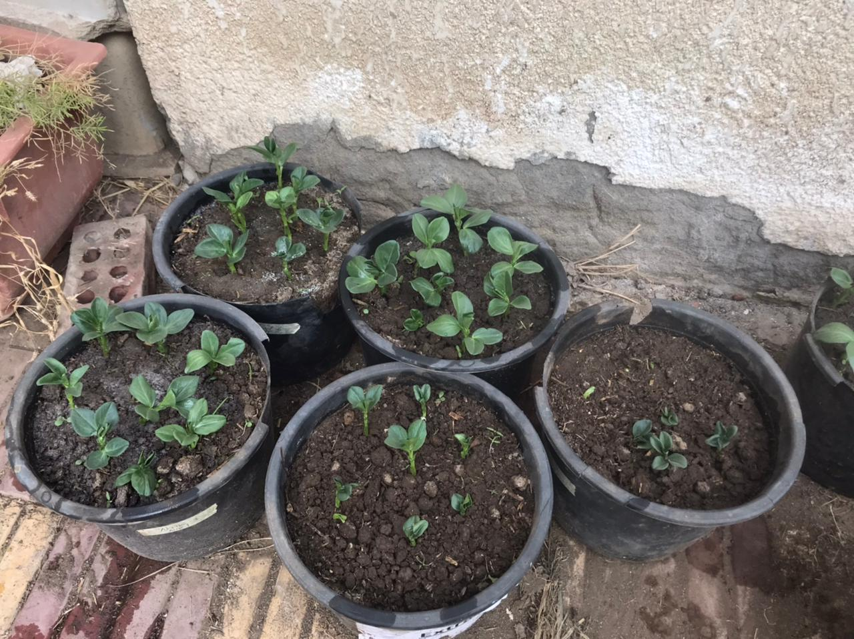  5  4  3  2  1ر  A | 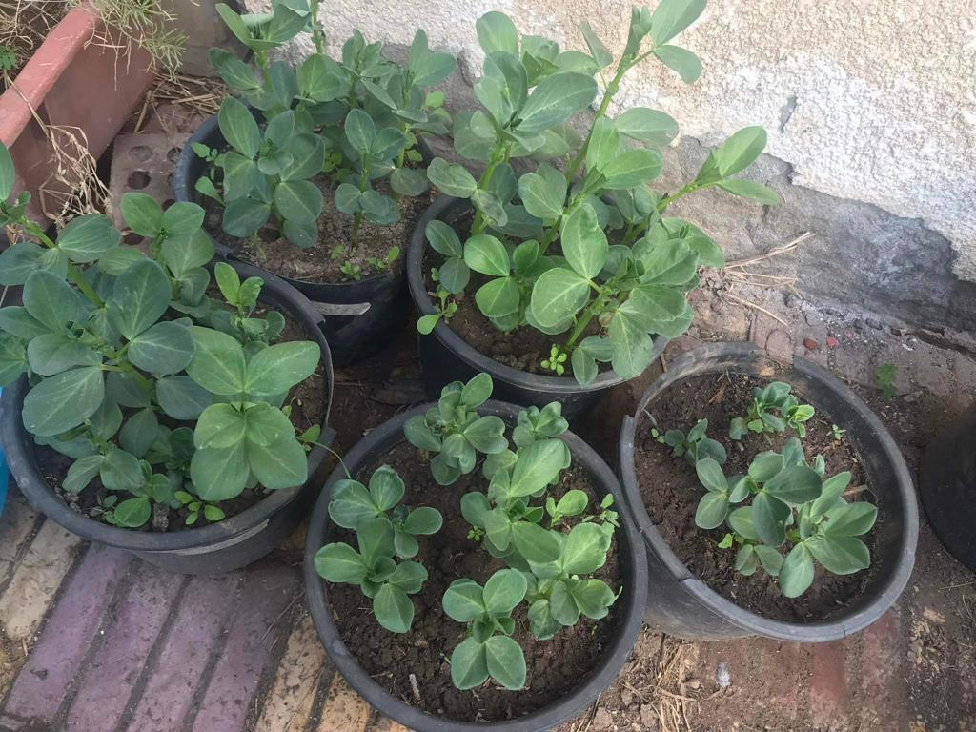  B  5  4  1ر  2  3
Fig.S1. Images showing the effect of seed priming with CaCl₂ (10 and 15 mol/m³) and salinity (S; 150 mol/m³ NaCl) (B) on the growth of Vicia faba (L.) seedlings (A) 7-day old seedlings and (B) 21-day old seedlings. 1: Salt stress (150 mol/m³ NaCl) (S); 2: Ca15 mol/m³; 3: Ca10 mol/m³; 4: S+Ca10 mol/m³ and 5: S+Ca15 mol/m³

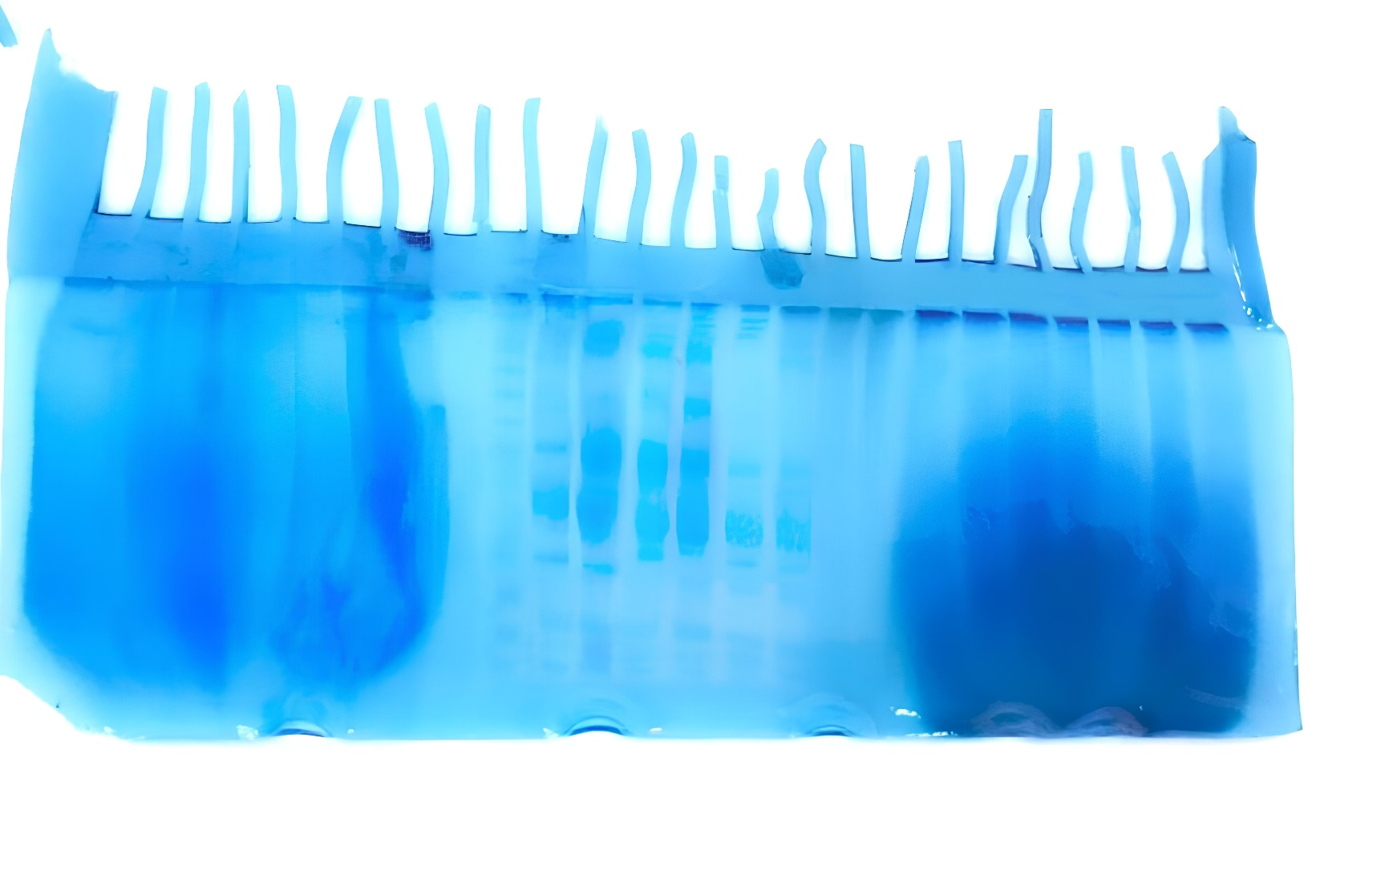

Fig. S2. Original gel of the Effect of seed priming with CaCl₂ (10 and 15 mol/m³) and salinity (S; 150 mol/m³ NaCl) on the protein profile in leaves of 21-day old Vicia faba (L.) seedlings.

.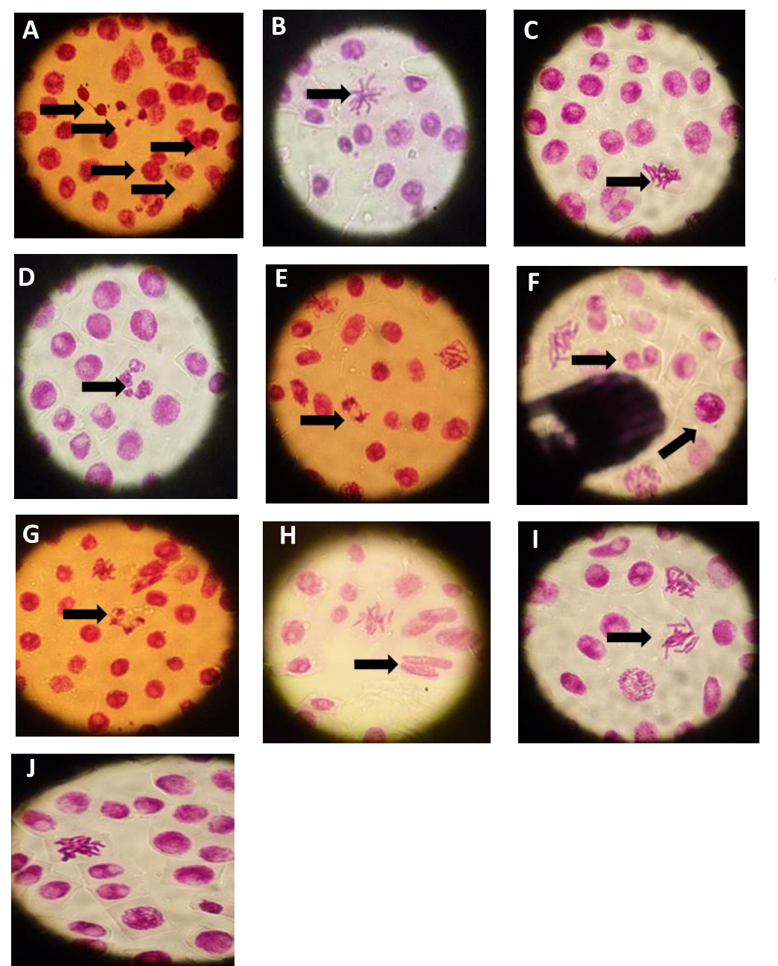
Fig. S3. Some original photo of Chromosome structures in the meristematic cells of Vicia faba roots treated for 24 h with NaCl (150 mol/m³) showing large micronucleus in interphase, nuclear bud in interphase, multinucleate cell with small micronucleus in interphase (A), star shape in prophase (B), stickiness in metaphase with chromosome fragment (C), multinucleate cell with chromatin bridge (D), chromosome bridges in anaphase (E), chromatin bridge in telophase (F), multipolar cell in anaphase and large micronucleus in metaphase (G), binucleated cell with strap nuclei and lesions (H), C-metaphase (I), and stickiness in prophase (J). Bar 20 µm

