Comparative and phylogenetic analysis of Potentilla and Dasiphora (Rosaceae) based on plastid genome
Xiaoping Li ^{1, 2}, Hao Xu ^{1, 3}, Jingya Yu ^{1, 3}, Yun Han ^{1, 3}, Shuang Han ^{1, 3}, Yu Niu ^{1, 3}, Faqi Zhang ^{1, 3, 4, *}
* Corresponding author.
Faqi Zhang
E-mail address: fqzhang@nwipb.cas.cn

Legends
Fig. S1. ML/BI phylogenetic tree of 20 Potentilla and Dasiphora species based on nrETS. The phylogenetic tree constructed by ML is shown on the right, and the phylogenetic tree constructed by BI is shown on the left, with the numbers above the branches representing the ML bootstrap (BS) and the BI posterior probability (PP), respectively.
Fig. S2. ML/BI phylogenetic tree of 20 Potentilla and Dasiphora species based on nrITS. The phylogenetic tree constructed by ML is shown on the right, and the phylogenetic tree constructed by BI is shown on the left, with the numbers above the branches representing the ML bootstrap (BS) and the BI posterior probability (PP), respectively.
Fig. S3. ML/BI phylogenetic tree of 20 Potentilla and Dasiphora species based on nrETS and nrITS. The numbers above the branches represent ML bootstrap values (BS)/BI posterior probabilities (PP).
Fig. S4. ML/BI phylogenetic tree of 20 Potentilla and Dasiphora species based on mitochondrial gene. The phylogenetic tree constructed by ML is shown on the right, and the phylogenetic tree constructed by BI is shown on the left, with the numbers above the branches representing the ML bootstrap (BS) and the BI posterior probability (PP), respectively.
Fig. S5. ML/BI phylogenetic tree of 24 Potentilla and Dasiphora species based on CDS. The phylogenetic tree constructed by ML is shown on the right, and the phylogenetic tree constructed by BI is shown on the left, with the numbers above the branches representing the ML bootstrap (BS) and the BI posterior probability (PP), respectively.
Fig. S6. ML/BI phylogenetic tree of 24 Potentilla and Dasiphora species based on LSC. The numbers above the branches represent ML bootstrap values (BS)/BI posterior probabilities (PP).
Fig. S7. ML/BI phylogenetic tree of 24 Potentilla and Dasiphora species based on SSC. The phylogenetic tree constructed by ML is shown on the right, and the phylogenetic tree constructed by BI is shown on the left, with the numbers above the branches representing the ML bootstrap (BS) and the BI posterior probability (PP), respectively.
Fig. S8. ML/BI phylogenetic tree of 24 Potentilla and Dasiphora species based on IR. The phylogenetic tree constructed by ML is shown on the right, and the phylogenetic tree constructed by BI is shown on the left, with the numbers above the branches representing the ML bootstrap (BS) and the BI posterior probability (PP), respectively.
Fig. S9. ML/BI phylogenetic tree of 24 Potentilla and Dasiphora species based on IGs. The phylogenetic tree constructed by ML is shown on the right, and the phylogenetic tree constructed by BI is shown on the left, with the numbers above the branches representing the ML bootstrap (BS) and the BI posterior probability (PP), respectively.

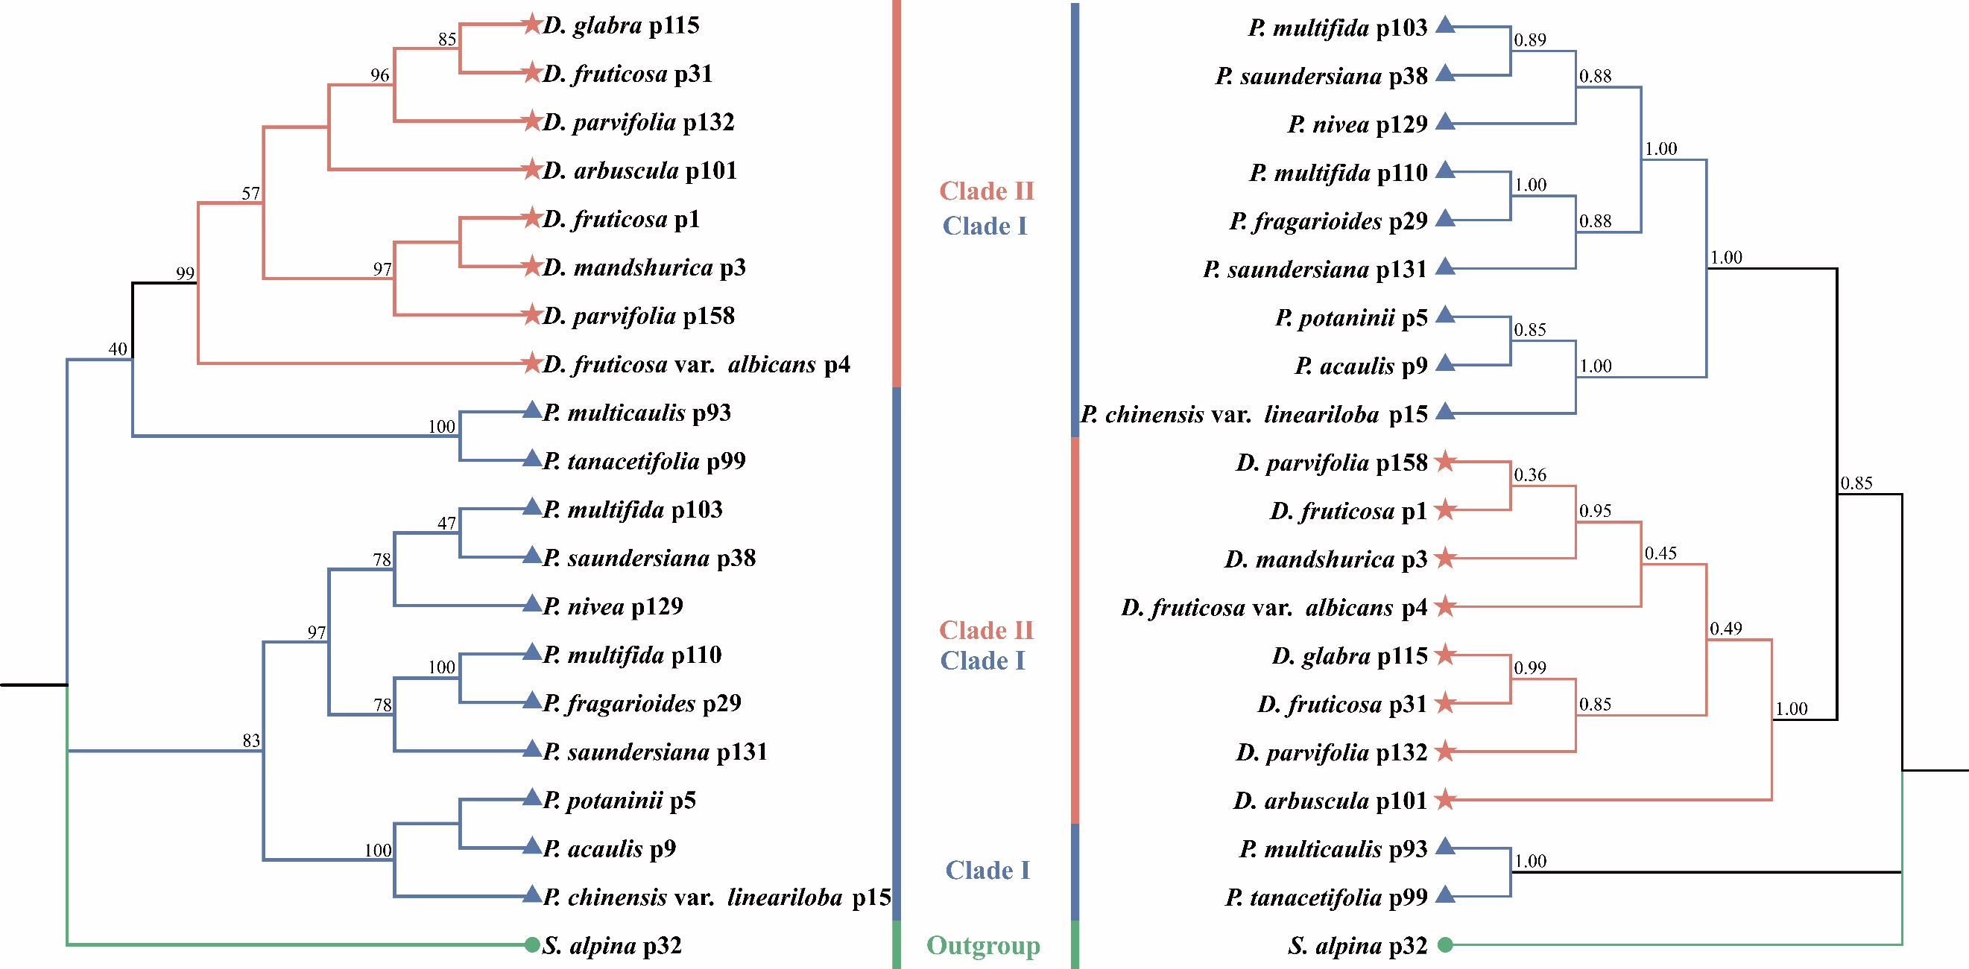
Fig. S1. ML/BI phylogenetic tree of 20 Potentilla and Dasiphora species based on nrETS. The phylogenetic tree constructed by ML is shown on the right, and the phylogenetic tree constructed by BI is shown on the left, with the numbers above the branches representing the ML bootstrap (BS) and the BI posterior probability (PP), respectively.
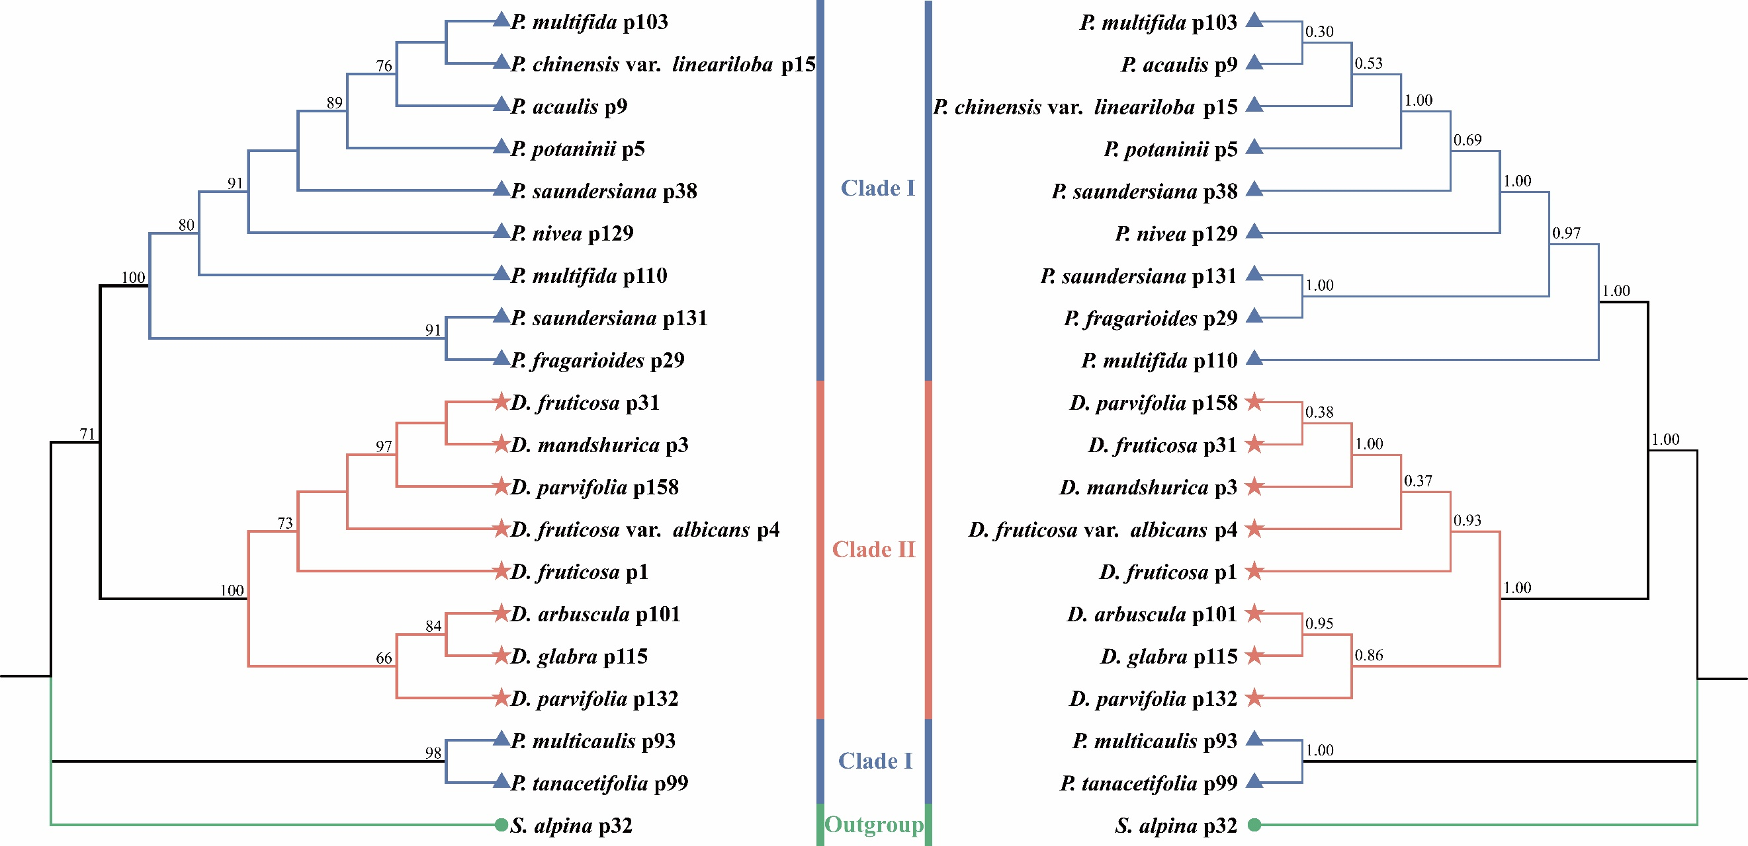
Fig. S2. ML/BI phylogenetic tree of 20 Potentilla and Dasiphora species based on nrITS. The phylogenetic tree constructed by ML is shown on the right, and the phylogenetic tree constructed by BI is shown on the left, with the numbers above the branches representing the ML bootstrap (BS) and the BI posterior probability (PP), respectively.
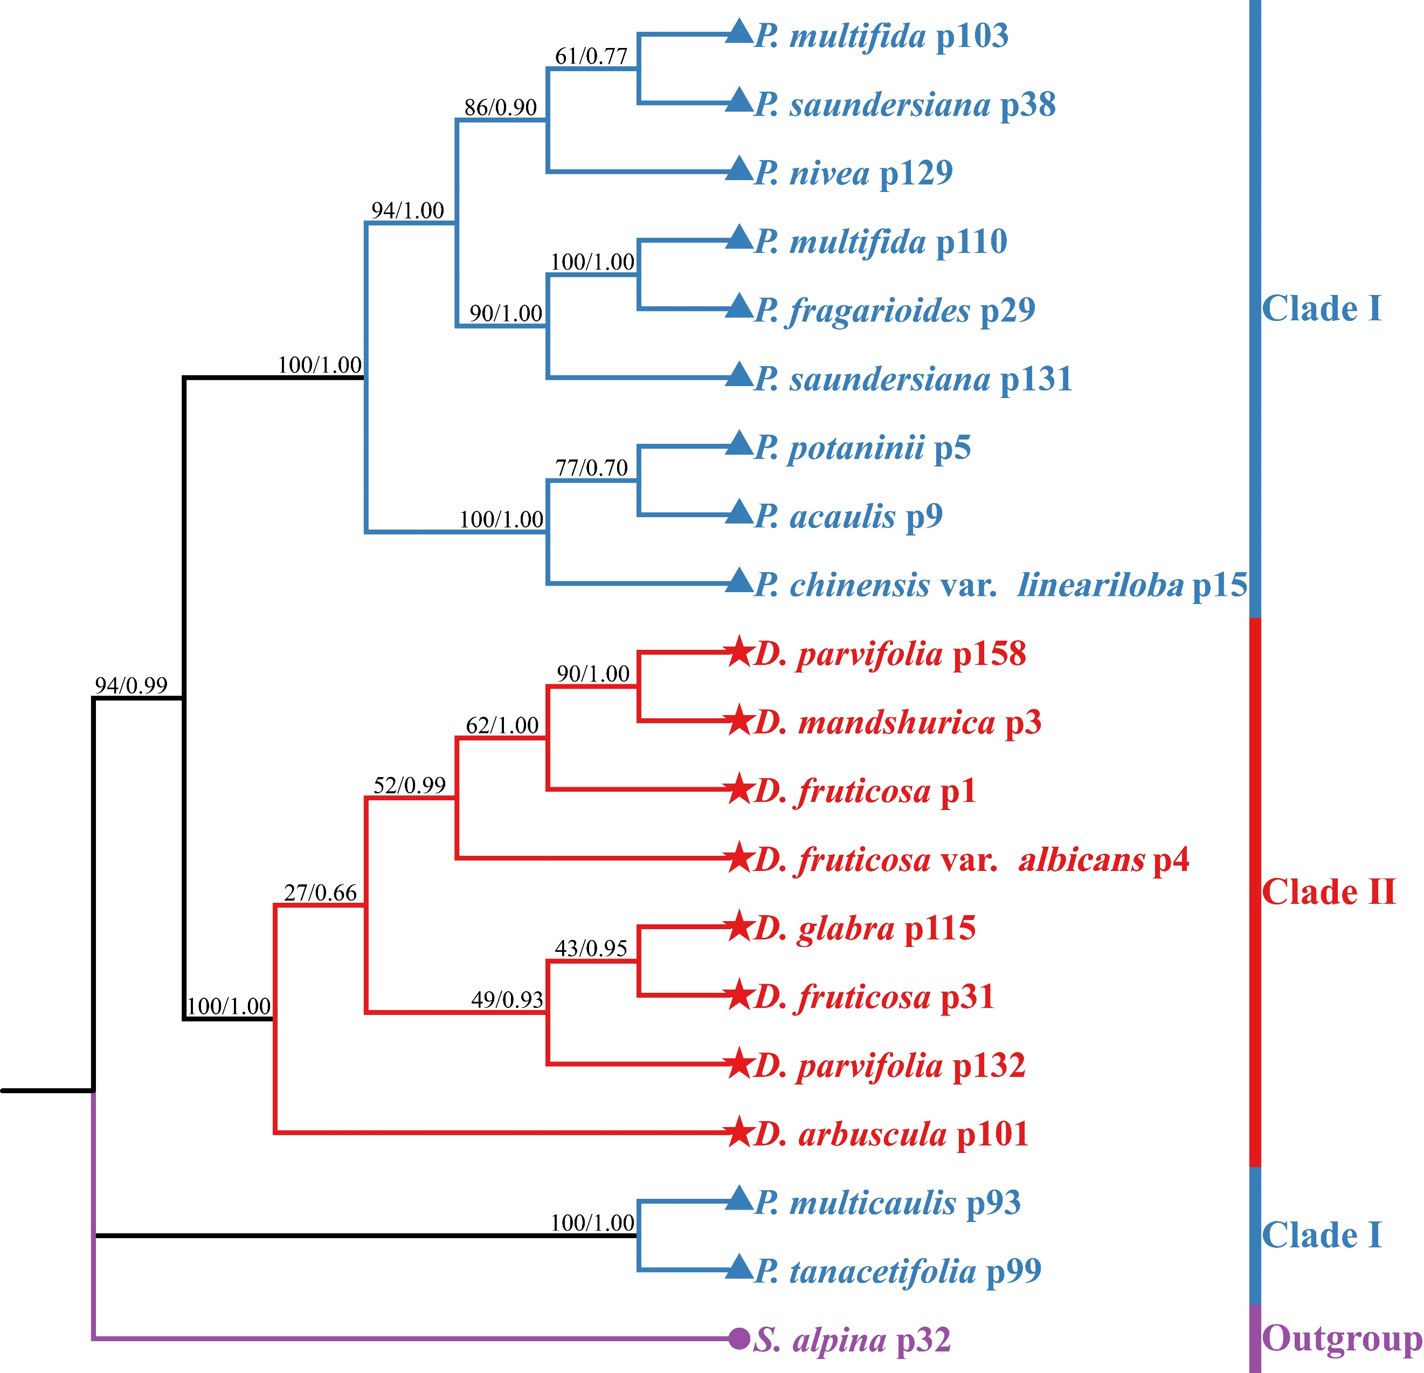
Fig. S3. ML/BI phylogenetic tree of 20 Potentilla and Dasiphora species based on nrETS and nrITS. The numbers above the branches represent ML bootstrap values (BS)/BI posterior probabilities (PP).
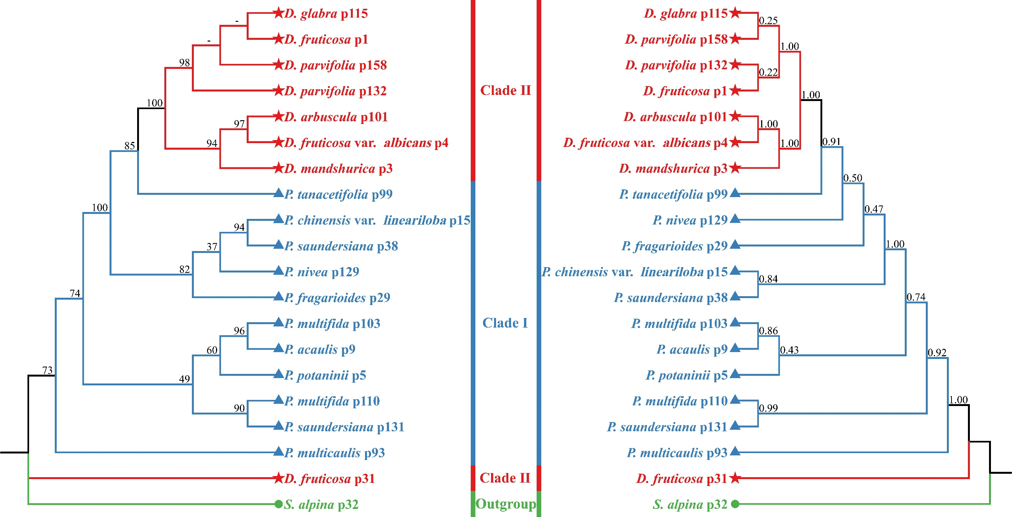
Fig. S4. ML/BI phylogenetic tree of 20 Potentilla and Dasiphora species based on mitochondrial gene. The phylogenetic tree constructed by ML is shown on the right, and the phylogenetic tree constructed by BI is shown on the left, with the numbers above the branches representing the ML bootstrap (BS) and the BI posterior probability (PP), respectively.
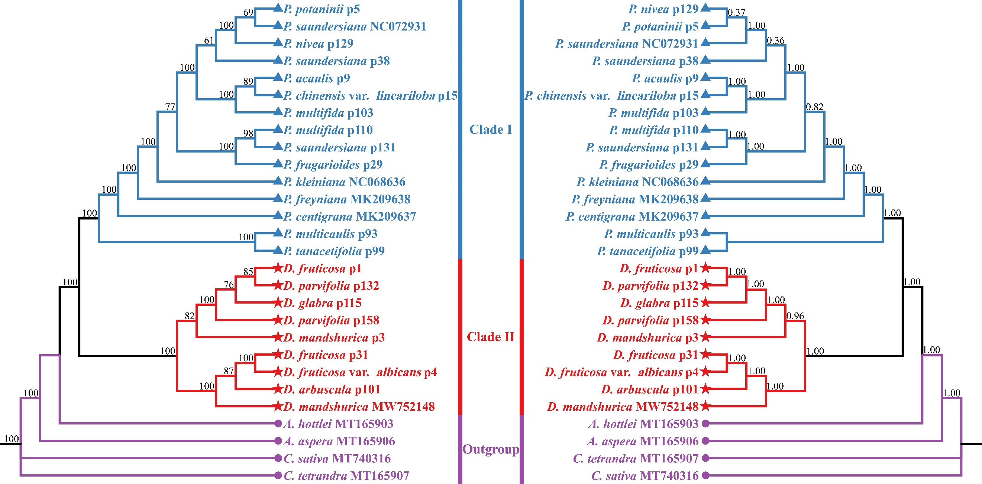
Fig. S5. ML/BI phylogenetic tree of 24 Potentilla and Dasiphora species based on CDS. The phylogenetic tree constructed by ML is shown on the right, and the phylogenetic tree constructed by BI is shown on the left, with the numbers above the branches representing the ML bootstrap (BS) and the BI posterior probability (PP), respectively.
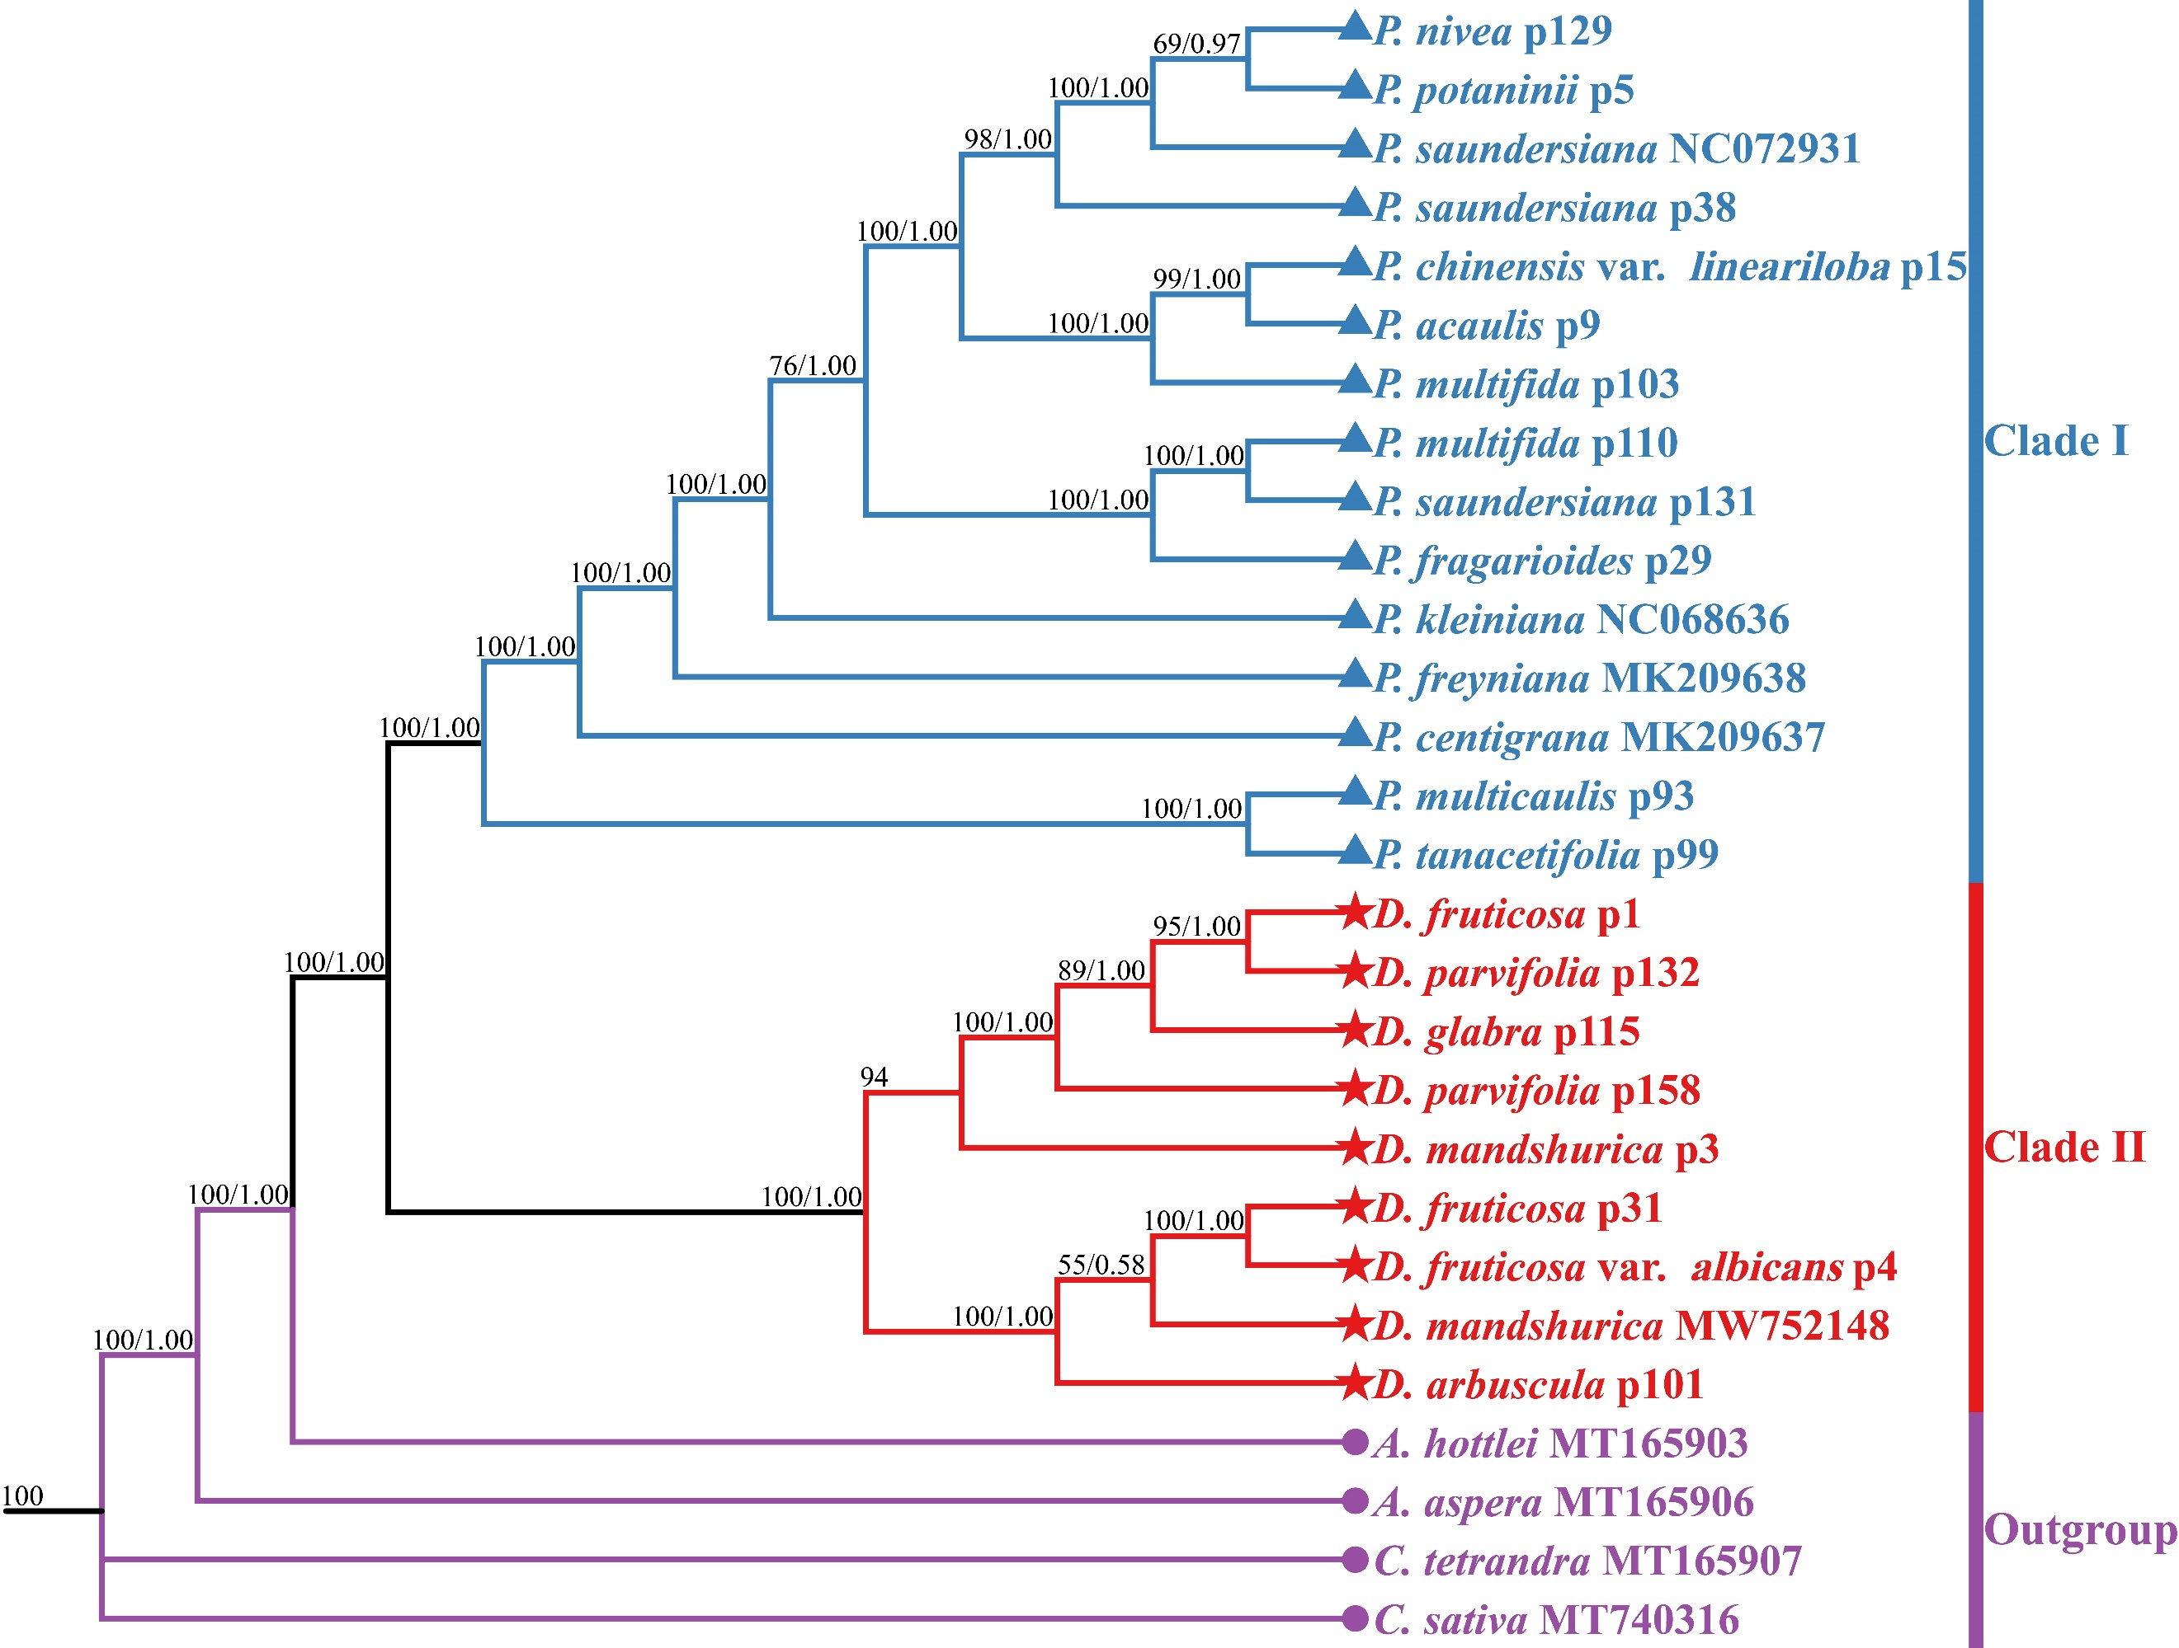
Fig. S6. ML/BI phylogenetic tree of 24 Potentilla and Dasiphora species based on LSC. The numbers above the branches represent ML bootstrap values (BS)/BI posterior probabilities (PP).
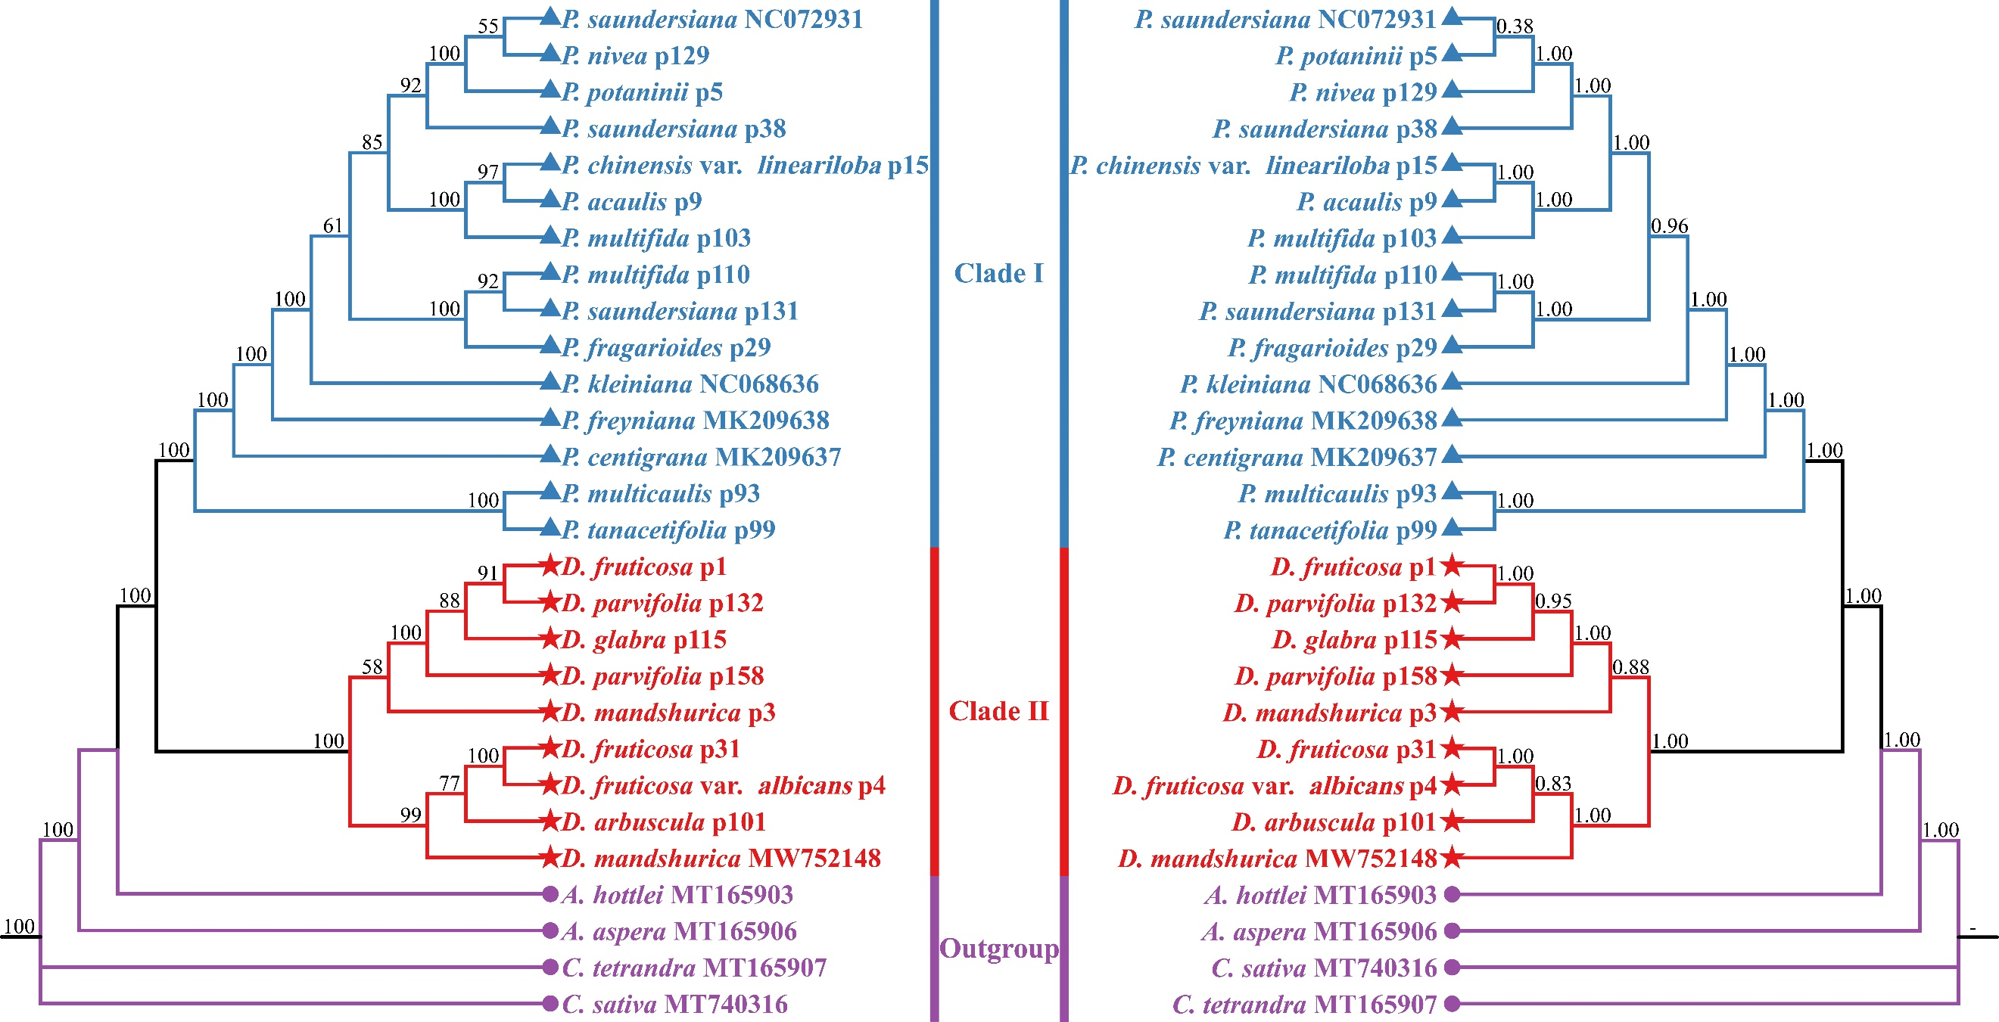
Fig. S7. ML/BI phylogenetic tree of 24 Potentilla and Dasiphora species based on SSC. The phylogenetic tree constructed by ML is shown on the right, and the phylogenetic tree constructed by BI is shown on the left, with the numbers above the branches representing the ML bootstrap (BS) and the BI posterior probability (PP), respectively.
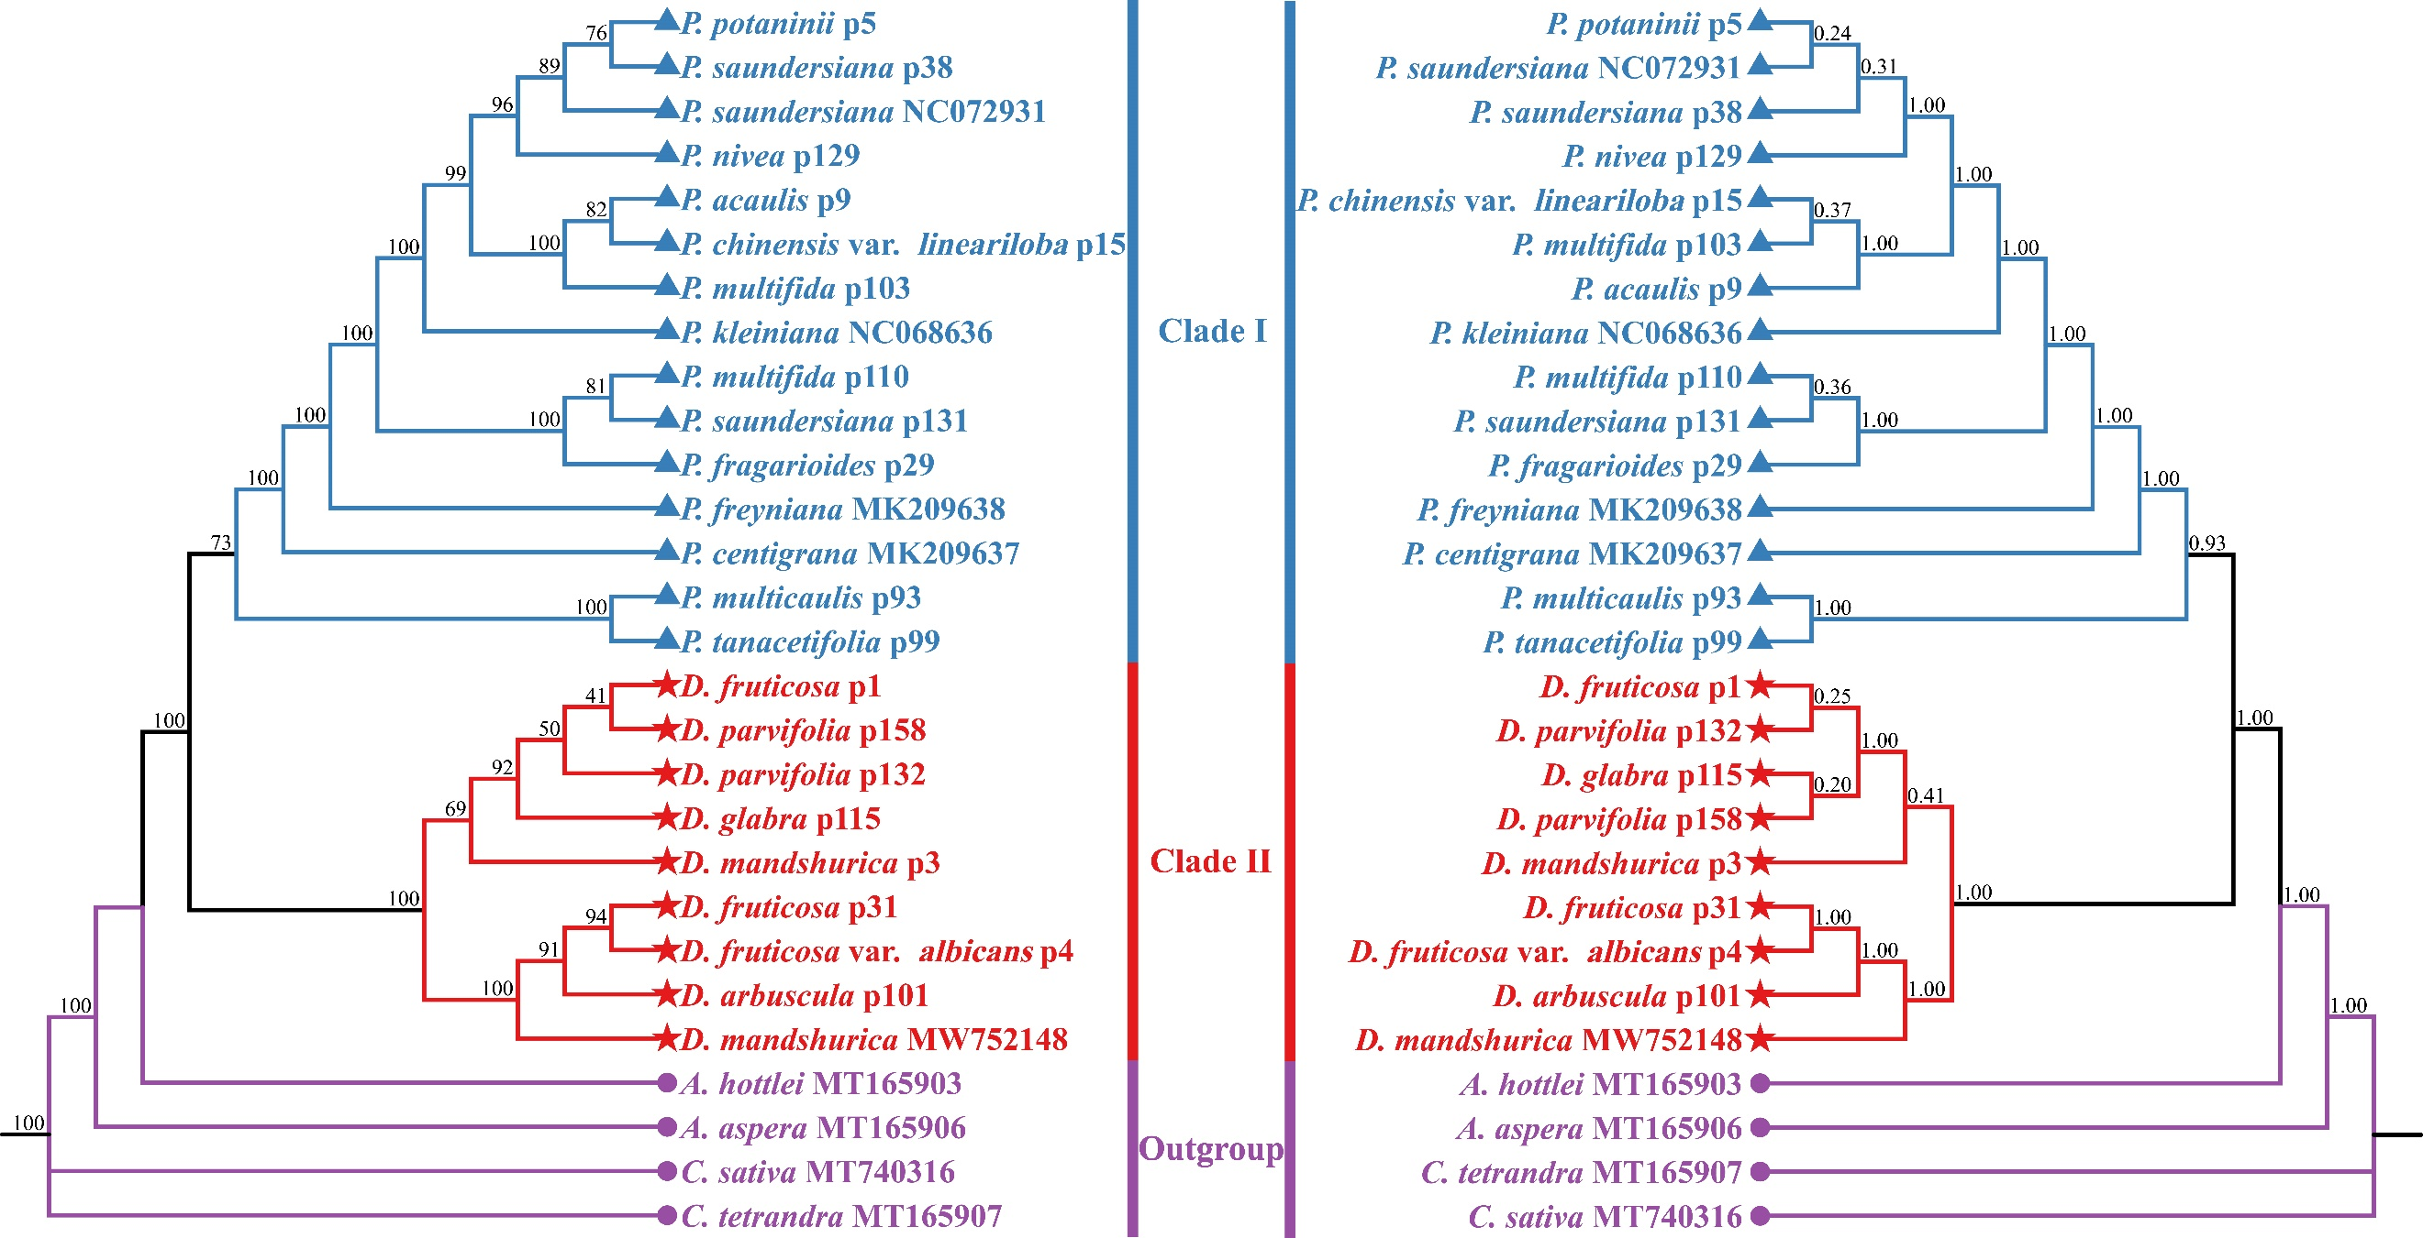
Fig. S8. ML/BI phylogenetic tree of 24 Potentilla and Dasiphora species based on IR. The phylogenetic tree constructed by ML is shown on the right, and the phylogenetic tree constructed by BI is shown on the left, with the numbers above the branches representing the ML bootstrap (BS) and the BI posterior probability (PP), respectively.
Fig. S9. ML/BI phylogenetic tree of 24 Potentilla and Dasiphora species based on IGs. The phylogenetic tree constructed by ML is shown on the right, and the phylogenetic tree constructed by BI is shown on the left, with the numbers above the branches representing the ML bootstrap (BS) and the BI posterior probability (PP), respectively.

