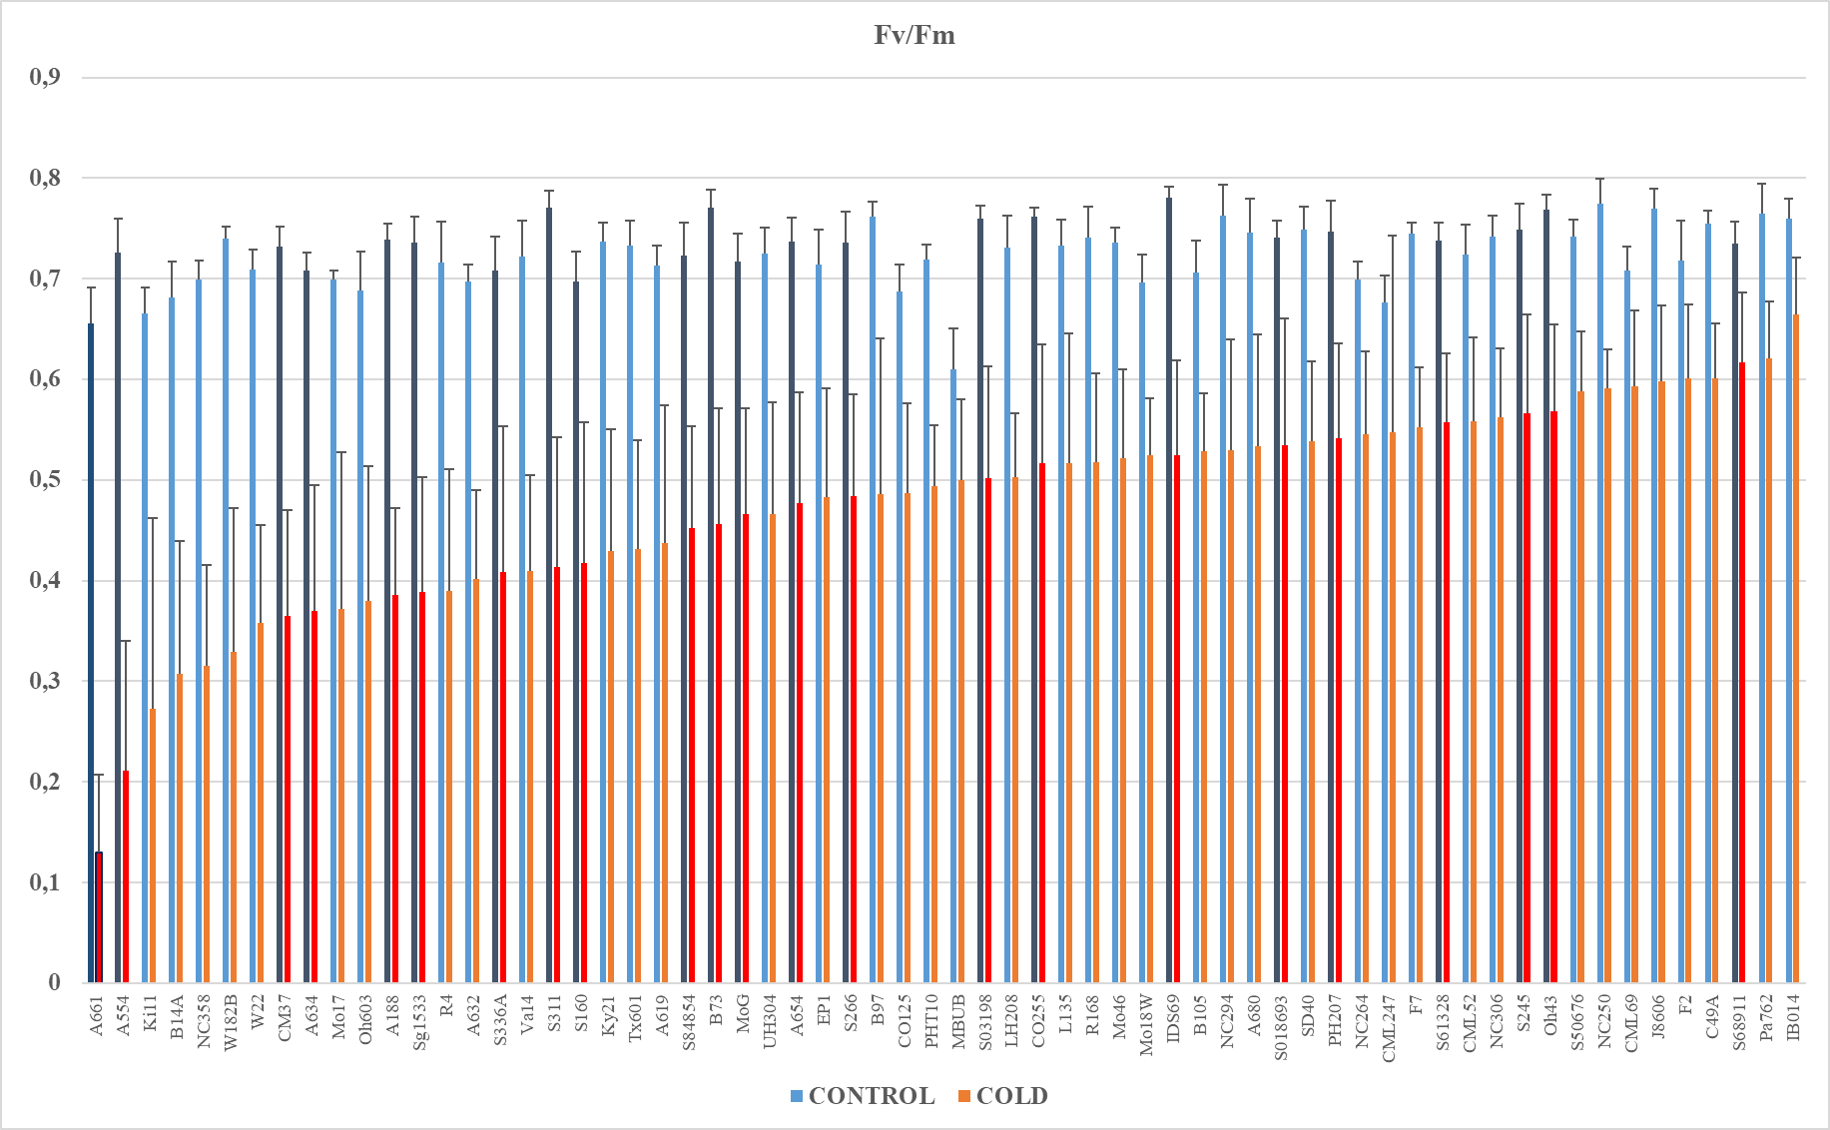
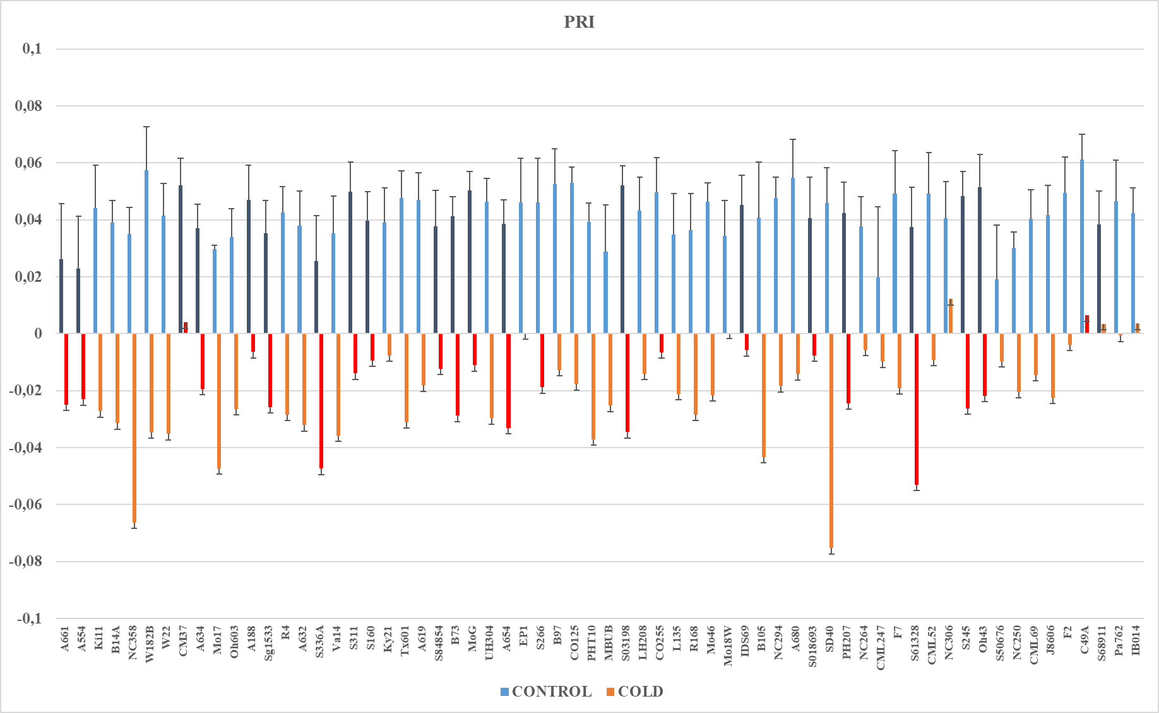

Additional file 1. Maximal quantum yield of PSII (Fv/Fm) and photochemical reflection index (PRI) in the first, fully developed leaf (V1 growth stage) . Measurements were performed on plants of 64 inbred lines grown at optimal temperatures (24°C/21°C; CONTROL) or at low temperatures (16°C/12°C; COLD). Experiments were repeated three times with three or four plants per experiment. Lines are sorted according to their Fv/Fm values for cold-grown plants. Control and low-temperature values are marked with blue and orange bars, respectively. Grey and red bars regard inbred lines selected for Experiment II.

