HUE [°]
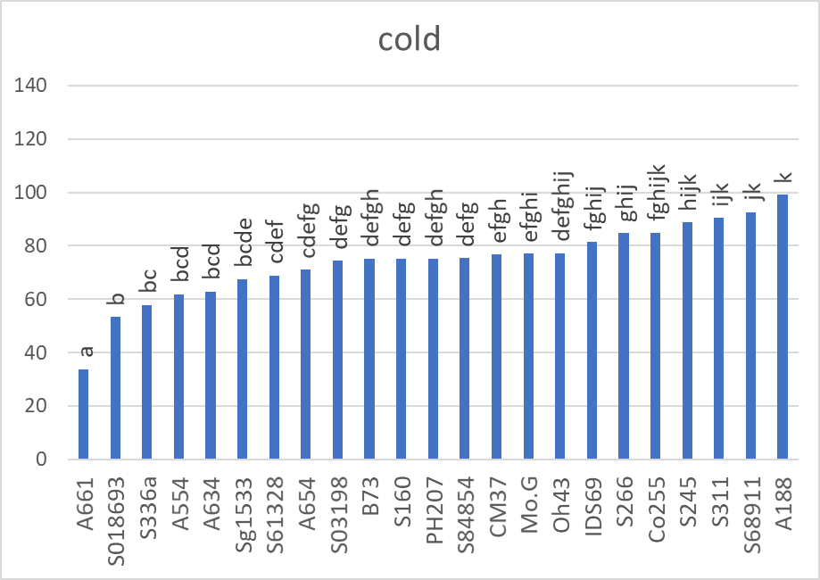 | 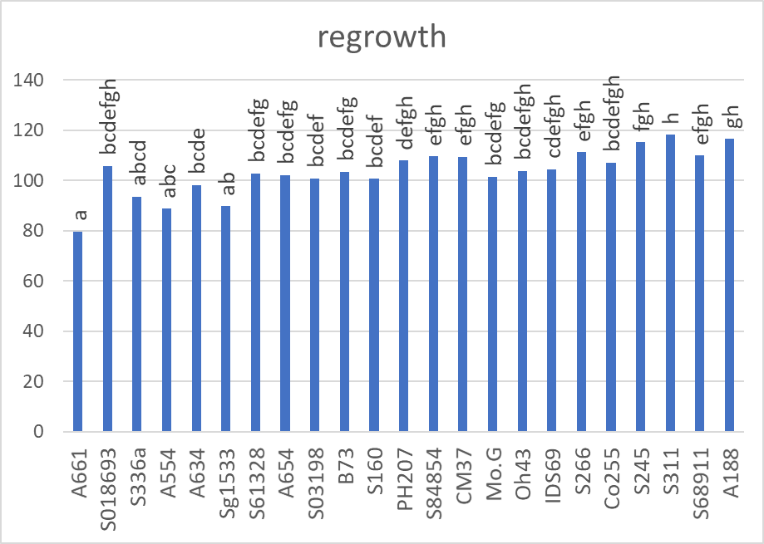
Digital biomass [mm³]
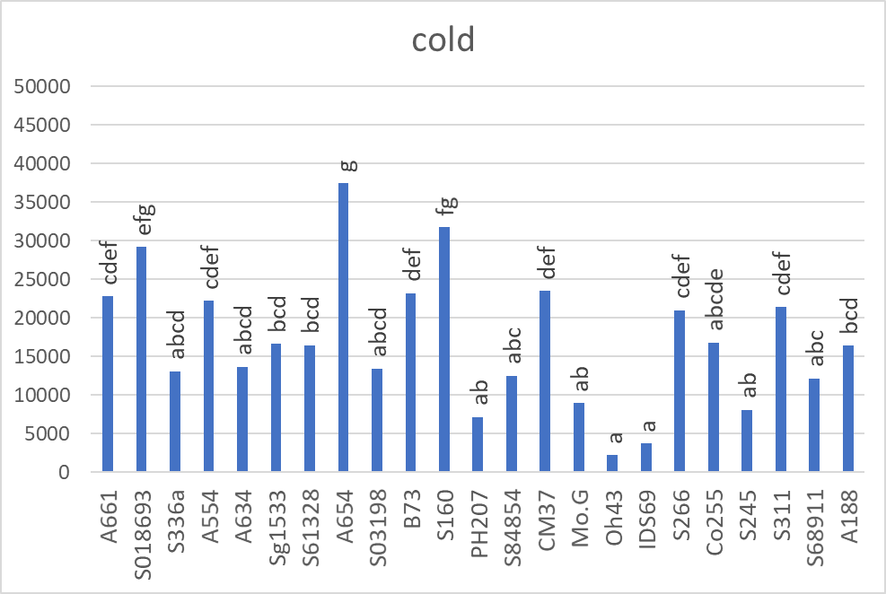 | 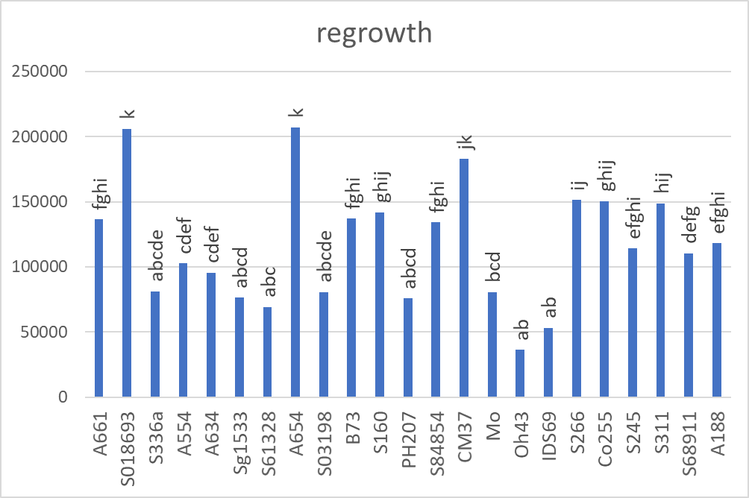
Leaf area [mm²]
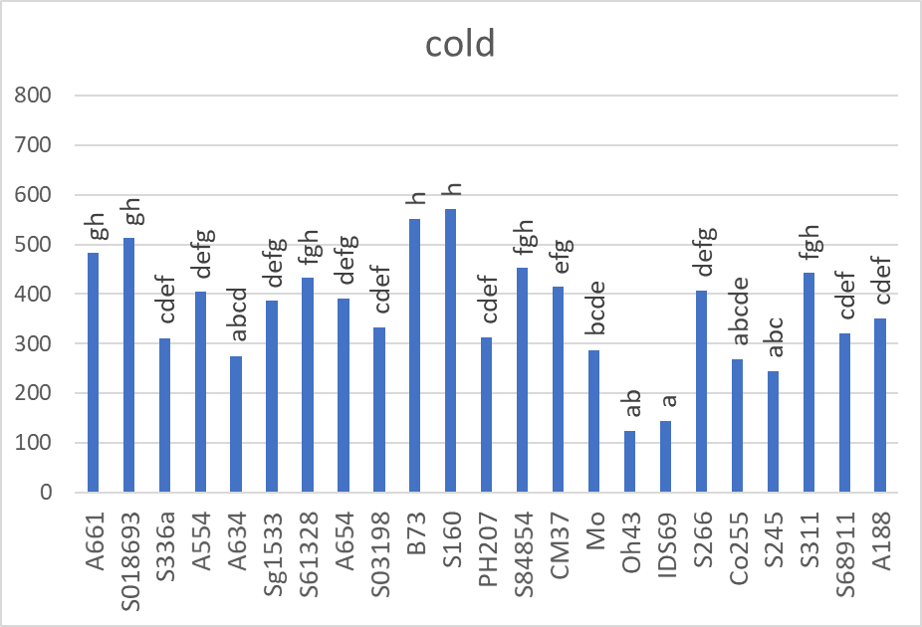 | 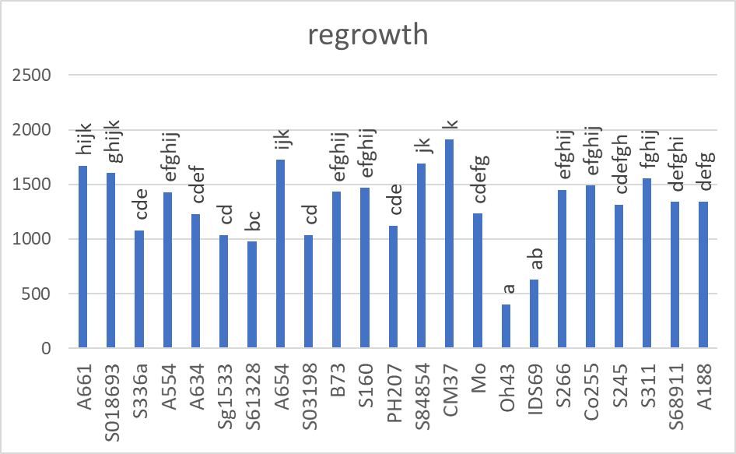

Additional file 3. Leaf hue and morphological traits of seedlings grown at low temperature till V1 growth stage (cold) and after 3-day-long recovery at optimal temperature (regrowth). The lines are sorted according to their HUE values for cold-grown plants. The experiments were repeated three to five times with five plants per experiment. The emmeans function was used to conduct post-hoc pairwise comparisons between all inbred lines, separately for each treatment condition. Tukey method was used for P-value adjustment with ɑ=5%. Different letters mark significantly different values.

