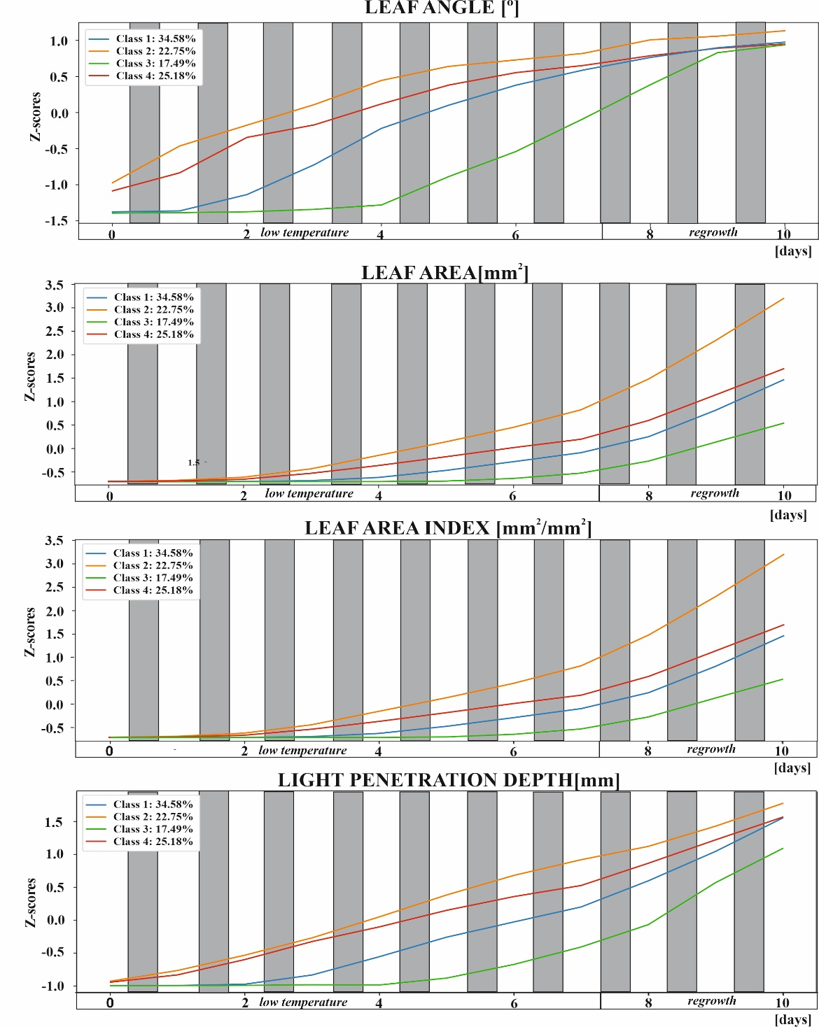

Additional file 4. Averaged time series of the morphological parameters height, leaf area, leaf area index, and light penetration depth for the four classes in Figure 3. Data were subjected to a z-transformation, with mean and standard deviation calculated for all experimental data (data shown in Table S3).

